Distributed computer systems

container Report

Build a Docker image that runs a dictionary server and deploy it as a container using ubuntu distribution.

Introduction: This report outlines the process of building a Docker image for a dictionary server and deploying it as a container.

1. Install docker: sudo apt install docker.io
2. create a directory to build your Docker image(I called it server)

3- create Dockerfile and put this code inside

FROM ubuntu: latest

ENV PYTHONUNBUFFERED=1

ENV PYTHONIOENCODING=UTF-8

RUN apt-get update \

&& apt-get -y upgrade \

&& apt-get -y install python3

ADD server.tar.gz /

CMD ["python3", "/server.py", "25565”]

1. This command will build the image:

sudo docker build -t dict-server:latest .

1. After the Docker image build completes this command will launch an instance of your Docker image:

sudo docker run -d -p 42:25565 dict-server



This hash is a unique identifier for referencing the newly deployed container.

1. After we built a container we can retrieve a list of all containers on your system by using the following command.

sudo docker ps -a



(Docker command):

1. this command will show the log generated by the dictionary server.

sudo docker logs cfa7

7- stop docker containers: sudo docker stop cfa7



1. start docker containers: sudo docker start cfa7



1. access terminal of a container : sudo docker exec -it cfa7 bash

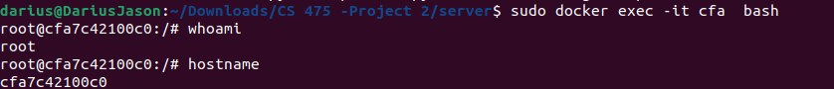

1. After a Docker container is no longer needed, it can easily be removed

sudo docker stop cfa7

sudo docker rm cfa7  


Mohammed Ahmad