Fig. 1.1 | deep-sea microfibres collection locations | 14
Fig. 1.2 | proportion of marine litter categories on reference beaches | 15
Fig. 1.3 | Entanglement of marine organisms in plastic | 20
Fig. 1.4 | 3 dead whale because of plastic debris swallowing | 21
Fig. 1.5 | Deep sea animals have been found with plastics in their stomachs | 22
Fig. 1.6 | plastic effect on water birds | 23
Fig. 1.7 | accumulation of plastic debris across food chain | 25
Fig. 1.8 | cycle of plastic product | 28
Fig. 1.9 | cumulative plastic waste generation and disposal | 29
Fig. 2.1 | Bio plastic manufacture process | 33
Fig. 2.2 | Bio plastic based material | 35
Fig.2.3 | Bio plastic from banana peels | 37
Fig. 2.4 | material and steps for bio plastic preparation | 39


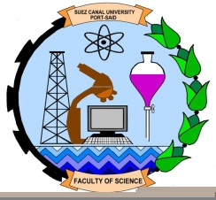
Port Said University
Faculty of Science
Environmental Science Department

production of bioplastic from local
agro-waste

An Essay prepared to fulfill requirements of the B.Sc. Degree

By
Abdulrhman Salem Mousa

4th level Environmental Science

Submitted to
The Environmental Science Department
Faculty of science
Port Said University

Supervised by
Dr. Ahmed Abdelaal
2018
ABSTRACT

Plastics have outgrown most man-made materials and have long been under environmental scrutiny. However, robust global information, particularly about their end-of-life fate, is lacking. By identifying and synthesizing dispersed data on production, use, and end-of-life management of polymer resins, synthetic fibers, and additives, we present the first global analysis of all mass-produced plastics ever manufactured We estimate that 8300 million
metric tons (Mt) as of virgin plastics have been produced to date
As of 2015, approximately 6300 Mt of plastic waste had been generated, around 9% of which had been recycled, 12% was incinerated, and 79% was accumulated in landfills or the natural environment.

If current production and waste management trends continue, roughly 12,000 Mt of plastic waste will be in landfills or in the natural environment by 2050.
The research work on synthesis of bio plastic material by using banana peels. Bio plastic prepared using the

banana peels serve as potential alternative to the conventional plastic material. Making bio plastic from banana
peels instead of traditional petroleum based plastic is believed to be successful solution to increase efficiency of
plastic industry. The result show that the plastic produced could bear the weight one and half times more than petroleum plastic.
This report introduces a scientific method to generate bio plastic from banana peels and help to reduce the pollution

Chapter 1
Introduction

1- INTRODUCTION
(2008 ( et al Browne, M. A
A world without plastics, or synthetic organic polymers, seems unimaginable today, yet their large-scale production and use only dates back to ~1950. Although the first synthetic plastics, such as Bakelite, appeared in the early 20th century, widespread use of plastics outside of the military did not occur until after World War II. The ensuing rapid growth in plastics production is extraordinary, surpassing most other man-made materials. Notable exceptions are materials that are used extensively in the construction sector, such as steel and cement (RF).
Instead, plastics’ largest market is packaging, an application whose growth was accelerated by a global shift from reusable to single-use containers. As a result, the share of plastics in municipal solid waste (by mass) increased from less than 1% in 1960 to more than 10% by 2005 in middle- and high-income countries At the same time, global solid waste generation, which is strongly correlated with gross national income per capita, has grown steadily over the past five decades.
The vast majority of monomers used to make plastics, such as ethylene and propylene, are derived from fossil hydrocarbons. None of the commonly used plastics are biodegradable. As a result, they accumulate, rather than decompose, in landfills or the natural environment The only way to permanently eliminate plastic waste is by destructive thermal treatment, such as combustion or pyrolysis. Thus, near-permanent contamination of the natural environment with plastic waste is a growing concern.
Plastic debris has been found in all major ocean basins, with an estimated 4 to 12 million metric tons (Mt) of plastic waste generated on land entering the marine environment in 2010 alone Contamination of freshwater systems and terrestrial habitats is also increasingly reported as is environmental contamination with synthetic fibers Plastic waste is now so ubiquitous in the environment that it has been suggested as a geological indicator of the proposed Anthropocene

We present the first global analysis of all mass-produced plastics ever made by developing and combining global data on production, use, and end-of-life fate of polymer resins, synthetic fibers, and additives into a comprehensive material flow model. The analysis includes thermoplastics, thermosets, polyurethanes (PURs), elastomers, coatings, and sealants but focuses on the most prevalent resins and fibers: high-density polyethylene (PE), low-density and linear low-density PE, polypropylene (PP), polystyrene (PS), polyvinylchloride (PVC), polyethylene terephthalate (PET), and PUR resins; and polyester, polyamide, and acrylic (PP&A) fibers. The pure polymer is mixed with additives to enhance the properties of the material.
Plastic causes environmental pollution because of having non-biodegradable characteristics and they are full of harmful by-products and chemicals which are released during their break down process. It's been estimated that 400.000 barrels of oil are used each day to make plastic packaging in the world. The oil-based plastics cannot be rid easily and create landfills or environmental pollution.
Bioplastics can be defined as plastics made of biomass such as banana peels and potato peels. Bio plastic is plastic made of biodegradable materials such as banana peels, fruit waste etc. They are completely safe and do not have any harmful chemicals or toxins. Bio plastics can replace petroleum-based plastics and can be made from vegetable wastes that contain starch.
1.1 Plastic problems
It is the accumulation of plastic products in the environment that adversely affects wildlife, wildlife habitat, or humans.[1] Plastics that act as pollutants are categorized into micro-, meso-, or macro debris, based on sizePlastics are inexpensive and durable, and as a result levels of plastic production by humans are highHowever, the chemical structure of most plastics renders them resistant to many natural processes of degradation and as a result they are slow to degradeTogether, these two factors have led to a high prominence of plastic pollution in the environment.

Plastic pollution can afflict land, waterways and oceans. Living organisms, particularly marine animals, can be harmed either by mechanical effects, such as entanglement in plastic objects or problems related to ingestion of plastic waste, or through exposure to chemicals within plastics that interfere with their physiology. Humans are also affected by plastic pollution, such as through disruption of various hormonal mechanisms (von Moos et al. 2012)
Land
Chlorinated plastic can release harmful chemicals into the surrounding soil, which can then seep into groundwater or other surrounding water sources and also the ecosystem This can cause serious harm to the species that drink the water.
Suszkiw, Jan et al (2011)
Oceans
In 2012, it was estimated that there was approximately 165 million tons of plastic pollution in the world's oceans one type of plastic that is of concern in terms of ocean plastic pollution is nurdles. Nurdles are manufactured plastic pellets (a type of microplastic) used in the creation of plastic products and are often shipped via cargo shipMany billions of nurdles are spilled into oceans each year, and it has been estimated that globally, around 10% of beach litter consists of nurdles Plastics in oceans typically degrade within a year, but not entirely.
In the process, toxic chemicals such as bisphenol A and polystyrene can leach into waters from some plastics.[21] Polystyrene pieces and nurdles are the most common types of plastic pollution in oceans, and combined with plastic bags and food containers make up the majority of oceanic debris.[23]

One study estimated that there are more than 5 trillion plastic pieces (defined into the four classes of small microplastics, large microplastics, meso- and macroplastics) afloat at sea.[24]
The litter that is being delivered into the oceans is toxic to marine life, and humans. The toxins that are components of plastic include diethylhexyl phthalate, which is a toxic carcinogen, as well as lead, cadmium, and mercury.
Plankton, fish, and ultimately the human race, through the food chain, ingest these highly toxic carcinogens and chemicals. Consuming the fish that contain these toxins can cause an increase in cancer, immune disorders, and birth defects citation needed.
The majority of the litter near and in the ocean is made up of plastics and is a persistent pervasive source of marine pollution According to Dr. Marcus Eriksen of The 5 Gyres Institute, there are 5.25 trillion particles of plastic pollution that weigh as much as 270,000 tons (2016). This plastic is taken by the ocean currents and accumulates in large
vortexes known as ocean gyres. The majority of the gyres become pollution dumps filled with plastic.
The amount of plastic pollution accumulating in the oceans is estimated at over five trillion pieces floating in the waters. This paper provides an overview of the amount of plastic pollution in the world’s waterways, and why it is there. Researching credible sources on this topic aided in answering the research question: “what would it take to reduce the amount of plastic in the ocean?” The findings suggest businesses to replace 50%, or more, of their common plastic products with biodegradable, or compostable, items because of the following: The main type of plastic being used by businesses is petroleum-based plastics. Businesses should switch to compostable items which break down within 90 days and do not leave a toxic residue (EPA, 2018a).The effect of plastic waste in the ocean has a negative impact on animal life, as well as, the coral reefs.
The oceans are filled with harmful plastics which are being digested and entangled by sea life on a daily basis (Dissanayake, 2016). Single-use items are contributing to the amount of plastic found in the five ocean gyres. There were over 260,000 tons of plastic debris in the ocean in 2013 (Eriksen et al., 2014). The problem with single-use items is the waste it involves. While it is very convenient to the consumer and provider to have access to disposable items, it poses a significant problem in landfills and waterway volumes.
Industrialized countries need to take aggressive action on the types of plastic being used, or evoke a monetary discipline (Dissanayake, 2016). By creating legislative mandates for recycling, ocean life may be able to thrive, and human life may be able to improve from a healthier environment. Using existing resources to convert from petroleum-based plastics to bioplastics. These conclusions identified a potential solution in reducing plastic pollution. With education and awareness, people can begin to clean the rivers and waters, and make them a safe place for sea animals to live.
Woodall, L. C et al (2015)
1-2 plastic in our life
Without plastics, or synthetic organic polymers, seems unimaginable today, yet their large-scale production and use only dates back to ~1950. Although the first synthetic plastics, such as Bakelite, appeared in the early 20th century, widespread use of plastics outside of the military did not occur until after World War II. The ensuing rapid growth in plastics production is extraordinary, surpassing most other man-made materials. Notable exceptions are materials that are used extensively in the construction sector, such as steel and cement).

Instead, plastics’ largest market is packaging, an application whose growth was accelerated by a global shift from reusable to single-use containers. As a result, the share of plastics in municipal solid waste (by mass) increased from less than 1% in 1960 to more than 10% by 2005 in middle- and high-income countries At the same time, global solid waste generation, which is strongly correlated with gross national income per capita, has grown steadily over the past five decades).
In the UK alone, more than 5 million tonnes of plastic are consumed each year, of which only an estimated 24% is recycled. The remaining 3.8 million tonnes of waste is disposed of in landfills. This large amount of plastic waste inevitably enters the environment, with studies suggesting that the bodies of 90% of seabirds contain plastic debris. In some areas there have been significant efforts to reduce the prominence of plastic pollution, through reducing plastic consumption and promoting plastic recycling. Since the 1950s, an estimated 6.3 billion tonnes of plastic has been produced, of which an estimated 9% has been recycled and another 12% of plastic waste has been incinerate.
Estimates for the contribution of land-based plastic vary widely. While one study estimated that a little over 10% of plastic debris in ocean water comes from land-based sources, responsible for 0.8 million tonnes (790,000 long tons; 880,000 short tons) every year. in 2015, Jambeck et al. ??? calculated that 275 million tonnes (271,000,000 long tons; 303,000,000 short tons) of plastic waste was generated in 192 coastal countries in 2010, with 4.8 to 12.7 million tonnes (12,500,000 long tons; 14,000,000 short tons) entering the ocean - a percentage of only up to 5%.
A source that has caused concern is landfills. Most waste in the form of plastic in landfills are single-use items such as packaging. Discarding plastics this way leads to accumulation although disposing of plastic waste in landfills has less of a gas emission risk than disposal through incineration, the former has space limitations. Another concern is that the liners acting as protective layers between the landfill and environment can break, thus leaking toxins and contaminating the nearby soil and water. Landfills located near oceans often contribute to ocean debris because content is easily swept up and transported to the sea by wind or small waterways like rivers and streams. Marine debris can also result from sewage water that has not been efficiently treated, which is eventually transported to the ocean through rivers. Plastic items that have been improperly discarded can also be carried to oceans through storm waters.
Thompson, R. C et al (2004)
1-3plastic
1-3-1plasticManufacture
Watts, A. J. R et al (2016).
The starting point of the plastic production model is global annual pure polymer (resin) production data from 1950 to 2015, published by the Plastics Europe Market Research Group, and global annual fiber production data from 1970 to 2015 published by The Fiber Year and Tecnon OrbiChem. The resin data closely follow a second-order polynomial time trend, which generated a fit of R2 = 0.9968. The fiber data closely follow a third-order polynomial time trend, which generated a fit of R2 = 0.9934. Global breakdowns of total production by polymer type and industrial use sector were derived from annual market and polymer data for North America, Europe, China, and India. U.S. and European data are available for 2002 to 2014. Polymer type and industrial use sector breakdowns of polymer production are similar across countries and regions.

Global additives production data, which are not publicly available, were acquired from market research companies and cross-checked for consistency (table S3) (17, 18). Additives data are available for 2000 to 2014. Polymer type and industrial use sector breakdowns of polymer production and the additives to polymer fraction were both stable over the time period for which data are available and thus assumed constant throughout the modeling period of 1950–2015. Any errors in the early decades were mitigated by the lower production rates in those years. Additives data were organized by additive type and industrial use sector and integrated with the polymer data. Pi (t) denotes the amount of primary plastics (that is, polymers plus additives) produced in year t and used in sector
Plastics are used in a wide variety of products and have displaced other materials, such as wood, metal, and glass. It can be formed into polyesters for use in fabrics and textiles, polyvinylidene chloride for food packaging, and polycarbonates for eyeglasses and compact discs, among thousands of other uses. The production of plastic requires four basic steps: the acquirement of raw material, synthesizing a basic polymer, compounding the polymer into a usable fraction, and lastly, molding or shaping the plastic. The production of plastic is quite energy intensive, requiring 62 to 108 mega joules of energy per kilogram based on U.S. efficiency averages. Producing silicon can require up to 235 mega joules per kilogram of material.
In 2016, the global production of plastics reached 335 million metric tons, with 60 million metric tons produced in Europe alone. China is one of the largest producers of plastics in the world, accounting for around one quarter of the global production. Plastic imports from China into the United States are steadily increasing as China’s plastic industry grows. Production of plastics in China will continue to develop and include more efficient companies that produce higher quality plastics
Plastics are a product of human ingenuity and innovation—one of civilization’s great solutions. They’re lightweight, durable, airtight, decay resistant, inexpensive, and moldable into a huge range of products. But projected 2050 levels of production are clearly too much of a good thing. Our growth-addicted economic system has a knack for turning every solution into a problem—every strength into a weakness.
At current and projected production levels, plastics are a big problem. Briefly:
Plastics are forever-well, almost. Except for the tonnage we’ve incinerated, nearly all the plastic ever produced still exists somewhere in the biosphere, although much of it is now invisible to humans, reduced to tiny particles in ocean and land ecosystems. Plastic is great because it lasts so long and resists decay. Plastic is a big problem for those same reasons.
Injection Molding
One of the most common plastic manufacturing methods, injection molding lends itself to mass production of products ranging from cell phone stands to toys. The injection molding process melts resin pellets inside the injection machine with a heated barrel. An auger moves the plastic forward and ensures an even mix of melted plastic. The machine then drives the melted plastic into a metal mold. The plastic fills the mold and results in a solid plastic part or product. Most injection molding processes employ thermoplastics that you can melt and cool multiple times, which limits material waste.
Extrusion Molding
Extrusion molding calls for a very similar process as injection molding. The machine still melts the plastic. Rather than filling a mold with the plastic, the machine presses the melted plastic through a die that gives the plastic a fixed shape. The extrusion molding process functions well in the production of a wide range of products, including pipes, door frames and seals. The extrusion process can employ either multiple-melt thermoplastics or thermoset plastics, which only tolerate a single melting cycle.
Blow Molding
Several variations of the blow molding process exist. The essential process calls for the production of a hollow, pre-shaped length of melted thermoplastic, known as a parison. A mold closes around the parison. Air pressure forces the hollow plastic to expand into the mold shape, leaving the interior of the object hollow. Variations on the blow molding process include injection and extrusion blow molding as well as stretch blow molding. Manufacturers employ blow molding processes to make bottles and other containers.
Rotational Molding
Rotational molding offers a second option for manufacturing hollow objects. In rotational molding, the plastic powder goes in the mold before heating. The closed mold enters a furnace and rotates, which allows the plastic powder to coat the entire interior of the mold. The heat melts the plastic into a single layer that conforms to the shape of the mold cavity, while leaving the interior of the final product hollow. Manufacturers use rotational molding to create products and components for a wide range of uses, including auto parts, toys and furniture.
1-3-2 plastic impacts
Barnes, D. K (2012)
Only 18 percent of plastic is recycled. This is the rate for plastics overall, including plastics in cars and buildings. For plastic packaging (water bottles, chip bags, supermarket packaging, etc.) the recycling rate is just 14 percent. But much of that plastic inflow is excluded during the sorting and recycling process, such that only 5 percent of plastic packaging material is actually returned to use through recycling. And one third of plastic packaging escapes garbage collection systems entirely and is lost directly into the environment: onto roadsides or into streams, lakes, and oceans.
. Oceans are now receptacles for at least 8 billion kilograms of plastic annually—equivalent to a garbage truck full of plastic unloading into the ocean every minute. The growth rates projected above will mean that by 2050 the oceans will be receiving the equivalent of one truckload of plastic every 15 second, night and day
. And unless we severely curtail plastic production and dumping, by 2050 the mass of plastic in our oceans will exceed the mass of fish. Once in the ocean, plastics persist for centuries, in the form of smaller and smaller particles. This massive contamination comes on top of other human impacts: overfishing, acidification, and ocean temperature increases.

Plastic is a fossil fuel product. Plastic is made from oil and natural gas feedstocks—molecules extracted from the oil and gas become the plastic. And oil, gas, and other energy sources are used to power the plastic-making processes. By one estimate, 4 percent of global oil production is consumed as raw materials for plastic and an additional 4 percent provides energy to run plastics factories.
. Plastics contain additives than harm humans and other species: fire retardants, stabilizers, antibiotics, plasticizers, pigments, bisphenol A, phthalates, etc. Many such additives mimic hormones or disrupt hormone systems. The 150 billion kilograms of plastics currently in the oceans includes 23 billion kgs of additives, all of which will eventually be released into those ocean ecosystems.
Decomposition of plastics
Plastics themselves contribute to approximately 10% of discarded waste. Many kinds of plastics exist depending on their precursors and the method for their polymerization. Depending on their chemical composition, plastics and resins have varying properties related to contaminant absorption and adsorption. Polymer degradation takes much longer as a result of haline environments and the cooling effect of the sea.
These factors contribute to the persistence of plastic debris in certain environments Recent studies have shown that plastics in the ocean decompose faster than was once thought, due to exposure to sun, rain, and other environmental conditions, resulting in the release of toxic chemicals such as bisphenol A. However, due to the increased volume of plastics in the ocean, decomposition has slowed down The Marine Conservancy has predicted the decomposition rates of several plastic products. It is estimated that a foam plastic cup will take 50 years, a plastic beverage holder will take 400 years, a disposable nappy will take 450 years, and fishing line will take 600 years to degrade.
Persistent organic pollutants
It was estimated that global production of plastics is approximately 250 mt/yr. Their abundance has been found to transport persistent organic pollutants, also known as POPs. These pollutants have been linked to an increased distribution of algae associated with red tides]
Some researchers suggest that by 2050 there could be more plastic than fish in the oceans by weigh

Effects on the environment
The distribution of plastic debris is highly variable as a result of certain factors such as wind and ocean currents, coastline geography, urban areas, and trade routes. Human population in certain areas also plays a large role in this. Plastics are more likely to be found in enclosed regions such as the Caribbean. It serves as a means of distribution of organisms to remote coasts that are not their native environments.

This could potentially increase the variability and dispersal of organisms in specific areas that are less biologically diverse. Plastics can also be used as vectors for chemical contaminants such as persistent organic pollutants and heavy metals.
Land
Chlorinated plastic can release harmful chemicals into the surrounding soil, which can then seep into groundwater or other surrounding water sources and also the ecosystem This can cause serious harm to the species that drink the water.
Landfill areas contain many different types of plastics. In these landfills, there are many microorganisms which speed up the biodegradation of plastics. The microorganisms include bacteria such as Pseudomonas, nylon-eating bacteria, and Flavobacteria.
These bacteria break down nylon through the activity of the nylonase enzyme. Breakdown of biodegradable plastics releases methane, a very powerful greenhouse gas that contributes significantly to global warming

Oceans
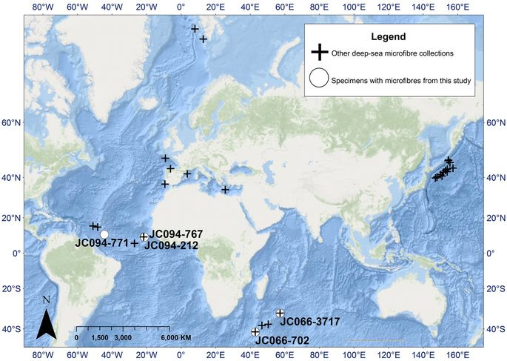
Fig 1.1 deep-sea microfibre collection locations
In 2012, it was estimated that there was approximately 165 million tons of plastic pollution in the world's oceans one type of plastic that is of concern in terms of ocean plastic pollution is nurdles. Nurdles are manufactured plastic pellets (a type of microplastic) used in the creation of plastic products and are often shipped via cargo ship Many billions of nurdles are spilled into oceans each year, and it has been estimated that globally, around 10% of beach litter consists of nurdles Plastics in oceans typically degrade within a year, but not entirely.
In the process, toxic chemicals such as bisphenol A and polystyrene can leach into waters from some plastics Polystyrene pieces and nurdles are the most common types of plastic pollution in oceans, and combined with plastic bags and food containers make up the majority of oceanic debris
One study estimated that there are more than 5 trillion plastic pieces (defined into the four classes of small microplastics, large microplastics, meso- and macroplastics) afloat at sea]
The litter that is being delivered into the oceans is toxic to marine life, and humans. The toxins that are components of plastic include diethylhexyl phthalate, which is a toxic carcinogen, as well as lead, cadmium, and mercury.
Plankton, fish, and ultimately the human race, through the food chain, ingest these highly toxic carcinogens and chemicals. Consuming the fish that contain these toxins can cause an increase in cancer, immune disorders, and birth defects citation needed
The majority of the litter near and in the ocean is made up of plastics and is a persistent pervasive source of marine pollution.[26] According to Dr. Marcus Eriksen of The 5 Gyres Institute, there are 5.25 trillion particles of plastic pollution that weigh as much as 270,000 tons (2016).
This plastic is taken by the ocean currents and accumulates in large vortexes known as ocean gyres. The majority of the gyres become pollution dumps filled with plastic.
Sources of ocean-based plastic pollution
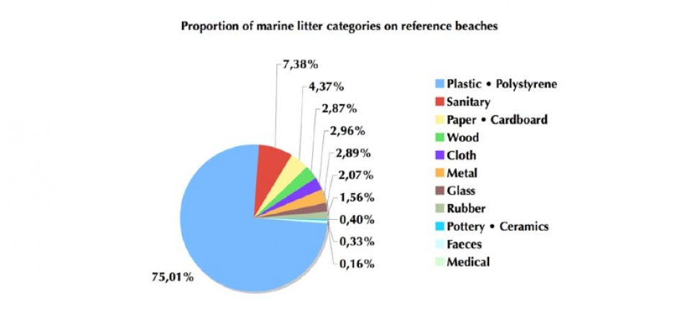
Fig 1.2proportion of marine litter categories on reference beaches
Almost 90% of plastic debris that pollutes ocean water, which translates to 5.6 million tons, comes from ocean-based sources. Merchant ships expel cargo, sewage, used medical equipment, and other types of waste that contain plastic into the ocean. Naval and research vessels eject waste and military equipment that are deemed unnecessary. Pleasure crafts release fishing gear and other types of waste, either accidentally or through negligent handling. The largest ocean-based source of plastic pollution is discarded fishing gear (including traps and nets), estimated to be up to 90% of plastic debris in some areas.
Continental plastic litter enters the ocean largely through storm-water runoff, flowing into watercourses or directly discharged into coastal waters] Plastic in the ocean has been shown to follow ocean currents which eventually form into what is known as Great Garbage Patches Knowledge of the routes that plastic follows in ocean currents comes from accidental container drops from ship carriers. For example, in May 1990 The Hansa Carrier, sailing from Korea to USA, broke apart due to a storm, ultimately resulting in thousands of dumped shoes; these eventually started showing up on the U.S western coast, and Hawaii.
The amount of plastic pollution accumulating in the oceans is estimated at over five trillion pieces floating in the waters. This paper provides an overview of the amount of plastic pollution in the world’s waterways, and why it is there. Researching credible sources on this topic aided in answering the research question: “what would it take to reduce the amount of plastic in the ocean?” The findings suggest businesses to replace 50%, or more, of their common plastic products with biodegradable, or compostable, items because of the following: The main type of plastic being used by businesses is petroleum-based plastics.
Businesses should switch to compostable items which break down within 90 days and do not leave a toxic residue (EPA, 2018a).The effect of plastic waste in the ocean has a negative impact on animal life, as well as, the coral reefs. The oceans are filled with harmful plastics which are being digested and entangled by sea life on a daily basis (Dissanayake, 2016). Single-use items are contributing to the amount of plastic found in the five ocean gyres. There were over 260,000 tons of plastic debris in the ocean in 2013 (Eriksen et al., 2014). The problem with single-use items is the waste it involves. While it is very convenient to the consumer and provider to have access to disposable items, it poses a significant problem in landfills and waterway volumes. Industrialized countries need to take aggressive action on the types of plastic being used, or evoke a monetary discipline (Dissanayake, 2016). By creating legislative mandates for recycling, ocean life may be able to thrive, and human life may be able to improve from a healthier environment.
Using existing resources to convert from petroleum-based plastics to bioplastics. These conclusions identified a potential solution in reducing plastic pollution. With education and awareness, people can begin to clean the rivers and waters, and make them a safe place for sea animals to live.
Land-based sources of ocean plastic pollution
Estimates for the contribution of land-based plastic vary widely. While one study estimated that a little over 10% of plastic debris in ocean water comes from land-based sources, responsible for 0.8 million tonnes (790,000 long tons; 880,000 short tons) every year, in 2015, Jambeck et al. calculated that 275 million tonnes (271,000,000 long tons; 303,000,000 short tons) of plastic waste was generated in 192 coastal countries in 2010, with 4.8 to 12.7 million tonnes (12,500,000 long tons; 14,000,000 short tons) entering the ocean - a percentage of only up to 5%.]

A source that has caused concern is landfills. Most waste in the form of plastic in landfills are single-use items such as packaging. Discarding plastics this way leads to accumulation although disposing of plastic waste in landfills has less of a gas emission risk than disposal through incineration, the former has space limitations.
Another concern is that the liners acting as protective layers between the landfill and environment can break, thus leaking toxins and contaminating the nearby soil and water Landfills located near oceans often contribute to ocean debris because content is easily swept up and transported to the sea by wind or small waterways like rivers and streams
. Marine debris can also result from sewage water that has not been efficiently treated, which is eventually transported to the ocean through rivers. Plastic items that have been improperly discarded can also be carried to oceans through storm waters.
Plastic pollution in the Pacific Ocean
In the Pacific Gyre, specifically 20°N-40°N latitude, large bodies with floating marine debris can be found Models of wind patterns and ocean currents indicate that the plastic waste in the northern Pacific is particularly dense where the Subtropical Convergence Zone (STCZ), 23°N-37°N latitude, meets a southwest-northeast line, found north of the Hawaiian archipelago

In the Pacific, there are two mass buildups: the western garbage patch and the eastern garbage patch, the former off the coast of Japan and the latter between Hawaii and California. The two garbage patches are both part of the great Pacific garbage patch, and are connected through a section of plastic debris off the northern coast of the Hawaiian islands. It is approximated that these garbage patches contain 100 million tons of debrisThe waste is not compact, and although most of it is near the surface of the pacific, it can be found up to more than 100 feet deep in the water]

Research published in April 2017[33] reported "the highest density of plastic rubbish anywhere in the world" on remote and uninhabited Henderson Island in South Pacific as a result of the South Pacific Gyre. The beaches contain an estimated 37.7 million items of debris together weighing 17.6 tonnes.
In a study transect on North Beach, each day 17 to 268 new items washed up on a 10-metre section. The study noted that purple hermit crabs (Coenobita spinosus) make their homes in plastic containers washed up on beaches
Plastic pollution in tap water
A 2017 study found that 83% of tap water samples taken around the world contained plastic pollutantsThis was the first study to focus on global drinking water pollution with plastics and showed that with a contamination rate of 94%, tap water in the United States was the most polluted, followed by Lebanon and India.
European countries such as the United Kingdom, Germany and France had the lowest contamination rate, though still as high as 72%This means that people may be ingesting between 3,000 and 4,000 microparticles of plastic from tap water per yearThe analysis found particles of more than 2.5 microns in size, which is 2500 times bigger than a nanometer.
It is currently unclear if this contamination is affecting human health, but if the water is also found to contain nano-particle pollutants, there could be adverse impacts on human well-being, according to scientists associated with the study]
However, plastic tap water pollution remains under-studied, as are the links of how pollution transfers between humans, air, water, and soil
Van Cauwenberghe, L et al (2013)
Van Cauwenberghe, L et al (2014)
Van Cauwenberghe, L et al (2015)

Effects on animals

Plastic pollution has the potential to poison animals, which can then adversely affect human food supplies. Plastic pollution has been described as being highly detrimental to large marine mammals, described in the book Introduction to Marine Biology as posing the "single greatest threat" to themSome marine species, such as sea turtles, have been found to contain large proportions of plastics in their stomach] When this occurs, the animal typically starves, because the plastic blocks the animal's digestive tract.[42] Marine mammals sometimes become entangled in plastic products such as nets, which can harm or kill them
Fischer, V et al (2015)

Entanglement

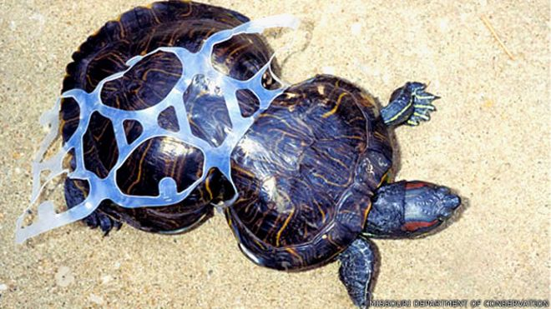
Fig 1.3 Entanglement of marine organisms in plastic
Entanglement in plastic debris has been responsible for the deaths of many marine organisms, such as fish, seals, turtles, and birds. These animals get caught in the debris and end up suffocating or drowning. Because they are unable to untangle themselves, they also die from starvation or from their inability to escape predators. Being entangled also often results in severe lacerations and ulcers. In a 2006 report known as Plastic Debris in the World's Oceans, it was estimated that at least 267 different animal species have suffered from entanglement and ingestion of plastic debris] It has been estimated that over 400,000 marine mammals perish annually due to plastic pollution in oceansMarine organisms get caught in discarded fishing equipment, such as ghost nets. Ropes and nets used to fish are often made of synthetic materials such as nylon, making fishing equipment more durable and buoyant. These organisms can also get caught in circular plastic packaging materials, and if the animal continues to grow in size, the plastic can cut into their flesh. Equipment such as nets can also drag along the seabed, causing damage to coral reefs.
Graham, E. R et al (2009)

Ingestion
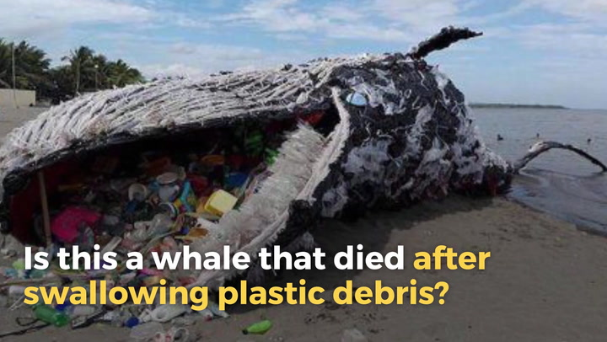
Fig 1.4 dead whale because of plastic debris swallowing
Mato,Y(2001)
Marine animals
Sea turtles are affected by plastic pollution. Some species are consumers of jelly fish, but often mistake plastic bags for their natural prey. This plastic debris can kill the sea turtle by obstructing the oesophagus.[46] So too are whales; large amounts of plastics have been found in the stomachs of beached whales]

Some of the tiniest bits of plastic are being consumed by small fish, in a part of the pelagic zone in the ocean called the Mesopelagic zone, which is 200 to 1000 metres below the ocean surface, and completely dark. Not much is known about these fish, other than that there are many of them. They hide in the darkness of the ocean, avoiding predators and then swimming to the ocean's surface at night to feedPlastics found in the stomachs of these fish were collected during Malaspina's circumnavigation, a research project that studies the impact of global change on the oceans.[48] A study conducted by Scripps Institution of Oceanography showed that the average plastic content in the stomachs of 141 mesopelagic fish over 27 different species was 9.2%. Their estimate for the ingestion rate of plastic debris by these fish in the North Pacific was between 12000 and 24000 tons per year The most popular mesopelagic fish is the lantern fish. It resides in the central ocean gyres, a large system of rotating ocean currents. Since lantern fish serve as a primary food source for the fish that consumers purchase, including tuna and swordfish, the plastics they ingest become part of the food chain. The lantern fish is one of the main bait fish in the ocean, and it eats large amounts of plastic fragments, which in turn will not make them nutritious enough for other fish to consume]
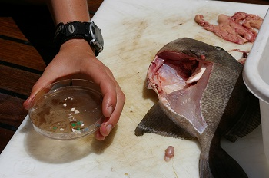
Fig 1.5 Deep sea animals have been found with plastics in their stomachs

(2016( Andreas Künkel et la

Birds

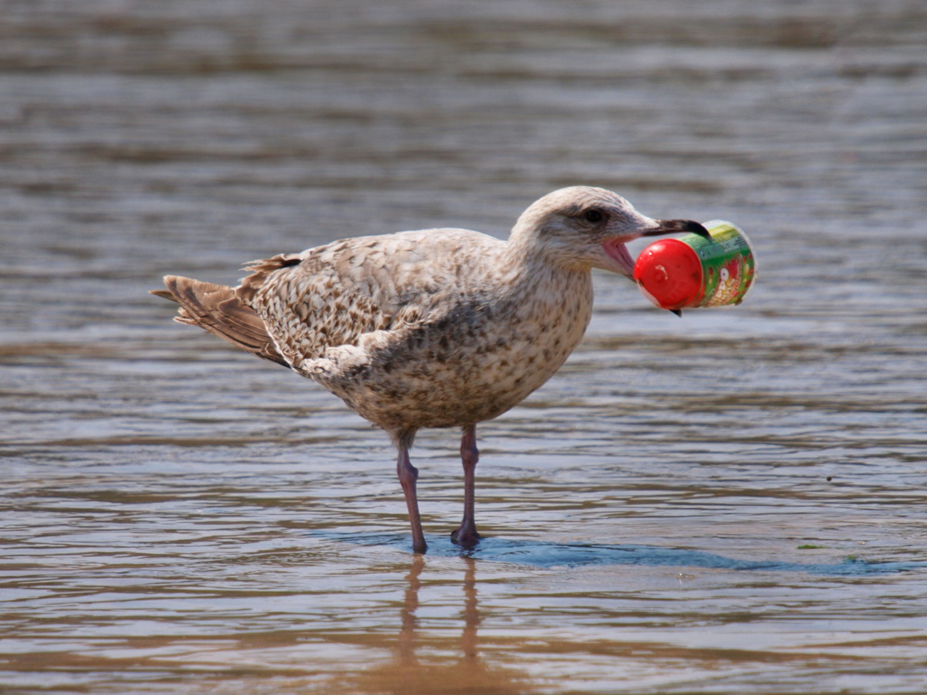
Fig 1.6 plastic effect on water birds
Plastic pollution does not only affect animals that live solely in oceans. Seabirds are also greatly affected. In 2004, it was estimated that gulls in the North Sea had an average of thirty pieces of plastic in their stomachs.[52] Seabirds often mistake trash floating on the ocean's surface as prey. Their food sources often has already ingested plastic debris, thus transferring the plastic from prey to predator. Ingested trash can obstruct and physically damage a bird's digestive system, reducing its digestive ability and can lead to malnutrition, starvation, and death. Toxic chemicals called polychlorinated biphenyls (PCBs) also become concentrated on the surface of plastics at sea and are released after seabirds eat them. These chemicals can accumulate in body tissues and have serious lethal effects on a bird's reproductive ability, immune system, and hormone balance. Floating plastic debris can produce ulcers, infections and lead to death. Marine plastic pollution can even reach birds that have never been at the sea. Parents may accidentally feed their nestlings plastic, mistaking it for food.[53] Seabird chicks are the most vulnerable to plastic ingestion since they can't regurgitate like the adult seabirds.]

After the initial observation that many of the beaches in New Zealand had high concentrations of plastic pellets, further studies found that different species of prion ingest the plastic debris. Hungry prions mistook these pellets for food, and these particles were found intact within the birds' gizzards and proventriculi.
Pecking marks similar to those made by northern fulmars in cuttlebones have been found in plastic debris, such as styrofoam, on the beaches on the Dutch coast, showing that this species of bird also mistakes plastic debris for food]
An estimate of 1.5 million Laysan albatrosses, which inhabit Midway Atoll, all have plastics in their digestive system. Midway Atoll is halfway between Asia and North America, and north of the Hawaiian archipelago. In this remote location, the plastic blockage has proven deadly to these birds. These seabirds choose red, pink, brown, and blue plastic pieces because of similarities to their natural food sources.
As a result of plastic ingestion, the digestive tract can be blocked resulting in starvation. The windpipe can also be blocked, which results in suffocationThe debris can also accumulate in the animal's gut, and give them a false sense of fullness which would also result in starvation.
On the shore, thousands of birds corpses can be seen with plastic remaining where the stomach once was. The durability of the plastics is visible among the remains. In some instances, the plastic piles are still present while the bird's corpse has decayed]
Similar to humans, animals exposed to plasticizers can experience developmental defects. Specifically, sheep have been found to have lower birth weights when prenatally exposed to bisphenol A. Exposure to BPA can shorten the distance between the eyes of a tadpole. It can also stall development in frogs and can result in a decrease in body length. In different species of fish, exposure can stall egg hatching and result in a decrease in body weight, tail length, and body length
Au, S. Y., Bruce et al (2015)

Effects on humans
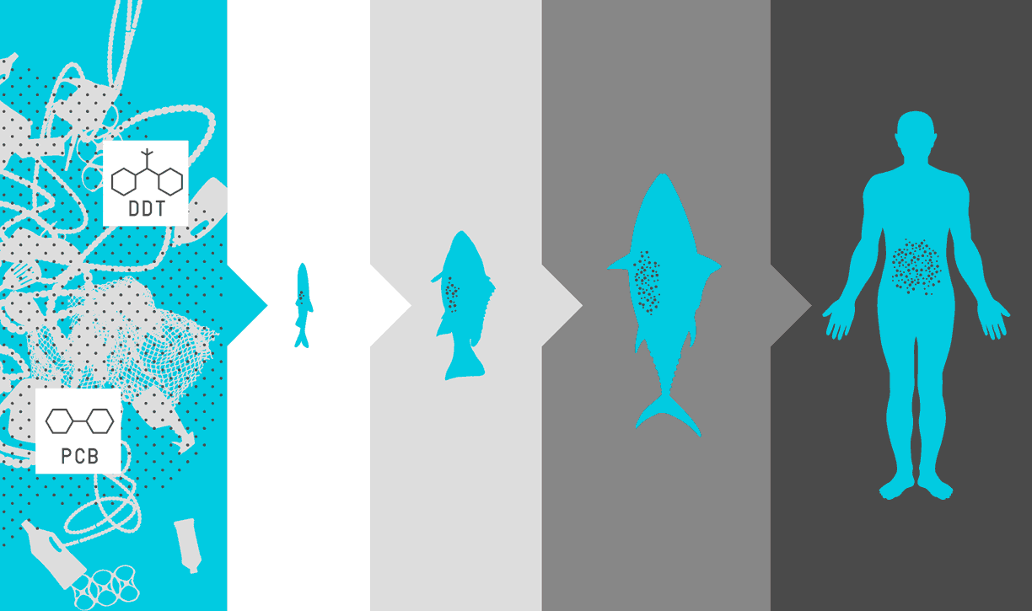
Fig 1.7 accumulation of plastic debris across food chain
Due to the use of chemical additives during plastic production, plastics have potentially harmful effects that could prove to be carcinogenic or promote endocrine disruption. Some of the additives are used as phthalate plasticizers and brominated flame retardantsThrough biomonitoring, chemicals in plastics, such as BPA and phthalates, have been identified in the human population. Humans can be exposed to these chemicals through the nose, mouth, or skin. Although the level of exposure varies depending on age and geography, most humans experience simultaneous exposure to many of these chemicals. Average levels of daily exposure are below the levels deemed to be unsafe, but more research needs to be done on the effects of low dose exposure on humans A lot is unknown on how severely humans are physically affected by these chemicals
. Some of the chemicals used in plastic production can cause dermatitis upon contact with human skin. In many plastics, these toxic chemicals are only used in trace amounts, but significant testing is often required to ensure that the toxic elements are contained within the plastic by inert material or polymer
It can also affect humans in which it may create an eyesore that interferes with enjoyment of the natural environment
(2013) Lee, K.-W et la.
Incineration
Up to 60% of used plastic medical equipment is incinerated rather than deposited in a landfill as a precautionary measure to lessen the transmission of disease. This has allowed for a large decrease in the amount of plastic waste that stems from medical equipment. If plastic waste is not incinerated and disposed of properly, a harmful amount of toxins can be released and dispersed as a gas through air or as ash through air and waterwaysMany studies have been done concerning the gaseous emissions that result from the incineration process.
1-3-3 plastic fate
We estimate that in 2015, 407 Mt of primary plastics (plastics manufactured from virgin materials) entered the use phase, whereas 302 Mt left it. Thus, in 2015, 105 Mt were added to the in-use stock. For comparison, we estimate that plastic waste generation in 2010 was 274 Mt, which is equal to the independently derived estimate of 275 Mt by Jambeck et al.
The different product lifetimes lead to a substantial shift in industrial use sector and polymer type between plastics entering and leaving use in any given year
Most of the packaging plastics leave use the same year they are produced, whereas construction plastics leaving use were produced decades earlier, when production quantities were much lower. For example, in 2015, 42% of primary nonfiber plastics produced (146 Mt) entered use as packaging and 19% (65 Mt) as construction, whereas nonfiber plastic waste leaving use was 54% packaging (141 Mt) and only 5% construction (12 Mt). Similarly, in 2015, PVC accounted for 11% of nonfiber plastics production (38 Mt) and only 6% of nonfiber plastic waste generation (16 Mt).

By the end of 2015, all plastic waste ever generated from primary plastics had reached 5800 Mt, 700 Mt of which were PP&A fibers. There are essentially three different fates for plastic waste. First, it can be recycled or reprocessed into a secondary material (22, 26). Recycling delays, rather than avoids, final disposal. It reduces future plastic waste generation only if it displaces primary plastic production (30); however, because of its counterfactual nature, this displacement is extremely difficult to establish (31). Furthermore, contamination and the mixing of polymer types generate secondary plastics of limited or low technical and economic value. Second, plastics can be destroyed thermally.
Although there are emerging technologies, such as pyrolysis, which extracts fuel from plastic waste, to date, virtually all thermal destruction has been by incineration, with or without energy recovery. The environmental and health impacts of waste incinerators strongly depend on emission control technology, as well as incinerator design and operation. Finally, plastics can be discarded and either contained in a managed system, such as sanitary landfills, or left uncontained in open dumps or in the natural environment.

We estimate that 2500 Mt of plastics—or 30% of all plastics ever produced—are currently in use. Between 1950 and 2015, cumulative waste generation of primary and secondary (recycled) plastic waste amounted to 6300 Mt. Of this, approximately 800 Mt (12%) of plastics have been incinerated and 600 Mt (9%) have been recycled, only 10% of which have been recycled more than once. Around 4900 Mt—60% of all plastics ever produced—were discarded and are accumulating in landfills or in the natural environment (Fig. 2). Of this, 600 Mt were PP&A fibers
. None of the mass-produced plastics biodegrade in any meaningful way; however, sunlight weakens the materials, causing fragmentation into particles known to reach millimeters or micrometers in size (32). Research into the environmental impacts of these “microplastics” in marine and freshwater environments has accelerated in recent years (33), but little is known about the impacts of plastic waste in land-based ecosystems.

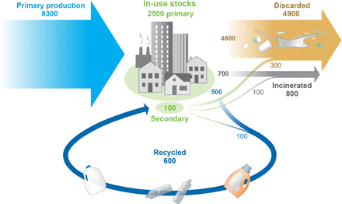
Fig 1.8 cycle of plastic product
Before 1980, plastic recycling and incineration were negligible. Since then, only nonfiber plastics have been subject to significant recycling efforts. The following results apply to nonfiber plastic only: Global recycling and incineration rates have slowly increased to account for 18 and 24%, respectively, of nonfiber plastic waste generated in 2014 (figs. S5 and S6). On the basis of limited available data, the highest recycling rates in 2014 were in Europe (30%) and China (25%), whereas in the United States, plastic recycling has remained steady at 9% since 2012 (12, 13, 34–36). In Europe and China, incineration rates have increased over time to reach 40 and 30%, respectively, in 2014). However, in the United States, nonfiber plastics incineration peaked at 21% in 1995 before decreasing to 16% in 2014 as recycling rates increased, with discard rates remaining constant at 75% during that time period Waste management information for 52 other countries suggests that in 2014, the rest of the world had recycling and incineration rates similar to those of the United States To date, end-of-life textiles (fiber products) do not experience significant recycling rates and are thus incinerated or discarded together with other solid waste.

Primary plastics production data describe a robust time trend throughout its entire history. If production were to continue on this curve, humankind will have produced 26,000 Mt of resins, 6000 Mt of PP&A fibers, and 2000 Mt of additives by the end of 2050. Assuming consistent use patterns and projecting current global waste management trends to 2050 9000 Mt of plastic waste will have been recycled, 12,000 Mt incinerated, and 12,000 Mt discarded in landfills or the natural environment).
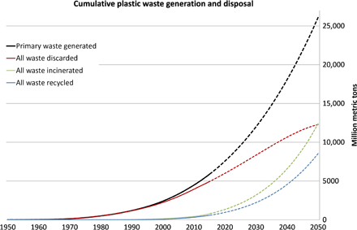
Fig 1.9 cumulative plastic waste generation and disposal
Any material flow analysis of this kind requires multiple assumptions or simplifications, which are listed in Materials and Methods, and is subject to considerable uncertainty; as such, all cumulative results are rounded to the nearest 100 Mt. The largest sources of uncertainty are the lifetime distributions of the product categories and the plastic incineration and recycling rates outside of Europe and the United States. Increasing/decreasing the mean lifetimes of all product categories by 1 SD changes the cumulative primary plastic waste generation (for 1950 to 2015) from 5900 to 4600/6200 Mt or by −4/+5%. Increasing/decreasing current global incineration and recycling rates by 5%, and adjusting the time trends accordingly, changes the cumulative discarded plastic waste from 4900 (for 1950 to 2015) to 4500/5200 Mt or by −8/+6%.

The growth of plastics production in the past 65 years has substantially outpaced any other manufactured material. The same properties that make plastics so versatile in innumerable applications—durability and resistance to degradation—make these materials difficult or impossible for nature to assimilate. Thus, without a well-designed and tailor-made management strategy for end-of-life plastics, humans are conducting a singular uncontrolled experiment on a global scale, in which billions of metric tons of material will accumulate across all major terrestrial and aquatic ecosystems on the planet. The relative advantages and disadvantages of dematerialization, substitution, reuse, material recycling, waste-to-energy, and conversion technologies must be carefully considered to design the best solutions to the environmental challenges posed by the enormous and sustained global growth in plastics production and use.
Recycling, incineration, and discard rates
Time series for resin, that is, nonfiber recycling, incineration, and discard rates were collected separately for four world regions: the United States, the EU-28 plus Norway and Switzerland, China, and the rest of the world. Detailed and comprehensive solid waste management data for the United States were published by the U.S. Environmental Protection Agency dating back to 1960 European data were from several reports by PlasticsEurope, which collectively cover 1996 to 2014 Chinese data were synthesized and reconciled from the English version of the China Statistical Yearbook, translations of Chinese publications and government reports, and additional waste management literature. Waste management for the rest of the world was based on World Bank data. Time series for global recycling, incineration, and discard rateswere derived by adding the rates of the four regions weighted by their relative contribution to global plastic waste generation. In many world regions, waste management data were sparse and of poor quality. For this reason, sensitivity analysis with regard to waste management rates was conducted.

The resulting global nonfiber recycling rate increased at a constant 0.7% per annum (p.a.) between 1990 and 2014. If this linear trend is assumed to continue, the global recycling rate would reach 44% in 2050. The global nonfiber incineration rate has grown more unevenly but, on average, increased 0.7% p.a. between 1980 and 2014. Assuming an annual increase of 0.7% between 2014 and 2050 yielded a global incineration rate of 50% by 2050. With those two assumptions, global discard rate would decrease from 58% in 2014 to 6% in 2050 (fig. S7). The dashed lines in Fig. 3 are based on those assumptions and therefore simply forward projections of historical global trends and should not be mistaken for a prediction or forecast. There is currently no significant recycling of synthetic fibers. It was thus assumed that end-of-life textiles are incinerated and discarded together with all other municipal solid waste.
(2012)et al Floros, Michael

FINDING SOLUTIONS
Current awareness and implementation of best practices in addressing the causes of marine debris are primarily focused on end-of-pipe solutions. However, a substantial, but relatively neglected underlying cause of debris entering the sea from the land is unsustainable production and consumption patterns. This includes the design and marketing of products internationally without appropriate regard for their environmental fate or ability to be recycled in the locations where sold, inadequate waste management infrastructure, and inappropriate disposal.

Often there is geographical separation between production of plastic in relatively developed economies and global consumption and disposal of the products in far-flung countries that lack the means to recycle or clean up the plastics used on a mass scale. From a life-cycle perspective, the current one-way flow of most plastics from production, through typically short-lived use to disposal, is a major barrier to trash reduction as well as a major opportunity to tackle the challenge of marine debris
Frias, J. P et al (2016).

Chapter 2

Bioplastic

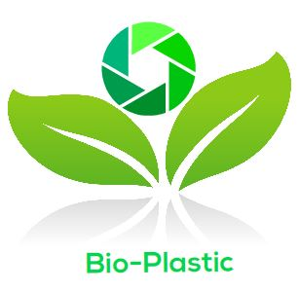

Bioplastic
2-1 what is bioplastic
plastics derived from renewable biomass sources, such as vegetable fats and oils, corn starch, or microbiotaBioplastic can be made from agricultural by-products and also from used plastic bottles and other containers using microorganisms. Common plastics, such as fossil-fuel plastics (also called petrobased polymers) are derived from petroleum or natural gas. Production of such plastics tends to require more fossil fuels and to produce more greenhouse gases than the production
of biobased polymers (bioplastics).[citation needed] Not all bioplastics are biodegrade nor biodegrade more readily than commodity fossil-fuel derived plastics.[citation needed] Bioplastics are usually derived from sugar derivatives, including starch, cellulose, lactic acid. As of 2014, bioplastics represented approximately 0.2% of the global polymer market (300 million tons)
J.H.Williams et al (2017)
2-2 bio plastic manufacture

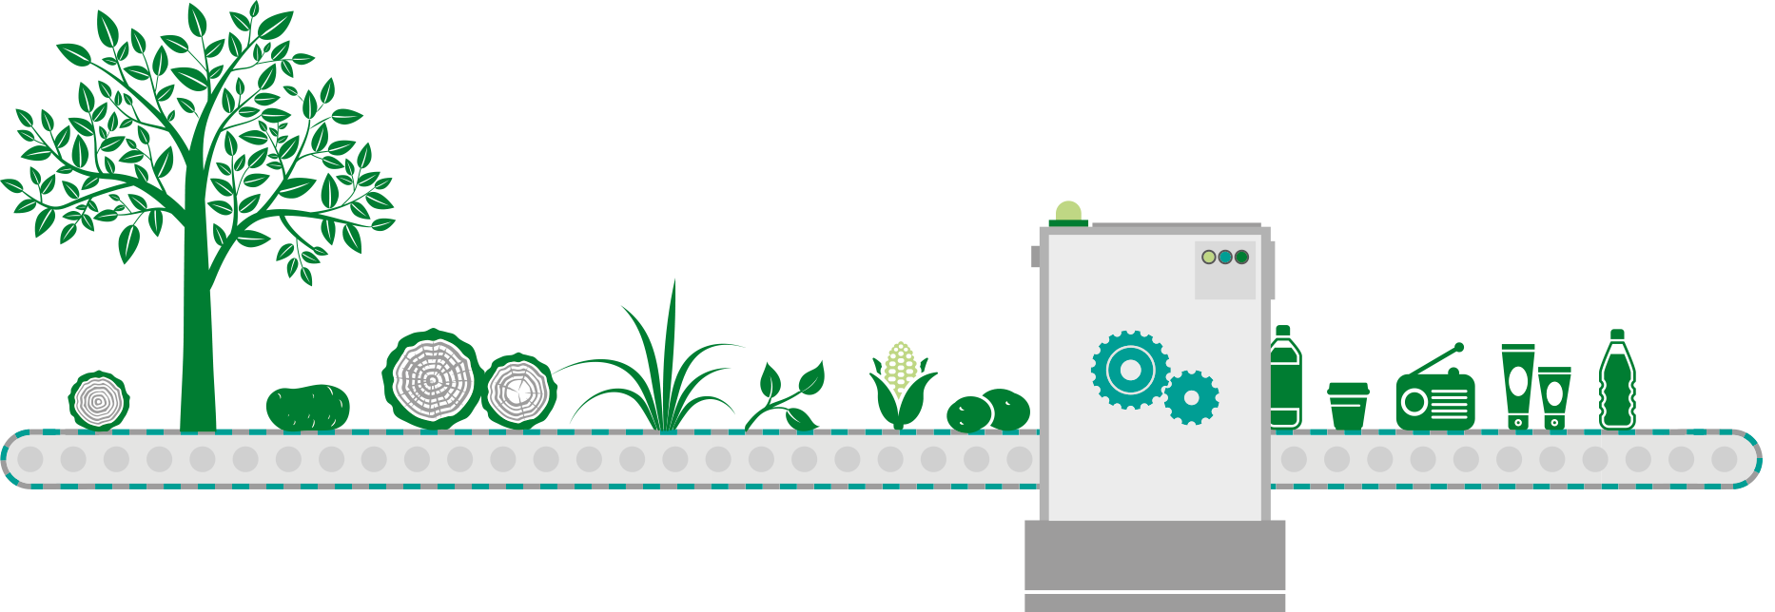
Fig 2.1 bioplastic manufacture process
Bioplastic manufacture is the next generation solution for manufacturing inexpensive, durable, attractive plastic products that are more earth-friendly and environmentally-safe than traditional petrochemical-based plastics.

Bioplastic manufacturing uses renewable biomass sources such as plant-based feedstock including corn, banana peel, rice, palm fiber, potatoes, wood cellulose and other plants. Unlike bioplastic manufacturing, traditional manufacturing of conventional plastic products utilizes non-renewable petroleum and natural gas resources. Their manufacturing processes are wasteful and not very environmentally-friendly. And while most plastics can be recycled, very few are. In fact, plastic is one of the fastest growing components of the general waste stream and one of the most expensive discarded materials for municipalities to manage.

Traditional injection molding processes do not work very well for bioplastic manufacturing and making compostable, plant-based bioplastics. In order to develop an efficient, cost-effective means of bioplastic manufacturing , we had to rethink everything – from raw stock processing to mold-making to finishing.

We have spent a lot of time and effort closely examining various ways to develop processes for bioplastic manufacturing and utilize plastics made from plants, not petroleum. We discovered that bioplastics such as those produced here at UrthPact share many of the same properties of traditional plastics, just none of the environmentally-unfriendly ones. Bioplastic manufacturing can provide products with the same look, feel, and functionality of conventional petroleum-based plastics, but utilizing attractive, durable bioplastic that can be composted and safely converted into soil components within as little as three months.

Here at UrthPact, we’re committed to developing next-gen bioplastic technology and materials for bioplastic manufacturing to help consumer products companies produce better plastic products in a renewable, ecological way that doesn’t harm the environment. To learn more about bioplastic manufacturing give us a call.

2-3biopalstic from biowaste
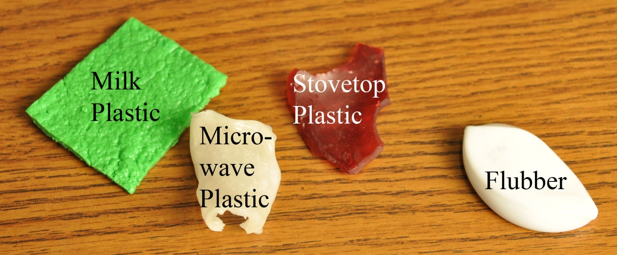
Fig 2.2 bioplastic based material
Agricultural residues management is considered to be a vital strategy in order to accomplish resource conservation and to maintain the quality of the environment. In recent years, biofibers have attracted increasing interest due to their wide applications in food packaging and in the biomedical sciences. These eco-friendly polymers reduce rapidly and replace the usage of the petroleum-based synthetic polymers due to their safety, low production costs, and biodegradability.
This paper reports an efficient method for the production of the cellulose acetate biofiber from flax fibers and cotton linters. The used process satisfied a yield of 81% and 54% for flax fibers and cotton linters respectively (based on the weight of the cellulosic residue used Plastics form an integral part of modern society.
They are found in applications as diverse as packaging material, in building and construction, in the electrical industry, automotives, furniture, household goods, clothing and agriculture.
Their durability has raised concerns about their end-of-life. Everyone agrees that there can be multiple approaches and technologies to plastics end-of-life. Recycling is clearly an important end-of-life strategy for plastics and continues to grow. Because of their invulnerability to microbial decomposition the precise time needed for biodegradation is unknown, and can produce greenhouse gases on incineration, thus causing environmental
problems. The only disposal route is landfill. The non biodegradability combined with their relatively low density and high bulk, means that plastics will occupy increasing amounts of landfill space in a world where available suitable landfill sites are shrinking. The extensive use of this plastic has created a problem world over.
Plastic waste is increasing every year and Environmental awareness has driven the development of new biodegradable materials. Bio-based plastics mean plastics based on renewable resources. The pattern of production is shifting from the true biodegradable plastics to the bio-based plastics, and that trend is likely to persist in the future
. Bio plastics are plastics derived from renewable biomass sources, such as vegetable fats and oils, corn starch, pea starch, or micro biota. Bioplastics are thus made from waste materials and not from products intended for food production
. There are a variety of materials that bioplastics can be composed of, including: starch, cellulose or other biopolymers. In this paper, one such alternative method to prepare bioplastic from potato peels is presented. Tons of potato chips are being consumed every day in the world.
Made under different brands potato chips are being prepared at a very high scale, leaving behind the potato peels 10-30% of the weight of potatoes consumed.
These peels can be converted to bioplastic after extracting starch from them thus saving the problem of their disposal after the chips have been prepared and at the same time some useable material is made out of it .Apart from this every individual place from where starch can be recovered can be changed to bioplastic, which to some extent can sort out the problem of conventional plastics.
This paper deals with the method of preparation of bioplastic from starchy material extracted from banana peels left after eating
(2010) Stephane Desobry et la
Production of bioplastic from banana peels
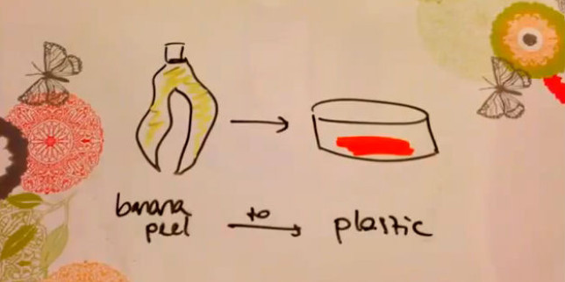
Fig 2.3 bioplastic from banana peels
Objectives
.production of bioplastics from banana peels as a substitute for conventional plastics
.to minimize pollution in the environment by use of bioplastics
.banana fruit's peels is selected for the experiment as it is a waste material rich of starch

A-materials and methods
- .Banana peels
- .Scissors
- .Blender
- .Colander
- .Spoon
- .Heater
- Oven .
- .Vinegar
- .Thyme, cinnamon
Methods
- .cutting banana peels into small pieces by scissors
- .add 250 ml water then blender the banana peels
- .collecting the mixture and put on heater for gain thickness and remove water
- .put thickness mixture in colander and press for extract excess water content
- .take sample and start (bioplastic cooking) on heater
- .add 40ml vinger and thyme ,cinnamon
- .heating and mixing about 5 minute
- .extracted sample put in filter paper and press for remove stucked water
- .put in oven for 45 minute in high temperature until completely dry
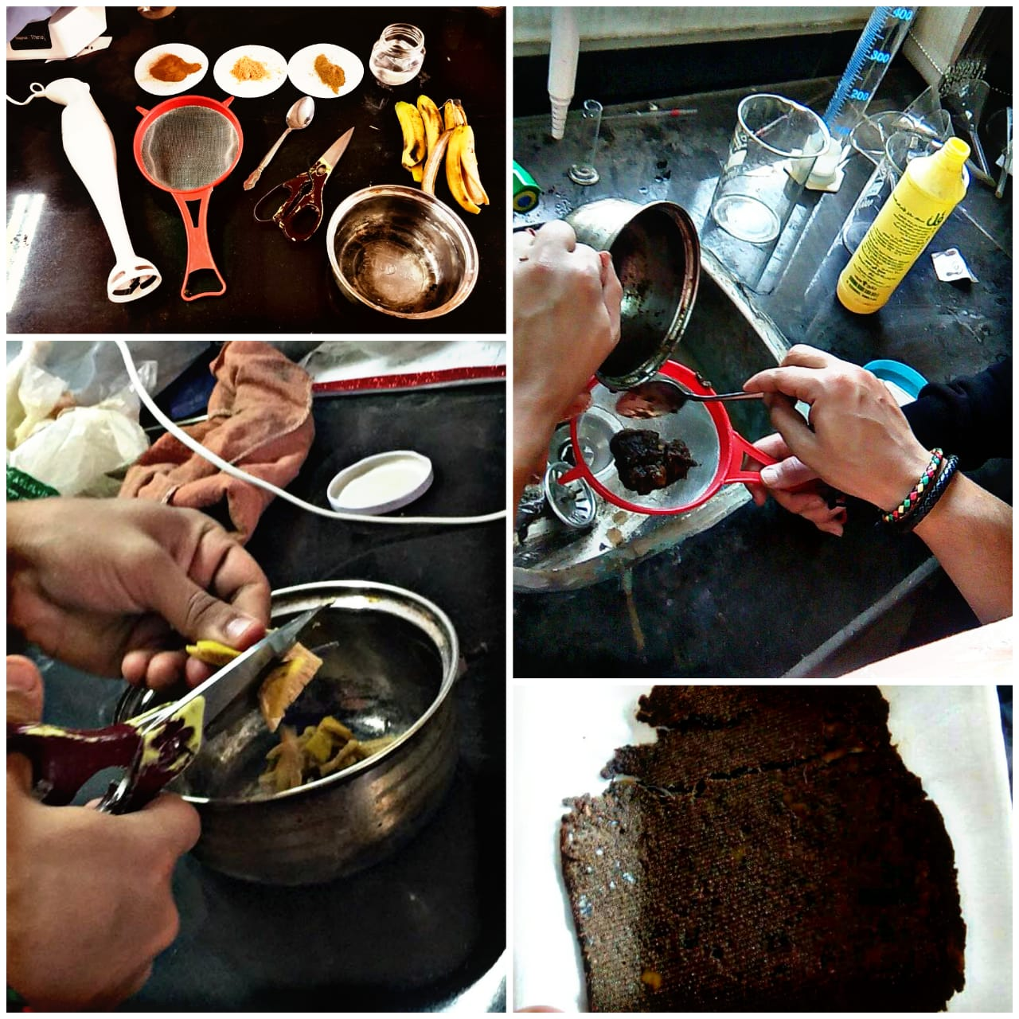
Fig 2.4 material and steps for bioplastic preparation
.

B-Results and discussion
- .after dry in oven bioplastic can be produced and feasible strength test can be done
- .use of rejected bio wastes and create a useful materials .
- ..biodegradable plastic have ability of breaking down and no residues content
- .take a few time for biodegradation about (45 days) .
- .contain no chemicals affect the soil or plant's root system .
- .no side effects on underground water .
- .no threats when eating by human or animals .
- .biomaterials have no problems when found in food chains .
- .no harmful gases produced while degradation

Conclusion
.These results supported our hypothesis . meaning that we succeeded and manufactured bioplastic from banana peels the reason why we were able to do so was because fruits rich with starch are preferred in the making of bio plastic and banana peels rich with starch
.the chemistry behind this is that starch consists two types of polymer chains called amylose and amylopectin made up of adjoined glucose molecules
The vinegar used in the procedure hydrolyzes amylopectin and prevents it from making hydrogen bonds with the amylose polymer chain and forming rows of polymer chains .acquiring a crystalline structure

Reference
Barnes, D. K., Walters, A. & Gonçalves, L. Macroplastics at sea around Antarctica. Mar Environ Res 70, 250–252 (2010).
Obbard, R. W. et al. Global warming releases microplastic legacy frozen in Arctic Sea ice. Earth’s Future 2, 315–320 (2014).
Kühn, S., Bravo Rebolledo, E. & van Franeker, J. In Marine Anthropogenic Litter (eds Melanie Bergmann, Lars Gutow & Michael Klages ) Ch. 4, 75–116 (Springer International Publishing, 2015).
Secretariat of the CBD and the Scientific and Technical Advisory Panel, G. Impacts of Marine Debris on Biodiversity: Current Status and Potential Solutions. 61 (Montreal, 2012)..
Laist, D. In Marine Debris Springer Series on Environmental Management (eds James M. Coe & Donald B. Rogers) Ch. 10, 99–139 (Springer New York, 1997).
Browne, M. A., Dissanayake, A., Galloway, T. S., Lowe, D. M. & Thompson, R. C. Ingested Microscopic Plastic Translocates to the Circulatory System of the Mussel, Mytilus edulis (L.). Environmental Science and Technology 42, 5026–5031 (2008).
Mato, Y. et al. Plastic Resin Pellets as a Transport Medium for Toxic Chemicals in the Marine Environment. Environmental Science and Technology 35, 318–324 (2001).
Brennecke, D., Duarte, B., Paiva, F., Caçador, I. & Canning-Clode, J. Microplastics as vector for heavy metal contamination from the marine environment. Estuar. Coast. Shelf Sci. in press (2016).
Rochman, C. M., Hentschel, B. T. & Teh, S. J. Long-Term Sorption of Metals Is Similar among Plastic Types: Implications for Plastic Debris in Aquatic Environments. PLoS ONE 9, e85433 (2014).
Browne, M. A., Niven, Stewart J., Galloway, Tamara S., Rowland, Steve J. & Thompson, Richard C. Microplastic Moves Pollutants and Additives to Worms, Reducing Functions Linked to Health and Biodiversity. Curr Biol 23, 2388–2392 (2013).
Li, H.-X. et al. Effects of Toxic Leachate from Commercial Plastics on Larval Survival and Settlement of the Barnacle Amphibalanus amphitrite. Environ Sci Technol 50, 924–931 (2016).
Rochman, C. M. et al. The ecological impacts of marine debris: unraveling the demonstrated evidence from what is perceived. Ecology 97, 302–312 (2015).
Moore, C. J., Moore, S. L., Leecaster, M. K. & Weisberg, S. B. A Comparison of Plastic and Plankton in the North Pacific Central Gyre. Mar Pollut Bull 42, 1297–1300 (2001).
Romeo, T. et al. First evidence of presence of plastic debris in stomach of large pelagic fish in the Mediterranean Sea. Mar Pollut Bull 95, 358–361 (2015).
Lusher, A. L. et al. Microplastic and macroplastic ingestion by a deep diving, oceanic cetacean: The True’s beaked whale Mesoplodon mirus. Environ Pollut 199, 185–191 (2015).
Besseling, E. et al. Microplastic in a macro filter feeder: Humpback whale Megaptera novaeangliae. Mar Pollut Bull 95, 248–252 (2015).
Murray, F. & Cowie, P. R. Plastic contamination in the decapod crustacean Nephrops norvegicus (Linnaeus, 1758). Mar Pollut Bull 62, 1207–1217 (2011).
Welden, N. A. C. Microplastic pollution in the Clyde sea area: a study using the indicator species Nephrops norvegicus PhD thesis thesis, University of Glasgow (2015).
Devriese, L. I. et al. Microplastic contamination in brown shrimp (Crangon crangon, Linnaeus 1758) from coastal waters of the Southern North Sea and Channel area. Mar Pollut Bull, doi: 10.1016/j.marpolbul.2015.1006.1051 (2015).
Van Cauwenberghe, L., Claessens, M., Vandegehuchte, M. B. & Janssen, C. R. Microplastics are taken up by mussels (Mytilus edulis) and lugworms (Arenicoal marina) living in natural habitats. Environ Pollut 199, 10–17 (2015).
Lee, K.-W., Shim, W. J., Kwon, O. Y. & Kang, J.-H. Size-Dependent Effects of Micro Polystyrene Particles in the Marine Copepod Tigriopus japonicus. Environmental Science and Technology 47, 11278–11283 (2013).
von Moos, N., Burkhardt-Holm, P. & Köhler, A. Uptake and Effects of Microplastics on Cells and Tissue of the Blue Mussel Mytilus edulis L. after an Experimental Exposure. Environmental Science and Technology 46, 11327–11335 (2012).
Hall, N. M., Berry, K. L. E., Rintoul, L. & Hoogenboom, M. O. Microplastic ingestion by scleractinian corals. Mar. Biol. 162, 725–732 (2015).
Watts, A. J. R. et al. Uptake and Retention of Microplastics by the Shore Crab Carcinus maenas. Environ Sci Technol 48, 8823–8830 (2014).
Woodall, L. C. et al. The deep sea is a major sink for microplastic debris. Royal Society Open Science 1, doi: 10.1098/rsos.140317 (2014).
Cole, M. et al. Microplastic Ingestion by Zooplankton. Environmental Science and Technology 47, 6646–6655 (2013).
Watts, A. J. R., Urbina, M. A., Corr, S., Lewis, C. & Galloway, T. S. Ingestion of Plastic Microfibers by the Crab Carcinus maenas and Its Effect on Food Consumption and Energy Balance. Environ Sci Technol 49, 14597–14604 (2015)..
Graham, E. R. & Thompson, J. T. Deposit- and suspension-feeding sea cucumbers (Echinodermata) ingest plastic fragments. J Exp Mar Biol Ecol 368, 22–29 (2009).
Brillant, M. G. & MacDonald, B. A. Postingestive selection in the sea scallop, Placopecten magellanicus (Gmelin): the role of particle size and density. J Exp Mar Biol Ecol 253, 211–227 (2000).
Thompson, R. C. et al. Lost at Sea: Where Is All the Plastic? Science 304, 838–838 (2004).
Ward, J. E. & Kach, D. J. Marine aggregates facilitate ingestion of nanoparticles by suspension-feeding bivalves. Mar Environ Res 68, 137–142 (2009).
Wright, S. L., Rowe, D., Thompson, R. C. & Galloway, T. S. Microplastic ingestion decreases energy reserves in marine worms. Curr Biol 23, R1031–R1033 (2013).
Wegner, A., Besseling, E., Foekema, E. M., Kamermans, P. & Koelmans, A. A. Effects of nanopolystyrene on the feeding behavior of the blue mussel (Mytilus edulis L.). Environ Toxicol Chem 31, 2490–2497 (2012).
Van Cauwenberghe, L., Vanreusel, A., Mees, J. & Janssen, C. R. Microplastic pollution in deep-sea sediments. Environ Pollut 182, 495–499 (2013).
Fischer, V., Elsner, N. O., Brenke, N., Schwabe, E. & Brandt, A. Plastic pollution of the Kuril–Kamchatka Trench area (NW pacific). Deep-Sea Research Part II 111, 399–405 (2015).
Jambeck, J. R. et al. Plastic waste inputs from land into the ocean. Science 347, 768–771 (2015).
Woodall, L. C. et al. Using a forensic science approach to minimize environmental contamination and to identify microfibres in marine sediments. Mar Pollut Bull 95, 40–46 (2015).
Morét-Ferguson, S. et al. The size, mass, and composition of plastic debris in the western North Atlantic Ocean. Mar Pollut Bull 60, 1873–1878 (2010).
Enders, K., Lenz, R., Stedmon, C. A. & Nielsen, T. G. Abundance, size and polymer composition of marine microplastics ≥10 μm in the Atlantic Ocean and their modelled vertical distribution. Mar Pollut Bull 100, 70–81 (2015).
Ivar do Sul, J. A. & Costa, M. F. The present and future of microplastic pollution in the marine environment. Environ Pollut 185, 352–364 (2014).
Frias, J. P. G. L., Gago, J., Otero, V. & Sobral, P. Microplastics in coastal sediments from Southern Portuguese shelf waters. Mar Environ Res 114, 24–30 (2016).
Hämer, J., Gutow, L., Köhler, A. & Saborowski, R. Fate of Microplastics in the Marine Isopod Idotea emarginata. Environmental Science and Technology 48, 13451–13458 (2014).
Au, S. Y., Bruce, T. F., Bridges, W. C. & Klaine, S. J. Responses of Hyalelal azteca to acute and chronic microplastic. Environ Toxicol Chem, doi: 10.1002/etc. 2993 (2015).
Mato, Y., Takada, H., Zakaria, M. P., Kuriyama, Y. & Kanehiro, H. Toxic chemicals contained in plastic resin pellets in the marine environment—spatial difference in pollutant concentrations and the effects of resin type. Kankyo Kagakukaishi 15, 415–423 (2002).
Koelmans, A. In Marine Anthropogenic Litter (eds M. Bergmann, L. Gutow & M. Klages) 309–324 (Springer, 2015).
Lithner, D., Larsson, Å. & Dave, G. Environmental and health hazard ranking and assessment of plastic polymers based on chemical composition. Sci Total Environ 409, 3309–3324 (2011).
Van Cauwenberghe, L. & Janssen, C. R. Microplastics in bivalves cultured for human consumption. Environ Pollut 193, 65–70 (2014).
Browne, M. A. et al. Linking effects of anthropogenic debris to ecological impacts. Proc. R. Soc. Lond., Ser. B: Biol. Sci. 282, 20142929 (2015).
Robson, R. & Coyle, T. Anti Contamination Procedures for Textile Fibre Examination – a Discussion Document. Problems of Forensic Sciences XLVI, 236–238 (2001).
Roux, C., Huttunen, J. & Rampling, K. Factors Affecting the Potential for Fibre Contamination in Purpose-Designed Forensic Search Rooms. Science and Justice 41, 135–144 (2001).
Y. J. Chen,” Bio plastics and their role in achieving global sustainability”, J. Chem. Pharm. Res., vol.6 (1),
J.H.Williams，A.DeBenedictis，R.Ghanadan，A. Mahone，J. Moore, W. R. Morrow III，S. Price an
M. S. Torn. Science, 335: 53–59, 2012.
M.F. Cervera, J. Heinamaki, K. Krogars, and A.C. Jorgensen, “Solid-State and Mechanical Properties of
Aqueous Chitosan-Amylose Starch Films Plasticized with Polyols”, AAPS PharmSciTech, vol.5, pp.15-20,
P. Astuti, A. A. Erprihana, “Antimicrobial Edible Film from Banana Peels as Food Packaging”, American
Journal of Oil and Chemical Technologies,vol. 2, pp. 65-70, February 2014
Hester, Ronald E.; Harrison, R. M. (editors) Marine Pollution and Human Health. Royal Society of
Chemistry (2011). pp. 84-85. Lytle, Claire Le Guern. "Plastic Pollution". Coastal Care. 2015; Retrieved 19
February.
Barnes, D. K. A.; Galgani, F.; Thompson, R. C.; Barlaz, M.. "Accumulation and fragmentation of plastic
debris in global environments". Philosophical Transactions of the Royal Society B: Biological Sciences.
Hong Chua; Peter H. F. Yu & Chee K. Ma (March 1999). "Accumulation of biopolymers in activated sludge biomass". Applied Biochemistry and Biotechnology. Humana Press Inc. 78: 389–399. doi:10.1385/ABAB:78:1-3:389. ISSN 0273-2289. Retrieved 2009-11-24.
Andreas Künkel, Johannes Becker, Lars Börger, Jens Hamprecht, Sebastian Koltzenburg, Robert Loos, Michael Bernhard Schick, Katharina Schlegel, Carsten Sinkel, Gabriel Skupin and Motonori Yamamoto (2016). "Polymers, Biodegradable". Ullmann's Encyclopedia of Industrial Chemistry. Weinheim: Wiley-VCH. doi:10.1002/14356007.n21_n01.pub2.
Vert, Michel (2012). "Terminology for biorelated polymers and applications (IUPAC Recommendations 2012)" (PDF). Pure and Applied Chemistry. 84 (2): 377–410. doi:10.1351/PAC-REC-10-12-04.
Chen, G.; Patel, M. (2012). "Plastics derived from biological sources: Present and future: P technical and environmental review". Chemical Reviews. 112 (4): 2082–2099. doi:10.1021/cr200162d.
"Consiglio dei Ministri conferma al messa al bando dei sacchetti di plastica non biodegradabili - Ministero dell'Ambiente e delal Tuteal del Territorio e del Mare". www.minambiente.it.
Suszkiw, Jan (December 2005). "Electroactive Bioplastics Flex Their Industrial Muscle". News & Events. USDA Agricultural Research Service. Retrieved 2011-11-28.
Khwaldia, Khaoula; Elmira Arab-Tehrany; Stephane Desobry (2010). "Biopolymer Coatings on Paper Packaging Materials". Comprehensive Reviews in Food Science and Food Safety. 9 (1): 82–91. doi:10.1111/j.1541-4337.2009.00095.x. Retrieved 9 Mar 2015.
Make Potato Plastic!. Instructables.com (2007-07-26). Retrieved on 2011-08-14.
Khalid, Saud; Yu, Long; Meng, Linghan; Liu, Hongsheng; Ali, Amjad; Chen, Ling (2017). "Poly(lactic acid)/starch composites: Effect of microstructure and morphology of starch granules on performance". Journal of Applied Polymer Science. 134: n/a–n/a. doi:10.1002/app.45504. Retrieved 25 July 2017.
"Starch based Bioplastic Manufacturers and Suppliers". Archived from the original on August 14, 2011.
"Enhancing biopolymers: additives are needed for toughness, heat resistance & processability.(biopolymers)(Cover story)". Archived from the original on 2012-07-13.
"BASF announces major bioplastics production expansion".
"Roquette, nouvel acteur sur le marché des plastiques, lance GAÏALENE® : une gamme innovante de plastique végétal".
Song, J. H.; Murphy, R. J.; Narayan, R.; Davies, G. B. H. (2009-07-27). "Biodegradable and compostable alternatives to conventional plastics". Philosophical Transactions of the Royal Society B: Biological Sciences. 364 (1526): 2127–2139. doi:10.1098/rstb.2008.0289. ISSN 0962-8436. PMC 2873018 Freely accessible. PMID 19528060.
"History, Travel, Arts, Science, People, Places - Smithsonian". smithsonianmag.com.
"Mirel: PHAs grades for Rigid Sheet and Thermoforming".
"Micromidas is using carefully constructed populations of bacteria to convert organic waste into bio-degradable plastics". Archived from the original on October 23, 2011.
"Home". dsm.com.
Nohra, Bassam; Laure Candy; Jean-Francois Blanco; Celine Guerin; Yann Raoul; Zephirin Mouloungui (2013). "From Petrochemical Polyurethanes to Biobased Polyhydroxyurethanes". Macromolecules. 46: 3771–3792. doi:10.1021/ma400197c.
Fortman, David J.; Jacob P. Brutman; Christopher J. Cramer; Marc A. Hillmyer; William R. Dichtel (2015). "Mechanically Activated, Catalyst-Free Polyhydroxyurethane Vitrimers". Journal of the American Chemical Society. 137: 14019–14022. doi:10.1021/jacs.5b08084. PMID 26495769.
Meier, Michael A. R.; Metzger, Jürgen O.; Schubert, Ulrich S. (2007-10-02). "Plant oil renewable resources as green alternatives in polymer science". Chemical Society Reviews. 36 (11): 1788. doi:10.1039/b703294c. ISSN 1460-4744.
Floros, Michael; Hojabri, Leila; Abraham, Eldho; Jose, Jesmy; Thomas, Sabu; Pothan, Laly; Leao, Alcides Lopes; Narine, Suresh (2012). "Enhancement of thermal stability, strength and extensibility of lipid-based polyurethanes with cellulose-based nanofibers". Polymer Degradation and Stability. 97 (10): 1970–1978.

