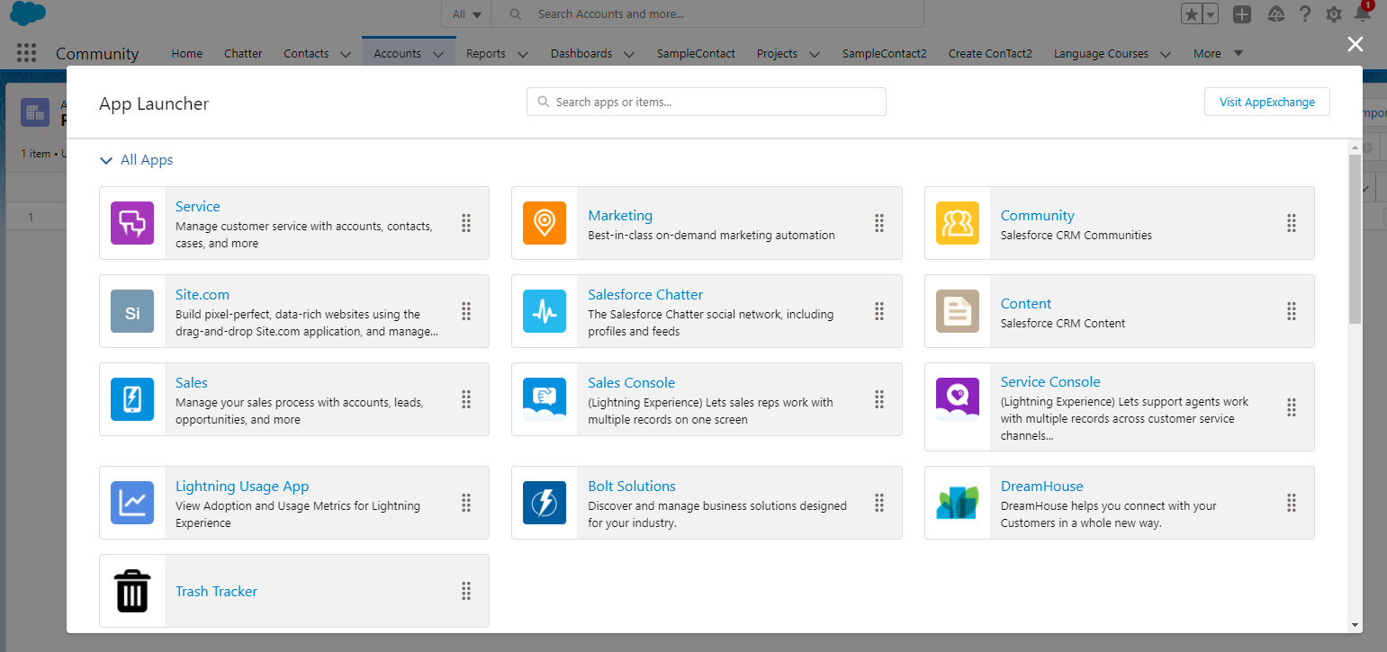

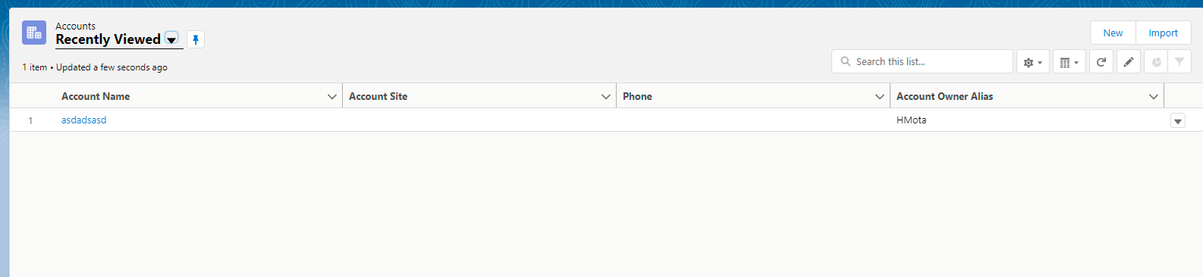

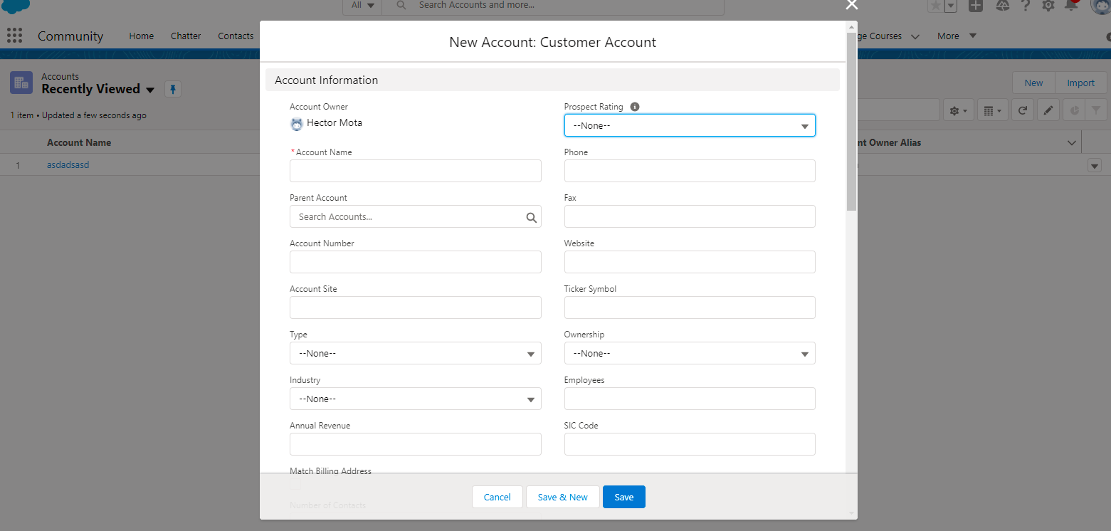

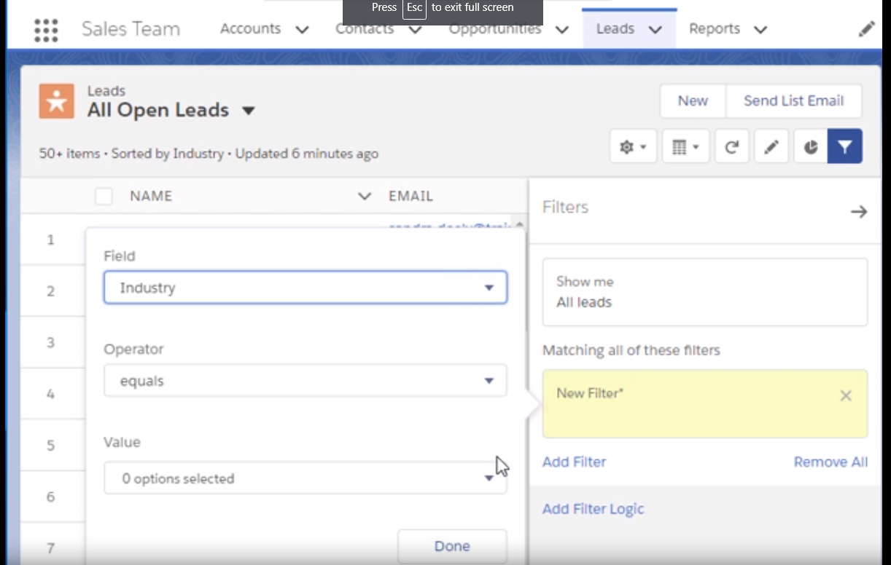

https://trailhead.salesforce.com/en/content/learn/modules/lightning-experience-for-salesforce-classic-users/work-with-list-views