Web vulnerability assessment using Acuetix
Start Acunitex after install acunetex:
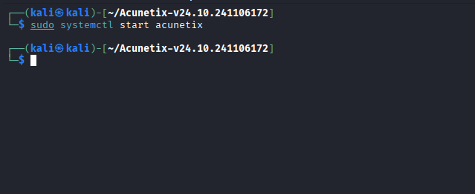
Step-1: Login in to the acunetix Dashboard browser:
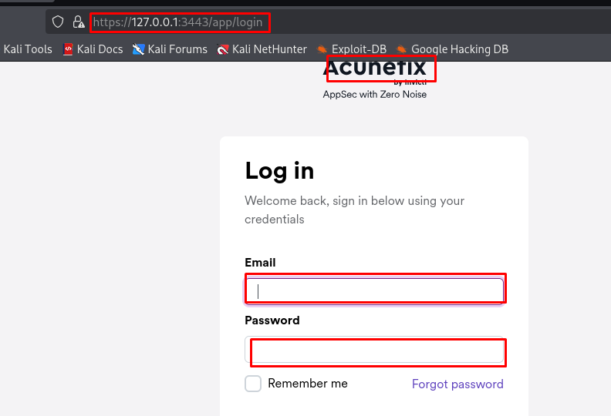
Step-2: Create new Terget:
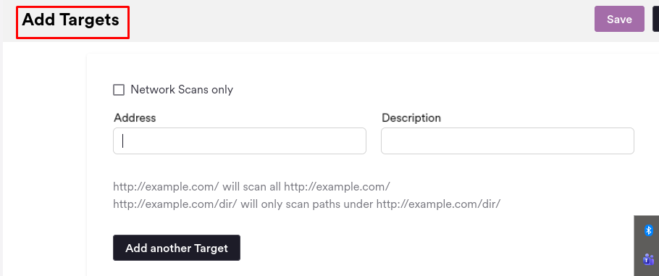
Step-3: configure the target setting:
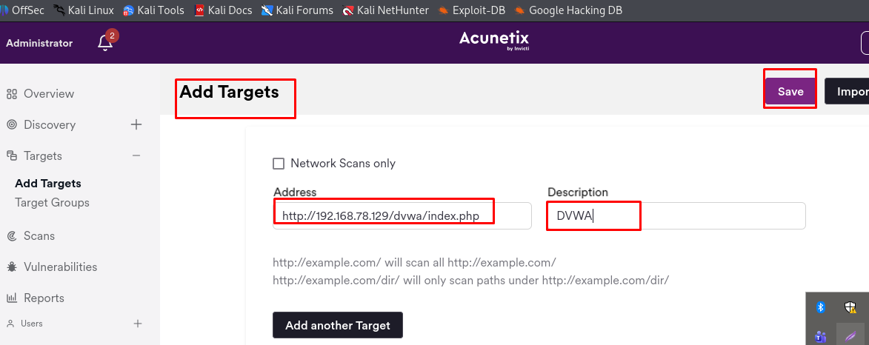
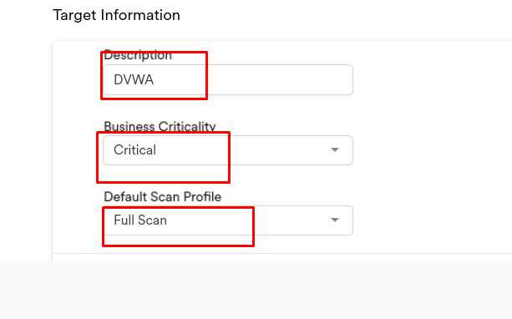
Step-4: Start a Full Scan on the target:
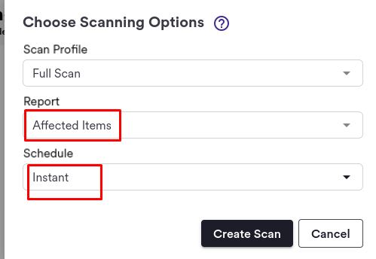
Step-5: Monitor the scan progress until it completes:
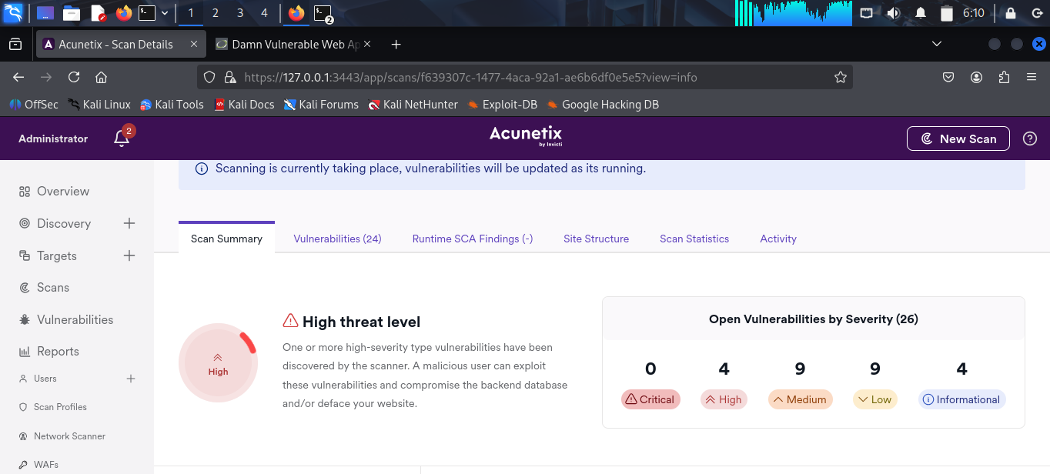
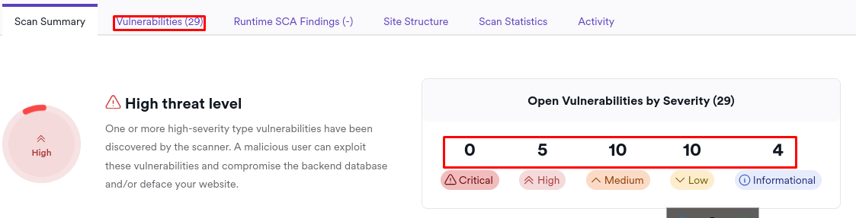
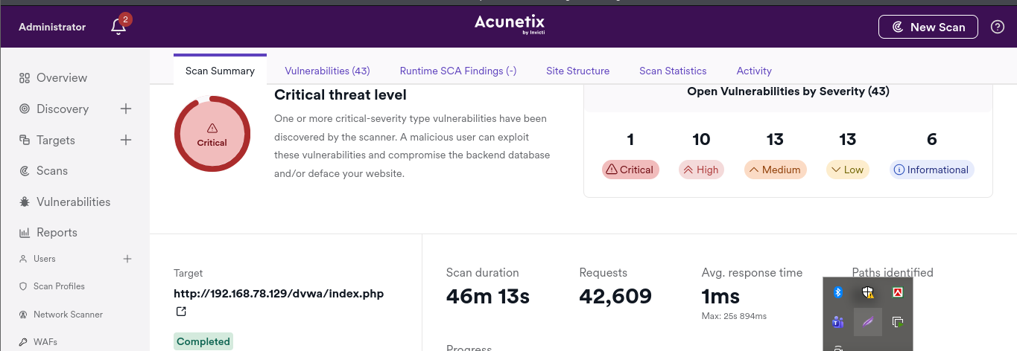
Step-6: Complete the scan and review the scan results and identify the discovered vulnerabilities:
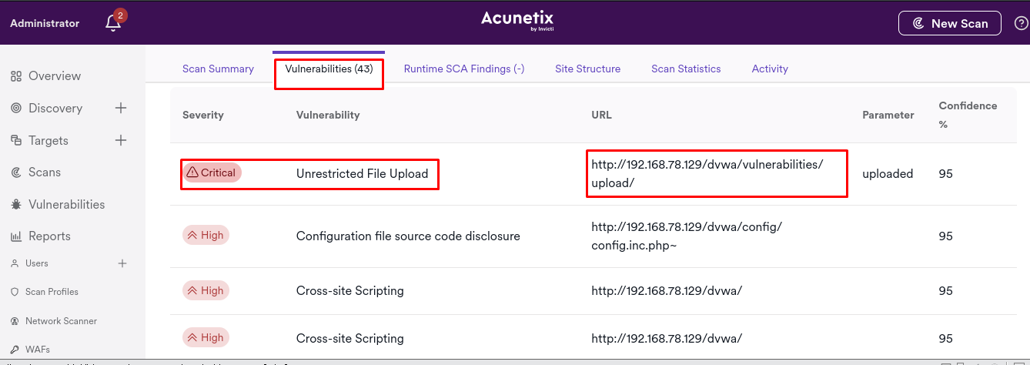
Step-7: Analyze the following vulnerability types:
SQL injection:
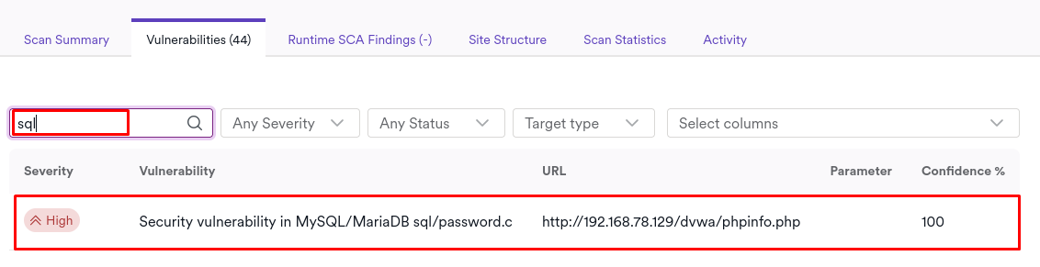

Cross site scripting(XSS):
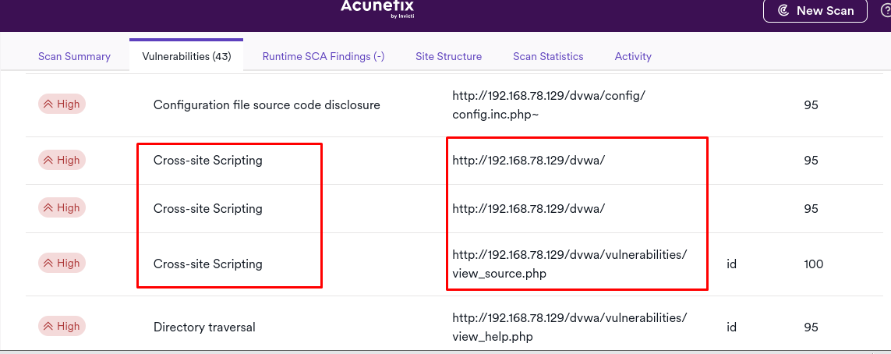
Cross-site Request Forgery(CSRF)
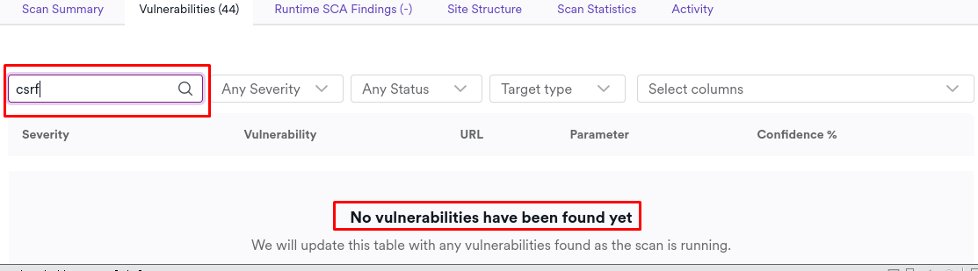

File Inclusion (LFI / RFI) :

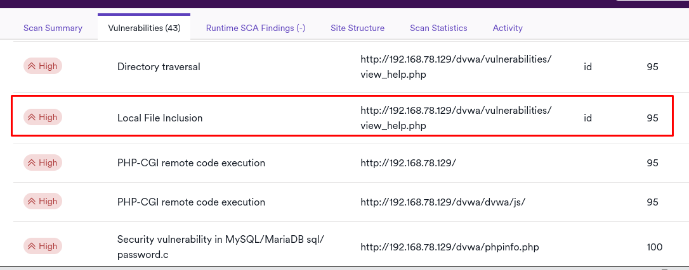
Step-9: Generate and export the scan report in PDF or HTML format:
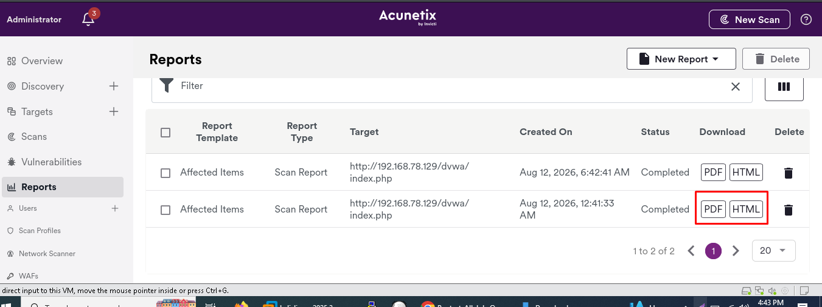
Step-8: For each identified vulnerability document
1. SQL Injection (SQLi)
​Vulnerability Name: SQL Injection (Error-Based / Blind)
​Risk Level: Critical
​Description: Input supplied to parameters (e.g., id) is insufficiently sanitized before being concatenated into a database query, allowing unauthorized database querying, data extraction, or authentication bypass.
​Affected URL: http://<DVWA_IP>/vulnerabilities/sqli/?id=1&Submit=Submit
​Recommended Remediation: Implement parameterized queries (prepared statements) using PDO or MySQLi to decouple code from data.
​2. Cross-Site Scripting (XSS)
​Vulnerability Name: Reflected / Stored Cross-Site Scripting
​Risk Level: High
​Description: Unsanitized user input is reflected or stored in the Web UI without contextual escaping, enabling malicious scripts to execute in the user's browser context and steal session cookies.
​Affected URL: http://<DVWA_IP>/vulnerabilities/xss_r/?name=<script>alert(1)</script>
​Recommended Remediation: Encode output based on context (HTML, attribute, JavaScript context) using safe API functions like htmlspecialchars().
​3. Cross-Site Request Forgery (CSRF)
​Vulnerability Name: Cross-Site Request Forgery (Password Change)
​Risk Level: not find
​4. File Inclusion (LFI / RFI)
​Vulnerability Name: Local / Remote File Inclusion
​Risk Level: High to Critical
​Description: User input passed to file-handling functions (like include() or require()) is executed directly without whitelist validation, allowing arbitrary local file reading or remote code execution.
​Affected URL: http://<DVWA_IP>/vulnerabilities/fi/?page=../../../../etc/passwd
​Recommended Remediation: Avoid passing dynamic paths directly into file-inclusion functions. Maintain a strict whitelist of allowed filenames and set allow_url_include = Off in php.ini.
​5. Security Misconfigurations
​Vulnerability Name: Information Disclosure / Verbose Error Messages / Missing Hardening Headers
​Risk Level: Low to Medium
​Description: Server responses display detailed PHP error stack traces, default configuration pages, or missing HTTP security headers (X-Frame-Options, Content-Security-Policy), aiding attackers during reconnaissance.
​Affected URL: http://<DVWA_IP>/
​Recommended Remediation: Set display_errors = Off in PHP settings, obscure server header tokens, and configure security headers via Web Server directives (Apache/Nginx).
Note: Add pdf document this folder(acunetix.pdf)

