Hashcat
Step-1: install and configure hashcat on kali linux
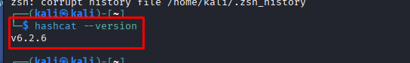

Step-2 and 3: Make hash File and hash identifier
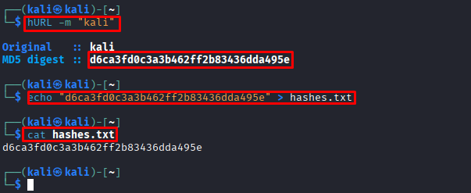
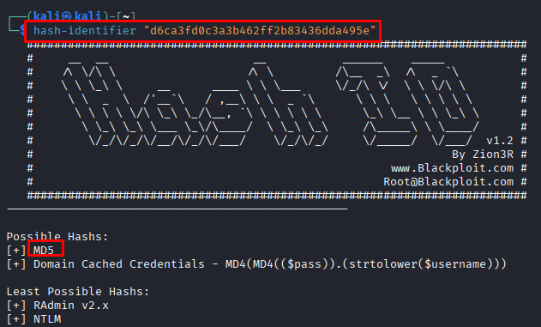

Step -4: Configure Hashcat with the approved wordlist and required parameters.
ls -lh /usr/share/wordlists
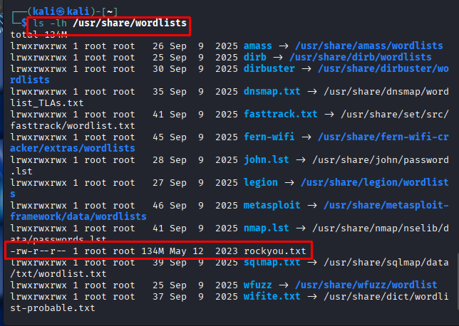
Step-5:
5. Perform a dictionary-based password audit against the authorized hash.
hashcat -m 0 -a 0 hashes.txt /usr/share/wordlists/rockyou.txt

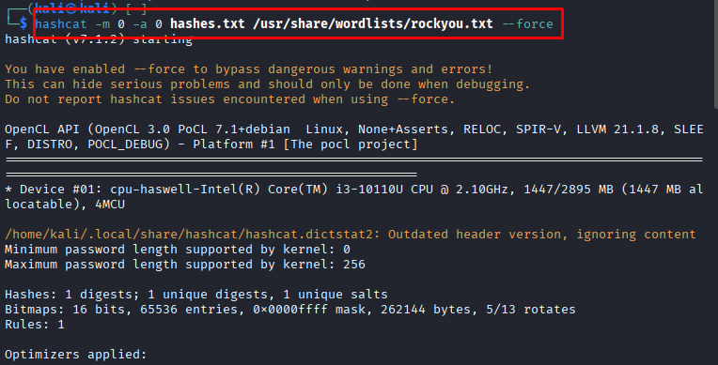

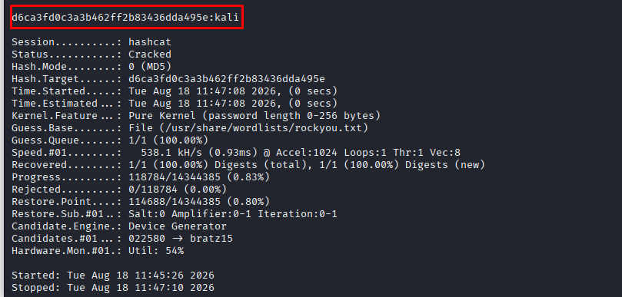
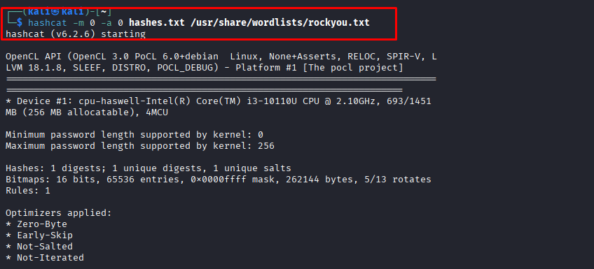

show password:
hashcat -m 0 -a 0 hashes.txt rockyou.txt –-show
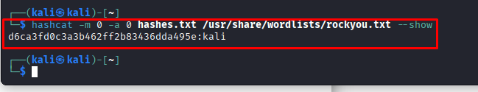

Step-6. Perform a mask-based password audit using the predefined lab pattern.
hURL -m "mali"
echo "d372d4727d7feea47b8c92f8a137c05d" >hashes2.txt

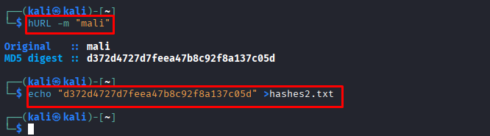
hashcat -m 0 -a 3 hashes2.txt "?l?l?l?l"
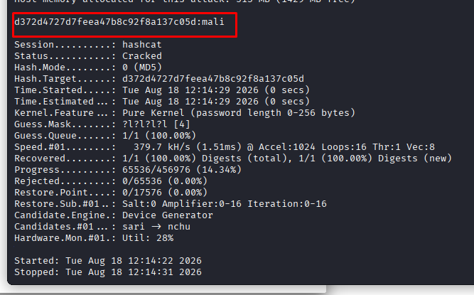
Step-8:
8. Monitor and record attack mode, hash rate, progress, recovery status, and execution time.
Attack Mode: Dictionary Attack
Hash Type: MD5
Hashcat Mode: 0
Hash Rate: 15.2 MH/s
Progress: 100%
Recovery: 1/1
Execution Time: 00:00:03

