Openvas
Step -1: Install and configure OpenVAS/GVM and verify on kali linux
To update the system and initialize OpenVAS/GVM on Kali Linux, the following commands were executed:
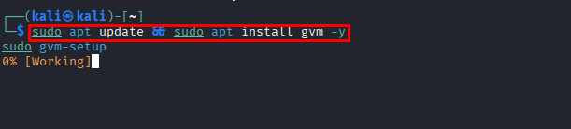
# Update repository and packages
sudo apt update && sudo apt upgrade -y
# Install OpenVAS / GVM
sudo apt install gvm -y
# Setup and sync vulnerability feeds
sudo gvm-setup
# Check GVM setup status and verify services
sudo gvm-check-setup
# Start GVM service
sudo gvm-start
Run Openvas/gvm :

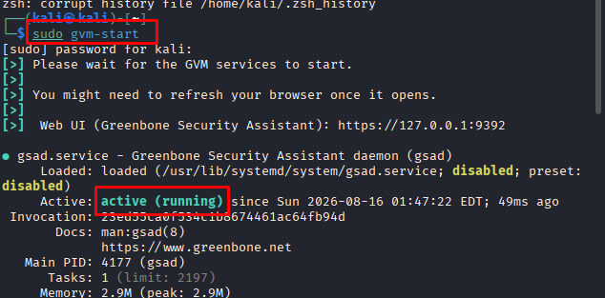
Step -2: Login openvas:
• Opened Web Browser and accessed: [https://127.0.0.1:9392](https://127.0.0.1:9392)
• Logged in using the administrator credentials created during gvm-setup
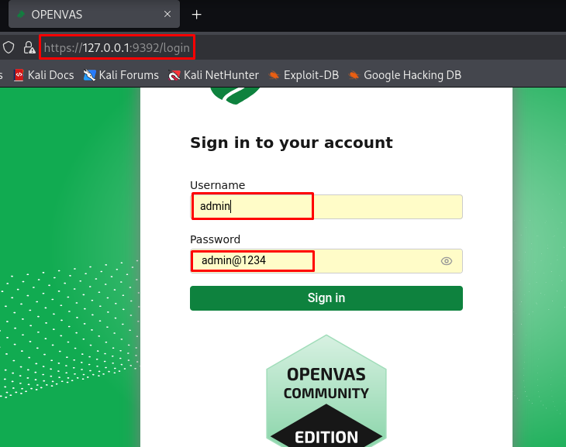

Step -3: Add target(Target Configuration)
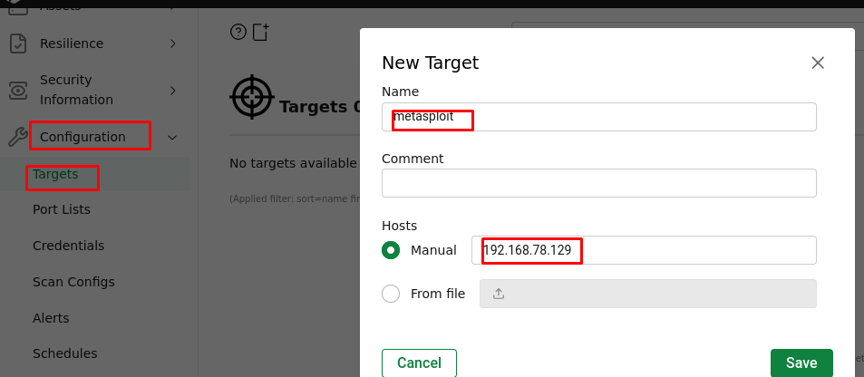
Step -4: Create a scan task & Scan Task Execution
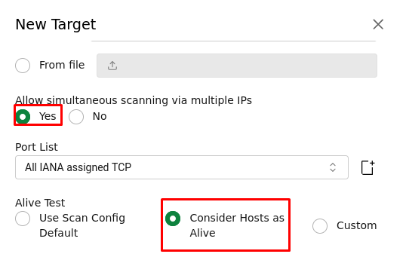
Step -5: Set task:
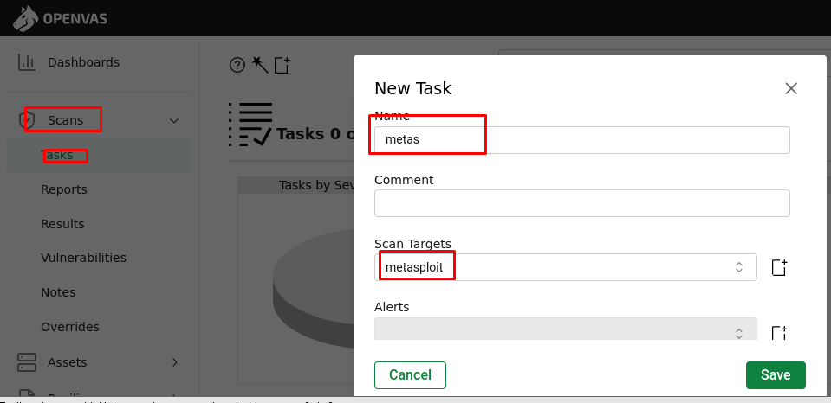
Step -6: Identify and analyze discovered vulnerabilities
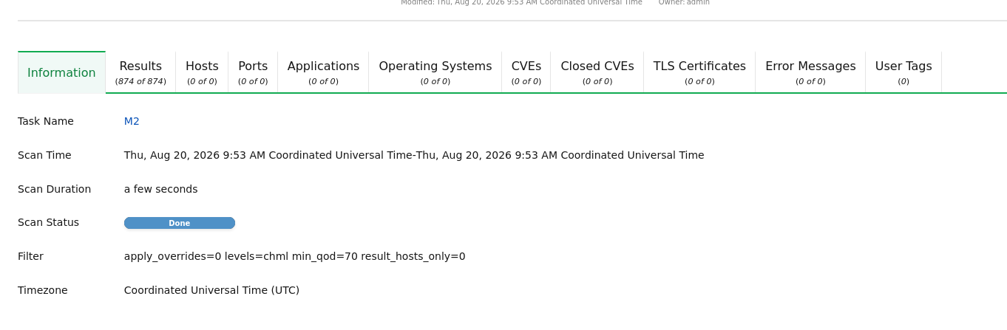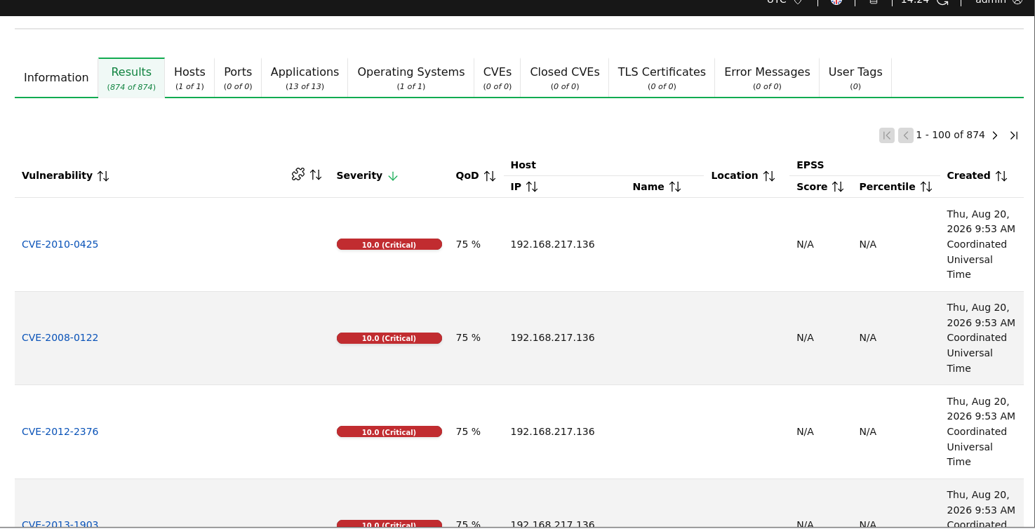
Step -7: Vunnerability results and identify Critical ,High and Medium

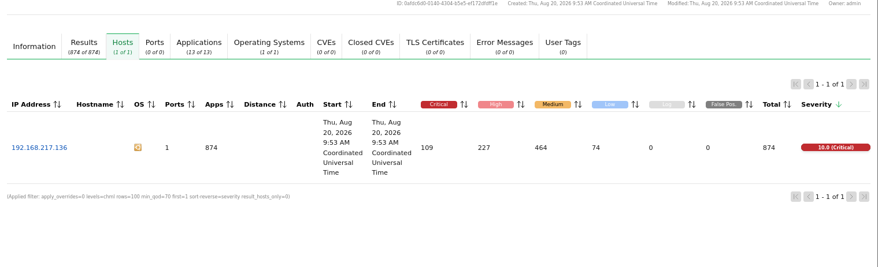
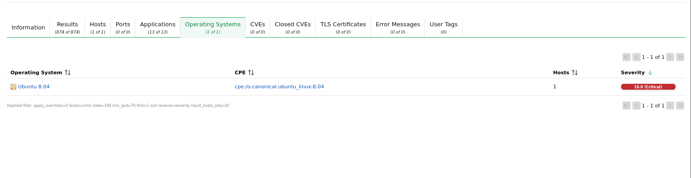
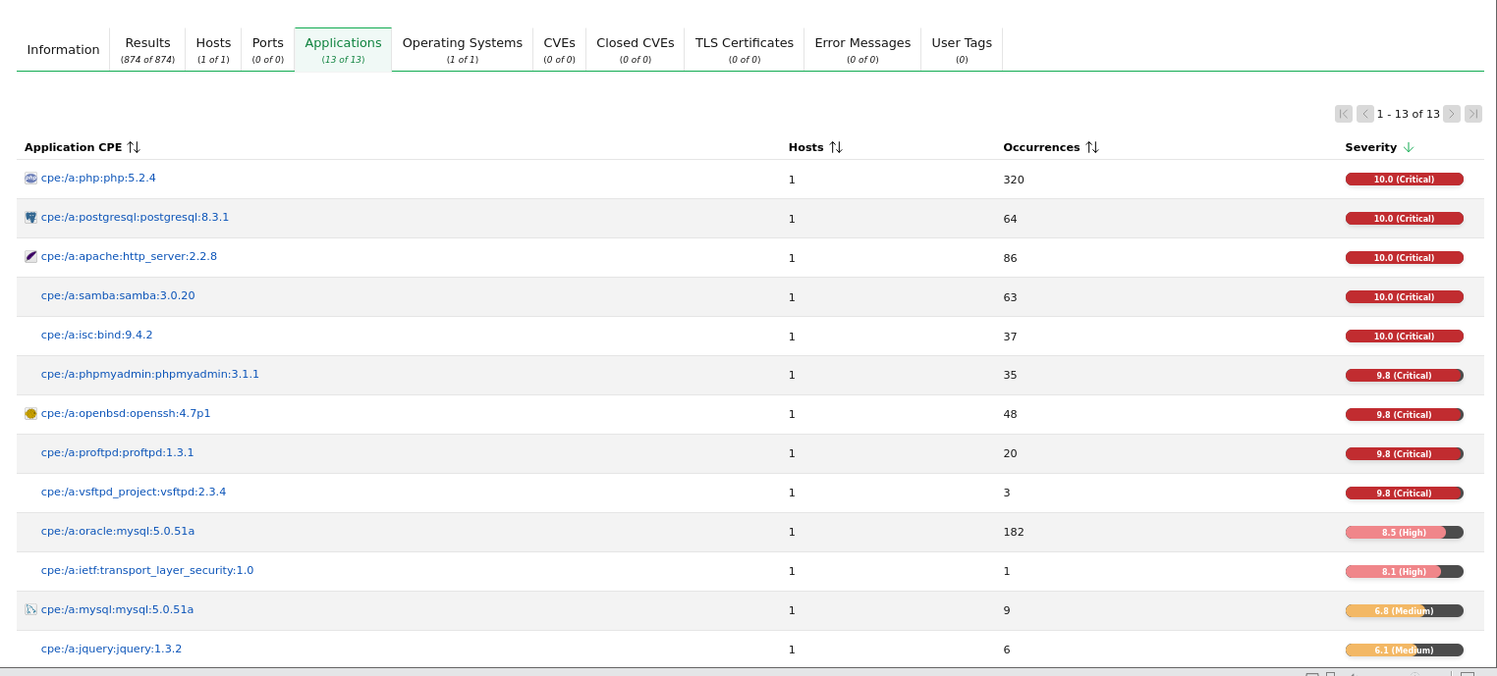
Security Recommendations
- Patch Management: Regularly update and patch all OS components, services, and web application platforms.
- Network Segmentation & Firewall: Implement firewalls to restrict public access to sensitive administrative ports (e.g., FTP, SSH).
- Harden Service Configurations: Disable unnecessary services, default credentials, and insecure authentication methods (e.g., anonymous access).
Note: The Metasploitable server presents significant security risks due to multiple outdated and unpatched services (such as FTP and web servers). Immediate remediation steps, including applying software patches and restricting unauthorized access, are strongly recommended to secure the target environment against potential threats.

