Post-Exploitation Tasks using Meterpreter

create malware
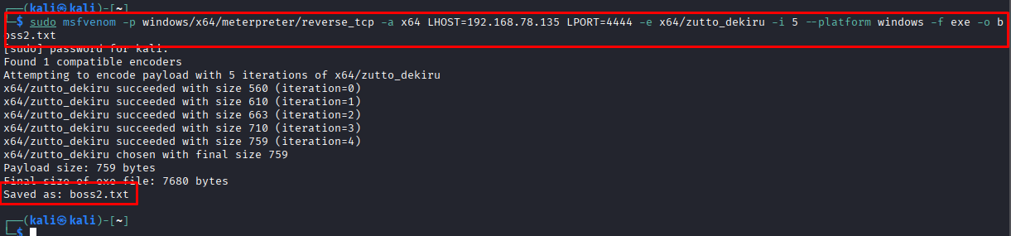
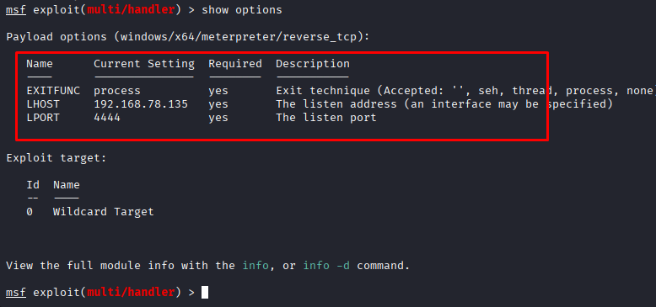
1. Retrieve and document target system information:
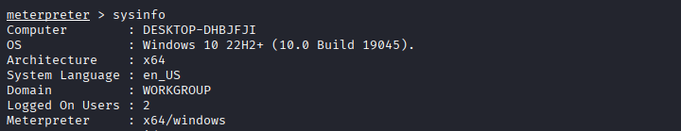
2. Identify and terminate a test process
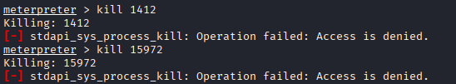

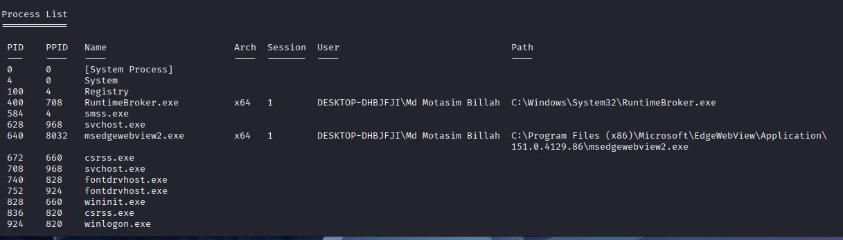
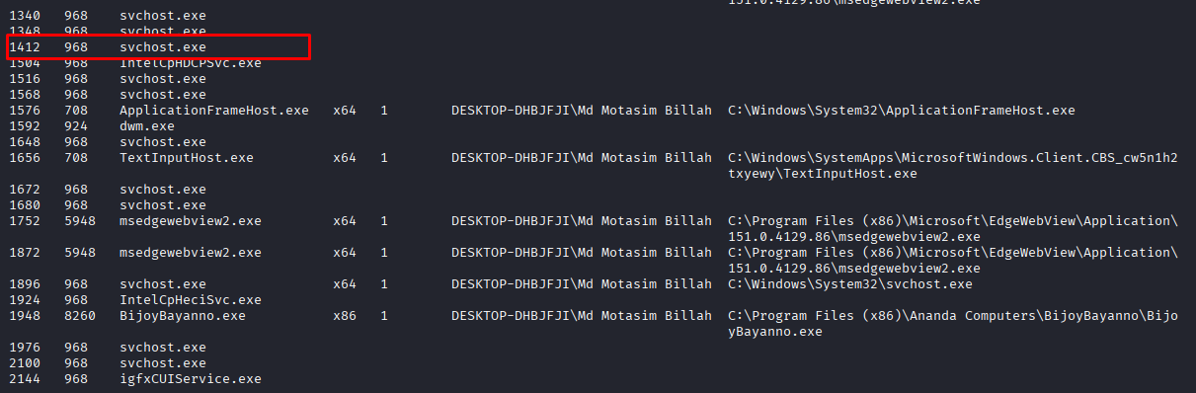
3. Navigate through the target file system
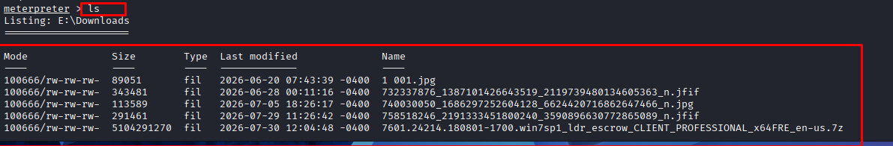

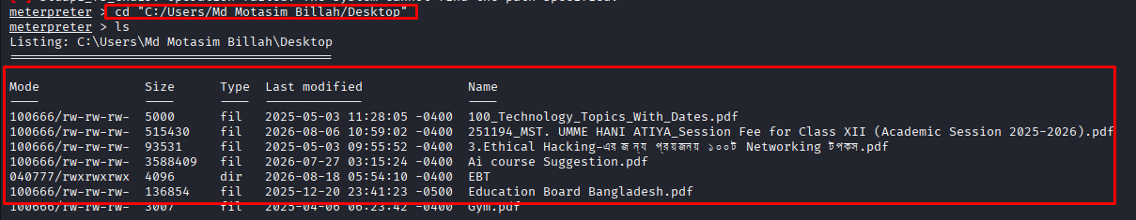
4. Create a designated NSDA directory:
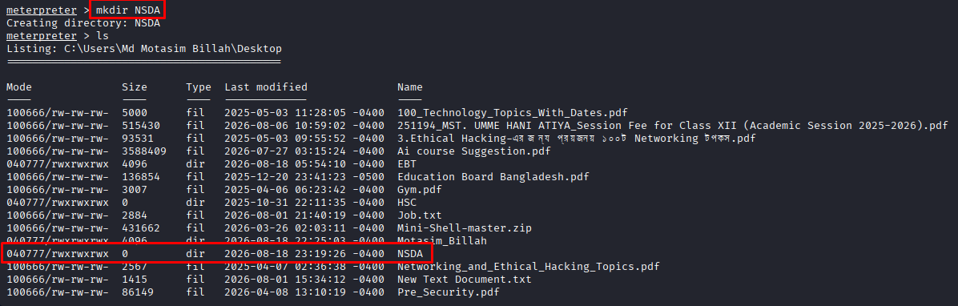

5. Create and update a designated FILE4.txt file:

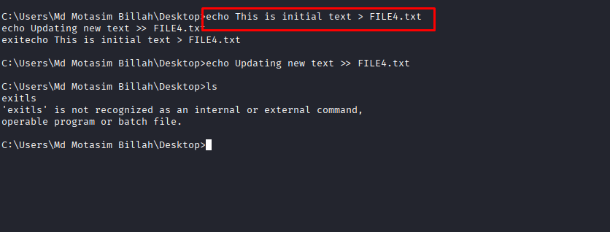
6. Remove the designated FILE4.txt file:
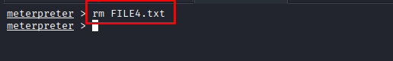
7. Download a designated text file/folder from the target system
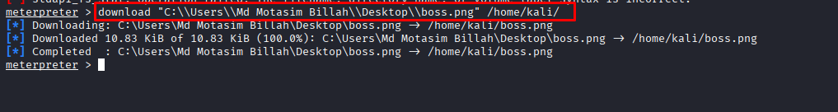
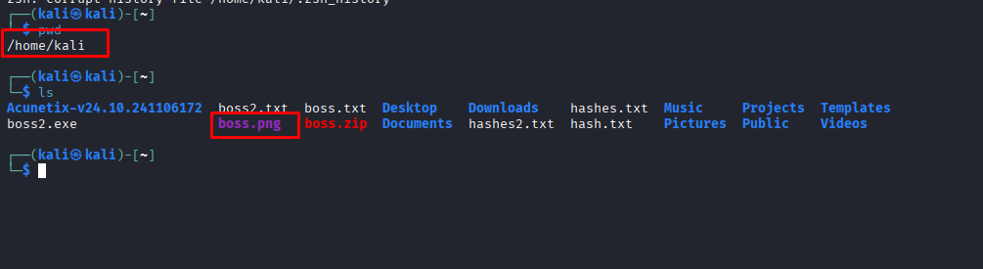
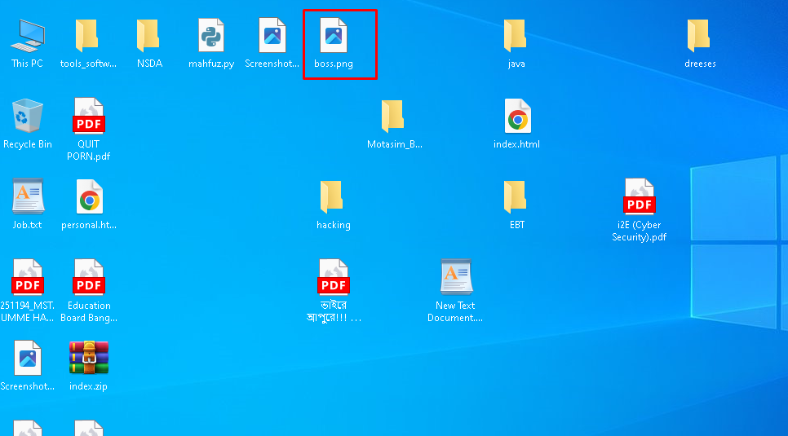
8. Upload a designated text file/folder to the authorized lab environment
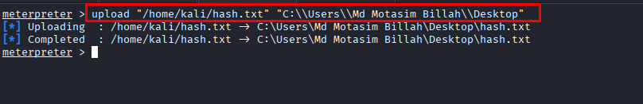
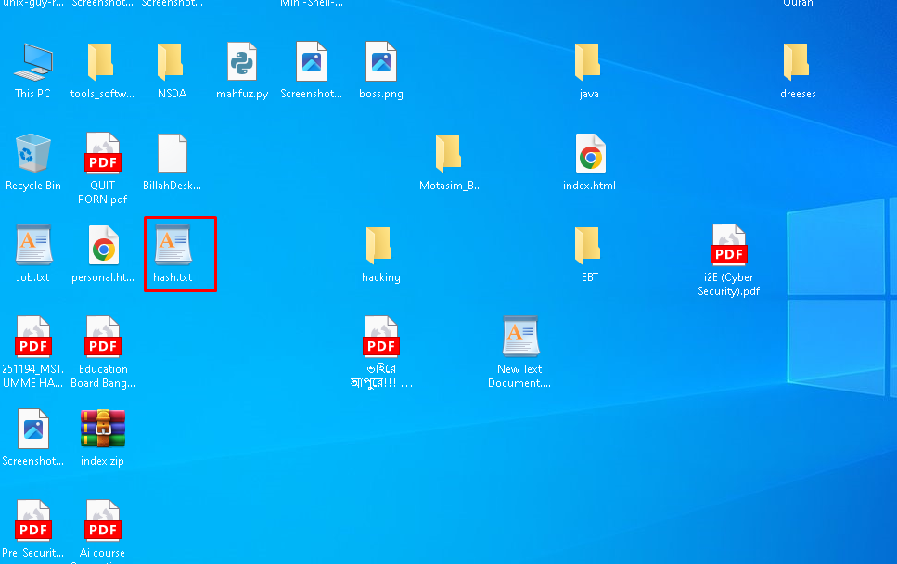
9. Search for specified .txt files within the target environment
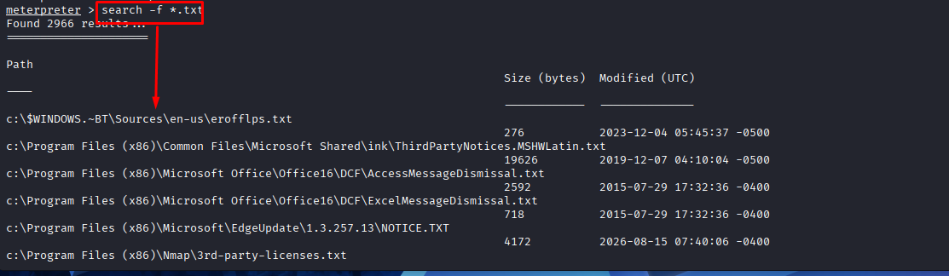

10. Retrieve and document the target ARP table:
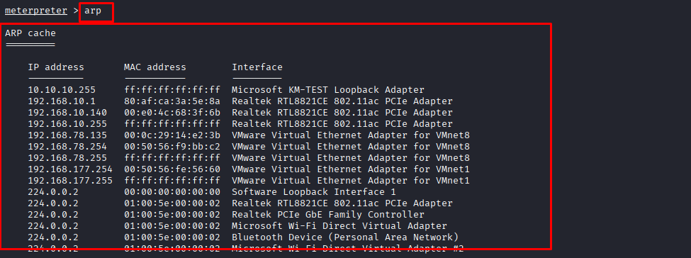

11. Enumerate and analyze the available user accounts
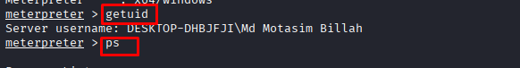
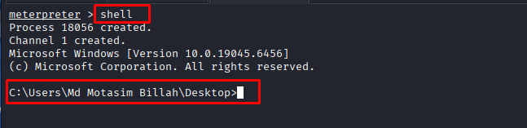
12. Capture the target screen for authorized lab evidence:
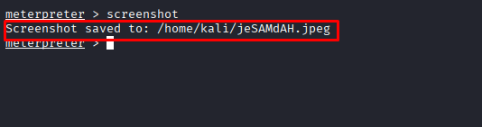
13. Place active session in background and manage session:
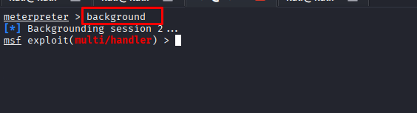
14. Safely terminate the Meterpreter session and target VM:
