#1294388 - #1311319
Using ant colony optimization to solve a Rubik's cube

Agents:
- ants

Interaction rules:
- walk randomly
- Follow the path that has more pheroneme ( on the way going to the food)
- Choose the path in a probalistic way based on the level of pheroneme on the way back to the nest)

Validation:
Since we have two distinct parts of the project ( 1- Ant colony optimization & 2- Ant colony optimization with cube), we can implement and validate them separately:

1- Ant colony optimisation
- Does it converge to an optimal solution ?
Since the cube has a very large search space (~ 4.2 * 10^19), we can add an upper bound to test it initially. By doing this we decrease the size of the graph greatly – for testing – and we can iteratively increase the upper bound, to test for larger search spaces of the cube:
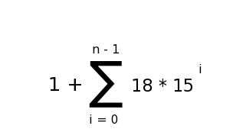
The size of the graph for an upper bound, n is given by :

Hence, our search space will grow as follows:

Upper bound | Size of the graph (search space)
1 | 19
2 | 289
3 | 4339
4 | 65089
5 | 976339
6 | 14645089

And so on ..

We test with cube states that have short solutions first, and then try larger ones.

2- cube
- Testing with a real cube
- Comparing with a CPU solver

Hypothesis
The “ants” (ant colony optimization) will converge to an optimal solution after a sufficient amount of time with a Rubik's cube graph.

