**SDM**

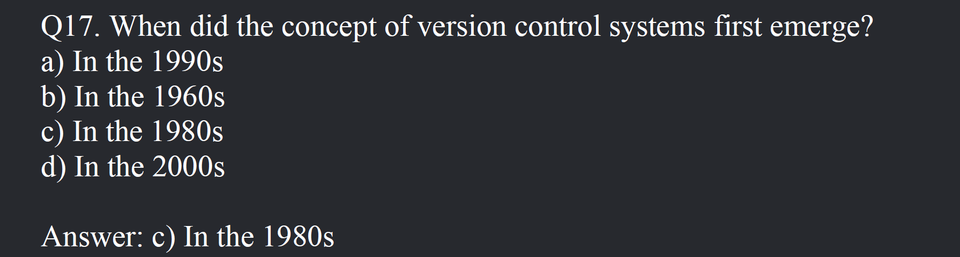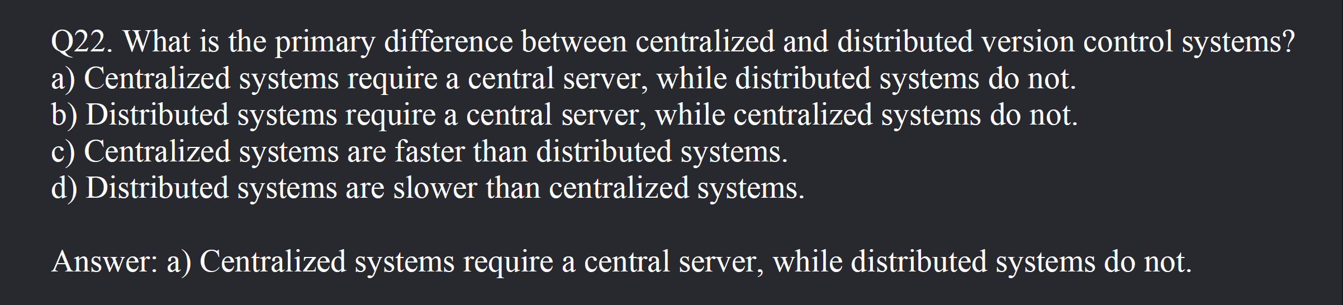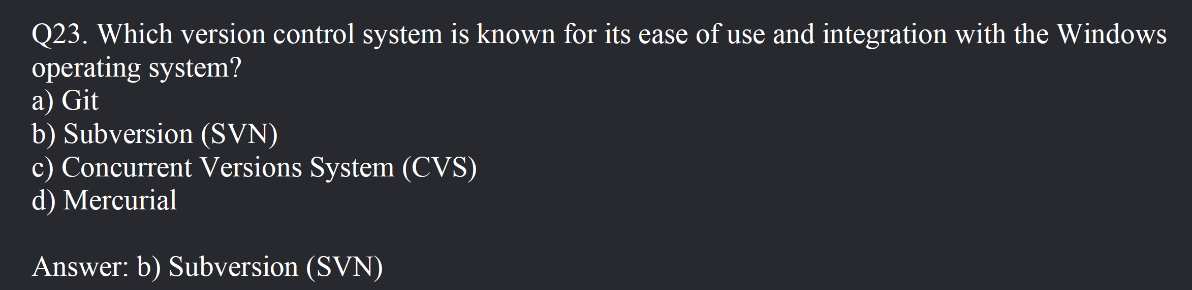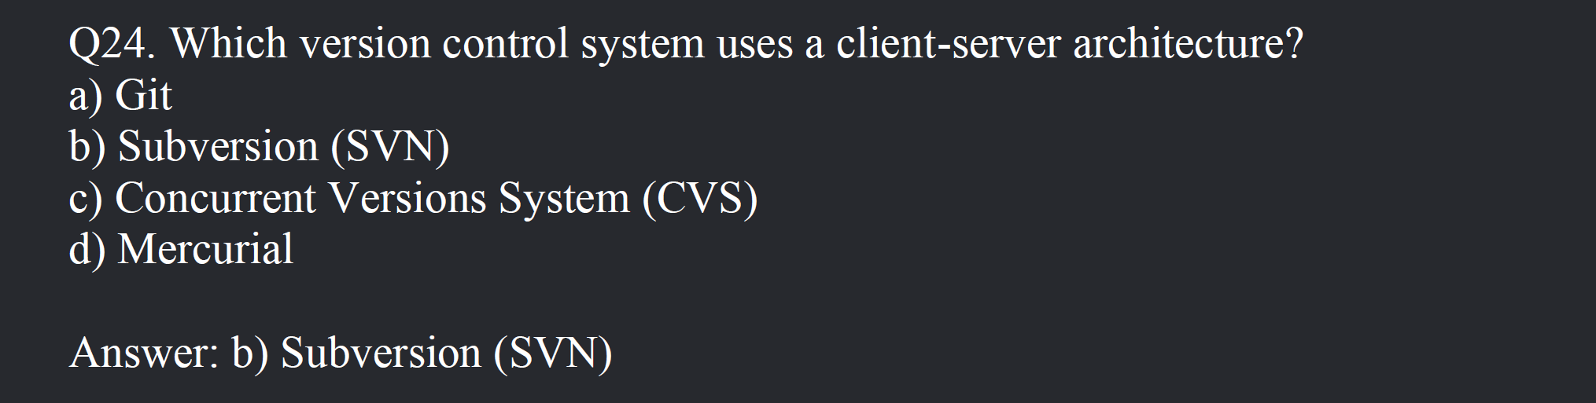

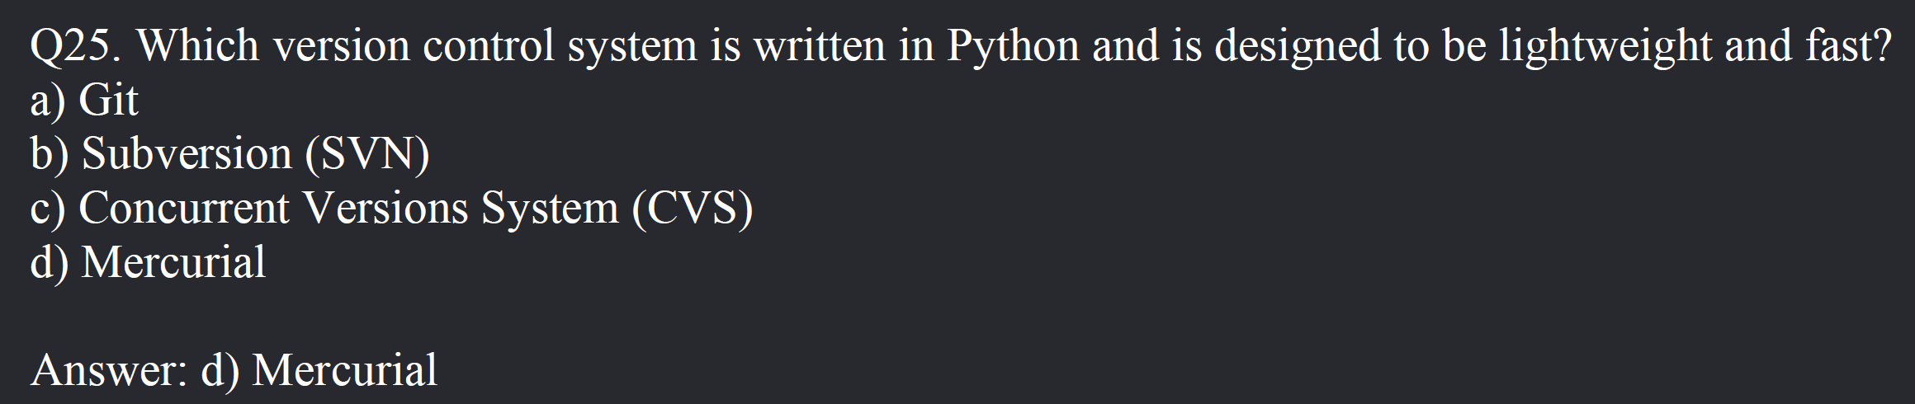

SDM MCQ Bank first 25 done till here