Main business aspects
Business aspect | What it means
1. Customer acquisition & conversion | Generate leads, provide quotes, convert customers into policy purchases
2. Policy sales | Sell/place insurance policies from multiple insurers
3. Policy renewal | Help existing customers renew policies and retain them
4. Claims management | Help customers submit, track and resolve claims
5. Policy administration | Manage policy documents, changes, additions/deletions and other servicing
6. Customer service | Dedicated advisors and ongoing customer support
7. Insurance comparison | Compare products, prices, coverage and insurer options
8. Insurer relationships | Maintain relationships with multiple insurance companies and select suitable products
9. Product diversification | Car, health, home, life, travel, business, pet, bike, yacht, cyber, etc.
10. Customer retention | Renewals, repeat purchases and ongoing policy servicing
11. Digital services | myAlfred allows customers to view policies, renew and manage claims digitally.
Bronze pipeline
The Get Metadata activity is used to retrieve information about files within a folder.
@pipeline().parameters.source_path (Take the value stored in the pipeline parameter called source_path.”)
source_path =Files/source/Customers
This means the source folder path is passed dynamically through a pipeline parameter.
{
"childItems": [
{
"name": "file1.csv",
"type": "File"
},
{
"name": "file2.csv",
"type": "File"
}
]
}
Why childItems?
childItems (All files) retrieves all files and folders under the specified directory.

ForEach Activity
The ForEach loop processes each file returned by Get Metadata.
@activity('Get File List').output.childItems

This mean:
File1 -> Process
2
File2 -> Process
3
File3 -> Process
3. Validate Source File
Purpose
Checks whether the source file is valid before copying.
Benefit
Prevents bad files from entering the Bronze layer.
4. Delete Existing Bronze File
I delete the existing target for the same load date before copying the latest source file. This prevents multiple copies of the same target from accumulating when the pipeline is rerun.
Run 1:
bronze/2026-08-17/raw_Customers.parquet

Run 2:
Delete old file
↓
Copy latest file
↓
bronze/2026-08-17/raw_Customers.parquet

- Delete old Parquet ↓
- Copy latest CSV ↓
- New raw_Customers.parquet

Purpose
Removes the existing target file before loading a new copy.
This avoids:
- Duplicate files
- Copy conflicts

5. Copy Bronze File (.item() Current file being processed)

Purpose
- Copies the validated source file into the Bronze layer.
No transformation usually occurs at Bronze.
Bronze is intended to store raw incoming data.

notebookutils (or mssparkutils) is a very important utility library in Microsoft Fabric. It helps notebooks interact with the Lakehouse, pipelines, files, secrets, and other notebooks without writing complex Spark code.
Incremental logic
silver_watermark
│
▼
Get last_ingested_at (in watermark table)
│
▼
(17/08/2026)
│
▼
Filter Customers
_ingested_at (18/08/2026) > (17/08/2026)
│
▼
New records only (10 new records)
│
▼
Process/Load them
│
▼
Find MAX(_ingested_at)
│
▼
(18/08/2026)
│
▼
Update watermark
│
▼
silver_watermark

Bridge and campaign table reason
I created Dim Channel as a common dimension for channel-based analysis. It also provides the common ChannelKey needed to solve the Campaigns-to-ConversionFunnel relationship through the bridge table."

Dim Channel (channelkey) → Bridge(channelkey) → Fact Funnel(channelkey)

gold_dim_channel
ChannelKey | ChannelName
-----------|-------------
1 | Website
2 | Call Center
3 | Mobile App
4 | Walk-in
5 | Advisor Direct
Campaign_channel_ mapping (Temp View)
Mapping = converts channel names
The Campaigns table has different channel names from the Gold Dim Channel table. So, I created a mapping table to match the channel names and get the correct ChannelKey.
Channel 'Paid Search','Organic','Display Ads'= 'Website'
Channel 'Social Media'= 'Mobile App''
Channel 'Radio'= 'Call Center'
Channel 'Referral'= 'Advisor Direct'
Channel 'Outdoor','Email','Video'= 'Walk-in'

Without mapping view/table:
Inside the code we have to write CASE statement but that is not production friendly

Benefit of campaign channel mapping:
Production-friendly benefits
- Easy to maintain
- Easy to add new channel mappings
- Business users can review the mapping
- Easier to audit
- Avoids large CASE statements
- Keeps transformation logic cleaner

Bridge = connects Campaigns to the Gold model
Campaigns does not have a direct relationship with the Conversion Funnel, so I created a bridge table using ChannelKey. I first standardized the campaign channel names and then mapped them to the Gold Channel dimension.

Kimball design in Gold layer:
For the Gold layer, I followed a Kimball style dimensional modeling approach. I first identified the main business processes, such as policy sales and lead conversion, and then defined the grain of each fact table. For example, the grain of my policy fact table is one row per policy, while the funnel fact is one row per lead.
Then, separated the measurable business events into fact tables and the descriptive information into dimension tables. For the policy process, my dimensions include Customer, ProductType, Channel, Advisor and Date. These dimensions are connected to the fact table using keys, forming a star-schema structure.
This approach makes the data easier to analyze in Power BI because business users can slice measures such as premium, policy count and conversion by product, channel, customer, advisor and date.

Bronze layer pipeline 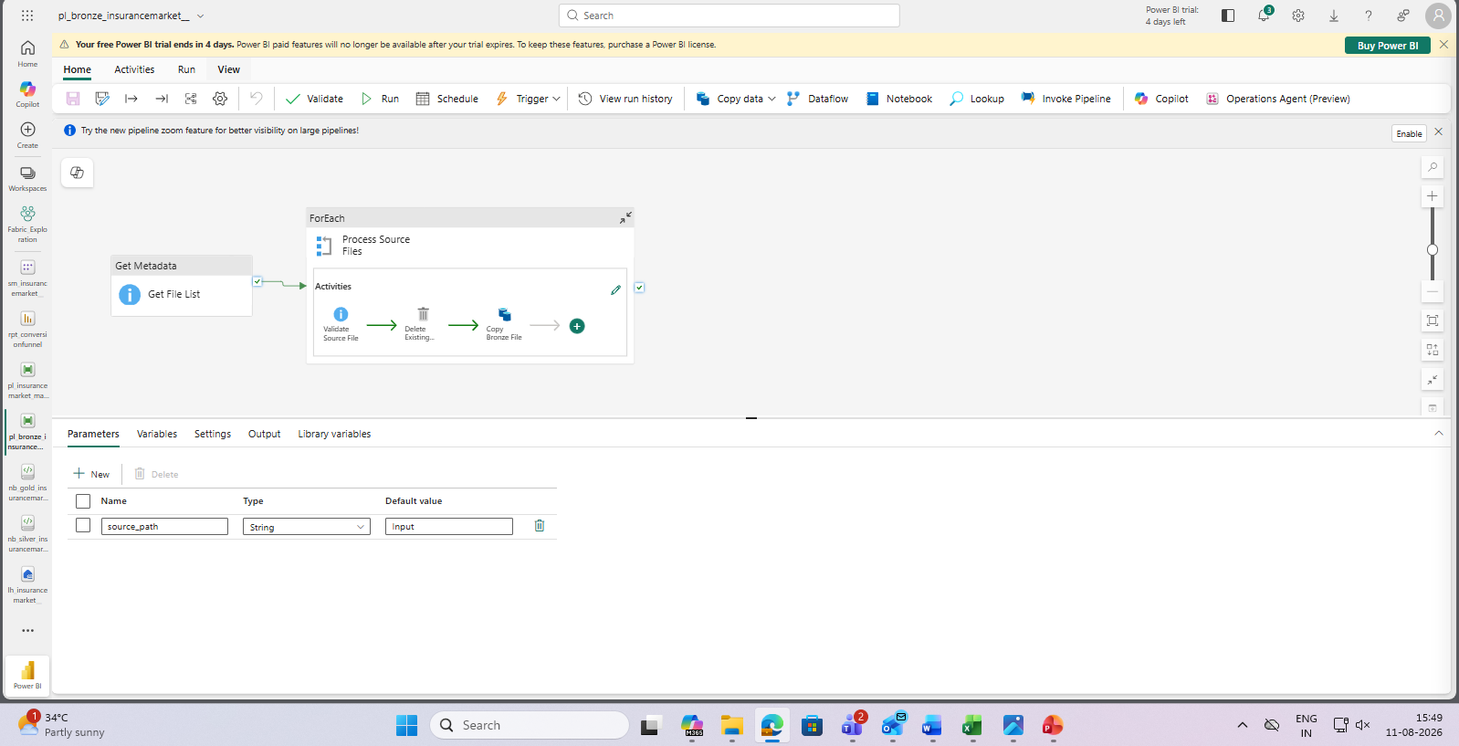
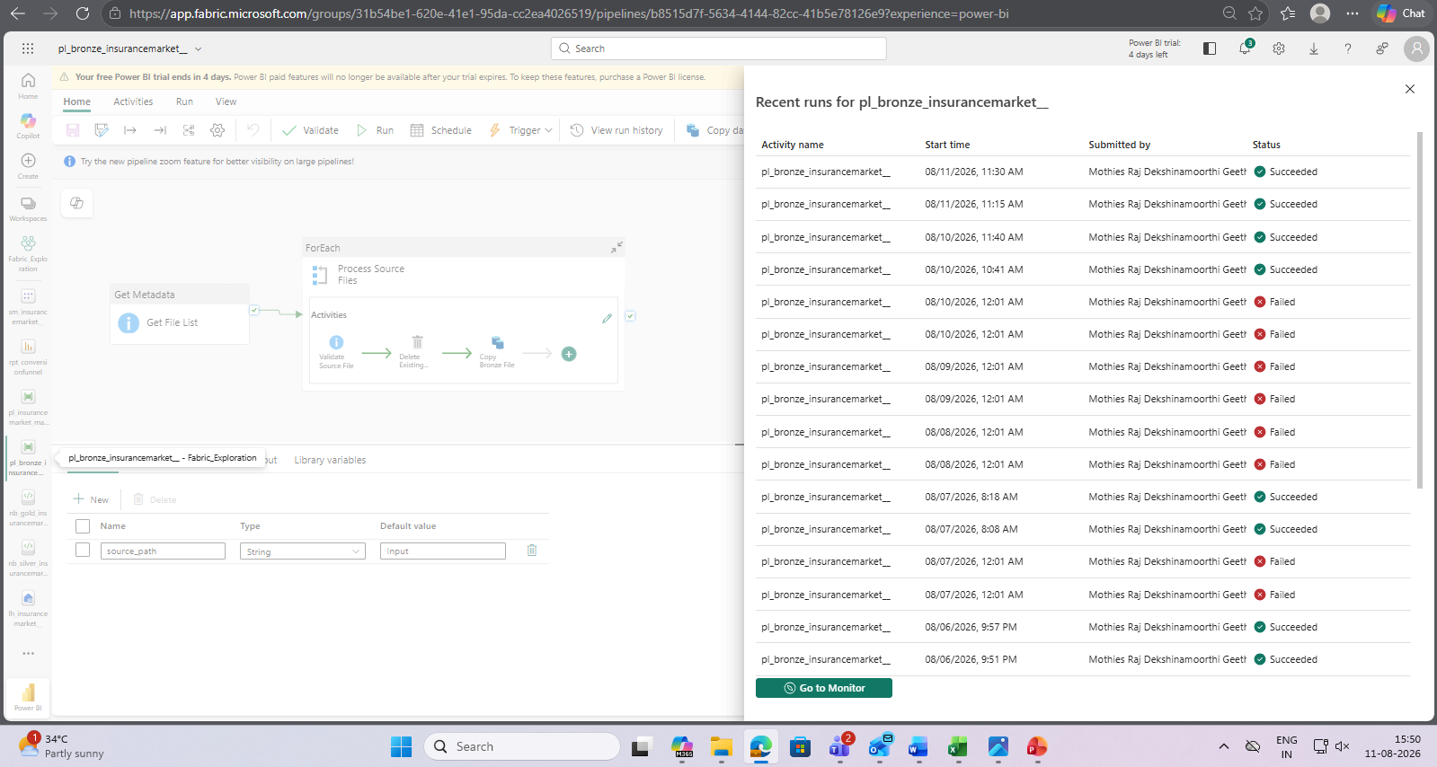
Lakehouse Delta table
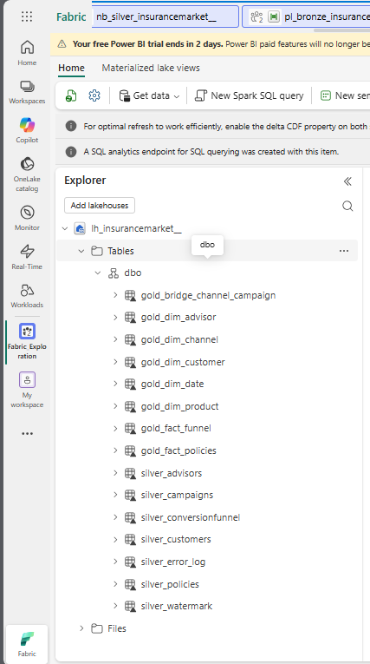
Silver_error_log:
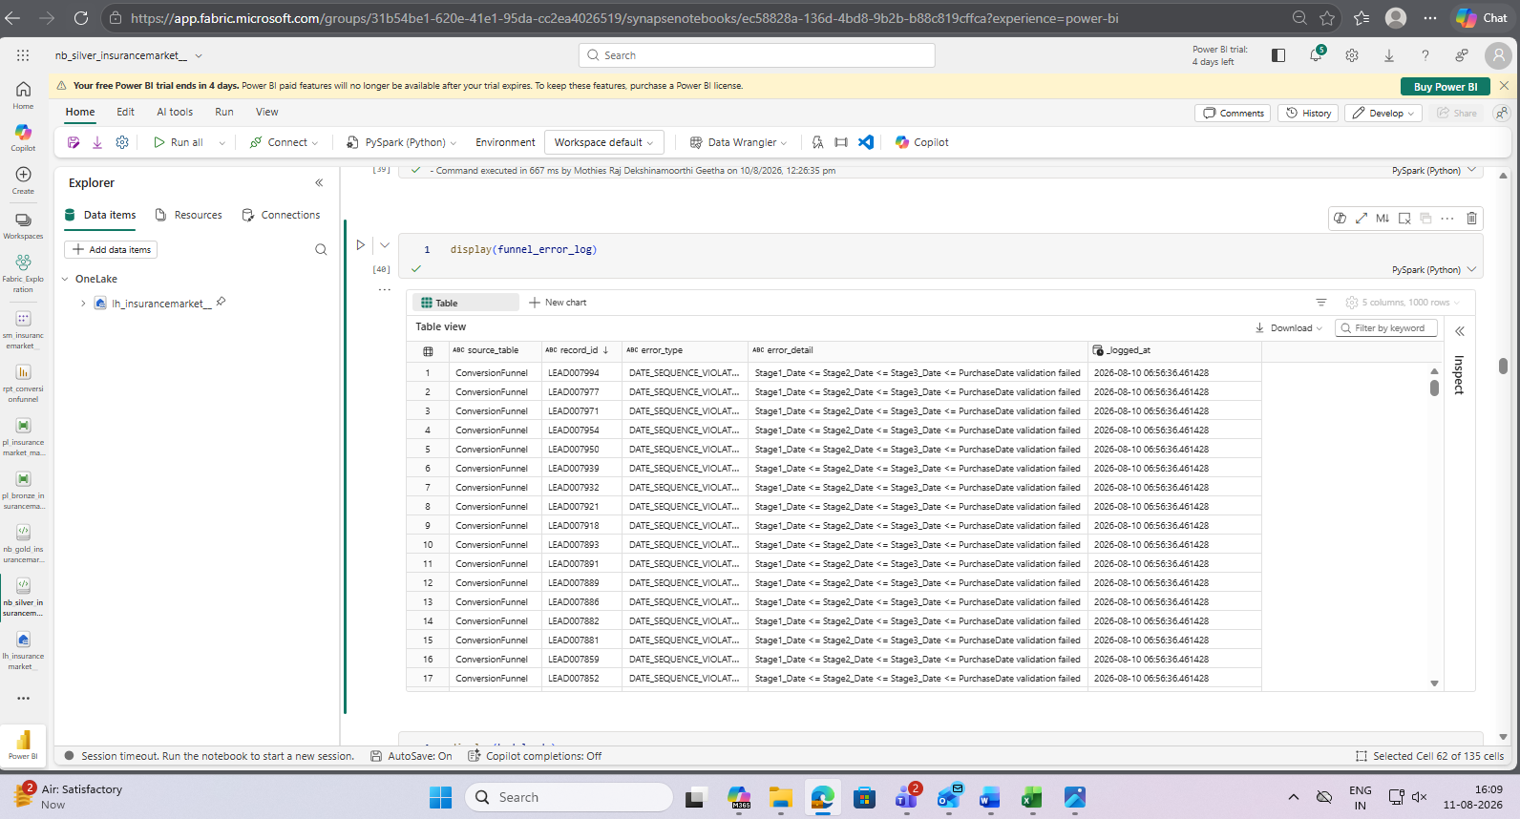
Master_pipeline screenshot
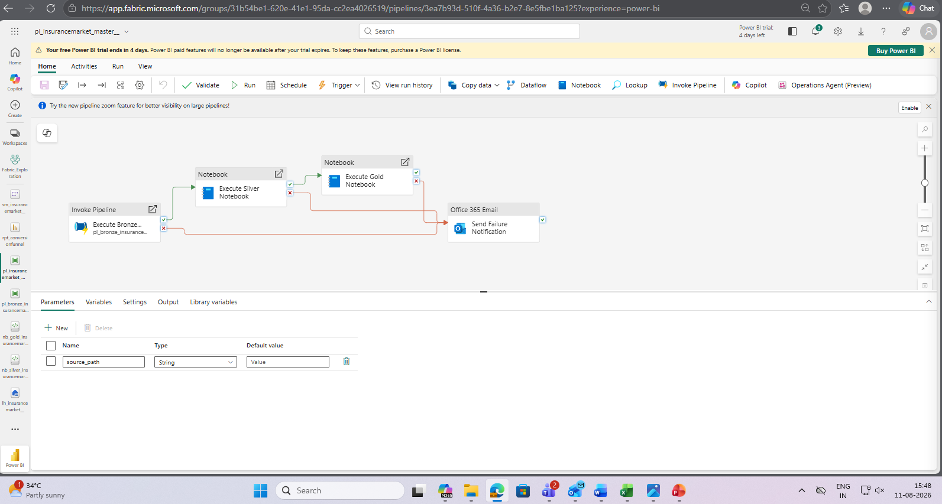
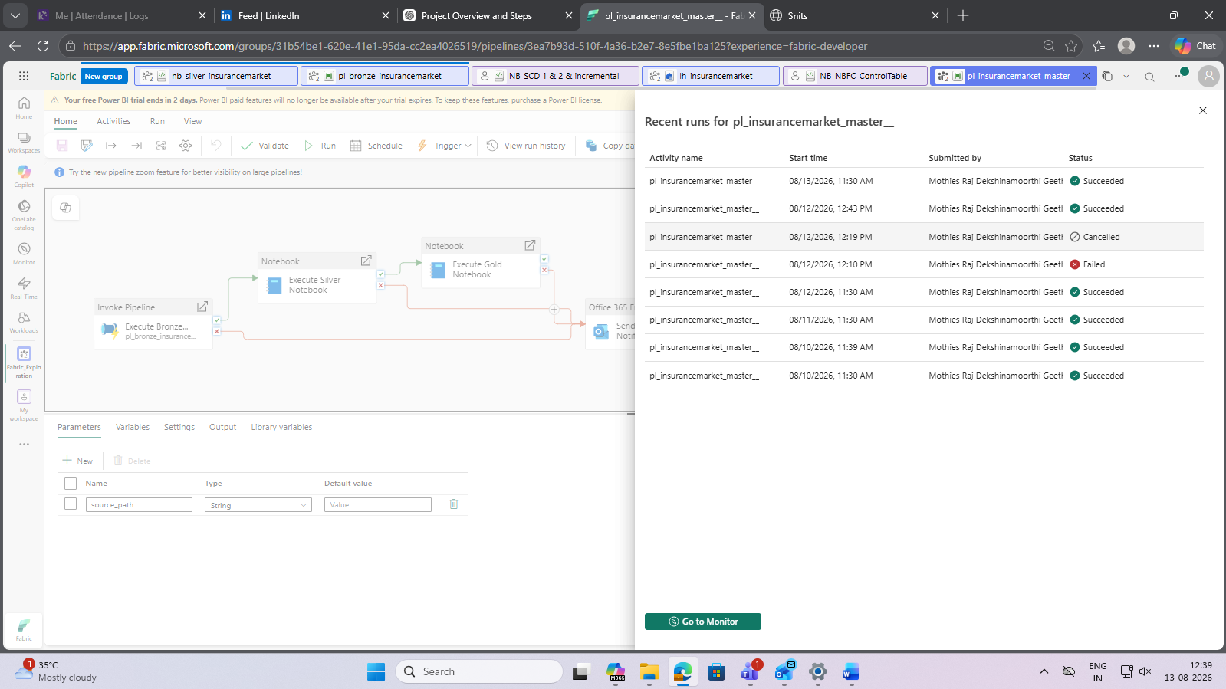
Semantic Model
