1. Master Pipeline Failure Reason
The primary reason for the Master Pipeline failures is data quality issues. I have successfully handled and resolved many of these data quality problems. However, some issues are business-related and require discussions and alignment with the business team and data architects. These issues cannot be resolved solely from a technical perspective and require collaborative decision-making. Once the business-related data quality issues are addressed, the next major challenge is validating data arrival and ensuring data availability on time.

Late arrival reason
Event is considered late when ingestion happens more than
24 hours after the actual event timestamp.

EVENT TIME 2026-08-15 10:00
Data arrives 2026-08-18 22:00

#Event happens
#Event timestamp
# within 24 hours ──────► Not late
# after 24 hours ───────► Late-arriving

2. Reason for the Failure Shown in the 2nd Screenshot
As shown in the 2nd screenshot, the failure is caused by a data quality issue. Technically, I could have replaced or corrected the data based on my assumptions and made the pipeline pass successfully. However, I chose not to do so because I wanted the pipeline to reflect the actual data condition and maintain data integrity. Therefore, I displayed the failure to highlight the real issue. Otherwise, the pipeline is designed and implemented at a production-ready level with robust validation and error-handling mechanisms.

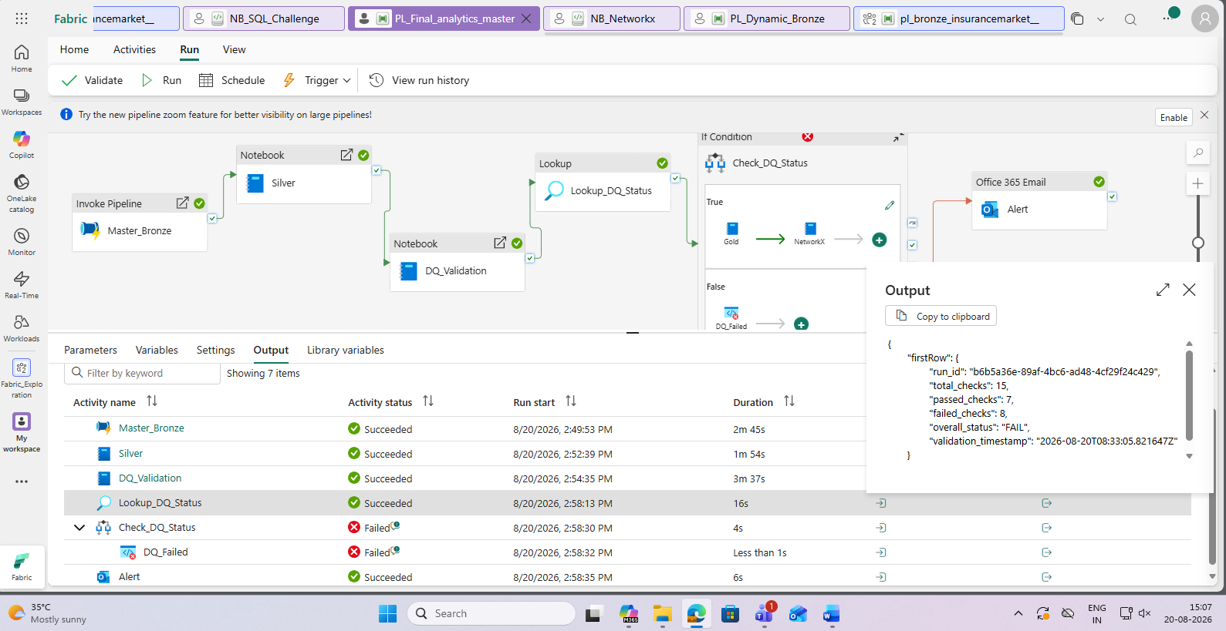
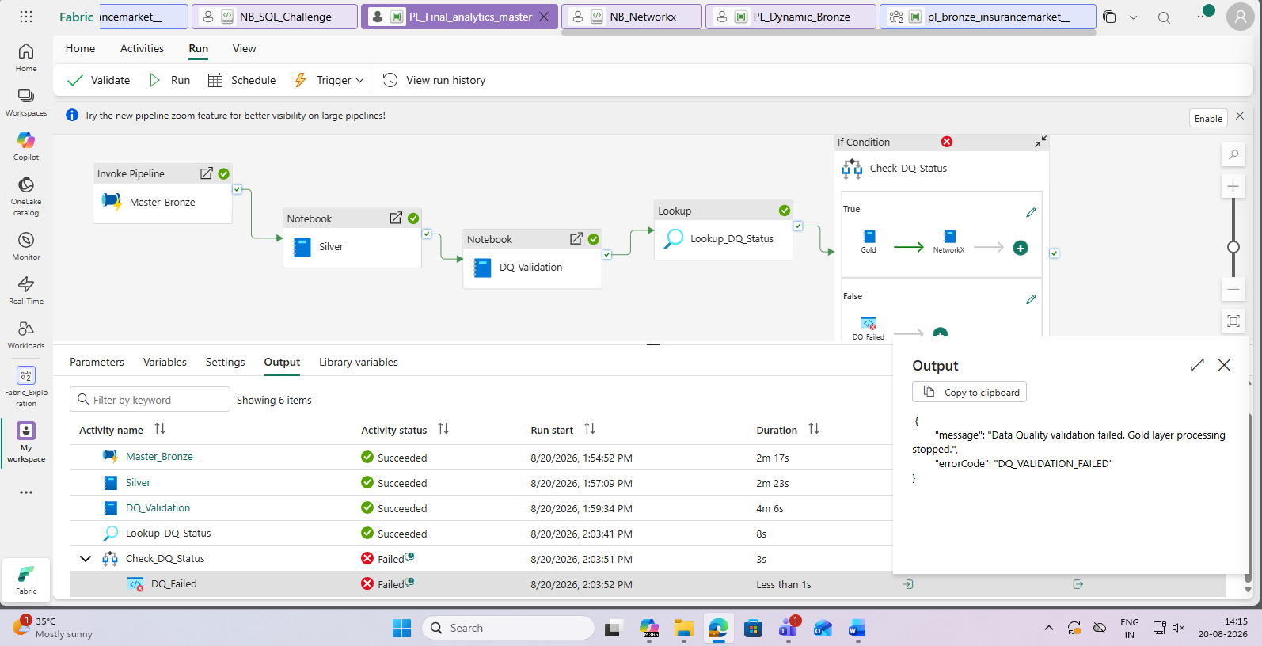

Alert send my mail
