# Data Quality Strategy
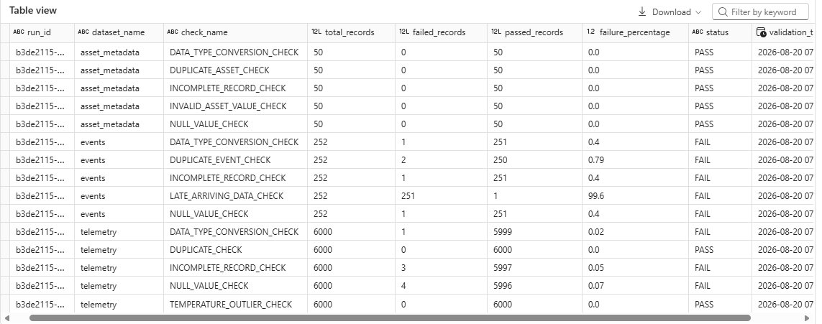

`dq_quality_report` stores detailed results.

`dq_quality_summary` aggregates by `run_id` and returns total checks, passed checks, failed checks and overall status.

## Gold gating

Critical validation failures do not contribute to Gold analytical facts. DQ failures remain visible for investigation.

