Speech to Indian Sign Language: Accent-Adapted Speech Recognition and Dictionary-Based Sign Retrieval
Abhishek Karthik J  Amrita School of Artificial Intelligence  Amrita Vishwa Vidyapeetham  India  cb.sc.u4aie23010.cb.students.amrita.edu | M. P. Mothishwaran  Amrita School of Artificial Intelligence  Amrita Vishwa Vidyapeetham  India  cb.sc.u4aie23041.cb.students.amrita.edu | Abhishek Karthik J  Amrita School of Artificial Intelligence  Amrita Vishwa Vidyapeetham  India  cb.sc.u4aie23010.cb.students.amrita.edu | M. P. Mothishwaran  Amrita School of Artificial Intelligence  Amrita Vishwa Vidyapeetham  India  cb.sc.u4aie23041.cb.students.amrita.edu
Abhishek R  Amrita School of Artificial Intelligence  Amrita Vishwa Vidyapeetham  India  cb.sc.u4aie23011.cb.students.amrita.edu | M S Bavesh Reddy  Amrita School of Artificial Intelligence  Amrita Vishwa Vidyapeetham  India  cb.sc.u4aie23044.cb.students.amrita.edu | Abhishek R  Amrita School of Artificial Intelligence  Amrita Vishwa Vidyapeetham  India  cb.sc.u4aie23011.cb.students.amrita.edu

Abstract— People whose first language is Indian Sign Language (ISL) are often excluded from spoken English in classrooms, offices, and public places. This paper describes a system that listens to spoken English and plays the matching signs as video recordings of Deaf signers taken from the ISLRTC dictionary. Speech is recognised with Whisper base.en, which we fine-tuned on Svarah, a corpus of Indian-accented English. On sixteen speakers who were kept out of training, the word error rate dropped from 13.2% to 11.3%, and fourteen of the sixteen improved. Recognised words are mapped to signs through a lookup chain that covers about 4,000 phrases stored locally and another 2,700 that are downloaded on demand from the dictionary archive; inflected forms and manually reviewed synonyms extend the vocabulary, and unknown words are fingerspelled. Classical analysis runs alongside the recogniser: short-time energy, zero-crossing rate, an autocorrelation pitch tracker and spectral-based subtraction. Two of the experiments built on these gave negative results that we report in full. Spectral subtraction raised the signal-to-noise ratio by up to 7 dB but made recognition worse in 15 of 18 noise situations, and the final pitch movement separated yes/no questions from statements with only 66.5% balanced accuracy. On twenty held-out everyday sentences, 67% of the words that ISL would sign had a dictionary sign. The whole pipeline runs interactively on a laptop GPU.
Index Terms—speech recognition, Indian Sign Language, Whisper, fine-tuning, accented speech, pitch detection, spectral subtraction, sign retrieval
I. Introduction
Indian Sign Language is a complete language with its own vocabulary and grammar; it is not English spelt out with the hands [1]. For a Deaf person who grew up signing, a lecture, a railway announcement or a conversation at a counter is easy to miss, and trained interpreters are few. A tool that turns speech into signs automatically could close part of that gap, even if it cannot replace an interpreter.
Most research in this area runs the other way, from signs to text. Generating signs from speech is harder. Neural sign production models learn to output skeletal poses or avatar animation [2], [3], but they need large aligned corpora, which hardly exist for ISL, and Deaf viewers have consistently rated signing avatars below human signers [4], [5]. We therefore took a retrieval approach: every sign the system shows is a real recording of a Deaf signer, and our modelling effort goes into the part that decides what was said, namely speech recognition and the speech processing around it.
Recognition is a weak point for Indian users. Whisper [6] performs well on many benchmarks, but the Svarah study found that English recognisers lose accuracy on Indian accents [7]. Our main contributions are:
- fine-tuning Whisper base.en on Indian-accented speech, evaluated on speakers who never appear in training, with a per-speaker analysis and a significance test;
- a speech analysis front end (energy, zero-crossing rate, autocorrelation pitch as well as spectral subtraction) shown live while the user speaks, with two controlled studies of whether the classical tools help a neural recogniser;
- a sign lookup chain over the full ISLRTC dictionary that combines locally stored clips, on-demand download, word forms, reviewed synonyms, number reading and fingerspelling;
- an evaluation that reports coverage error rates as well as negative results without merging approximate matches into the headline numbers.
Section II reviews related work and states the gaps we address. Section III presents the objectives and datasets, Section IV the method, Section V the results, Section VI the limitations, and Section VII the conclusion.

II. Related Work sp
A. Speech Recognition and Indian Accents
Whisper [6] is an encoder-decoder Transformer [8] trained on about 680,000 hours of weakly labelled audio. The encoder reads an 80-band log-mel spectrogram, a representation descended from the mel-frequency features studied by Davis and Mermelstein [9], and the decoder writes text token by token. Svarah [7] collected read and spontaneous English from 117 speakers across India and showed that error rates rise noticeably on these accents. Svarah was released as a test benchmark; we re-split it by speaker so that it could also be used for adaptation.
B. Classical Speech Analysis
Rabiner's study of autocorrelation pitch detection [10] is still a standard reference for estimating the fundamental frequency of voiced speech. For noise, Boll's spectral subtraction [11] estimates the noise spectrum during pauses and removes it from each frame, and Berouti et al. [12] added over-subtraction and a spectral floor to suppress the residual "musical noise". These methods were developed for older recognisers and for human listeners, and it is an open practical question whether they still help a large neural model.
C. Sign Language Translation and Production
Camgöz et al. framed sign language translation as neural machine translation from video [13] and later trained recognition and translation jointly with Transformers [14]. In the production direction, Saunders et al. generated continuous pose sequences from text [2], and Kapoor et al. went directly from speech to sign poses for Indian Sign Language [3]. These systems output a skeleton or avatar rather than a human signer, and they depend on paired data that is scarce for ISL.
D. ISL Resources
INCLUDE [15] is a word-level ISL recognition dataset of 263 signs recorded on video. ISLTranslate [16] provides about 31,000 sentence-level ISL-English pairs from educational videos, and iSign [17] gathers several ISL processing tasks into one benchmark. None of these provides the clean, one-sign-per-clip lexicon that a retrieval system needs; the ISLRTC dictionary does.
E. Avatars, Semantics and Grammar
Kipp et al. [4] found that Deaf participants judged signing avatars critically, mainly for stiff motion and missing facial expression, and Quandt et al. [5] showed that attitudes depend on hearing status and avatar type. For word meaning, Sentence-BERT [18] gives sentence embeddings for semantic similarity, while WordNet [19] organises English words into hand-built synonym sets. Zeshan's typological outline of Indo-Pakistani Sign Language [1] describes word-order tendencies such as question words at the end of a clause. We use the bootstrap [20] to test whether differences in error rate are larger than chance.
F. Identified Gaps
Three gaps motivated this work. First, speech-to-sign systems rarely adapt the recogniser to Indian speakers or report its error on them, although recognition errors pass straight into the signed output. Second, production models depend on parallel data and avatar rendering, while retrieval systems built on real signers seldom report how much of a sentence, they can actually sign. Third, classical enhancement and prosodic cues are usually assumed to help, and are rarely measured against a modern neural recogniser inside a working pipeline.
III. Objectives and Datasets
A. Objectives
The objectives were: (i) to lower the recognition error for Indian-accented English and prove it on unfamiliar speakers; (ii) to implement and evaluate classical speech processing within the pipeline; (iii) to sign as much of an everyday sentence as possible using genuine ISL signs, without silently dropping words; and (iv) to run in real time on a laptop.
B. ISLRTC Sign Dictionary
The Indian Sign Language Research and Training Centre (ISLRTC) publishes a video dictionary in which each clip shows one sign performed by a Deaf signer. The full archive holds 15,462 videos (about 250 GB). Downloading it all was impractical, so we kept 5,615 videos locally and built a manifest by parsing file names: for example, I_Don_t_Know.mp4 becomes the phrase "I don't know" and Rupee, money.mp4 yields two phrases. Clips longer than 30 s explain a word rather than showing the sign itself and were excluded, as were Hindi-only files and regional compilations. The remaining files were catalogued for download on demand. Videos are never redistributed; the repository stores only the manifest and file references. Table I summarises the dictionary.
TABLE I
ISLRTC dictionary as used
Item | Count
Videos in the online archive | 15,462
Videos stored locally | 5,615
Phrases in the local manifest | 4,068
Further phrases fetchable on demand | 2,740
Clips skipped (longer than 30 s) | 1,256
Alphabet clips for fingerspelling | 26

C. Svarah Speech Corpus
Svarah [7] contains 6,656 utterances (9.6 h) from 117 speakers and is released under CC BY 4.0. Because the corpus has no speaker column, and because its file-name prefixes did not identify speakers (about 2,900 distinct prefixes for 117 people), we grouped utterances by each speaker’s full demographic profile. A speaker’s profile never changes, so no speaker can appear in two splits. This gives 115 groups, because a few speakers share a profile and are kept together, which errs on the safe side; in the rest of the paper a “speaker” means one such group. Table II shows the split.
TABLE II
Speaker-disjoint split of Svarah
Split | Speaker groups | Utterances | Hours
Train | 84 | 5,342 | 7.61
Dev | 15 | 694 | 0.99
Test | 16 | 620 | 1.02

D. Evaluation Sentences
We wrote two sets of twenty everyday sentences. The first was used during development. We wrote the second, the held-out set, after fixing all matching rules and never used it to tune anything, so we treat its figures as representative. We also spoke both sets with a synthetic voice and ran them through the full system.
.
IV. Methodology
Fig. 1 shows the pipeline. The browser records audio, the server recognises it, maps it to signs, and the browser plays it back.
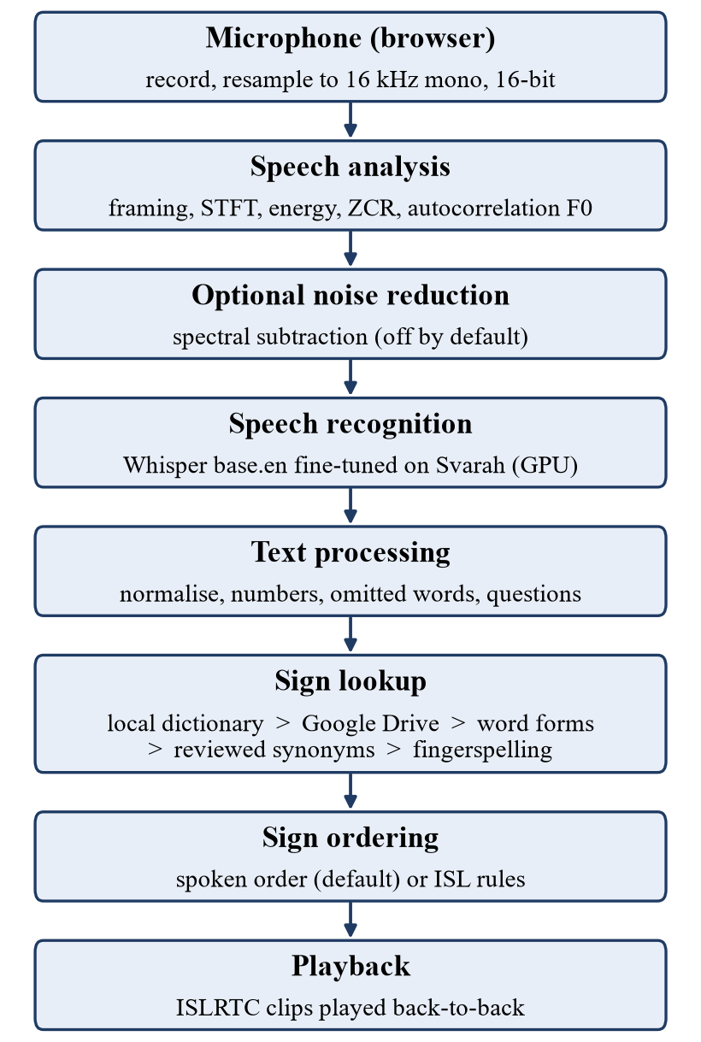
Fig. 1. Processing pipeline of the speech-to-ISL system.
A. Signal Acquisition
The browser records the microphone at its native rate and resamples to 16 kHz mono, 16-bit PCM before upload. Speech information lies mostly below 8 kHz, so 16 kHz preserves it by the Nyquist criterion, and it is the rate Whisper was trained on. Sixteen-bit samples give a quantisation floor about 96 dB below full scale.
B. Short-Time Spectral Analysis
Speech is treated as stationary over 20 to 40 ms, so it is divided into overlapping frames x_{m}[n] and multiplied by a Hann window w[n] to limit spectral leakage. The short-time Fourier transform of frame m is
X(m, k) = Σ_{n} x[n] w[n − mH] e^{−j2πkn/N} (1)
with hop size H. Whisper's input is the log-mel spectrogram, obtained by pooling the power spectrum with 80 triangular mel filters M_{b}(k):
S(m, b) = log₁₀( Σ_{k} M_{b}(k) |X(m, k)|² ) (2)
computed with 25 ms windows and a 10 ms hop over a 30 s window, which gives an 80 × 3000 matrix.
C. Time-Domain Features
For a frame of N samples, the short-time energy and zero-crossing rate are
E(m) = 10 log₁₀( (1/N) Σ_{n} x_{m}²[n] ) (3)
Z(m) = (f_{s} / 2N) Σ_{n} |sgn(x_{m}[n]) − sgn(x_{m}[n − 1])| (4)
Energy separates speech from silence. Unvoiced sounds such as /s/ are noise-like and cross zero often, while vowels cross it rarely.
D. Pitch Estimation
The fundamental frequency of a voiced frame is found from its normalised autocorrelation
r_{m}(τ) = Σ x_{m}[n]x_{m}[n+τ] / √( Σ x_{m}²[n] · Σ x_{m}²[n+τ] ) (5)
Searched over lags corresponding to 70–400 Hz, with F₀ = f_{s} / τ₀ for the selected lag τ₀. A frame is voiced when the peak reaches 0.5, and its energy is above the silence-level threshold.
Because multiples of the true period score almost as high as the period itself, we take the shortest local peak within 10% of the maximum; without this rule, a 330 Hz test voice was read as 82.5 Hz. To describe intonation, we compare the median F₀ of the last 300 ms of voiced speech with the median of the rest, in semitones:
Δ = 12 log₂( median F_{0,final} / median F_{0,body} ) (6)
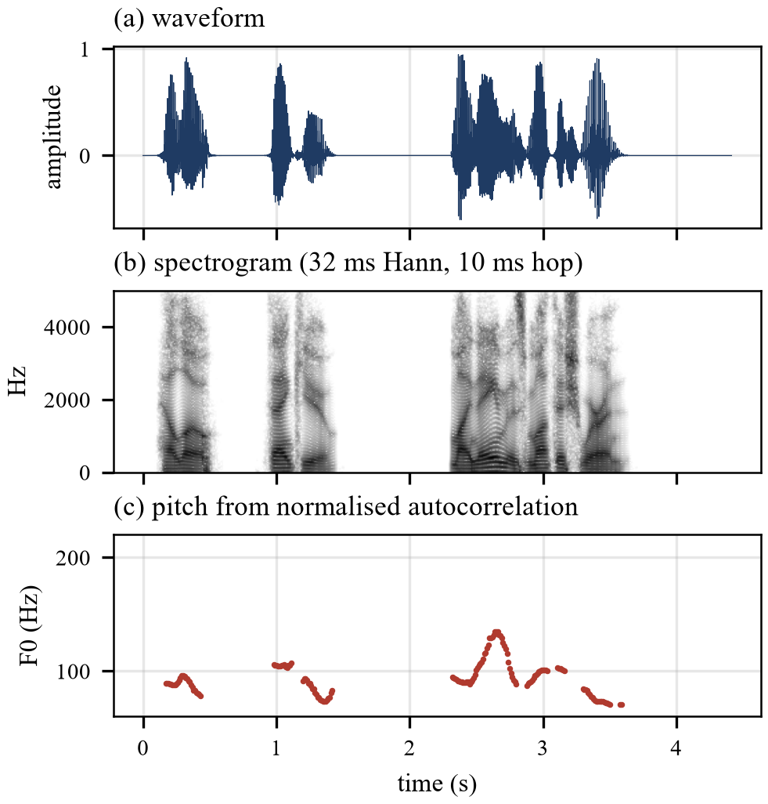
Fig. 2. Analysis of a sample sentence: (a) waveform, (b) spectrogram, (c) pitch track from the autocorrelation tracker. Gaps in (c) are unvoiced or silent frames.
E. Spectral Subtraction
The optional noise reducer follows Boll [11] with over-subtraction [12]. The noise power spectrum N̂(k) is the mean over the quietest 10% of frames, which avoids assuming the recording starts with silence, and the clean power is
|Ŝ(m, k)|² = max( |Y(m, k)|² − αN̂(k), β|Y(m, k)|² ) (7)
with α = 2 and β = 0.02, 32 ms frames and an 8 ms hop. The noisy phase is kept, and the signal is rebuilt by overlap-add. With α = 0, the implementation reconstructs its input at 147 dB SNR, confirming the transform pair.

F. Speech Recognition and Fine-Tuning
We started from Whisper base.en, a 74-million-parameter English model, and fine-tuned all of its weights on the Svarah training split with the settings in Table III. We saved checkpoints every 200 steps, including the optimiser state, so training can resume on another machine. The checkpoint with the lowest dev error was converted to CTranslate2 with 8-bit weights (76 MB). At runtime, it is decoded greedily in 16-bit floating point on the GPU, falling back to 8-bit on the CPU.
TABLE III
Fine-tuning settings
Setting | Value
Base model | Whisper base.en
Epochs/steps | 3 / 1,002
Batch size | 16
Optimiser | AdamW, lr 1×10⁻⁵, 100 warm-up steps
Precision | mixed (fp16)
Hardware/time | RTX 4050 laptop GPU, 69 min
Selection | lowest dev WER (step 600)

G. Text Processing
The transcript is lower-cased and split into words, keeping apostrophes so that don't match the dictionary entry. Numbers are read as they are spoken (25 becomes TWENTY-FIVE, 7:30 becomes SEVEN THIRTY) and are signed digit by digit when part of the reading has no sign, which is the case for forty, eighty and ninety. Articles and forms of he is marked as omitted because ISL does not sign them. A sentence is treated as a question when it begins with a question word followed by a verb, starts with an auxiliary verb (“Can you …”), or concludes with a question mark.
H. Sign Lookup
Signs are matched greedily, longest phrase first, so that "thank you" maps to its own sign rather than two separate ones. A word that has no direct match passes through a fixed chain: the local manifest, then the online archive, then number reading, then fingerspelling for names, then the omitted-word list, then inflected forms, then reviewed synonyms, and finally fingerspelling. Inflected forms (went to GO, children to CHILD) come from WordNet [19]; a form is accepted only when it’s part of speech accounts for at least 70% of the base word's tagged uses, which keeps ambiguous cases such as trained unmapped. Synonyms are proposed from the most frequent sense in WordNet and used only after a manual review, which accepted 121 of 171 proposals. When a needed clip is only in the archive, the server downloads that one file, checks that it is a single sign, converts it if a browser cannot play it, and caches it.
I. Ordering and Playback
By default, the signs follow the spoken order. An optional mode applies three rules within every clause that are consistent with descriptions of ISL grammar [1]: time expressions first, negation last, and a question word last. Clips play back-to-back using two alternating video players to avoid gaps. Because very short phrases are sometimes misheard, the interface also lets the user type a corrected sentence and sign it through the same pipeline.
V. Results and Analysis
A. Effect of Fine-Tuning
Table IV and Fig. 3 compare the stock and fine-tuned models on the 620 test utterances, decoded exactly as the application decodes them. The word error rate is (S + D + I)/N, counting substituted, deleted and inserted words against the N reference words, after Whisper's English text normaliser. Whisper re-decodes difficult segments with random sampling, so two runs differ slightly; both are reported.
TABLE IV
Word error rate on 16 unseen test speakers
Model | Run 1 | Run 2
Whisper base.en (stock) | 13.12% | 13.32%
Fine-tuned on Svarah | 11.30% | 11.27%

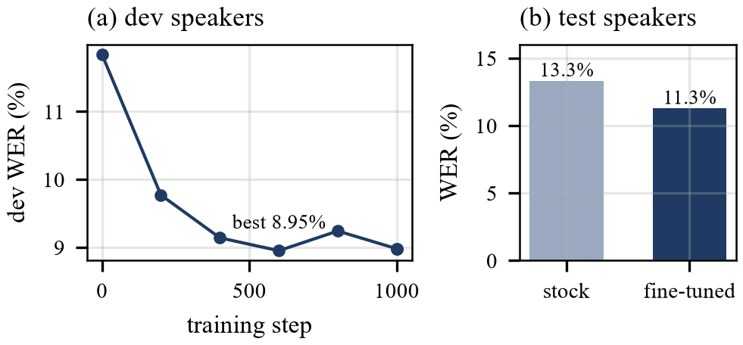
Fig. 3. (a) Dev WER during fine-tuning; the checkpoint at step 600 was kept. (b) Test WER of the stock and fine-tuned models.
The relative reduction is about 14%. Fourteen of the sixteen speakers improved (Fig. 4); the other two worsened slightly, by 0.4 and 0.5 points. The largest gains came for speakers the stock model found hard: from 53.8% to 41.0%, from 37.4% to 28.2% and from 19.6% to 10.6%. In a paired bootstrap over utterances [20], the fine-tuned model had fewer errors in all 2,000 resamples. We also tried running both models and keeping the more confident transcript; this gave 11.25%, too small a gain to justify doubling the computation, so it was not adopted.
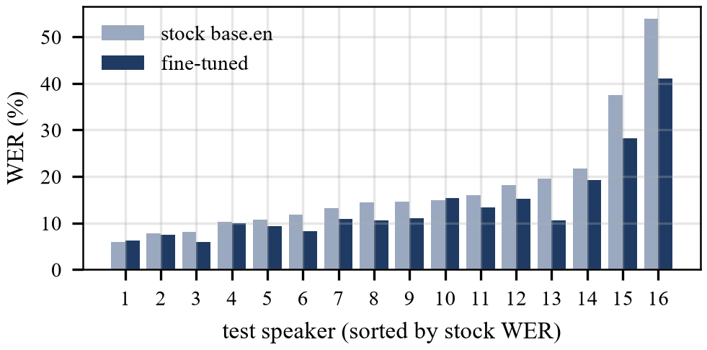
Fig. 4. Per-speaker WER on the sixteen test speakers, sorted by the stock model's error.
B. Noise Robustness and Spectral Subtraction
To test robustness, we mixed 200 test utterances with white noise and babble from four other speakers at 20, 10, 5, and 0 dB SNR, and decoded each with both models, with and without spectral subtraction. Table V gives selected results and Fig. 5 the full curves.
TABLE V
WER (%) under noise; SS = spectral subtraction
Condition | Stock | +SS | Tuned | +SS
Clean | 13.1 | 13.6 | 11.0 | 11.9
White 10 dB | 28.3 | 28.8 | 25.4 | 24.5
White 5 dB | 44.9 | 43.9 | 34.5 | 36.5
White 0 dB | 67.7 | 73.6 | 55.6 | 59.8
Babble 10 dB | 22.2 | 25.8 | 21.1 | 21.3
Babble 5 dB | 41.5 | 47.4 | 36.8 | 39.8

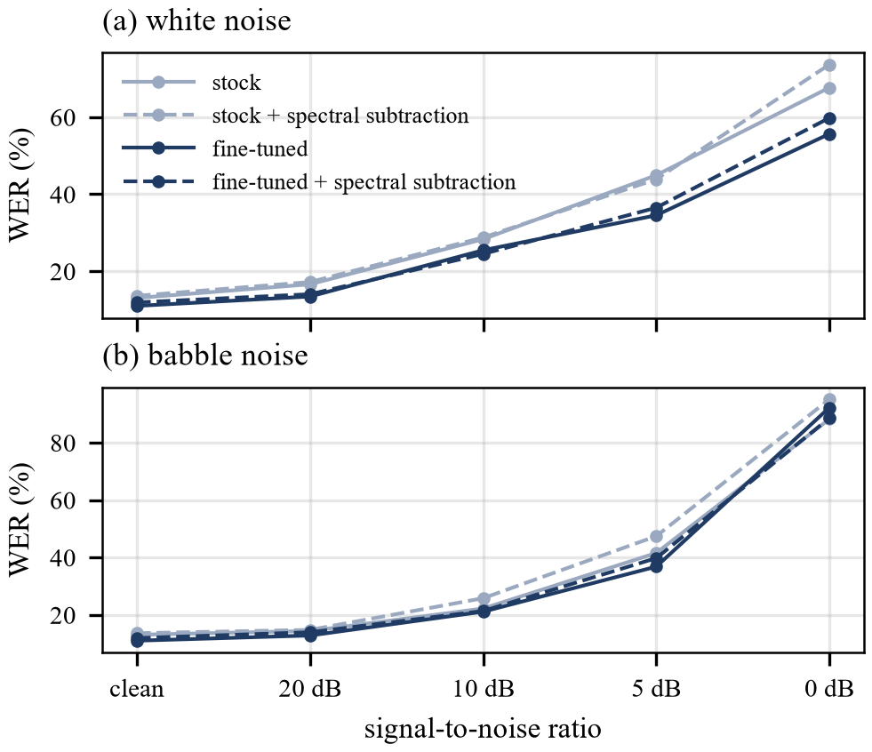
Fig. 5. WER against signal-to-noise ratio for (a) white and (b) babble noise. Dashed lines include the spectral subtraction.
Two findings stand out. The fine-tuned model was more robust at every white-noise level, although it never saw added noise during training; at 5 dB, its error was 34.5% against 44.9%. Spectral subtraction, by contrast, improved the SNR by 3.7 to 7.1 dB for white noise but by less than 1 dB for babble, as expected for a method that assumes stationary noise, and it raised the error rate in 15 of the 18 conditions. Whisper was trained on noisy audio and appears to cope better with noise than with the artefact’s subtraction leaves. The noise reducer is therefore off by default.
C. Pitch as a Question Cue
We measured the final pitch movement of all 387 questions in Svarah and of 387 randomly chosen statements. We chose the threshold on training speakers and evaluated it on dev and test speakers (Table VI).
TABLE VI
Question detection on UNKNOWN SPEAKERS
Method | Result
Median final movement | yes/no −0.3, wh −2.6, statement −2.2 st
Pitch alone (yes/no vs statement) | 66.5% balanced accuracy
Word order and "?" | 79/85 questions, 1/70 false alarms
Word order, "?" removed | 61/85 questions, 1/70 false alarms

In this read Indian English, yes/no questions did not rise at the end; they fell less than statements did. Pitch alone was a weak cue, and adding it to the word-order rule mostly added false alarms on the training speakers. The system therefore decides from word order and shows the pitch movement only as supporting evidence.
D. Sign Coverage
Coverage is the share of words that receive a dictionary sign. We report it over all words, over the words that ISL actually signs (excluding articles and forms of be), and with on-demand download and synonyms added (Fig. 6). On the held-out sentences, 54% of all words and 66% of ISL-signed words had a local sign; the archive raised this to 67% and synonyms to 72%. The development set reached 87%, showing how optimistic figures can become once a test set influences the design. In the end-to-end test with a synthetic voice, recognition errors were 2.0% and 2.4% on the two sets, and every requested clip was served. Fig. 7 shows the clips played for one sentence.
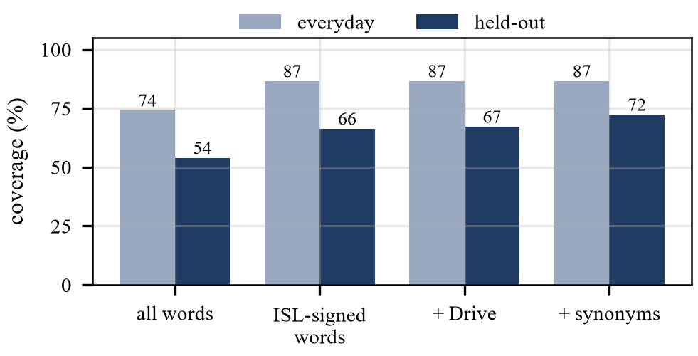
Fig. 6. Sign coverage on the development (everyday) and held-out sentence collections.
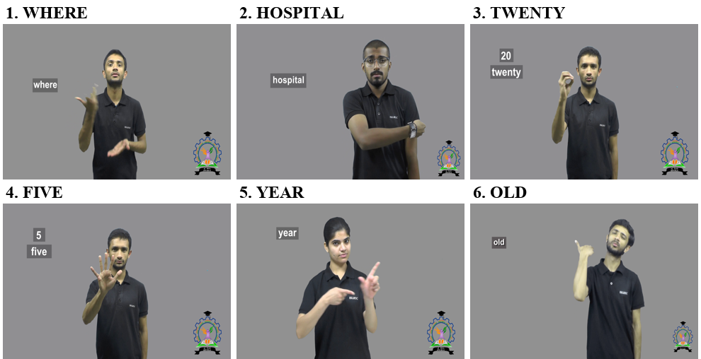
Fig. 7. Clips played for "Where is the hospital? I am 25 years old." Articles and the verb he are omitted, and 25 is signed as TWENTY-FIVE. The pronoun I has no dictionary entry and is deliberately not fingerspelled, since a single letter I would mislead.
E. Embeddings Versus WordNet
Before using sentence embeddings for synonyms, we tested a MiniLM model, from the Sentence-BERT family [18], on 30 true synonym pairs and 30 pairs of related but different words. At every useful threshold, it accepted wrong pairs such as Monday and Tuesday or husband and wife, both with a cosine similarity of 0.87, which is higher than many real synonyms. WordNet accepted none of the wrong pairs (Table VII). Because showing the sign for a different word is worse than showing nothing, we used WordNet with manual review.
TABLE VII
Synonym check: 30 true and 30 false pairs
Method | True accepted | False accepted
Embeddings, threshold 0.70 | 18 | 8
Embeddings, threshold 0.85 | 7 | 2
WordNet (used) | 11 | 0

F. Latency
On the same short recording, recognition took about 3.1 s on the CPU on battery power, 1.6 s on mains power, and 0.15 to 0.25 s on the GPU. Matching against the dictionary takes under a millisecond, so the recogniser accounts for almost all of the delay. A sign that has to be downloaded adds a few seconds the first time it is used (5.6 s for a 3.3 MB clip on our connection) and nothing afterwards.
G. Error Analysis
Some problems appeared only in live use. A short recording of "cricket match" was misheard by the fine-tuned model ("trickier to match"), by the stock model ("click here to match") and by the three-times-larger small.en ("couldn't get the match"); with so little context, the decoder has almost nothing to go on, which is why the interface has a correction box. In the longer sentence "I play cricket and hockey", the stock and small models were correct, but the fine-tuned model wrote "chicken", a sign that a lower average error does not mean every word improves. Users also reported that fingerspelling was unreadably fast. The cause was a timestamp error in the tool that cut the alphabet clips, which stored 1.5 s of signing as 0.03 s; the clips were re-timed and fingerspelling now runs at about one letter per second.
VI. Discussion and Limitations
The system retrieves signs; it does not translate. Signs follow English order unless the reordering option is used, and that option applies only three rules. Facial expressions, which carry grammatical information in ISL, cannot be expressed by joining isolated dictionary clips; for example, yes/no questions are marked with raised eyebrows. We reviewed synonyms for English meaning but not with an ISL signer. We evaluated recognition on Svarah and synthetic speech, and the evaluation with the two authors’ own voices is still small. Most importantly, no Deaf user has yet judged whether the output is understandable, so our coverage figures measure what the dictionary can express, not what a viewer understands.
VII. Conclusion and Future Work
We built a speech-to-ISL system that uses real signer videos and concentrated the speech processing work where it matters most for Indian users. Fine-tuning Whisper on Indian-accented English reduced errors on unfamiliar speakers from 13.2% to 11.3% and made the model more robust to noise. We implemented and candidly evaluated two standard techniques: spectral subtraction did not help a modern recogniser, and final pitch movement was a weak question cue for this speech. The lookup chain signs about two-thirds of the signable words in unseen everyday sentences and never drops a word silently. Future work should include evaluation with Deaf ISL users, training on more Indian speech (including noisy recordings), and richer ISL grammar learnt from aligned corpora such as ISLTranslate [16].
Acknowledgment
We thank ISLRTC for making the ISL dictionary available and AI4Bharat for releasing the Svarah corpus under an open licence.
References
[1] U. Zeshan, "Indo-Pakistani Sign Language grammar: A typological outline," Sign Language Studies, vol. 3, no. 2, pp. 157–212, 2003. doi: https://doi.org/10.1353/sls.2003.0005
[2] B. Saunders, N. C. Camgöz, and R. Bowden, "Progressive transformers for end-to-end sign language production," in Proc. Eur. Conf. Comput. Vis. (ECCV), LNCS, 2020, pp. 687–705. doi: https://doi.org/10.1007/978-3-030-58621-8_40
[3] P. Kapoor, R. Mukhopadhyay, S. B. Hegde, V. Namboodiri, and C. V. Jawahar, "Towards automatic speech to sign language generation," in Proc. Interspeech, 2021, pp. 3700–3704. doi: https://doi.org/10.21437/Interspeech.2021-1094
[4] M. Kipp, Q. Nguyen, A. Heloir, and S. Matthes, "Assessing the deaf user perspective on sign language avatars," in Proc. 13th Int. ACM SIGACCESS Conf. Comput. Accessibility (ASSETS), 2011, pp. 107–114. doi: https://doi.org/10.1145/2049536.2049557
[5] L. C. Quandt, A. Willis, M. Schwenk, K. Weeks, and R. Ferster, "Attitudes toward signing avatars vary depending on hearing status, age of signed language acquisition, and avatar type," Frontiers in Psychology, vol. 13, art. 730917, 2022. doi: https://doi.org/10.3389/fpsyg.2022.730917
[6] A. Radford, J. W. Kim, T. Xu, G. Brockman, C. McLeavey, and I. Sutskever, "Robust speech recognition via large-scale weak supervision," arXiv:2212.04356, 2022 (also in Proc. ICML, 2023). doi: https://doi.org/10.48550/arXiv.2212.04356
[7] T. Javed, S. Joshi, V. Nagarajan, S. Sundaresan, J. Nawale, A. Raman, K. Bhogale, P. Kumar, and M. M. Khapra, "Svarah: Evaluating English ASR systems on Indian accents," in Proc. Interspeech, 2023, pp. 5087–5091. doi: https://doi.org/10.21437/Interspeech.2023-2588
[8] A. Vaswani, N. Shazeer, N. Parmar, J. Uszkoreit, L. Jones, A. N. Gomez, Ł. Kaiser, and I. Polosukhin, "Attention is all you need," arXiv:1706.03762, 2017 (also in Proc. NeurIPS, 2017). doi: https://doi.org/10.48550/arXiv.1706.03762
[9] S. Davis and P. Mermelstein, "Comparison of parametric representations for monosyllabic word recognition in continuously spoken sentences," IEEE Trans. Acoust., Speech, Signal Process., vol. 28, no. 4, pp. 357–366, 1980. doi: https://doi.org/10.1109/TASSP.1980.1163420
[10] L. Rabiner, "On the use of autocorrelation analysis for pitch detection," IEEE Trans. Acoust., Speech, Signal Process., vol. 25, no. 1, pp. 24–33, 1977. doi: https://doi.org/10.1109/TASSP.1977.1162905
[11] S. Boll, "Suppression of acoustic noise in speech using spectral subtraction," IEEE Trans. Acoust., Speech, Signal Process., vol. 27, no. 2, pp. 113–120, 1979. doi: https://doi.org/10.1109/TASSP.1979.1163209
[12] M. Berouti, R. Schwartz, and J. Makhoul, "Enhancement of speech corrupted by acoustic noise," in Proc. IEEE Int. Conf. Acoust., Speech, Signal Process. (ICASSP), vol. 4, 1979, pp. 208–211. doi: https://doi.org/10.1109/ICASSP.1979.1170788
[13] N. C. Camgöz, S. Hadfield, O. Koller, H. Ney, and R. Bowden, "Neural sign language translation," in Proc. IEEE/CVF Conf. Comput. Vis. Pattern Recognit. (CVPR), 2018, pp. 7784–7793. doi: https://doi.org/10.1109/CVPR.2018.00812
[14] N. C. Camgöz, O. Koller, S. Hadfield, and R. Bowden, "Sign language transformers: Joint end-to-end sign language recognition and translation," in Proc. IEEE/CVF Conf. Comput. Vis. Pattern Recognit. (CVPR), 2020, pp. 10020–10030. doi: https://doi.org/10.1109/CVPR42600.2020.01004
[15] A. Sridhar, R. G. Ganesan, P. Kumar, and M. Khapra, "INCLUDE: A large-scale dataset for Indian Sign Language recognition," in Proc. 28th ACM Int. Conf. Multimedia, 2020, pp. 1366–1375. doi: https://doi.org/10.1145/3394171.3413528
[16] A. Joshi, S. Agrawal, and A. Modi, "ISLTranslate: Dataset for translating Indian Sign Language," in Findings of the Assoc. Comput. Linguistics: ACL 2023, 2023, pp. 10466–10475. doi: https://doi.org/10.18653/v1/2023.findings-acl.665
[17] A. Joshi, R. Mohanty, M. Kanakanti, A. Mangla, S. Choudhary, M. Barbate, and A. Modi, "iSign: A benchmark for Indian Sign Language processing," in Findings of the Assoc. Comput. Linguistics: ACL 2024, 2024, pp. 10827–10844. doi: https://doi.org/10.18653/v1/2024.findings-acl.643
[18] N. Reimers and I. Gurevych, "Sentence-BERT: Sentence embeddings using Siamese BERT-networks," in Proc. Conf. Empirical Methods Natural Lang. Process. (EMNLP-IJCNLP), 2019, pp. 3980–3990. doi: https://doi.org/10.18653/v1/D19-1410
[19] G. A. Miller, "WordNet: A lexical database for English," Commun. ACM, vol. 38, no. 11, pp. 39–41, 1995. doi: https://doi.org/10.1145/219717.219748
[20] B. Efron and R. J. Tibshirani, An Introduction to the Bootstrap. New York, NY, USA: Springer, 1993. doi: https://doi.org/10.1007/978-1-4899-4541-9

