STUDENT ENROLLMENT & COURSE MANAGEMENT SYSTEM (SECMS)
PROJECT DOCUMENTATION
A Salesforce-Based Academic Enrollment Management Solution

Submitted By
Team Id : 6ab20723674bb282fc3f04a7

Team Leader : Mothishwari V

Team Members : 1.Sharunithi M

2.Sivagangadevi I

- Sc., Computer Science



Government Arts and Science College ,Vanur.
Villupuram - 605 111.

ABSTRACT
The Student Enrollment & Course Management System (SECMS) is a Salesforce-based application designed to streamline and automate academic enrollment operations within an educational institute. The system centralizes student, course, enrollment and instructor information in a unified Salesforce environment. It supports student management, course management, enrollment processing, instructor assignment, approval workflows, reporting and dashboard-based monitoring.
The project addresses problems associated with fragmented records, manual enrollment processing, delayed approvals and limited visibility into academic operations. Salesforce custom objects are used to represent Student, Course, Enrollment and Instructor data. Relationships between these objects provide a structured representation of academic activities. Validation rules help prevent invalid records, while Salesforce Flows automate date population, notifications, record updates and instructor assignment. An approval process is used to route enrollment requests for verification.
Reports and dashboards provide operational visibility into student status, course enrollments, revenue and pending approvals. Security is configured using profiles, permission sets and sharing settings so that access can be aligned with user responsibilities. Functional and performance testing is documented using Salesforce interface evidence and test scenarios.

TABLE OF CONTENTS
The following structure is used for the documentation. In Microsoft Word, the automatic Table of Contents can be updated after opening the document by selecting the table and choosing “Update Field → Update entire table.”
No. | Chapter / Section | Page
1 | Introduction | 11
2 | Existing System and Proposed System | 14
3 | Requirement Analysis | 16
4 | System Design | 19
5 | Project Planning and Scheduling | 22
6 | System Implementation | 25
7 | Automation and Workflow | 27
8 | Reports and Dashboards | 29
9 | Security | 30
10 | Functional and Performance Testing | 31
11 | Results and Discussion | 33
12 | Conclusion and Future Enhancement | 34
 | References | 35

LIST OF FIGURES
Figure | Description | Source
Figure 1 | Problem Statement | Source page 2
Figure 2 | Empathy Map Canvas | Source page 3
Figure 3 | Brainstorming and Idea Prioritization | Source page 4
Figure 4 | Customer Journey Map and Requirements | Source page 5
Figure 5 | Data Flow Diagram and Technology Stack | Source page 8
Figure 6 | Problem–Solution Fit and Proposed Architecture | Source page 9
Figure 7 | Solution Architecture and Project Planning | Source page 10
Figure 8 | Salesforce Developer Account Creation | Source page 14
Figure 9 | Salesforce Account Activation | Source page 15
Figure 10 | Salesforce Account Activation | Source page 15
Figure 11 | Student Custom Object Creation | Source page 16
Figure 12 | Object Field Configuration | Source page 17
Figure 13 | Object Field Configuration | Source page 17
Figure 14 | Object Field Configuration | Source page 17
Figure 15 | Enrollment Relationship Configuration | Source page 19

LIST OF TABLES
Table | Description
Table 1 | Functional Requirements
Table 2 | Non-Functional Requirements
Table 3 | Technology Stack
Table 4 | Student Object Fields
Table 5 | Course Object Fields
Table 6 | Instructor Object Fields
Table 7 | Enrollment Object Fields
Table 8 | Project Backlog / User Stories
Table 9 | Test Cases

LIST OF ABBREVIATIONS
Abbreviation | Meaning
SECMS | Student Enrollment & Course Management System
UI | User Interface
DFD | Data Flow Diagram
OWD | Organization-Wide Defaults
FR | Functional Requirement
NFR | Non-Functional Requirement
USN | User Story Number
API | Application Programming Interface

1. INTRODUCTION

1.1 Project Overview
The Student Enrollment & Course Management System is a comprehensive Salesforce application designed to streamline and automate academic enrollment operations of an educational institute. The system enables administrators, enrollment officers and instructors to manage student records, course offerings, enrollments, instructor assignments, approval processes, payments and reporting within a unified Salesforce environment.
The project centralizes student, course and enrollment-related information to provide structured workflows and accurate reporting. Salesforce Flows, Approval Processes, Validation Rules, Reports and Dashboards are used to support the enrollment lifecycle from registration and course selection through approval, instructor assignment and reporting.

1.2 Purpose
The primary purpose of SECMS is to replace manual and fragmented enrollment processes with a scalable, automated and secure Salesforce solution. The system is intended to improve data accuracy, structure enrollment workflows, support automated approvals and validations, and provide transparent reporting and monitoring.
- Accurate student data management.
- Structured enrollment workflows.
- Automated approvals and validations.
- Transparent reporting and monitoring.
- Centralized access to academic information.

1.3 Objectives
- Create a centralized data model for students, courses, enrollments and instructors.
- Automate enrollment-related operations using Salesforce Flows.
- Validate important input conditions before records are accepted.
- Provide an approval process for enrollment requests.
- Support instructor assignment based on course information.
- Generate reports and dashboards for operational monitoring.
- Apply role-based security using Salesforce configuration.

1.4 Scope
The documented scope covers the Salesforce application configuration and implementation activities described in the supplied SECMS material, including object creation, fields, relationships, page layouts, record types, validation rules, flows, approval processes, reports, dashboards and security configuration.

1.5 Key Stakeholders
- Administrator
- Enrollment Officer
- Instructor
- Student / User

1.6 Problem Context
The project identifies fragmented enrollment data, manual processing and delayed reporting as important operational problems. The source project material uses a customer problem statement to represent the concerns of enrollment officers and administrators.
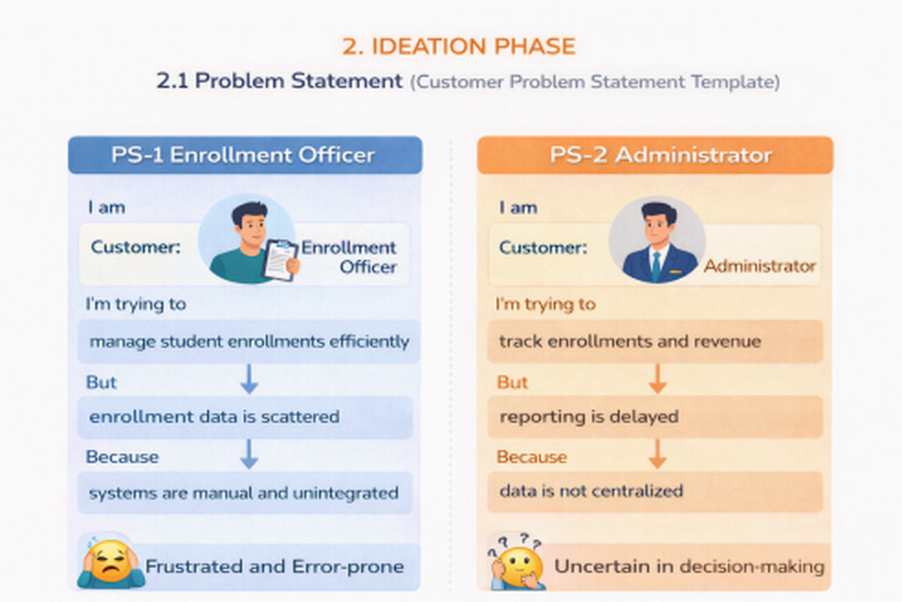
Figure 1. Problem Statement from the Source Project Material
The problem statement highlights the need for efficient enrollment management, centralized information and reduced manual effort. The empathy map and brainstorming activities further connect these problems to duplicate entries, approval bottlenecks and the need for automation.

2. EXISTING SYSTEM AND PROPOSED SYSTEM

2.1 Existing System
The project material describes an enrollment environment in which information can be scattered across spreadsheets, emails and manual processes. Such an arrangement can make it difficult for enrollment officers to maintain consistent records and for administrators to obtain timely operational information.

2.2 Problems in the Existing Approach
- Student and enrollment information may be distributed across multiple sources.
- Manual rechecking increases the effort required for routine processing.
- Approval activities can become bottlenecks.
- Reporting may be delayed when information is not centralized.
- Duplicate or inconsistent entries can affect data quality.

2.3 Proposed System
The proposed solution is a Salesforce-based Student Enrollment & Course Management System. It brings student, course, enrollment and instructor information into a unified platform and uses Salesforce-native capabilities for automation, approval, reporting and security.

2.4 Problem–Solution Fit
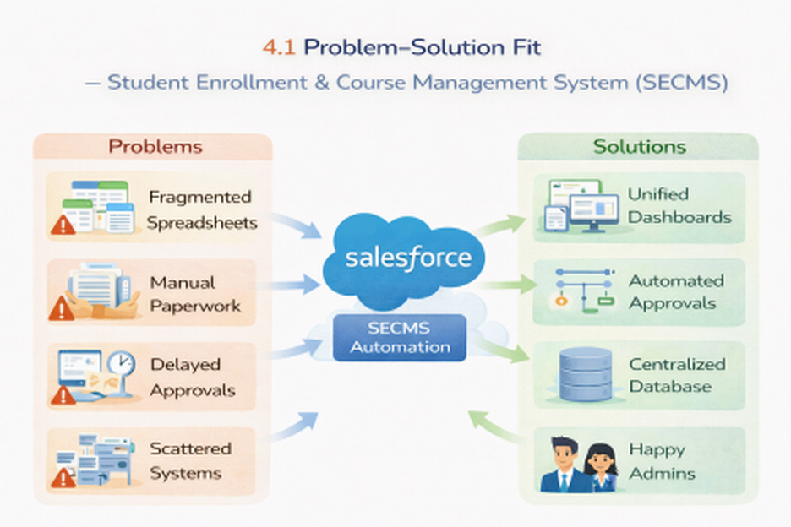
Figure 2. Problem–Solution Fit and Proposed Solution Architecture

2.5 Benefits of the Proposed System
- Centralized academic data.
- Structured enrollment processing.
- Automated workflow activities.
- Improved visibility through reports and dashboards.
- Role-based access to project data.
- Support for future growth and additional modules.

3. REQUIREMENT ANALYSIS

3.1 Customer Journey
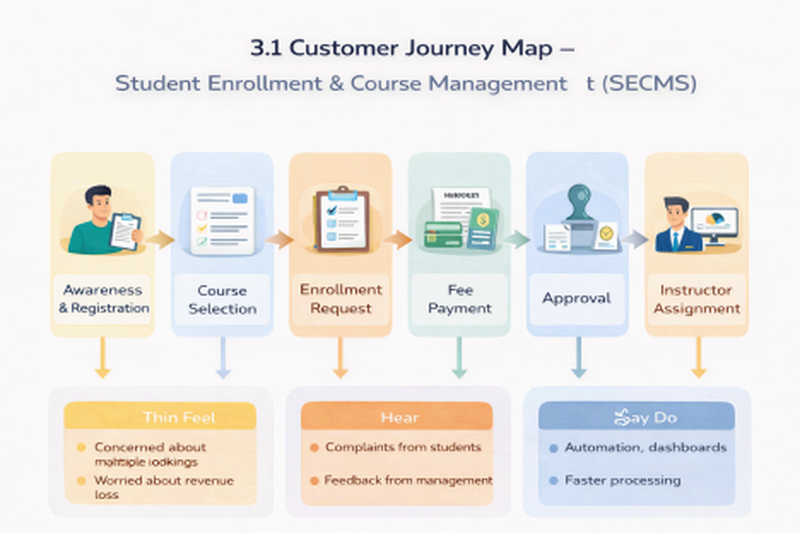
Figure 3. Customer Journey Map from the Source Project Material
The documented customer journey covers awareness and registration, course selection, enrollment request, fee payment, approval, instructor assignment and reporting/completion.

3.2 Functional Requirements
ID | Epic | Description
FR-1 | Student Management | Manage student records.
FR-2 | Course Management | Create and manage courses.
FR-3 | Enrollment Processing | Request, approve and reject enrollments.
FR-4 | Instructor Assignment | Automatically assign instructors.
FR-5 | Reporting | Provide reports and dashboards.

3.3 Non-Functional Requirements
ID | Requirement | Description
NFR-1 | Usability | Simple, intuitive and user-friendly interface.
NFR-2 | Security | Protect student and institutional information through access controls.
NFR-3 | Reliability | Consistent enrollment processing, approvals and reporting.
NFR-4 | Performance | Fast response for operations and dashboard refresh.
NFR-5 | Scalability | Support future growth in students, courses, departments and users.
NFR-6 | Availability | Continuous access during institutional working hours with minimized downtime.

3.4 Technology Requirements
Layer | Technology
User Interface | Salesforce Lightning
Application Logic | Salesforce Flows
Data | Salesforce Objects
Automation | Validation Rules and Approval Process
Reporting | Salesforce Reports and Dashboards

4. SYSTEM DESIGN

4.1 Data Flow Design
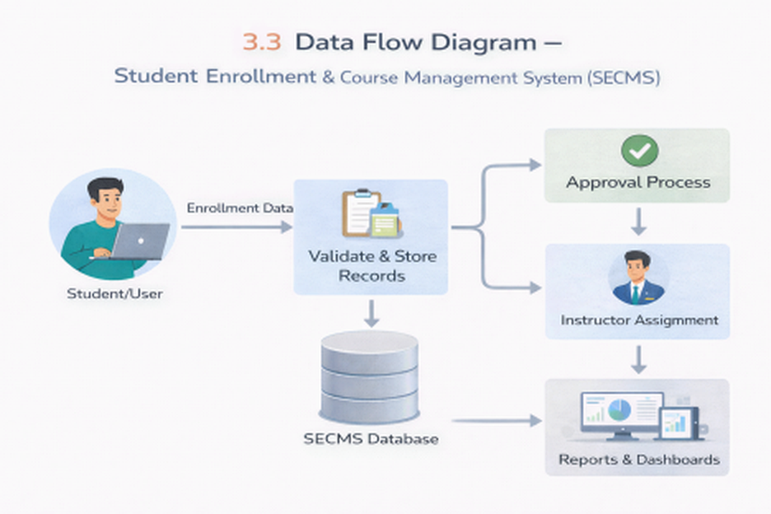
Figure 4. Data Flow Diagram and Technology Stack
The data flow described in the source material begins with user input of student and enrollment information. The system validates and stores records, routes enrollment data through the approval process, performs instructor assignment and provides processed information to reports and dashboards.

4.2 Solution Architecture
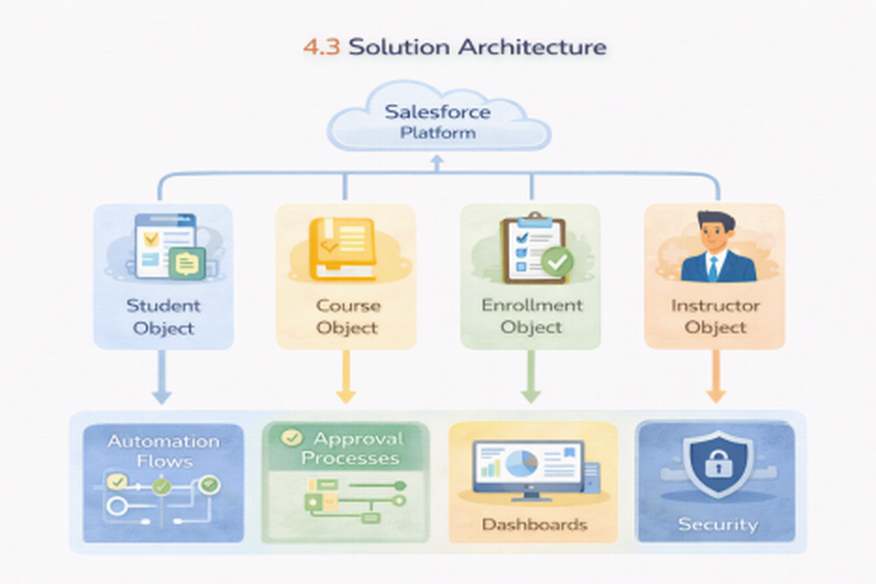
Figure 5. Solution Architecture and Project Planning
The architecture integrates Salesforce objects with automation flows, approval processes, dashboards and security configuration. The core data objects are Student, Course, Enrollment and Instructor. Enrollment relationships connect academic activity with the corresponding student, course and instructor.

4.3 Object Model
Object | Purpose
Student | Stores student personal, contact and status information.
Course | Stores course details such as category, duration, fee and description.
Instructor | Stores instructor identity, code, expertise and contact information.
Enrollment | Stores student-course enrollment details, instructor assignment, date, status and fee information.

4.4 Relationships
The Enrollment object uses lookup relationships to connect Enrollment records with Student, Course and Instructor records. This allows the system to maintain a structured connection between the person enrolled, the selected course and the assigned instructor.

5. PROJECT PLANNING AND SCHEDULING

5.1 Development Methodology
The source project material follows an Agile-oriented planning approach using epics, user stories, story points and sprint-based execution. The documented plan uses sprint activities to organize data modeling, automation, security, reporting and dashboard work.

5.2 Project Backlog
Sprint | User Story | Main Task | Points
Sprint 1 | USN-1 | Create Salesforce developer account. | 1
Sprint 2 | USN-2 | Create Student, Course, Enrollment and Instructor objects. | 3
Sprint 2 | USN-3 | Create dedicated tabs. | 3
Sprint 2 | USN-4 | Create relevant fields. | 5
Sprint 2 | USN-6 | Define relationships. | 5
Sprint 3 | USN-8 | Configure validation rules. | 3
Sprint 3 | USN-9 | Create automated flows. | 5
Sprint 3 | USN-10 | Configure enrollment approval process. | 4
Sprint 4 | USN-11 | Configure role-based security. | 4
Sprint 5 | USN-12 | Create operational reports. | 4
Sprint 6 | USN-13 | Create dashboard visualizations. | 4

5.3 Sprint Schedule
Sprint | Story Points | Duration | Planned Period
Sprint 1 | 20 | 6 Days | 24 Oct 2022 – 29 Oct 2022
Sprint 2 | 20 | 6 Days | 31 Oct 2022 – 05 Nov 2022
Sprint 3 | 20 | 6 Days | 07 Nov 2022 – 12 Nov 2022
Sprint 4 | 20 | 6 Days | 14 Nov 2022 – 19 Nov 2022

5.4 Development Milestones
- Salesforce Developer Account Creation
- Custom Object Creation
- Tabs Creation
- Lightning App Creation
- Fields Creation
- Relationship Creation
- Page Layout Customization
- Validation Rules
- Flows and Automation
- Approval Process
- Reports
- Dashboards
- Security Setup
- Conclusion

6. SYSTEM IMPLEMENTATION

6.1 Salesforce Developer Environment
The project starts with creation and activation of a Salesforce Developer environment. The supplied material documents the developer account registration and activation process.
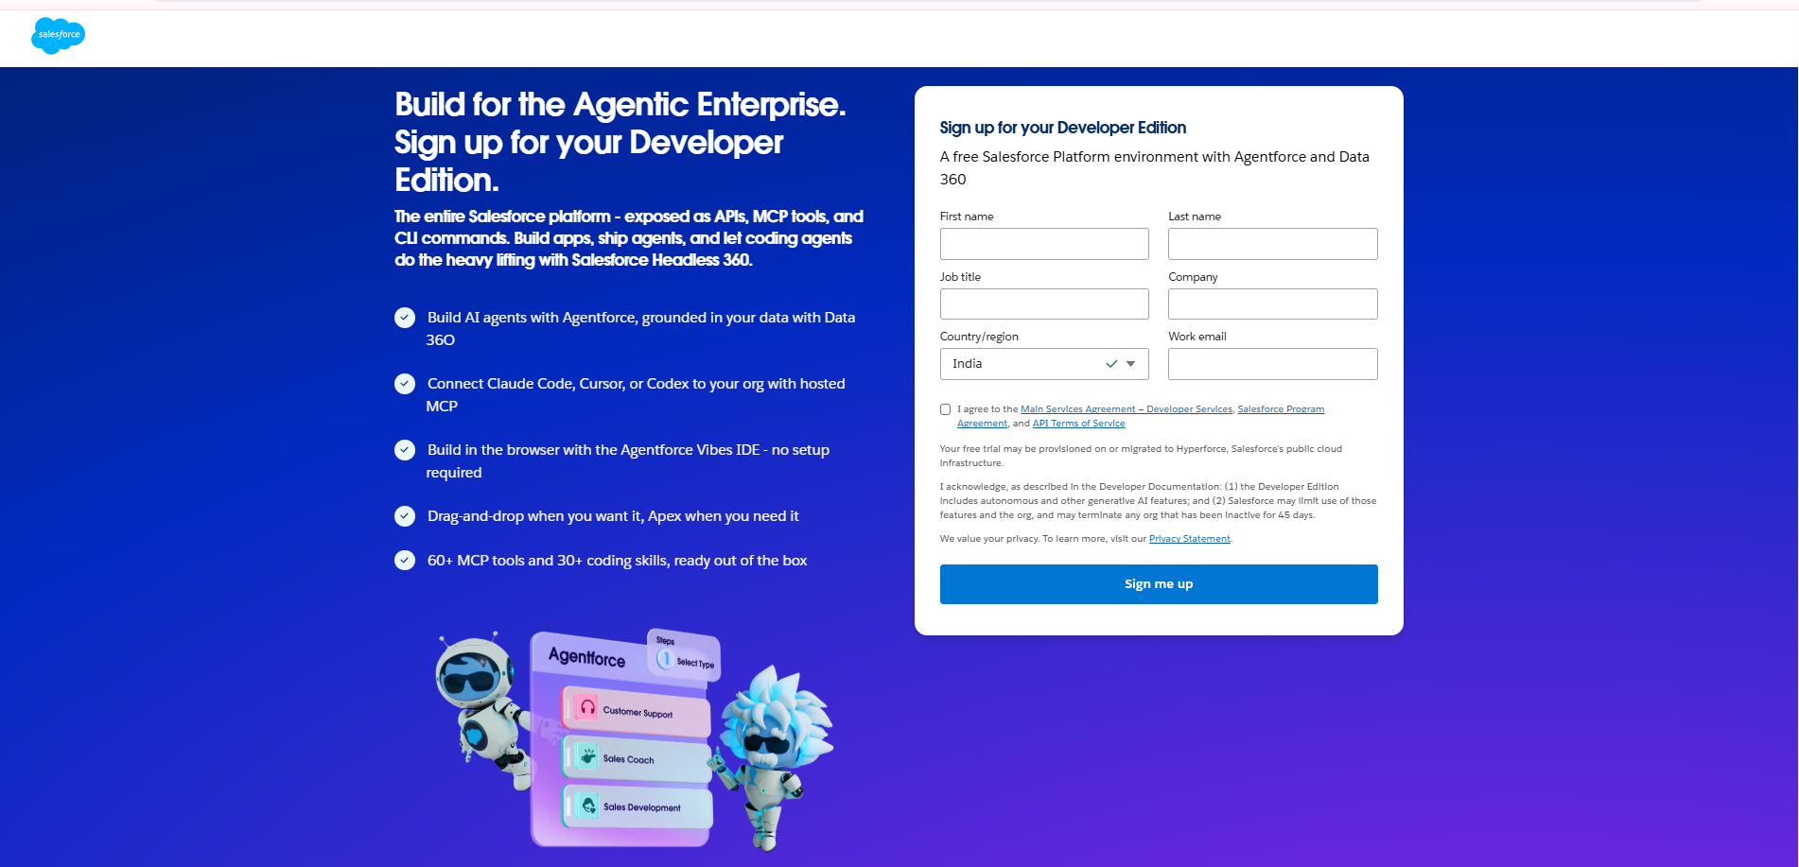
Figure 6. Salesforce Developer Account Creation
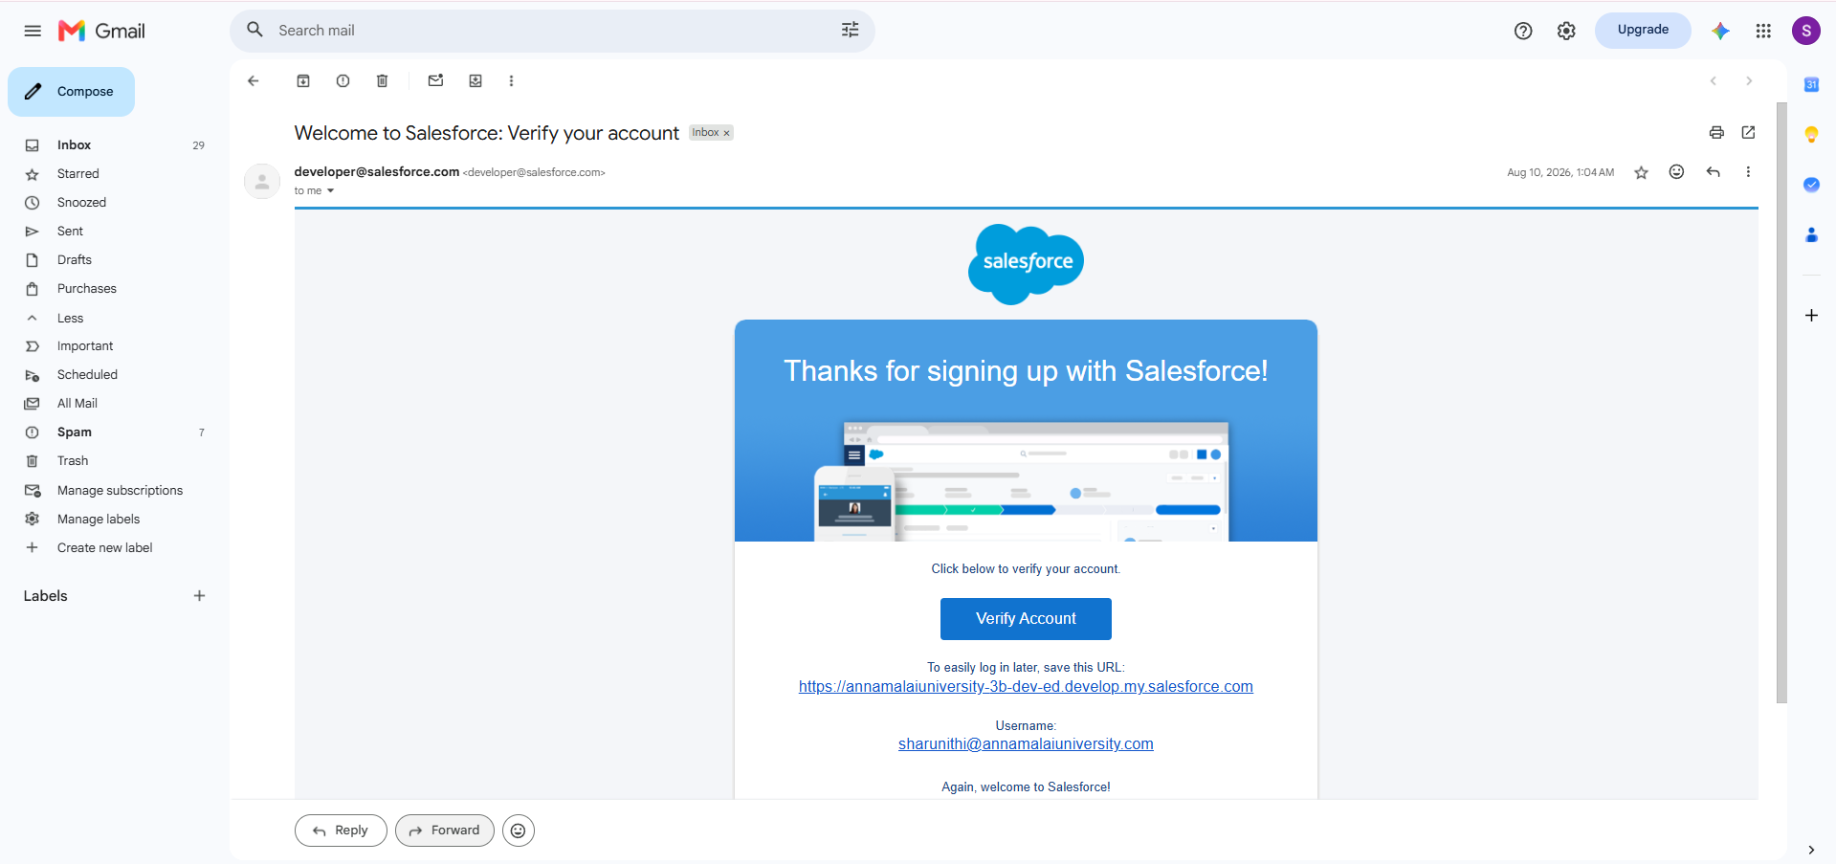
Figure 7. Salesforce Account Verification / Activation

6.2 Custom Object Implementation
The project uses four primary custom objects: Student, Course, Instructor and Enrollment. The Student object is intended to store personal details, contact information and enrollment status. Similar objects are used to represent course, instructor and enrollment information.
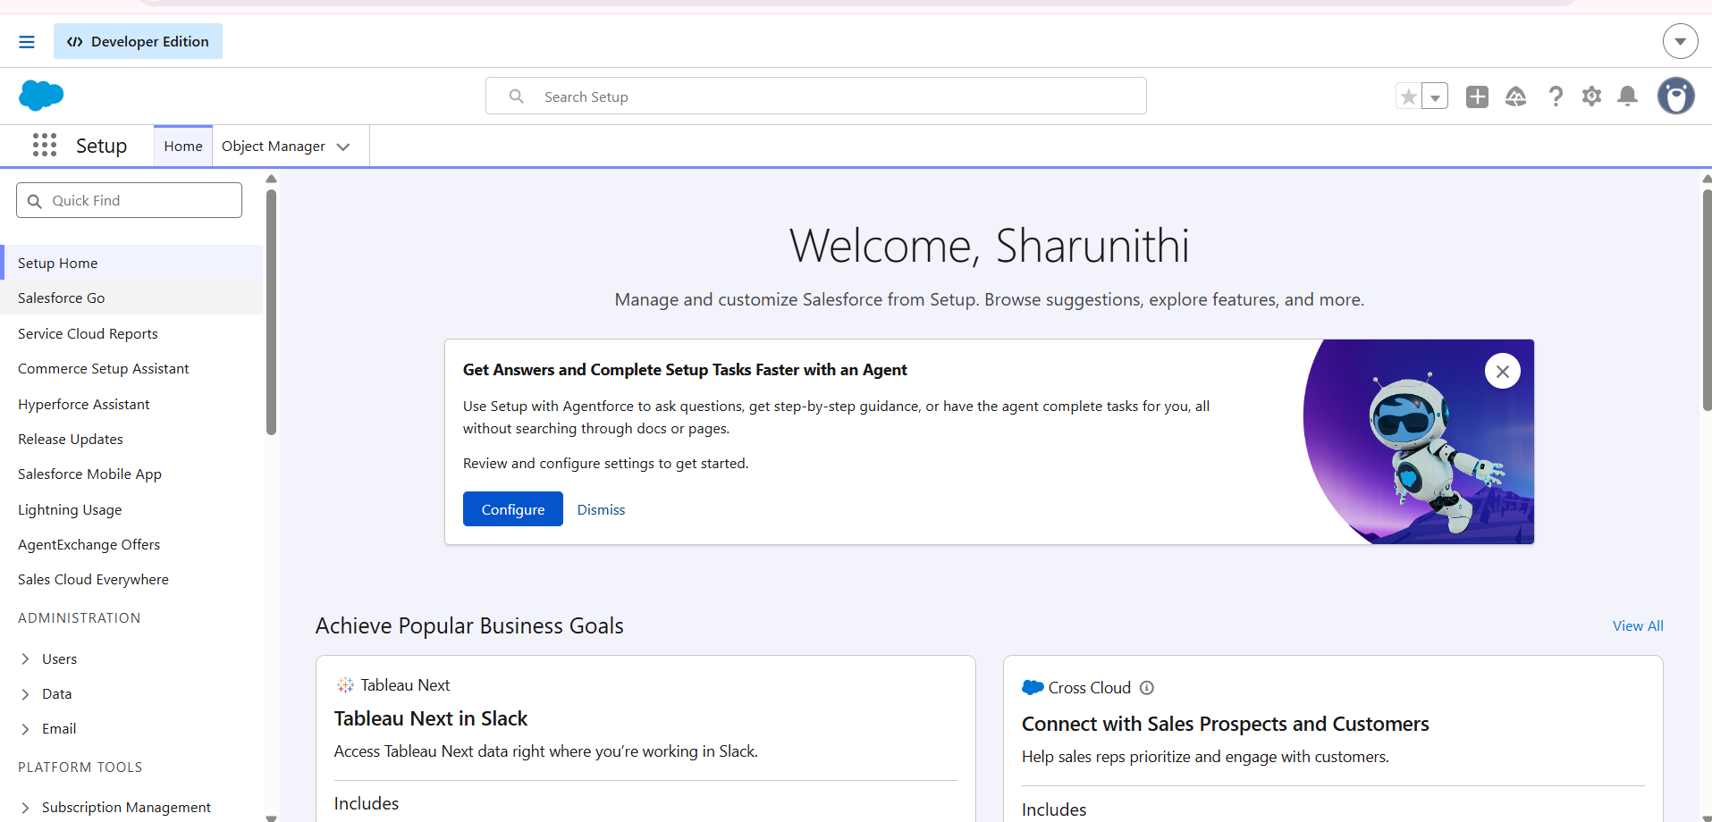
Figure 8. Student Custom Object Configuration

6.3 Student Object Fields
Field | Data Type
Student Name | Text (Standard)
Email | Email
Phone | Phone
Date of Birth | Date
Student Status | Picklist
Address | Text Area

6.4 Course Object Fields
Field | Data Type
Course Name | Text (Standard)
Category | Picklist
Duration | Number / Text
Course Fee | Currency
Description | Text / Description

6.5 Instructor Object Fields
Field | Data Type
Instructor Name | Text (Standard)
Instructor Code | Text
Expertise | Picklist
Phone | Phone
Email | Email

6.6 Enrollment Object Fields
Field | Data Type
Student | Lookup (Student)
Course | Lookup (Course)
Instructor | Lookup (Instructor)
Enrollment Date | Date
Enrollment Status | Picklist
Fees Paid | Checkbox
Total Amount | Currency
Comments | Text Area

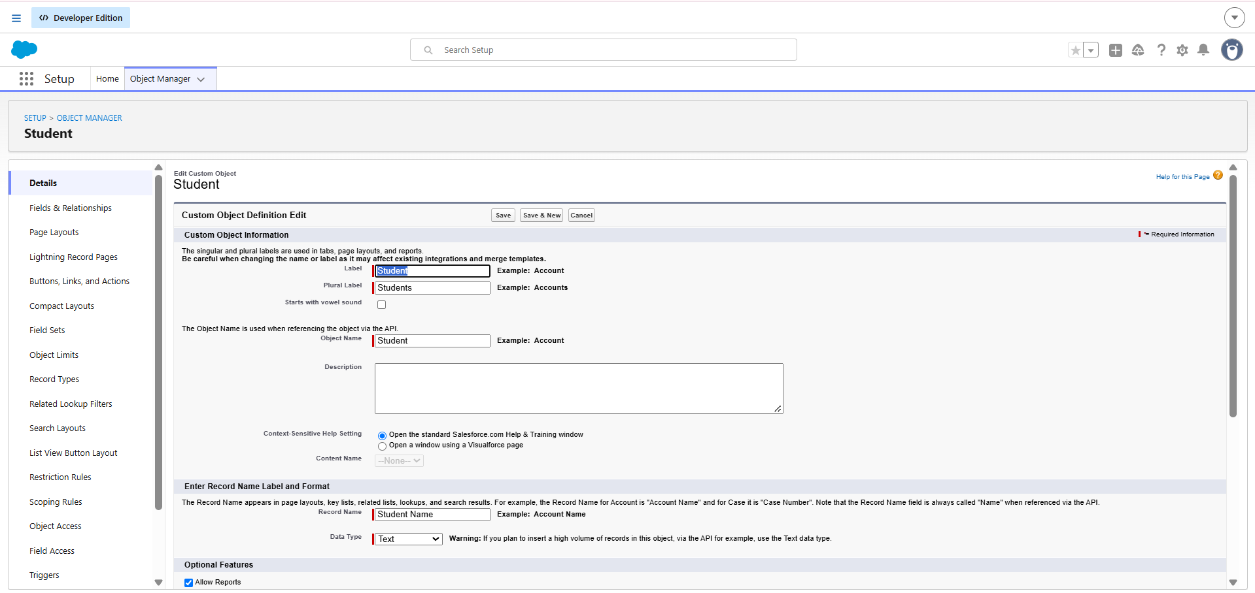
Figure 9. Student / Course / Instructor / Enrollment Field Configuration

6.8 Lightning Tabs and Application
Custom tabs are created for Student, Course, Instructor and Enrollment. A Lightning application named “Student Enrollment & Course Management” brings the major project items together. The documented navigation items include Student, Course, Instructor, Enrollment, Reports, Dashboards, Home and Tasks.

6.9 Page Layouts and Record Types
The Enrollment object is configured with separate record types for New Enrollment and Re-Enrollment. Separate page layouts can be assigned to these record types so that relevant fields are presented for each process.
- New Enrollment – fields relevant to first-time enrollment.
- Re-Enrollment – fields relevant to previous enrollment reference, re-enrollment reason, status and fees.
- Related lists are added to Student, Course and Instructor layouts so that Enrollment records can be viewed from the related parent records.

6.10 Implementation Summary
The implementation phase establishes the Salesforce data model and user-facing application structure before automation and reporting are applied. This sequence ensures that automation rules and reports operate on structured objects and relationships.

7. AUTOMATION AND WORKFLOW

7.1 Validation Rule – Student Email Domain
The Student Email Domain Validation rule is intended to ensure that students use an allowed institutional email address. The documented example uses a formula that checks whether the email contains the required institutional domain.
Example rule documented in the source: NOT(CONTAINS(Email__c, "@student.edu")). The associated error message informs the user that the email must be a valid student institutional email.

7.2 Validation Rule – Fees Before Approval
The Fees Must Be Paid Before Approval rule prevents an Enrollment record from being approved when the Fees Paid checkbox is false. The documented condition combines an Approved status with a false Fees Paid value and returns an error message.

7.3 Enrollment Approval Process
The approval process is configured for enrollment requests. The documented entry condition is an Enrollment Status of “Requested”. The request is routed to a Training Manager for approval or rejection.
- Entry Criteria: Enrollment Status = Requested.
- Approver: Specific Training Manager user.
- Final Approval Action: Set Enrollment Status = Approved.
- Final Rejection Action: Set Enrollment Status = Rejected.
- Email notification can be configured for rejection.

7.4 Record-Triggered Flow – Enrollment Date
A record-triggered flow is configured on Enrollment. When an Enrollment record is created, the flow updates Enrollment Date using the current flow date. The documented flow is saved as SetEnrollmentDate and activated.

7.5 Flow – Enrollment Approval Notification
The documented automation for an approved enrollment triggers when Enrollment Status becomes Approved. It retrieves the related Student record, sends an email notification, optionally notifies an administrator and updates the Student status to Active.

7.6 Flow – Instructor Assignment
The source material documents automatic instructor assignment based on Course Category. The stated mapping is Technical → Instructor A, Language → Instructor B and Non-Technical → Instructor C. The flow retrieves the related Course record and uses the category to determine the instructor.

7.7 Automation Value
- Reduces repetitive manual processing.
- Maintains consistent status updates.
- Supports automated notifications.
- Supports automatic date population.
- Supports course-category-based instructor assignment.

8. REPORTS AND DASHBOARDS

8.1 Students by Status Report
A Students by Status report is created from the Students report type. Rows are grouped by Status and columns can include Name, Email and Phone.

8.2 Enrollments by Course Report
The project includes an enrollment report grouped by Course. This report supports monitoring of course-wise enrollment activity.

8.3 Pending Enrollment Approvals
A pending approval report is used to identify enrollment records that require approval action.

8.4 Revenue Report – Fees Paid
The Revenue Report – Fees Paid uses Enrollment data filtered to records where Fees Paid is true. The source material specifies grouping by Course and summarizing the applicable fee field.

8.5 Student Management Dashboard
The dashboard combines the project reports into visual components for operational monitoring. The documented components include a donut chart for Students by Status, a bar chart for Enrollments by Course, a gauge for paid revenue and a table for Pending Enrollment Approvals.
Component | Source Report / Purpose
Donut Chart | Students by Status
Bar Chart | Enrollments by Course
Gauge | Revenue / Fees Paid
Table | Pending Enrollment Approvals

9. SECURITY

9.1 Profiles
The security configuration described in the source material uses profiles to control access. The required profiles include Admin, Enrollment Officer and Instructor.
Profile | Documented Access Focus
Admin | Full access to project data and configuration.
Enrollment Officer | Create and update enrollment records; access student and course information as required.
Instructor | Read-only access to assigned enrollment information.

9.2 Permission Sets
Permission sets are used for additional access where needed. The source material includes Custom Object Access and Dashboard Editor permission-set examples.

9.3 Sharing and Organization-Wide Defaults
The documented sharing configuration sets Students and Courses to Public Read/Write and Enrollments to Private. An optional instructor-user lookup and flow-based ownership approach is described for restricting instructors to their own assigned enrollment records.

9.4 Security Objectives
- Protect personal and academic data.
- Provide access according to responsibilities.
- Restrict modification of sensitive configuration.
- Support controlled access to enrollment information.

10. FUNCTIONAL AND PERFORMANCE TESTING
The supplied project material states that screenshots were captured from the Salesforce user interface during testing. The testing activities cover student, course, instructor and enrollment record creation; validation rule checks; record type behavior; flow execution; approval-related automation; Apex trigger functionality mentioned in the testing section; and generated reports and dashboards.

10.1 Test Cases
Test ID | Test Scenario | Expected Result | Status
TC-01 | Create Student record | Student record is created and stored. | Pass / Verify
TC-02 | Enter invalid institutional email | Validation error is displayed. | Pass / Verify
TC-03 | Create Course record | Course record is created. | Pass / Verify
TC-04 | Create Enrollment | Enrollment record is stored with linked Student and Course. | Pass / Verify
TC-05 | Approve enrollment without fee | Approval is blocked by fee validation. | Pass / Verify
TC-06 | Submit Requested enrollment | Approval process routes the request. | Pass / Verify
TC-07 | Approve enrollment | Status becomes Approved and related automation executes. | Pass / Verify
TC-08 | Generate Students by Status report | Report groups students by status. | Pass / Verify
TC-09 | Open dashboard | Dashboard components display project data. | Pass / Verify
TC-10 | Check instructor access | Instructor sees only permitted enrollment information. | Pass / Verify

10.2 Testing Evidence
For the final submission, the actual Salesforce screenshots available from the project implementation should be placed beside the relevant test case or result. The supplied source contains implementation screenshots and describes additional testing screenshots; where the source PDF contains missing image placeholders, no replacement screenshot has been invented in this report.

10.3 Performance Considerations
The requirements specify quick dashboard refresh, fast student record search and avoidance of lag during bulk uploads. These are treated as non-functional performance expectations in the project requirements.

11. RESULTS AND DISCUSSION

11.1 Student Management Result
The project establishes a dedicated Student object with fields for name, email, phone, date of birth, status and address. This creates a structured location for student information.

11.2 Course Management Result
The Course object stores course name, category, duration, course fee and description. Course information can therefore be linked directly to enrollment records.

11.3 Enrollment Management Result
The Enrollment object connects Student, Course and Instructor records and stores enrollment date, enrollment status, fee information and comments. This provides a central transaction record for the enrollment lifecycle.

11.4 Automation Result
The documented automation includes enrollment-date population, approval notifications, student status updates and instructor assignment. Validation rules provide additional controls before important record changes are accepted.

11.5 Reporting Result
The project provides reports for student status, course-wise enrollment, pending approvals and fees-paid revenue. These reports support operational monitoring.

11.6 Dashboard Result
The dashboard combines report outputs into visual components so that enrollment status, course activity, revenue and pending approvals can be monitored from a single view.

11.7 Security Result
Profiles, permission sets and sharing configuration provide a structured access model. The documented configuration differentiates administrator, enrollment officer and instructor responsibilities.

12. CONCLUSION AND FUTURE ENHANCEMENT

12.1 Conclusion
The Student Enrollment & Course Management System provides a centralized Salesforce-based approach to academic enrollment management. The project combines structured Salesforce objects and relationships with validation rules, approval processes, flows, reports, dashboards and security configuration. This combination addresses the documented need for centralized records, structured workflows, automated processing and improved monitoring.
The implementation covers the major lifecycle described in the project material: student and course management, enrollment processing, fee-related validation, approval, instructor assignment, reporting, dashboard visualization and access control.

12.2 Future Enhancement
- Extend the solution with additional academic departments and modules.
- Support increased annual admission volume.
- Extend access through a mobile or portal experience as suggested in the scalability requirements.
- Add further reporting views when institutional reporting requirements expand.
- Refine role-based sharing as the number of users and departments grows.

12.3 Final Project Flow
Student / User → Student and Course Data → Enrollment Request → Validation → Approval → Instructor Assignment → Student Status Update / Notification → Reports and Dashboard Monitoring

REFERENCES
- Supplied project document: Student Enrollment & Course Management System (SECMS), 49-page source PDF used as the primary basis for this documentation.
- Salesforce platform and Salesforce Lightning implementation concepts referenced in the supplied project material.
- Salesforce Flows, Approval Processes, Validation Rules, Reports, Dashboards, Profiles, Permission Sets and Sharing configuration as documented in the project material.
Note: This report intentionally does not add unsupported external claims. The implementation descriptions, terminology, field names, user stories and project workflow are based on the supplied SECMS source document.

