

copyright fusion technologies 2013

videolounge marketing application manual

**TABLE OF CONTENTS**

Chapter 1

* The Login screen

Chapter 2

* Client Contact Sheet
  + Jobs in the Pipeline
  + Quotes
  + Debt Collection
  + Appointments

Chapter 3

* Live Jobs

Chapter 4

* Daily Actions

Chapter 5

* All Appointments

Chapter 6

* Reports

Chapter 7

* Setup
  + User Accounts
    - Add User
    - Edit User
  + Company
    - Add Company
    - View/Edit Company (Client Contact Sheet)
  + Country
    - Add Country
    - Edit Country
  + Add Industry
  + Add Agency
  + Add Location

**The Login Screen**

In order to access the VideoLounge application, you need to login. The login screen is shown below.



Enter your username and password. If you enter an incorrect username, the system will alert you that you have not entered a valid username. If you enter the correct username but incorrect password, the system will alert you that the password entered is incorrect. If you login successfully, you will be taken to the Client Contact Sheet. Options to add additional users to the system can be found in the application’s Setup menu, but that is only accessible once a user is logged in.

**Client Contact Sheet**

The Client Contact Sheet is where the marketer will add and edit details about clients and all jobs. By default, the Company tab is selected, where you can select the company whose details you wish to view or edit. Before you can select a company, you need to select whether you wish to see companies which channels are either *Ad Agency*, *Corporate* or *All*. Clicking on *Ad Agency* will only load companies whose channel is ad agency, and similarly, clicking on *Corporate* will only load companies whose channel is corporate. Clicking on *All* will load all companies, regardless of channel. The Client Contact Sheet is shown below.

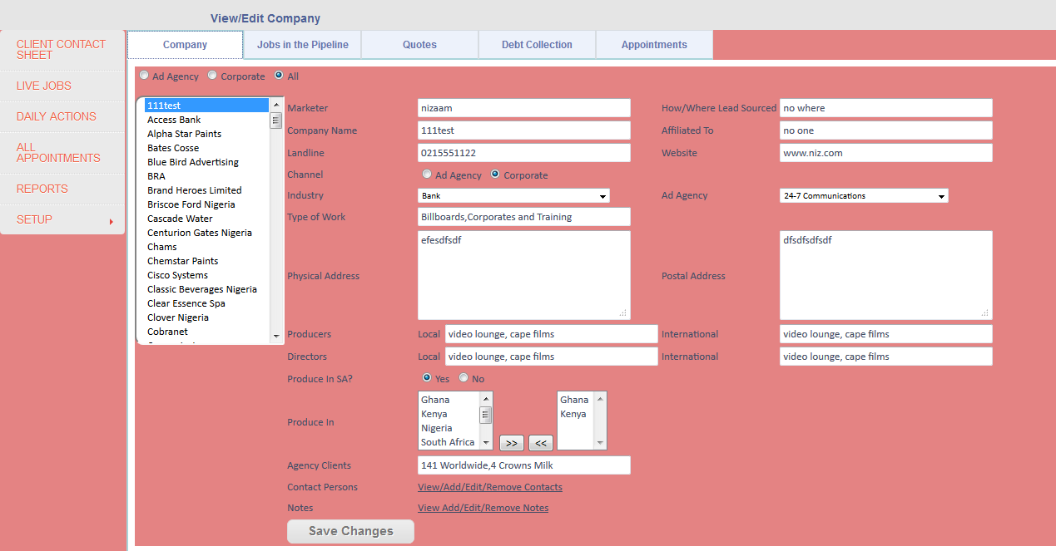

The menu for the VideoLounge application can be seen on the far left hand side.

In the example above, I’ve selected the *All* on the Client Contact Sheet. The list of companies then loads into the listbox on the left. Clicking on the company will load its details into the fields to the right of the listbox. In the example above, I’ve selected the company “111test”, which is a fake client used for testing purposes. Here you can enter/edit any details that you desire, as can be seen above. The fields are very straightforward and there are hints that will help guide the user as to what information they should be entering into the fields. Most of the fields requires the user to type in information, while others are dropdown lists and listboxes where information can be moved from one list to another. For example, the *Produce in* listbox, lists all countries where the client produces in. If you want to add a country to this list for the client, simply click on the country, then click the *>>* button. This adds the selected country to the newly added countries listbox on the right. The *Channel* option means that the client is either an ad agency or a corporate. The *Contact Persons* link allows the marketer to add/edit/delete contact persons for this specific client. The *Contact Persons* page is shown below.

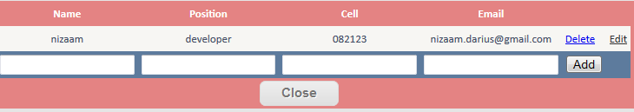

This page easily allows the marketer to add a new contact person, edit a contact person’s details, or delete an existing contact person. To edit or delete a contact person, simply click the *Edit* or *Delete* button next to the contact person’s name. The grid will automatically update after this. To *Add* a new contact person, first fill in the fields, such as *Name, Position, Cell* and *email address*, then click *Add*. The grid will automatically update after this. It is important to note that when a new company is added to the system (discussed later in Setup), a dummy contact person is created and linked to it. The marketer should only delete this dummy contact once he/she has added a new one. If this is not done, the grid will not show any contact persons, since there would be nothing to show. If the marketer delete this dummy contact before adding a new one, he/she would not be able to add any new contact persons to the system, because the grid will only be visible if there is at least one record.

There is also an option to view *Notes.* Simply click the *Notes* link. The *Notes* page is shown below.

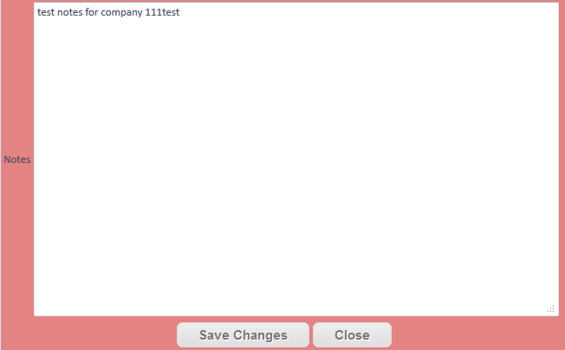

This page can be used to store general information about the company. Once you are done with your changes, click the *Save Changes* button, then click *Close*.

Once you are done with all your changes, click the *Save Changes button* on the *Client Contact Sheet*.

**Jobs in the Pipeline**

When you select a company as we just did, you can view its Jobs in the Pipeline, Quotes, Debt Collection and Appointments. These are all related to the company which you select from the listbox, as we did in the steps before. Jobs in the Pipeline are all possible leads/future jobs that the marketer will capture to the system. Below is what the Jobs in the Pipeline screen looks like.

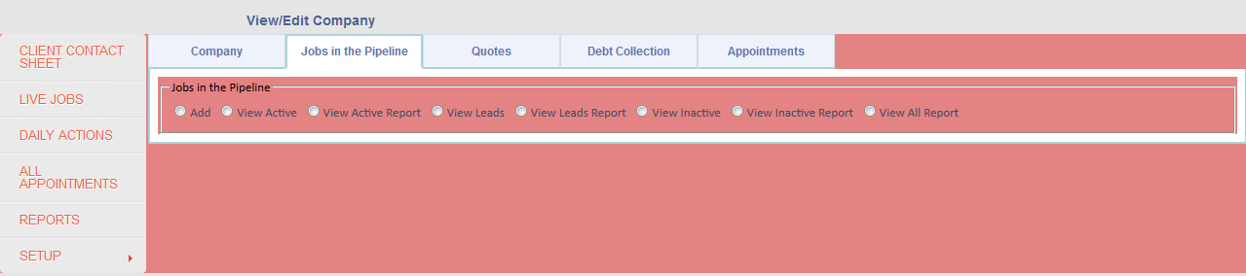

There are various options within this menu. You can add a job to the pipeline, view all active jobs, all inactive jobs, leads and reports for all these options. Let’s quickly differentiate between these various options.

*View Active* – These are all the active jobs in the system. What’s an active job? When you add a new job, you have the option to set it to active. The options are “Yes”, “No” and “Not set”. When you select “Yes”, the job is set to active. This is what an active job is. The *View Active Report* is a report of all the active jobs.

*View Leads* – These are jobs that have not been set to active when you add a new job. The *View Leads Report* is a report of all the leads.

*View Inactive* – When you add a new job and set its active property to “No”, the job is classified as inactive. This is useful when you add a new lead but later on if the job can/will no longer occur, you can set this option to “No” to ensure it is inactive.

The *View Inactive Report* is a report of all the inactive jobs. Let’s look at adding a new job. Below is the screen for adding a new job.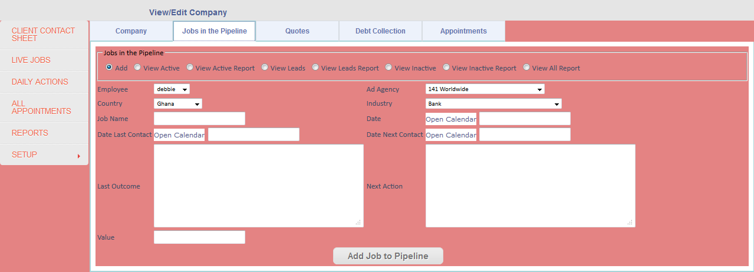

There are various options to be selected, such as the Employee/Marketer whose lead it is, the Ad Agency, the Country, the Industry, the Job Name and many more. Some of these fields are dropdown lists and other information needs to be typed in. There are also calendars to conveniently select dates. The information that needs to be entered is very straightforward. Once you are done entering the information for the new job, click *Add Job to Pipeline*. This will add the job to the system. At this point, the job is not active. It will be a *Lead* until such time that the marketer selects the job from the *View Leads* option and sets its active property to “Yes”. The other screens, such as *View Active, View Inactive* and *View Leads* all have the same look at the screen above, with the exception that you can set the jobs active state and also move it to *Quotes.*

Let’s say the lead is definitely going to be a job. We may now want to either set it to active or move it to the *Quotes* section. This is what the *View Leads* option looks like.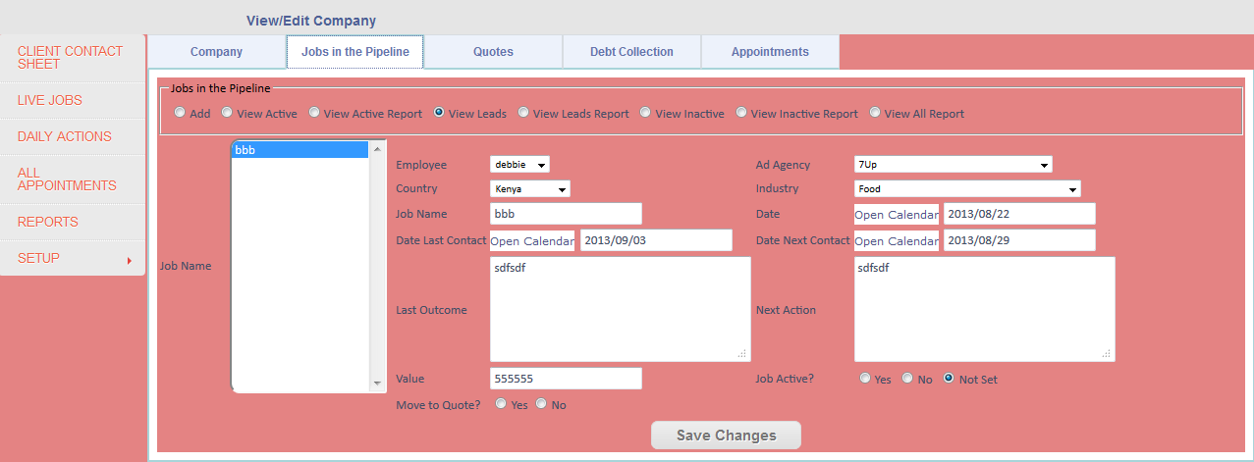

In the example above, I’ve selected a lead and the system loaded its details. I can now either just set the job to active or move it to the *Quotes* section. If I just set the job to active, the job is now no longer a lead, but an active job. If I want to move it to the *Quotes* section, I should select the option that says “Yes”, which is next to the “Move to Quote?” field. This firstly sets the job to active and then moves it to the next stage of the process, which is *Quotes.* I’m going to select the option to move the job to the *Quotes* section and then I’ll click *Save Changes*. The job is now active and we will see it in the *Quotes* section. This is what the screen looks like after it is successfully move to the *Quotes* section.

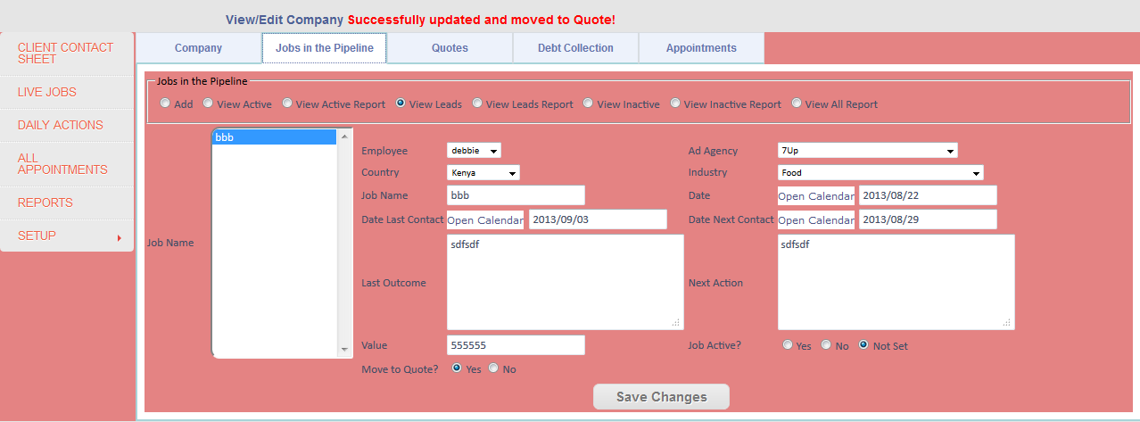

**Quotes**

Quotes is the next step in the process of a job. We’ve already moved the job to the quote section, so let’s take a look at how the quote section looks and works. Below is the *Quotes* screen.

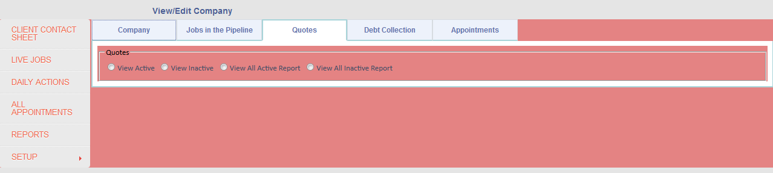

The options we have are *View Active, View Inactive* and their respective report options. The *View Active* option will show us all the active quotes in the system and similarly, the *View Inactive* option will show us all of the inactive quotes. The *View All Active Report* and *View All Inactive Report* are reports that will show you the jobs that are in the quote stage of the process. The former will show all active jobs and the latter will show all inactive jobs. We define this below.

Let’s see what happens when we click on the *View Active* option.

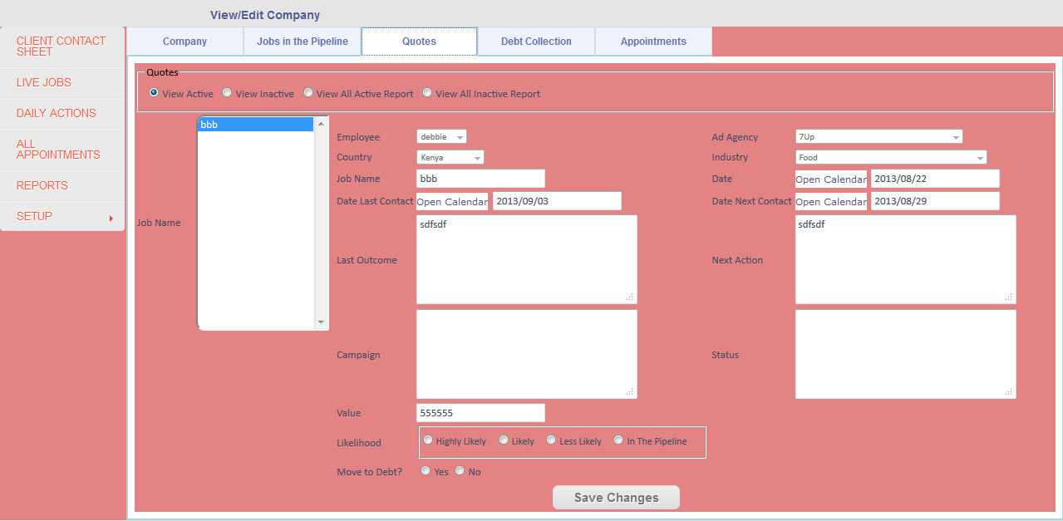

This lists all the active jobs that are in the quote stage of the job process. I’ve selected the job on the left “*bbb*” and its details have been loaded into the fields to the right. Here we can edit some of the job info or add some extra details, such as *Campaign* and *Status*, add the job’s *Value* and set its *Likelihood*. The last option on the page allows us to move the job to the debt collection stage of the process. If we choose “Yes”, the job will be moved to the *Debt Collection* section. If we choose “No”, the job becomes inactive and we can then view it from the *View Inactive* option at the top of the page. I’m going to choose to move the job to the *Debt Collection* section. Once again, the system will tell me that I’ve successfully moved it to the *Debt Collection* section.

**Debt Collection**

Debt collection is the final stage of the job process. Let’s take a look at the *Debt Collection* screen.

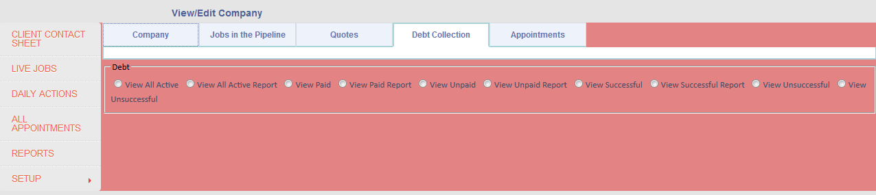

Here we can view all active, paid, unpaid, successful, unsuccessful jobs in the debt collection stage. There are also reports for each of these options. The paid and unpaid options will show us jobs that either have or have not been paid yet. The successful and unsuccessful options will show us jobs that were either successful or not, which will set later. For now, let’s take a look at what the *View All Active* option states.

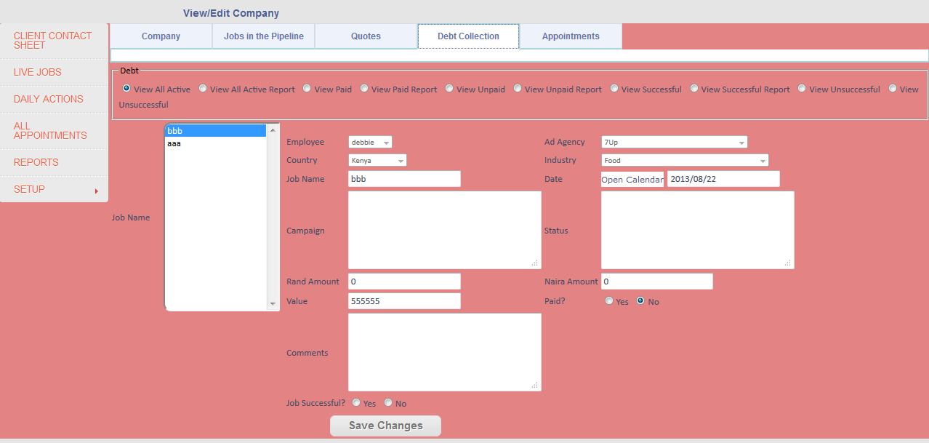

When we select *View All Active*, the active jobs that are in the debt stage of the process will be loaded into the listbox on the left. I’ve selected the “*bbb*” job once again. Its details have been loaded into the fields to the right. Here you can make changes to the job if need be. Once you are done, you can have two options: you can either set the job to successful or not. If you set the job’s successful property to “Yes”, the job is no longer active in the system but you will be able to view it via the View *Successful* option or its report. If you set the job’s successful property to “No”, the job is no longer active and is also set to unsuccessful. You can view the unsuccessful jobs via the *View Unsuccessful* option or its report option. When you are done with your changes, you need to click *Save Changes*. This will save all the changes you made to the job.

**Appointments**

To view, add or edit any appointments you have with a client, you can facilitate this via the *Appointments* menu. All appointments you add here will be stored for the currently selected client/company. Let’s take a look at the *Appointments* screen.

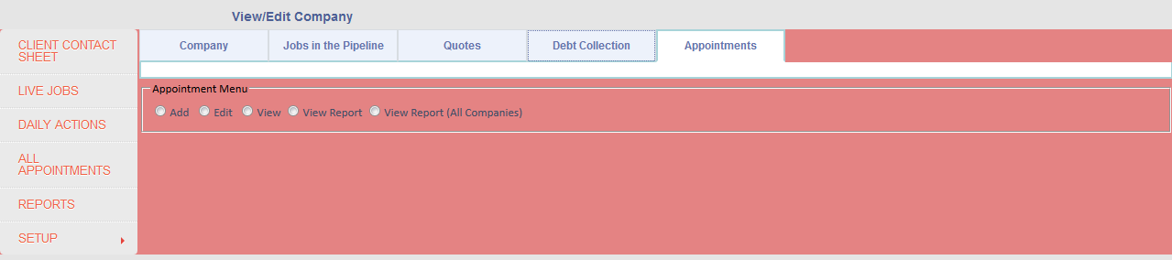

Here we can add new appointments, edit existing ones or simply just view appointments for the current month. We can also extract a report of all the appointments for the current month, for the currently selected company or for all companies. Let’s take a look at adding a new appointment.

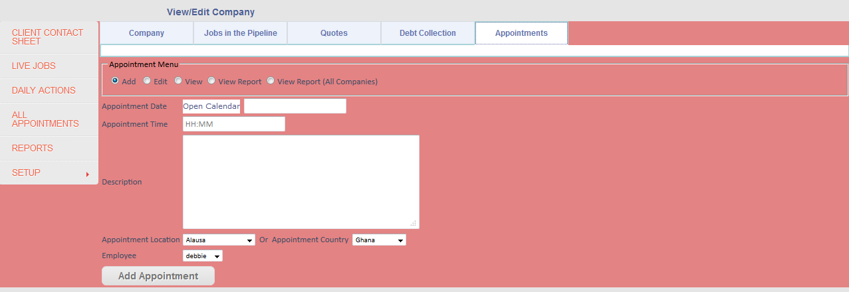

The screen above allows us to add a new appointment. We can select the date, time, enter a description of the appointment and also set its location. Once we are done, simply click *Add Appointment*. The system will tell us that it was successfully added. I’m going to create a new appointment, so that we can see how the edit and view options work. Let’s take a look at the edit screen.

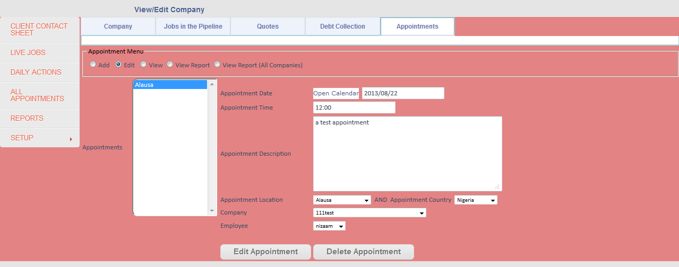

I’ve clicked on the *Edit* option and selected the new appointment that I just added. Its details are now loaded into the fields to the right. Here we can make changes to the appointment if need be. Once we are done, simply click *Edit Appointment* and the updated details will be saved. If you wish to delete this appointment, simply click *Delete Appointment*. If you clicked *Edit Appointment*, the system will let you know that it was successfully saved. If you click *Delete Appointment*, the system will ask if you are sure with a yes or no option. If you select “Yes”, the appointment will be deleted. If you select “No”, the appointment remains. Let’s take a look at the *View* option.

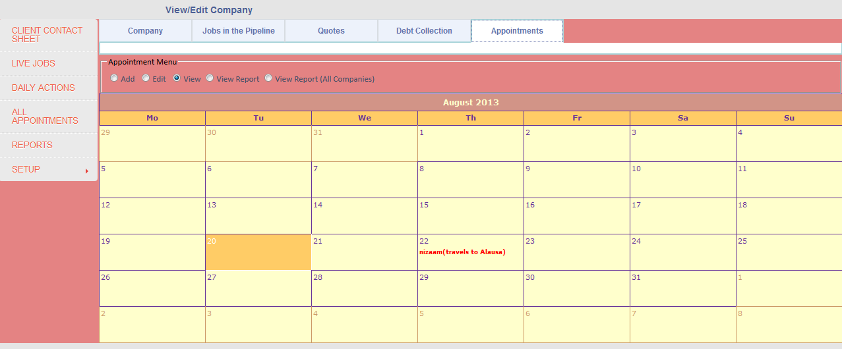

At a glance, we can see all the appointments for the current client/company for the current month. We can see that on the 22nd of August 2013, the user *nizaam* is travelling to *Alausa*. If we hover over this appointment, we will see its details, as shown below:

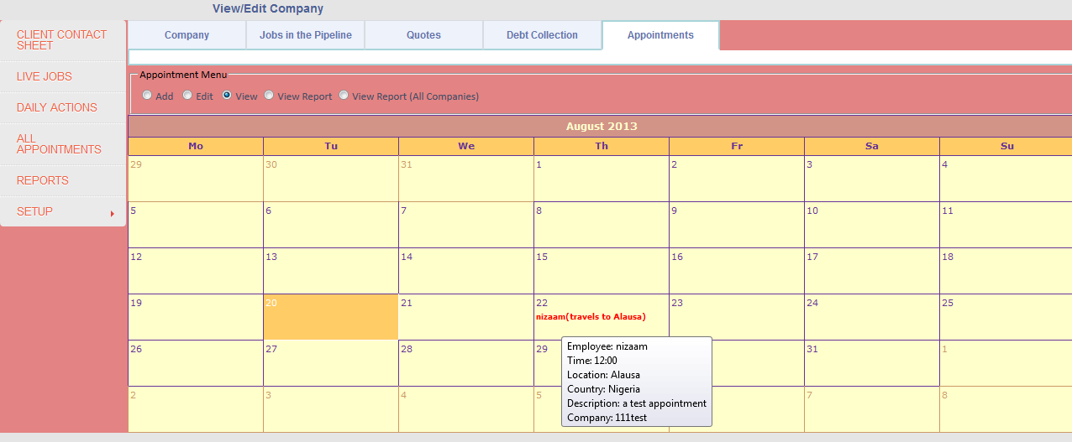

**Live Jobs**

The *Live Jobs* screen basically shows us all the live jobs in the system, regardless of its state (pipeline/quotes/debt collection). We have the options to either just view the jobs or to also extract a report of them. Let’s take a look at the *Live Jobs* screen.

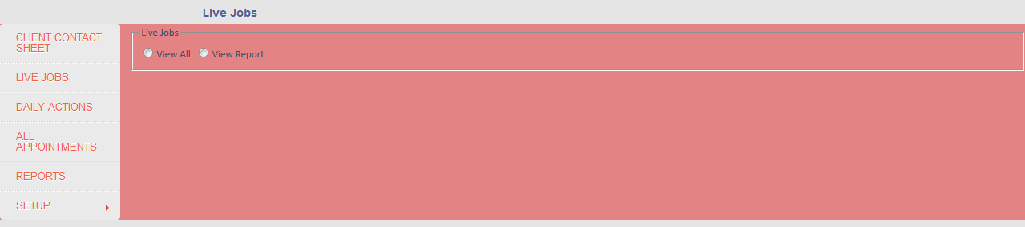

This is a very simple, yet useful page. Let’s see what happens when we click on *View All*.

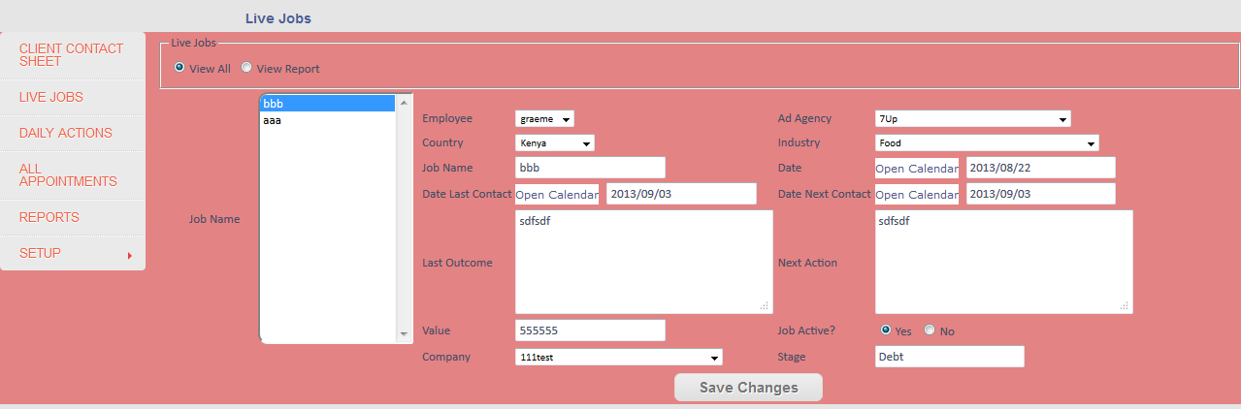

I’ve chosen the *View All* option and it has loaded the two active jobs we currently have in the system. I’ve also selected the job “*bbb”* and the system has loaded its details to the right. Here we can also edit certain details of the job. If you choose to edit any details, click *Save Changes* when you are done and the system will alert you that the changes have been saved. We can also see from this that the currently selected job is only in the debt collection stage of the job process. The *View Report* option will show us a report of all the live jobs currently in the system.

**Daily Actions**

The *Daily Actions* page is a very useful tool for the marketer. It allows him/her to see which jobs or clients they need to follow up on for the current day. This is done by the system checking to see which jobs’ next contact date falls on today’s date. Let’s say for example, that I add a new job and I set the *Next Contact Date* to tomorrow’s date. This means that when the marketer checks this *Daily Actions* page tomorrow, it will show this job, so the marketer knows that he has to follow up with a specific client. Let’s take a look at the *Daily Actions* page.

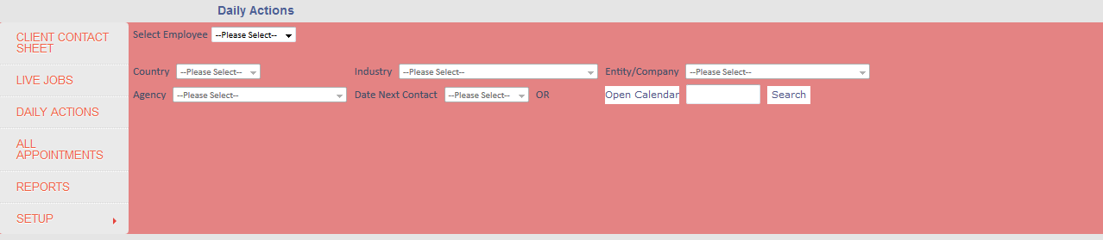

Here we are offered various options to filter on. We can either select all employees/marketers or just a particular one, which will either show you all jobs for all employees/marketers or just show you a particular employee/marketer’s jobs. There are various other filters to choose from, such as Country, Industry, Agency, Company or even date selections. These will all filter based on their names. For example, if I just wanted to see all jobs for any employee in the country Ghana, I would just select Ghana from the country dropdown list and the results will be shown below. The same applies for the other fields. If you are not sure about the exact date, you can even select a month from the first *Date Next Contact* dropdown list. Let’s say you knew the job is in August but you weren’t sure of the date, this function will show you all jobs in August. If you know the exact date, you can select it from the *Open Calendar* option and the results will be shown below.

**All Appointments**

Earlier we saw that once we selected a company, we could view all appointments for that specific company. The *All Appointments* page shows you all appointments, regardless of company/country/marketer. There is also an option to print a report of it. Let’s take a look at this page.

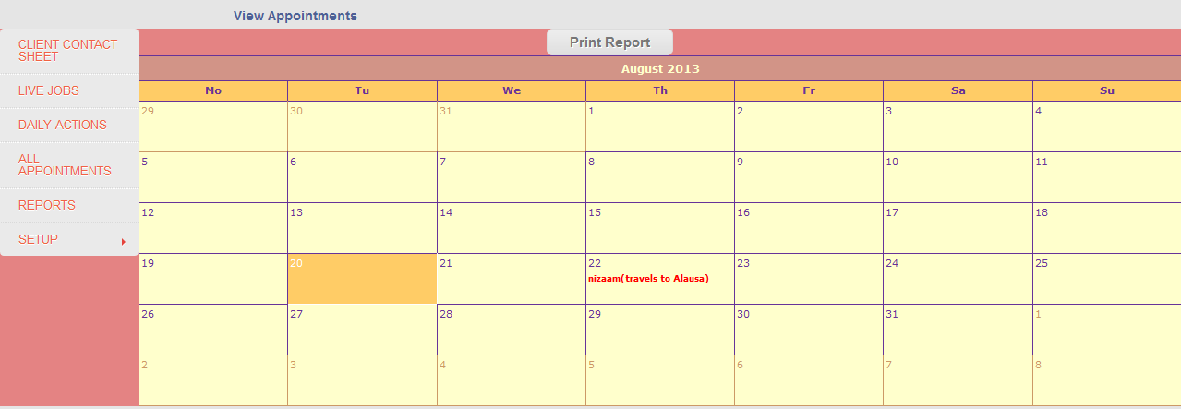

The same functionality applies here as we demonstrated earlier. We can see all appointments for the current month at a glance and if we hover over one, we can see all its details.

**Reports**

The *Reports* page allows the marketer to view reports on jobs, whether they’re active or not, based on the selection criteria. The jobs are sorted by the active ones first. There are various options to choose from, such as *Region*, which will show the marketer all the jobs for that particular region. There is a filter for *Country*, so the marketer can view all jobs in a particular country. There is a *Channel* option, which allows the marketer to either choose *Ad Agency* or *Corporate*, which will show all jobs by an ad agency or a corporate entity. There is also an *Industry* option, which shows all jobs for a particular industry. The other option is *Production Services*, which shows all the companies that offer those services. The final option is *Company/Client*, which allows the marketer to select a company and the system will generate a report of all the jobs for that particular company. The marketer just needs to select which option he/she wants and click the *Generate Report* button and the report will be generated. This is what the *Reports* page looks like.

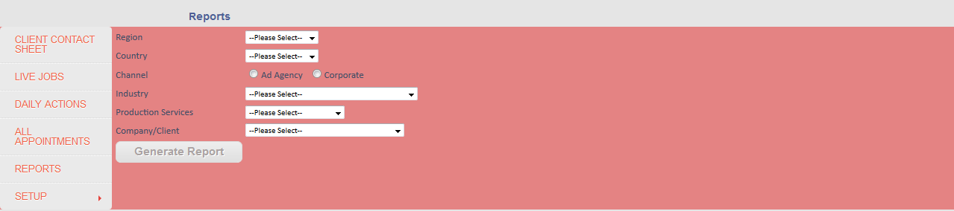

**Setup**

**User Accounts**

**Add User**

The *Add User* page allows the marketer to add a new user to the system. If the new user has the same name as an existing user, the system will alert the marketer that the username already exists and that they need to choose a new name. Once a name is chosen, the marketer should enter a password for the new user. Once done, the password will need to be retyped into the *Confirm Password* field. If the passwords match, the new user will successfully be added to the system. If the passwords do not match, the system will alert the marketer that the passwords do not match. They will then need to re-enter the password until it matches. Once the *Username*, *Password* and *Confirm Password* fields are done, click *Add User*. This will add the new user to the system. Let’s take a look at the *Add User* page.

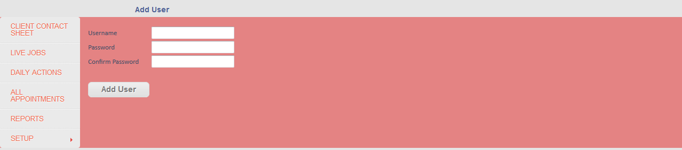

**Edit User**

The *Edit User* page allows the marketer to edit the details his/her account or for another marketer. The marketer can change his/her password and also set his/her status to either *Enabled* or *Disabled*. The marketer has to select the username from the dropdown list, then he/she can decide what to do next. If the marketer chooses to disabled an account, the disabled option must be chosen. This effectively disables the username and the marketer whose name was selected from the dropdown list will no longer be able to login to the system. If the marketer wants to change his/her password, they can do so by entering it twice (once for the new password and again in the password confirm field). Once the marketer has either updated their password or set their account to enabled/disabled, they must simply click *Update User*. The system will alert the user that the changes have been made. Let’s take a look at the *Edit Page*.

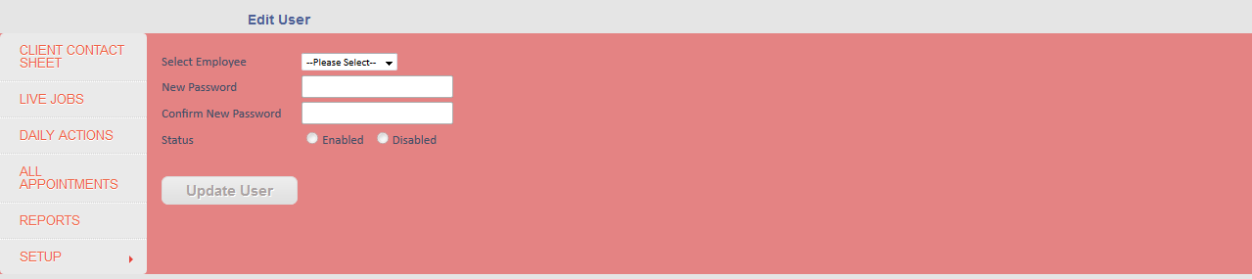

**Company**

**Add Company**

The *Add Company* page allows the marketer to add a new company to the system. This page is exactly the same as the *Client Contact Sheet*, with a few small differences. All the marketer has to do is enter the relevant information into the fields or select the options they want. It is important to enter information into every field, to capture as much detail as possible. Let’s take a look at the *Add Company* screen.

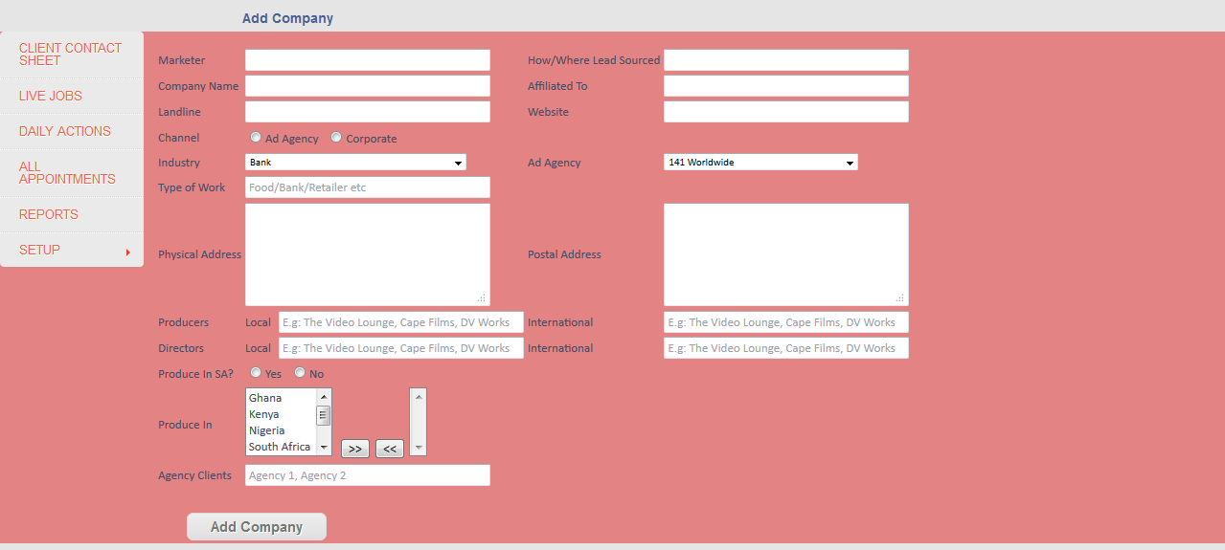

Once the marketer has selected and entered all the details, he/she simply needs to click *Add Company* and the company will be added to the system. The system will alert the marketer that the new company has been added. It is important to note that on this screen, there is no provision to add contact persons to the newly created company. However, this can be done on the *Client Contact Sheet*, where the marketer can select the company, then add/edit/delete contact persons. There is also no provision for notes on this page but it is accessible from the *Client Contact Sheet*.

**Country**

**Add Country**

To add a new country is really simple. Just type the name of the new country and select its region. At the moment, there are four regions, namely Africa, Asia, Europe and the Middle East. Once you have typed the new country name and selected the region, simply click *Add Country*. The system will alert the marketer that the country was successfully added. The *Add Country* screen can be seen below.

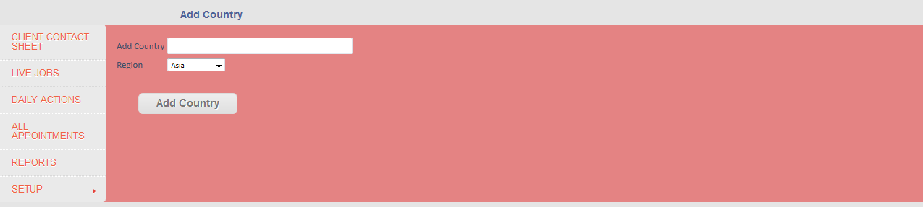

**Edit Country**

The *Edit Country* option simply allows a region of a country to be changed to another. To do this, simply select the country from the dropdown list and select its new region. Then click *Edit Country*. When you select the country, the current region will be shown in a text area, just so that the marketer knows which region it is currently linked to. The *Edit Country* can be seen below.

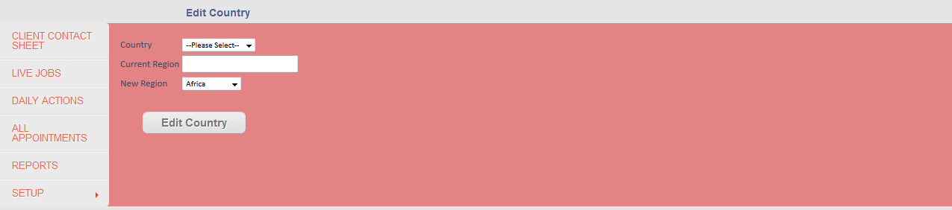

**Add Industry**

To add a new industry is really simple. Simply enter the industry name and click *Add Industry*. The system will alert the marketer that the industry has been added. The *Add Industry* screen can be seen below.

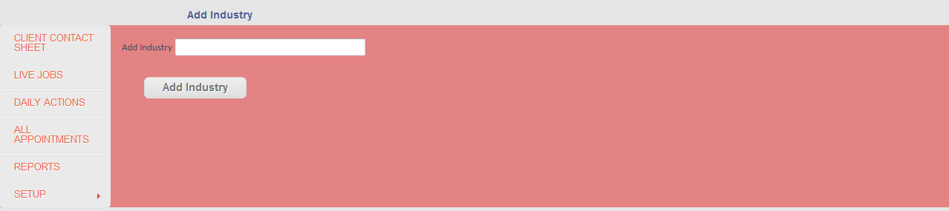

**Add Agency**

To add a new agency to the system, simply type in the new agency name and click *Add Agency*. There is an extra field for additional information about the agency, should you want to add that. The *Add Agency* screen can be seen below.

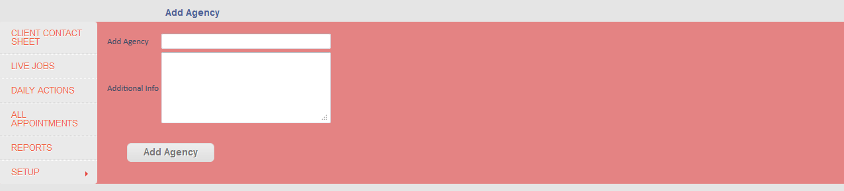

**Add Location**

To add a new location is really simple. Simply type in the new location’s name and click *Add Location*. The system will alert the marketer that the new location has been added. The *Add Location* screen can be seen below.

