# 3D App Deeper Understanding Statement

**1、More complicated 3D models, user Blender4.1 create 3d models**

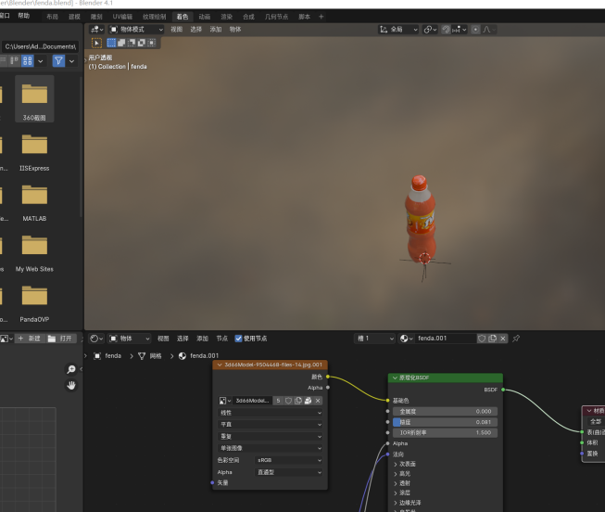

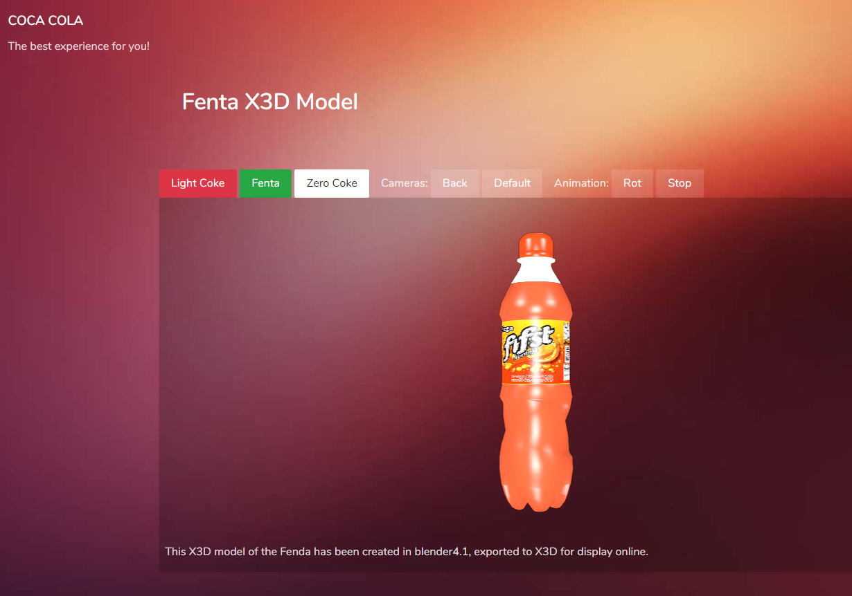

1. **Good use of a JavaScript Libraries, e.g. JQuery, JQuery Mobile**

Use jquery ajax to get 3d model descriptions.

function getContents() {

    $.ajax({

        url: 'api.php/getall',

        type: 'GET',

        dataType: 'json',

        success: function(data) {

            obj_contents = data;

        },

        error: function(jqXHR, textStatus, errorThrown) {

            console.log('Error: ' + textStatus, errorThrown);

        }

    });

}

1. **Good use of PHP libraries, e.g. PDO (PHP Data Objects).**

Use php sqlite get data from sqlite db.

<?php

class ObModel{

    public $id;

    public $content;

    public function __construct($id, $content) {

        $this->id = $id;

        $this->content = $content;

    }

    public static function getAll() {

        try {

            # SQLite Database

            $db = new PDO("sqlite:db/my.db");

            $db->setAttribute(PDO::ATTR_ERRMODE, PDO::ERRMODE_EXCEPTION);

            $stmt = $db->prepare("SELECT * FROM obejct_content order by id asc");

            $stmt->execute();

            $result = $stmt->fetchAll(PDO::FETCH_ASSOC);

            return $result;

        }catch(PDOException $e) {

            echo $e->getMessage();

        }

    }

}

?>

**4、Good use of a front-end JavaScript framework, e.g. Bootstrap**

    <script 'text/javascript' src="js/jquery-3.2.1.js"></script>

    <script src="vendors/bower_components/popper.js/dist/umd/popper.min.js"></script>

    <script src="vendors/bower_components/bootstrap/dist/js/bootstrap.min.js"></script>

    <script src="vendors/bower_components/salvattore/dist/salvattore.min.js"></script>

    <script type='text/javascript' src='js/x3dom.js'> </script>

    <script type='text/javascript' src='js/jquery.fancybox.min.js'> </script>

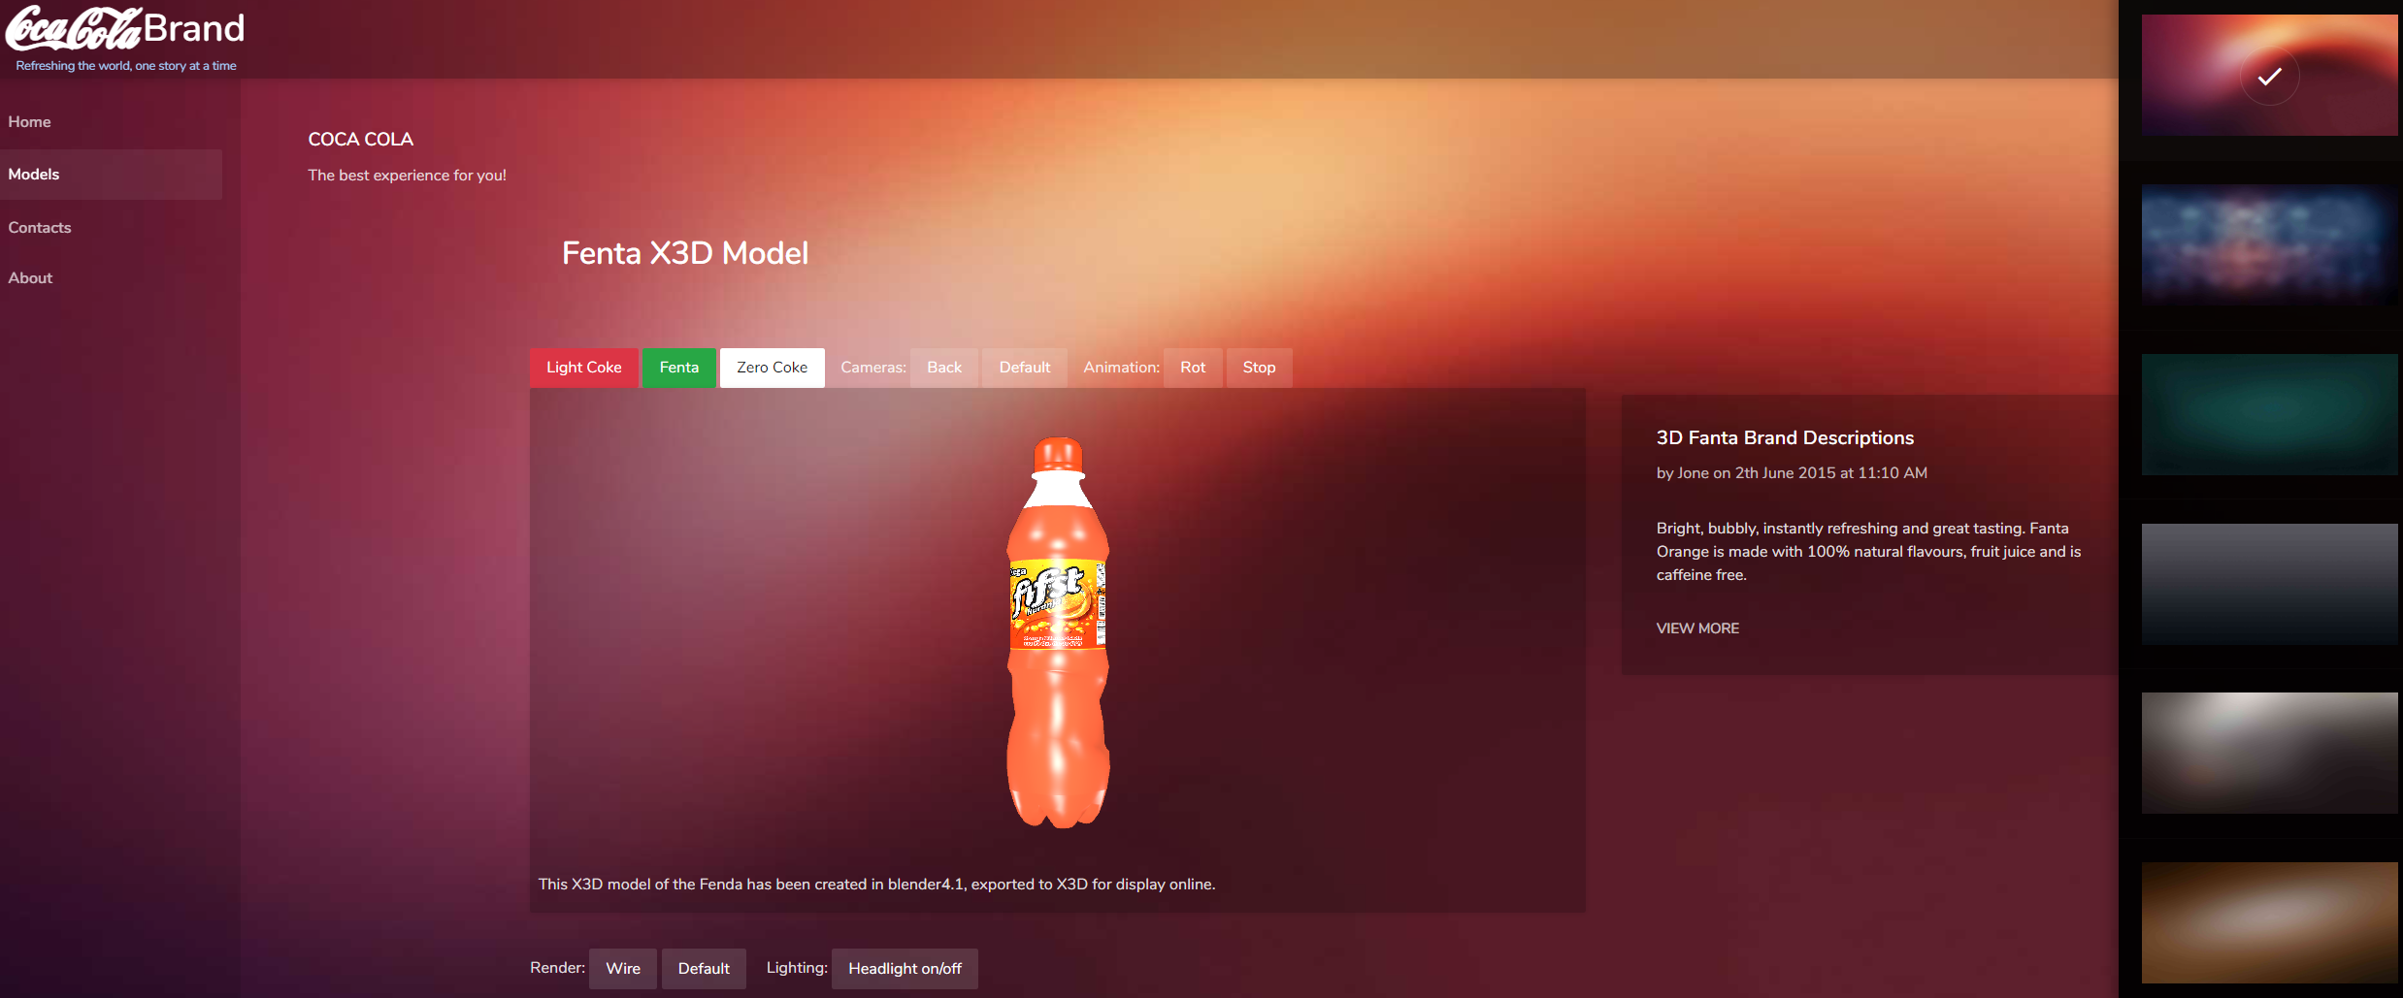

•

1. **Going beyond the level of PHP covered in the labs, e.g. Use of a PHP database abstraction layer in the form of a lightweight framework, e.g. SLIMLinks to an external site., and a simple database for the backend.•More focus on developing your own simple API for the backend.**

In this website use slimlink mvc framework and pdo sqlite to get 3d model description from sqlite db.

