Navid Milani
May 5 2014

DNP 2D Game Engine

//make slides

Whats the big Idea?

A polyglot, poly-paradigm game engine using LUA as a interactive scripting interface and C++ as the core application.

What in the world does that mean?
-polyglot means in this context many languages.
-poly-paradigm in this context means many ways to program!

Why in the world do something like this?
In a world where employers and consumers expect a quality application that has networking, persistent data, scalability, and high function features … all by the end of the week, developers need a way to sate the expectations quickly and reliably. NOTE: all the language binding was native.

I am attempting to accomplish this in a few ways;
- A game engine / abstraction makes it so who ever uses the code base can create applications with a significantly less amount of code.

For example. I can create a in game object with in image that has ways to add functionality to important events such as creation, destruction, update, render and pressed (if you set it as a button), all in a few lines!
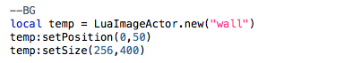
Here is some code from the LUA side to create that object and position it with the “wall” asset that is loaded.
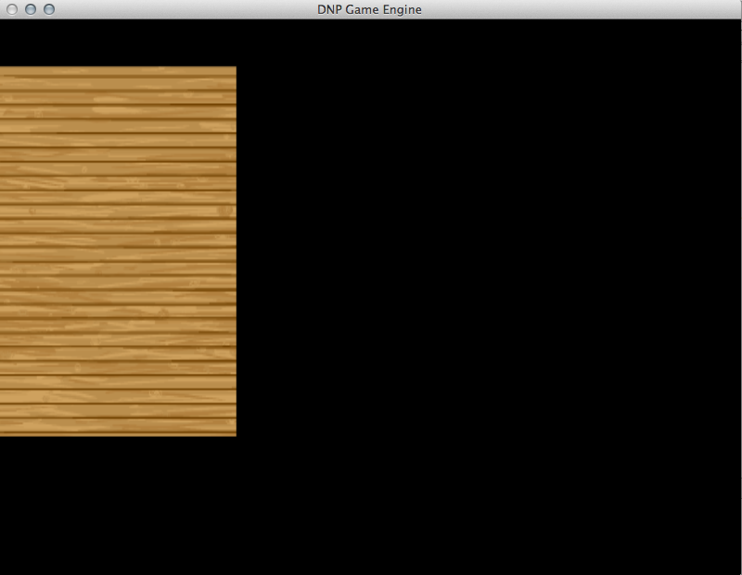

2) Allows a dev team to develop in multiple languages. LUA/Python for prototyping needs (you can actually change some of the code as it runs and you can see it change in the scene)

3)Pre-optimized storage and utilization of assets. (asset store and texture binding)
//reword this to make sense
4)Facade design (Encapsulated subsystems with high level interfaces)

5)”On the fly” modifiable behavior.
-We can add lambda functions from both LUA and C++ to entities in the scene on the fly.

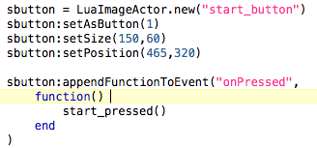
Here is the example from the LUA side. I have a button that I create and I go ahead and append a function to the event “onPressed.” In this example, I can actually edit it as the application runs.

6)Scene transitions and Scene management

7)Depth system
-We can layer things as we want on the fly.
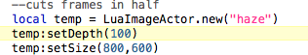
Here I make sure my overlay is always on top. (objects default to depth 0 so 100 is definitely on top ).
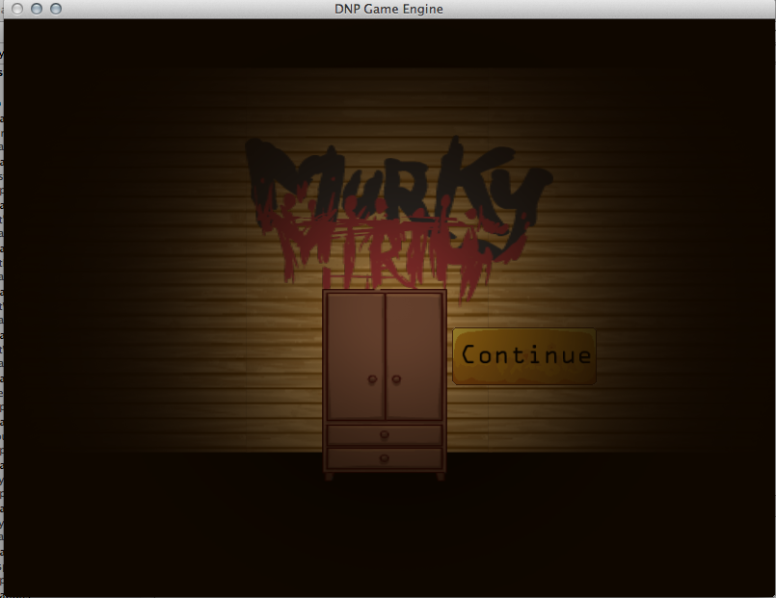

8)Controllable Camera.

9)Convenience objects/functionality
-CollisionBoxes
-2D Game Math Library(C++)

How did I tackle the implementation?

Technology used:
- OpenGL (GLUT)
- C++ ~ G++
- An IDE
- Lua 5.2 (no bridge, native binding)
- bash
- Mac OsX (my os, can be anything)

Techniques used:
- A medley of game engine optimizations
  - asset store
  - automatic cleanup
  - basic occlusion

- A medley of design patterns
  - facade
  - OOP
  - Factory
  - Bridge

Whats next?

//More info

Some more high level features:
- Text rendering.
- Playable sounds and sound subsystem to manage memory/playing/assets
- Python binding
- Persistence tools
- Scene Editor GUI

Some low level features:
1) Lighting
2) Low level optimizations to the render pass
3) Optional Post Processing effects

