# **Help Documents**

# **Software & Tools Details.**

-Java1.8

-SpringBoot/Tomcat Embedded Server

- H2 Memory Database

- Spring STS

# **Step to export Projects.**

* 1. Import “CurrencyExchangeCalculator” and “CurrencyExchangeCalculatorClient” project in SpringSTS/Eclipse.

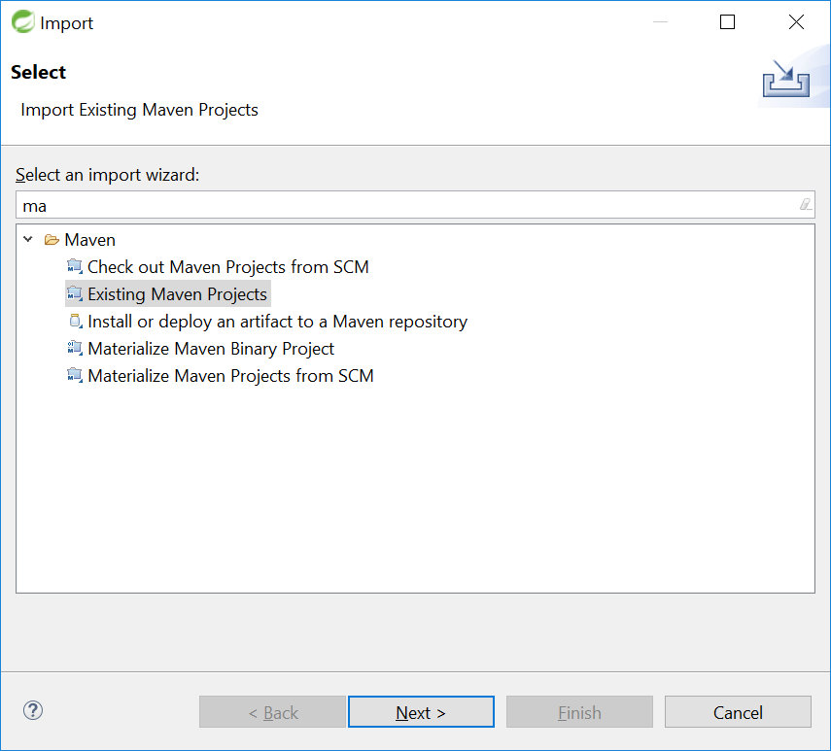

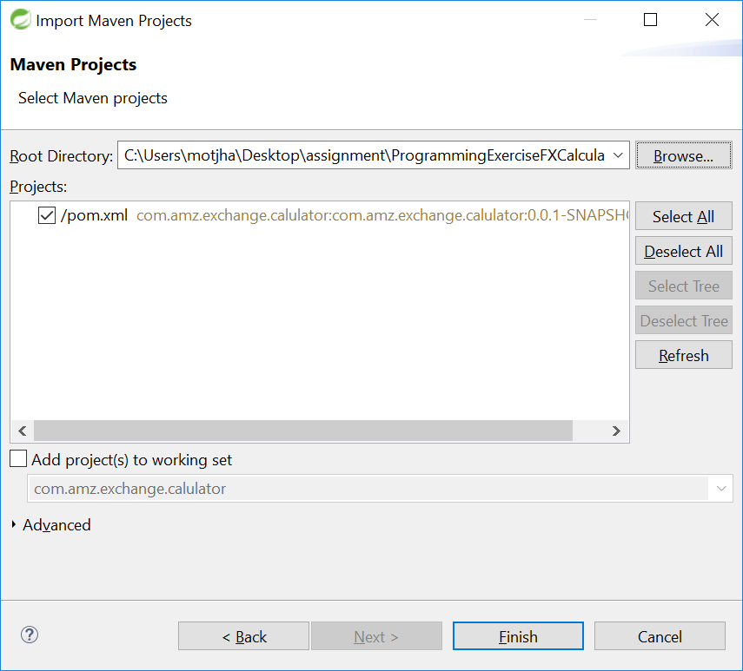

* 1. Build as maven project.

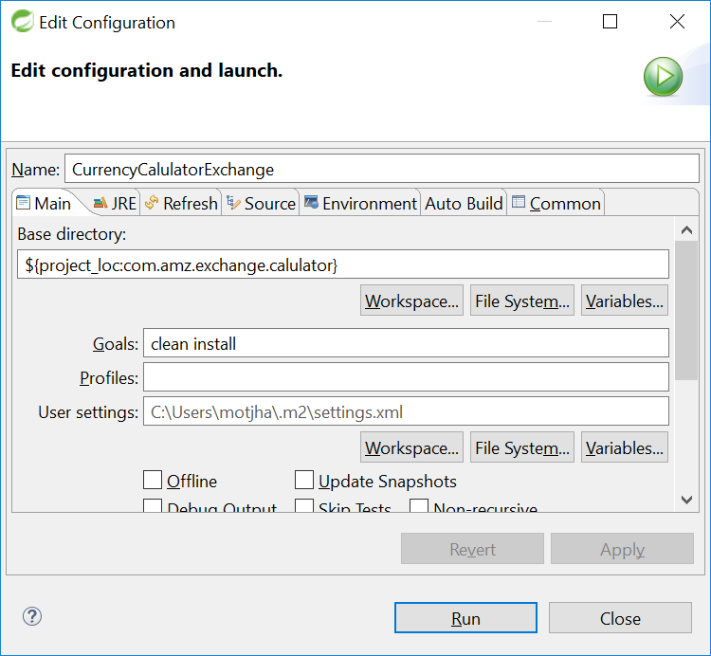

* 1. Import Java client project

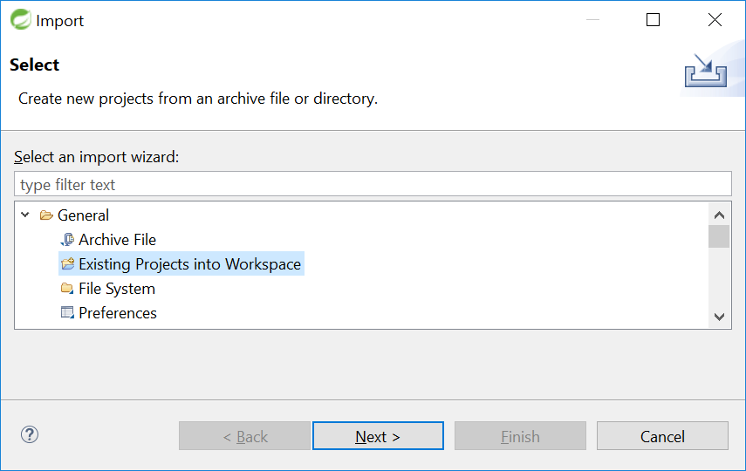

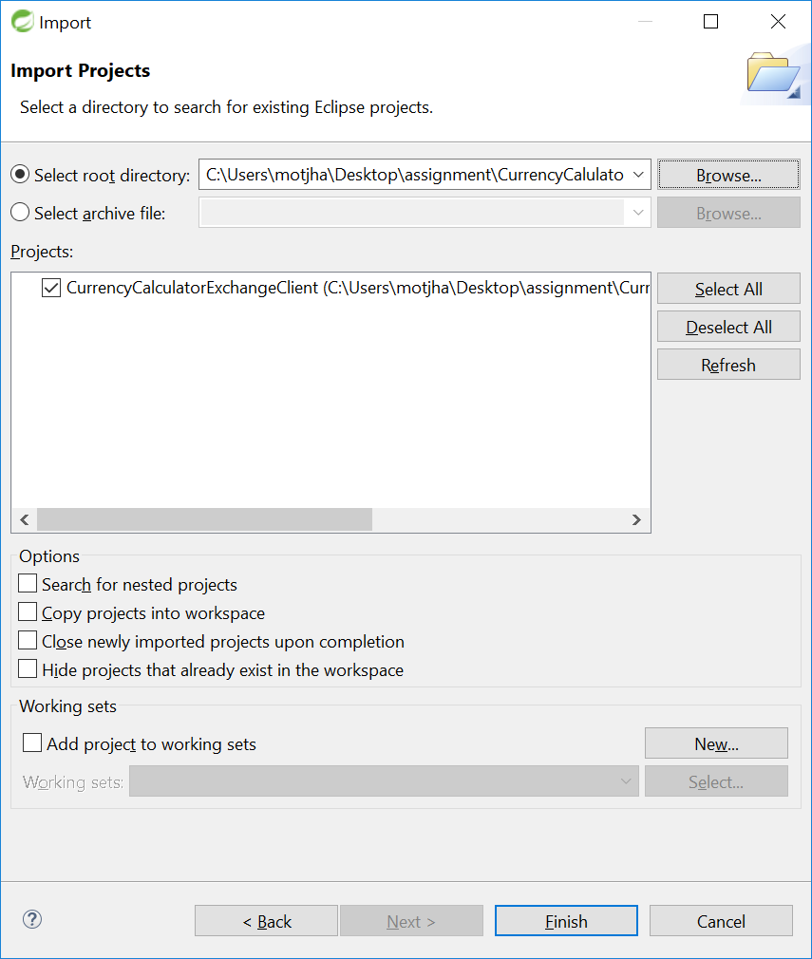

# **Run spring boot application (CurrencyExchangeCalculator).**

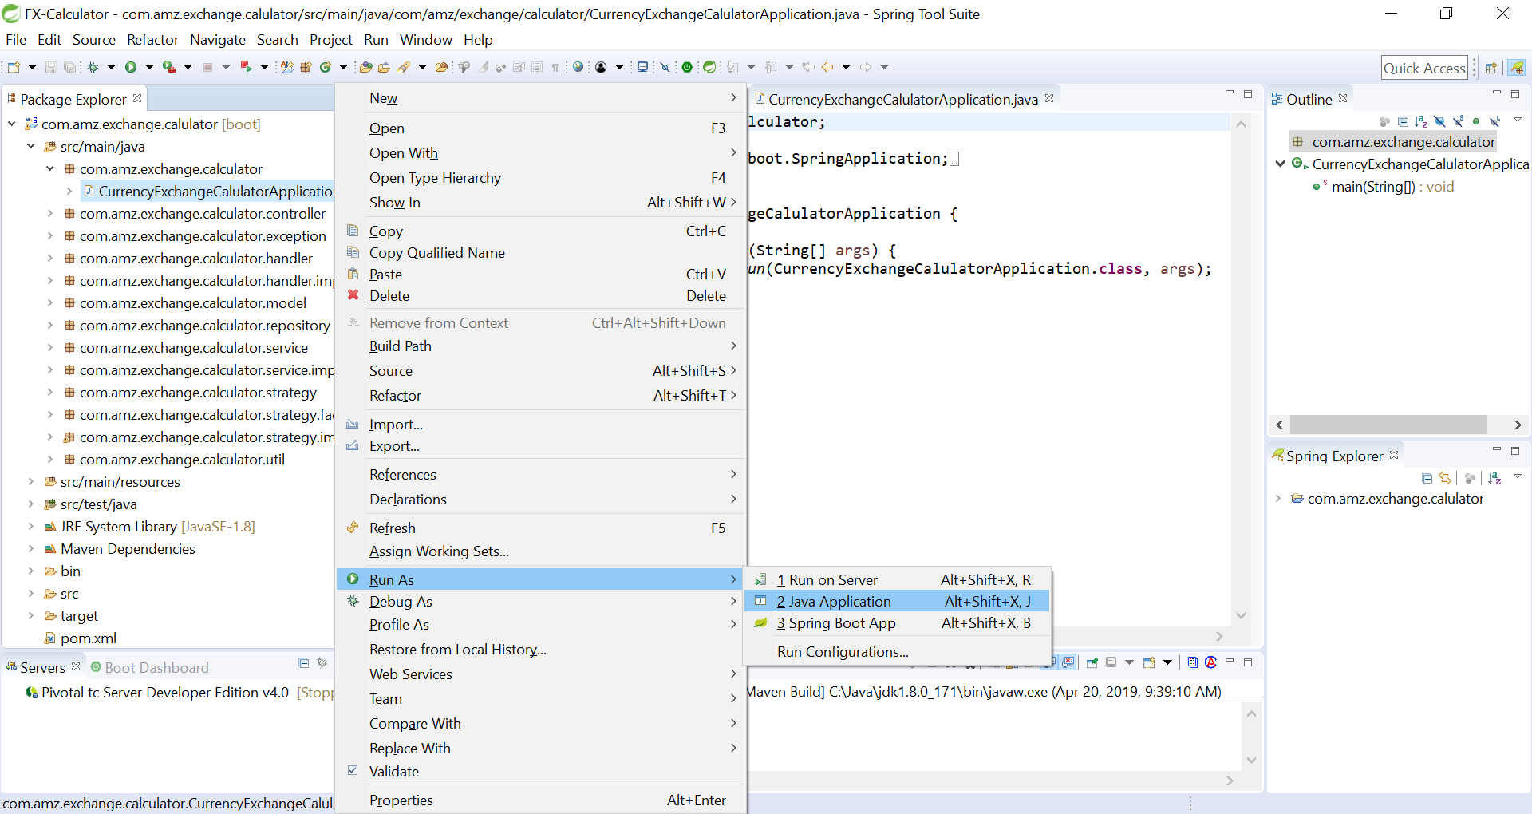

3.2 Please make sure application started.

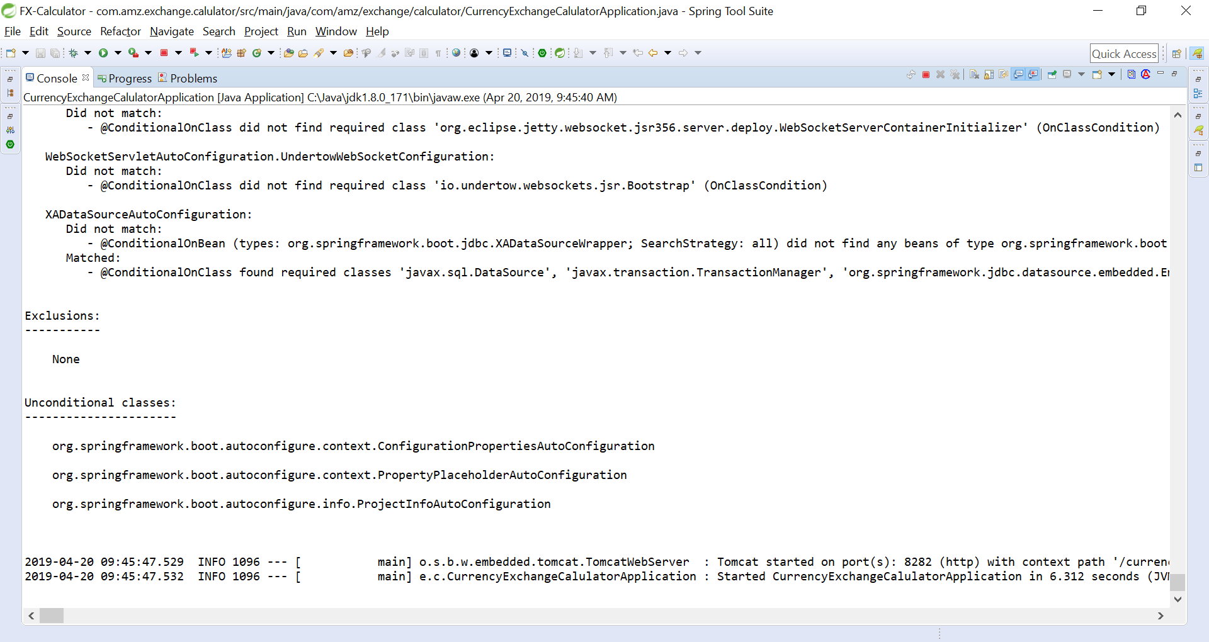

# **Run java class (CurrencyExchangeClientApplication) from Client Program(CurrencyExchangeCalculatorClient).**

* 1. Please provide input in console.

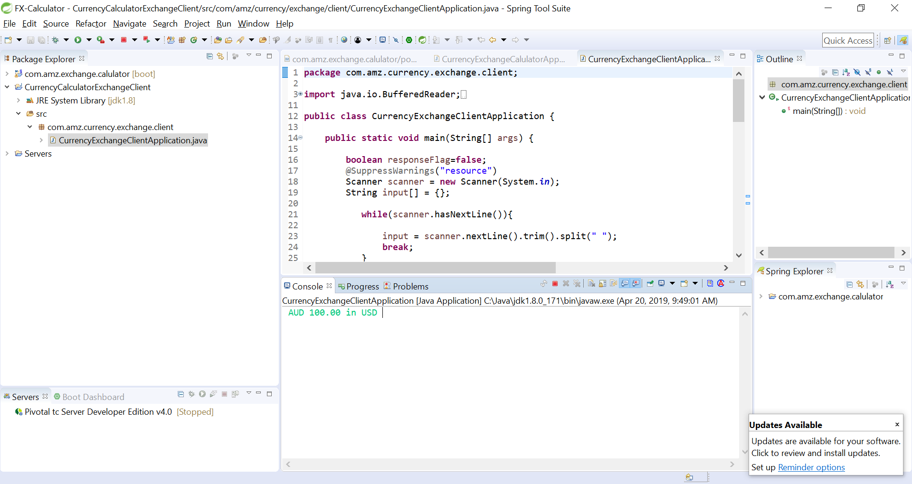

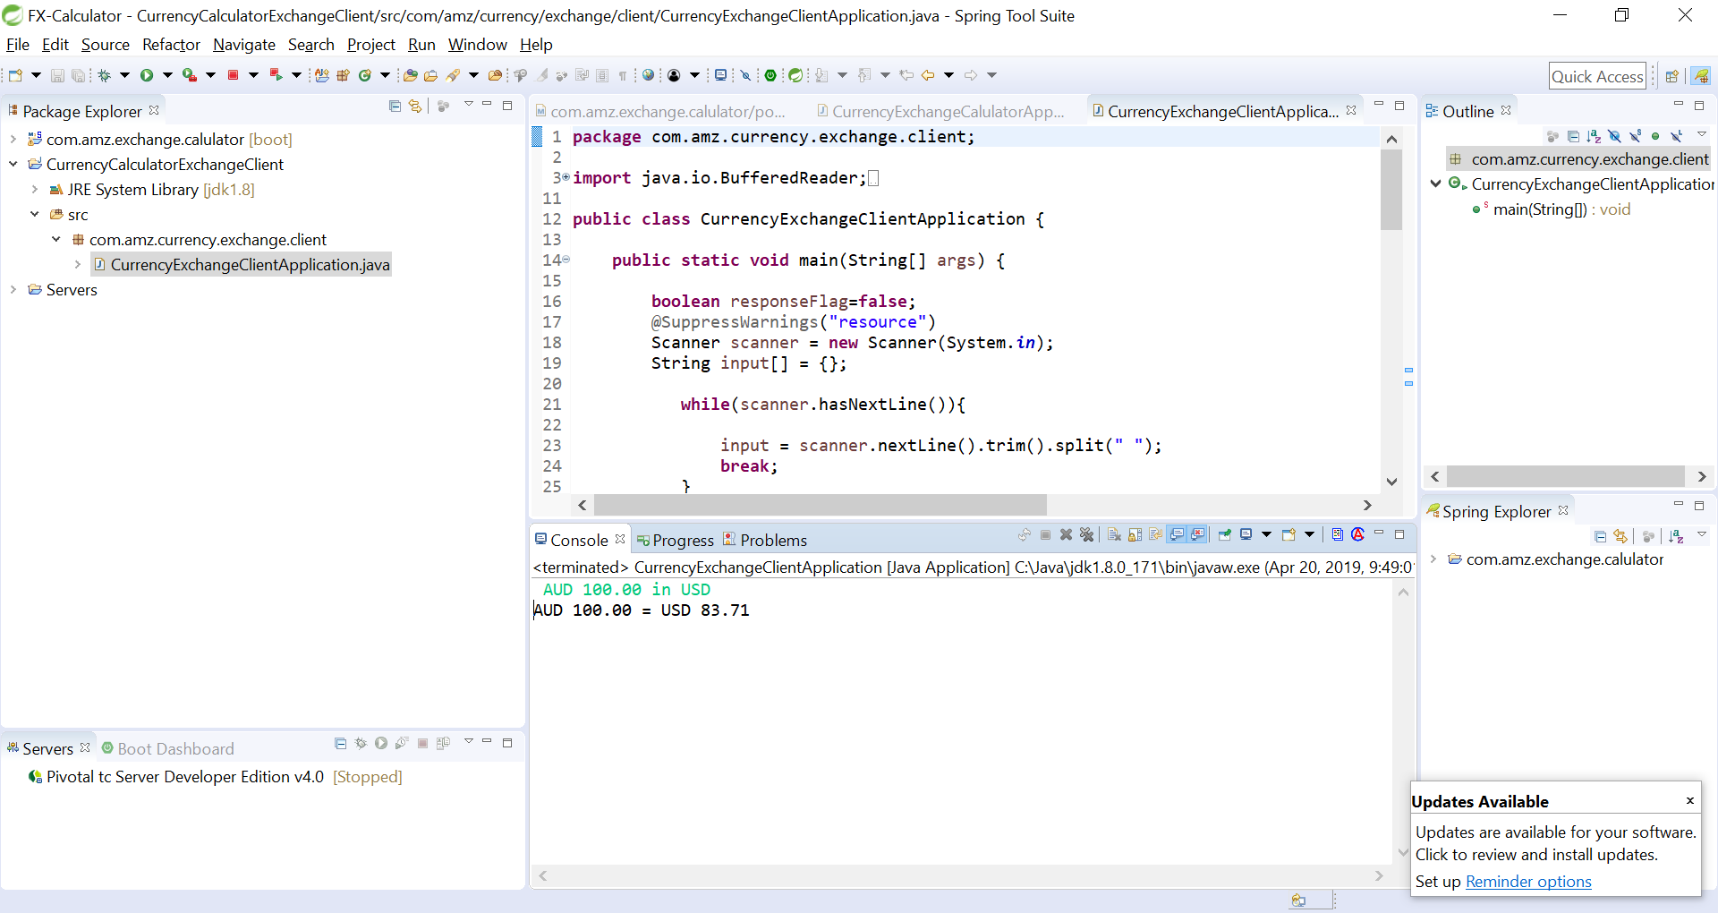

# **Data Details: data.sql**



# **Application Configuration**

