Tools:

-Spring STS

-Postman

-Robo 3T

NoSql: Mongo DB

Framework: Springboot

Language: Java

Mongo DB:

Step1: Created a “continentdb” mongo DB.

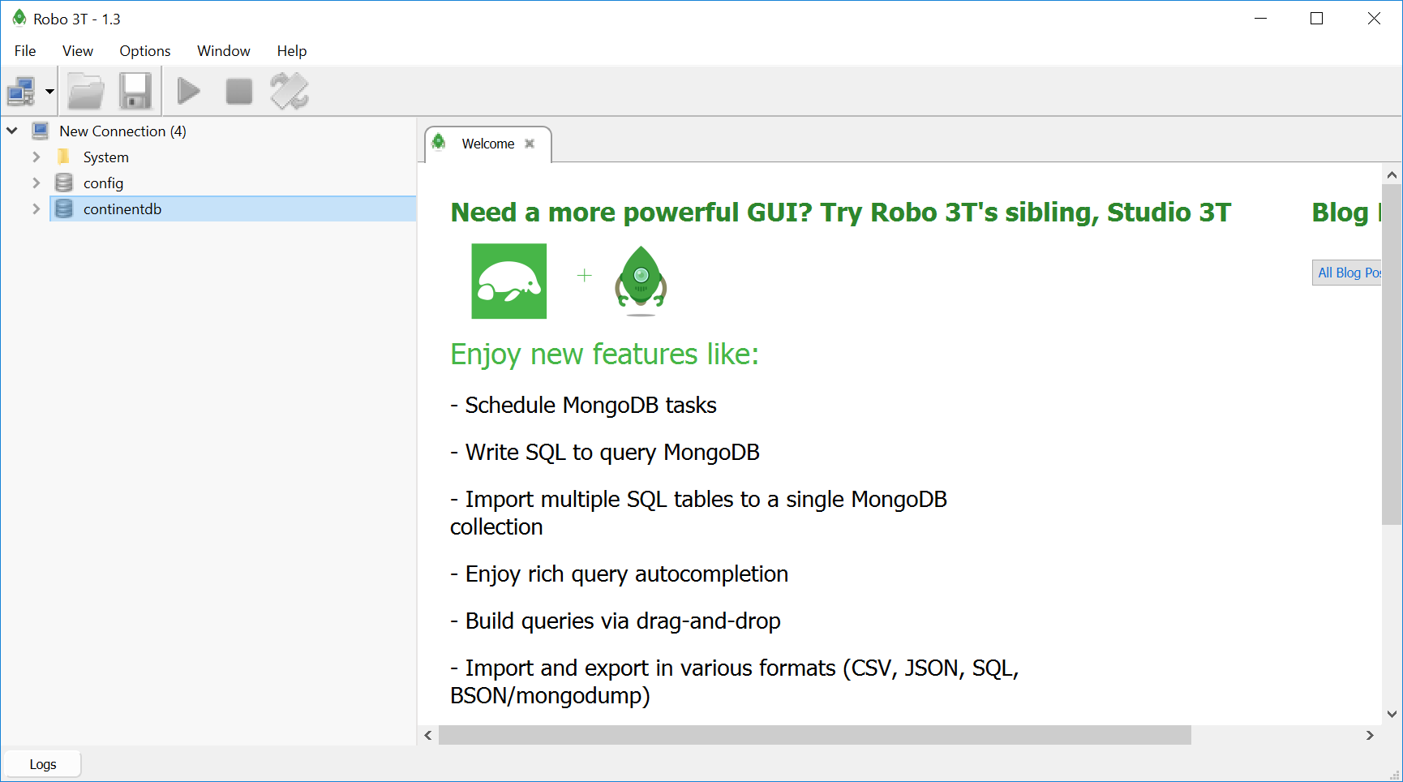

Step2: Created collection and inserted provided json data.

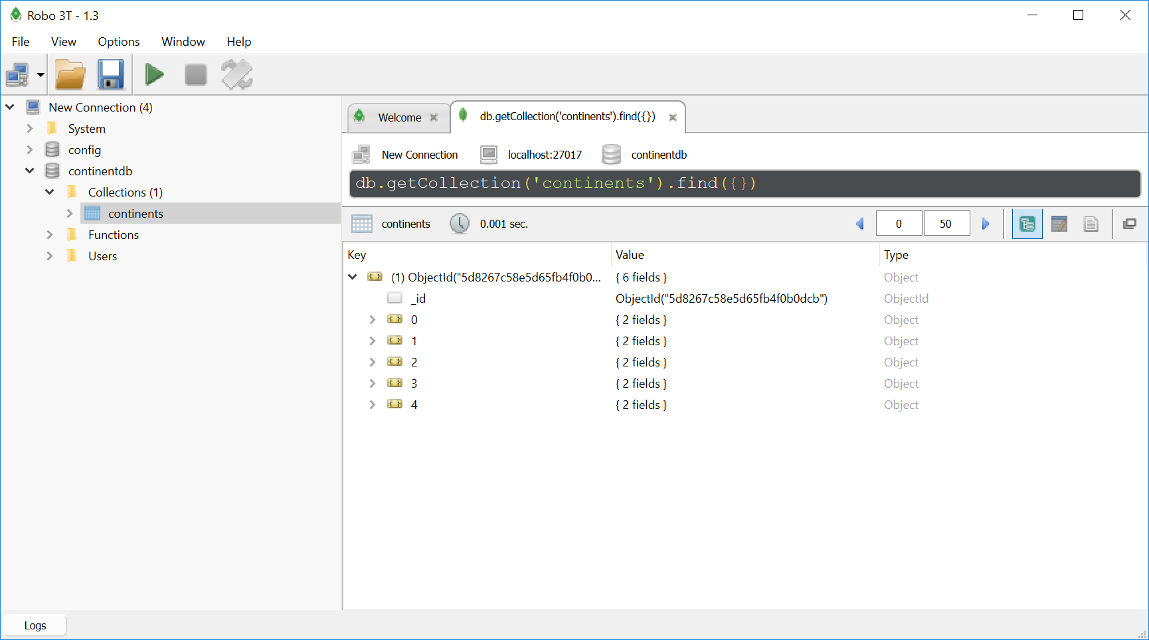

Step3: Created Springboot project as below.

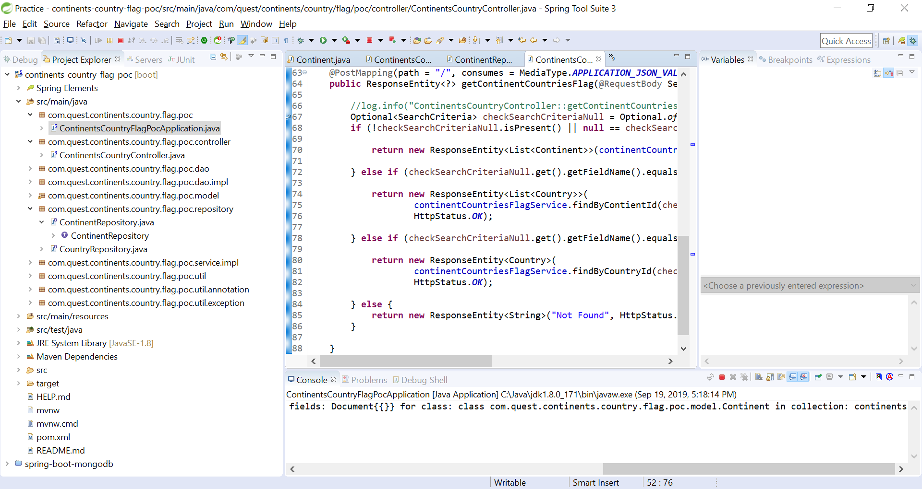

Step4: Maven build

Step5: Unit Test.