**GCP-** **Diageo Dashboard Screens**

The following screens are showcased in the Diageo dashboard:

* **Screen 1:** Price Forecast
* **Screen 2:** Forecast Accuracy
* **Screen 3:** Key Variables

1. **Screen 1: Price Forecast**

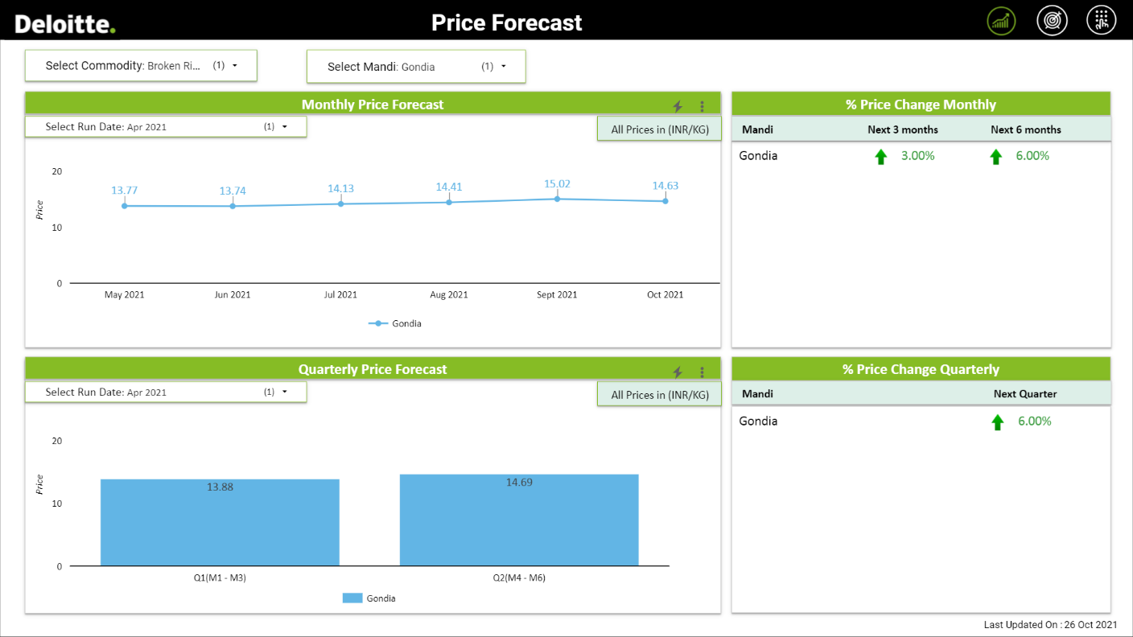

**1.1**

**1.2**

**1.4**

**1.3**

This screen emphasizes on the output generated by the AI/ML models.

* 1. **Commodity Selection:** The drop down allows to select a commodity, for this case it is set to Broken Rice by default.
  2. **Mandi Selection:** The drop down allows to select a Mandi for which the results are to be displayed. By default, Gondia Mandi is selected and multiple selection can be done to compare results of various Mandis.
  3. **Monthly Forecast & Price Change:** The top half of the screen shows monthly results for price forecast and % change in prices at different frequencies. The plot shows price forecast for the next 6 months from the selected Run Date. The % price change table displays the change in forecasted price after the next 3 and 6 months.
  4. **Quarterly Forecast & Price Change:** The bottom half of the screen displays the average of monthly forecasts (populated in above graph) as quarters. Q1 is the average of forecasts for the 1st 3 months and Q2 is for the last 3 months. The % price change table displays the change in prices observed between 2 quarters.

1. **Screen 2: Forecast Accuracy**

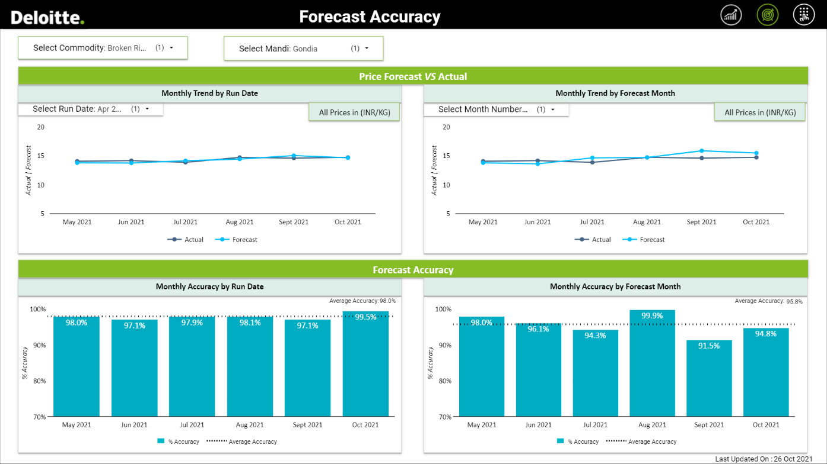

**2.3**

**2.4**

**2.2**

**2.1**

As a next step after model building, model accuracy is obtained to evaluate its performance. This screen emphasizes on the model assessment.

* 1. **Commodity Selection:** The drop down allows to select a commodity, for this case it is set to Broken Rice by default.
  2. **Mandi Drop Selection:** The drop down allows to select a Mandi for which the results are to be displayed. By default, Gondia Mandi is selected.
  3. **By Run Date:** The left half of the screen displays two charts for assessing the model robustness **based on Run Dates.** We can observe the trend of the forecast vs actual values at the top and the corresponding accuracies for the chosen run date at the bottom. The dotted line in the accuracy chart depicts the average of next 6-month accuracies.
  4. **By Forecast Month:** The right half of the screen displays two charts for assessing the model robustness **by Forecast Month**. This view would help to see the forecast/accuracies at the Month 1 to Month 6 level, irrespective of run dates. We can observe the trend of the forecast vs actual values at the top and the corresponding accuracies for the chosen month at the bottom. The dotted line in the accuracy chart depicts the average accuracy of the chosen month (For e.g., if Month 1 is selected, the dotted line would indicate the average of all Month 1 accuracies)

1. **Screen 3: Key Variables**

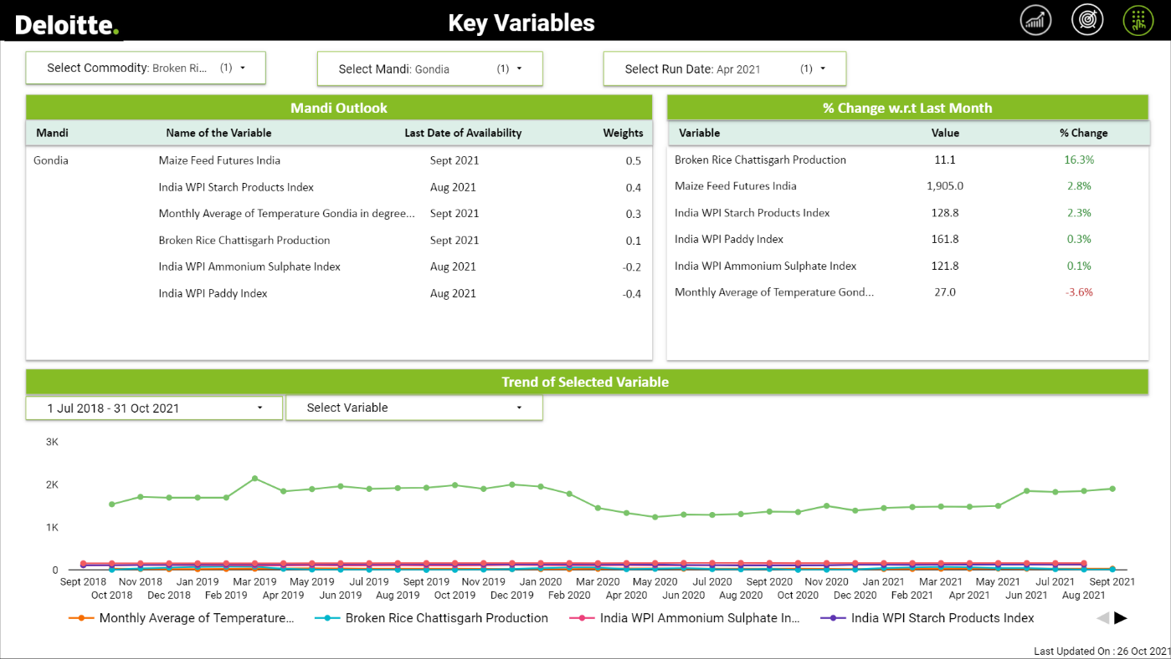

**3.6**

**3.2**

**3.3**

**3.5**

**3.4**

**3.1**

This screen emphasizes on the variables that were used to generate forecasts.

* 1. **Commodity Selection:** The drop down allows to select a commodity, for this case it is set to Broken Rice by default.
  2. **Mandi Drop Selection:** The drop down allows to select a Mandi for which the results are to be displayed. By default, Gondia Mandi is selected.
  3. **Run Date Selection:** The drop down allows to select a Run Date for which we want to see the results in this screen.
  4. **Mandi Outlook**: This table shows the set of variables that are highly significant in the model along with the weights (coefficient/relative importance). Weight (x) can be interpreted as: 1-unit change in the value of independent, would lead to a corresponding change of ‘x’ units in dependent, where x is the magnitude of the weight. The sign of the weights means the directional change in the dependent, for e.g., weight of 0.4 will indicate increase by 0.4 units in dependent, however, a weight of (0.4) will indicate a decrease in price of dependent by 0.4 units. In addition to that, the last availability of the given factor is displayed. This is the primary table to observe the trend of any variable by clicking on the name of the variable. Last data of availability in this table is according to the run date selected.
  5. **% Change w.r.t Last Month:** This tables displays the latest value of the variable along with the % change compared to its last month value.
  6. **Trend of Selected Variable:** The plot helps us to understand the trend of the chosen variable in the last three years. The ‘Select Variable’ control in this chart allows to select the variables for which we want to observe the trend. To reset the control, click on the ‘-‘ sign beside Select Variable in the drop-down.