====[]====JAVASCRIPT====[]====

STRING
- Write string with 3 methods : “double quotes” , ‘single quote ’ , ` backtick`

NUMBER
- int(33) , float (21.5) , NaN(Not a Number) , Infinity(∞)

UNDEFINED VS NULL
- Undefined – Undefined
- Null – Nothing inside/Null

OBJECT
- Proprieties and atributes
- {name:’cat’, age:3}
- Ex: let gamer_pc = {
cpu:'Intel i9-12900k',
mobo:'Rog strix z690',
ram:'64gb ddr5 6000mhz',
gpu:'RTX 3090 24gb',
psu:'Corsair 1200w platinum',
ssd:'Aorus 2tb m.2',
case:'Cooler Master C700p full tower',
cooling:'Cooler Master Ml360r RGB'
}
VARIABLES
- var x = “value”

- const – constant
- var is global, hoisting(scope to global), can be acessed before declarated
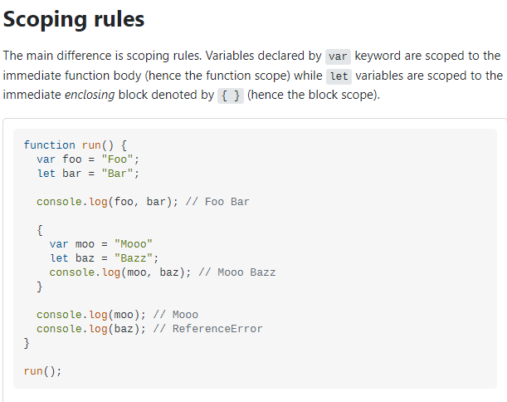
- let is local, only works in his scope, can’t be acessed before declarared

- variables are case-sensitive and acepts accent(unicode characters too) and $ in the start

- concatenation – (“potato” + price + “dollars”)
- interpolation – (“potato ${price} dollars”)

- Array > const x =[“element1”,”element2”]

FUNCTIONS
- Expression Functions > function[name](parameter1){statements}

- Ex: var x = function(y){return y * y;}

- Functions are hoisted

- Arrow function const [name] = (parameter) => {statements}

- Callback function >call a function inside other function

- Function Person(name){}

- Constructor > const John = new Person(“John”)
> Construct a Person() called “John”

- Constructor > const Joao = new Person(“Joao”)
> Construct a Person() called “Joao”

PROTOTYPE
- “name”.__proto__
> Acess “name” proprieties
- JS prototype-based language
- Prototype chain

TYPE CONVERSION & TYPE COERSION
- Type conversion(typecasting) > change one type of data into another type of data
> Number
- Number(“123”) > converts to number 123
- String(123) > converts to string “123”

MANIPULATING STRINGS AND ARRAYS
- let word = “Potato” > word.length > 6
- let number = 1234 > number.length > 4

- let number = 554.4443 > number.toFixed(2) > 554.44
> Change the size of the decimal part

- let num = 54.223 > num.toFixed(2).replace(“.”,”,”) > “54,22”
> Change decimal part and replaces “.” to “,”
> Change number to string

- toUpperCase() > Upper case
- toLowerCase() > Lower case

- let phrase = “I want to believe”
- let array1 = phrase.split(“ ”)
> Splits by space
- let phrase2 = phrase1.join(“_”)
> Joins the words with “_”

- let phrase.includes(“name”)
> Search by the parameter and returns if has the word or it doesn’t have (true or false)
- let myArray = new Array(‘a’,’b’,’c’)
> Create a new array

- let word = “Potato”
- Array.from(word)
> Create an Array using string(string to array)

- let techs = [“html”,”css”,”js”]
- techs.push(“node.js”)
> Insert a object at the end of the array
- techs.unshift(“node.js”)
> Insert a object at the beginning of the array
- techs.pop()
> Remove a object at the end of the array
- techs.shift()
> Remove a object at the beginning of the array
- techs.slice(1,2)
> Show the objects in the range
- techs.splice(1,2)
> Remove the objects in the range
- let index = techs.indexOff(‘css’)
> Show the index of the object

EXPRESSIONS AND OPERATORS
- let food = new String('Potato')
- food.cook = "Fried"

- typeof > type of anything
- delete food.cook > delete an object property

- “==” > equals to
- “!=” > different to

- “===” > strictly equal to
- “!==” > strictly different to
> Compares value and type

- && > AND
- || > OR
- ! > NOT

