Quiz-3 HTML 5, Date: 08/10/2018

1. Make A Layout using DIV and external CSS like bellow:

|  |  |
| --- | --- |
| Logo | **IDB-BISEW IT ScholarShip Project** |
| Un Order List | **List/Table /Form Display Here through iframe** |
| Table |
| Form |
| 2018 All Rights reserved. | **Mr. Shetu, ID: 12345678, Round: 39** |

1. Make an un-ordered list

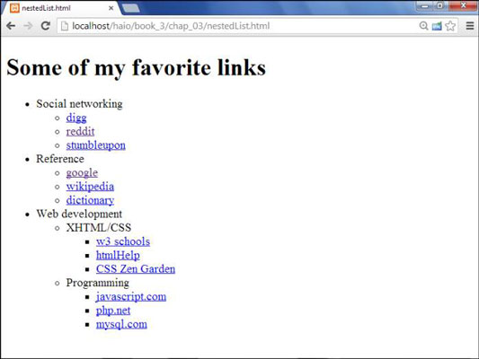

1. Make a Table similar to following one.

|  |  |  |  |  |  |  |
| --- | --- | --- | --- | --- | --- | --- |
|  |  |  |  |  |  |  |
|  |  |  | |  |  |  |
|  |  |  |
|  |  |  |  |  |
|  |  |  |  |  |

Or

|  |  |  |  |  |  |  |  |
| --- | --- | --- | --- | --- | --- | --- | --- |
| **Java Inc.** | | | | | | | |
| S.L | **Personal Details** | | **Financial Details** | | | | Comments |
| Name | ID | Salary | Paid | Due | Balance (Due) |
| 1 | Mr. X | 123456 | 120000.00 | 100000.00 | 20000.00 | ***20000.00*** | ***Due By October 15, 18*** |
| 1 | Mr. X | 123456 | 120000.00 | 100000.00 | 20000.00 | ***20000.00*** | ***Due By October 15, 18*** |
| ***Total dues*:** | | | | | | ***40000.00*** |  |

1. Make a Form like bellow:

Name:

ID:

Gender: Male Female

Completed Module: One Two Three Four

Round: Select A Round

Comments:

**Clear**

**Submit**