1.What is the function of wait() and notify ()?

### **1) wait() method**

Causes current thread to release the lock and wait until either another thread invokes the notify() method or the notifyAll() method for this object, or a specified amount of time has elapsed.

### **2) notify() method**

Wakes up a single thread that is waiting on this object's monitor. If any threads are waiting on this object, one of them is chosen to be awakened. The choice is arbitrary and occurs at the discretion of the implementation.

2.What is Deadlock?

Deadlock can occur in a situation when a thread is waiting for an object lock, that is acquired by another thread and second thread is waiting for an object lock that is acquired by first thread. Since, both threads are waiting for each other to release the lock, the condition is called deadlock.

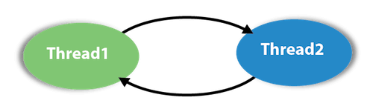

3.What is stream ? How you classify them?

Introduced in Java 8, the Stream API is used to process collections of objects. A stream is a sequence of objects that supports various methods which can be pipelined to produce the desired result.

Note: a stream can be defined as a sequence of data.

**Types of Streams**

The java.io package contains a large number of stream classes that provide capabilities for processing all types of data. These classes may be categorized into two groups based on the data type on which they operate.

* **Byte stream classes**
* **Character stream classes**

## **Reading and Writing Files**

As described earlier, a stream can be defined as a sequence of data. The **InputStream** is used to read data from a source and the **OutputStream** is used for writing data to a destination.

Here is a hierarchy of classes to deal with Input and Output streams.

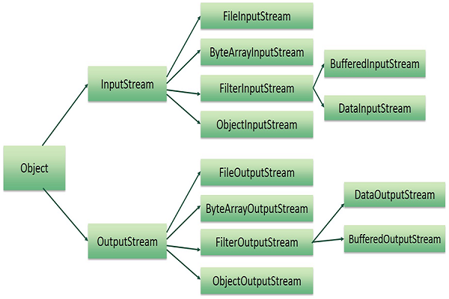

4.What is collection? Write the type of collection.

The **Collection in Java** is a framework that provides an architecture to store and manipulate the group of objects.

Java Collections can achieve all the operations that you perform on a data such as searching, sorting, insertion, manipulation, and deletion.

Write the type of collection.

* Set
* **Queue**
* **List**
* **Stack**
* **PriorityQueues**

5.What is event handler?

Event Handling is the mechanism that controls the event and decides what should happen if an event occurs. This mechanism has a code which is known as an event handler, that is executed when an event occurs.

6.What is the advantage of adapter class? Write down three adapter class.

Advantages of an Adapter Class:

* If a class extends an Adapter Class, we can override some methods which is needed;
* It can simplify the creation of the Event handlers in certain situations;
* It provides an empty implementation of all methods in an EventListener Methods.

**Advantages of the Adapter class**

* Assists unrelated classes to work together.
* Provides a way to use classes in multiple ways.
* Increases the transparency of classes.
* Its provides a way to include related patterns in a class.
* It provides a pluggable kit for developing applications.
* It makes a class highly reusable.

three adapter class

* FocusAdapter
* WindowAdapter
* KeyAdapter
* MouseAdapter
* MouseMotionAdapterS
* MouseInputAdapter

7.What is the feature of Swing?

* Java swing components are **platform-independent**.
* Swing components are **lightweight**.
* Swing **supports pluggable look and feel**.
* Swing provides **more powerful components** such as tables, lists, scrollpanes, colorchooser, tabbedpane etc.

8.What is layout manager?

The layout manager automatically positions all the components within the container. Even if you do not use the layout manager, the components are still positioned by the default layout manager. It is possible to lay out the controls by hand, however, it becomes very difficult.

Layout managers are

*BorderLayout

*CardLayout

*GridLayout

# 9.What are the two ways of creating thread?

There are two ways to create a thread:

1. By extending Thread class
2. By implementing Runnable interface.