Motion Detection System using Arduino and PIR Sensor
School Project Documentation
Submitted by: _______________________
Class: _____________________________
Date: _____________________________

Abstract
This project demonstrates a simple motion detection system using an Arduino Uno and a Passive Infrared (PIR) sensor. The system detects motion in its surroundings and activates an LED when movement is detected. Such systems are commonly used in security, automation, and energy-efficient lighting applications.

Introduction
In today’s world, automation and security are of great importance. Motion detection systems play a vital role in these fields. The Arduino-based motion detection system utilizes a PIR sensor to detect infrared radiation emitted by moving bodies. When motion is detected, the Arduino turns on an LED as a visual indicator.

Components Required
1. Arduino Uno Board
2. PIR (Passive Infrared) Sensor
3. LED
4. 220Ω Resistor
5. Jumper Wires
6. Breadboard
7. USB Cable for Programming

Circuit Diagram
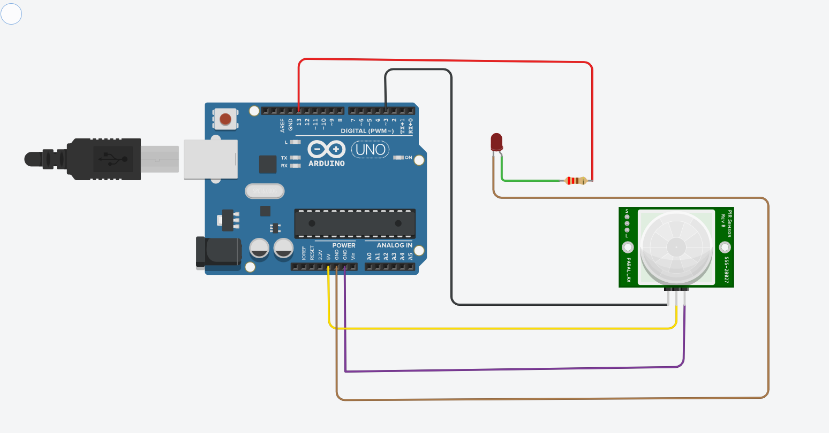
The PIR sensor is connected to the Arduino Uno as follows:
- VCC of PIR → 5V on Arduino
- GND of PIR → GND on Arduino
- OUT of PIR → Digital Pin 2 on Arduino
An LED is connected to Digital Pin 13 with a 220Ω resistor in series.

Arduino Code
Below is the complete Arduino sketch used in this project:
int pirPin = 3; // PIR sensor output pin
int ledPin = 13; // LED pin
void setup() {
pinMode(pirPin, INPUT);
pinMode(ledPin, OUTPUT);
Serial.begin(9600);
}
void loop() {
int motion = digitalRead(pirPin);
if (motion == HIGH) { // If motion detected
digitalWrite(ledPin, HIGH); // Turn LED ON
Serial.println("Motion detected!");
} else {
digitalWrite(ledPin, LOW); // Turn LED OFF
Serial.println("No motion");
}
delay(500);
}

Code Explanation
1. The PIR sensor output is connected to a digital pin of the Arduino.
2. The LED pin is set as an output to indicate motion.
3. When motion is detected, the PIR sensor sends a HIGH signal to the Arduino.
4. The Arduino then turns ON the LED to indicate motion.
5. When there is no motion, the signal goes LOW and the LED turns OFF.

Working Principle
The PIR sensor detects infrared radiation emitted by objects in motion. When a moving object such as a human passes in front of the sensor, the infrared radiation pattern changes, triggering the sensor’s output. This signal is then read by the Arduino, which turns ON the LED to indicate motion.

Applications
1. Home and office security systems
2. Automatic lighting systems
3. Motion-activated alarms
4. Smart automation projects

Conclusion
This project successfully demonstrates how a PIR sensor and Arduino can be combined to create a basic motion detection system. The system is simple, cost-effective, and can be easily expanded into more advanced applications such as alarm systems or automatic lighting controls.

