Project Documentation: Fantastic Gaaris

1. Objective
The aim of this project is to design an automatic lighting system using Arduino. The system uses a PIR (Passive Infrared) sensor to detect human motion and an LDR (Light Dependent Resistor) to measure ambient light intensity. The LED automatically lights up when motion is detected in a dark environment.

2. Components Required
- Arduino Uno
- PIR Motion Sensor
- LDR (Light Dependent Resistor)
- LED
- 2 Resistors (10kΩ for LDR, 220Ω for LED)
- Jumper Wires
- Breadboard

3. Circuit Diagram
The following image shows the circuit diagram created in Tinkercad.
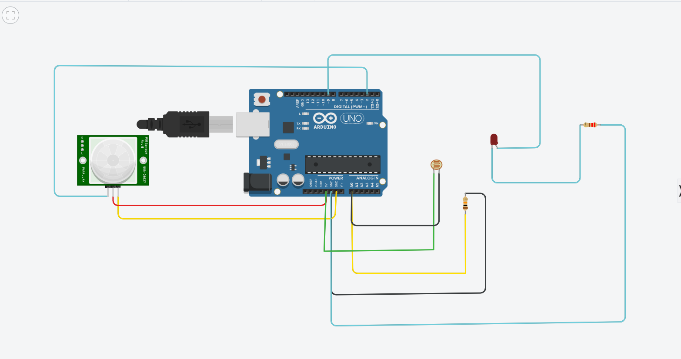

4. Working Principle
The LDR measures the surrounding light level. If it detects a dark environment (low light value), the system then checks for motion using the PIR sensor. If motion is detected, the LED turns on to provide illumination. When no motion is detected or if the environment is bright enough, the LED remains off. This setup conserves energy by ensuring the LED only operates when necessary.

5. Code Explanation
The Arduino sketch begins by defining the sensor and LED pins. In the setup() function, the PIR and LED pins are configured as INPUT and OUTPUT respectively, and serial communication is initialized.
In the loop() function, the Arduino continuously reads values from the LDR (using analogRead) and the PIR sensor (using digitalRead). It then prints both values to the Serial Monitor for debugging. If the light value indicates darkness (e.g., below a threshold of 700) and motion is detected, the LED lights up at full brightness using analogWrite(). Otherwise, the LED is turned off.

6. Conclusion
This project demonstrates a simple and efficient automatic lighting system using Arduino. By combining the PIR motion sensor and the LDR light sensor, the system only activates when both conditions—darkness and motion—are met. Such a system is ideal for home automation and energy-saving applications.

7. Full Arduino Code
int LDR = A0; // Light sensor pin
int PIR = 2; // PIR sensor pin
int LED = 9; // LED output pin
void setup() {
pinMode(PIR, INPUT);
pinMode(LED, OUTPUT);
Serial.begin(9600);
}
void loop() {
int lightValue = analogRead(LDR);
int motion = digitalRead(PIR);
Serial.print("Light: ");
Serial.print(lightValue);
Serial.print(" | Motion: ");
Serial.println(motion);
// Adjust brightness based on conditions
if (lightValue > 700) { // dark condition (tune this threshold)
if (motion == HIGH) {
analogWrite(LED, 255); // Full brightness
} else {
analogWrite(LED, 100); // Dim
}
} else {
analogWrite(LED, 0); // Turn off during day
}
delay(500);
}

