

**Project Proposal**

Course Code: CIS232

Course Title: Operating Systems

**Submitted to**

Ms. Sonia Nasrin

Lecturer

Department of CIS

Daffodil International University

**Submitted by**

Motiullah Sajit

222-16-663

Department of CIS

Daffodil International University

Date of Submission 03.08.2023

Project Proposal

Title: Number Guessing Adventure

1. Background:

Command-line interfaces (CLIs) are the heart of Linux systems, offering a robust set of tools for users and administrators. This project builds upon the idea of combining the excitement of a number guessing game with the practicality of learning Linux shell commands in an engaging and interactive manner. The unique feature of this project is the addition of a multiplayer mode, fostering competition and collaboration among players.

2. Function List:

a. Number Guessing Gameplay:

- Engaging number guessing game with varying difficulty levels.

- Integration of Linux shell commands into the game's challenges and puzzles.

b. Shell Command Simulation:

- A virtual Linux terminal within the game where players input Linux shell commands.

- A diverse set of Linux shell commands integrated into the game's progression.

- Realistic command execution results and feedback within the game.

c. Educational Content:

- Detailed explanations of Linux shell commands, their usage, and relevance within the game.

- Hints and tips to help players learn Linux concepts while playing.

d. Gamification:

- Points, rewards, and achievements for correct guesses and effective command usage.

- Difficulty levels catering to beginners and advanced users.

e. Progress Tracking:

- Player profiles with progress tracking and game statistics.

- Leaderboards showcasing top-performing players in both single-player and multiplayer modes.

f. User Interface:

- An intuitive and user-friendly command-line interface with a clear number guessing game component.

- ASCII art and color coding for an immersive experience.

g. Multiplayer Mode:

- Real-time multiplayer mode allowing players to challenge each other.

- Competitive number guessing challenges with leaderboards for individual and team rankings.

- Collaborative Linux command tasks that encourage teamwork and problem-solving.

- In-game chat functionality for communication between players.

- Team formation and joining options to facilitate cooperative play.

h. Platform Compatibility:

- Ensure compatibility with various Linux distributions.

3. UML Model:

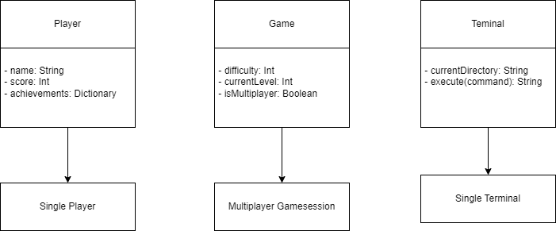

4. Tools:

a. Shell Scripting: Utilization of Bash or another shell scripting language for game logic, command-line simulation, and random number generation.

b. Text Editors: Vi, Nano, or other preferred Linux text editors.

c. Version Control: Git for code management and collaboration.

d. UML Modeling: Tools like draw.io or UMLet for creating UML diagrams.

5. Project Requirements:

To successfully develop the Linux Shell Game: The Command-Line Number Guessing Adventure - Multiplayer Edition, the following requirements must be met:

a. Linux Compatibility: Ensure the game functions seamlessly on various Linux distributions without external dependencies.

b. Command-Line Accuracy: Accurately simulate Linux shell commands and their behavior within the game.

c. Educational Content: Provide comprehensive explanations and tutorials for each command, emphasizing their relevance in the game.

d. User Experience: Develop the game to deliver an enjoyable and intuitive user experience for players of all skill levels.

e. Progress Tracking: Implement a system to track player progress and achievements in both the number guessing game and Linux shell command usage.

Conclusion:

The Linux Shell Game: The Command-Line Number Guessing Adventure - Multiplayer Edition project aims to offer a unique and enriched learning experience by gamifying Linux shell commands through an exciting number guessing adventure with a competitive and collaborative multiplayer mode. The inclusion of multiplayer functionality enhances player engagement and interaction, making it an exceptional educational and entertainment tool for Linux enthusiasts of all backgrounds and skill levels.