

**Lab Report**

Course Code: CIS216L

Course Title: Object Oriented Programming Lab

**Submitted to**

Mr. Md. Faruk Hosen

Lecturer

Department of CIS

Daffodil International University

**Submitted by**

Motiullah Sajit

222-16-663

Department of CIS

Daffodil International University

Date of Submission 13.09.2023

**Level-1: Let’s program**

1.Write a program to get the following output. Hey there, I am data!

Code:

class Problem1 {

    public static void main(String[] args) {

            System.out.println("Hello there,\nI am data!");

    }

}

Output:

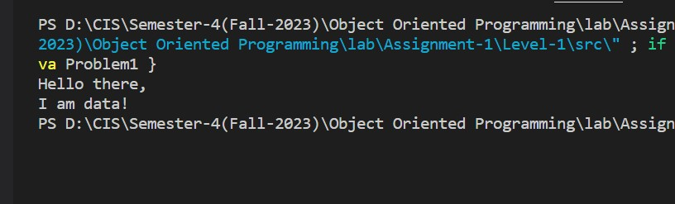

2. Write a program to print

*

**

***

****

on screen.

Code:

public class Problem2 {

    public static void main(String[] args) {

        int rows = 4;

        for (int i = 1; i <= rows; i++) {

            for (int j = 1; j <= i; j++) {

                System.out.print("*");

            }

            System.out.println();

        }

    }

}

Output:

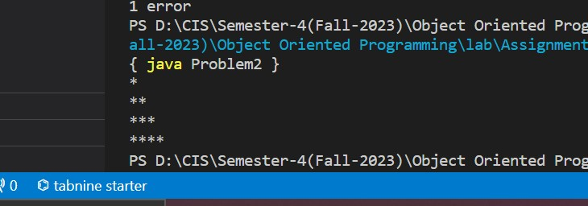

3. Print the following pattern on the screen

*****

***

*

***

*****

Code:

public class Problem3 {

    public static void main(String[] args) {

        int n = 5;

        for (int i = 1; i <= n; i += 2) {

            for (int j = 1; j <= (n - i) / 2; j++) {

                System.out.print(" ");

            }

            for (int k = 1; k <= i; k++) {

                System.out.print("*");

            }

            System.out.println();

        }

        for (int i = n - 2; i >= 1; i -= 2) {

            for (int j = 1; j <= (n - i) / 2; j++) {

                System.out.print(" ");

            }

            for (int k = 1; k <= i; k++) {

                System.out.print("*");

            }

            System.out.println();

        }

    }

}

Output:

4. Write a program to print the sum of the numbers 2, 4 and 5.

Code:

public class Problem4 {

    public static void main(String[] args) {

        int number1 = 2;

        int number2 = 4;

        int number3 = 5;

        int sum = number1 + number2 + number3;

        System.out.println("The sum of " + number1 + ", " + number2 + ", and " + number3 + " is: " + sum);

    }

}

Output:

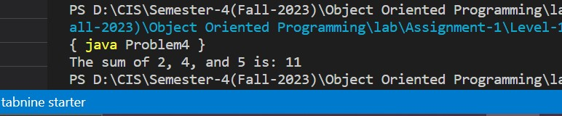

5. Write a program to print the difference and product of the numbers 45 and 32

Code:

public class Problem5 {

    public static void main(String[] args) {

        int number1 = 45;

        int number2 = 32;

        int difference = number1 - number2;

        int product = number1 * number2;

        System.out.println("The difference of " + number1 + " and " + number2 + " is: " + difference);

        System.out.println("The product of " + number1 + " and " + number2 + " is: " + product);

    }

}

Output:

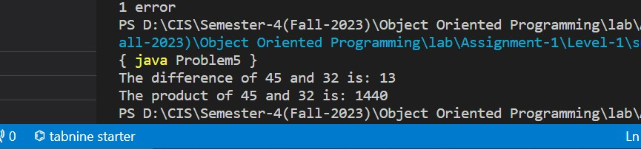

**Level-2: Know Data-types**

1. Write a Java program to print an int, a double and a char on screen.

Code:

public class Problem1 {

    public static void main(String[] args) {

        int intValue = 42;

        double doubleValue = 3.14;

        char charValue = 'A';

        System.out.println("Integer value: " + intValue);

        System.out.println("Double value: " + doubleValue);

        System.out.println("Character value: " + charValue);

    }

}

Output:

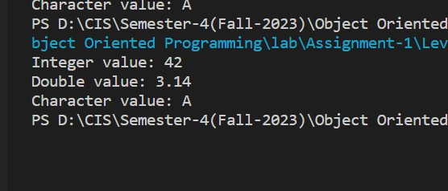

2. Write a program to print the area of a rectangle of sides 2 and 3 units respectively.

Code:

public class Problem2 {

    public static void main(String[] args) {

        double length = 2.0;

        double width = 3.0;

        double area = length * width;

        System.out.println("The area of the rectangle is: " + area + " square units");

    }

}

Output:

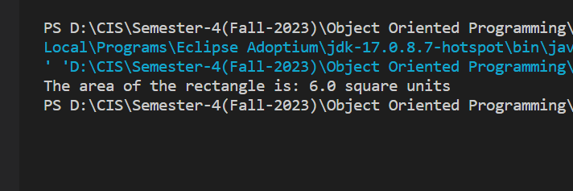

3. Write a program to print the product of the numbers 8.2 and 6.

Code:

public class Problem3 {

    public static void main(String[] args) {

        double num1 = 8.2;

        double num2 = 6.0;

        double product = num1 * num2;

        System.out.println("The product of " + num1 + " and " + num2 + " is: " + product);

    }

}

Output:

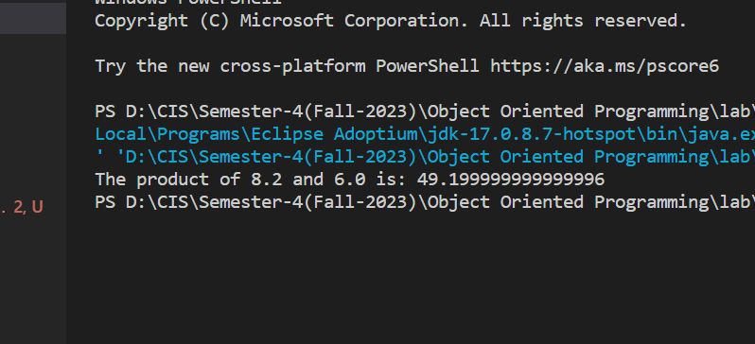

4. Print the ASCII value of the character 'h'.

Code:

public class Problem4 {

    public static void main(String[] args) {

        char character = 'h';

        int asciiValue = (int) character;

        System.out.println("The ASCII value of 'h' is: " + asciiValue);

    }

}

Output:

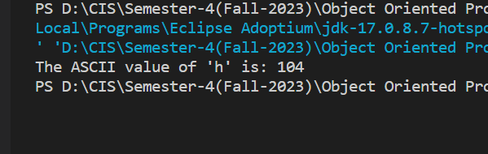

5. Write a program to assign a value of 100.235 to a double variable and then convert it to int.

Code:

public class Problem5 {

    public static void main(String[] args) {

        double doubleValue = 100.235;

        int intValue = (int) doubleValue;

        System.out.println("Double value: " + doubleValue);

        System.out.println("Integer value after conversion: " + intValue);

    }

}

Output:

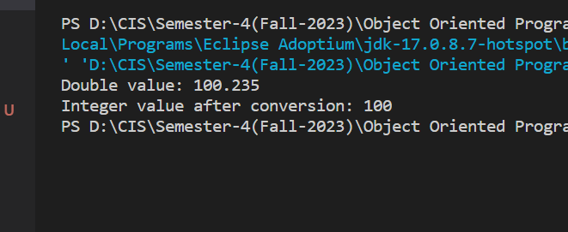

6. Write a program to add 3 to the ASCII value of the character 'd' and print the equivalent character.

Code:

public class Problem6 {

    public static void main(String[] args) {

        char character = 'd';

        int asciiValue = (int) character;

        int newAsciiValue = asciiValue + 3;

        char newCharacter = (char) newAsciiValue;

        System.out.println("Original character: " + character);

        System.out.println("ASCII value of 'd': " + asciiValue);

        System.out.println("New character: " + newCharacter);

    }

}

Output:

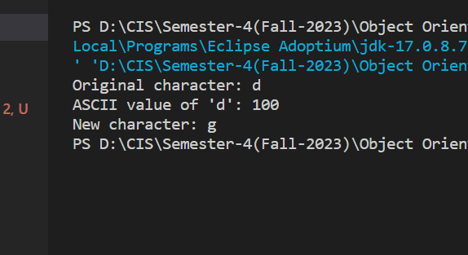

7. Write a program to add an integer variable having value 5 and a double variable having value 6.2.

Code:

public class Problem7 {

    public static void main(String[] args) {

        int intValue = 5;

        double doubleValue = 6.2;

        double sum = intValue + doubleValue;

        System.out.println("Integer value: " + intValue);

        System.out.println("Double value: " + doubleValue);

        System.out.println("Sum: " + sum);

    }

}

Output:

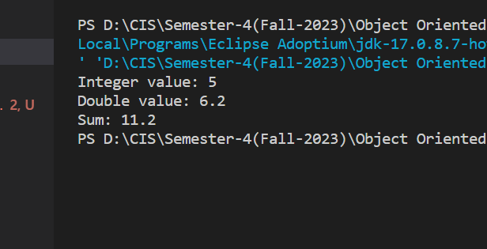

8. Write a program to find the square of the number 3.9.

Code:

public class Problem8 {

    public static void main(String[] args) {

        double number = 3.9;

        double square = number * number;

        System.out.println("The square of " + number + " is: " + square);

    }

}

Output:

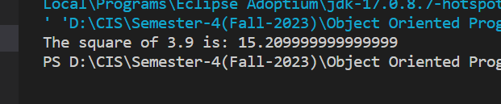

**Level 3: Java Operators**

1. Length and breadth of a rectangle are 5 and 7 respectively. Write a program to calculate the area and perimeter of the rectangle

Code:

public class Problem1 {

    public static void main(String[] args) {

        double length = 5.0;

        double breadth = 7.0;

        double area = length * breadth;

        double perimeter = 2 * (length + breadth);

        System.out.println("Length of the rectangle: " + length + " units");

        System.out.println("Breadth of the rectangle: " + breadth + " units");

        System.out.println("Area of the rectangle: " + area + " square units");

        System.out.println("Perimeter of the rectangle: " + perimeter + " units");

    }

}

Output:

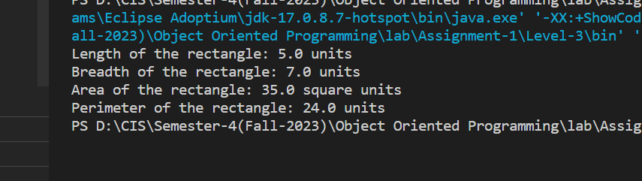

2. Write a program to calculate the perimeter of a triangle having sides of length 2,3 and 5 units

Code:

public class Problem2 {

    public static void main(String[] args) {

        double side1 = 2.0;

        double side2 = 3.0;

        double side3 = 5.0;

        double perimeter = side1 + side2 + side3;

        System.out.println("Side 1 length: " + side1 + " units");

        System.out.println("Side 2 length: " + side2 + " units");

        System.out.println("Side 3 length: " + side3 + " units");

        System.out.println("Perimeter of the triangle: " + perimeter + " units");

    }

}

Output:

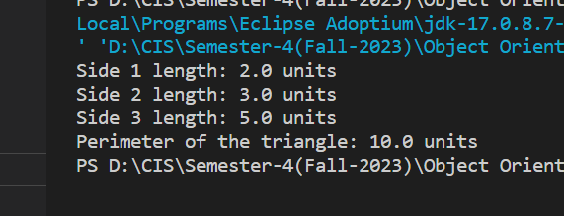

3. Write a program to add 8 to the number 2345 and then divide it by 3. Now, the modulus of the quotient is taken with 5 and then multiply the resultant value by 5. Display the final result

Code:

public class Problem3 {

    public static void main(String[] args) {

        int number = 2345;

        int result = (((number + 8) / 3) % 5) * 5;

        System.out.println("Final result: " + result);

    }

}

Output:

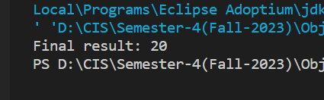

4. Now, solve the above question using assignment operators (eg. +=, -=, *=)

Code:

public class Problem4 {

    public static void main(String[] args) {

        int number = 2345;

        number += 8;

        number /= 3;

        number %= 5;

        number *= 5;

        System.out.println("Final result: " + number);

    }

}

Output:

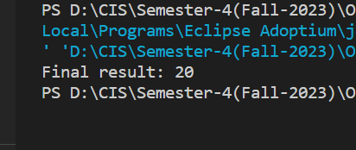

5. Write a program to check if the two numbers 23 and 45 are equal

Code:

public class Problem5 {

    public static void main(String[] args) {

        int num1 = 23;

        int num2 = 45;

        if (num1 == num2) {

            System.out.println("The numbers are equal.");

        } else {

            System.out.println("The numbers are not equal.");

        }

    }

}

Output:

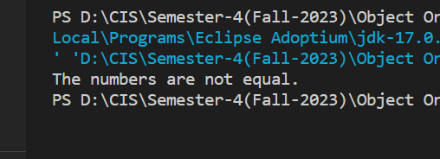

6. Write a program to print the power of 7 raised to 5

Code:

public class Problem6 {

    public static void main(String[] args) {

        int base = 7;

        int exponent = 5;

        long result = 1;

        for (int i = 0; i < exponent; i++) {

            result *= base;

        }

        System.out.println("7 raised to the power of 5 is: " + result);

    }

}

Output:

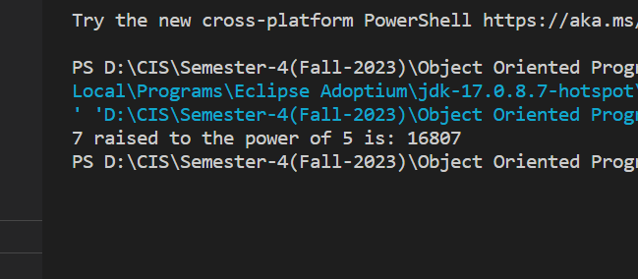

7. Assign values of variables 'a' and 'b' as 55 and 70 respectively and then check if both the conditions 'a < 50' and 'a < b' are true

Code:

public class Problem7 {

    public static void main(String[] args) {

        int a = 55;

        int b = 70;

        boolean condition1 = a < 50;

        boolean condition2 = a < b;

        if (condition1 && condition2) {

            System.out.println("Both conditions are true.");

        } else {

            System.out.println("At least one condition is false.");

        }

    }

}

Output:

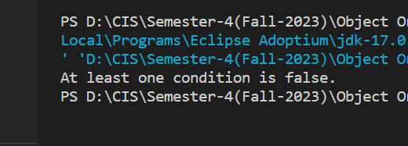

8. Now solve the above question to check if atleast one of the conditions 'a < 50' or 'a < b' is true

Code:

public class Problem8 {

    public static void main(String[] args) {

        int a = 55;

        int b = 70;

        boolean condition1 = a < 50;

        boolean condition2 = a < b;

        if (condition1 || condition2) {

            System.out.println("At least one condition is true.");

        } else {

            System.out.println("Both conditions are false.");

        }

    }

}

Output:

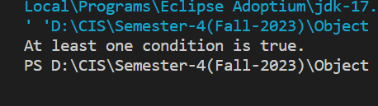

9. If the marks of Robert in three subjects are 78,45 and 62 respectively (each out of 100 ), write a program to calculate his total marks and percentage marks.

Code:

public class Problem9 {

    public static void main(String[] args) {

        int subject1Marks = 78;

        int subject2Marks = 45;

        int subject3Marks = 62;

        int totalMarks = subject1Marks + subject2Marks + subject3Marks;

        int maxMarksPerSubject = 100;

        double percentage = (double) totalMarks / (3 * maxMarksPerSubject) * 100;

        System.out.println("Marks in Subject 1: " + subject1Marks);

        System.out.println("Marks in Subject 2: " + subject2Marks);

        System.out.println("Marks in Subject 3: " + subject3Marks);

        System.out.println("Total Marks: " + totalMarks);

        System.out.println("Percentage Marks: " + percentage + "%");

    }

}

Output:

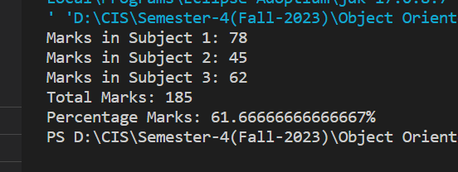

10. Suppose the values of variables 'a' and 'b' are 6 and 8 respecrtively, write two programs to swap the values of the two variables. 1 - first program by using a third variable 2 - second program without using any third variable

Code:

public class Problem101 {

    public static void main(String[] args) {

        int a = 6;

        int b = 8;

        int temp;

        System.out.println("Before swapping:");

        System.out.println("a = " + a);

        System.out.println("b = " + b);

        temp = a;

        a = b;

        b = temp;

        System.out.println("\nAfter swapping using a third variable:");

        System.out.println("a = " + a);

        System.out.println("b = " + b);

    }

}

public class Problem102 {

    public static void main(String[] args) {

        int a = 6;

        int b = 8;

        System.out.println("Before swapping:");

        System.out.println("a = " + a);

        System.out.println("b = " + b);

        a = a + b;

        b = a - b;

        a = a - b;

        System.out.println("\nAfter swapping without using a third variable:");

        System.out.println("a = " + a);

        System.out.println("b = " + b);

    }

}

Output:

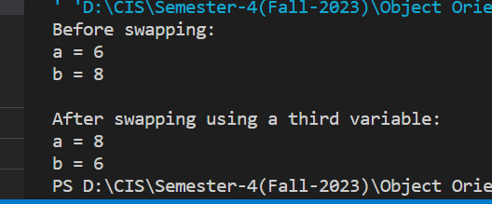

11. Write a program to convert Fahrenheit into Celsius

Code:

public class Problem11 {

    public static void main(String[] args) {

        double fahrenheit = 98.6;

        double celsius = (fahrenheit - 32) * 5/9;

        System.out.println(fahrenheit + " degrees Fahrenheit is equal to " + celsius + " degrees Celsius.");

    }

}

Output:

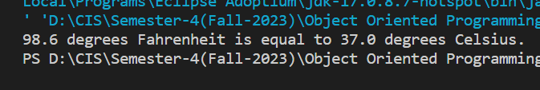

12. The total number of students in a class are 90 out of which 45 are boys. If 50% of the total students secured grade 'A' out of which 20 are boys, then write a program to calculate the total number of girls getting grade 'A'

Code:

public class Problem12 {

    public static void main(String[] args) {

        int totalStudents = 90;

        int totalBoys = 45;

        double percentageGradeA = 50.0;

        int gradeABoys = 20;

        double totalGradeA = (percentageGradeA / 100) * totalStudents;

        int totalGirls = totalStudents - totalBoys;

        int gradeAGirls = (int) (totalGradeA - gradeABoys);

        System.out.println("Total number of girls getting grade 'A': " + gradeAGirls);

    }

}

Output:

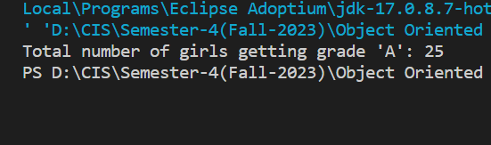

13. Write a program to calculate the sum of the first and the second last digit of a 5 digit. E.g.- NUMBER : 12345 OUTPUT : 1+4=5

Code:

import java.util.Scanner;

public class Problem13 {

     public static void main(String[] args) {

        Scanner scanner = new Scanner(System.in);

        System.out.print("Enter a 5-digit number: ");

        int number = scanner.nextInt();

        scanner.close();

        if (number >= 10000 && number <= 99999) {

            int firstDigit = number / 10000;

            int secondLastDigit = (number / 10) % 10;

            int sum = firstDigit + secondLastDigit;

            System.out.println("Sum of the first and second last digit: " + sum);

        } else {

            System.out.println("Please enter a valid 5-digit number.");

        }

    }

}

Output:

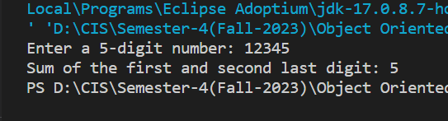

14. Take a 4 digit number. Write a program to display a number whose digits are 2 greater than the corresponding digits of the number TAKEN

Code:

import java.util.Scanner;

public class Problem14 {

    public static void main(String[] args) {

        Scanner scanner = new Scanner(System.in);

        System.out.print("Enter a 4-digit number: ");

        int originalNumber = scanner.nextInt();

        scanner.close();

        if (originalNumber >= 1000 && originalNumber <= 9999) {

            int digit1 = (originalNumber / 1000 + 2) % 10;

            int digit2 = ((originalNumber / 100) % 10 + 2) % 10;

            int digit3 = ((originalNumber / 10) % 10 + 2) % 10;

            int digit4 = (originalNumber % 10 + 2) % 10;

            int resultNumber = digit1 * 1000 + digit2 * 100 + digit3 * 10 + digit4;

            System.out.println("Original number: " + originalNumber);

            System.out.println("Displayed number: " + resultNumber);

        } else {

            System.out.println("Please enter a valid 4-digit number.");

        }

    }

}

Output:

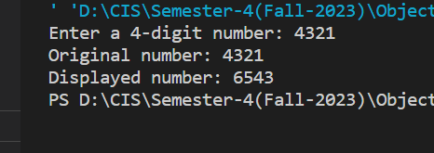

15. Take a 4 digit number. Write a program to display a number whose digits are 2 greater than the corresponding digits of the number TAKEN

Code:

import java.util.Scanner;

public class Problem15 {

    public static void main(String[] args) {

        Scanner scanner = new Scanner(System.in);

        System.out.print("Enter a 3-digit number: ");

        int number = scanner.nextInt();

        scanner.close();

        if (number >= 100 && number <= 999) {

            int digit1 = number / 100;

            int digit2 = (number / 10) % 10;

            int digit3 = number % 10;

            int sum = digit1 + digit2 + digit3;

            System.out.println("Sum of the digits: " + sum);

        } else {

            System.out.println("Please enter a valid 3-digit number.");

        }

    }

}

Output:

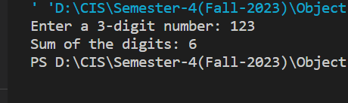

16. Write a program to reverse a 3-digit number. E.g.-Number : 132 Output : 231

Code:

import java.util.Scanner;

public class Problem16 {

     public static void main(String[] args) {

        Scanner scanner = new Scanner(System.in);

        System.out.print("Enter a 3-digit number: ");

        int number = scanner.nextInt();

        scanner.close();

        if (number >= 100 && number <= 999) {

            int digit1 = number / 100;

            int digit2 = (number / 10) % 10;

            int digit3 = number % 10;

            int reversedNumber = digit3 * 100 + digit2 * 10 + digit1;

            System.out.println("Original number: " + number);

            System.out.println("Reversed number: " + reversedNumber);

        } else {

            System.out.println("Please enter a valid 3-digit number.");

        }

    }

}

Output:

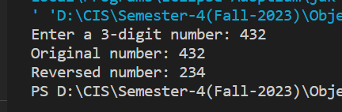

**Level 4: Input by user**

1. Write a program to take two integer inputs from user and print sum and product of them.

Code:

import java.util.Scanner;

public class Problem1 {

    public static void main(String[] args) {

        Scanner scanner = new Scanner(System.in);

        System.out.print("Enter the first integer: ");

        int num1 = scanner.nextInt();

        System.out.print("Enter the second integer: ");

        int num2 = scanner.nextInt();

        scanner.close();

        int sum = num1 + num2;

        int product = num1 * num2;

        System.out.println("Sum: " + sum);

        System.out.println("Product: " + product);

    }

}

Output:

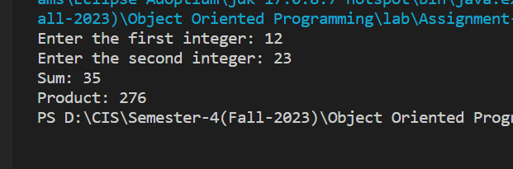

2. Take two integer inputs from user. First calculate the sum of two then product of two. Finally, print the sum and product of both obtained results

Code:

import java.util.Scanner;

public class Problem2 {

     public static void main(String[] args) {

        Scanner scanner = new Scanner(System.in);

        System.out.print("Enter the first integer: ");

        int num1 = scanner.nextInt();

        System.out.print("Enter the second integer: ");

        int num2 = scanner.nextInt();

        int sum = num1 + num2;

        int product = num1 * num2;

        int sumOfResults = sum + product;

        int productOfResults = sum * product;

        System.out.println("Sum of the two numbers: " + sum);

        System.out.println("Product of the two numbers: " + product);

        System.out.println("Sum of results: " + sumOfResults);

        System.out.println("Product of results: " + productOfResults);

        scanner.close();

    }

}

Output:

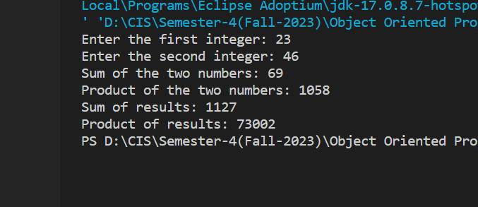

3. Ask user to give two double input for length and breadth of a rectangle and print area type casted to int.

Code:

import java.util.Scanner;

public class Problem3 {

     public static void main(String[] args) {

        Scanner scanner = new Scanner(System.in);

        System.out.print("Enter the length of the rectangle: ");

        double length = scanner.nextDouble();

        System.out.print("Enter the breadth of the rectangle: ");

        double breadth = scanner.nextDouble();

        double area = length * breadth;

        int areaAsInteger = (int) area;

        System.out.println("Area of the rectangle (type-casted to int): " + areaAsInteger);

        scanner.close();

    }

}

Output:

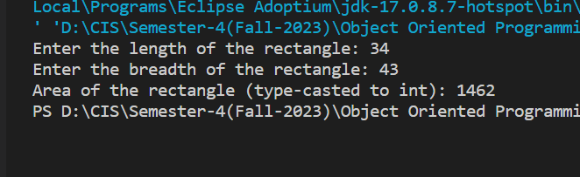

4. Take name, roll number and field of interest from user and print in the format below : Hey, my name is xyz and my roll number is xyz. My field of interest are xyz.

Code:

import java.util.Scanner;

public class Problem4 {

    public static void main(String[] args) {

        Scanner scanner = new Scanner(System.in);

        System.out.print("Enter your name: ");

        String name = scanner.nextLine();

        System.out.print("Enter your roll number: ");

        String rollNumber = scanner.nextLine();

        System.out.print("Enter your field of interest: ");

        String fieldOfInterest = scanner.nextLine();

        System.out.println("Hey, my name is " + name + " and my roll number is " + rollNumber + ". My field of interest is " + fieldOfInterest + ".");

        scanner.close();

    }

}

Output:

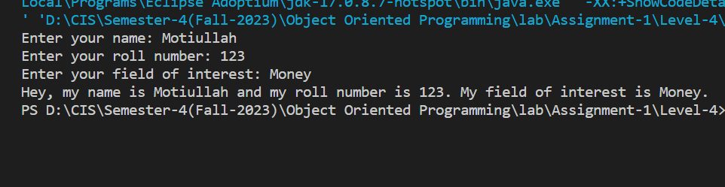

5. Take side of a square from user and print area and perimeter of it.

Code:

import java.util.Scanner;

public class Problem5 {

    public static void main(String[] args) {

        Scanner scanner = new Scanner(System.in);

        System.out.print("Enter the side length of the square: ");

        double sideLength = scanner.nextDouble();

        double area = sideLength * sideLength;

        double perimeter = 4 * sideLength;

        System.out.println("Area of the square: " + area);

        System.out.println("Perimeter of the square: " + perimeter);

        scanner.close();

    }

}

Output:

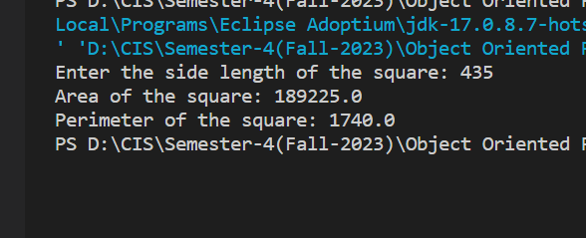

6. Write a program to find square of a number. E.g.- INPUT : 2 OUTPUT : 4 INPUT : 5 OUTPUT : 25

Code:

import java.util.Scanner;

public class Problem6 {

    public static void main(String[] args) {

        Scanner scanner = new Scanner(System.in);

        System.out.print("Enter a number: ");

        double number = scanner.nextDouble();

        double square = number * number;

        System.out.println("Square of the number: " + square);

        scanner.close();

    }

}

Output:

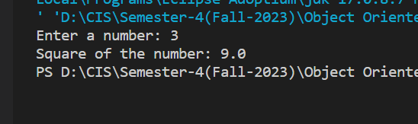

7. Take two different string input and print them in same line

Code:

import java.util.Scanner;

public class Problem7 {

    public static void main(String[] args) {

        Scanner scanner = new Scanner(System.in);

        System.out.print("Enter the first string: ");

        String firstString = scanner.nextLine();

        System.out.print("Enter the second string: ");

        String secondString = scanner.nextLine();

        String concatenatedString = firstString + secondString;

        System.out.println("Concatenated string: " + concatenatedString);

        scanner.close();

    }

}

Output:

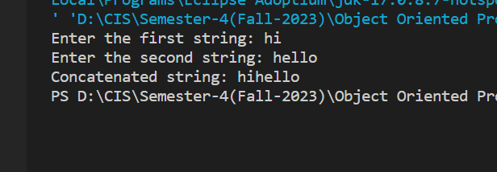

8. Take 3 inputs from user and check : all are equal any of two are equal

Code:

import java.util.Scanner;

public class Problem8 {

    public static void main(String[] args) {

        Scanner scanner = new Scanner(System.in);

        System.out.print("Enter the first number: ");

        int num1 = scanner.nextInt();

        System.out.print("Enter the second number: ");

        int num2 = scanner.nextInt();

        System.out.print("Enter the third number: ");

        int num3 = scanner.nextInt();

        boolean allEqual = num1 == num2 && num2 == num3;

        boolean anyTwoEqual = num1 == num2 || num1 == num3 || num2 == num3;

        if (allEqual) {

            System.out.println("All three numbers are equal.");

        } else if (anyTwoEqual) {

            System.out.println("Any two of the three numbers are equal.");

        } else {

            System.out.println("None of the numbers are equal.");

        }

        scanner.close();

    }

}

Output:

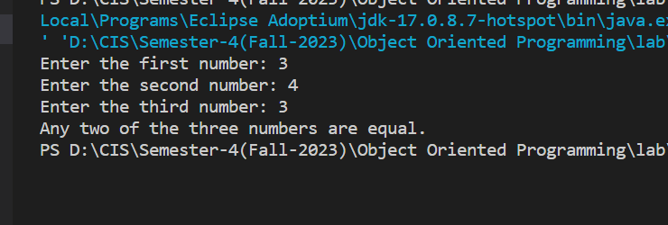

9. Write a program to enter the values of two variables 'a' and 'b' from keyboard and then check if both the conditions 'a < 50' and 'a < b' are true

Code:

import java.util.Scanner;

public class Problem9 {

    public static void main(String[] args) {

        Scanner scanner = new Scanner(System.in);

        System.out.print("Enter the value of 'a': ");

        int a = scanner.nextInt();

        System.out.print("Enter the value of 'b': ");

        int b = scanner.nextInt();

        boolean condition1 = a < 50;

        boolean condition2 = a < b;

        if (condition1 && condition2) {

            System.out.println("Both conditions are true.");

        } else {

            System.out.println("At least one condition is false.");

        }

        scanner.close();

    }

}

Output:

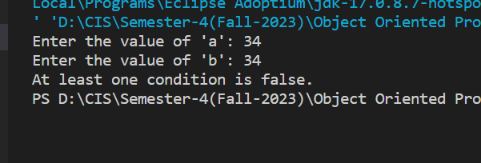

10. If the marks of Robert in three subjects are entered through keyboard (each out of 100 ), write a program to calculate his total marks and percentage marks.

Code:

import java.util.Scanner;

public class Problem10 {

     public static void main(String[] args) {

        Scanner scanner = new Scanner(System.in);

        System.out.print("Enter the marks for the first subject (out of 100): ");

        int subject1Marks = scanner.nextInt();

        System.out.print("Enter the marks for the second subject (out of 100): ");

        int subject2Marks = scanner.nextInt();

        System.out.print("Enter the marks for the third subject (out of 100): ");

        int subject3Marks = scanner.nextInt();

        int totalMarks = subject1Marks + subject2Marks + subject3Marks;

        double percentageMarks = (totalMarks / 300.0) * 100.0;

        System.out.println("Total Marks: " + totalMarks);

        System.out.println("Percentage Marks: " + percentageMarks + "%");

        scanner.close();

    }

}

Output:

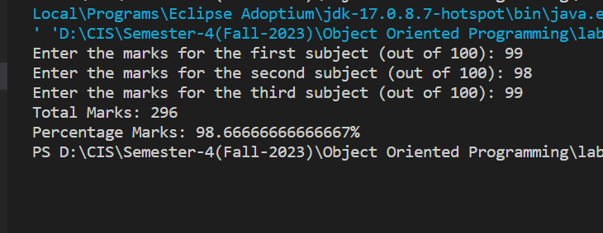

**Level 5: Decide if or else**

1. Take values of length and breadth of a rectangle from user and check if it is square or not.

Code:

import java.util.Scanner;

public class Problem1 {

     public static void main(String[] args) {

        Scanner scanner = new Scanner(System.in);

        System.out.print("Enter the length of the rectangle: ");

        double length = scanner.nextDouble();

        System.out.print("Enter the breadth of the rectangle: ");

        double breadth = scanner.nextDouble();

        boolean isSquare = length == breadth;

        if (isSquare) {

            System.out.println("It is a square.");

        } else {

            System.out.println("It is not a square.");

        }

        scanner.close();

    }

}

Output:

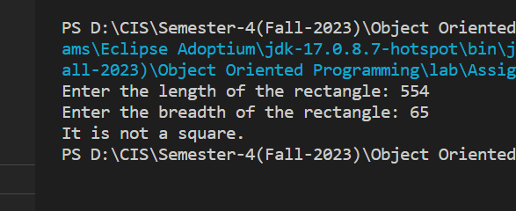

2. Take two int values from user and print greatest among them.

Code:

import java.util.Scanner;

public class Problem2 {

     public static void main(String[] args) {

        Scanner scanner = new Scanner(System.in);

        System.out.print("Enter the first integer: ");

        int num1 = scanner.nextInt();

        System.out.print("Enter the second integer: ");

        int num2 = scanner.nextInt();

        int greatest = (num1 > num2) ? num1 : num2;

        System.out.println("The greatest number is: " + greatest);

        scanner.close();

    }

}

Output:

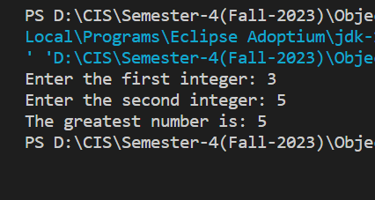

3. A shop will give discount of 10% if the cost of purchased quantity is more than 1000. Ask user for quantity Suppose, one unit will cost 100. Judge and print total cost for user

Code:

import java.util.Scanner;

public class Problem3 {

    public static void main(String[] args) {

        Scanner scanner = new Scanner(System.in);

        System.out.print("Enter the quantity of units purchased: ");

        int quantity = scanner.nextInt();

        int unitCost = 100;

        int totalCost = quantity * unitCost;

        if (totalCost > 1000) {

            double discount = 0.10 * totalCost;

            totalCost -= discount;

        }

        System.out.println("Total cost for the user: " + totalCost);

        scanner.close();

    }

}

Output:

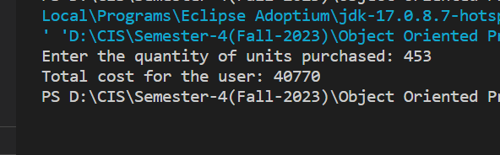

4. A company decided to give bonus of 5% to employee if his/her year of service is more than 5 years. Ask user for their salary and year of service and print the net bonus amount

Code:

import java.util.Scanner;

public class Problem4 {

      public static void main(String[] args) {

        Scanner scanner = new Scanner(System.in);

        System.out.print("Enter your salary: ");

        double salary = scanner.nextDouble();

        System.out.print("Enter your years of service: ");

        int yearsOfService = scanner.nextInt();

        double bonus = 0.0;

        if (yearsOfService > 5) {

            bonus = 0.05 * salary;

        }

        System.out.println("Net bonus amount: " + bonus);

        scanner.close();

    }

}

Output:

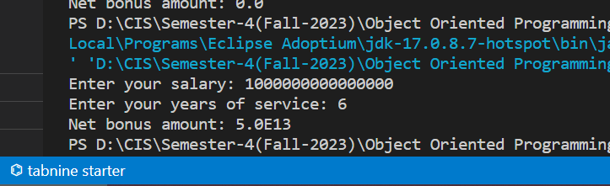

5. A school has following rules for grading system: a. Below 25 - F b. 25 to 45 - E c. 45 to 50 - D d. 50 to 60 - C e. 60 to 80 - B f. Above 80 - A Ask user to enter marks and print the corresponding grade

Code:

import java.util.Scanner;

public class Problem5 {

    public static void main(String[] args) {

        Scanner scanner = new Scanner(System.in);

        System.out.print("Enter your marks: ");

        int marks = scanner.nextInt();

        char grade;

        if (marks < 25) {

            grade = 'F';

        } else if (marks >= 25 && marks < 45) {

            grade = 'E';

        } else if (marks >= 45 && marks < 50) {

            grade = 'D';

        } else if (marks >= 50 && marks < 60) {

            grade = 'C';

        } else if (marks >= 60 && marks < 80) {

            grade = 'B';

        } else {

            grade = 'A';

        }

        System.out.println("Your grade: " + grade);

        scanner.close();

    }

}

Output:

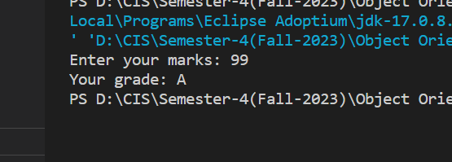

6. Take input of age of 3 people by user and determine oldest and youngest among them.

Code:

import java.util.Scanner;

public class Problem6 {

    public static void main(String[] args) {

        Scanner scanner = new Scanner(System.in);

        System.out.print("Enter the age of person 1: ");

        int age1 = scanner.nextInt();

        System.out.print("Enter the age of person 2: ");

        int age2 = scanner.nextInt();

        System.out.print("Enter the age of person 3: ");

        int age3 = scanner.nextInt();

        int oldest = Math.max(age1, Math.max(age2, age3));

        int youngest = Math.min(age1, Math.min(age2, age3));

        System.out.println("Oldest person's age: " + oldest);

        System.out.println("Youngest person's age: " + youngest);

        scanner.close();

    }

}

Output:

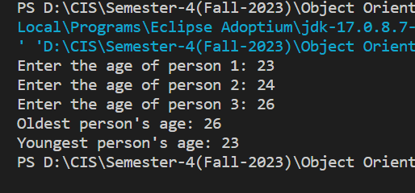

7. Write a program to print absolute vlaue of a number entered by user. E.g.- INPUT: 1 OUTPUT: 1 INPUT: -1 OUTPUT: 1

Code:

import java.util.Scanner;

public class Problem7 {

    public static void main(String[] args) {

        Scanner scanner = new Scanner(System.in);

        System.out.print("Enter a number: ");

        double number = scanner.nextDouble();

        double absoluteValue = Math.abs(number);

        System.out.println("Absolute value: " + absoluteValue);

        scanner.close();

    }

}

Output:

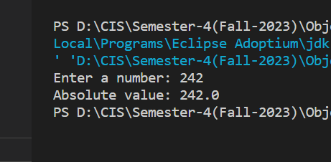

8. A student will not be allowed to sit in exam if his/her attendence is less than 75%. Take following input from user Number of classes held Number of classes attended. And print percentage of class attended Is student is allowed to sit in exam or not.

Code:

import java.util.Scanner;

public class Problem8 {

    public static void main(String[] args) {

        Scanner scanner = new Scanner(System.in);

        System.out.print("Enter the number of classes held: ");

        int totalClasses = scanner.nextInt();

        System.out.print("Enter the number of classes attended: ");

        int attendedClasses = scanner.nextInt();

        double attendancePercentage = (double) attendedClasses / totalClasses * 100.0;

        System.out.println("Percentage of classes attended: " + attendancePercentage + "%");

        if (attendancePercentage >= 75.0) {

            System.out.println("You are allowed to sit in the exam.");

        } else {

            System.out.println("You are not allowed to sit in the exam due to low attendance.");

        }

        scanner.close();

    }

}

Output:

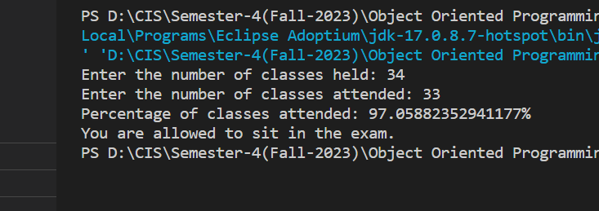

9. Modify the above question to allow student to sit if he/she has medical cause. Ask user if he/she has medical cause or not ( 'Y' or 'N' ) and print accordingly.

Code:

import java.util.Scanner;

public class Problem9 {

    public static void main(String[] args) {

        Scanner scanner = new Scanner(System.in);

        System.out.print("Enter the number of classes held: ");

        int totalClasses = scanner.nextInt();

        System.out.print("Enter the number of classes attended: ");

        int attendedClasses = scanner.nextInt();

        double attendancePercentage = (double) attendedClasses / totalClasses * 100.0;

        System.out.println("Percentage of classes attended: " + attendancePercentage + "%");

        scanner.nextLine();

        System.out.print("Do you have a medical cause? (Y/N): ");

        char medicalCause = scanner.nextLine().charAt(0);

        if (medicalCause == 'Y' || medicalCause == 'y') {

            System.out.println("You are allowed to sit in the exam due to a medical cause.");

        } else if (attendancePercentage >= 75.0) {

            System.out.println("You are allowed to sit in the exam.");

        } else {

            System.out.println("You are not allowed to sit in the exam due to low attendance.");

        }

        scanner.close();

    }

}

Output:

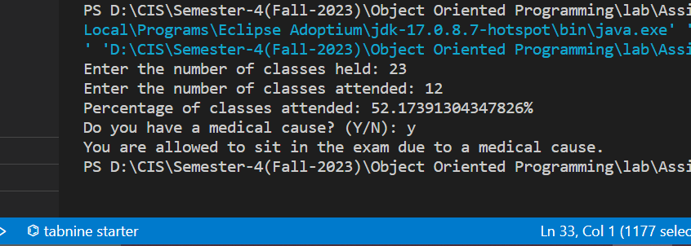

10. If x = 2 y = 5 z = 0 then find values of the following expressions: a. x == 2 b. x != 5 c. x != 5 && y >= 5 d. z != 0 || x == 2 e. !(y < 10)

Code:

public class Problem10 {

    public static void main(String[] args) {

        int x = 2;

        int y = 5;

        int z = 0;

        boolean resultA = x == 2;

        boolean resultB = x != 5;

        boolean resultC = x != 5 && y >= 5;

        boolean resultD = z != 0 || x == 2;

        boolean resultE = !(y < 10);

        System.out.println("a. x == 2: " + resultA);

        System.out.println("b. x != 5: " + resultB);

        System.out.println("c. x != 5 && y >= 5: " + resultC);

        System.out.println("d. z != 0 || x == 2: " + resultD);

        System.out.println("e. !(y < 10): " + resultE);

    }

}

Output:

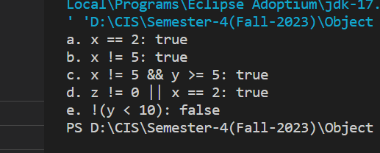

11. Write a program to check whether a entered character is lowercase ( a to z ) or uppercase ( A to Z ).

Code:

import java.util.Scanner;

public class Problem11 {

    public static void main(String[] args) {

        Scanner scanner = new Scanner(System.in);

        System.out.print("Enter a character: ");

        char ch = scanner.next().charAt(0);

        if (ch >= 'a' && ch <= 'z') {

            System.out.println("The entered character is lowercase.");

        } else if (ch >= 'A' && ch <= 'Z') {

            System.out.println("The entered character is uppercase.");

        } else {

            System.out.println("The entered character is not a letter.");

        }

        scanner.close();

    }

}

Output:

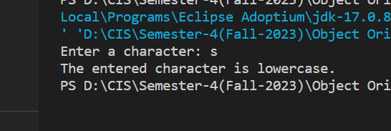

**Level 6: Loop**

1. Take 10 integers from keyboard using loop and print their average value on the screen.

Code:

import java.util.Scanner;

public class Problem1 {

    public static void main(String[] args) {

        Scanner scanner = new Scanner(System.in);

        int sum = 0;

        int count = 10;

        for (int i = 1; i <= count; i++) {

            System.out.print("Enter integer #" + i + ": ");

            int num = scanner.nextInt();

            sum += num;

        }

        double average = (double) sum / count;

        System.out.println("Average value: " + average);

        scanner.close();

    }

}

Output:

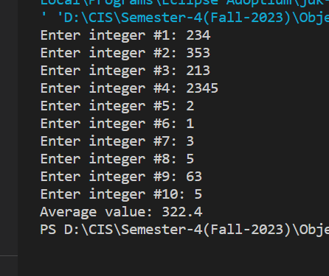

2. Print the following patterns using loop:

a.

*

**

***

****

b.

*

***

*****

***

*

c.

1010101

10101

101

1

Code:

public class Problem2a {

    public static void main(String args[]){

        for (int i = 1; i <= 4; i++) {

            for (int j = 1; j <= i; j++) {

                System.out.print("*");

            }

            System.out.println();

        }

    }

}

public class Problem2b {

    public static void main(String args[]){

        int n = 3;

        for (int i = 1; i <= n; i++) {

            for (int j = 1; j <= n - i; j++) {

                System.out.print(" ");

            }

            for (int k = 1; k <= 2 * i - 1; k++) {

                System.out.print("*");

            }

            System.out.println();

        }

        for (int i = n - 1; i >= 1; i--) {

            for (int j = 1; j <= n - i; j++) {

                System.out.print(" ");

            }

            for (int k = 1; k <= 2 * i - 1; k++) {

                System.out.print("*");

            }

            System.out.println();

        }

    }

}

public class Problem2c {

    public static void main(String args[]){

        int n = 4;

        for (int i = n; i > 0; i--) {

            for (int j = i; j < n; j++) {

                System.out.print(" ");

            }

            for (int k = 1; k <= 2 * i - 1; k++) {

                if (k % 2 == 0) {

                    System.out.print("0");

                } else {

                    System.out.print("1");

                }

            }

            System.out.println();

        }

    }

}

Output:

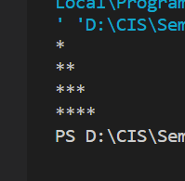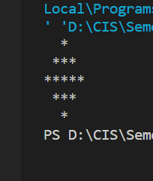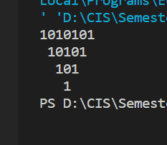

3. Print multiplication table of 24, 50 and 29 using loop.

Code:

public class Problem3 {

    public static void main(String[] args) {

        int num1 = 24;

        int num2 = 50;

        int num3 = 29;

        System.out.println("Multiplication Table of " + num1 + ":");

        for (int i = 1; i <= 10; i++) {

            System.out.println(num1 + " x " + i + " = " + (num1 * i));

        }

        System.out.println("\nMultiplication Table of " + num2 + ":");

        for (int i = 1; i <= 10; i++) {

            System.out.println(num2 + " x " + i + " = " + (num2 * i));

        }

        System.out.println("\nMultiplication Table of " + num3 + ":");

        for (int i = 1; i <= 10; i++) {

            System.out.println(num3 + " x " + i + " = " + (num3 * i));

        }

    }

}

Output:

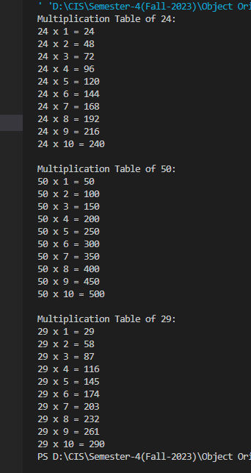

4. Print ASCII values and their equivalent characters. ASCII value vary from 0 to 255.

Code:

public class Problem4 {

    public static void main(String[] args) {

        System.out.println("ASCII Values and Their Equivalent Characters:");

        for (int i = 0; i <= 255; i++) {

            System.out.println("ASCII Value: " + i + " Character: " + (char) i);

        }

    }

}

Output:

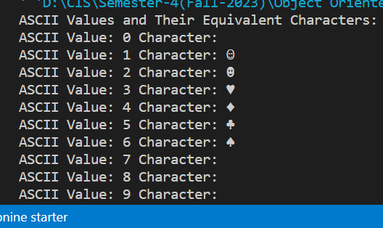

5. Factorial of any number n is represented by n! and is equal to 1*2*3*....*(n-1)*n. E.g.- 4! = 1*2*3*4 = 24 3! = 3*2*1 = 6 2! = 2*1 = 2 Also, 1! = 1 0! = 0 Write a Java program to calculate factorial of a number

Code:

import java.util.Scanner;

public class Problem5 {

    public static void main(String[] args) {

        Scanner scanner = new Scanner(System.in);

        System.out.print("Enter a non-negative integer: ");

        int n = scanner.nextInt();

        long factorial = 1;

        if (n < 0) {

            System.out.println("Factorial is not defined for negative numbers.");

        } else {

            for (int i = 1; i <= n; i++) {

                factorial *= i;

            }

            System.out.println(n + "! = " + factorial);

        }

        scanner.close();

    }

}

Output:

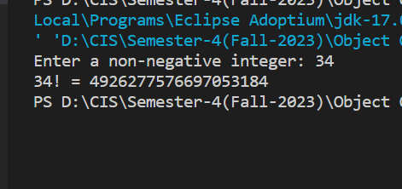

6. Write a program to find greatest common divisor (GCD) or highest common factor (HCF) of given two numbers

Code:

import java.util.Scanner;

public class Problem6 {

     public static void main(String[] args) {

        Scanner scanner = new Scanner(System.in);

        System.out.print("Enter the first number: ");

        int num1 = scanner.nextInt();

        System.out.print("Enter the second number: ");

        int num2 = scanner.nextInt();

        int gcd = findGCD(num1, num2);

        System.out.println("GCD (HCF) of " + num1 + " and " + num2 + " is: " + gcd);

        scanner.close();

    }

    public static int findGCD(int a, int b) {

        while (b != 0) {

            int temp = b;

            b = a % b;

            a = temp;

        }

        return a;

    }

}

Output:

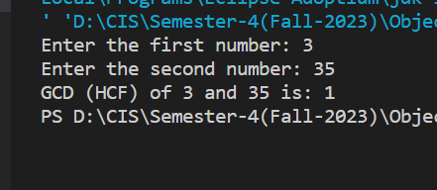

7. Take integer inputs from user until he/she presses q ( Ask to press q to quit after every integer input ). Print average and product of all numbers.

Code:

import java.util.Scanner;

public class Problem7 {

    public static void main(String[] args) {

        Scanner scanner = new Scanner(System.in);

        int sum = 0;

        int product = 1;

        int count = 0;

        while (true) {

            System.out.print("Enter an integer (or 'q' to quit): ");

            String input = scanner.next();

            if (input.equals("q")) {

                break;

            }

            try {

                int number = Integer.parseInt(input);

                sum += number;

                product *= number;

                count++;

            } catch (NumberFormatException e) {

                System.out.println("Invalid input. Please enter an integer or 'q' to quit.");

            }

        }

        if (count == 0) {

            System.out.println("No valid numbers entered.");

        } else {

            double average = (double) sum / count;

            System.out.println("Average of entered numbers: " + average);

            System.out.println("Product of entered numbers: " + product);

        }

        scanner.close();

    }

}

Output:

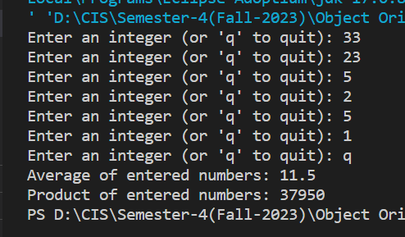

8. Write an infinite loop. A inifinte loop never ends. Condition is always true.

Code:

public class Problem8 {

    public static void main(String[] args) {

        while (true) {

            System.out.println("This is an infinite loop.");

        }

    }

}

Output:

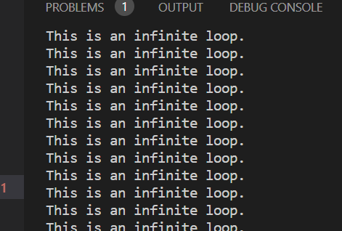

**Level 7: Have your own methods**

1. Define two methods to print the maximum and the minimum number respectively among three numbers entered by user.

Code:

import java.util.Scanner;

public class Problem1 {

     public static void main(String[] args) {

        Scanner scanner = new Scanner(System.in);

        System.out.print("Enter the first number: ");

        double num1 = scanner.nextDouble();

        System.out.print("Enter the second number: ");

        double num2 = scanner.nextDouble();

        System.out.print("Enter the third number: ");

        double num3 = scanner.nextDouble();

        double max = findMax(num1, num2, num3);

        double min = findMin(num1, num2, num3);

        System.out.println("Maximum number among the three: " + max);

        System.out.println("Minimum number among the three: " + min);

        scanner.close();

    }

    public static double findMax(double a, double b, double c) {

        double max = a;

        if (b > max) {

            max = b;

        }

        if (c > max) {

            max = c;

        }

        return max;

    }

    public static double findMin(double a, double b, double c) {

        double min = a;

        if (b < min) {

            min = b;

        }

        if (c < min) {

            min = c;

        }

        return min;

    }

}

Output:

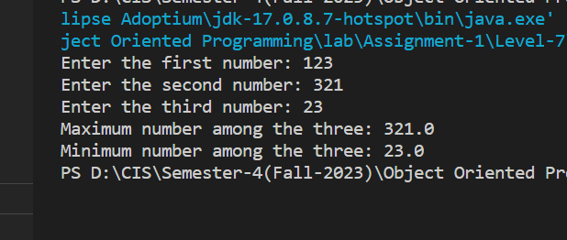

2. Define a program to find out whether a given number is even or odd.

Code:

import java.util.Scanner;

public class Problem2 {

    public static void main(String[] args) {

        Scanner scanner = new Scanner(System.in);

        System.out.print("Enter a number: ");

        int number = scanner.nextInt();

        if (isEven(number)) {

            System.out.println(number + " is even.");

        } else {

            System.out.println(number + " is odd.");

        }

        scanner.close();

    }

    public static boolean isEven(int number) {

        return number % 2 == 0;

    }

}

Output:

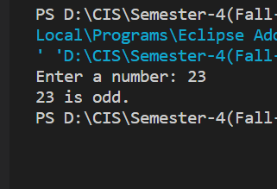

3. A person is elligible to vote if his/her age is greater than or equal to 18. Define a method to find out if he/she is elligible to vote.

Code:

import java.util.Scanner;

public class Problem3 {

    public static void main(String[] args) {

        Scanner scanner = new Scanner(System.in);

        System.out.print("Enter your age: ");

        int age = scanner.nextInt();

        if (isEligibleToVote(age)) {

            System.out.println("You are eligible to vote.");

        } else {

            System.out.println("You are not eligible to vote.");

        }

        scanner.close();

    }

    public static boolean isEligibleToVote(int age) {

        return age >= 18;

    }

}

Output:

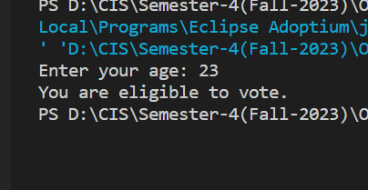

4. Write a program to print the sum of two numbers entered by user by defining your own method

Code:

import java.util.Scanner;

public class Problem4 {

    public static void main(String[] args) {

        Scanner scanner = new Scanner(System.in);

        System.out.print("Enter the first number: ");

        double num1 = scanner.nextDouble();

        System.out.print("Enter the second number: ");

        double num2 = scanner.nextDouble();

        double sum = calculateSum(num1, num2);

        System.out.println("Sum of " + num1 + " and " + num2 + " is: " + sum);

        scanner.close();

    }

    public static double calculateSum(double a, double b) {

        return a + b;

    }

}

Output:

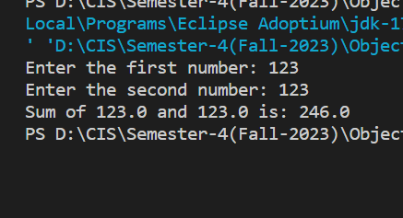

5. Define a method that returns the product of two numbers entered by user.

Code:

import java.util.Scanner;

public class Problem5 {

    public static void main(String[] args) {

        Scanner scanner = new Scanner(System.in);

        System.out.print("Enter the first number: ");

        double num1 = scanner.nextDouble();

        System.out.print("Enter the second number: ");

        double num2 = scanner.nextDouble();

        double product = calculateProduct(num1, num2);

        System.out.println("Product of " + num1 + " and " + num2 + " is: " + product);

        scanner.close();

    }

    public static double calculateProduct(double a, double b) {

        return a * b;

    }

}

Output:

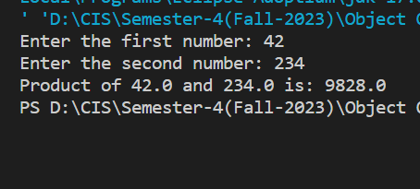

6. Define a method that returns the product of two numbers entered by user.

Code:

import java.util.Scanner;

public class Problem6 {

    public static void main(String[] args) {

        Scanner scanner = new Scanner(System.in);

        System.out.print("Enter the radius of the circle: ");

        double radius = scanner.nextDouble();

        double circumference = calculateCircumference(radius);

        double area = calculateArea(radius);

        System.out.println("Circumference of the circle: " + circumference);

        System.out.println("Area of the circle: " + area);

        scanner.close();

    }

    public static double calculateCircumference(double radius) {

        return 2 * 3.1416 * radius;

    }

    public static double calculateArea(double radius) {

        return 3.1416 * radius * radius;

    }

}

Output:

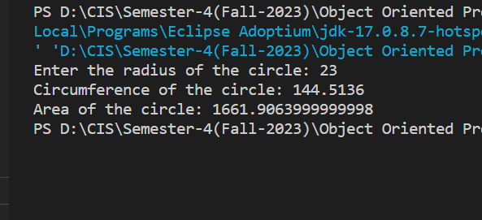

7. Define a method to find out if number is prime or not.

Code:

import java.util.Scanner;

public class Problem7 {

     public static void main(String[] args) {

        Scanner scanner = new Scanner(System.in);

        System.out.print("Enter a number: ");

        int number = scanner.nextInt();

        if (isPrime(number)) {

            System.out.println(number + " is a prime number.");

        } else {

            System.out.println(number + " is not a prime number.");

        }

        scanner.close();

    }

    public static boolean isPrime(int number) {

        if (number <= 1) {

            return false;

        }

        if (number <= 3) {

            return true;

        }

        if (number % 2 == 0 || number % 3 == 0) {

            return false;

        }

        for (int i = 5; i * i <= number; i += 6) {

            if (number % i == 0 || number % (i + 2) == 0) {

                return false;

            }

        }

        return true;

    }

}

Output:

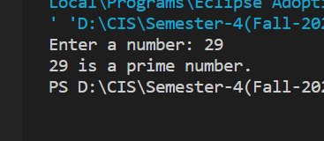

8. Write a program which will ask the user to enter his/her marks (out of 100). Define a method that will display grades according to the marks entered as below: Marks Grade 91-100 AA 81-90 AB 71-80 BB 61-70 BC 51-60 CD 41-50 DD <=40 Fail

Code:

import java.util.Scanner;

public class Problem8 {

    public static void main(String[] args) {

        Scanner scanner = new Scanner(System.in);

        System.out.print("Enter your marks (out of 100): ");

        int marks = scanner.nextInt();

        String grade = calculateGrade(marks);

        System.out.println("Grade: " + grade);

        scanner.close();

    }

    public static String calculateGrade(int marks) {

        if (marks >= 91 && marks <= 100) {

            return "AA";

        } else if (marks >= 81 && marks <= 90) {

            return "AB";

        } else if (marks >= 71 && marks <= 80) {

            return "BB";

        } else if (marks >= 61 && marks <= 70) {

            return "BC";

        } else if (marks >= 51 && marks <= 60) {

            return "CD";

        } else if (marks >= 41 && marks <= 50) {

            return "DD";

        } else {

            return "Fail";

        }

    }

}

Output:

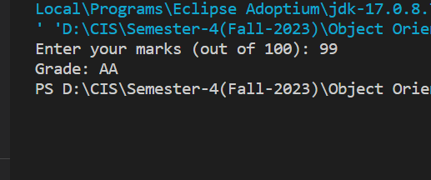

9. Write a program to print the factorial of a number by defining a method named 'Factorial'. Factorial of any number n is represented by n! and is equal to 1*2*3*....*(n-1)*n. E.g.- 4! = 1*2*3*4 = 24 3! = 3*2*1 = 6 2! = 2*1 = 2 Also, 1! = 1 0! = 0

Code:

import java.util.Scanner;

public class Problem9 {

    public static void main(String[] args) {

        Scanner scanner = new Scanner(System.in);

        System.out.print("Enter a non-negative integer: ");

        int n = scanner.nextInt();

        long factorial = calculateFactorial(n);

        System.out.println(n + "! = " + factorial);

        scanner.close();

    }

    public static long calculateFactorial(int n) {

        if (n < 0) {

            System.out.println("Factorial is not defined for negative numbers.");

            return -1;

        } else if (n == 0 || n == 1) {

            return 1;

        } else {

            long result = 1;

            for (int i = 2; i <= n; i++) {

                result *= i;

            }

            return result;

        }

    }

}

Output:

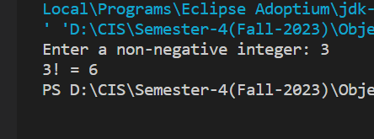

**Level 8: Java Array**

1. Take 10 integer inputs from user and store them in an array and print them on screen.

Code:

import java.util.Scanner;

public class Problem1 {

    public static void main(String[] args) {

        Scanner scanner = new Scanner(System.in);

        int[] numbers = new int[10];

        System.out.println("Enter 10 integers:");

        for (int i = 0; i < 10; i++) {

            System.out.print("Enter number " + (i + 1) + ": ");

            numbers[i] = scanner.nextInt();

        }

        System.out.println("Entered numbers:");

        for (int i = 0; i < 10; i++) {

            System.out.println("Number " + (i + 1) + ": " + numbers[i]);

        }

        scanner.close();

    }

}

Output:

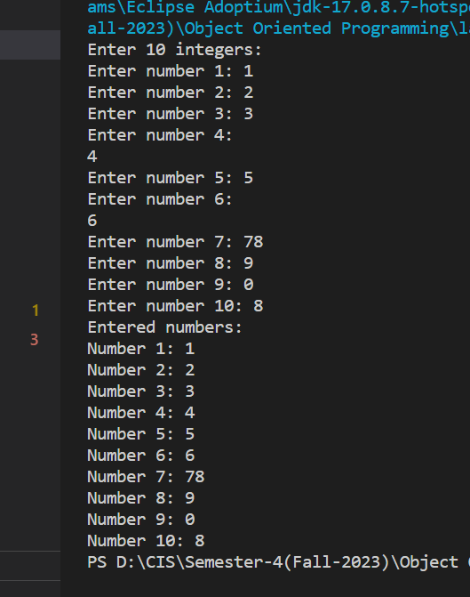

2. Take 10 integer inputs from user and store them in an array. Again ask user to give a number. Now, tell user whether that number is present in array or not.

Code:

import java.util.Scanner;

public class Problem2 {

     public static void main(String[] args) {

        Scanner scanner = new Scanner(System.in);

        int[] numbers = new int[10];

        System.out.println("Enter 10 integers:");

        for (int i = 0; i < 10; i++) {

            System.out.print("Enter number " + (i + 1) + ": ");

            numbers[i] = scanner.nextInt();

        }

        System.out.print("Enter a number to check: ");

        int numberToCheck = scanner.nextInt();

        boolean found = false;

        for (int i = 0; i < 10; i++) {

            if (numbers[i] == numberToCheck) {

                found = true;

                break;

            }

        }

        if (found) {

            System.out.println(numberToCheck + " is present in the array.");

        } else {

            System.out.println(numberToCheck + " is not present in the array.");

        }

        scanner.close();

    }

}

Output:

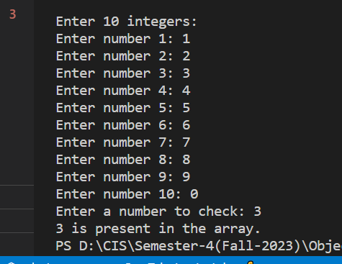

3. Take 20 integer inputs from user and print the following: number of positive numbers number of negative numbers number of odd numbers number of even numbers number of 0s.

Code:

import java.util.Scanner;

public class Problem3 {

    public static void main(String[] args) {

        Scanner scanner = new Scanner(System.in);

        int[] numbers = new int[20];

        System.out.println("Enter 20 integers:");

        for (int i = 0; i < 20; i++) {

            System.out.print("Enter number " + (i + 1) + ": ");

            numbers[i] = scanner.nextInt();

        }

        int positiveCount = 0;

        int negativeCount = 0;

        int oddCount = 0;

        int evenCount = 0;

        int zeroCount = 0;

        for (int i = 0; i < 20; i++) {

            if (numbers[i] > 0) {

                positiveCount++;

            } else if (numbers[i] < 0) {

                negativeCount++;

            }

            if (numbers[i] % 2 != 0) {

                oddCount++;

            } else {

                evenCount++;

            }

            if (numbers[i] == 0) {

                zeroCount++;

            }

        }

        System.out.println("Number of positive numbers: " + positiveCount);

        System.out.println("Number of negative numbers: " + negativeCount);

        System.out.println("Number of odd numbers: " + oddCount);

        System.out.println("Number of even numbers: " + evenCount);

        System.out.println("Number of zeros: " + zeroCount);

        scanner.close();

    }

}

Output:

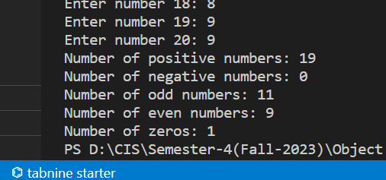

4. Take 10 integer inputs from user and store them in an array. Now, copy all the elements in an another array but in reverse order

Code:

import java.util.Scanner;

public class Problem4 {

    public static void main(String[] args) {

        Scanner scanner = new Scanner(System.in);

        int[] originalArray = new int[10];

        System.out.println("Enter 10 integers:");

        for (int i = 0; i < 10; i++) {

            System.out.print("Enter number " + (i + 1) + ": ");

            originalArray[i] = scanner.nextInt();

        }

        int[] reversedArray = new int[10];

        for (int i = 0; i < 10; i++) {

            reversedArray[i] = originalArray[9 - i];

        }

        System.out.println("Original Array:");

        printArray(originalArray);

        System.out.println("Reversed Array:");

        printArray(reversedArray);

        scanner.close();

    }

    public static void printArray(int[] arr) {

        for (int i = 0; i < arr.length; i++) {

            System.out.print(arr[i] + " ");

        }

        System.out.println();

    }

}

Output:

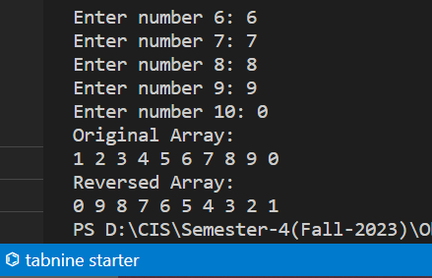

5. Write a program to find the sum and product of all elements of an array.

Code:

import java.util.Scanner;

public class Problem5 {

     public static void main(String[] args) {

        Scanner scanner = new Scanner(System.in);

        System.out.print("Enter the size of the array: ");

        int size = scanner.nextInt();

        int[] array = new int[size];

        System.out.println("Enter " + size + " integers:");

        for (int i = 0; i < size; i++) {

            System.out.print("Enter number " + (i + 1) + ": ");

            array[i] = scanner.nextInt();

        }

        int sum = calculateSum(array);

        long product = calculateProduct(array);

        System.out.println("Sum of all elements: " + sum);

        System.out.println("Product of all elements: " + product);

        scanner.close();

    }

    public static int calculateSum(int[] arr) {

        int sum = 0;

        for (int num : arr) {

            sum += num;

        }

        return sum;

    }

    public static long calculateProduct(int[] arr) {

        long product = 1;

        for (int num : arr) {

            product *= num;

        }

        return product;

    }

}

Output:

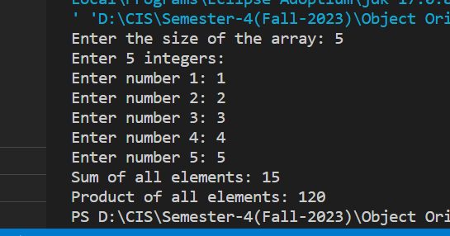

6. Initialize and print all elements of a 2D array.

Code:

public class Problem6 {

    public static void main(String[] args) {

        int[][] array2D = {

            {1, 2, 3},

            {4, 5, 6},

            {7, 8, 9}

        };

        System.out.println("Elements of the 2D array:");

        for (int i = 0; i < array2D.length; i++) {

            for (int j = 0; j < array2D[i].length; j++) {

                System.out.print(array2D[i][j] + " ");

            }

            System.out.println();

        }

    }

}

Output:

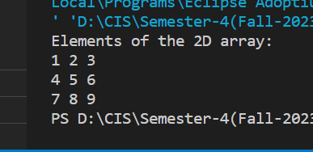

7. Find largest and smallest elements of an array.

Code:

public class Problem7 {

    public static void main(String[] args) {

        int[] arr = { 5, 12, 7, 2, 8, 15, 1, 6 };

        int smallest = arr[0];

        int largest = arr[0];

        for (int i = 1; i < arr.length; i++) {

            if (arr[i] < smallest) {

                smallest = arr[i];

            } else if (arr[i] > largest) {

                largest = arr[i];

            }

        }

        System.out.println("Smallest element: " + smallest);

        System.out.println("Largest element: " + largest);

    }

}

Output:

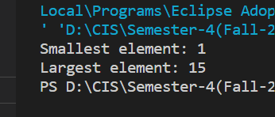

8. Write a program to check if elements of an array are same or not it read from front or back

Code:

public class Problem8 {

    public static void main(String[] args) {

        int[] arr = {1, 2, 3, 4, 3, 2, 1};

        boolean isPalindrome = checkPalindrome(arr);

        if (isPalindrome) {

            System.out.println("The array is a palindrome.");

        } else {

            System.out.println("The array is not a palindrome.");

        }

    }

    public static boolean checkPalindrome(int[] arr) {

        int start = 0;

        int end = arr.length - 1;

        while (start < end) {

            if (arr[start] != arr[end]) {

                return false;

            }

            start++;

            end--;

        }

        return true;

    }

}

Output:

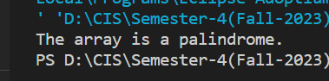

9. Take an array of 10 elements. Split it into middle and store the elements in two dfferent arrays

Code:

public class Problem9 {

    public static void main(String[] args) {

        int[] initialArray = {58, 24, 13, 15, 63, 9, 8, 81, 1, 78};

        int length = initialArray.length;

        int middle = length / 2;

        int[] firstArray = new int[middle];

        int[] secondArray = new int[length - middle];

        for (int i = 0; i < middle; i++) {

            firstArray[i] = initialArray[i];

        }

        for (int i = middle; i < length; i++) {

            secondArray[i - middle] = initialArray[i];

        }

        System.out.println("INITIAL array:");

        printArray(initialArray);

        System.out.println("After splitting:");

        System.out.print("First Array: ");

        printArray(firstArray);

        System.out.print("Second Array: ");

        printArray(secondArray);

    }

    public static void printArray(int[] arr) {

        for (int num : arr) {

            System.out.print(num + " ");

        }

        System.out.println();

    }

}

Output:

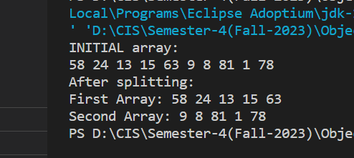

10. Consider an integer array, the number of elements in which is determined by the user. The elements are also taken as input from the user. Write a program to find those pair of elements that has the maximum and minimum difference among all element pairs.

Code:

import java.util.Scanner;

public class Problem10 {

     public static void main(String[] args) {

        Scanner scanner = new Scanner(System.in);

        System.out.print("Enter the number of elements in the array: ");

        int n = scanner.nextInt();

        if (n <= 1) {

            System.out.println("At least two elements are required for comparisons.");

            return;

        }

        int[] array = new int[n];

        System.out.println("Enter " + n + " integers:");

        for (int i = 0; i < n; i++) {

            System.out.print("Enter element " + (i + 1) + ": ");

            array[i] = scanner.nextInt();

        }

        int maxDifference = Integer.MIN_VALUE;

        int minDifference = Integer.MAX_VALUE;

        int maxDiffPair1 = 0, maxDiffPair2 = 0;

        int minDiffPair1 = 0, minDiffPair2 = 0;

        for (int i = 0; i < n - 1; i++) {

            for (int j = i + 1; j < n; j++) {

                int diff = Math.abs(array[i] - array[j]);

                if (diff > maxDifference) {

                    maxDifference = diff;

                    maxDiffPair1 = array[i];

                    maxDiffPair2 = array[j];

                }

                if (diff < minDifference) {

                    minDifference = diff;

                    minDiffPair1 = array[i];

                    minDiffPair2 = array[j];

                }

            }

        }

        System.out.println("Pair with maximum difference: " + maxDiffPair1 + " and " + maxDiffPair2);

        System.out.println("Maximum difference: " + maxDifference);

        System.out.println("Pair with minimum difference: " + minDiffPair1 + " and " + minDiffPair2);

        System.out.println("Minimum difference: " + minDifference);

        scanner.close();

    }

}

Output:

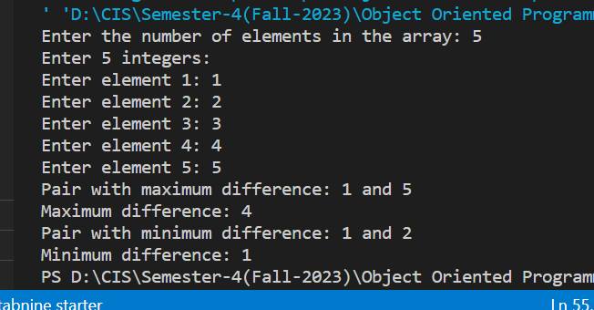

11. If the input array is [10, 12, 20, 30, 25, 40, 32, 31, 35, 50, 60], your program should be able to find that the subarray lies between the indexes 3 and 8.

Code:

import java.util.Scanner;

public class Problem11 {

public class MaxMinDifferenceSubarray {

    public static void main(String[] args) {

        Scanner scanner = new Scanner(System.in);

        System.out.print("Enter the number of elements in the array: ");

        int n = scanner.nextInt();

        if (n <= 1) {

            System.out.println("At least two elements are required for comparisons.");

            return;

        }

        int[] array = new int[n];

        System.out.println("Enter " + n + " integers:");

        for (int i = 0; i < n; i++) {

            System.out.print("Enter element " + (i + 1) + ": ");

            array[i] = scanner.nextInt();

        }

        int maxDifference = Integer.MIN_VALUE;

        int minDifference = Integer.MAX_VALUE;

        int maxDiffStart = 0, maxDiffEnd = 0;

        int minDiffStart = 0, minDiffEnd = 0;

        for (int i = 0; i < n - 1; i++) {

            for (int j = i + 1; j < n; j++) {

                int diff = Math.abs(array[i] - array[j]);

                if (diff > maxDifference) {

                    maxDifference = diff;

                    maxDiffStart = i;

                    maxDiffEnd = j;

                }

                if (diff < minDifference) {

                    minDifference = diff;

                    minDiffStart = i;

                    minDiffEnd = j;

                }

            }

        }

        System.out.println("Subarray with maximum difference:");

        printSubarray(array, maxDiffStart, maxDiffEnd);

        System.out.println("Maximum difference: " + maxDifference);

        System.out.println("Subarray with minimum difference:");

        printSubarray(array, minDiffStart, minDiffEnd);

        System.out.println("Minimum difference: " + minDifference);

        scanner.close();

    }

    public static void printSubarray(int[] arr, int start, int end) {

        for (int i = start; i <= end; i++) {

            System.out.print(arr[i] + " ");

        }

        System.out.println();

    }

}

}

Output:

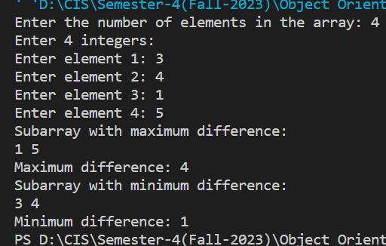

**Level 9: Characters and Strings**

1. Write a program to print a string entered by user

Code:

import java.util.Scanner;

public class Problem1 {

    public static void main(String[] args) {

        Scanner scanner = new Scanner(System.in);

        System.out.print("Enter a string: ");

        String inputString = scanner.nextLine();

        System.out.println("You entered: " + inputString);

        scanner.close();

    }

}

Output:

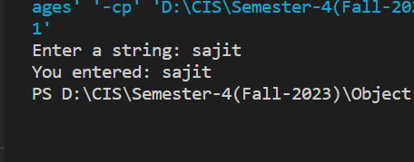

2. Write a program to input and display the sentence I love candies

Code:

import java.util.Scanner;

public class Problem2 {

    public static void main(String[] args) {

        Scanner scanner = new Scanner(System.in);

        System.out.print("Enter a sentence: ");

        String sentence = scanner.nextLine();

        System.out.println("You entered: " + sentence);

        scanner.close();

    }

}

Output:

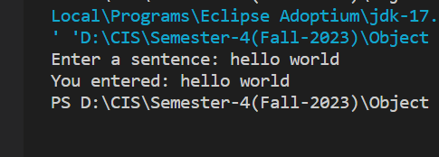

3. Write a program to find the length of the string "refrigerator".

Code:

public class Problem3 {

    public static void main(String[] args) {

        String str = "refrigerator";

        int length = str.length();

        System.out.println("Length of the string \"" + str + "\" is: " + length);

    }

}

Output:

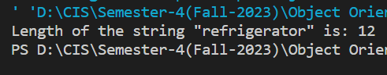

4. Write a program to check if the letter 'e' is present in the word 'Umbrella'.

Code:

public class Problem4 {

    public static void main(String[] args) {

        String word = "Umbrella";

        char targetLetter = 'e';

        boolean isPresent = false;

        for (int i = 0; i < word.length(); i++) {

            if (word.charAt(i) == targetLetter) {

                isPresent = true;

                break;

            }

        }

        if (isPresent) {

            System.out.println("The letter 'e' is present in the word 'Umbrella'.");

        } else {

            System.out.println("The letter 'e' is not present in the word 'Umbrella'.");

        }

    }

}

Output:

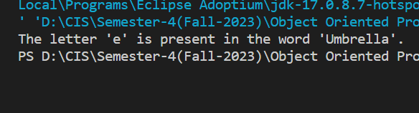

5. Write a program to check if the word 'orange' is present in the "This is orange juice".

Code:

public class Problem5 {

        public static void main(String[] args) {

            String sentence = "This is orange juice";

            String targetWord = "orange";

            boolean isPresent = false;

            String[] words = sentence.split(" ");

            for (String word : words) {

                if (word.equals(targetWord)) {

                    isPresent = true;

                    break;

                }

            }

            if (isPresent) {

                System.out.println("The word 'orange' is present in the sentence.");

            } else {

                System.out.println("The word 'orange' is not present in the sentence.");

            }

        }

    }

Output:

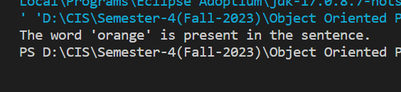

6. Write a program to find the first and the last occurence of the letter 'o' and character ',' in "Hello, World”

Code:

public class Problem6 {

    public static void main(String[] args) {

        String str = "Hello, World";

        char targetChar1 = 'o';

        char targetChar2 = ',';

        int firstOccurrence1 = -1;

        int lastOccurrence1 = -1;

        int firstOccurrence2 = -1;

        int lastOccurrence2 = -1;

        for (int i = 0; i < str.length(); i++) {

            char currentChar = str.charAt(i);

            if (currentChar == targetChar1) {

                if (firstOccurrence1 == -1) {

                    firstOccurrence1 = i;

                }

                lastOccurrence1 = i;

            }

            if (currentChar == targetChar2) {

                if (firstOccurrence2 == -1) {

                    firstOccurrence2 = i;

                }

                lastOccurrence2 = i;

            }

        }

        if (firstOccurrence1 != -1) {

            System.out.println("First occurrence of 'o' is at index: " + firstOccurrence1);

            System.out.println("Last occurrence of 'o' is at index: " + lastOccurrence1);

        } else {

            System.out.println("The letter 'o' is not present in the string.");

        }

        if (firstOccurrence2 != -1) {

            System.out.println("First occurrence of ',' is at index: " + firstOccurrence2);

            System.out.println("Last occurrence of ',' is at index: " + lastOccurrence2);

        } else {

            System.out.println("The character ',' is not present in the string.");

        }

    }

}

Output:

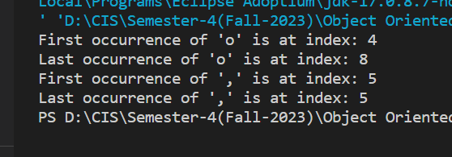

7. Write a program that takes your full name as input and displays the abbreviations of the first and middle names except the last name which is displayed as it is. For example, if your name is Robert Brett Roser, then the output should be R.B.Roser.

Code:

import java.util.Scanner;

public class Problem7 {

    public static void main(String[] args) {

        Scanner scanner = new Scanner(System.in);

        System.out.print("Enter your full name: ");

        String fullName = scanner.nextLine();

        String[] nameParts = fullName.split(" ");

        int nameLength = nameParts.length;

        StringBuilder abbreviatedName = new StringBuilder();

        for (int i = 0; i < nameLength - 1; i++) {

            String namePart = nameParts[i];

            abbreviatedName.append(namePart.charAt(0)).append(".");

        }

        abbreviatedName.append(nameParts[nameLength - 1]);

        System.out.println("Abbreviated name: " + abbreviatedName.toString());

        scanner.close();

    }

}

Output:

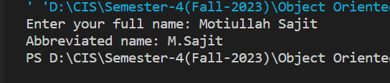

8. Write a program to find the number of vowels, consonents, digits and white space characters in a string.

Code:

import java.util.Scanner;

public class Problem8 {

    public static void main(String[] args) {

        Scanner scanner = new Scanner(System.in);

        System.out.print("Enter a string: ");

        String input = scanner.nextLine().toLowerCase();

        int vowels = 0;

        int consonants = 0;

        int digits = 0;

        int spaces = 0;

        for (int i = 0; i < input.length(); i++) {

            char ch = input.charAt(i);

            if (ch >= 'a' && ch <= 'z') {

                if (ch == 'a' || ch == 'e' || ch == 'i' || ch == 'o' || ch == 'u') {

                    vowels++;

                } else {

                    consonants++;

                }

            } else if (ch >= '0' && ch <= '9') {

                digits++;

            } else if (ch == ' ') {

                spaces++;

            }

        }

        System.out.println("Vowels: " + vowels);

        System.out.println("Consonants: " + consonants);

        System.out.println("Digits: " + digits);

        System.out.println("Whitespace characters: " + spaces);

        scanner.close();

    }

}

Output:

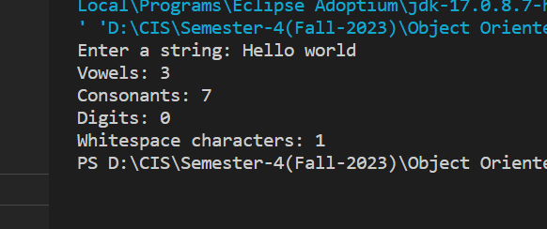

9. Write a program to delete all consonents from the string "Hello, have a good day".

Code:

public class Problem9 {

    public static void main(String[] args) {

        String input = "Hello, have a good day";

        String result = removeConsonants(input);

        System.out.println("Original string: " + input);

        System.out.println("String after removing consonants: " + result);

    }

    public static String removeConsonants(String input) {

        StringBuilder result = new StringBuilder();

        for (int i = 0; i < input.length(); i++) {

            char ch = input.charAt(i);

            if (isVowel(ch) || Character.isWhitespace(ch)) {

                result.append(ch);

            }

        }

        return result.toString();

    }

    public static boolean isVowel(char ch) {

        ch = Character.toLowerCase(ch);

        return ch == 'a' || ch == 'e' || ch == 'i' || ch == 'o' || ch == 'u';

    }

}

Output:

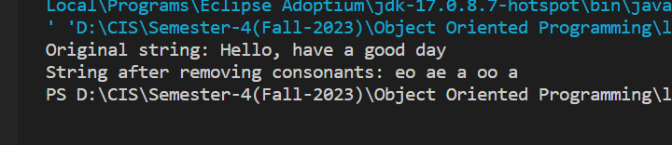

10. Input a string of alphabets. Find out the number of occurrence of all alphabets in that string. Find out the alphabet with maximum occurrence.

Code:

import java.util.Scanner;

public class Problem10 {

    public static void main(String[] args) {

        Scanner scanner = new Scanner(System.in);

        System.out.print("Enter a string of alphabets: ");

        String input = scanner.nextLine().toLowerCase();

        int[] frequency = new int[26];

        for (int i = 0; i < input.length(); i++) {

            char ch = input.charAt(i);

            if (Character.isLetter(ch)) {

                int index = ch - 'a';

                frequency[index]++;

            }

        }

        int maxFrequency = 0;

        char maxAlphabet = ' ';

        for (char ch = 'a'; ch <= 'z'; ch++) {

            int index = ch - 'a';

            if (frequency[index] > maxFrequency) {

                maxFrequency = frequency[index];

                maxAlphabet = ch;

            }

        }

        System.out.println("Alphabet frequencies:");

        for (char ch = 'a'; ch <= 'z'; ch++) {

            int index = ch - 'a';

            if (frequency[index] > 0) {

                System.out.println(ch + ": " + frequency[index]);

            }

        }

        System.out.println("Alphabet with maximum occurrence: " + maxAlphabet + " (" + maxFrequency + " times)");

        scanner.close();

    }

}

Output:

