MT - Motivational Techniques Documentation

Contents:

1. Short description
2. Full description
3. Installation
4. Reporting a bug
5. Scheduled tasks/cron job
6. Plugin options and management
   1. Plugin global settings
   2. Feature specific settings
   3. Scheduled task run frequency
   4. Forum Settings
7. Details of and how to use each feature
   1. Awards
   2. Goals
   3. Progress Annotation
   4. Progress Timeline
   5. Rankings

Short description:

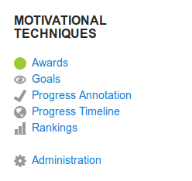This block plugin provides 5 domain and content independent features that are designed to provide students more motivation in a course.

Full description:

The block consists of 5 separate features. Use of each feature is independent of the others, allowing them to be used individually or in conjunction with one another. Which features are available through the block is configurable through the Administration link in the block.

The first feature is Awards, which gives students gold, silver, and bronze awards based on their performance in certain areas of the course such as forum posts and assignment grades. The thresholds for the different award categories is adjustable from the administrator options.

The second feature is Goals, which provides student with the ability to set goals and monitor their progress toward those goals. Goals that can be set for the grade the student wishes to achieve and the date by which to complete the assignment. Goals can also be set for overall grade, for rankings against other students, and for achieving awards. As well, course progress against the goals can be monitored by comparing against actual results on a line graph.

The third feature is Progress Annotation, which tracks the completion status of the activities in the course. There are 3 icons added to each activity link on the course page that are selectable to indicate the completion status of that activity. There is also a pie chart that shows the percentages of activities that are complete, in progress, and not completed. Clicking a slice of the chart shows a list of the activities with that completion status.

There is also a Progress Timeline feature, which shows the student progress through the course as a line chart. The feature considers gradable milestones in the course such as assignments and quizzes. An ideal timeline is set by the instructor and shown on the chart. Each student can view how their progress timeline compares against the ideal timeline and the average student timeline.

Finally there is a Rankings feature, which ranks the students according to their performance in certain areas of the course such as forum posts and assignment grades. The rank is derived from a comparison with other students, where students are ranked higher for achieving higher grades.

Installation:

The plugin can be installed from the Moodle plugin repository. When logged in as admin, go to Site administration > Plugins > Install plugins and click the button labeled "Install plugins from the Moodle plugins directory."

OR

The plugin can be installed from its zip file archive. First, download the archive from https://github.com/motivational-techniques/moodle-block_mt. Then, when logged in as admin, go to Site administration > Plugins > Install plugins and use the file picker to upload the zip file.

OR

The plugin can be installed manually at the server. All the plugin files will need to be placed into the /path/to/moodle/blocks/mt directory.

After installing, (as admin) navigate to Settings > Site administration > Notifications, which will show a message saying the plugin is to be installed.

See https://docs.moodle.org/37/en/Installing_plugins#Installing_a_plugin for more details about these installation methods.

Report a bug:

If you find a bug in the program or want to request a feature be added to the program, create an issue at https://github.com/motivational-techniques/moodle-block_mt/issues.

Scheduled Tasks/Cron Job:

Three of the five features in this block require that the Moodle 'cron' process is set up. The Awards, Goals, and Rankings features use a Moodle scheduled task to generate the necessary data for the features. Moodle recommends that the cron process is set up for all installations, as Moodle itself relies on the process, so your Moodle installation likely already has this process enabled. However, if you need to set up cron, see https://docs.moodle.org/37/en/Cron. Alternatively, the cron script can be run manually from the command line.

Plugin options and management:

Plugin global settings:

The Motivational Techniques plugin has a few global settings that can be adjusted by the administrator. When the plugin is first installed, these settings are shown and can be adjusted, but also have default values that can be used. After the plugin is installed, these settings can be accessed from Site administration > Plugins > Plugins overview, which shows a long list of all the installed plugins. Search for the MT - Motivational Techniques plugin and click settings.

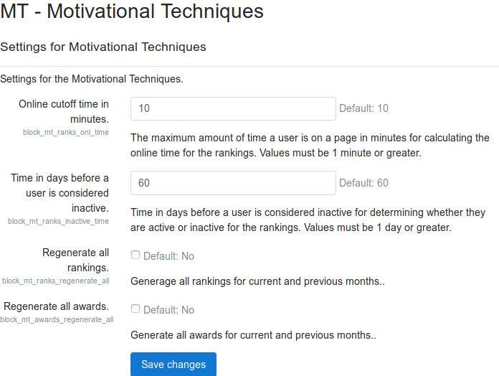

There are 4 settings that can be altered. The first is online cutoff time, which is the maximum time value used when calculating a student's time spent online for the Rankings feature. The second also affects the Rankings feature and determines the number of days without activity before a student is considered inactive.

The third and fourth settings are for regenerating the Rankings and Awards data. Having these values checked causes the ranking and award goals to be wiped out every time the scheduled task is run. Unless the data needs to be regenerated, it is best to leave these settings at their default (unchecked) value.

Feature specific settings:

The Awards and Timeline features have settings that can be altered. These settings are available to teachers and administrators, but not students. The Awards settings all come with default values and do not necessarily need to be adjusted. The Timeline settings are for the ideal timeline through the course and need to be manually entered as there are no default values.

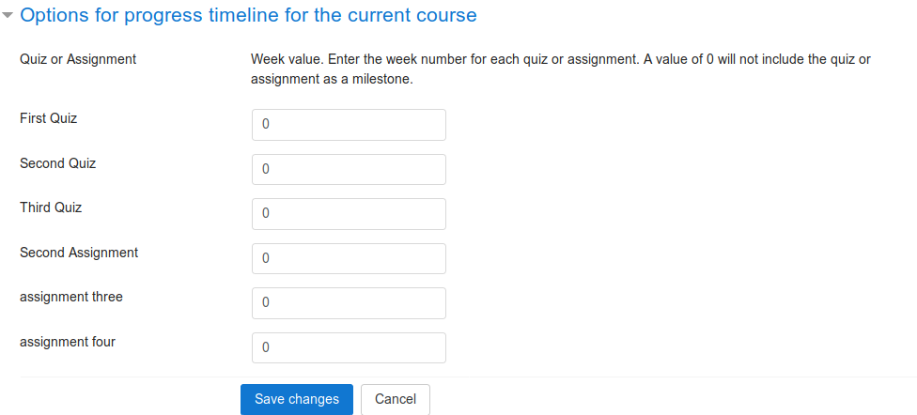

The Awards and Rankings features have milestone related sub-features that require that the Timeline settings page be viewed and saved. The Timeline feature itself does not need to be enabled, but its administration page must be viewed and saved in order for the course milestones to show up in milestone related sub-features of the Awards and Rankings features.

Scheduled task run frequency:

The Awards, Rankings, and Goals features of the plugin require the Moodle 'cron' process is set up. By default, the plugin's scheduled task will run every minute to update the data for those 3 features. The frequency for running the update can be changed by an administrator through Moodle's scheduled task interface, which can be found at Site administration > Server > Scheduled tasks. Clicking the settings icon will bring up the interface to change the schedule. The task can also be run on demand by clicking the 'Run now' link.

Forum settings:

To track read posts, it is necessary that the global forum settings allow posts to be tracked as read or unread. The Moodle defaults work fine, but these may get changed. The global forum settings must be accessed as administrator and can be found under Site administration > Plugins > Forum. The "Track unread posts" option must be selected (default). It is also possible to select "Manual read message marking" (not default), which changes the way posts are marked as being read. The "Read after days" option will also affect when posts are considered read.

The Awards and Rankings features make use of forum posts, including how many posts a student makes, how many posts a student reads, and the rating of the posts. The features that use read posts require that the student have forum tracking enabled in their preferences. Students can enable forum tracking by clicking their name in the top right corner of any Moodle page and going to Preferences > Forum preferences, and ensuring that forum tracking is set to Yes.

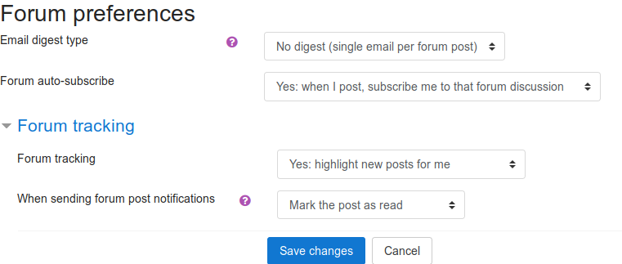

When adding a forum activity module to a course, there are some options that need to be set correctly for certain plugin features to work. Under Subscription and tracking, the Read tracking option must be enabled for read and unread posts to be tracked in that forum.

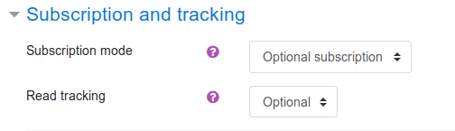

For posts to be rated, the Ratings options need to be set up. There are different aggregate types and different rating scales, any of which will allow posts to be rated and give the post rating related features data.

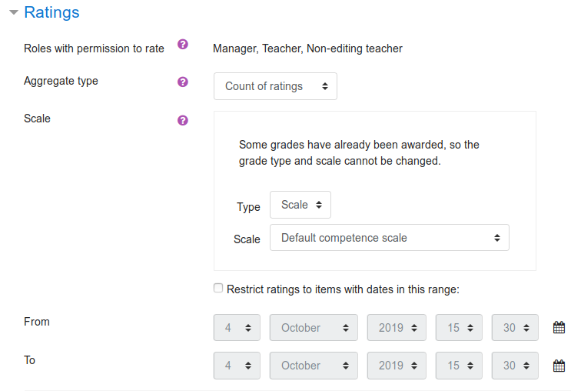

Details of and how to use each feature:

Awards:

The Awards feature enables students to view their awards in the course. Clicking the Awards link in the block shows the interface for the Awards feature, which contains several categories, each of which contains links to further explore the awards for that category. The first category is Personal Achievements, which lists a summary and details of the awards for the student. The awards by grade category has 3 links to view awards for grades by assignment, by quiz, and overall. The Milestones category contains a single link for viewing awards for completing milestones within a certain time. The amount of time online category has awards for the amount of time spent online in the current month as well as the average time online over all the months enrolled with a breakdown by month. There is also a participation category that allows students to view their awards for forum posts, reading others posts, and post ratings, each of which can be seen for the current month or an average over all months enrolled.

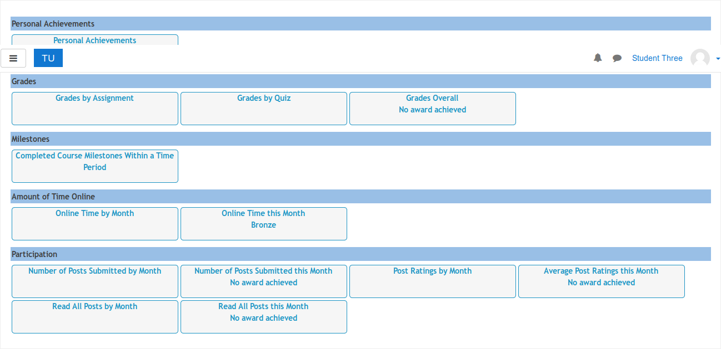

The Moodle administrator can modify the default settings for the online cutoff time in minutes and the time in days before a user is considered inactive. These settings are available from the Site administration > Plugins > Plugins overview page. Search through the list of plugins to find MT - Motivational Techniques and click settings. These settings can also be altered when the plugin is installed.

The teacher can set the values for the weighing of awards and for the values needed to attain an award. Students can choose whether or not they want their name displayed in the awards listing. These settings are accessible through the administration/options link in the block.

Goals:

The Goals feature enables students to set goals and monitor their progress towards those goals. The goals interface contains numerous links for setting various goals and viewing progress. The All Goals link shows all the goals with status a student has set. Students can also view their progress through the course as a line chart, which will show their progress against their goals or their progress against the class average. A student can set a goal for overall course grade as well as for individual quiz and assignment grades. Assignments and quizzes also have the option to set a goal for the date by which the assessment should be completed. Quizzes also allow students to set goals for start dates. The final two categories are ranking and awards, where a student can set goals for their ranking against other students and for achieving certain award levels.

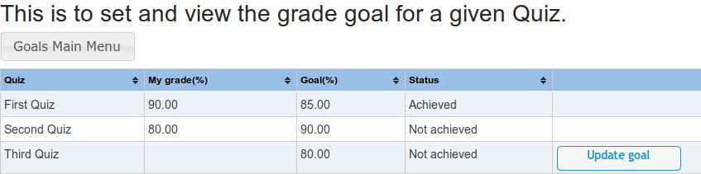

Progress Annotation:

The Progress Annotation feature enables students to keep track of which learning activities they have completed, are still working on, and have not completed. The feature adds a set of three icons to each learning activity on the main course page. The icons include a green check mark, a red X, and a yellow diamond. If the check mark is clicked, the module is considered complete, while the X indicates incomplete (default), and the diamond indicates in progress. These icons are not changed automatically and must be clicked by the student. Along with the activity icons on the course page, the student can click the link in the block to view a pie chart of their completion status in the course. Each category is represented by a slice of the chart. Clicking any slice of the pie brings up a tip box showing the number of learning activities in that category. The tip box also includes a link that will produce a list of the learning activities in that category.

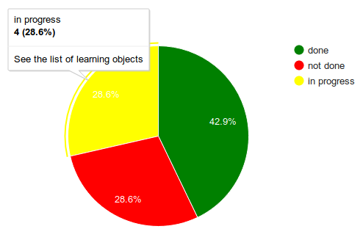

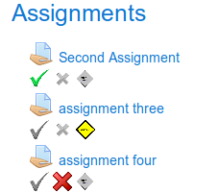

Progress Timeline:

The Progress Timeline feature enables students to view their progress in the course as a line chart. The chart shows the time in weeks on one axis and milestones (gradable assessments) on the other axis. The teacher user must set up the ideal week values (0-26) for each milestone in the course before any milestones will show on the chart. This can be done by clicking the Administration link in the block. The default value is 0, which excludes the milestone from the chart. When viewed, the chart will show the ideal timeline as defined by the teacher, an average timeline for all students who have completed that milestone, and a timeline for the student who is viewing the chart.

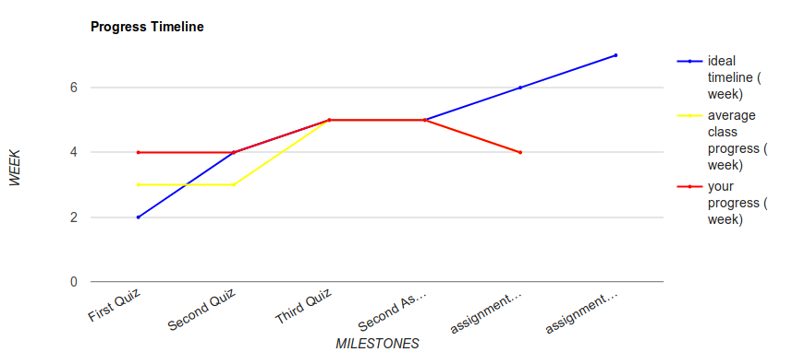

Rankings:

The Rankings feature enables students to view their rankings in the course. Clicking the Rankings link in the block shows the interface for the Rankings feature, which contains several categories, each of which contains link to further explore the rankings for that category. The first category is all rankings, which shows a list of all the rankings the student has achieved. Next is the grades category, which has 3 links to view rankings for grades by assignment, by quiz, and overall. The achievements category has a link that shows all the awards each student has achieved so far in the course. The amount of time online category has rankings for the amount of time spent online in the current month as well as the average time online over all the months enrolled with a breakdown by month. There is also a participation category that allows students to view their rankings for forum posts, reading others posts, and post ratings, each of which can be seen for the current month or an average over all months enrolled. Finally, there is a milestones category that ranks students by the time it took them to reach each milestone or the pace at which the milestones are being completed.

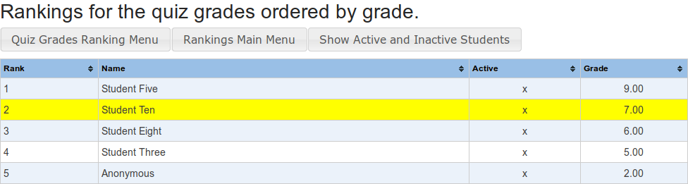

The Moodle administrator can modify the default settings for the online cutoff time in minutes and the time in days before a user is considered inactive. These settings are available from the Site administration > Plugins > Plugins overview page. Search through the list of plugins to find MT - Motivational Techniques and click settings. These settings can also be altered when the plugin is installed.

Students can choose whether or not they want their name displayed in the rankings. This setting is accessible through the options link in the block.