**Name:-dhruv motka**

**Module:1**

**Q1: what is software? What is software engineering ?**

**Ans:** **Software is a set of instructions, data or programs used to operate computers and execute specific tasks. It is the opposite of hardware, which describes the physical aspects of a computer. Software is a generic term used to refer to applications, scripts and programs that run on a device. It can be thought of as the variable part of a computer, while hardware is the invariable part.**

**🡪Software Engineering** is the process of designing, developing, testing, and maintaining software. It is a systematic and disciplined approach to software development that aims to create high-quality, reliable, and maintainable software.

1. Software engineering includes a variety of techniques, tools, and methodologies, including requirements analysis, design, testing, and maintenance.
2. It is a rapidly evolving field, and new tools and technologies are constantly being developed to improve the software development process.
3. By following the principles of software engineering and using the appropriate tools and methodologies, software developers can create high-quality, reliable, and maintainable software that meets the needs of its users.
4. Software Engineering is mainly used for large projects based on software systems rather than single programs or applications.
5. The main goal of Software Engineering is to develop software applications for improving quality,  budget, and time efficiency.
6. Software Engineering ensures that the software that has to be built should be consistent, correct, also on budget, on time, and within the required requirements.

**Q2: Explain types of software?**

**Ans: types of software**

* **Application software:**The most common type of software, application software is a computer software package that performs a specific function for a user, or in some cases, for another application. An application can be self-contained, or it can be a group of programs that run the application for the user. Examples of [modern applications](https://www.techtarget.com/searchcio/feature/The-rise-of-modern-applications-Why-you-need-them) include office suites, graphics software, databases and database management programs, web browsers, word processors, software development tools, image editors and communication platforms.
* **System software.** These software programs are designed to run a computer's application programs and hardware. System software coordinates the activities and functions of the hardware and software. In addition, it controls the operations of the computer hardware and provides an environment or platform for all the other types of software to work in. The OS is the best example of system software; it manages all the other computer programs. Other examples of system software include the [firmware](https://www.techtarget.com/whatis/definition/firmware), computer language translators and system [utilities](https://www.techtarget.com/whatis/definition/utility).

**. Driver software:** Also known as device drivers, this software is often considered a type of system software. Device drivers control the devices and peripherals connected to a computer, enabling them to perform their specific tasks. Every device that is connected to a computer needs at least one device driver to function. Examples include software that comes with any nonstandard hardware, including special game controllers, as well as the software that enables standard hardware, such as USB storage devices, keyboards, headphones and printers.

. **Middleware:**The term *middleware* describes software that mediates between application and system software or between two different kinds of application software. For example, middleware enables Microsoft Windows to talk to Excel and Word. It is also used to send a remote work request from an application in a computer that has one kind of OS, to an application in a computer with a different OS. It also enables newer applications to work with legacy ones.

* **Programming software:** Computer programmers use programming software to write code. Programming software and programming tools enable developers to develop, write, test and [debug](https://www.techtarget.com/searchsoftwarequality/definition/debugging) other software programs. Examples of programming software include assemblers, compilers, debuggers and interpreters.

**Q3:what is SDLC?Expain each phase of SDLC**

ANS**: Software development life cycle (SDLC) is a structured process that is used to design, develop, and test good-quality software.** SDLC, or software development life cycle, is a methodology that defines the entire procedure of software development step-by-step.

**Stage-1: Planning and Requirement Analysis**

Planning is a crucial step in everything, just as in[software development](https://www.geeksforgeeks.org/software-development/). In this same stage, [requirement analysis](https://www.geeksforgeeks.org/activities-involved-in-software-requirement-analysis/)is also performed by the developers of the organization. This is attained from customer inputs, and sales department/market surveys.

The information from this analysis forms the building blocks of a basic project. The quality of the project is a result of planning. Thus, in this stage, the basic project is designed with all the available information.

## Stage-2: Defining Requirements

In this stage, all the requirements for the target software are specified. These requirements get approval from customers, market analysts, and stakeholders.   
This is fulfilled by utilizing SRS (Software Requirement Specification). This is a sort of document that specifies all those things that need to be defined and created during the entire project cycle.

## Stage-3: Designing Architecture

SRS is a reference for software designers to come up with the best architecture for the software. Hence, with the requirements defined in SRS, multiple designs for the product architecture are present in the Design Document Specification (DDS).

This DDS is assessed by market analysts and stakeholders. After evaluating all the possible factors, the most practical and logical design is chosen for development.

## Stage-4: Developing Product

At this stage, the fundamental development of the product starts. For this, developers use a specific programming code as per the design in the DDS. Hence, it is important for the coders to follow the protocols set by the association. Conventional programming tools like compilers, interpreters, debuggers, etc. are also put into use at this stage. Some popular languages like C/C++, Python, Java, etc. are put into use as per the software regulations.

## Stage-5: Product Testing and Integration

After the development of the product, testing of the software is necessary to ensure its smooth execution. Although, minimal testing is conducted at every stage of SDLC. Therefore, at this stage, all the probable flaws are tracked, fixed, and retested. This ensures that the product confronts the quality requirements of SRS.

## Stage-6: Deployment and Maintenance of Products

After detailed testing, the conclusive product is released in phases as per the organization’s strategy. Then it is tested in a real industrial environment. It is important to ensure its smooth performance. If it performs well, the organization sends out the product as a whole. After retrieving beneficial feedback, the company releases it as it is or with auxiliary improvements to make it further helpful for the customers. However, this alone is not enough. Therefore, along with the deployment, the [product’s supervision](https://www.geeksforgeeks.org/product-management/).

**Q4:what if DFD? create a DFD diagram on flipkart**

**ANS:** A data flow diagram (DFD) maps out the flow of information for any process or system. It uses defined symbols like rectangles, circles and arrows, plus short text labels, to show data inputs, outputs, storage points and the routes between each destination.

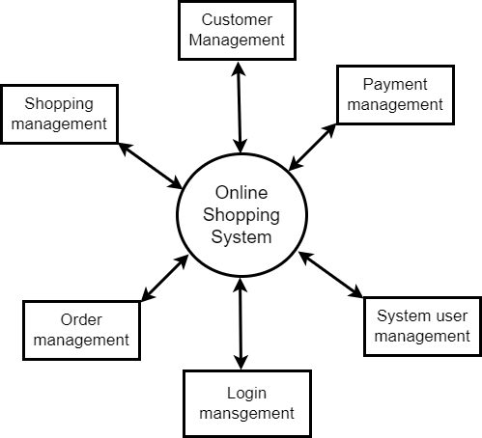

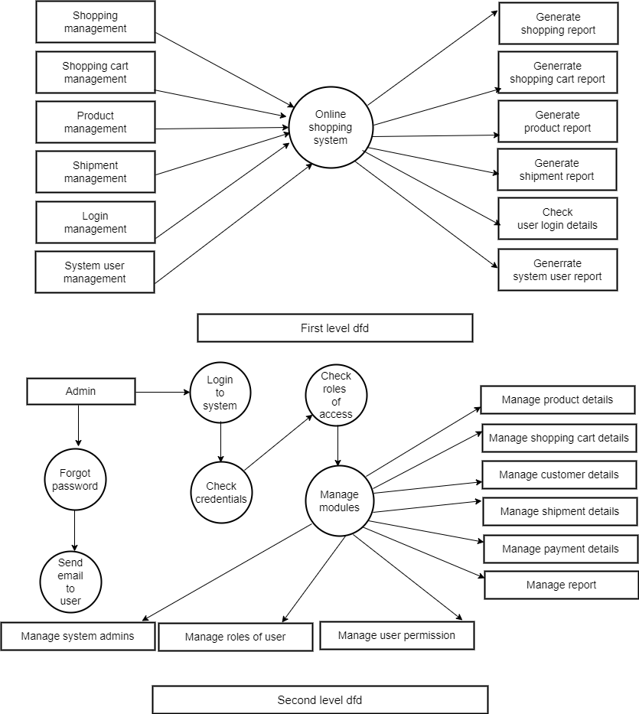

**Q5:what is flow chart? Create a flowchart to make additionof two numbers**

**Ans:**A flowchart is a type of diagram that represents a workflow or process. A flowchart can also be defined as a diagrammatic representation of an algorithm, a step-by-step approach to solving a task*.*

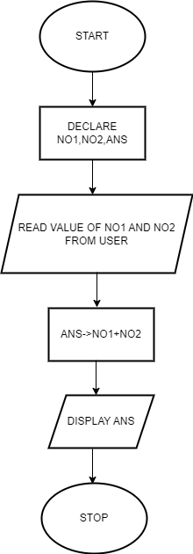

Q.6 **What is Use case Diagram? Create a use-case on bill payment on paytm.**

**ANS :-** A Use Case Diagram is a vital tool in system design, it provides a visual representation of how users interact with a system. It serves as a blueprint for understanding the functional requirements of a system from a user’s perspective, aiding in the communication between stakeholders and guiding the development process.

