SUPERSTORE
Sales Performance Report

Business Analytics Dashboard Insights & Recommendations
Tools used: Tableau
Dataset: Superstore Sales (Kaggle)

1. Top 10 Products by Sales
This chart shows which products brought in the most revenue for the business. It helps identify the items that customers value most and spend the most money on.

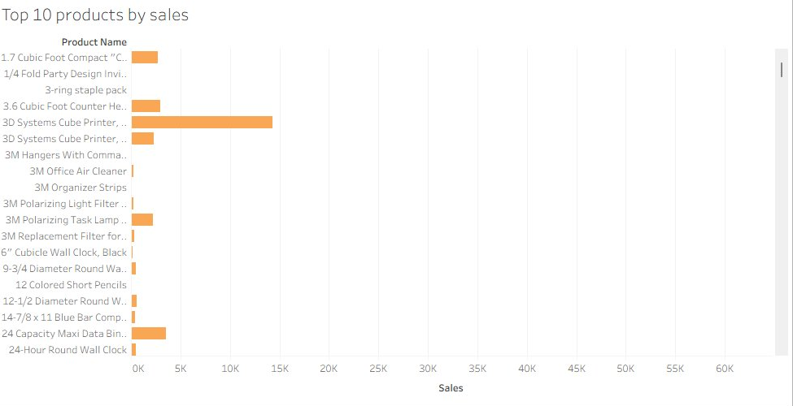
Insights
- The 3D Systems Cube Printer stands out as the clear top seller, pulling in significantly more revenue than any other product on the list.
- Most of the top 10 products fall under the Technology category( printers, copiers and office ) machines dominate the rankings.
- Products like the 3M Polarizing Task Lamp and 24 Capacity Maxi Data Binder also make the list, showing that customers buy across price points.
Recommendations
- Always keep top-selling tech products well-stocked; running out of these items would directly impact revenue.
- Consider bundling high-performing products (e.g. printers with ink or accessories) to increase average order value.

2. Sales Performance Over Time
This line chart tracks how monthly sales changed throughout the year, giving a clear picture of when the business performs best and when it slows down.

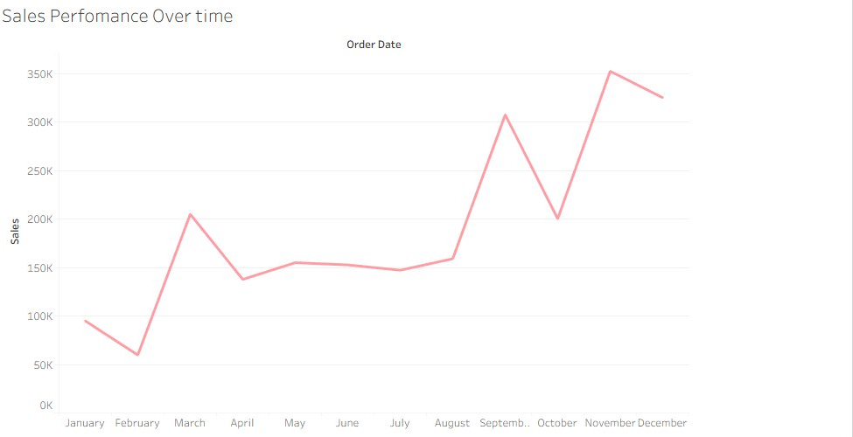
Insights
- Sales started relatively low in January and February, then picked up sharply around March and Aprill, suggesting a strong start to Q2.
- There's a noticeable dip around May, followed by a steady climb that peaks dramatically in November, likely driven by end-of-year business purchases and promotions.
- December shows a slight decline after the November peak, which is common as businesses wrap up budgets.
Recommendations
- Plan marketing campaigns and stock replenishment ahead of October and November to capitalise on the year-end sales surge.
- Use the slower months (January–February) to run promotions and clear slow-moving inventory.

3. Profit by Category
This pie chart breaks down how much profit comes from each of the three main product categories , giving a quick visual of where the real money is made.

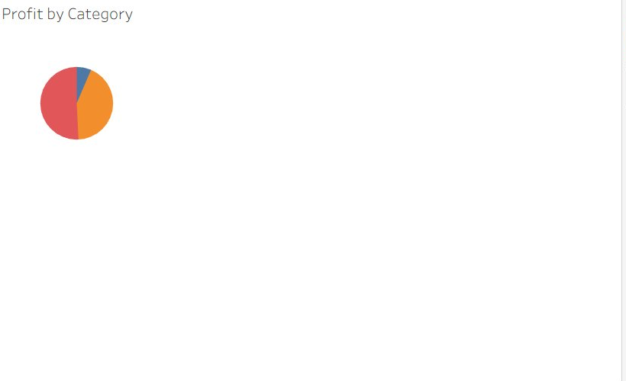
Insights
- Technology is the most profitable category by far, making up the largest slice of total profit ($145,455).
- Office Supplies comes in second with solid profit ($122,491), driven by high volume sales of everyday items.
- Furniture is clearly underperforming; despite being a visible product category, it contributes very little to overall profit ($18,451).
Recommendations
- Prioritise growing the Technology product range as it delivers the best return on investment.
- Investigate the Furniture category, heavy discounting or high return rates may be eating into margins. A pricing review is needed.

4. Profit by State and Category
This chart maps profit performance across US states, separated by product category. It makes it easy to spot which states are thriving and which are dragging performance down.

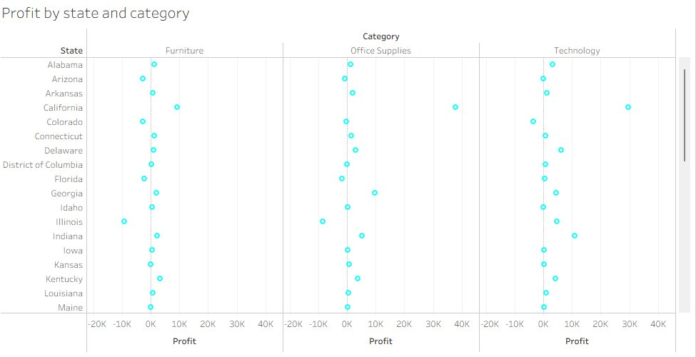
Insights
- A handful of states, like California and New York, show strong positive profit across all three categories, making them the most valuable markets.
- Several states show negative profit in the Furniture category, meaning the business is losing money selling furniture there.
- Technology consistently shows positive profit across almost all states, reinforcing its role as the most reliable category.
Recommendations
- Focus sales and marketing efforts on high-performing states. They offer the best return with the least risk.
- For states where Furniture is showing losses, consider pulling back on discounts or reducing the product range offered there.

5. Quantity Sold by Sub-Category and Segment
This side-by-side bar chart shows how many units were sold in each product subcategory, split across the three customer segments: Consumer, Corporate, and Home Office.

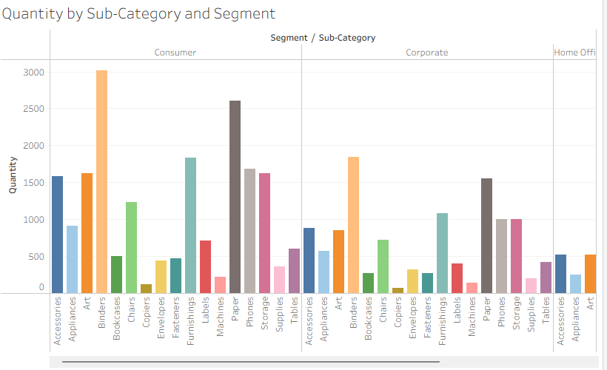
Insights
- Binders are the highest-volume product across all segments, with the Consumer segment purchasing the most, over 3,000 units alone.
- Paper is a close second, also driven heavily by Consumer purchases, reflecting everyday office needs.
- Copiers and Machines have the lowest quantities across all segments, not surprisingly given their high price points.
Recommendations
- Ensure a consistent stock of Binders and Paper, especially for the Consumer segment — these are bread-and-butter products.
- For low-volume, high-value products like Copiers, consider a targeted B2B sales approach focused on the corporate segment.

6. Segment Discount Over Time
This area chart shows how discounts given to each customer segment changed between 2014 and 2018, helping us understand discount trends and their potential impact on profit.

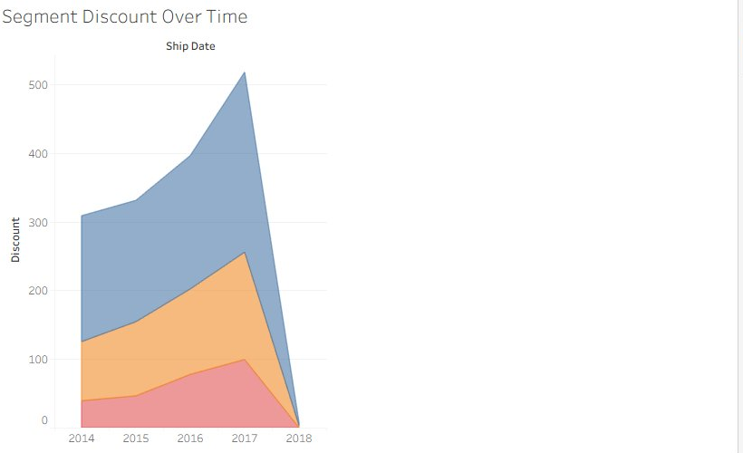
Insights
- Discounts grew significantly across all segments from 2014 to 2017, with the Consumer segment receiving the highest total discounts.
- The sharp rise peaking in 2017 suggests the business was increasingly relying on discounts to drive sales, which could be hurting profit margins.
- All three segments follow a very similar discount pattern, meaning there is no real differentiation in how customers are being incentivised.
Recommendations
- Reduce blanket discounting and instead introduce targeted promotions, so that not every customer needs the same discount to make a purchase.
- Monitor the relationship between discount increases and profit closely, especially in the Furniture category, where margins are already thin.

7. Overall Recommendations
Pulling everything together, here is what the data is telling us about where this business should focus its energy going forward.

- Technology is the star; it drives the most profit and performs well across regions and segments. Invest more here.
- Fix the Furniture problem. Low profit, negative returns in several states, and heavy discounting make this category a liability. A pricing and discount strategy review is urgent.
- Ride the November wave. The year-end sales spike is the biggest revenue opportunity. Prepare early with stock, staffing, and promotions.
- Be smarter with discounts. All segments are getting similar discounts regardless of behaviour. A tiered or loyalty-based discount model would be more profitable.
- Double down on California and New York. These are consistently the highest-profit markets and deserve focused marketing attention.
- The Consumer segment is the biggest buyer. Retention strategies such as loyalty programmes or personalised offers would have a significant impact here.

