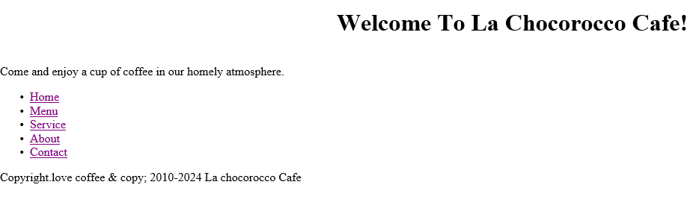 <!DOCTYPE html>

<html>

<head>

<title>La chocorocco Cafe - Home</title>

<meta charset="UTF-8">

<link rel="stylesheet" href="styles.css">

</head>

<body>

<nav>

<div class="wrapper">

<section id="home">

<marquee><h1>Welcome To La Chocorocco Cafe!</h1></marquee>

<p>Come and enjoy a cup of coffee in our homely atmosphere.</p>

</section>

</div>

<ul>

<li><a href="Home.html">Home</a></li>

<li><a href="Menu.html">Menu</a></li>

<li><a href="Service.html">Service</a></li>

<li><a href="About.html">About</a></li>

<li><a href="Contact.html">Contact</a></li>

</ul>

</nav>

<footer>

<p>Copyright.love coffee & copy; 2010-2024 La chocorocco Cafe</p>

</footer>

<script src="script.js"></script>

</body>

</html>