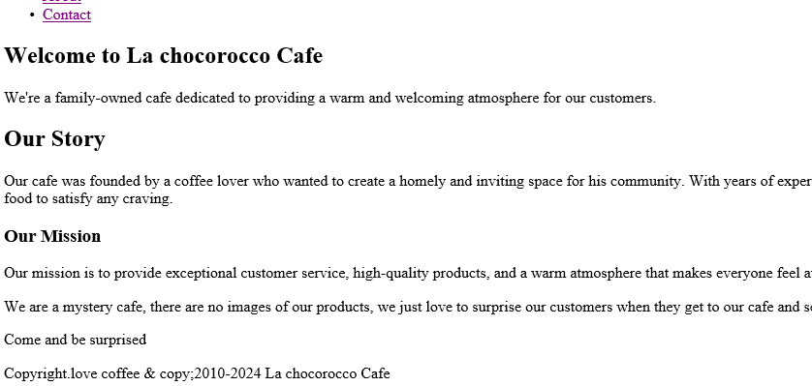

<!DOCTYPE html>

<html>

<head>

<title>La chocorocco Cafe - About</title>

<meta charset="UTF-8">

<link rel="stylesheet" href="styles.css">

</head>

<body>

<nav>

<ul>

<li><a href="Home.html">Home</a></li>

<li><a href="Menu.html">Menu</a></li>

<li><a href="Service.html">Service</a></li>

<li><a href="About.html">About</a></li>

<li><a href="Contact.html">Contact</a></li>

</ul>

</nav>

<main>

<section id="about">

<h1>Welcome to La chocorocco Cafe</h1>

<p>We're a family-owned cafe dedicated to providing a warm and welcoming atmosphere for our customers.</p>

<h2>Our Story</h2>

<p>Our cafe was founded by a coffee lover who wanted to create a homely and inviting space for his community.

With years of experience in the coffee industry, he created a menu of specialty drinks and

delicious food to satisfy any craving.</p>

<h3>Our Mission</h3>

<p>Our mission is to provide exceptional customer service, high-quality products, and

a warm atmosphere that makes everyone feel at home.</p>

<p>We are a mystery cafe, there are no images of our products, we just love to surprise

our customers when they get to our cafe and see for themselves how tasty everything look

like.</p>

<p>Come and be surprised</p>

</section>

</main>

<footer>

<p>Copyright.love coffee & copy;2010-2024 La chocorocco Cafe</p>

</footer>

<script src="script.js"></script>

</body>

</html>