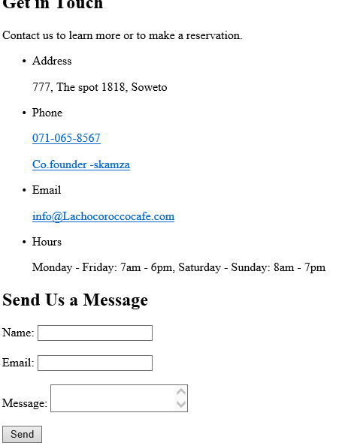

<!DOCTYPE html>

<html>

<head>

<title>La chocorocco Cafe - Contact</title>

<meta charset="UTF-8">

<link rel="stylesheet" href="styles.css">

</head>

<body>

<nav>

<ul>

<li><a href="Home.html">Home</a></li>

<li><a href="Menu.html">Menu</a></li>

<li><a href="Service.html">Service</a></li>

<li><a href="About.html">About</a></li>

<li><a href="Contact.html">Contact</a></li>

</ul>

</nav>

<main>

<section id="contact">

<h1>Get in Touch</h1>

<p>Contact us to learn more or to make a reservation.</p>

<ul>

<li>

<span>Address</span>

<p>777, The spot 1818, Soweto</p>

</li>

<li>

<span>Phone</span>

<p><a href="Tel:071-065-8567">071-065-8567</a></p>

<p><a href="Co.founder - skamza">Co.founder -skamza</a></p>

</li>

<li>

<span>Email</span>

<p><a href="mailto:info@Lachocoroccocafecafe.com">info@Lachocoroccocafe.com</a></p>

</li>

<li>

<span>Hours</span>

<p>Monday - Friday: 7am - 6pm, Saturday - Sunday: 8am - 7pm</p>

</li>

</ul>

<h2>Send Us a Message</h2>

<form>

<label for="name">Name:</label>

<input type="text" id="name" name="name"><br><br>

<label for="email">Email:</label>

<input type="email" id="email" name="email"><br><br>

<label for="message">Message:</label>

<textarea id="message" name="message"></textarea><br><br>

<input type="submit" value="Send">

</form>

</section>

</main>

<footer>

<p>Copyright.love coffee & copy; 2010-2024 La chocorocco Cafe</p>

</footer>

<script src="script.js"></script>

</body>

</html>