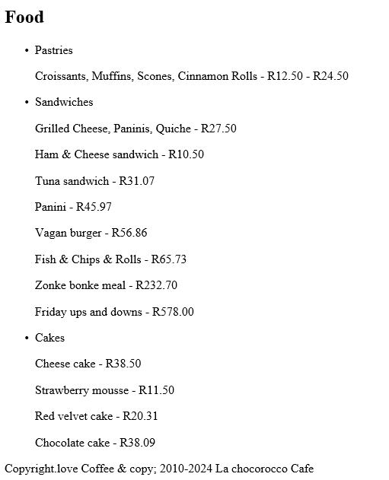

<!DOCTYPE html>

<html>

<head>

<title>La chocorocco Cafe - Menu</title>

<meta charset="UTF-8">

<link rel="stylesheet" href="styles.css">

</head>

<body>

<nav>

<ul>

<li><a href="Home.html">Home</a></li>

<li><a href="Menu.html">Menu</a></li>

<li><a href="Service.html">Service</a></li>

<li><a href="About.html">About</a></li>

<li><a href="Contact.html">Contact</a></li>

</ul>

</nav>

<main>

<section id="menu">

<h1>Our Menu</h1>

<h2>Beverages</h2>

<ul>

<li>

<span>Hot caffeine ones</span>

<p>Espresso, Macchiato, Cappuccino, Latte - R23.50 - R15.50 </p>

<p>Red eye - R60.09</p>

<p>Frappe - R44.87</p>

<p>Doppie - R23.65</p>

<p>Long black - R32.99</p>

<p>Breve - R11.00</p>

<p>Lungo - R44.09</p>

<p>Irish chomi - R27.65</p>

<p>Turkish boi - R20.43</p>

<p>Decaf - R10.33</p>

</li>

<li>

<span>Tea</span>

<p>Black, Green, Herbal, Chai</p>

<p>R32.50 - R54.50</p>

</li>

<li>

<span>Cold ones</span>

<p>Mocha, Chai Latte, London Fog - R44.50</p>

<p>Absolute Vodka - R46.50</p>

<p>Jameson reserve - R435.00 </p>

<p>Hennessy(very special) - R4211.09</p>

<p>Remy martin VSOP - R4530.87</p>

<p>Jack daniels - R4155.65</p>

<p>Heineken - R45.00</p>

<p>Corona extra - R60.73</p>

<p>the black one - R46.50 </p>

<p>castle - R44.50</p>

<p>amstel - R56.05</p>

<p>windhoek - R60.73</p>

<p>savanna - R70.02</p>

<p>flying fish - R432.00 </p>

<p>red square - R56.05</p>

</li>

</ul>

<h2>Food</h2>

<ul>

<li>

<span>Pastries</span>

<p>Croissants, Muffins, Scones, Cinnamon Rolls - R12.50 - R24.50</p>

</li>

<li>

<span>Sandwiches</span>

<p>Grilled Cheese, Paninis, Quiche - R27.50</p>

<P>Ham & Cheese sandwich - R10.50</P>

<p>Tuna sandwich - R31.07</p>

<p>Panini - R45.97 </p>

<p>Vagan burger - R56.86 </p>

<p>Fish & Chips & Rolls - R65.73</p>

<p>Zonke bonke meal - R232.70</p>

<p>Friday ups and downs - R578.00</p>

</li>

<li>

<span>Cakes</span>

<p>Cheese cake - R38.50</p>

<p>Strawberry mousse - R11.50</p>

<p>Red velvet cake - R20.31</p>

<p>Chocolate cake - R38.09</p>

</li>

</ul>

</section>

</main>

<footer>

<p>Copyright.love Coffee & copy; 2010-2024 La chocorocco Cafe</p>

</footer>

<script src="script.js"></script>

</body>

</html>