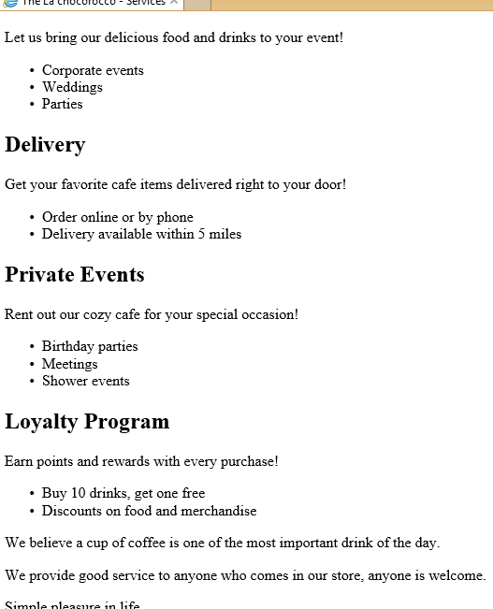

<!DOCTYPE html>

<html>

<head>

<title>The La chocorocco - Services</title>

<meta charset="UTF-8">

<link rel="stylesheet" href="styles.css">

</head>

<body>

<nav>

<ul>

<li><a href="Home.html">Home</a></li>

<li><a href="Menu.html">Menu</a></li>

<li><a href="Services.html">Services</a></li>

<li><a href="About.html">About</a></li>

<li><a href="Contact.html">Contact</a></li>

</ul>

</nav>

<main>

<section id="services">

<h1>Our Services</h1>

<h2>Catering</h2>

<p>Let us bring our delicious food and drinks to your event!</p>

<ul>

<li>Corporate events</li>

<li>Weddings</li>

<li>Parties</li>

</ul>

<h2>Delivery</h2>

<p>Get your favorite cafe items delivered right to your door!</p>

<ul>

<li>Order online or by phone</li>

<li>Delivery available within 5 miles</li>

</ul>

<h2>Private Events</h2>

<p>Rent out our cozy cafe for your special occasion!</p>

<ul>

<li>Birthday parties</li>

<li>Meetings</li>

<li>Shower events</li>

</ul>

<h2>Loyalty Program</h2>

<p>Earn points and rewards with every purchase!</p>

<ul>

<li>Buy 10 drinks, get one free</li>

<li>Discounts on food and merchandise</li>

</ul>

</section>

</main>

<p>We believe a cup of coffee is one of the most important drink of the day.</p>

<p>We provide good service to anyone who comes in our store, anyone is welcome.</p>

<p>Simple pleasure in life.</p>

<p>RICH & NATURAL</p>

<footer>

<p>Copyright.love coffee & copy; 2010-2024 La chocorocco Cafe</p>

</footer>

<script src="script.js"></script>

</body>

</html>