**ART FILM - RefDes_Top**

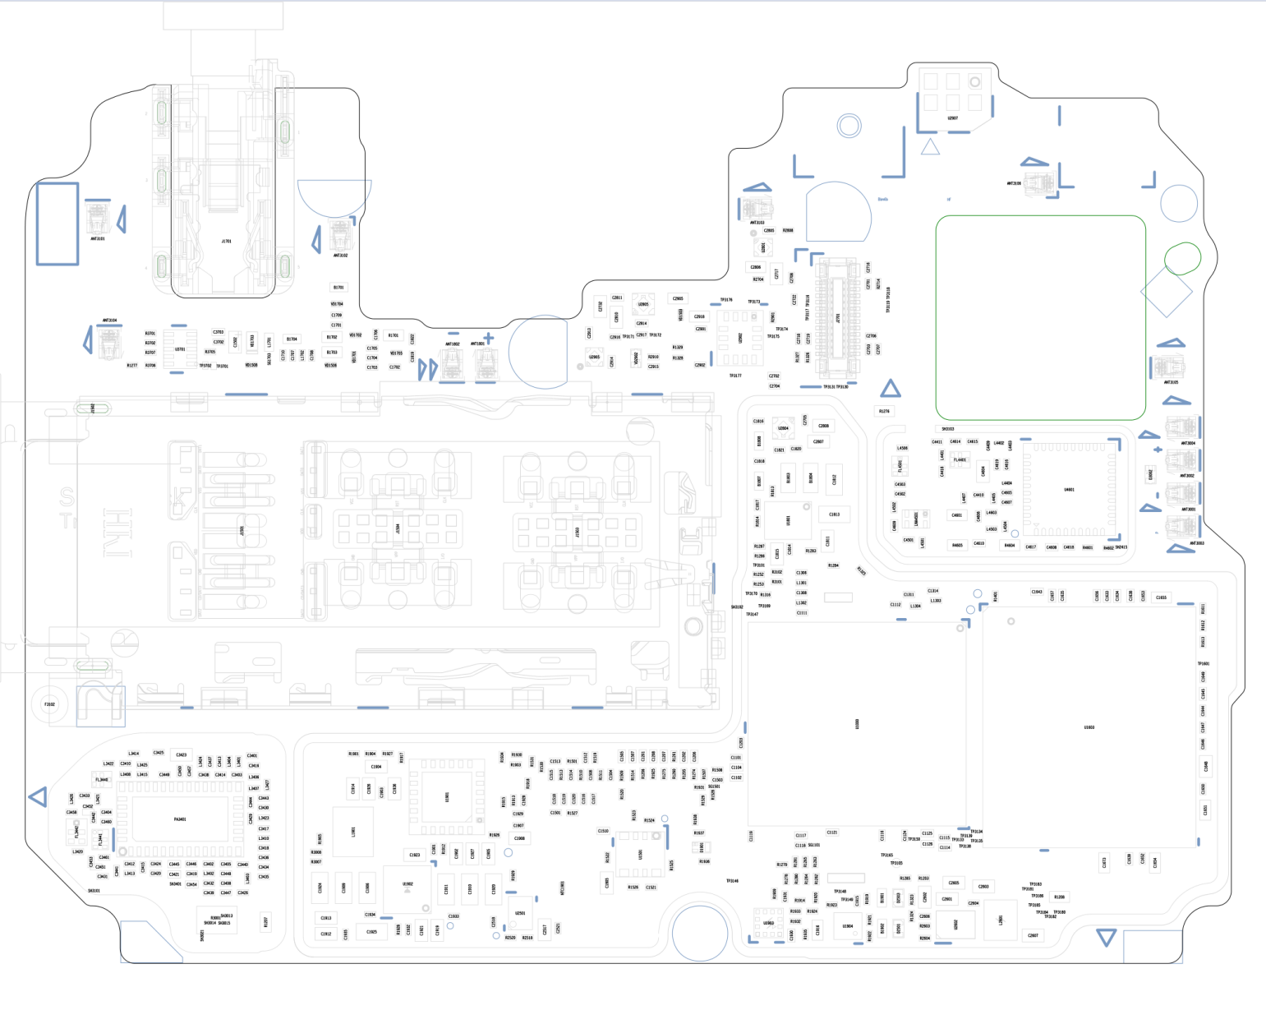

**ART FILM - RefDes_Bot**

