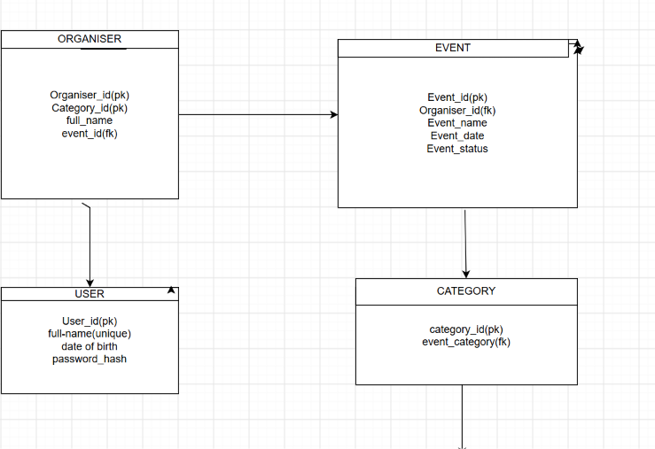
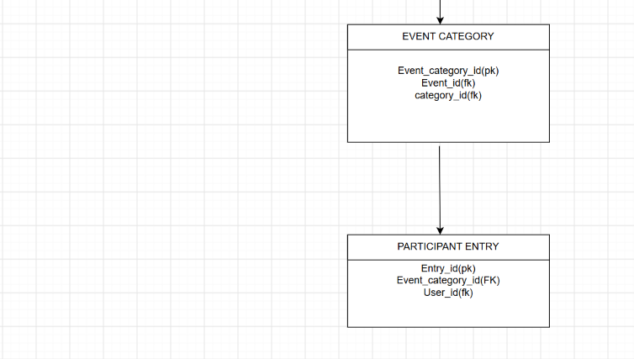

ORGANISER >EVENT(1:M)
EVENT>CATEGORY(1:M)
CATEGORY>EVENT CATEGORY(1:M)
EVENT CATEGORY>PARTICIPANT ENTRY(1:M)
ORGANISER>USER(1:M)

