Practical 01: Command-Line Input

Write a java program to take input as a command line argument like Your name, course, university roll no and semester. And Display the information in the Given Format :
- Name
- University Roll No
- Course :
- Semester :

# Name : Mohit Singh
# Roll No : 35
# Section : A2
# Course : B.Tech ( CSE )

public class test{ // Class Name == File Name
public static void main(String[] args) { // Main Fuction

System.out.println("Name : "+args[0]); // single word is acceptable in args
System.out.println("Course : "+args[1]);
System.out.println("Roll No : "+args[2]);
System.out.println("Semester : "+args[3]);

//!! String.valueOf(num);
}
}

OUTPUT – P1

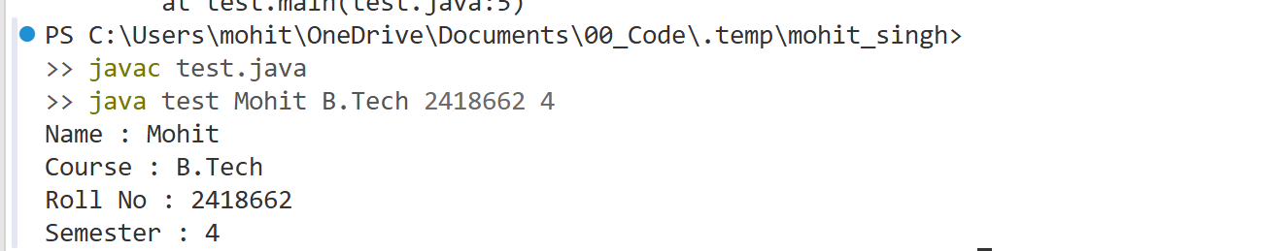

Practical 02 : Control Statements and Arithmetic

Write a Menu Driven Program for Calculating the Rd and Md with the Switch Case statements. The Formula is as Following :
- Term Deposit -> res = p (1 + r / 100)ⁿ
- Recurring Deposit -> res = p × n + p × n(n + 1) / 2 × r / 100 × 1 / 12.

import java.util.Scanner;

public class test{ // Class Name == File Name
public static float inputX(int ctrl, Scanner sc){

float res, p, r;
int nY;

System.out.print("Enter Principle : ");
p = sc.nextFloat();
System.out.print("Enter Rate : ");
r = sc.nextFloat();
System.out.print("Enter Years : ");
nY = sc.nextInt();

if(ctrl == 1){
res = p*(1+r/100)*nY;
}else if (ctrl == 2){
res = p * nY + p * nY * ((nY + 1) / 2) * (r / 100) * (1 / 12);
}else{
System.out.println("Error : 101");
res = -1;
}

return res;
}
public static void main(String[] args) {
Scanner sc = new Scanner(System.in);

System.out.println("(1) [to term Deposit] (2) [to Rate Deposit] (0)[to Exit] : ");

float res;
int ctrl;

do{
ctrl= sc.nextInt();
switch (ctrl) {
case 0:
System.out.println("Exit.");
break;

case 1:
res = inputX(ctrl, sc);
System.out.println("Maturity is : "+res);
break;

case 2:
res = inputX(ctrl, sc);
System.out.println("Maturity is : "+res);
break;

default:
System.out.println("Try Again (Error : xyz)");
break;
}

}while(ctrl != 0);

sc.close();
}
}

OUTPUT – P2

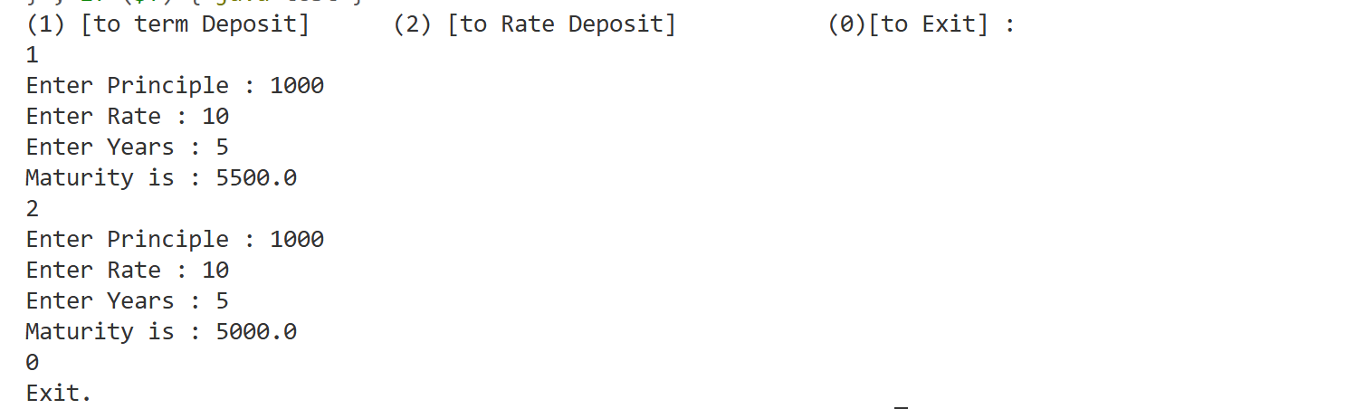

Practical 03: Friendly Pair

Write Program to determine Wheather the two given integer is really a Friendly Pair or Not, A friendly pair is the pair where the sum of is divisor divdes by its own matches with each other.

import java.util.Scanner;
public class test{
// Method to calculate sum of proper divisors
public static int getSum(int num){
int sum = 0;
for(int i=1; i<=num/2; i++){
if(num % i == 0){
sum += i;
}
}
return sum;
}
public static void main(String[] args) {
Scanner sc = new Scanner(System.in);
System.out.print("Enter n1 n2 : ");
int num1 = sc.nextInt();
int num2 = sc.nextInt();
int sum1 = getSum(num1);
int sum2 = getSum(num2);
// Check Friendly Pair condition
if ((sum1 / (float) num1) == (sum2 / (float) num2)) {
System.out.println("Friendly Pair");
} else {
System.out.println("Not Friendly Pair");
}

sc.close(); //!
}
}
OUTPUT – P4

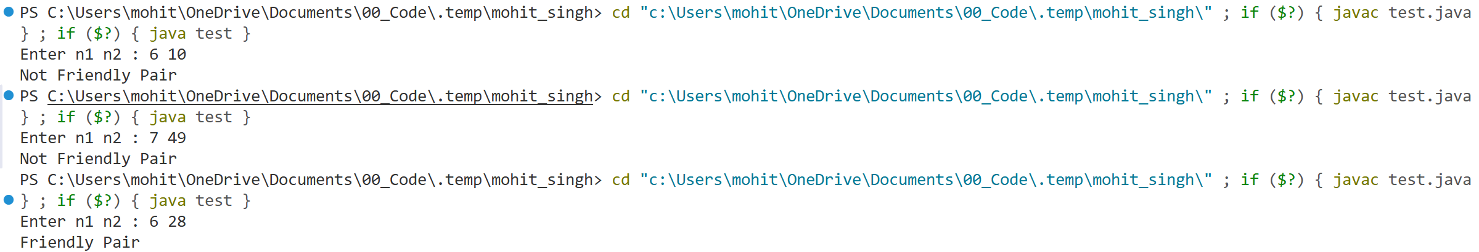

Practical 04: Replace 0 with 1 in the Number Digits

Write Program to Replace all the 0’s from the user inputed string.

import java.util.Scanner;

public class test{
public static void main(String[] args){
Scanner scan = new Scanner(System.in);
int number = scan.nextInt();
int numberTemp = number;

int i = 1;
while(numberTemp > 0){

if(numberTemp % 10 == 0){
number += i;
}

numberTemp /= 10;
i *= 10;
}

System.out.println(number);
scan.close();

}
}

OUTPUT – P4

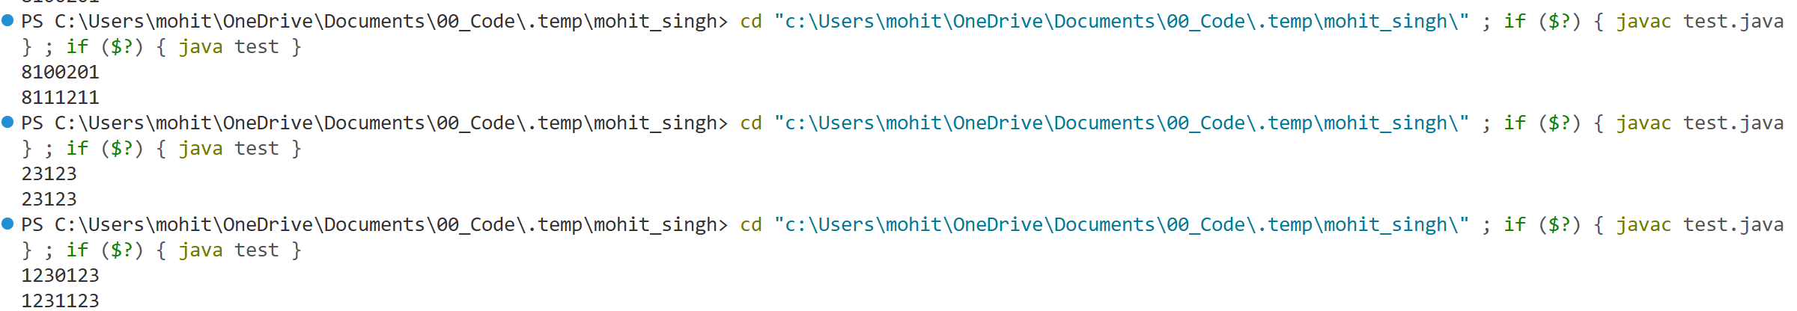

Practical 05 : Print Zig Zag Array

Given an array of n integers, rearrange the elements such that the first element is less than the second, the second is greater than the third, the third is less than the fourth, and so on. In general, the array should follow the pattern
a₁ < a₂ > a₃ < a₄ > a₅ < a₆ …

import java.util.Scanner;

public class test {
public static void printZigZag(int arr[], int n){
int mid = n/2;

int i1 ,i2;
for (i1 = 0, i2 = mid ; i1 <= mid-1 && i2 <= n-1; i1++, i2++) {
System.out.print(arr[i1]+" ");
System.out.print(arr[i2]+" ");
}
if(n%2!=0 && i1 == mid){ //for odd n
System.out.print(arr[i2]+" ");
}
}

public static void main(String[] args) {
Scanner sc = new Scanner(System.in);
int n = sc.nextInt(); //? n >= 3
int arr[] = new int[n];
for (int i = 0; i < n; i++) {
arr[i] = sc.nextInt(); //? every n is distinct
}

printZigZag(arr, n);
}
}

OUTPUT – P5
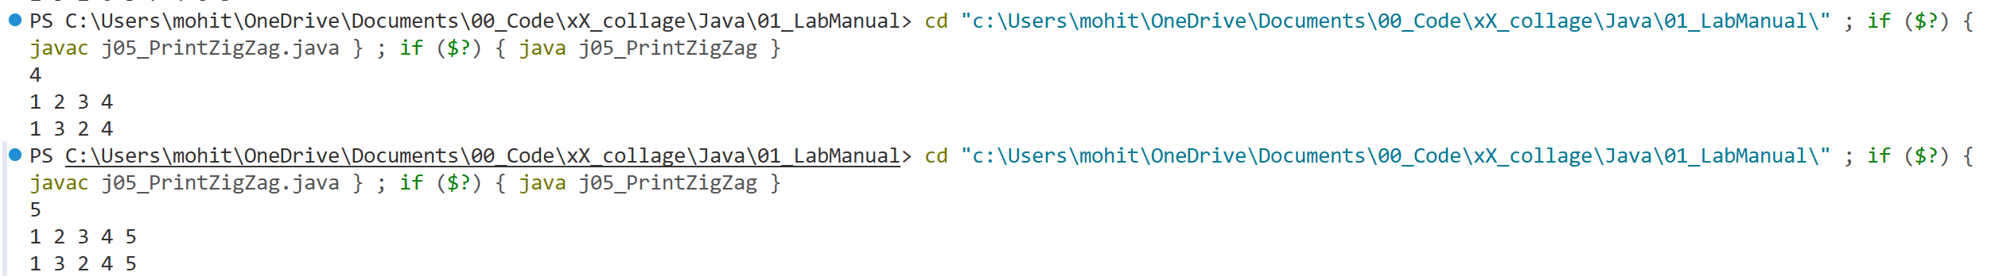

Practical 06 : Rearrange array in +ve -ve Sorting

Write a Java program to rearrange the elements of an array such that all negative numbers are moved to the beginning of the array and all positive numbers are moved to the end. The rearrangement should be done using a method that does not preserve the original order of elements.

import java.util.Scanner;

public class j06_sortingForSign {
public static void swap (int arr[], int a, int b){
int temp = arr[a];
arr[a] = arr[b];
arr[b] = temp;
}

public static void sortSign(int arr[], int n){
int low = 0, i = 0, high = n-1;
while (low < high && i <= high && i < n) {
if( arr[i] > 0){
swap(arr, i, high);
high--;
}else if(arr[i] < 0){
swap(arr, i, low); // what if i and low is same
low++;
i++;
}else{
i++; //increment on 0 or -ve
}
}
}

public static void printArr(int []arr, int n){
for (int x : arr) {
System.out.print(x + " ");
}
System.out.println();
}

public static void main(String[] args) {
Scanner sc = new Scanner(System.in);
int n = sc.nextInt();
int arr[] = new int[n];

for (int i = 0; i < n; i++) {
arr[i] = sc.nextInt();
}

sortSign(arr, n);
printArr(arr, n);

sc.close();
}
}

OUTPUT – P6

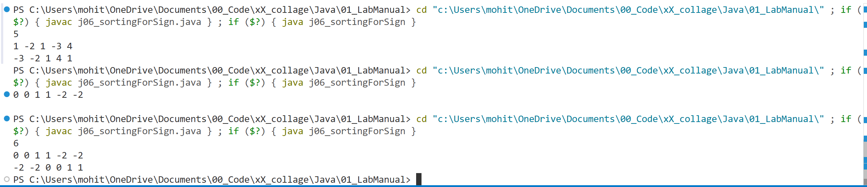

Practical 07 : Find Saddle Element

Write a program to find the saddle point in a given matrix.A saddle point is an element that is the minimum in its row and the maximum in its column.If such an element exists, output its coordinates; otherwise, indicate that no saddle point is present.

// it should be the row = col

import java.util.Scanner;

public class Saddle{
public static void swap(int []arr, int a, int b) {
int temp = arr[a];
arr[a] = arr[b];
arr[b] = temp;
}
public static void sort(int []arr){
for (int i = 0; i < arr.length - 1; i++) {
int minIdx = i;
for (int j = i+1; j < arr.length; j++) {
if(arr[minIdx] > arr[j]){
minIdx = j;
}
}
swap(arr, i, minIdx); // noting hapen if same i and idx
}
}
public static int findSattleEle(int [][]arr){
for (int i = 0; i < arr.length; i++) {
sort(arr[i]);
}

int max = arr[0][0]; //! hard code
for (int i = 1; i < arr.length; i++) {
if(max < arr[i][0]){
max = arr[i][0];
}
}

return max;
}
public static void inputArr(int [][]arr, Scanner sc){
for (int i = 0; i < arr.length - 1; i++) {
for (int j = 0; j < arr[i].length; j++) {
arr[i][j] = sc.nextInt();
}
}
}

public static void outputArr(int [][]arr){
for (int i = 0; i < arr.length; i++) {
for (int j = 0; j < arr[i].length; j++) {
System.out.print( arr[i][j] + " ");
}
System.out.println();
}
}
public static void main(String []args ){
Scanner sc = new Scanner(System.in);
int n = sc.nextInt();
int m = sc.nextInt();

int arr [][] = new int[n][m];

inputArr(arr, sc);

outputArr(arr);

System.out.println( findSattleEle(arr) + " is desired ele ");
sc.close();
}
}

OUTPUT – P7

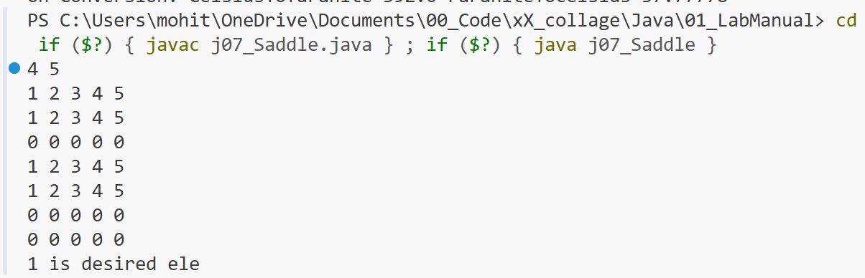

Practical 08 : Bank System

Write a Java program to create a Bank class that generates unique account numbers and performs deposit, withdrawal, address update, and display operations for multiple depositors using a menu-driven approach.

import java.util.Scanner;

class Bank {
private static int nextAccNo = 1001; // static for unique account numbers

private String name;
private String address;
private int accountNumber;
private double balance;

// Constructor
public Bank(String name, String address, double balance) {
this.name = name;
this.address = address;
this.balance = balance;
this.accountNumber = nextAccNo++;
}

// Display depositor info
public void display() {
System.out.println("Account Number : " + accountNumber);
System.out.println("Name : " + name);
System.out.println("Address : " + address);
System.out.println("Balance : " + balance);
}

// Deposit amount
public void deposit(double amount) {
if (amount > 0) {
balance += amount;
System.out.println("Deposited Successfully !");
}else{
System.err.println("Wrong Amount !");
}
}

// Withdraw amount
public void withdraw(double amount) {
if (balance - amount >= 0) {
balance -= amount;
System.out.println("Balance !");
} else {
System.out.println("Insufficient balance !");
}
}

// Change address
public void changeAddress(String newAddress) {
address = newAddress;
System.out.println("Adress Changed Sucessfully !");
}

public int getAccountNumber() {
return accountNumber;
}
}

public class j08_BankSystem {
public static void main(String[] args) {
Scanner sc = new Scanner(System.in);

System.out.print("Enter number of depositors: ");
int n = sc.nextInt();
sc.nextLine();

Bank[] accounts = new Bank[n];

// Input depositor details
for (int i = 0; i < n; i++) {
System.out.println("Enter details for depositor " + (i + 1));
System.out.print("Name: ");
String name = sc.nextLine();

System.out.print("Address: ");
String address = sc.nextLine();

System.out.print("Initial Balance: ");
double balance = sc.nextDouble();
sc.nextLine();

accounts[i] = new Bank(name, address, balance);
}

// Menu-driven operations
System.out.println("BANK MENU:");
System.out.println("1. Display account info");
System.out.println("2. Deposit amount");
System.out.println("3. Withdraw amount");
System.out.println("4. Change address");
System.out.println("5. Exit");

int choice = -1;
do {
System.out.print("Enter choice: ");
choice = sc.nextInt();

if (choice == 5) break;

System.out.print("Enter account number: ");
int accNo = sc.nextInt();
sc.nextLine();

Bank selected = null;
for (Bank b : accounts) {
if (b.getAccountNumber() == accNo) {
selected = b;
break;
}
}

if (selected == null) {
System.out.println("Account not found!");
continue;
}

switch (choice) {
case 1:
selected.display();
break;

case 2:
System.out.print("Enter amount to deposit: ");
selected.deposit(sc.nextDouble());
selected.display();
break;

case 3:
System.out.print("Enter amount to withdraw: ");
selected.withdraw(sc.nextDouble());
selected.display();
break;

case 4:
System.out.print("Enter new address: ");
selected.changeAddress(sc.nextLine());
selected.display();
break;

default:
System.out.println("Invalid choice!");
}

} while (choice == 5);

sc.close();
}
}

OUTPUT – P8

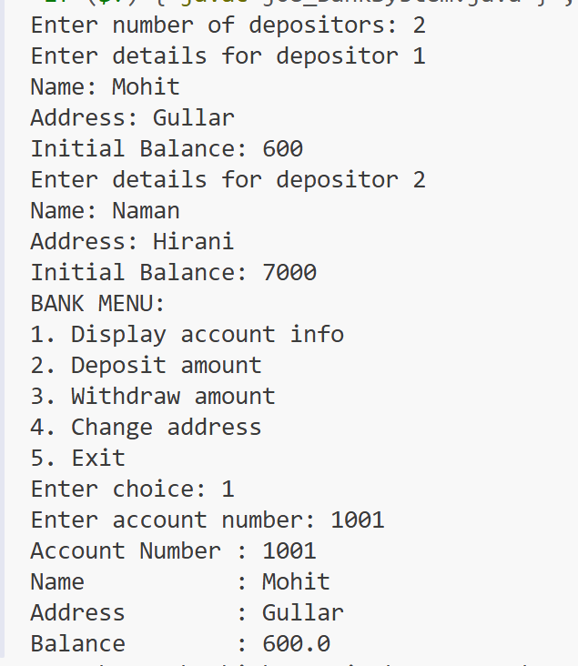

Practical 09 : Count Vovels

Define a class WordExample that stores a sentence and provides methods to count and rearrange words that begin and end with a vowel.

class j09_WordExample {
private String strdata;

// Parameterized constructor
j09_WordExample(String str) {
strdata = str;
}

// Check if a word begins and ends with a vowel
private boolean isVowelWord(String word) {
char first = word.charAt(0);
char last = word.charAt(word.length() - 1);
return "AEIOU".indexOf(first) != -1 && "AEIOU".indexOf(last) != -1;
}

// Count words beginning and ending with a vowel
void countWord() {
String sentence = strdata.substring(0, strdata.length() - 1); // remove punctuation
String[] words = sentence.trim().split("\\s+");

int count = 0;
for (String w : words) {
if (isVowelWord(w)) {
count++;
}
}
System.out.println("Count of vowel words: " + count);
}

// Rearrange words
void placeWord() {
String sentence = strdata.substring(0, strdata.length() - 1);
String[] words = sentence.trim().split("\\s+");

StringBuilder vowelWords = new StringBuilder();
StringBuilder otherWords = new StringBuilder();

for (String w : words) {
if (isVowelWord(w)) {
vowelWords.append(w).append(" ");
} else {
otherWords.append(w).append(" ");
}
}

System.out.println("Rearranged Sentence:");
System.out.println(vowelWords.toString() + otherWords.toString());
}

// Main method for testing
public static void main(String[] args) {
j09_WordExample obj = new j09_WordExample("AREA IS UNDER A UNIQUE IDEA.");

obj.countWord();
obj.placeWord();
}
}

OUTPUT – P09

Practical 10 : Overloading

Create a Java class named ArrayDemo to demonstrate compile-time polymorphism (method overloading).

import java.util.ArrayList;
import java.util.Scanner;

class ArrayDemo{
// For Searching Pair
public void arrayFunction(ArrayList<Integer> arr, Integer target){
for (int i = 0; i < 9; i++) {
for (int j = i+1; j < 10; j++) {
int sum = arr.get(i) + arr.get(j);
if(sum == target){
System.out.println("Found : " + arr.get(i) + " and " + arr.get(j));
}
}
}
}
// For Merging sorted array
public ArrayList<Integer> arrayFunction(ArrayList<Integer> arr1, ArrayList<Integer> arr2){
int size1 = arr1.size(), size2 = arr2.size();
ArrayList<Integer> arr3 = new ArrayList<>();
int p1 = 0, p2 = 0;

while (p1 < size1 && p2 < size2) {
if(arr1.get(p1) <= arr2.get(p2)){
arr3.add(arr1.get(p1++));
}else{
arr3.add(arr2.get(p2++));
}
}
while (p1 < size1) {
arr3.add(arr1.get(p1++));
}
while (p2 < size2) {
arr3.add(arr2.get(p2++));
}
return arr3;
}
}

public class j10_ArrayDemo{
public static void main(String[] args) {
Scanner sc = new Scanner(System.in);
ArrayList<Integer> arr = new ArrayList<>();
System.out.println("Enter Array (n=10) : ");
for (int i = 0; i < 10; i++) {
int x = sc.nextInt();
arr.add(x);
}

System.out.println("Enter Target : ");
int target = sc.nextInt();
ArrayDemo tool = new ArrayDemo();
tool.arrayFunction(arr, target); // first overload test
//

ArrayList<Integer> arr1 = new ArrayList<>();
ArrayList<Integer> arr2 = new ArrayList<>();
System.out.println("Enter Array1 (n=5) : ");
for (int i = 0; i < 5; i++) {
int x = sc.nextInt();
arr1.add(x);
}
System.out.println("Enter Array2 (n=5) : ");
for (int i = 0; i < 5; i++) {
int x = sc.nextInt();
arr2.add(x);
}
ArrayList<Integer> arr3 = tool.arrayFunction(arr2, arr1);
System.out.println( " Merged Array : "+ arr3);
sc.close();
}
}

OUTPUT – P10

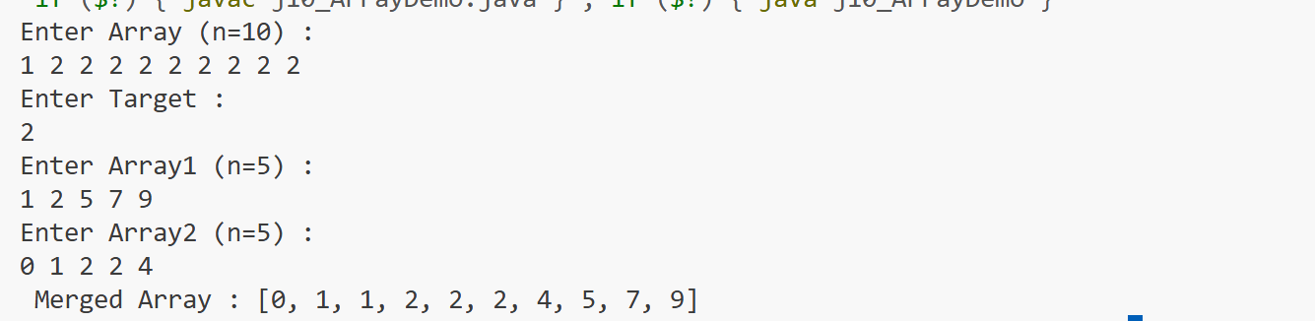

Practical 11 : Overriding

Create a Java program to demonstrate runtime polymorphism using an abstract class. Define an abstract class Shape with three abstract methods:
- rectangleArea(double length, double breadth)
- squareArea(double side)
- circleArea(double radius)
Create a class Area that extends Shape and implements all three methods to calculate and print the respective areas. In the main method, create an object of Area using a Shape reference and call all three methods.

abstract class BaseArea{
public final float PI = 3.14f;

public void areaSquare(float side){
System.out.println("Area of Square (PARENT) : " + side*side);
}
public void areaCircle(float radius){
System.out.println("Area of Circle (PARENT) : " + PI*radius);
}
public void areaTriangle(float height, float base ){
System.out.println("Area of Triangle (PARENT) : " + 0.5*height*base);
}
}

class ChildArea extends BaseArea{
@Override
public void areaSquare(float side){
System.out.println("Area of Square (CHILD) : " + side*side);
}
@Override
public void areaCircle(float radius){
System.out.println("Area of Circle (CHILD) : " + PI * radius * radius);
}
@Override
public void areaTriangle(float height, float base ){
System.out.println("Area of Triangle (CHILD) : " + 0.5*height*base);
}
}
public class j11_Overriding {
public static void main(String[] args) {
BaseArea obj = new ChildArea(); //! Resolved at runtime
obj.areaCircle(10);
}
}

OUTPUT – P11

Practical 12 : Abstract Class

Create a Java program to demonstrate runtime polymorphism using an abstract class. Define an abstract class Shape with three abstract methods:
- rectangleArea(double length, double breadth)
- squareArea(double side)
- circleArea(double radius)
Create a class Area that extends Shape and implements all three methods to calculate and print the respective areas. In the main method, create an object of Area using a Shape reference and call all three methods.

abstract class Temperature{
public float temp;
public void setTemp(float temp){
this.temp = temp;
}
abstract public float changeTemp(float temp); //abstract method
}

class F_Temperature extends Temperature{
@Override
public float changeTemp(float temp) { //? lets assume it changes to the C --> F
return (float)(9.0 / 5) * temp + 32;
}
}

class C_Temperature extends Temperature{
@Override
public float changeTemp(float temp) {//? lets assume it changes to the F --> C
return (float) (5.0 / 9) * (temp - 32);
}
}

public class j12_AbstractClass{
public static void main(String[] args) {
F_Temperature fahranheitTemp = new F_Temperature();
fahranheitTemp.setTemp(100);
C_Temperature celsiusTemp = new C_Temperature();
celsiusTemp.setTemp(200);

System.out.println("Initially : Celsius=" + celsiusTemp.temp + " Faranite="+fahranheitTemp.temp);

System.out.println("On Conversion: CelsiusTOfaranite=" + fahranheitTemp.changeTemp(celsiusTemp.temp) + " FaraniteTOcelsius="+celsiusTemp.changeTemp(fahranheitTemp.temp));
}
}

OUTPUT – P12

