通过第一部分，我完成了MVP的构建，但是识别率依然存在改善空间，所以要用到其它特征，并且面对二值化后反相的图像没法处。

Part I Feature 2~6
1.Feature2、5、6(区域密度，Feature2区域大小为8*8，Feature5区域大小为4*4，Feature6区域大小为6*6)
Feature2Extraction.m
function Feature2Extraction()
[input1, input2, input3] = textread('Char_Index.txt','%d %d %s',1000, 'headerlines',1);%读取图片的编号，类别信息和文件名
indexFileName = input3;%获得文件名
fid=fopen('feature2.txt','w+');%打开feature1.txt，用以储存特征1的数据

step = 8; %设置方块步长
for k=1:1000 %共1000个图片
A=imread(strcat('Char_Image_Binary\',char(indexFileName(k,1))));%读入图片
t=graythresh(A); %取阈值
B=im2bw(A,t);%二值化，B为二值化后的图像矩阵，每个元素的值为0或1
[a,b]=size(B);
countSquare = ceil(a/step) * ceil (b/step); %ceil为向上取整，计算共多少个方块

fprintf(fid,'%d',k);
fprintf(fid,'%s',' ');

count = 0; %方块计数
for i = 1:step:a
for j = 1:step:b
temp = 0; %白点计数
count = count+1;

%不是满step的也要计
if(a-i > step)
i2f = step;
elseif(a-i < step)
i2f = a-i+1;
end

if(b-j > step)
j2f = step;
else
j2f = b-j+1;
end

for i2 = 0:i2f-1
for j2 = 0:j2f-1
if(B(i+i2,j+j2) == 1)
temp = temp+1;%方块中白色计数
end
end
end
%调试用
% fprintf(fid,'%d',i2f);
% fprintf(fid,'*');
% fprintf(fid,'%d',j2f);
% fprintf(fid,':');

fprintf(fid,'%d',temp);
if(countSquare ~= count)
fprintf(fid,',');
% fprintf(fid,'\t');
end
end
end
%调试用
% fprintf(fid,'count:');
% fprintf(fid,'%d',count);
% fprintf(fid,'\n');

if k~=1000
fprintf(fid,'\n');%不为最后一行，则每行末尾加回车
end

end
fclose(fid);%关闭文件

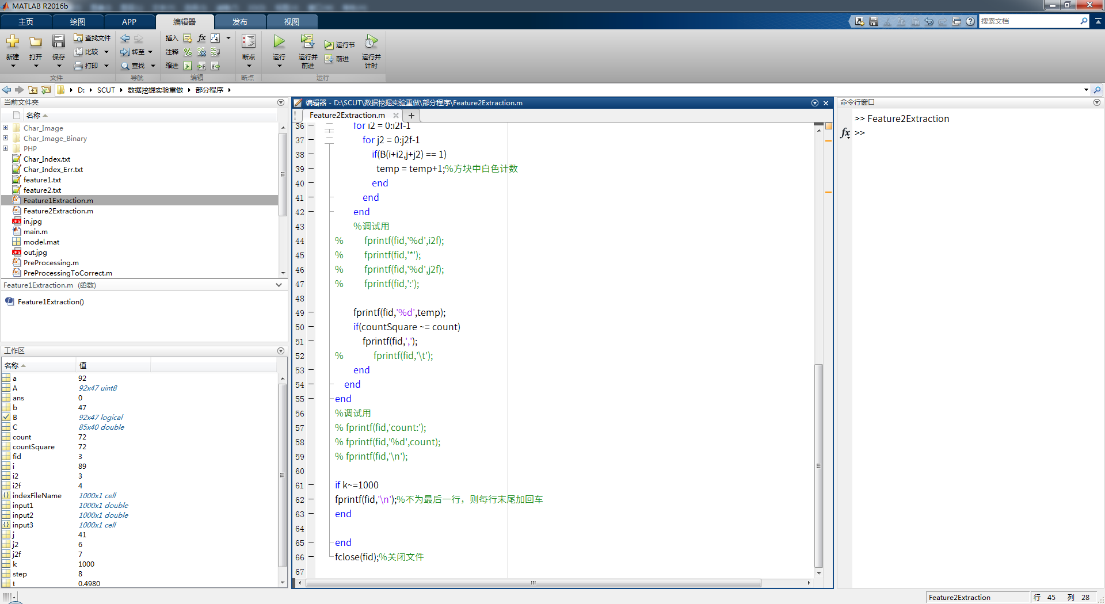

并经过人工复检证明无误
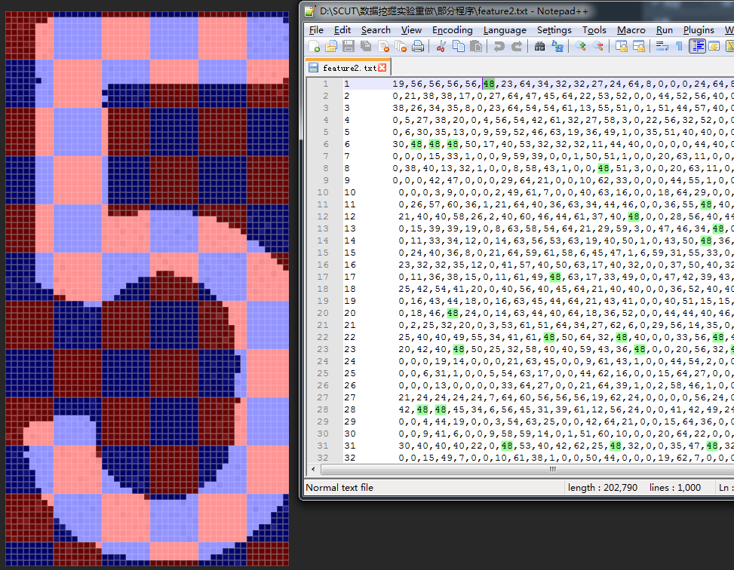

2.feature3(字符左右上下与边界的距离)
Feature3Extraction.m
function Feature3Extraction()
[input1, input2, input3] = textread('Char_Index.txt','%d %d %s',1000, 'headerlines',1);%读取图片的编号，类别信息和文件名
indexFileName = input3;%获得文件名
fid=fopen('feature3.txt','w+');%打开feature1.txt，用以储存特征1的数据

for k=1:1000 %共1000个图片
A=imread(strcat('Char_Image_Binary\',char(indexFileName(k,1))));%读入图片
t=graythresh(A); %取阈值
B=im2bw(A,t);%二值化，B为二值化后的图像矩阵，每个元素的值为0或1
[a,b]=size(B);

fprintf(fid,'%d',k);
fprintf(fid,'%s',' ');

%首次出现白点位置-左
% fprintf(fid,'L ');
for i = 1:a
temp = 0; %首次出现白点位置
for j = 1:b
if(B(i,j) == 1)
fprintf(fid,'%d,',temp);
break;
else
temp = temp+1;
end
end

if(temp == b)
fprintf(fid,'%d,',b);
end
end

%首次出现白点位置-右
% fprintf(fid,'R ');
for i = 1:a
temp = 0; %首次出现白点位置
for j = b:-1:1
if(B(i,j) == 1)
fprintf(fid,'%d,',temp);
break;
else
temp = temp+1;
end
end

if(temp == b)
fprintf(fid,'%d,',b);
end
end

%首次出现白点位置-上
% fprintf(fid,'U ');
for j = 1:b
temp = 0; %首次出现白点位置
for i = 1:a
if(B(i,j) == 1)
fprintf(fid,'%d,',temp);
break;
else
temp = temp+1;
end
end

if(temp == a)
fprintf(fid,'%d,',a);
end
end

%首次出现白点位置-下
% fprintf(fid,'D ');
for j = 1:b
temp = 0; %首次出现白点位置
for i = a:-1:1
if(B(i,j) == 1)
fprintf(fid,'%d',temp);
break;
else
temp = temp+1;
end
end

if(temp == a)
fprintf(fid,'%d',a);
end

if(j ~= b)
fprintf(fid,',');
end
end

if k~=1000
fprintf(fid,'\n');%不为最后一行，则每行末尾加回车
end

end
fclose(fid);%关闭文件

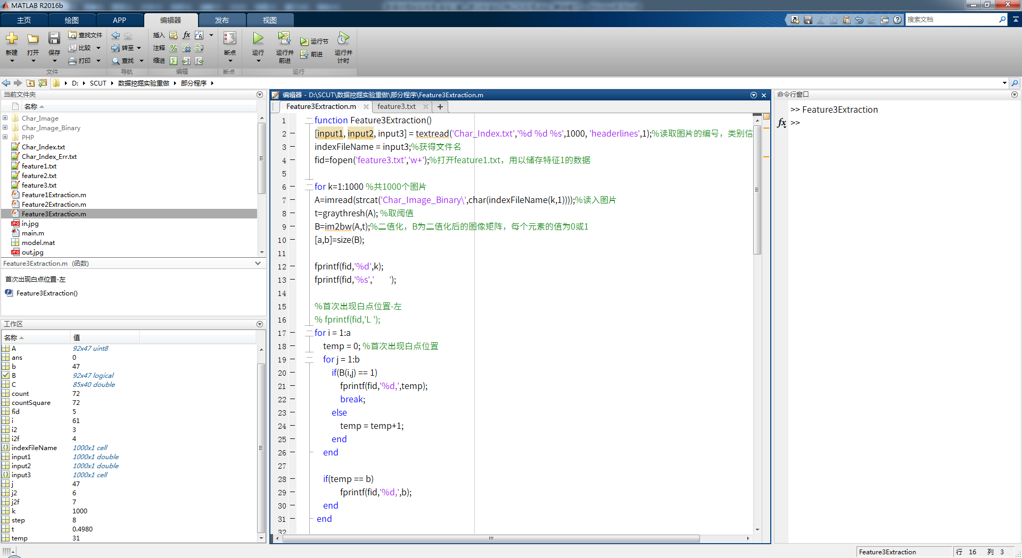
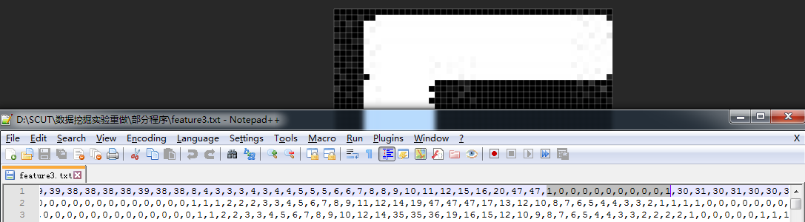

3.Feature4(每一行和每一列的线段数目)
Feature4Extraction.m
function Feature4Extraction()
[input1, input2, input3] = textread('Char_Index.txt','%d %d %s',1000, 'headerlines',1);%读取图片的编号，类别信息和文件名
indexFileName = input3;%获得文件名
fid=fopen('feature4.txt','w+');%打开feature1.txt，用以储存特征1的数据
for k=1:1000 %共1000个图片
A=imread(strcat('Char_Image_Binary\',char(indexFileName(k,1))));%读入图片
t=graythresh(A); %取阈值
B=im2bw(A,t);%二值化，B为二值化后的图像矩阵，每个元素的值为0或1
[a,b]=size(B);

fprintf(fid,'%d',k);
fprintf(fid,'%s',' ');

%逐行统计线段数
temp=0; %使用temp作为标记是否连续
for i=1:a
line=0;
for j=1:b
if(B(i,j)==1)&(temp==0)
line=line+1;
temp=1; %置位避免重复记数
elseif(B(i,j)==0)&(temp==1)
temp=0;
end
end
fprintf(fid,'%d',line);
fprintf(fid,',');
end

%逐列统计线段数
temp=0; %使用temp作为标记是否连续
for j=1:b
line=0;
for i=1:a
if(B(i,j)==1)&(temp==0)
line=line+1;
temp=1; %置位避免重复记数
elseif(B(i,j)==0)&(temp==1)
temp=0;
end
end
fprintf(fid,'%d',line);

if (j ~=b)
fprintf(fid,',');
end
end

if k~=1000
fprintf(fid,'\n');%不为最后一行，则每行末尾加回车
end

end
fclose(fid);%关闭文件

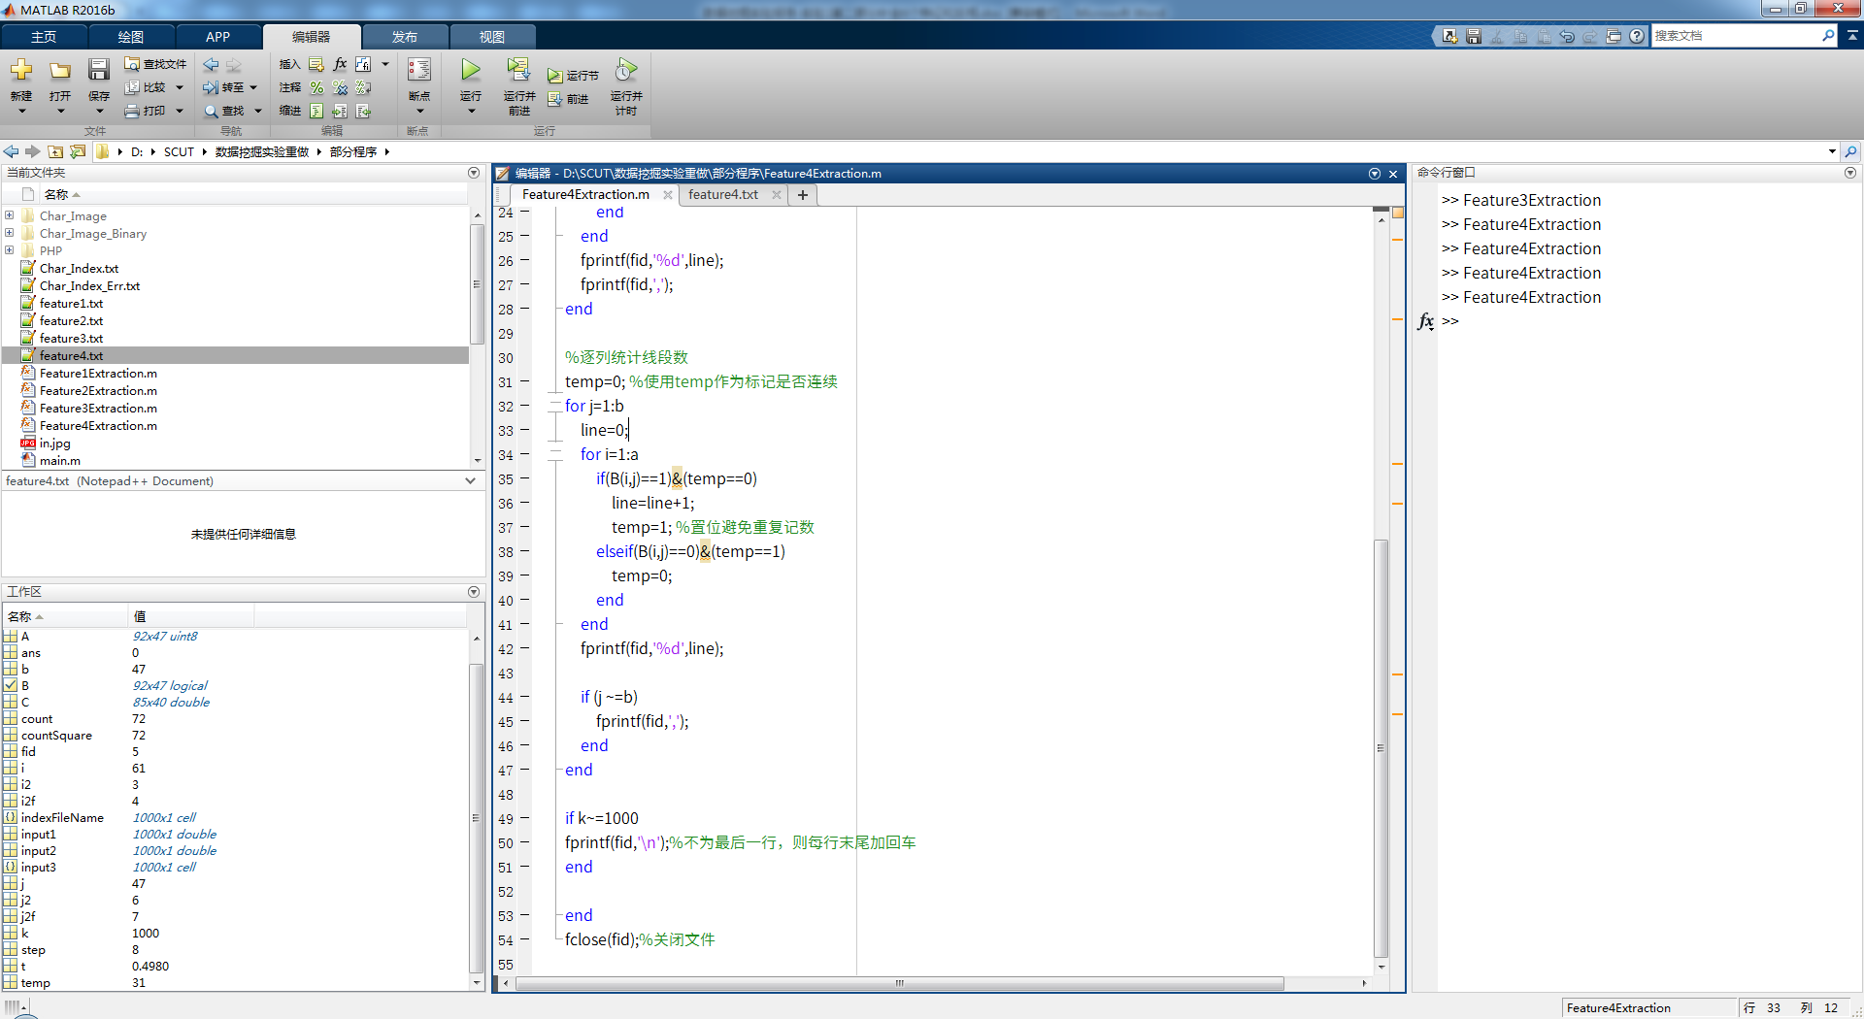
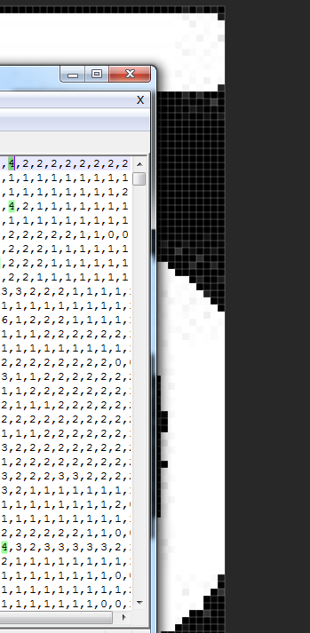

Part II测试Feature 1~6预测的正确率
特征 | 正确率 | 错误测试样本
Feature1  每一行和每一列的白点数 | 98.5% | 49 20081130163845687ch1IMG.JPG 30 10  149 20090109123040296ch0IMG.JPG 10 30  200 20090114235300546ch0IMG.JPG 11 10
Feature2  8*8区域密度 | 98.5% | 49 20081130163845687ch1IMG.JPG 30 10  149 20090109123040296ch0IMG.JPG 10 11  200 20090114235300546ch0IMG.JPG 11 10
Feature3  字符左右上下与边界的距离 | 88.5% | 45 20081130162257734ch6IMG.JPG 20 11  49 20081130163845687ch1IMG.JPG 30 20  51 20081130164315078ch3IMG.JPG 28 20  52 20081130164434453ch5IMG.JPG 28 20  55 20081130165546406ch2IMG.JPG 33 31  57 20081203224143265ch2IMG.JPG 32 26  58 20081203224526359ch2IMG.JPG 32 28  64 20081203231634343ch5IMG.JPG 28 20  103 20081214003537812ch4IMG.JPG 22 10  114 20081215130728765ch2IMG.JPG 34 20  121 20081219142527546ch2IMG.JPG 32 20  123 20081224162710765ch2IMG.JPG 31 33  124 20081224164308093ch2IMG.JPG 32 28  125 20081224164913984ch3IMG.JPG 33 20  135 20090105213336500ch3IMG.JPG 32 26  140 20090109104517437ch0IMG.JPG 10 11  144 20090109112035296ch0IMG.JPG 10 26  149 20090109123040296ch0IMG.JPG 10 12  156 20090109233525875ch3IMG.JPG 34 20  160 20090110232827565ch2IMG.JPG 33 20  177 20090112161351015ch0IMG.JPG 12 32  187 20090114201458015ch2IMG.JPG 34 20  200 20090114235300546ch0IMG.JPG 11 20
Feature4  每一行和每一列的线段数目 | 89% | 8 20081124220640765ch2IMG.JPG 33 20  54 20081130165501031ch2IMG.JPG 33 20  55 20081130165546406ch2IMG.JPG 33 20  92 20081206160527843ch6IMG.JPG 20 33  96 20081208220727718ch6IMG.JPG 20 33  103 20081214003537812ch4IMG.JPG 22 12  115 20081215132119343ch5IMG.JPG 20 33  125 20081224164913984ch3IMG.JPG 33 20  128 20081231194706937ch4IMG.JPG 20 33  129 20081231195631765ch4IMG.JPG 20 33  131 20081231224555000ch5IMG.JPG 20 33  134 20090105212512562ch4IMG.JPG 20 33  137 20090105220049671ch2IMG.JPG 33 20  145 20090109112231265ch2IMG.JPG 33 31  152 20090109144527468ch2IMG.JPG 33 20  153 20090109160329046ch2IMG.JPG 33 20  155 20090109215924015ch2IMG.JPG 33 20  162 20090110235036187ch2IMG.JPG 33 20  166 20090112140952140ch0IMG.JPG 12 28  177 20090112161351015ch0IMG.JPG 12 10  181 20090112164636656ch0IMG.JPG 12 28  191 20090114213358015ch3IMG.JPG 34 20
Feature5  4*4区域密度 | 99% | 149 20090109123040296ch0IMG.JPG 10 11  200 20090114235300546ch0IMG.JPG 11 10
Feature6  6*6区域密度 | 98.5% | 49 20081130163845687ch1IMG.JPG 30 10  149 20090109123040296ch0IMG.JPG 10 11  200 20090114235300546ch0IMG.JPG 11 10

测试脚本
clc; %清屏
clear all; %清缓存

fid = fopen('feature6.txt');
ferror = fopen('error.txt','w');
C = textscan(fid,'%d','delimiter',',');
D = C{1,1}; %因为新版建议用textscan，但textscan却要转一下
feature_matrix = zeros(1000,length(D)/1000);
for i = 1:1000
for j = 1:(length(D)/1000)
feature_matrix(i,j) = D(j+(i-1)*(length(D)/1000));
end
end
feature_matrix(:,[1])=[]; %去掉第一列的编号

fchar_index = fopen('Char_Index.txt');
Index = textscan(fchar_index,'%f %f %s',1000,'delimiter','\t','HeaderLines',1);
char_index = Index{1,2};
char_file_name = Index{1,3};

char_index_predict = zeros(200,1);
char_file_name_predict = {};
char_index_train = zeros(800,1);
it=1;
ip=1;
for i =1:1000
if rem(i,5)==0
char_index_predict(ip) = char_index(i);
char_file_name_predict(ip) = char_file_name(i);
feature_matrix_predict(ip,:) = feature_matrix(i,:); %按行复制
ip = ip+1;
else
char_index_train(it) = char_index(i);
feature_matrix_train(it,:) = feature_matrix(i,:); %按行复制
it = it+1;
end
end

% model = svmtrain(char_index, feature_matrix);
% [predict_label, accuracy, dec_values] = svmpredict(char_index, feature_matrix, model);

model = svmtrain(char_index_train, feature_matrix_train,'-t 1 -d 3 -g 0.01 -r 2');
% save model.mat model;
% load model.mat model;
[predict_label, accuracy, dec_values] = svmpredict(char_index_predict, feature_matrix_predict, model);

noCorrect = []; %初始化
for i = 1:200
if char_index_predict(i) ~= predict_label(i) %matlab取反是~而不是!
noCorrect =[noCorrect; i char_file_name_predict(i) char_index_predict(i) predict_label(i)];
fprintf(ferror, '%d %s %d %d\n', i, char(char_file_name_predict(i)), char_index_predict(i), predict_label(i));
end
end

noCorrect

%
% fmp1=feature_matrix_predict(1,:);
%
% predict_label = svmpredict(1, fmp1, model); %看说明label是可以随意
% predict_label

Part II 二值化后反相学习与识别
由于图像反相不可能进行手工处理，而进行普通的二值化转换的过程中有14/1000，即1.4%的概率会出现图像反相的情况，将降低识别的准确率
PreProcessingTo_Inv.m
function PreProcessingTo_Inv()
[input1, input2, input3] = textread('Char_Index.txt','%d %d %s',1000, 'headerlines',1);
indexFileName = input3;
%提示有14张图片是白底黑字的错误
for k=1:1000 %提示有14张图片是白底黑字的错误
A=imread(strcat('Char_Image_Binary\',char(indexFileName(k,1))));
t=graythresh(A);
B=im2bw(A,t);
[a,b]=size(B);
for i=1:a
for j=1:b
B(i,j)=1-B(i,j); %明显这个又是反相
end
end
imwrite(B,strcat('Char_Image_Binary_Inv\',char(indexFileName(k,1))));
end

其余6个特征均只需要将读取时多读一次
indexFileName = [input3;input3];%复制1000

for k=1:2000 %共2000个图片
if k<1001
A=imread(strcat('Char_Image_Binary\',char(indexFileName(k,1))));%读入图片
else
A=imread(strcat('Char_Image_Binary_Inv\',char(indexFileName(k,1))));%读入图片
end

if k~=2000
fprintf(fid,'\n');%不为最后一行，则每行末尾加回车
end

当然训练程序也要相应修改
train_inv.m
clc; %清屏
clear all; %清缓存

fid = fopen('feature6_Inv.txt');
ferror = fopen('error.txt','w');
C = textscan(fid,'%d','delimiter',',');
D = C{1,1}; %因为新版建议用textscan，但textscan却要转一下
feature_matrix = zeros(2000,length(D)/2000);
for i = 1:2000
for j = 1:(length(D)/2000)
feature_matrix(i,j) = D(j+(i-1)*(length(D)/2000));
end
end
feature_matrix(:,[1])=[]; %去掉第一列的编号

[input1, input2, input3] = textread('Char_Index.txt','%d %d %s',1000, 'headerlines',1);%读取图片的编号，类别信息和文件名
indexFileName = [input3;input3];%复制1000
char_index = [input2;input2];
char_file_name = [input3;input3];

char_index_predict = zeros(400,1);
char_file_name_predict = {};
char_index_train = zeros(1600,1);
it=1;
ip=1;
for i =1:2000
if rem(i,5)==0
if i < 1001
char_index_predict(ip) = char_index(i);
else
char_index_predict(ip) = char_index(i) + 100;
end
char_file_name_predict(ip) = char_file_name(i);
feature_matrix_predict(ip,:) = feature_matrix(i,:); %按行复制
ip = ip+1;
else
if i < 1001
char_index_train(it) = char_index(i);
else
char_index_train(it) = char_index(i) + 100;
end
feature_matrix_train(it,:) = feature_matrix(i,:); %按行复制
it = it+1;
end
end

% model = svmtrain(char_index, feature_matrix);
% [predict_label, accuracy, dec_values] = svmpredict(char_index, feature_matrix, model);

model = svmtrain(char_index_train, feature_matrix_train,'-t 1 -d 3 -g 0.01 -r 2');
% save model.mat model;
% load model.mat model;
[predict_label, accuracy, dec_values] = svmpredict(char_index_predict, feature_matrix_predict, model);

noCorrect = []; %初始化
for i = 1:400
if char_index_predict(i) ~= predict_label(i) %matlab取反是~而不是!
noCorrect =[noCorrect; i char_file_name_predict(i) char_index_predict(i) predict_label(i)];
fprintf(ferror, '%d %s %d %d\n', i, char(char_file_name_predict(i)), char_index_predict(i), predict_label(i));
end
end

noCorrect

%
% fmp1=feature_matrix_predict(1,:);
%
% predict_label = svmpredict(1, fmp1, model); %看说明label是可以随意
% predict_label

验证加反相后的正确率
特征 | 正确率 | 错误测试样本
Feature1  每一行和每一列的白点数 | 97.25% | 49 20081130163845687ch1IMG.JPG 30 10  149 20090109123040296ch0IMG.JPG 10 30  177 20090112161351015ch0IMG.JPG 12 126  200 20090114235300546ch0IMG.JPG 11 10  249 20081130163845687ch1IMG.JPG 130 110  344 20090109112035296ch0IMG.JPG 110 126  345 20090109112231265ch2IMG.JPG 133 30  349 20090109123040296ch0IMG.JPG 110 33  360 20090110232827565ch2IMG.JPG 133 120  377 20090112161351015ch0IMG.JPG 112 110  400 20090114235300546ch0IMG.JPG 111 110
Feature2  8*8区域密度 | 98.5% | 49 20081130163845687ch1IMG.JPG 30 10  149 20090109123040296ch0IMG.JPG 10 11  200 20090114235300546ch0IMG.JPG 11 10  249 20081130163845687ch1IMG.JPG 130 110  377 20090112161351015ch0IMG.JPG 112 133  400 20090114235300546ch0IMG.JPG 111 110
Feature3  字符左右上下与边界的距离 | 75% | 45 20081130162257734ch6IMG.JPG 20 11  49 20081130163845687ch1IMG.JPG 30 20  51 20081130164315078ch3IMG.JPG 28 20  52 20081130164434453ch5IMG.JPG 28 20  55 20081130165546406ch2IMG.JPG 33 31  57 20081203224143265ch2IMG.JPG 32 26  58 20081203224526359ch2IMG.JPG 32 28  64 20081203231634343ch5IMG.JPG 28 20  103 20081214003537812ch4IMG.JPG 22 10  114 20081215130728765ch2IMG.JPG 34 20  121 20081219142527546ch2IMG.JPG 32 20  123 20081224162710765ch2IMG.JPG 31 33  124 20081224164308093ch2IMG.JPG 32 28  125 20081224164913984ch3IMG.JPG 33 20  135 20090105213336500ch3IMG.JPG 32 26  140 20090109104517437ch0IMG.JPG 10 11  144 20090109112035296ch0IMG.JPG 10 26  145 20090109112231265ch2IMG.JPG 33 130  149 20090109123040296ch0IMG.JPG 10 12  156 20090109233525875ch3IMG.JPG 34 20  160 20090110232827565ch2IMG.JPG 33 20  177 20090112161351015ch0IMG.JPG 12 32  187 20090114201458015ch2IMG.JPG 34 20  200 20090114235300546ch0IMG.JPG 11 20  206 20081124214820109ch6IMG.JPG 126 120  207 20081124215744140ch6IMG.JPG 126 125  212 20081124222840703ch3IMG.JPG 120 125  213 20081124223410781ch6IMG.JPG 126 110  216 20081125195529375ch5IMG.JPG 128 132  217 20081125195957812ch6IMG.JPG 125 10  219 20081125201840718ch4IMG.JPG 126 120  220 20081125202014812ch5IMG.JPG 126 125  223 20081127142206500ch3IMG.JPG 128 120  224 20081127144201468ch6IMG.JPG 126 120  229 20081129162129234ch5IMG.JPG 120 132  230 20081129163318812ch4IMG.JPG 126 110  234 20081129185329359ch6IMG.JPG 128 120  235 20081129190358734ch3IMG.JPG 128 120  237 20081129231007984ch3IMG.JPG 125 131  238 20081129231828812ch4IMG.JPG 128 132  239 20081129232213171ch4IMG.JPG 128 126  240 20081129232539687ch5IMG.JPG 125 126  241 20081129233204343ch1IMG.JPG 131 120  245 20081130162257734ch6IMG.JPG 120 132  249 20081130163845687ch1IMG.JPG 130 31  250 20081130163956515ch3IMG.JPG 125 34  251 20081130164315078ch3IMG.JPG 128 126  252 20081130164434453ch5IMG.JPG 128 126  256 20081130165657218ch2IMG.JPG 132 126  257 20081203224143265ch2IMG.JPG 132 120  258 20081203224526359ch2IMG.JPG 132 120  260 20081203224844359ch5IMG.JPG 125 126  261 20081203225308718ch3IMG.JPG 122 125  265 20081203232706984ch5IMG.JPG 126 125  267 20081203234057437ch3IMG.JPG 125 111  268 20081203234311750ch5IMG.JPG 126 128  276 20081204000053656ch1IMG.JPG 131 120  277 20081204000435281ch1IMG.JPG 130 120  278 20081204000626625ch5IMG.JPG 125 126  279 20081204000924609ch1IMG.JPG 130 111  283 20081204172547937ch4IMG.JPG 120 132  287 20081206115230421ch2IMG.JPG 134 33  288 20081206123520375ch2IMG.JPG 134 132  290 20081206151118734ch5IMG.JPG 122 125  292 20081206160527843ch6IMG.JPG 120 133  295 20081208215950625ch1IMG.JPG 130 120  297 20081208235222296ch3IMG.JPG 122 33  298 20081208235805312ch2IMG.JPG 131 128  309 20081215122331421ch6IMG.JPG 122 125  314 20081215130728765ch2IMG.JPG 134 120  316 20081215132949921ch2IMG.JPG 131 133  318 20081219131722687ch2IMG.JPG 134 120  319 20081219133608968ch1IMG.JPG 132 120  320 20081219135242578ch2IMG.JPG 131 111  322 20081219144301578ch3IMG.JPG 132 128  325 20081224164913984ch3IMG.JPG 133 34  332 20090105211334421ch6IMG.JPG 120 111  333 20090105211850640ch3IMG.JPG 120 133  334 20090105212512562ch4IMG.JPG 120 111  335 20090105213336500ch3IMG.JPG 132 110  339 20090109102214031ch0IMG.JPG 110 111  344 20090109112035296ch0IMG.JPG 110 122  345 20090109112231265ch2IMG.JPG 133 12  350 20090109124038468ch3IMG.JPG 133 120  351 20090109125032968ch0IMG.JPG 110 111  352 20090109144527468ch2IMG.JPG 133 122  354 20090109183436203ch2IMG.JPG 133 122  356 20090109233525875ch3IMG.JPG 134 126  358 20090110145834546ch1IMG.JPG 134 31  359 20090110165157796ch1IMG.JPG 134 130  370 20090112145055000ch0IMG.JPG 112 120  373 20090112154012578ch0IMG.JPG 112 132  377 20090112161351015ch0IMG.JPG 112 10  382 20090112215720198ch3IMG.JPG 134 111  383 20090112221119823ch3IMG.JPG 134 132  387 20090114201458015ch2IMG.JPG 134 120  388 20090114210804781ch0IMG.JPG 111 120  391 20090114213358015ch3IMG.JPG 134 126  396 20090114230630093ch0IMG.JPG 111 120  400 20090114235300546ch0IMG.JPG 111 30
Feature4  每一行和每一列的线段数目 | 75.75% | 8 20081124220640765ch2IMG.JPG 33 20  16 20081125195529375ch5IMG.JPG 28 128  17 20081125195957812ch6IMG.JPG 25 125  22 20081126162613609ch6IMG.JPG 22 122  24 20081127144201468ch6IMG.JPG 26 126  52 20081130164434453ch5IMG.JPG 28 128  54 20081130165501031ch2IMG.JPG 33 120  55 20081130165546406ch2IMG.JPG 33 120  62 20081203225614015ch3IMG.JPG 22 122  65 20081203232706984ch5IMG.JPG 26 126  67 20081203234057437ch3IMG.JPG 25 125  68 20081203234311750ch5IMG.JPG 26 126  69 20081203234534812ch3IMG.JPG 22 122  72 20081203234811609ch6IMG.JPG 25 125  76 20081204000053656ch1IMG.JPG 31 131  78 20081204000626625ch5IMG.JPG 25 125  84 20081204173842343ch3IMG.JPG 25 125  86 20081204174834375ch5IMG.JPG 26 126  92 20081206160527843ch6IMG.JPG 20 33  96 20081208220727718ch6IMG.JPG 20 33  100 20081209000443859ch5IMG.JPG 20 120  103 20081214003537812ch4IMG.JPG 22 112  106 20081214131844034ch6IMG.JPG 20 120  108 20081214193351331ch6IMG.JPG 22 122  113 20081215125708671ch2IMG.JPG 31 131  115 20081215132119343ch5IMG.JPG 20 33  118 20081219131722687ch2IMG.JPG 34 33  125 20081224164913984ch3IMG.JPG 33 20  128 20081231194706937ch4IMG.JPG 20 133  129 20081231195631765ch4IMG.JPG 20 33  134 20090105212512562ch4IMG.JPG 20 33  135 20090105213336500ch3IMG.JPG 32 132  137 20090105220049671ch2IMG.JPG 33 20  145 20090109112231265ch2IMG.JPG 33 122  147 20090109121918640ch0IMG.JPG 10 110  150 20090109124038468ch3IMG.JPG 33 133  152 20090109144527468ch2IMG.JPG 33 20  153 20090109160329046ch2IMG.JPG 33 20  155 20090109215924015ch2IMG.JPG 33 20  158 20090110145834546ch1IMG.JPG 34 134  161 20090110233705328ch1IMG.JPG 33 133  162 20090110235036187ch2IMG.JPG 33 20  163 20090110235913687ch1IMG.JPG 33 133  166 20090112140952140ch0IMG.JPG 12 28  171 20090112150016953ch0IMG.JPG 12 112  173 20090112154012578ch0IMG.JPG 12 112  174 20090112154647265ch0IMG.JPG 12 112  175 20090112155810031ch0IMG.JPG 12 112  177 20090112161351015ch0IMG.JPG 12 110  180 20090112163500921ch0IMG.JPG 12 112  181 20090112164636656ch0IMG.JPG 12 28  191 20090114213358015ch3IMG.JPG 34 20  200 20090114235300546ch0IMG.JPG 11 111  208 20081124220640765ch2IMG.JPG 133 120  220 20081125202014812ch5IMG.JPG 126 26  223 20081127142206500ch3IMG.JPG 128 28  231 20081129163847515ch5IMG.JPG 120 33  240 20081129232539687ch5IMG.JPG 125 25  241 20081129233204343ch1IMG.JPG 131 128  246 20081130162731796ch5IMG.JPG 120 20  248 20081130163445906ch4IMG.JPG 125 25  249 20081130163845687ch1IMG.JPG 130 30  254 20081130165501031ch2IMG.JPG 133 120  255 20081130165546406ch2IMG.JPG 133 120  271 20081203234731859ch4IMG.JPG 125 25  282 20081204171908828ch6IMG.JPG 120 133  287 20081206115230421ch2IMG.JPG 134 120  292 20081206160527843ch6IMG.JPG 120 133  299 20081209000029437ch2IMG.JPG 131 31  303 20081214003537812ch4IMG.JPG 122 112  315 20081215132119343ch5IMG.JPG 120 33  317 20081215133608000ch6IMG.JPG 120 20  320 20081219135242578ch2IMG.JPG 131 31  323 20081224162710765ch2IMG.JPG 131 31  325 20081224164913984ch3IMG.JPG 133 120  329 20081231195631765ch4IMG.JPG 120 133  331 20081231224555000ch5IMG.JPG 120 20  332 20090105211334421ch6IMG.JPG 120 20  333 20090105211850640ch3IMG.JPG 120 133  334 20090105212512562ch4IMG.JPG 120 133  337 20090105220049671ch2IMG.JPG 133 120  345 20090109112231265ch2IMG.JPG 133 122  348 20090109122531218ch2IMG.JPG 134 34  352 20090109144527468ch2IMG.JPG 133 120  353 20090109160329046ch2IMG.JPG 133 120  354 20090109183436203ch2IMG.JPG 133 33  355 20090109215924015ch2IMG.JPG 133 20  356 20090109233525875ch3IMG.JPG 134 33  360 20090110232827565ch2IMG.JPG 133 120  362 20090110235036187ch2IMG.JPG 133 120  366 20090112140952140ch0IMG.JPG 112 128  370 20090112145055000ch0IMG.JPG 112 12  377 20090112161351015ch0IMG.JPG 112 110  378 20090112162259484ch0IMG.JPG 112 12  381 20090112164636656ch0IMG.JPG 112 28  385 20090114012229437ch0IMG.JPG 111 11  391 20090114213358015ch3IMG.JPG 134 34
Feature5  4*4区域密度 | 98.75% | 149 20090109123040296ch0IMG.JPG 10 11  200 20090114235300546ch0IMG.JPG 11 10  249 20081130163845687ch1IMG.JPG 130 110  377 20090112161351015ch0IMG.JPG 112 133  400 20090114235300546ch0IMG.JPG 111 110
Feature6  6*6区域密度 | 98.5% | 49 20081130163845687ch1IMG.JPG 30 10  149 20090109123040296ch0IMG.JPG 10 11  200 20090114235300546ch0IMG.JPG 11 10  249 20081130163845687ch1IMG.JPG 130 110  377 20090112161351015ch0IMG.JPG 112 133  400 20090114235300546ch0IMG.JPG 111 110

加了反相后，正确率均有不同程度的下降
统计一下错误>3的图片
49错误4次及249错误6次
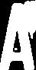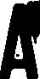

149错误5次及349错误1次
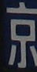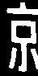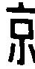

177错误3次及377错误6次
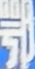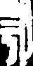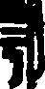

200错误6次及400错误5次
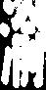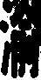

而49明显可以用直方图均衡化
histeq直方图均衡化
图像的对比度太差，常用的方法就是灰度直方图均衡化
原理：
1.找到包含个数最少的灰度级
2.计算各个灰度级像素个数累计分布
3.找到图像中等于某个灰度级所有像素点所在位置
4.利用灰度换算公式，替换所有位置上的像素值

修改程序
RunPreProcessing.m
function RunPreProcessing()
A=imread('in.jpg'); %读取图像
A=rgb2gray(A);
% A=medfilt2(A,[3 3]);
% A=adapthisteq(A); % 自适应直方图均值化
A=histeq(A); % 直方图均值化
t=graythresh(A); %使用最大类间方差法来获得一个阈值，这个阈值在[0, 1]范围内。 该阈值可以传递给im2bw完成灰度图像转换为二值图像的操作。 最大类间方差法是一种自适应的阈值确定的方法,它是按图像的灰度特性,将图像分成背景和目标2部分。背景和目标之间的类间方差越大,说明构成图像的2部分的差别越大,当部分目标错分为背景或部分背景错分为目标都会导致2部分差别变小。因此,使类间方差最大的分割意味着错分概率最小。
B=im2bw(A,t); %使用刚才的阈值转换成二值图像
[a,b]=size(B); %获取图像的大小

if(B(1,1)+B(1,b)+B(a,1)+B(a,b)>=2) %图像的四个角位，如果有2个以上是白色，就做图像的反相操作
for i=1:a
for j=1:b
B(i,j)=1-B(i,j);
end
end
end
imwrite(B,'out.jpg'); %写入二值图像

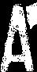

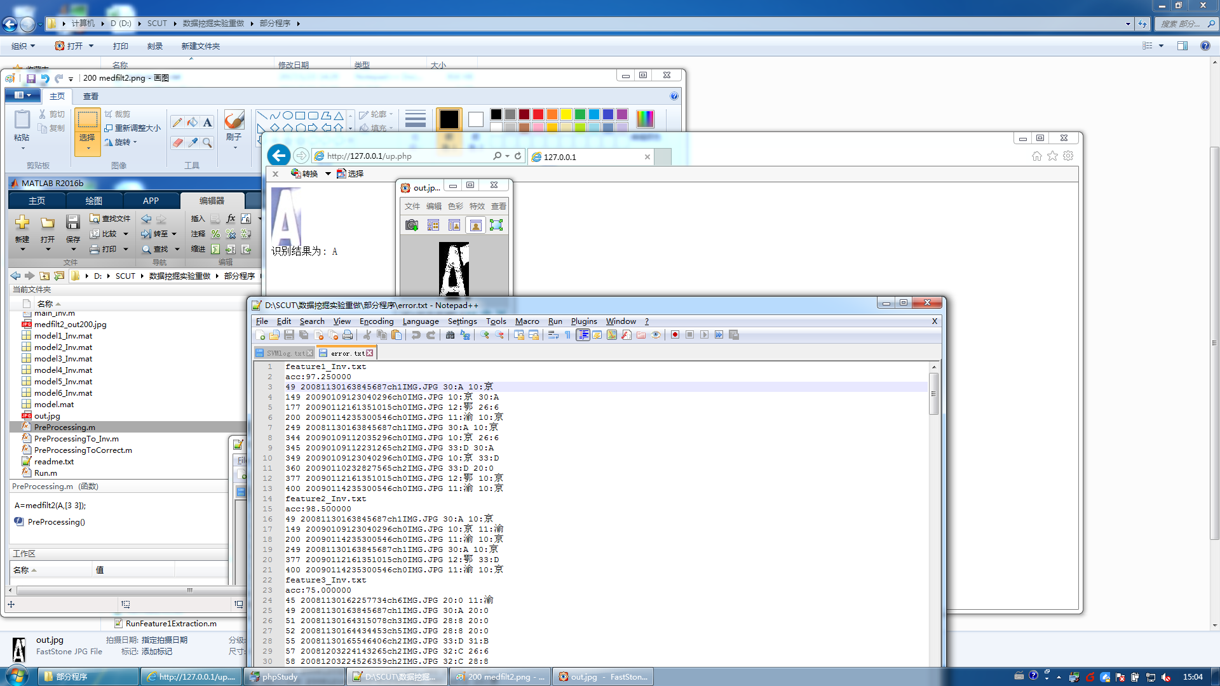

而149需要进行图像的resize，resize前需要进行对上下左右边距的判断，代码较麻烦，暂时跳过
177也可以用直方图均值化，省略

200则需要用到中值滤波
medfilt2中值滤波(非线性平滑滤波技术)
注意要选奇数，因为易选中值，如：1~5易选3
为什么中值滤波可以起到去噪的效果，这还是要回到开始中值滤波的基本原理来说，当选定一个窗口，然后对其窗口中的像素值进行排序时，用其中值去代替中心值，这样就使每个像素值与周围(邻域)的像素值非常接近，这样就使去除那些孤立的噪点(选择适当的点来替代污染点的值)，达到了很好的去噪效果，特别是针对被椒盐噪声污染的图像
实例：
[80 120 90 200 100 110 70]
其中间位置上的灰度值为100，则该灰度序列的中值即为100。
一维信号中值滤波实际上就是用中值代替规定位置（一般指原始信号序列中心位置）的信号值。对前面所举的序列而言，中值滤波的结果是用中值100替代序列中200，得到的滤波序列就是
[80 120 90 100* 100 110 70]
如果在此序列中200是一个噪声信号，则用此方法即可去除这个噪声点。

注意：以前一般听到的是均值滤波
均值滤波：是把每个像素都用周围的8个像素来做均值操作，幅值近似相等且随机分布在不同位置上，这样可以平滑图像，速度较快，算法简单。但是无法去掉噪声，只能微弱的减弱它。
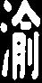
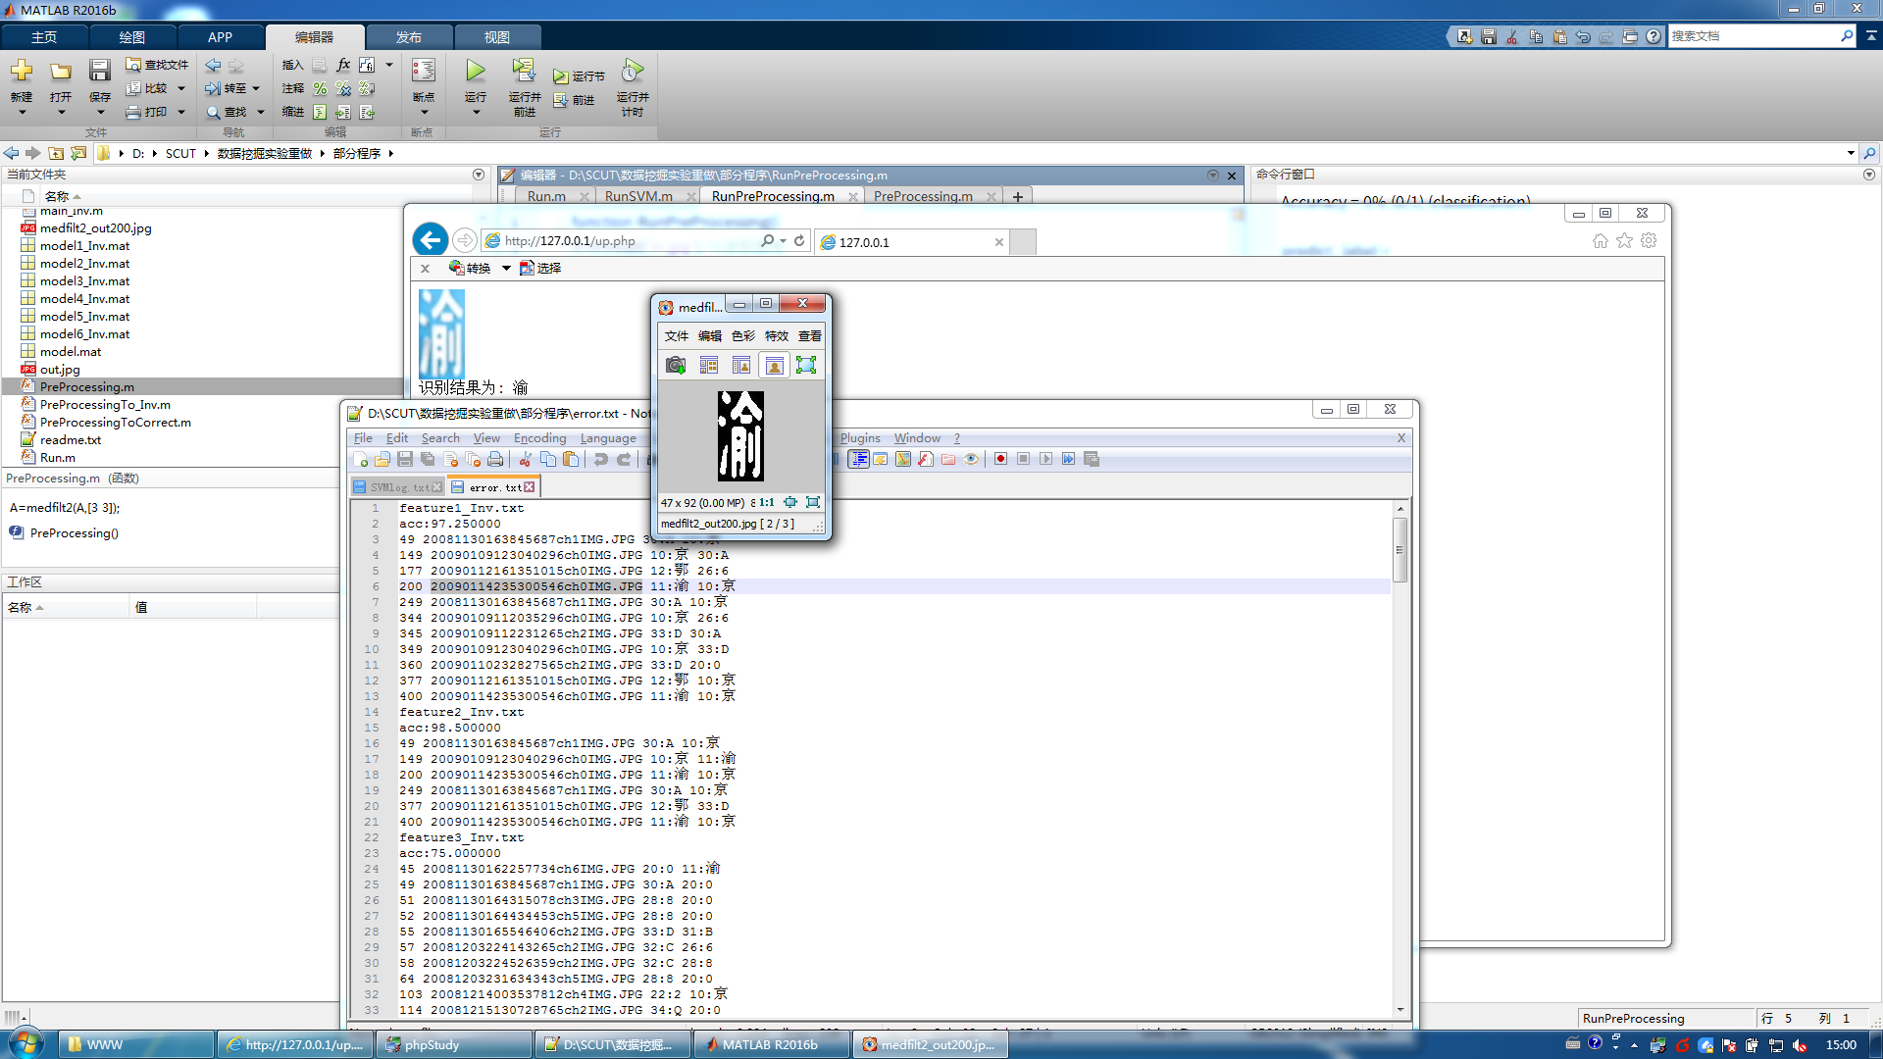

所以整个预处理程序可以修改成先调用直方图均值化，再调用3*3中值滤波。
function PreProcessing()
[input1, input2, input3] = textread('Char_Index.txt','%d %d %s',1000, 'headerlines',1);
indexFileName = input3;
parfor k=1:1000
A=imread(strcat('Char_Image\',char(indexFileName(k,1)))); %读取图像
A=rgb2gray(A);
A=histeq(A); % 直方图均值化
A=medfilt2(A,[3 3]);
t=graythresh(A); %使用最大类间方差法来获得一个阈值，这个阈值在[0, 1]范围内。 该阈值可以传递给im2bw完成灰度图像转换为二值图像的操作。 最大类间方差法是一种自适应的阈值确定的方法,它是按图像的灰度特性,将图像分成背景和目标2部分。背景和目标之间的类间方差越大,说明构成图像的2部分的差别越大,当部分目标错分为背景或部分背景错分为目标都会导致2部分差别变小。因此,使类间方差最大的分割意味着错分概率最小。
% A=adapthisteq(A); % 自适应直方图均值化
B=im2bw(A,t); %使用刚才的阈值转换成二值图像
[a,b]=size(B); %获取图像的大小

if(B(1,1)+B(1,b)+B(a,1)+B(a,b)>=2) %图像的四个角位，如果有2个以上是白色，就做图像的反相操作
for i=1:a
for j=1:b
B(i,j)=1-B(i,j);
end
end
end
imwrite(B,strcat('Char_Image_Binary\',char(indexFileName(k,1)))); %写入二值图像
end

但发觉图片很多都被错误反相
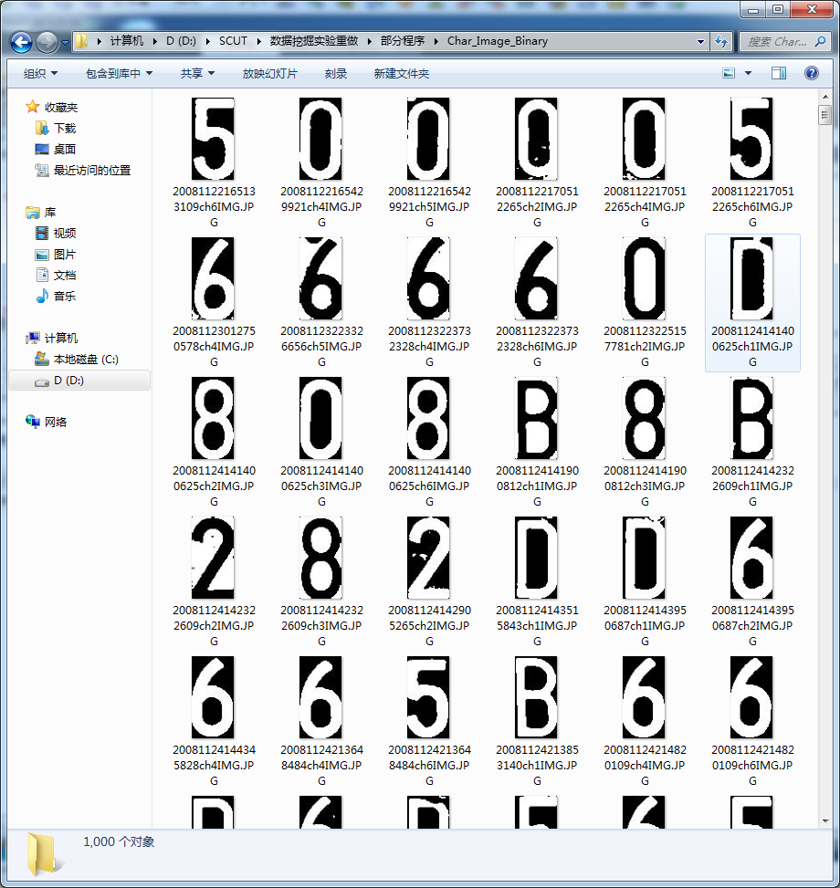

先不管，继续进行训练和预测。由于libsvm自带的正确率统计无法将+100的反相识别转换成正相。所以，正确率判断函数也得要自己重写

train_inv.m
clc; %清屏
clear all; %清缓存
ferror = fopen('error.txt','w+');

for file=1:6
feature_name=strcat('feature',num2str(file));
feature_name=strcat(feature_name,'_Inv.txt');
fprintf(ferror,'%s\n',feature_name);

% fid = fopen('feature1_Inv.txt');
fid = fopen(feature_name);
C = textscan(fid,'%d','delimiter',',');
D = C{1,1}; %因为新版建议用textscan，但textscan却要转一下
clear feature_matrix;
clear feature_matrix_train;
clear feature_matrix_predict;
feature_matrix = zeros(2000,length(D)/2000);
for i = 1:2000
for j = 1:(length(D)/2000)
feature_matrix(i,j) = D(j+(i-1)*(length(D)/2000));
end
end
feature_matrix(:,[1])=[]; %去掉第一列的编号

[input1, input2, input3] = textread('Char_Index.txt','%d %d %s',1000, 'headerlines',1);%读取图片的编号，类别信息和文件名
indexFileName = [input3;input3];%复制1000
char_index = [input2;input2];
char_file_name = [input3;input3];

char_index_predict = zeros(400,1);
char_file_name_predict = {};
char_index_train = zeros(1600,1);
it=1;
ip=1;
for i =1:2000
if rem(i,5)==0
if i < 1001
char_index_predict(ip) = char_index(i);
else
char_index_predict(ip) = char_index(i) + 100;
end
char_file_name_predict(ip) = char_file_name(i);
feature_matrix_predict(ip,:) = feature_matrix(i,:); %按行复制
ip = ip+1;
else
if i < 1001
char_index_train(it) = char_index(i);
else
char_index_train(it) = char_index(i) + 100;
end
feature_matrix_train(it,:) = feature_matrix(i,:); %按行复制
it = it+1;
end
end

% model = svmtrain(char_index, feature_matrix);
% [predict_label, accuracy, dec_values] = svmpredict(char_index, feature_matrix, model);

model = svmtrain(char_index_train, feature_matrix_train,'-t 1 -d 3 -g 0.01 -r 2');

model_name=strcat('model',num2str(file));
model_name=strcat(model_name,'_Inv.mat');
save (model_name,'model');
% load model.mat model;

[predict_label, accuracy, dec_values] = svmpredict(char_index_predict, feature_matrix_predict, model);
% fprintf(ferror,'acc:%f\n',accuracy(1,1));

noCorrect = []; %初始化

CharNo = [10 11 12 20 22 25 26 28 30 31 32 33 34];
CharTrans = ['京' '渝' '鄂' '0' '2' '5' '6' '8' 'A' 'B' 'C' 'D' 'Q'];

noCorrect_count=0;
for i = 1:400
if char_index_predict(i) > 100
char_index_predict_temp = char_index_predict(i) -100;
else
char_index_predict_temp = char_index_predict(i);
end

if predict_label(i) > 100
predict_label_temp = predict_label(i) -100;
else
predict_label_temp = predict_label(i);
end

if char_index_predict_temp ~= predict_label_temp %matlab取反是~而不是!
noCorrect_count = noCorrect_count+1;
noCorrect =[noCorrect; i char_file_name_predict(i) char_index_predict(i) predict_label(i)];

for k = 1:length(CharNo)
if char_index_predict_temp == CharNo(k);
char_index_predict_char = CharTrans(k);
end
end

for k = 1:length(CharNo)
if predict_label_temp == CharNo(k);
predict_char = CharTrans(k);
end
end
fprintf(ferror, '%d %s %d:%s %d:%s\n', i, char(char_file_name_predict(i)),char_index_predict(i),char_index_predict_char, predict_label(i),predict_char);
end
end

fprintf(ferror, 'Correct %f\n\n',((400-noCorrect_count)/400)*100); %正确率

noCorrect
end

fclose(ferror);

feature1_Inv.txt
160 20090110232827565ch2IMG.JPG 33:D 20:0
177 20090112161351015ch0IMG.JPG 12:鄂 26:6
332 20090105211334421ch6IMG.JPG 120:0 134:Q
344 20090109112035296ch0IMG.JPG 110:京 126:6
360 20090110232827565ch2IMG.JPG 133:D 120:0
377 20090112161351015ch0IMG.JPG 112:鄂 126:6
Correct 98.500000

feature2_Inv.txt
Correct 100.000000

feature3_Inv.txt
16 20081125195529375ch5IMG.JPG 28:8 20:0
39 20081129232213171ch4IMG.JPG 28:8 20:0
49 20081130163845687ch1IMG.JPG 30:A 134:Q
51 20081130164315078ch3IMG.JPG 28:8 20:0
54 20081130165501031ch2IMG.JPG 33:D 20:0
65 20081203232706984ch5IMG.JPG 26:6 20:0
94 20081207233956203ch1IMG.JPG 30:A 26:6
99 20081209000029437ch2IMG.JPG 31:B 33:D
109 20081215122331421ch6IMG.JPG 22:2 31:B
123 20081224162710765ch2IMG.JPG 31:B 33:D
138 20090107191436328ch0IMG.JPG 10:京 126:6
145 20090109112231265ch2IMG.JPG 33:D 111:渝
149 20090109123040296ch0IMG.JPG 10:京 30:A
160 20090110232827565ch2IMG.JPG 33:D 20:0
177 20090112161351015ch0IMG.JPG 12:鄂 20:0
187 20090114201458015ch2IMG.JPG 34:Q 20:0
201 20081122170512265ch4IMG.JPG 120:0 133:D
204 20081124142322609ch3IMG.JPG 128:8 120:0
208 20081124220640765ch2IMG.JPG 133:D 111:渝
218 20081125201114078ch6IMG.JPG 126:6 120:0
231 20081129163847515ch5IMG.JPG 120:0 128:8
240 20081129232539687ch5IMG.JPG 125:5 126:6
243 20081130161407890ch4IMG.JPG 128:8 131:B
244 20081130162211968ch3IMG.JPG 128:8 125:5
250 20081130163956515ch3IMG.JPG 125:5 126:6
252 20081130164434453ch5IMG.JPG 128:8 111:渝
255 20081130165546406ch2IMG.JPG 133:D 130:A
256 20081130165657218ch2IMG.JPG 132:C 122:2
257 20081203224143265ch2IMG.JPG 132:C 122:2
258 20081203224526359ch2IMG.JPG 132:C 122:2
260 20081203224844359ch5IMG.JPG 125:5 126:6
263 20081203231101921ch1IMG.JPG 130:A 111:渝
264 20081203231634343ch5IMG.JPG 128:8 126:6
267 20081203234057437ch3IMG.JPG 125:5 134:Q
277 20081204000435281ch1IMG.JPG 130:A 120:0
288 20081206123520375ch2IMG.JPG 134:Q 120:0
292 20081206160527843ch6IMG.JPG 120:0 133:D
298 20081208235805312ch2IMG.JPG 131:B 128:8
313 20081215125708671ch2IMG.JPG 131:B 111:渝
314 20081215130728765ch2IMG.JPG 134:Q 120:0
316 20081215132949921ch2IMG.JPG 131:B 120:0
319 20081219133608968ch1IMG.JPG 132:C 120:0
320 20081219135242578ch2IMG.JPG 131:B 111:渝
322 20081219144301578ch3IMG.JPG 132:C 126:6
324 20081224164308093ch2IMG.JPG 132:C 130:A
328 20081231194706937ch4IMG.JPG 120:0 126:6
332 20090105211334421ch6IMG.JPG 120:0 130:A
333 20090105211850640ch3IMG.JPG 120:0 133:D
334 20090105212512562ch4IMG.JPG 120:0 111:渝
335 20090105213336500ch3IMG.JPG 132:C 128:8
336 20090105214047750ch2IMG.JPG 132:C 130:A
338 20090107191436328ch0IMG.JPG 110:京 28:8
339 20090109102214031ch0IMG.JPG 110:京 128:8
344 20090109112035296ch0IMG.JPG 110:京 132:C
347 20090109121918640ch0IMG.JPG 110:京 111:渝
352 20090109144527468ch2IMG.JPG 133:D 31:B
354 20090109183436203ch2IMG.JPG 133:D 31:B
355 20090109215924015ch2IMG.JPG 133:D 131:B
356 20090109233525875ch3IMG.JPG 134:Q 126:6
357 20090110123741062ch1IMG.JPG 133:D 131:B
358 20090110145834546ch1IMG.JPG 134:Q 133:D
363 20090110235913687ch1IMG.JPG 133:D 131:B
373 20090112154012578ch0IMG.JPG 112:鄂 130:A
377 20090112161351015ch0IMG.JPG 112:鄂 130:A
381 20090112164636656ch0IMG.JPG 112:鄂 28:8
382 20090112215720198ch3IMG.JPG 134:Q 111:渝
383 20090112221119823ch3IMG.JPG 134:Q 120:0
385 20090114012229437ch0IMG.JPG 111:渝 131:B
387 20090114201458015ch2IMG.JPG 134:Q 120:0
388 20090114210804781ch0IMG.JPG 111:渝 125:5
393 20090114221538343ch0IMG.JPG 111:渝 131:B
394 20090114224654796ch0IMG.JPG 111:渝 120:0
396 20090114230630093ch0IMG.JPG 111:渝 32:C
400 20090114235300546ch0IMG.JPG 111:渝 130:A
Correct 81.500000

feature4_Inv.txt
9 20081124221139093ch3IMG.JPG 20:0 33:D
29 20081129162129234ch5IMG.JPG 20:0 33:D
45 20081130162257734ch6IMG.JPG 20:0 33:D
49 20081130163845687ch1IMG.JPG 30:A 120:0
54 20081130165501031ch2IMG.JPG 33:D 20:0
55 20081130165546406ch2IMG.JPG 33:D 20:0
65 20081203232706984ch5IMG.JPG 26:6 132:C
83 20081204172547937ch4IMG.JPG 20:0 33:D
105 20081214131359034ch2IMG.JPG 20:0 33:D
118 20081219131722687ch2IMG.JPG 34:Q 20:0
129 20081231195631765ch4IMG.JPG 20:0 33:D
135 20090105213336500ch3IMG.JPG 32:C 22:2
136 20090105214047750ch2IMG.JPG 32:C 31:B
137 20090105220049671ch2IMG.JPG 33:D 20:0
150 20090109124038468ch3IMG.JPG 33:D 20:0
154 20090109183436203ch2IMG.JPG 33:D 20:0
156 20090109233525875ch3IMG.JPG 34:Q 33:D
160 20090110232827565ch2IMG.JPG 33:D 20:0
162 20090110235036187ch2IMG.JPG 33:D 20:0
181 20090112164636656ch0IMG.JPG 12:鄂 28:8
209 20081124221139093ch3IMG.JPG 120:0 133:D
245 20081130162257734ch6IMG.JPG 120:0 133:D
254 20081130165501031ch2IMG.JPG 133:D 120:0
255 20081130165546406ch2IMG.JPG 133:D 120:0
265 20081203232706984ch5IMG.JPG 126:6 132:C
292 20081206160527843ch6IMG.JPG 120:0 133:D
312 20081215124846312ch5IMG.JPG 120:0 133:D
317 20081215133608000ch6IMG.JPG 120:0 133:D
318 20081219131722687ch2IMG.JPG 134:Q 120:0
325 20081224164913984ch3IMG.JPG 133:D 120:0
326 20081224165659000ch5IMG.JPG 120:0 133:D
329 20081231195631765ch4IMG.JPG 120:0 133:D
330 20081231223320703ch2IMG.JPG 120:0 133:D
331 20081231224555000ch5IMG.JPG 120:0 133:D
335 20090105213336500ch3IMG.JPG 132:C 122:2
336 20090105214047750ch2IMG.JPG 132:C 131:B
337 20090105220049671ch2IMG.JPG 133:D 120:0
350 20090109124038468ch3IMG.JPG 133:D 120:0
356 20090109233525875ch3IMG.JPG 134:Q 133:D
360 20090110232827565ch2IMG.JPG 133:D 120:0
362 20090110235036187ch2IMG.JPG 133:D 120:0
381 20090112164636656ch0IMG.JPG 112:鄂 28:8
391 20090114213358015ch3IMG.JPG 134:Q 120:0
Correct 89.250000

feature5_Inv.txt
Correct 100.000000

feature6_Inv.txt
Correct 100.000000

Feature2、5、6的正确率都达到100%，所以直接使用Feature2来更新自己的MVP

Run.m
function Run()
tic;
RunPreProcessing();
RunFeature2Extraction();
RunSVM();
toc;
exit; %为命令行运行添加的

RunPreProcessing.m
function RunPreProcessing()
A=imread('in.jpg'); %读取图像
A=rgb2gray(A);
A=medfilt2(A,[3 3]);
% A=adapthisteq(A); % 自适应直方图均值化
A=histeq(A); % 直方图均值化
t=graythresh(A); %使用最大类间方差法来获得一个阈值，这个阈值在[0, 1]范围内。 该阈值可以传递给im2bw完成灰度图像转换为二值图像的操作。 最大类间方差法是一种自适应的阈值确定的方法,它是按图像的灰度特性,将图像分成背景和目标2部分。背景和目标之间的类间方差越大,说明构成图像的2部分的差别越大,当部分目标错分为背景或部分背景错分为目标都会导致2部分差别变小。因此,使类间方差最大的分割意味着错分概率最小。
B=im2bw(A,t); %使用刚才的阈值转换成二值图像
[a,b]=size(B); %获取图像的大小

if(B(1,1)+B(1,b)+B(a,1)+B(a,b)>=2) %图像的四个角位，如果有2个以上是白色，就做图像的反相操作
for i=1:a
for j=1:b
B(i,j)=1-B(i,j);
end
end
end
imwrite(B,'out.jpg'); %写入二值图像

RunFeature2Extraction.m
function RunFeature2Extraction()
fid=fopen('Runfeature2.txt','w+');

step = 8; %设置方块步长
k=1;
A=imread('out.jpg');%读入图片
t=graythresh(A); %取阈值
B=im2bw(A,t);%二值化，B为二值化后的图像矩阵，每个元素的值为0或1
[a,b]=size(B);
countSquare = ceil(a/step) * ceil (b/step); %ceil为向上取整，计算共多少个方块

fprintf(fid,'%d',k);
fprintf(fid,'%s',' ');

count = 0; %方块计数
for i = 1:step:a
for j = 1:step:b
temp = 0; %白点计数
count = count+1;

%不是满step的也要计
if(a-i > step)
i2f = step;
elseif(a-i < step)
i2f = a-i+1;
end

if(b-j > step)
j2f = step;
else
j2f = b-j+1;
end

for i2 = 0:i2f-1
for j2 = 0:j2f-1
if(B(i+i2,j+j2) == 1)
temp = temp+1;%方块中白色计数
end
end
end
%调试用
% fprintf(fid,'%d',i2f);
% fprintf(fid,'*');
% fprintf(fid,'%d',j2f);
% fprintf(fid,':');

fprintf(fid,'%d',temp);
if(countSquare ~= count)
fprintf(fid,',');
% fprintf(fid,'\t');
end
end
end
%调试用
% fprintf(fid,'count:');
% fprintf(fid,'%d',count);
% fprintf(fid,'\n');

if k~=1
fprintf(fid,'\n');%不为最后一行，则每行末尾加回车
end

fclose(fid);%关闭文件

RunSVM.m
function RunSVM()
clc; %清屏
clear all; %清缓

fid = fopen('RunFeature2.txt');
fout=fopen('RunSVMOut.txt','w+');

c = textscan(fid,'%f','delimiter',',');
d = c{1,1}; %因为新版建议用textscan，但textscan却要转一下
feature_matrix_predict = d'; % '代表将矩阵转置
feature_matrix_predict(:,[1])=[]; %去掉第一列的编号

% save model.mat model;
load('model2_Inv.mat','model');
fmp1=feature_matrix_predict(1,:);
predict_label = svmpredict(1, feature_matrix_predict, model); %看说明label是可以随意
predict_label

CharNo = [10 11 12 20 22 25 26 28 30 31 32 33 34];
CharTrans = ['京' '渝' '鄂' '0' '2' '5' '6' '8' 'A' 'B' 'C' 'D' 'Q'];
for i = 1:length(CharNo)
if predict_label > 100
predict_label = predict_label -100;
end
if predict_label == CharNo(i);
fprintf(fout,'%s',CharTrans(i));
end
end

再测试几张，正确无误。Finish！！！！
