[](https://www.studocu.com/in?utm_campaign=shared-document&utm_source=studocu-document&utm_medium=social_sharing&utm_content=water-conservation-word-document)

[Water conservation WORD Document](https://www.studocu.com/in/document/osmania-university/environmental-sciences/water-conservation-word-document/49362757?utm_campaign=shared-document&utm_source=studocu-document&utm_medium=social_sharing&utm_content=water-conservation-word-document)

[Environmental Sciences (Osmania University)](https://www.studocu.com/in/course/osmania-university/environmental-sciences/3073389?utm_campaign=shared-document&utm_source=studocu-document&utm_medium=social_sharing&utm_content=water-conservation-word-document)



Scan to open on Studocu

Studocu is not sponsored or endorsed by any college or university

# Water conservation, Rain water harvesting & Watershed management Water conservation:

For any living being, water is one of the essential necessities and we cannot imagine a life without water. It is the natural resource of our earth and its primary constituent. In the nature of different types of life on the earth, water is the universal solvent and plays an important role. For various functions, like washing, bathing, cleaning, cooking, drinking, and other household and commercial uses, it is commonly utilized.

Water is a material that is colourless and odourless and essential for the survival of living creatures. Water sources, like wells, rivers, ponds, reservoirs, seas, massive dams, and streams, are different. Nearly 70 – 80 per cent of the Earth’s surface, as we all know, is filled by water, of which about 1-2 per cent is pure water and appropriate for human usage.

* Water conservation refers specifically to the protection, preservation, and regulation of the use of water and its properties.
* In order to mitigate and prevent scarcity, it is the method implemented to control freshwater, reduce pollution and conserve water and its properties.
* Therefore we should all build awareness among our own friends, families, neighbours, community, etc. about water conservation.
* It is really important to conserve water because it protects life on the planet.

# Method to preserve water:

Several ways to conserve water are available. Here are a few effective and simple methods of safeguarding water

* When not in use, maintain the tap closed.
* Test for holes in water supply pipes.
* For gardening or washing purposes, make sure the rainwater is used.
* Always calculate how many water buckets are lost in a day and try to minimize it.
* When washing and cleaning clothing, utensils, etc., do not use more water than required.
* One of the best techniques used for water conservation is rainwater harvesting. Rather than wasting it, there are distinct approaches used to conserve rainwater.

# Water Conservation Methods:

With a well-planned system, water is supplied to many places regularly in a city. This is generally planned by civic authorities in a city. But many times we observe that some amount of water is wasted through leakage of pipe and many other reasons. As we know that proper water management is necessary for the conservation of water. Thus, it is important for civic authorities to take care of these issues while supplying water to our homes.

We usually observe that most of the rainwater gets wasted although it is one of the most precious natural resources. This rainwater can be used to recharge the groundwater levels by a technique known as [rainwater harvesting.](https://byjus.com/biology/rainwater-harvesting/) Farmers can play an important role in water management by using a water conservation method for irrigation known as drip irrigation. In this technique, plants are watered using narrow tubes and this water is directly delivered at the base of the plant.

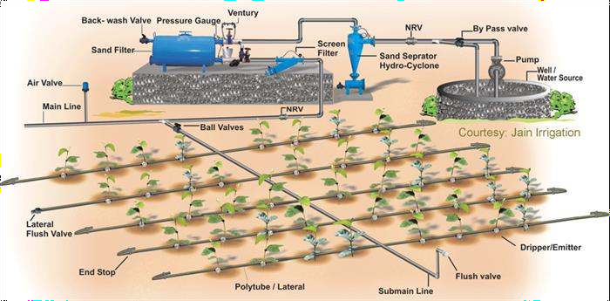

We can also play an important role in minimizing the wastage of the water we use. Some of those habits can be turning off the taps while brushing, mopping the floor instead of washing. A little water conservation methods that can be practised by individuals to reduce the wastage of water are provided below.

* Installing flow-restricting shower heads to save water during showers.
* Taking bucket-baths instead of showers.
* Turning off the tap while shaving or brushing teeth.
* Immediately fixing any leaking taps and pipes in our homes.
* Practising rainwater harvesting to reduce the wastage of rainwater.

# Rainwater harvesting

[](https://www.studocu.com/in?utm_campaign=shared-document&utm_source=studocu-document&utm_medium=social_sharing&utm_content=water-conservation-word-document)Rainwater harvesting is the simple process or technology used to conserve Rainwater by collecting, storing, conveying and purifying of Rainwater that runs off from rooftops, parks, roads, open grounds, etc. for later use.

# How to Harvest the Rainwater?

Rainwater harvesting systems consists of the following components:

* Catchment- Used to collect and store the captured Rainwater.
* Conveyance system – It is used to transport the harvested water from the catchment to the recharge zone.
* Flush- It is used to flush out the first spell of rain.
* Filter – Used for filtering the collected Rainwater and remove pollutants.
* Tanks and the recharge structures: Used to store the filtered water which is ready to use.

The process of rainwater harvesting involves the collection and the storage of rainwater with the help of artificially designed systems that run off naturally or man-made catchment areas like- the rooftop, compounds, rock surface, hill slopes, artificially repaired impervious or semi-pervious land surface.

Several factors play a vital role in the amount of water harvested. Some of these factors are:

* The quantum of runoff
* Features of the catchments
* Impact on the environment
* Availability of the technology
* The capacity of the storage tanks
* Types of the roof, its slope and its materials
* The frequency, quantity and the quality of the rainfall
* The speed and ease with which the Rainwater penetrates through the subsoil to recharge the groundwater.

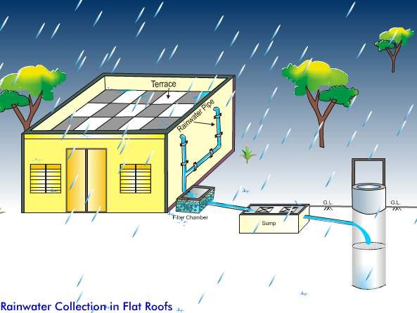

# Why do we Harvest Rainwater?

The rainwater harvesting system is one of the best methods practised and followed to support the [conservation of water.](https://byjus.com/biology/how-can-we-conserve-water/) Today, scarcity of good quality water has become a significant cause of concern. However, Rainwater, which is pure and of good quality, can be used for irrigation, washing, cleaning, bathing, cooking and also for other livestock requirements.

# Advantages of Rainwater Harvesting:

The benefits of rainwater harvesting system are listed below.

* Less cost.
* Helps in reducing the water bill.
* Decreases the demand for water.
* Reduces the need for imported water.
* Promotes both water and energy conservation.
* Improves the quality and quantity of groundwater.
* Does not require a filtration system for landscape irrigation.
* This technology is relatively simple, easy to install and operate.
* It reduces soil erosion, storm water runoff, flooding, and pollution of surface water with fertilizers, pesticides, metals and other sediments.
* It is an excellent source of water for landscape irrigation with no chemicals and dissolved salts and free from all minerals.

# Disadvantages of Rainwater Harvesting:

In addition to the great advantages, the rainwater harvesting system has a few disadvantages like unpredictable rainfall, unavailability of the proper storage system, etc.

Listed below are few more disadvantages of the rainwater harvesting process.

* Regular Maintenance is required.
* Requires some technical skills for installation.
* Limited and no rainfall can limit the supply of Rainwater.
* If not installed correctly, it may attract mosquitoes and other waterborne diseases.
* One of the significant drawbacks of the rainwater harvesting system is storage limits.

# Watershed management:

Watershed management is the study of the relevant characteristics of a [watershed](https://en.wikipedia.org/wiki/Drainage_basin) aimed at the [sustainable distribution](https://en.wikipedia.org/wiki/Sustainable_distribution) of its resources and the process of creating and implementing plans, programs and projects to sustain and enhance [watershed](https://en.wikipedia.org/wiki/Drainage_basin) functions that affect the [plant,](https://en.wikipedia.org/wiki/Plant) [animal,](https://en.wikipedia.org/wiki/Animal) and [human](https://en.wikipedia.org/wiki/Human) communities within the watershed boundary.[[1]](https://en.wikipedia.org/wiki/Watershed_management#cite_note-1) Features of a watershed that agencies seek to manage to include [water supply,](https://en.wikipedia.org/wiki/Water_supply) [water quality,](https://en.wikipedia.org/wiki/Water_quality) [drainage,](https://en.wikipedia.org/wiki/Drainage) [stormwater runoff,](https://en.wikipedia.org/wiki/Stormwater_runoff) [water rights](https://en.wikipedia.org/wiki/Water_right) and the overall planning and utilization of watersheds. [Landowners,](https://en.wikipedia.org/wiki/Landowners) [land use](https://en.wikipedia.org/wiki/Land_use) agencies, stormwater management experts, environmental specialists, water use surveyors and communities all play an integral part in watershed management.

# Objectives of watershed management:

The different objectives of watershed management programmes are:

* To control damaging runoff and degradation and thereby conservation of soil and water.
* [](https://www.studocu.com/in?utm_campaign=shared-document&utm_source=studocu-document&utm_medium=social_sharing&utm_content=water-conservation-word-document)To manage and utilize the runoff water for useful purpose.
* To protect, conserve and improve the land of watershed for more efficient and sustained production.
* To protect and enhance the water resource originating in the watershed.
* To check soil erosion and to reduce the effect of sediment yield on the watershed.
* To rehabilitate the deteriorating lands.
* To moderate the floods peaks at downstream areas.
* To increase infiltration of rainwater.
* To enhance the ground water recharge, wherever applicable.