|  |  |
| --- | --- |
| stockxpertcom_id6270461_jpg_55ed321dcdebd30606bbda7b91c35b8f.jpg | |
| Financial Analysis for Commercial Investment Real Estate | |
|  |  |
|  | In This Module  Module Snapshot 1.1  Module Goal 1.1  Objectives 1.1  Overview 1.3  Two Major Decision Makers 1.3  User Decisions 1.3  Investor Decisions 1.5  The CCIM Curriculum 1.7  Real Estate as Part of the Capital Market 1.9  Three Major Asset Classes 1.10  Space (User/Tenant) Markets Versus Capital (Investment) Markets 1.14  Capital Market 1.14  Space Market 1.16  Interaction Between the Space and Capital Markets 1.17  The Four Quadrants of Real Estate Investment 1.19  The Equity Component of Commercial Real Estate 1.21  Private Investors and Private Institutions 1.21  Public REITs 1.21  Pension Funds 1.22  Foreign Investors 1.22  Life Insurance Companies 1.22  The Debt Component of Commercial Real Estate 1.23  Commercial Banks 1.23  Commercial Mortgage-Backed Securities and Collateralized Debt Obligations 1.23  Life Insurance Companies 1.24  Savings Institutions 1.25  Government Sponsored Entities 1.25  Summary 1.26  Module 1: Self-Assessment Review 1.27  Answer Section 1.29  Module 1: Self-Assessment Review 1.30 |
| Overview of the Real Estate Universe |

Overview of the Real Estate Universe

# camera.wmfModule Snapshot

## Module Goal

After completing this module, you will be able to recognize your “location” within the larger real estate universe and identify how other areas of the real estate universe impact your own.

## Objectives

* Identify the participants in the real estate market.
* List some of the decisions facing participants in the real estate universe.
* Explain the impact of supply and demand, net operating income, and value.
* Identify the role of real estate in the capital market.
* Explain the four quadrants of commercial real estate.

Notes

# Overview

This module provides an overview of investment real estate and sets the stage for the rest of this course and the rest of the CCIM curriculum. It outlines the key players and key markets that are important when making real estate investment decisions. The CCIM curriculum is structured around user and investor decisions. The curriculum assumes that the vast majority of students coming through the curriculum have some role in the decision-making process for users and/or investors, even if they are not the decision makers themselves. Thus, we begin by discussing the motivations of these two major decision makers.

# Two Major Decision Makers

There are two major decision makers who we will focus on in the CCIM curriculum:

* Users, those who make decisions regarding space that they need to use for their business
* Investors, those who make decisions regarding investment in properties that are or could be leased to users

A user might also be an investor, e.g. a company that owns the building that it occupies for a home office or uses for a warehouse. Even so, it is useful to separate the decision to use the real estate from the decision to invest in the real estate because the user could have chosen to lease the same property from an investor or sell it to an investor and lease it back. A property might be of great use for a business but not a good investment for that particular company. On the other hand, a property might be a great investment but not a good location or good space for a particular business. Thus, we want to understand the decisions that are important for users and investors regardless of whether a particular user is also an investor.

## User Decisions

Users want space that meets the needs of their business in terms of the location, size and layout of the space, quality of the building, and perhaps proximity to other business that might be suppliers or customers. Users will be concerned about the occupancy costs of the space which will depend (to a large extent) on the terms of the lease. As noted above, users could own or lease their space. Deciding to use the space is a use decision and deciding to own the space they use is an investment decision which must provide an adequate return as any investment. The company could be using the capital for other purposes.

Users are confronted with many decisions while acquiring the space, holding the space, and disposing of the space. The following is a partial list of the major decisions with which users are confronted:

### Acquisition Decisions

* Should space be acquired?
* What type and how much space should be acquired?
* Where should space be acquired?
* Which space should be acquired?
* What should the space acquisition entity be?
* Should the space be leased or purchased?
* What should the space acquisition process be?

### Holding Period Decisions

* Leased space
* Should discretionary capital expenditures be made?
* Should the capital structure of occupancy be changed?
* Should the space utilization be changed?
* Should the user continue to occupy the space?
* Should any lease options be exercised?
* Should the lease be renegotiated?
* Should the space be disposed of?
* Owned Space
* Should discretionary capital expenditures be made?
* Should the capital structure be changed?
* Should the space utilization be changed?
* Should the user continue to occupy the space?
* Should the property be sold or exchanged?

### Disposition Decisions

* What should the disposition price be?
* What should the disposition method be?
* What should the disposition process be?

The skills and knowledge necessary to make such user decisions will be taught in subsequent courses in the CCIM curriculum.

## Investor Decisions

Investors are primarily interested in receiving a return on investment (yield) that is commensurate with the risk that they will incur by making an investment. The rate of return is the percentage return on each dollar invested for each period it is invested. Investors can compare investment alternatives using the rate of return. Rates of return can be estimated on a before-tax or an after-tax basis.

The more risk that the investment entails, the higher the return the investor should expect. Of course the actual return may differ from the expected return. Investors are ultimately interested in maximizing their wealth, but they will have different tolerances for risk that they are willing to accept in achieving this goal so they may be willing to strive for a lower wealth target if that means they will not incur as much risk. Thus, investors usually decide on the level of risk they are willing to accept and try to maximize their return while keeping the risk at that level.

As was the case for users, investors are confronted with many decisions about acquiring the investment real estate, owning the investment real estate, and disposing of the investment real estate. The following is a partial list of major decisions with which investors are confronted:

### Acquisition Decisions

* Should investment real estate be acquired?
* What type of investment real estate should be acquired?
* When should investment real estate be acquired?
* Where should investment real estate be acquired?
* Which of the available investment real estate alternatives should be acquired?
* How should the investment real estate be acquired?
* What should be the sources of debt and equity capital?
* What should the investment real estate acquisition entity be?
* What should the acquisition price and terms of the investment real estate be?

### Holding Period Decisions

* Should discretionary capital expenditures be made?
* Should the financing structure be changed?
* Should the property use be changed?
* Should the ownership entity be changed?
* Should the property be held or sold?
* Should the operating strategy be changed?

### Disposition Decisions

* What should the disposition price be?
* What should the disposition method be?
* What should the marketing process be?

# The CCIM Curriculum

The CCIM curriculum was structured around the skills and knowledge necessary to make the user and/or investor decisions listed above. This first course is structured primarily around the basic investor decisions in the three decision phases (acquisition, ownership, and disposition). The remainder of this course and the other courses in the CCIM curriculum will enhance your skills and knowledge needed to make many types of real estate decisions. Some of these skills are as follows:

* Identify, compare, and contrast various types of investments.
* Determine the role of real estate in the overall portfolio.
* Factor investor objectives and capabilities into the real estate decision-making process.
* Analyze various property types.
* Apply and interpret the real estate and business cycle models to real estate decision making.
* Conduct and/or analyze a feasibility analysis including a strategic analysis, a market and competitive analysis, a political and legal analysis, a physical and design analysis, and a financial analysis. Describe the property acquisition process.
* Analyze the historic performance of properties.
* Identify the various types of due diligence and interpret the results.
* Determine the impact of leverage on risk and return.
* Conduct a lease buyout analysis for an owner and tenant.
* Compare and contrast the advantages and disadvantages of various real estate acquisition entities.
* Analyze hold and disposition options.
* Conduct a user needs analysis.
* Analyze continue to lease alternatives.
* Complete a comparative lease qualitative analysis for a user.
* Quantify various measures of occupancy cost for a user/tenant and a user/owner.
* Compare and contrast real estate investment value and real estate market value.
* Determine user acquisition value.
* Describe the marketing process and identify the key components of a marketing plan.
* Determine the appropriate discount rate for corporate and non-corporate entities to conduct various discounted cash flow analyses.
* Develop strategies for managing the various types of risk.
* Evaluate cost, structure, amount, and sources of debt and equity capital.

# Real Estate as Part of the Capital Market

Real estate competes for investor dollars with other investment alternatives. Investors will only invest in real estate if it has an expected return that is competitive with other investment alternatives of comparable risk. Investors can put their money in stocks, bonds, money market funds, and many other investment alternatives.

To understand the real estate universe, the discussion must involve commercial real estate as it compares to the two major asset classes that compete with real estate for investment capital: bonds and stocks.

It’s also important to understand the major investment asset classes in today’s sophisticated investment environment. Historically, bonds and stocks were the two major investments that were monitored by the media. Prior to 1960, major institutions invested only in highly liquid bonds. Stocks were ignored due to a lack of information and transparency. Now, investors are giving significant attention to another major asset class—commercial real estate. Commercial real estate is a significant portion of the capital market and now considered to be an “asset class” like stocks and bonds.

During the past several years, commercial real estate has become a major investment alternative. Commercial real estate has investment behavior attributes similar to both the bond market and the stock market. Contract leases behave like bonds, and the upside created in commercial real estate by re-tenanting and repositioning simulates the investment characteristics of the stock market. As discussed earlier, it is often thought that unleveraged, institutional commercial real estate should provide returns that settle somewhere in between bonds and stocks. This is an important basic concept to keep in mind when developing a risk and return profile for a property.

Although the risk and return of real estate may fall between that of stocks and bonds, real estate tends to be impacted by different economic events than stocks and bonds. For example, real estate tends to do better in an inflationary environment. There are periods of time when stock and/or bonds may be performing poorly when real estate is performing well and vice versa. This is important because it means that real estate helps to reduce the overall risk of a portfolio that consists of stocks, bonds and real estate. Because the returns for real estate are not highly correlated with that of stocks and bonds, including real estate in the portfolio tends to smooth out the performance of the portfolio. This is especially important to institutional investors that don’t want to “hold all their eggs in one basket.”

## Three Major Asset Classes

There are three major classes of assets:

* Bonds
* Stocks
* Real Estate

### Bond Market

The bond market serves as a financing mechanism for corporations. The corporation issues the bonds, which have set parameters in terms of the repayment schedule, coupon rate, term, and maturity.

In simple terms, the bond market can be regarded as the investor serving as the lender, and the entity (i.e., the corporation) issuing the bond serves as the borrower. When large companies need to generate additional funds quickly, they typically need far more than a bank can provide. Therefore, a public issue of bonds allows the company to acquire large amounts of money from thousands of investors, each contributing a small portion and earning a return on their investment, referred to as a coupon, which is paid out on a regular schedule. Bonds also are known as fixed-income securities, because an investor knows how much they will get and when the bond will mature or be repaid.

The government also issues bonds, which are known as Treasury bonds. The structure and pricing of government bonds are identical to that of corporate bonds; however, government bonds typically are referred to as risk-free bonds—in that they essentially have no risk of default, as they are backed by the full faith and credit of the U.S. government. Even so, Treasury bonds still exhibit other types of risk, including interest rate risk.

### Stock Market

Like the bond market, the stock market also serves as a financing mechanism for corporations, although without a set repayment schedule or set interest rate. However, when the corporation issues shares of stock to the public, each share of stock represents a stake in that particular corporation. The person(s) or organization(s) holding shares of stock are called shareholders.

The stock market is characterized as being a highly marketable, yet risky investment. A share of stock is said to have greater risk than a bond, mainly due to the volatility of returns associated with the stock market. However, the volatility of returns in the stock market is due to the fact that a shareholder takes a second seat to the bond investor in terms of repayment. In addition, the stock market is characterized as a limited-liability investment in that its shareholders risk only the amount they invest. (For example, if a corporation filed bankruptcy, the creditors cannot come after the shareholders’ personal assets.)

### Real Estate

Investing in real estate typically is not just investing in buildings, but rather investing in the income stream tied to a particular building, which is generated through the rent paid by the tenants. As such, the income generated by a property can cause the price of the property to greatly fluctuate. In most scenarios, real estate investments exhibit greater risk characteristics than bond investments; however, real estate investments also have greater return expectations. In addition, by its nature, direct investment in real estate is not considered a highly liquid investment because it is not traded on a public basis like stocks and bonds. Real estate investment trusts (REITs) are the exception. REITs, which will be discussed further in this module, are companies that have a special tax status and can be listed on a public stock exchange.

Figure 1.1 shows the historic returns for private real estate held by institutional investors (NCREIF), stocks (S&P 500), and thirty-year Treasury bonds. We see that over time the performance of each of these investment alternatives can be quite different. A portfolio consisting of each of these investment alternatives would have a more stable return performance over time; this is because when one asset class is doing poorly, another may be doing well to offset it.

Figure 1.1  Historic Returns by Asset Class, S&P 500, U.S. 30-year Treasury, NCREIF 1978-2020

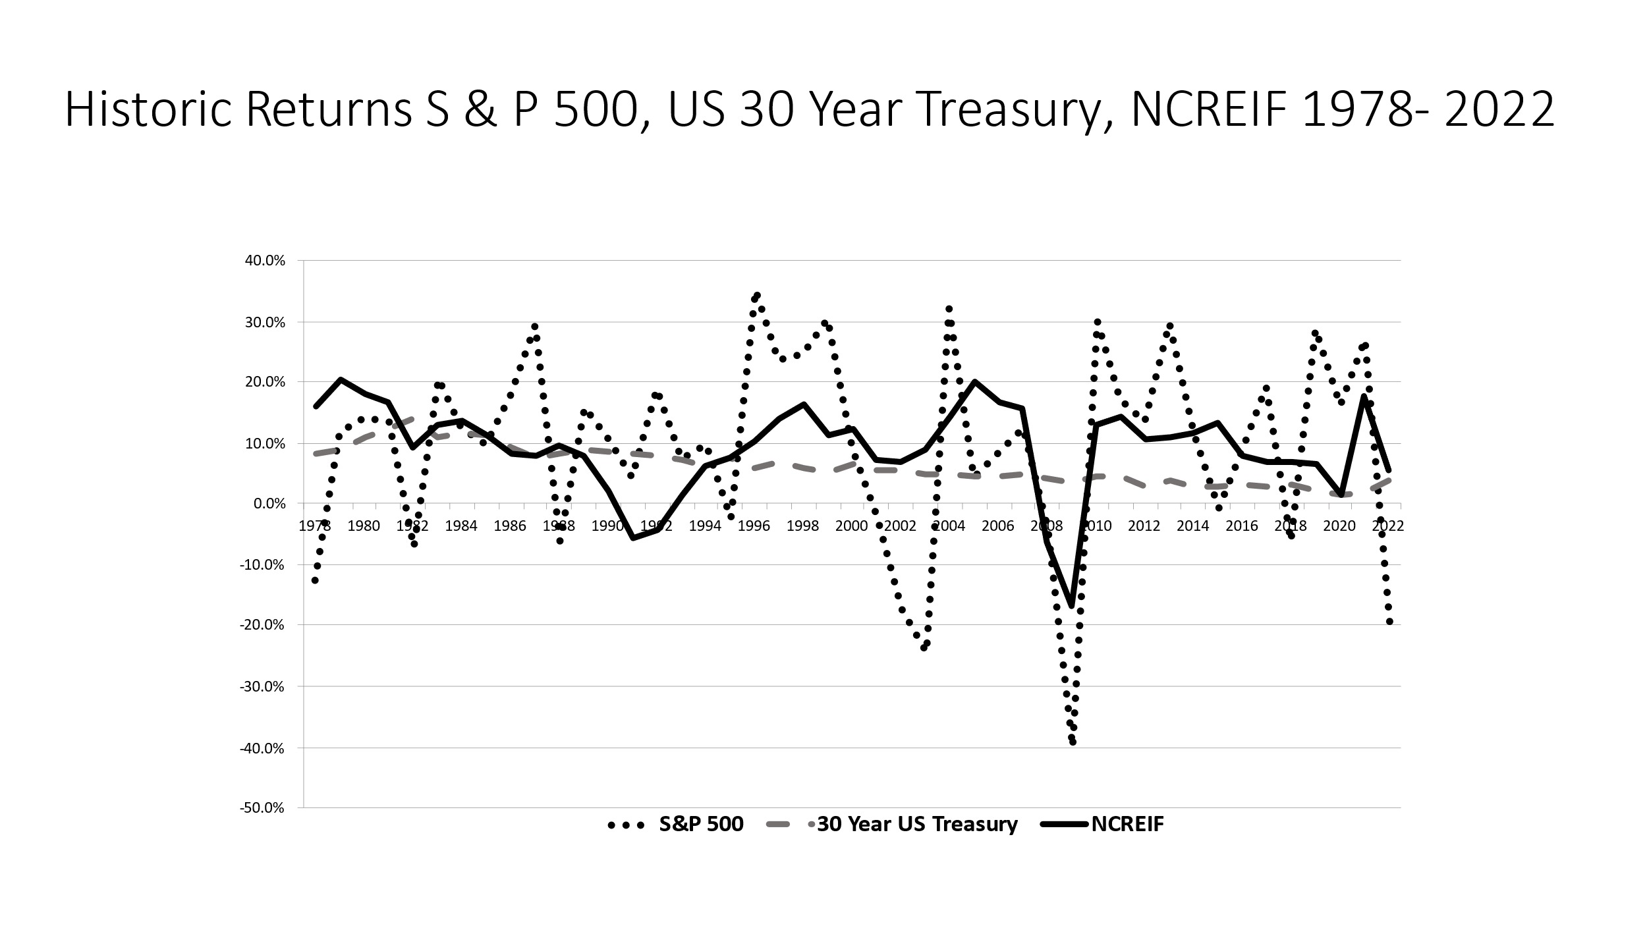

Figure 1.1 shows the historical performance of real estate versus other assets over different historical time periods. The indices that are included are as follows:

* **NCREIF**. This is an index published by the National Council of Real Estate Investment Fiduciaries (NCREIF) and measures the performance of real estate held by institutional investors. The index has over 6,000 properties consisting of office, retail, industrial, multi-family, and hotel properties around the U.S. The market value is more than $300,000,000,000. (See www.NCREIF.org for further information.) The institutional investors include investment managers and pension funds that directly own the properties. These properties are typically purchased free-and-clear at values that exceed $10,000,000. Each quarter NCREIF collects information on the market value of the property, net operating income (NOI), capital expenditures, and other information. NCREIF values the properties using this information and calculates the properties’ returns.
* **S&P 500**. The S&P 500 is a stock market index containing the stocks of 500 large-cap corporations, most of which are American. The index is the most notable of the many indices owned and maintained by Standard & Poor's, a division of McGraw-Hill. The S&P 500 is used in reference not only to the index but also to the 500 companies that have their common stock included in the index. All of the stocks in the index are those of large publicly held companies and trade on the two largest U.S. stock markets, the NYSE and NASDAQ. After the Dow Jones Industrial Average, the S&P 500 is the most widely watched index of large-cap U.S. stocks. It is considered to be a bellwether for the U.S. economy and is a component of the Index of Leading Indicators.
* **Ten-year Treasury Bonds**. A Treasury bond is a marketable, fixed-interest U.S. government debt security that is issued with maturities of ten years or more. Treasury bonds make interest payments semi-annually and the income that holders receive is only taxed at the federal level. (They are exempt from any state or local income tax.) The ten-year Treasury note is the most-followed metric of the U.S. bond market.

All of the previously discussed indices are historical and measure what the returns have been in the past. They measure the return from change in value plus any income such as interest on bonds, dividends on stocks and NOI on real estate. Future performance may be quite different. The point is that investors want to know how real estate has compared with other investments.

Figure 1.2  What Do the Financial Markets Tell Us?

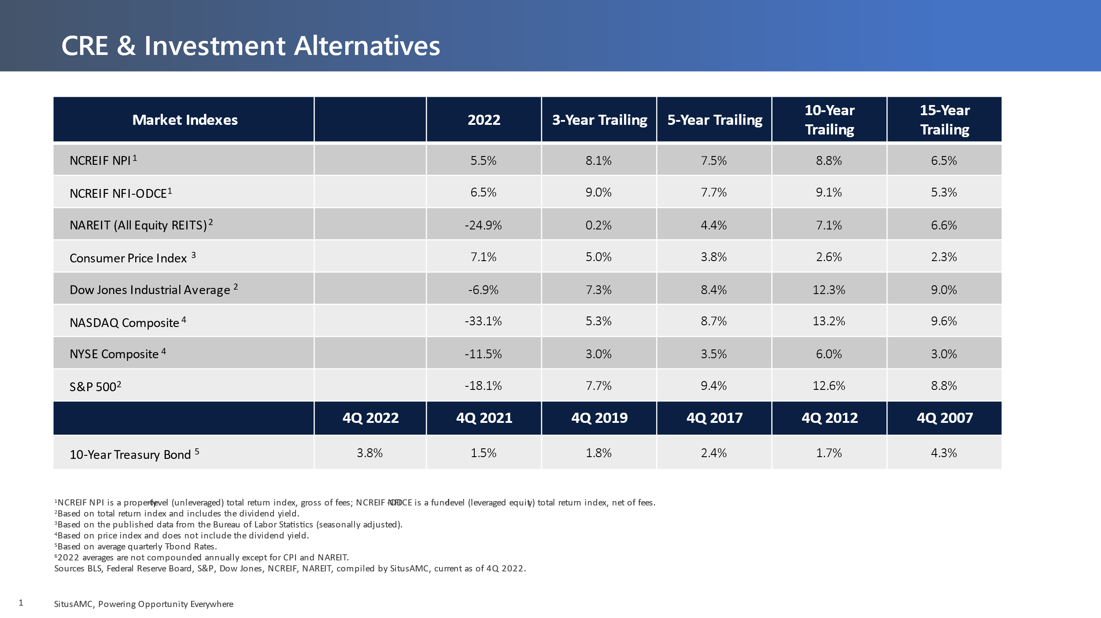

In general, real estate is usually considered to have risk that is somewhere between that of stocks and bonds. The leases on the real estate are somewhat bond-like while the market rents that will be received when leases renew and the expected sale price of the property in the future have a risk more like stocks. This is somewhat of an oversimplification as individual bonds can be riskier than real estate just as some stocks might be considered less risky. The main point is that investors will evaluate real estate investments within the context of other investment alternatives.

Even users of space that might consider owning instead of leasing must consider investment alternatives. The capital that they would have tied up in the building could be used for other business purposes related to their core business such as new equipment, a marketing campaign, investing in a new product line, etc.

Investors may have other motivations in addition to expecting a competitive return. For example, some investors may be more concerned about receiving an annual cash flow from their investment while others are more interested in price appreciation. Many investors have preservation of capital as a primary objective.

Real estate provides diversification benefits to investors because it performs differently from stocks and bonds. A portfolio that includes real estate may be less risky than one that does not. Real estate has also proven to be a good hedge against inflation. That is, when inflation heats up in the economy, owners of properties are usually able to increase the market rent. Leases tend to have provisions that protect owners from increases in expense from inflation and rising construction costs puts upward pressure on prices. Thus, real estate tends to be a good investment in an inflationary environment.

# Space (User/Tenant) Markets Versus Capital (Investment) Markets

We have discussed the fact that the two key decision makers are the users of space and the investors in properties that can be leased to users. Although users can also be investors in their own space (owner occupants) it is useful to separate the decisions to use space from decisions to invest in the space being used.

## Capital Market

Investors will consider what return they can expect to get from their investment in real estate. Returns depend, to a large extent, on what current market rents are and how investors think those rents will change over time due to changes in the supply and demand for space in the space market. Depending on how the expected return on the property compares to other investment alternatives with similar risk, there will be demand for real estate as an investment, that is, a demand for capital to flow into the real estate asset class. This demand must be met by the existing supply of buildings available for investment—which might also include owner-occupied space since those users could decide to sell the building and lease it back.

The interaction between the demand for real estate as an investment and the existing supply of space results in the price of space in what is referred to as the *capital market*. The price for space is often expressed relative to the net operating income (NOI) that would be expected during the first year of ownership of the property. The ratio of NOI to the price investors are willing to pay for the property is referred to as the capitalization rate or *cap rate*.

*The cap rate is what investors are willing to pay for a dollar of NOI.* The value of the property is found as follows:

|  |
| --- |
| Value = NOI /cap rate |

As we will learn in later modules, the investor’s expected return considers not only the NOI expected during the first year of ownership but also how the NOI will change over time and how that change impacts the change in property value. The ability to leverage the property with debt and receive tax benefits is also important. These additional considerations impact the internal rate of return (IRR) on the investment which will usually differ from the cap rate.

For example, assuming the acquisition and disposition cap rates are the same and that the *future* NOI is increasing, then the IRR will be higher than the cap rate based on *current* NOI. Nevertheless, the cap rate provides an important gauge for what investors are willing to pay. We could say that the cap rate implicitly reflects what investors expect the NOI growth to be as well as leverage and tax benefits.

Consider that the more likely an increase in NOI over time, the more an investor would be willing to purchase a property at a lower cap rate. In other words, suppose an investor acquires a property at a 6 percent cap with the expectation of a 7.5 percent yield. To meet the yield requirement the property will either need to grow in value, increase in NOI, or both. The larger the spread between the acquisition cap rate and the required yield, the greater the required growth in value or increase in NOI. This is analogous to investors being willing to purchase a growth stock at a higher price-earnings (PE) ratio compared to stocks that are not expected to have as much earnings growth. A stock’s PE ratio is the ratio of the price to earnings expected for the stock over the first year of ownership. In real estate the tradition is to take the ratio of earnings to price rather than price to earnings. So a lower cap rate suggests a property that is projected to have more NOI growth.

Figure 1.3 illustrates that as NOI increases investors are willing to pay a higher price for the NOI. The ratio of the NOI to the price of the space is the cap rate as discussed above.

 Figure 1.3  Capital Markets

**Price of Space (Value)**

**NOI**

Current Price

Current NOI

The slope of this line is the ratio of NOI to price, which is the cap rate.

## Space Market

At any given point in time the current and potential users of space create a demand for space in what we sometimes refer to as the *space market*. The demand for space is impacted by factors such as the growth of the economy, the demand for products and services from business, employment growth, etc. (this is covered in more depth in the next module and other CCIM courses). The demand for space, coupled with the existing supply of space in the market, will result in a “price” for the space which we refer to as the market rent. Of course this will differ for different types of space in different markets and can even vary considerably within the same building. But the point is that it is the interaction of users of space with owners of existing space that determines market rents and results in lease terms offered to tenants.

Figure 1.4 illustrates the way the supply and demand for space interacts to result in market rents. The supply curve (S) is steep because in the short run it takes time for new supply to come on the market. The only way there can be new supply is for some of the existing vacant space to be made available to tenants. Property owners may be holding off on leasing some of this space in anticipation of higher rents and if the price is right will make it available. At the highest rent level all the vacant space might be made available although in practice this will probably never occur as there are always some frictions in the market resulting in vacancy. The demand curve (D) reflects willingness of tenants to lease more space at lower rents, e.g., make more space available for each employee of an office building. The intersection of supply and demand results in market rents and determines current occupancy of space (quantity occupied). The difference between this and available supply is the vacancy.

Figure 1.4  The Market for Space

**Market Rent**

**Quantity**

**of Space**

Current

Market Rent

Existing Supply of Space

Space

Currently

Occupied

Vacancy

S

D

## Interaction Between the Space and Capital Markets

Putting the space market (Figure 1.4) together with the capital market (Figure 1.3) we can see how the two markets interact as shown in Figure 1.5. The market rents determined by the space market determine the NOI that investors realize in the capital market. For simplicity we can assume that the leases are absolutely net such that the tenant pays all expenses so the rent is the NOI received. (Also assume a property is leased at current market rents.) The cap rate which is the ratio of the NOI to price or the slope of the line in the figure determines the price. A change in the slope of the line would occur because of things like a change in interest rates, a more positive outlook for real estate compared to other investments.

 Figure 1.5 Interaction of the Space and Capital Markets

**Price of Space**

**(Market Rent)**

**Quantity of Space**

Current Market

Rent

Space

Currently Occupied

**NOI**

Current Price

Space Market

Capital Market

S

D

Slope is Cap Rate

**Price of Space**

**(Value)**

An increase in the demand for office space due to an improvement in the economy leading to more job growth and more demand for space in office buildings would shift the demand curve in Figure 1.5 to the right. This would result in higher market rents with the same supply curve and this would in turn lead to higher values with the same cap rate. Or a decrease in cap rates due to say a decrease in mortgage rates would cause the cap rate line to have a smaller slope (lower cap rate) and also result in higher values for the same NOI.

The main point of the above discussion about the space and capital markets is that market rents and lease terms are determined in the market for space whereas cap rates and property values are determined in the capital market. These are two distinct but inter-related markets that are important to the understanding of real estate. Real estate values can change because of events that impact either market. For example, there could be an increase in office employment that increases the demand for office space by users which pushes up rent levels and results in higher values *at the same cap rate*. That is, the increase in prices is driven by the space market. On the other hand, interest rates and the cost of debt capital might decline resulting in investors being willing to accept a lower cap rate *for the same NOI*. So they bid up the price for real estate and prices rise because of the actions of investors in the capital market.

It should be clear that those in real estate should keep track of factors that impact both the space market and the capital market. Both markets can ultimately impact the decisions of users and investors. These relationships are examined in more detail in the Market Analysis for Commercial Investment Real Estate CCIM course.

# The Four Quadrants of Real Estate Investment

Commercial real estate has been defined from a capital market perspective in the context of a quadrant, or four main areas where capital can be invested. The quadrants are a result of two dimensions of investment. The first dimension is whether the investment is in the private or public market. The private market is investing directly in the asset, for example, purchasing a property. The public market is investing in a security like purchasing shares of stock in a REIT.

The second dimension is debt or equity. Debt assets and equity assets describe two different types of capital assets. An example of a debt asset would be a mortgage loan; an example of an equity asset would be ownership of the equity position in the property or shares of stock in a REIT that invests in equity ownership of real estate. Debt is an investment from the perspective of the lender. Combining the two dimensions we have four quadrants: private equity, public equity, private debt, and public debt, as illustrated in Figure 1.6. Each of these areas operates with individual risk/return requirements, regulations, legal structures, and market structures. The influence of these dynamics has evolved and matured to create relatively efficient market structures for accessing all types of capital for real estate, which is absolutely critical for the success of the asset class for both owners and investors.

 Figure 1.6  The Four Quadrants

|  |  |  |
| --- | --- | --- |
|  | Equity | Debt |
| Private | Individuals  Pension Funds  Insurance Companies | Commercial Bank  Pension Funds  Insurance Companies  Individuals |
| Public | Equity REITs | Commercial Mortgage-Backed Securities (CMBS)  Debt REITs |

Why is it useful to categorize real estate into the four quadrants? First of all, investors may have different investment strategies. Some may prefer the greater liquidity and professional management offered by purchasing REITS in the public market. On the other hand, investors may prefer to determine their own destiny in the private market and decide themselves when to buy or sell properties and how much leverage to use. Investing in debt—whether as a lender or purchaser of a mortgage backed security—is also an investment alternative. Lenders are still investors. They take on less risk than equity investors because they have the first claim on the asset. The four quadrants can also be thought of as a way to diversify. Some investors may want to invest in each quadrant or allocate more capital to one quadrant or the other over time as they perceive shifts in the relative value of each. Each quadrant offers differences in risk and expected return, including the impact of taxes on the return. Investors should explore the relative merits of each quadrant as part of their investment decisions.

### Sources of Debt and Equity Capital

There are many different sources of debt and equity capital that participate in the various quadrants. The following sections provide a brief summary of the main sources. This summary is what is referred to as “institutional” real estate. It includes real estate that is or could be owned by institutions such as a pension fund, investment managers, REITs, corporations, etc. These institutions may also provide debt capital for real estate.

# The Equity Component of Commercial Real Estate

Several categories of equity investors target commercial real estate in the U.S., primarily private investors, public REITs, pension funds, foreign investors, and life insurance companies.

## Private Investors and Private Institutions

Private investors are the most significant influence in the equity market. Unlike stocks and bonds, real estate is a visible and tangible asset, so for individuals, the decision to own property can be based on pride as much as profitability. Real estate also has the benefit of being more transparent than stocks and bonds, especially with respect to investment returns and the investment decision process. Individuals can invest in commercial real estate in a variety of ways, including purchasing individual pieces of property alone or with other private investors. Some individuals control billions of dollars in capital and invest a significant amount of that wealth in commercial real estate. Private institutions include investment banks, mutual funds, mortgage brokers, venture capital companies, and other private institutions that may provide equity capital for real estate.

## Public REITs

An easy way for the average person to invest in commercial real estate is through a publicly traded REIT. Many retirement plans include REITs among their fund offerings. A REIT is a means by which many investors can invest a small amount of capital in a portfolio of real estate properties. The tax status for a REIT requires the REIT to distribute a large majority of its income to its shareholders (the current regulation is 90 percent), and as such, the income generated by the REIT is not subject to corporate income taxes.

REITs are traded on the stock exchanges and are companies that invest the majority of their assets in real estate. Although some REITS invest in mortgages, the majority invest equity capital in commercial real estate. They typically specialize in a particular property type but hold a fairly well diversified portfolio of properties in different geographic areas. Thus, investors in REITs get diversification benefits as well as liquidity.

## Pension Funds

Since pension funds in general are focused on long-term prospects, they are good candidates for real estate holdings. Pension funds may invest directly in real estate or invest through an investment manager that has expertise in purchasing and managing the properties for them. The investment manager may create a fund for a specific pension fund or commingle funds from several pension funds in order to have a larger more diversified portfolio.

## Foreign Investors

Foreign investors have long thought of the U.S. as a safe place to put their money, and as a core asset, U.S. real estate is even safer. The velocity of foreign investment in U.S. real estate increased in the 1980s when the commercial real estate market was in its boom phase.

According to the Association of Foreign Investors in Real Estate (AFIRE), international investors continue to broaden their allocation of investment funds around the world and have adopted innovative strategies to acquire real estate more easily within the most competitive markets. The impact of foreign investment varies depending on the global dynamics of the various countries, but the U.S. remains one of the nations seeing significant investment. Just as investors can diversify by investing in different property types and geographic areas in the U.S., foreign investors can diversify by including the U.S. in their portfolio along with investments in their own country. Similarly, U.S. investors can diversify by investing in foreign countries. Many institutional investors in the U.S. are now investing funds in many other countries.

## Life Insurance Companies

Real estate, with its home and farm mortgages, has served as the foundation of the life insurance industry for nearly 200 years. This history with real estate, along with the billions of dollars the industry has to invest and its long-term and whole-life policies, has made life insurance companies ideally suited for investing in real estate including making equity investments.

Although their liabilities have changed somewhat over the years and their investment in real estate has lessened, life insurance companies in general are still significantly involved in real estate lending. They also invest a significant amount of funds in acquiring actual property that may be very profitable or is beneficial in some way for the company to own, whether it is a strategic location or a popular building that is useful for marketing efforts.

# The Debt Component of Commercial Real Estate

The lender composition for debt includes commercial banks, commercial mortgage-backed securities (CMBS)/government-sponsored enterprises and related pools, collateralized debt obligations (CDOs), life insurance companies, and savings institutions.

## Commercial Banks

Although commercial banks, by nature, have shifted away from holding long-term loans, they still make most of the initial mortgages. Their sources are short-term deposits, so typically most of their original loans are sold to other large institutions in the secondary mortgage market.

Commercial banks can provide direct contact to the customers/borrowers, and they often work hand in hand with insurance companies or funds. Banks constantly adjust their position to lending, and the various stages of the economy come into play here as well. If interest rates rise or inflation slows down, banks must be conscious of their short-term funds. With that said, banks always will play a role in real estate lending and investing—the potential money to be made is too great for them not to.

## Commercial Mortgage-Backed Securities and Collateralized Debt Obligations

Commercial Mortgage-Backed Securities (CMBS) are financial assets that are securitized by mortgages made on commercial real estate. Commonly issued in the U.S., they work like bonds. One benefit of CMBS as compared to residential mortgage-backed securities (MBS) is that CMBS more often are protected from prepayment by using prepayment penalties, yield maintenance, or defeasance.

In a CMBS, first mortgages, usually from several different properties diversified by property type (office, retail, multi-family, etc.) and location are pooled and held by a trust, which serves as a pass-through entity for bondholders. Securities with different investment characteristics are created from the same pool of mortgages. The securities given a bond rating (typically AAA through BBB), that are based on their priority for receiving principal payments and payments in the event of default on any of the mortgages underlying the pool. There are also some securities that are unrated and are the “first loss” piece meaning that if there is default, they are the first to lose money (last to be paid any principal). Investors can choose their preferred combination of risk, yield, and duration. The AAA rated securities would have the lowest risk but the lowest expected return. The unrated securities would have the highest risk but the highest expected return.

Commercial Real Estate Collateralized Debt Obligations (CRE CDOs) are somewhat similar to CMBS except they typically have lots of different types of mortgages as assets and may also have other securities as part of their asset pool. For example, they may include mezzanine debt and lower rated CMBS securities as part of the assets against which new securities are issued as in the case of CMBS where the securities have different priorities for principal payment and different credit ratings. Unfortunately, CDOs were the vehicle used to securitize a lot of the subprime mortgages on residential real estate that were made to home owners who had poor credit ratings and got into trouble as home prices began to fall in the late 2000s and interest rates began to rise triggering resets on the adjustable interest rate mortgages. Many of these securities had high credit ratings under the theory that they were diversified with lots of residential mortgages backing them but the drop in home prices and rise in interest rates affected virtually all the mortgages. It remains to be seen if the CDO market will recover as investors have become skeptical of these types of securities whether they are backed by residential or commercial mortgages.

## Life Insurance Companies

Typically serving as the lender for large loans, life insurance companies provide billions of dollars in real estate mortgages each year. Most companies utilize various mortgage brokers throughout the country to originate loans.

The interest of life insurance companies holding positions in the commercial real estate debt market is more significant than their interest in equity. This has to do with the regulatory requirements on risk-based capital requirements and matching their liability structure.

## Savings Institutions

Originally thought of as home mortgage lenders, savings institutions held longer-term savings deposits, which enabled them to make longer-term loans. However, in the early 1980s when real estate values dropped drastically as a result of significantly increasing interest rates, savings institutions were forced to decrease their mortgage holdings by more than $25 billion. Now, large stock organizations usually cover one to several states for lending. Lender, or debt, positions have increased from around $1 billion in 1994 to more than $2.5 billion in 2006.

## Government Sponsored Entities

Government Sponsored Entities (GSEs) like the Federal National Mortgage Association (Fannie Mae) also play an important role in mortgage lending and issuing mortgage backed securities. Fannie Mae provides multifamily financing for affordable and market-rate rental housing. They provide financing for apartment buildings, condominiums, or cooperatives with five or more individual units.

Figure 1.7  The Debt Component

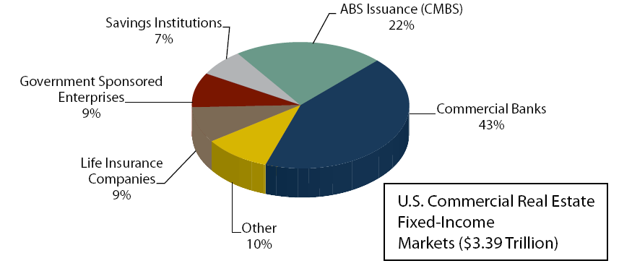

Figure 1.8  The Equity Component

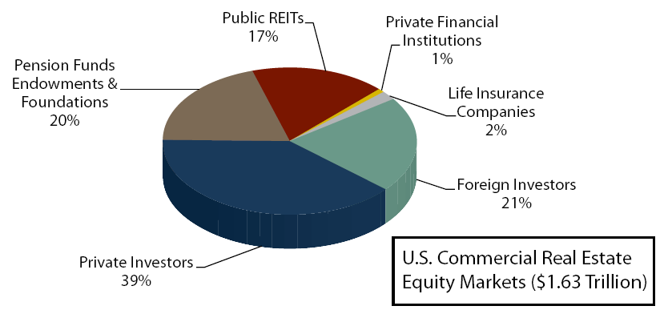

# summary.emfSummary

This module has provided an overview of the key decision makers, the user and investor that we will analyze throughout the rest of this module and the CCIM curriculum. We have seen that the interaction of users and investors in the space and capital markets determine market rents and values for commercial real estate. A variety of sources of debt and equity capital, both private and public, are available to finance the purchase of real estate. This allows lenders and equity investors to participate in different ways in performance of real estate depending on their risk tolerances.

We have discussed that commercial real estate competes with stocks, bonds and other investment alternatives for capital. Investors want to know what returns to expect from each asset class as well as its risk. Investors also want to be sure that information is available to understand the investment. CCIMs help bring transparency to the real estate market by helping to provide information and analytics to investors and users.

Before beginning the analysis process for a specific real estate investment property, the investor must understand the geography of real estate and how a specific property fits into a specific market, particularly how the market where the property resides impacts the numbers utilized in a financial analysis of the specific property. This is the subject of the next module.

# Module 1: Self-Assessment Review

To review the concepts learned in this module, complete the following section.

1. The goal of investing is to return income to the investor above the investments cost. What forms can this income take?
   1. Interest
   2. Dividends or rents
   3. Profits realized from selling an investment that has appreciated in value
   4. All of the above
2. For an investor, the decision to sell a property or not is considered what type of decision?
   1. Acquisition decision
   2. Construction period decision
   3. Holding period decision
   4. Disposition decision
3. Rents are determined by which of the following.
   1. Capital markets
   2. Properties markets
   3. Space markets
   4. None of the above
4. Who are the largest investors in the equity market?
   1. Public REITs
   2. Life insurance companies
   3. Pension funds
   4. Private investors
5. How does risk and return for real estate as an asset class compare to stocks and bonds?
   1. Greater than stocks and bonds
   2. Generally, somewhere between stocks and bonds
   3. Less than stocks and bonds
   4. About the same as stocks and bonds

End of assessment

# 

# Answer Section

## Module 1: Self-Assessment Review

1. The goal of investing is to return income to the investor above the investments cost. What forms can this income take?
   1. ***All of the above***
2. For an investor, the decision to sell a property or not is considered what type of decision?
   1. ***Holding period decision***
3. Rents are determined by which of the following.
   1. ***Space markets***
4. Who are the largest investors in the equity market?
   1. ***Private investors***
5. How does risk and return for real estate as an asset class compare to stocks and bonds?
   1. ***Generally somewhere between stocks and bonds***

Bond market, 9

Collateralized Debt Obligations (CDO), 24

Commercial Mortgage-Backed Securities (CMBS), 23

Investors, 5

mortgage-backed securities (MBS), 23

Rate of return (yield), 5

real estate (asset), 11

Real estate investment trust (REIT), 11

return on investment (yield), 5

*space market*, 16

stock market, 10

Users, 3