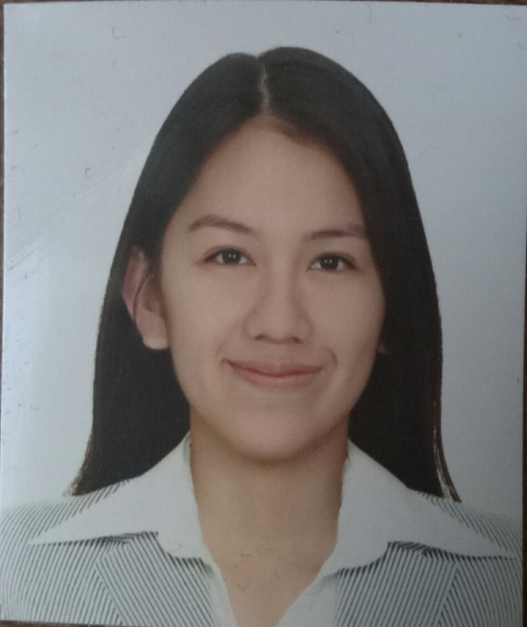

Stephanie De Jesus Basalo was born on July 24, 1999 and is currently living at Bacoor, Cavite. She graduated Elementary in Children School of Tomorrow and completed Junior High School at Millennium Christian Highschool Cavite. She is now a Grade 12 Senior High School student taking Academic Track - Accountancy, Business, and Management Strand at Lyceum of the Philippines University - Manila