Table of Contents

**1.** List of Figures 3

**2.** List of Tables 3

**3.** List of Abbreviations 3

**4.** Abstract 3

**5.** Chapter 1: Introduction 4

**1.1** Problem Statement 4

**1.2** Problem Solving 4

**1.3** Objectives 4

**1.4** Scope & Constraints 5

**6.** Chapter 2: Literature Review 5

**6.1** Introduction 5

**6.2** Reviewing the Literature 5

**6.3** Findings & Discussion 5

**7.** Chapter 3: Methodology 6

**7.2.2** UML Diagrams ER/EER DIAGRAM AND MAPPING 6

**7.3** System Implementation/Prototyping 8

**7.4** Testing 9

**8.** Chapter 4: System Initiation and Planning 9

**8.1** Assessing Project Feasibility 9

**8.2** Project Plan 9

**9.** Chapter 5: System Analysis 9

**9.1** Determining System Requirements 10

**9.2** Structuring System Requirements 10

**10.1** Chapter 6 :Advantages of the System 10

**10.2** Future Enhancement of the System 10

**10.3** Potential Benefits 10

**10.4** Conclusion 11

References 11

Appendices 12

**TT Holding Database System: A Relational Database for Employee and Organizational Management**

# **1.** List of Figures

* Figure 1: ER/EER Diagram of TT Holding Database System
* Figure 2: Mapping Diagram of TT Holding Database System

# **2.** List of Tables

* Table 1: Employment Table
* Table 2: Organization Table
* Table 3: Parttime Table
* Table 4: Permanent Table
* Table 5: Person Table
* Table 6: Position Table
* Table 7: Useraccounts Table

# **3.** List of Abbreviations

* PK: Primary Key
* FK: Foreign Key
* ER/EER: Entity-Relationship/Enhanced Entity-Relationship
* SQL: Structured Query Language
* UML: Unified Modelling Language

# **4.** Abstract

This report details the design and implementation of a relational database system for TT Holding, aimed at managing employee and organizational data. The system addresses the need for a centralized, efficient, and secure data management solution. The report includes an ER/EER diagram, database schema, data insertion examples, advanced SQL features (views, triggers, functions, procedures), and user access control implementation. The system aims to improve data accuracy, accessibility, and overall operational efficiency for TT Holding.

# **5.** Chapter 1: Introduction

The TT Holding Database Design is a well-structured system developed to efficiently organize, store, and manage essential business data for TT Holding. This database serves as a centralized solution for handling various business operations, including customer information, financial transactions, inventory management, and employee records.

Designed for optimal performance, the database follows a relational model that ensures data accuracy, consistency, and security. It leverages MySQL (or another RDBMS) and incorporates normalization techniques to minimize redundancy and enhance efficiency.

# **1.1** Problem Statement

TT Holding encounters data management issues due to the intricate relationships between employees and organizations. Manual processes or insufficient systems lead to data redundancy and challenges in retrieving information. A centralized database is required to optimize operations and maintain data accuracy.

# **1.2** Problem Solving

A relational database system will address these issues by providing a structured framework for data storage and retrieval. This system will ensure data integrity, reduce redundancy, and enable efficient information access through SQL queries. Implementing advanced SQL features will further automate data management processes.

# **1.3** Objectives

The primary objectives are to design and implement a relational database for TT Holding, create an ER/EER diagram, establish database tables, populate data, and implement advanced SQL functionalities. User access control will be implemented to secure data.

# **1.4** Scope & Constraints

The project will focus on managing employee, organizational, employment, position, and position history data. Time constraints and the project description served as the project's main constraints.

# **6.** Chapter 2: Literature Review

A well-structured database is crucial for organizations to efficiently manage and process large volumes of data. Research in database management highlights the importance of data integrity, security, and scalability in designing effective database systems. The TT Holding Database Design incorporates these best practices, utilizing modern database management techniques to optimize business operations.

# **6.1** Introduction

Effective database design is fundamental for efficient data management. Relational databases provide a structured approach, while advanced SQL enhances functionality. This review explores relevant literature to inform the system's development.

# **6.2** Reviewing the Literature

Research focused on relational database principles, advanced SQL techniques, and database security. Academic papers, books, and SQL documentation were examined to understand best practices and latest developments.

# **6.3** Findings & Discussion

The review emphasized the significance of structured database design for ensuring data integrity and operational efficiency. Advanced SQL capabilities provide strong tools for automation, while implementing strong security measures is essential to safeguard sensitive data.

# **7.** Chapter 3: Methodology

According to (Date, 2004)a properly designed database is essential for organizations to efficiently handle and process vast amounts of data. Studies in database management emphasize the significance of data integrity, security, and scalability in developing robust database systems. The TT Holding Database Design integrates these key principles, leveraging advanced database management strategies to enhance business efficiency.

# **7.1** Requirement Analysis

Requirements were derived from the project scenario, detailing relationships between entities. These were analysed to identify entities, attributes, and relationships necessary for the database design.

# **7.2** System Design

(Connolly, 2015)Further explained that the TT Holding Database Design adopts a systematic approach to system design, prioritizing efficiency, security, and scalability in business operations management. It comprises two key components—Logical Design and Physical Design—which function together to establish a strong and well-optimized database framework.

# **7.2.1** Architectural Design

# The system was built using a relational database structure, utilizing SQL for data definition and manipulation. An ER/EER diagram was developed to visually depict the database schema and the relationships among the tables.

# **7.2.2** UML Diagrams ER/EER DIAGRAM AND MAPPING

* Figure 1: ER/EER Diagram of TT Holding Database System
* 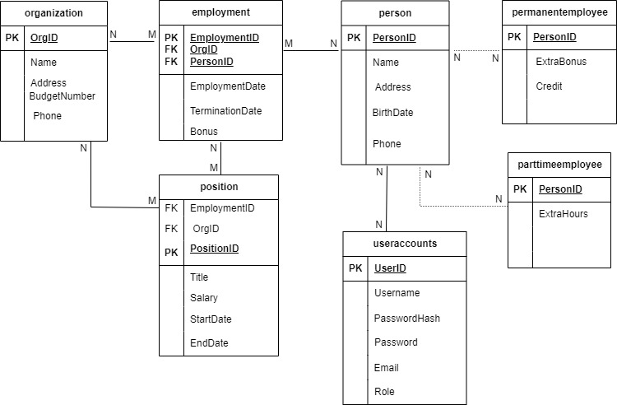
* Figure 2: Mapping Diagram of TT Holding Database System

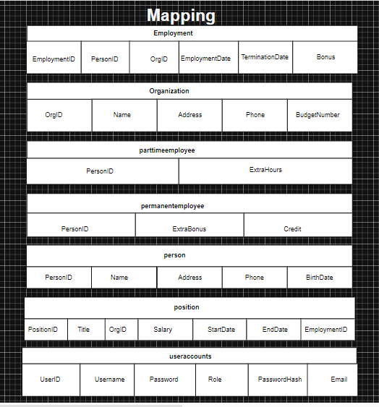

# **7.3** System Implementation/Prototyping

The database was implemented with SQL, where tables were created according to the ER/EER diagram. Data was populated, and advanced SQL features were applied. User accounts were set up with specific privileges to maintain data security.

# **7.4** Testing

Data integrity was validated through tests for insertion, updates, and deletions. SQL queries were checked for accuracy, and advanced SQL features were thoroughly tested. User access control was also evaluated to ensure correct enforcement of privileges.

# **8.** Chapter 4: System Initiation and Planning

(Hoffer, 2013)The system initiation and planning phase of the TT Holding Database Design is essential as it establishes the groundwork for a successful database system. This phase involves tasks that outline the project’s scope, goals, resources, timeline, and risk management plans. The aim is to ensure that the project is well-defined, achievable, and aligned with the organization’s goals. The following steps are part of this phase:

# **8.1** Assessing Project Feasibility

The project was considered viable because of well-defined requirements and readily available SQL tools. It was completed within the set timeframe, proving its feasibility.

# **8.2** Project Plan

The project adhered to a systematic plan, including requirement analysis, design of the ER/EER diagram, database creation, data insertion, implementation of advanced SQL features, user access control, testing, and documentation.

# **9.** Chapter 5: System Analysis

According to (Elmasri, 2015) the system analysis phase of the TT Holding Database Design is centred around comprehending and documenting the requirements and limitations of the current system. This phase is crucial to ensure the database system is crafted to address business needs while enhancing performance, security, and scalability. The objective of this phase is to evaluate existing processes, identify any gaps, and create a clear roadmap for the database solution. The following are the key steps involved in this analysis.

# **9.1** Determining System Requirements

The requirements were determined by carefully analysing the project description, focusing on the entities, attributes, and the relationships described within the scenario.

# **9.2** Structuring System Requirements

The identified requirements were organized into a relational database schema, with tables representing entities and relationships, ensuring a structured and efficient data management system.

# **10.1** Chapter 6 :Advantages of the System

As noted by (Garcia-Molina, 2008) The system provides centralized data management, improved integrity, efficient retrieval, and enhanced security. Advanced SQL features automate business rules, improving operational efficiency.

# **10.2** Future Enhancement of the System

(O'Neil, 2001)Future enhancements include a web interface, integration with other systems, reporting capabilities, and robust backup procedures. These additions will further improve the system's functionality and usability.

# **10.3** Potential Benefits

(Munoz, 2014)TT Holding will benefit from improved data management, increased operational efficiency, and enhanced data security. The system provides a foundation for future growth and development.

# **10.4** Conclusion

The TT Holding Database System effectively meets the project objectives, offering a strong solution for managing employee and organizational data. It improves data management practices and sets the foundation for future enhancements.

# References

Connolly, T. &. B. C., 2015. A Practical Approach to Design, Implementation, and Management. In: N/A, ed. *Database Systems: A Practical Approach to Design, Implementation, and Management.* Harlow, England: Pearson, p. 1440.

Date, C. J., 2004. An Introduction to Database Systems. In: N/A, ed. *An Introduction to Database Systems.* Boston, MA: Pearson Education, p. 1024.

Elmasri, R. &. N. S., 2015. Fundamentals of Database Systems. In: N/A, ed. *Fundamentals of Database Systems.* Boston: Pearson Education, p. 1100.

Garcia-Molina, H. U. J. D. &. W. J., 2008. Database Systems: The complete Book. In: N/A, ed. *Database Systems: The complete Book.* Upper Saddle River, NJ: Prentice Hall, p. 1030.

Hoffer, J. P. M. &. M. F., 2013. Modern Database Management. In: N/A, ed. *Morden Database Management.* 11th ed. Boston: Pearson, p. 715.

Munoz, 2014. Relational Database Management Systems: concepts, design, and practice. In: N/A, ed. *Relational Database Management Systems: Concepts, Design, and Practice.* Berlin, Germany: Springer, p. 800.

O'Neil, P. &. O. E., 2001. Database: Principles, Programming, and perfomance. In: N/A, ed. *Database: Principles, Programming, and perfomance.* Burlington, MA: Morgan Kaufmann, p. 1750.

## Appendices

Appendix A: SQL Code for Table Creation

Appendix B: SQL Code for Data Insertion

