02 – Electrical Design: 55 MW Baseline and 60 MW Operating Window (Rev A)
Status: DRAFT – HOLD POINT 2 (Project Leader review) Basis: docs/01_Engineering_Design_Basis.md Rev C, with the default answers to Q3, Q4, Q7 and Q8 accepted by the Project Leader on 2026-11-11. Verification: every number below is reproduced by calcs/02_electrical_operating_points.py, with inputs in calcs/parameters.py. Outputs are results/02_operating_points.csv and results/02_operating_chart.png.
Data integrity: the scenario is hypothetical and no plant data was supplied (S-10). The baseline is a reference furnace calibrated on published values for ferrochrome furnaces. Those values were taken from search excerpts because the full texts could not be retrieved from this session (network policy). They are flagged AB in references/REFERENCES.md and must be checked against the full text before the final report.

1. Electrical model
Balanced three-phase equivalent star circuit, one phase per electrode:
Quantity | Equation | Unit
Active power | P = 3 I² R | W
Reactive power | Q = 3 I² X | var
Apparent power | S = 3 I² Z = 3 V_ph I, with Z = √(R² + X²) | VA
Power factor | PF = R / Z = cos φ | –
Line (secondary) voltage | V_LL = √3 V_ph | V
Electrode current density | J = I / (π D²/4) | A/cm²
Westly similarity [R-01, R-12] | I = C₃ P^(2/3) (I in kA, P in MW, total furnace power) | –
R is the furnace operating resistance per phase (bath + burden + electrode). X is the total circuit reactance per phase referred to the secondary (transformer + short network + electrode columns).
Limitations, stated openly: (i) the star equivalent ignores the electrical interaction between electrodes and phase unbalance [R-02]; (ii) circuit (busbar) resistance is lumped into R, so the electrical efficiency η_el is handled as a sensitivity (A-06); (iii) Westly's relation is used only to calibrate the baseline current, and its validity is disputed [R-03].

2. Calibrating the baseline current (Westly C₃)
No baseline current was given. It is anchored on a published ferrochrome furnace with the same electrode diameter as the 63 MVA South African ferrochrome analogue (A-16):
Analogue [R-13]: P = 48 MW, I = 110 kA, D = 1.55 m.
C₃ = I / P^(2/3) = 110 / 48^(2/3) = 110 / 13.21 = 8.33
This lies inside the range of 6–11 reported for high-carbon ferrochrome [R-12], which supports the calibration.
Current density of the analogue: J = 110 000 A / (π × 155² / 4 cm²) = 110 000 / 18 869 = 5.83 A/cm²
Challenge to assumption A-07: the published furnace runs at 5.83 A/cm², above the patent guideline of 4.5–5 A/cm² for D > 1.3 m [R-08]. That guideline is therefore not treated as a hard limit. The design criterion becomes: the 60 MW case must not exceed the current density the existing furnace already operates at. That level is proven in service for this furnace (by A-14/A-16), which is a more defensible criterion than a single patent.

3. The 55 MW baseline (reference furnace)
Assumptions: A-11 (power into the furnace) and A-14 (the existing 55 MW furnace already runs at the full 65 MVA).
Step | Equation and substitution | Result
Current | I = 8.33 × 55^(2/3) = 8.33 × 14.46 | 120.5 kA
Resistance | R = 55×10⁶ / (3 × (120.5×10³)²) = 55×10⁶ / 4.356×10¹⁰ | 1.264 mΩ
Impedance | Z = 65×10⁶ / 4.356×10¹⁰ | 1.494 mΩ
Reactance | X = √(1.494² − 1.264²) | 0.796 mΩ
Power factor | PF = 1.264 / 1.494 | 0.846
Reactive power | Q = √(65² − 55²) | 34.6 Mvar
Secondary voltage | V_LL = √3 × 65×10⁶ / (3 × 120.5×10³) | 312 V
Current density | J = 120 500 / 18 869 | 6.38 A/cm²
R/X | 1.264 / 0.796 | 1.59
Significance: these values are consistent with the literature. A PF of 0.85 is typical for ferrochrome furnaces [R-02, R-14], and a few hundred volts at around 100–130 kA is consistent with the analogue furnaces. The baseline therefore describes a typical modern closed ferrochrome furnace running at its transformer limit. That is exactly why 60 MW is not available "for free".

4. The 60 MW cases

4.1 Cases that fail
Case | I (kA) | R (mΩ) | PF | S (MVA) | V_LL (V) | J (A/cm²) | Verdict
3a Westly-ideal current, existing X | 127.6 | 1.228 | 0.839 | 71.5 | 323 | 6.76 | ✗ exceeds 65 MVA by 10 % and exceeds baseline J
3b Same resistance (just "turn up the current"), existing X | 125.8 | 1.264 | 0.846 | 70.9 | 325 | 6.67 | ✗ exceeds 65 MVA by 9 % and exceeds baseline J
Significance: simply pushing more current, or following Westly's "ideal" scaling, overloads the 65 MVA transformers and the electrodes. The uprate has to come from a different electrical operating regime.

4.2 Required operating point at the 65 MVA limit
At S = 65 MVA and P = 60 MW: PF = 60/65 = 0.923, so R/X = 0.923 / √(1 − 0.923²) = 2.40.
Increase in R/X relative to the baseline = 2.40 / 1.59 − 1 = +51.2 %. This percentage is independent of the assumed C₃, because it depends only on the two power factors (calc 02, section 4). It is therefore the most robust result of this phase.
The +51 % can be split between raising R (electrode geometry and burden) and lowering X (short network):
Case | X reduction | X (mΩ) | R needed (mΩ) | ΔR vs baseline | I (kA) | V_LL (V) | J (A/cm²) | Westly C₃
3c-0 | 0 % | 0.796 | 1.910 | +51 % | 102.3 | 367 | 5.42 | 6.68
3c-10 | 10 % | 0.716 | 1.719 | +36 % | 107.9 | 348 | 5.72 | 7.04
3c-20 (proposed) | 20 % | 0.637 | 1.528 | +21 % | 114.4 | 328 | 6.06 | 7.46
3c-30 | 30 % | 0.557 | 1.337 | +6 % | 122.3 | 307 | 6.48 | 7.98
Worked substitution for the proposed case 3c-20: X = 0.8 × 0.796 = 0.637 mΩ; R = 2.40 × 0.637 = 1.528 mΩ; I = √(60×10⁶ / (3 × 1.528×10⁻³)) = √(1.309×10¹⁰) = 114.4 kA; V_LL = √3 × 65×10⁶ / (3 × 114.4×10³) = 328 V; J = 114 400 / 18 869 = 6.06 A/cm² (5 % below the baseline 6.38 A/cm²).

4.3 Engineering interpretation
- The 60 MW case is a higher-voltage, lower-current, higher-resistance operation. In every feasible case the current is lower than the baseline 120.5 kA (except the 30 % reactance-reduction case), while the secondary voltage rises from 312 V to 328–367 V.
- The electrode diameter does not need to increase. Because the current falls, the current density falls (5.4–6.1 A/cm² against 6.38 A/cm² today). This is a key outcome for "optimised electrode geometry": the optimisation is about the pitch circle diameter (PCD) and the electrode tip position (which set R), not the diameter. Keeping D = 1.55 m avoids new electrode holders, contact clamps and casings.
- The required Westly C₃ drops from 8.33 to 6.7–7.5. That is still inside the reported ferrochrome range of 6–11 [R-12], at the low end that the literature associates with "a particular group of furnaces". The new operating point is therefore unusual but not unprecedented. This needs to be verified against the full text of R-12.
- Raising R alone (+51 %) is the high-risk route. Higher resistance is usually obtained by raising the electrode tips (shallower penetration). That moves heat upward: hotter burden top, roof and off-gas, a colder hearth, slower tapping, and possibly more Cr₂O₃ lost to the slag. A combination is therefore proposed (case 3c-20): about 20 % lower total reactance plus about 21 % higher operating resistance.
- Is a 20 % reduction in total X credible? About 70 % of a submerged arc furnace's reactance comes from the short network [R-14]. A 20 % total reduction therefore means about 29 % less short-network reactance (0.20 / 0.70). That requires real re-engineering: interleaved or bifilar busbars, a shorter distance from transformer to electrodes, and closing the delta at the electrodes. It is plausible but must be demonstrated in Phase 4 with conductor geometry. Until then it is assumption A-17 (low confidence).
- Electrical efficiency matters. If 60 MW must arrive in the bath and the secondary circuit loses 2–6 %, the PF must rise to 0.94–0.98 (calc 02, section 4). At η_el = 0.96 that is practically impossible. This is why A-11 (power counted at the furnace terminals) is used, and why the circuit losses must be quantified in Phase 4.

4.4 Operating chart
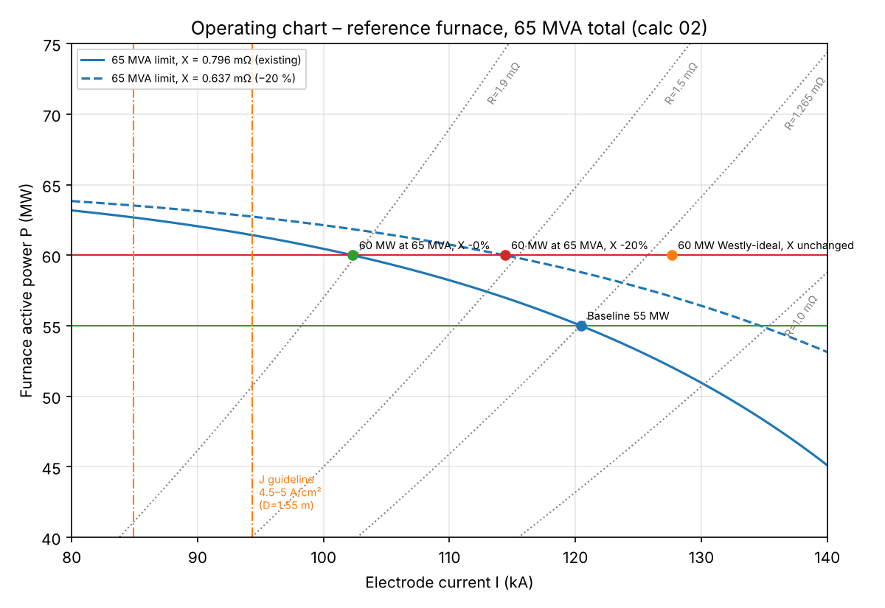
The baseline sits on the 65 MVA limit curve (solid line). With the existing reactance, the 60 MW line can only be reached at about 102 kA and R ≈ 1.9 mΩ (green point). Reducing X by 20 % lifts the limit curve (dashed line), and 60 MW is reached at 114 kA and R ≈ 1.53 mΩ (red point). The Westly-ideal point (orange) lies outside both limits.

5. Sensitivity to the baseline calibration (C₃ from 6 to 11)
C₃ | I_base (kA) | R_base (mΩ) | X (mΩ) | R required at 60 MW, existing X (mΩ) | ΔR | V_LL base (V)
6.00 | 86.8 | 2.435 | 1.533 | 3.680 | +51 % | 432
7.00 | 101.2 | 1.789 | 1.127 | 2.704 | +51 % | 371
8.33 | 120.5 | 1.264 | 0.796 | 1.910 | +51 % | 312
9.00 | 130.2 | 1.082 | 0.682 | 1.636 | +51 % | 288
11.00 | 159.1 | 0.724 | 0.456 | 1.095 | +51 % | 236
Interpretation: the absolute currents and voltages depend on the calibration, but the relative changes do not. The conclusions in Section 4.3 therefore hold for any furnace in the reported ferrochrome range. C₃ = 6 or 11 would give a current density of 4.6 or 8.4 A/cm² on 1.55 m electrodes. The latter is implausible, which supports a mid-range calibration.

6. Transformer requirements (preliminary; full specification in Phase 4)
Item | Requirement | Basis
Rating | 65 MVA total, preferably 3 × 21.7 MVA single-phase units | S-07; single-phase units suit the triangular electrode layout and closing the delta at the electrodes
Secondary voltage range | Must cover 312 V (baseline) to 367 V (60 MW with no X reduction), plus about ±10 % control margin, ≈ 280–400 V | Section 4.2
Current rating | Electrode current up to the existing 120.5 kA plus margin (≈ 125 kA). With the delta closed at the electrodes, the winding current is I/√3 ≈ 72 kA | Baseline current, and to keep the ability to run 55 MW at a low resistance
Rated region | Constant MVA (65) above ≈ 310 V; constant current (≈ 125 kA) below | Standard furnace transformer practice (to be referenced, IEEE C57.17)
On-load tap changer | Steps of roughly 5–8 V (to be optimised in Phase 4) for fine power and resistance control | Engineering judgement
Short-circuit reactance | As low as practicable. The transformer's share of X counts toward the 20 % reduction target | A-17
Significance: if the existing transformers' tap range tops out near the baseline voltage (unknown, S-10), the uprate needs a new tap range or new transformers even though the MVA stays 65. This is the real reason the brief specifies the "65 MVA transformers" alongside the uprate.

7. New and updated assumptions (added to the register in docs/01)
ID | Assumption | Value | Basis | Conf.
A-07 (revised) | Current-density criterion | J(60 MW) ≤ J(baseline) = 6.38 A/cm² | Published ferrochrome furnace at 5.83 A/cm² [R-13] exceeds the patent guideline [R-08]; the existing furnace's own J is the proven limit | M
A-15 | Grid frequency | 50 Hz | South African grid | H
A-16 | Baseline electrode diameter | 1.55 m Söderberg | Same as the 63 MVA SA ferrochrome analogues [R-11] and the 48 MW model furnace [R-13] | M
A-17 | Achievable total reactance reduction | 20 % (≈ 29 % in the short network) | 70 % of SAF reactance is in the short network [R-14]; feasibility to be shown in Phase 4 | L
A-18 | Westly C₃ calibration | 8.33 | Analogue furnace [R-13]; within reported range [R-12] | M

8. Open items carried to Phase 4
- Translate the required +21 % in R into geometry: PCD, tip position, burden/reductant resistivity. This needs the Westly / Andreae–Kelly full texts (blocked, R-01).
- Demonstrate the 20 % X reduction with short-network conductor geometry, and quantify the circuit losses (η_el).
- Check the existing roof penetrations and electrode-to-wall clearance for any PCD change (S-08).
- Harmonics, flicker and the HV-side power factor (capacitors improve the grid PF, not the transformer loading).

9. Decisions requested at HP-2
Q | Question
Q9 | Accept the proposed operating point 3c-20 (60 MW, 114 kA, 328 V, R = 1.53 mΩ, X −20 %) as the design case, or prefer an option that changes only the resistance (3c-0) or only the reactance (3c-30)?
Q10 | Accept the revised current-density criterion (no higher than the existing furnace) in place of the patent guideline?
Q11 | Proceed to Phase 3 (metallurgical mass and energy balance) next, or Phase 4 (geometry and short network) first?

