1. Navigate to Finance > Transactions > Payments > Direct Bank Payment

**Error2:**

There is no subledger selected cannot create RTGS Payment

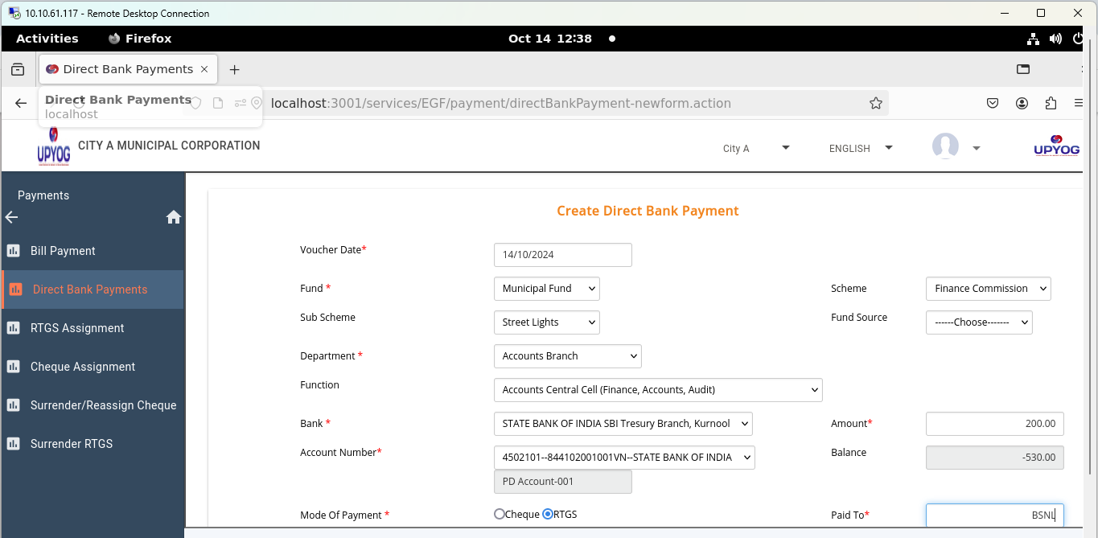

Subledger detail dropdown is not getting

