

МИНОБРНАУКИ РОССИИ
Федеральное государственное бюджетное образовательное учреждение
Высшего образования
«МИРЭА – Российский технологический университет»

Институт перспективных технологий и индустриального программирования (ИПТИП)
Кафедра компьютерного дизайна

ОТЧЕТ ПО ПРАКТИЧЕСКОЙ РАБОТЕ №1
По дисциплине «Программная верстка в дизайне»

Выполнил студент группы ТКБО-02-24 Мотырева М. А.
Проверил Соловов Р. Р.

Москва, 2025
Практическая работа 1. Часть 1
Мотырева Мария Алексеевна, ТКБО-02-24
Ссылки:
Github-pages: https://motureva929-pixel.github.io/teapoz.github.io/
Github-репозиторий: https://github.com/motureva929-pixel/teapoz.github.io
Макет в Figma: https://www.figma.com/design/IC5YqdihEbRE5aJUzaglHX/E-Commerce-Tea-Shop-Website--Community-?node-id=0-1&t=x41oHQs6OFmbVHkC-1

Реализована разметка компонентов:
Обязательные:
- форма
- слайдер
- аккордеон
- табы
- бургер – меню
- модальное окно
Дополнительные:
- Карточки
- Уведомления

Таблица реализованных основных компонентов
Компонент | Картинка
форма | 
слайдер | 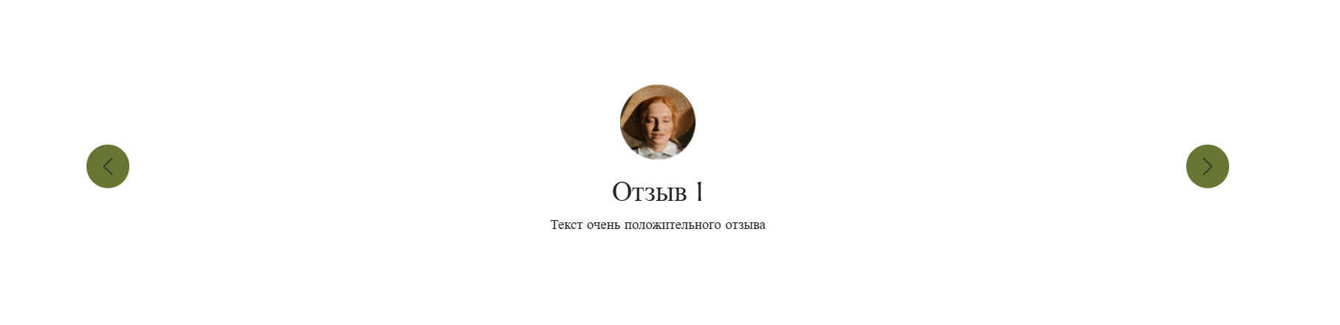
аккордеон | 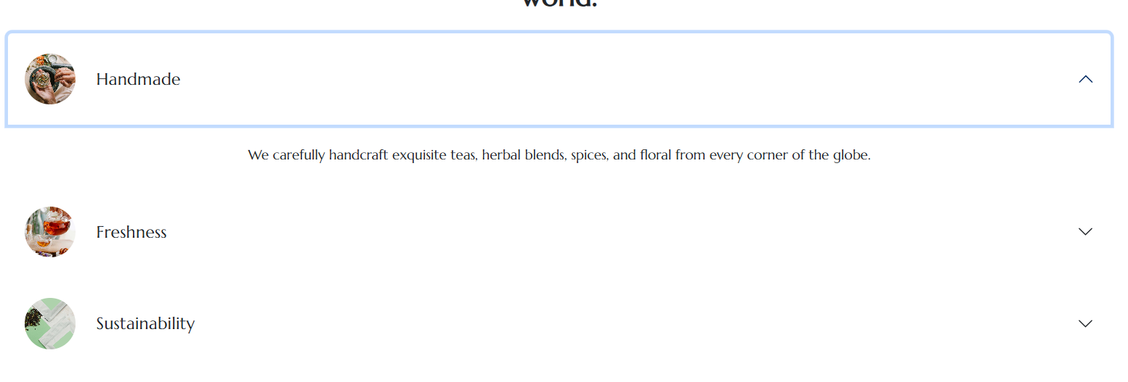
табы | 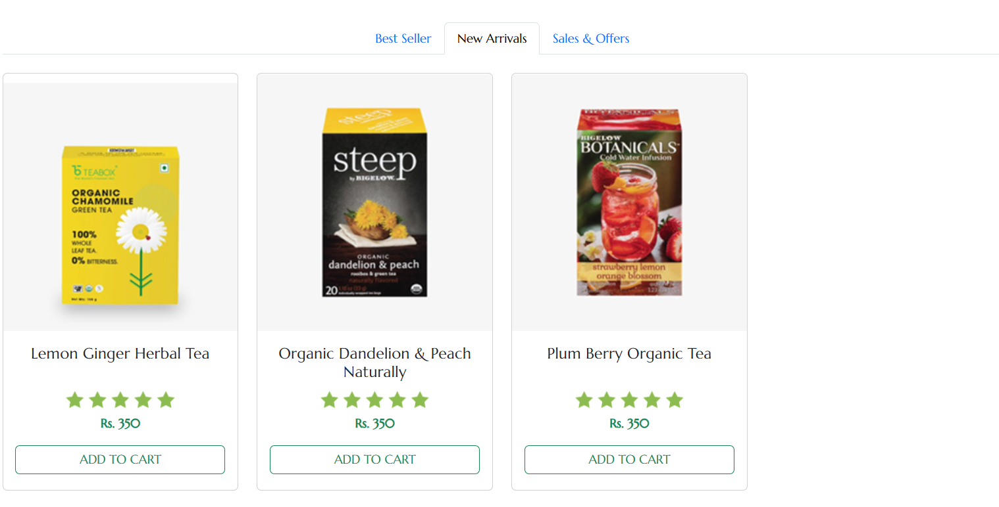
Бургер меню | 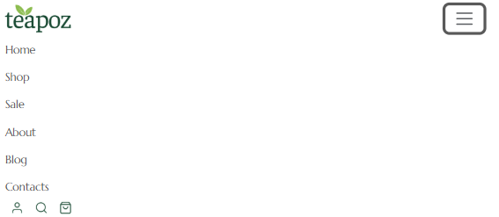
Модальное окно | 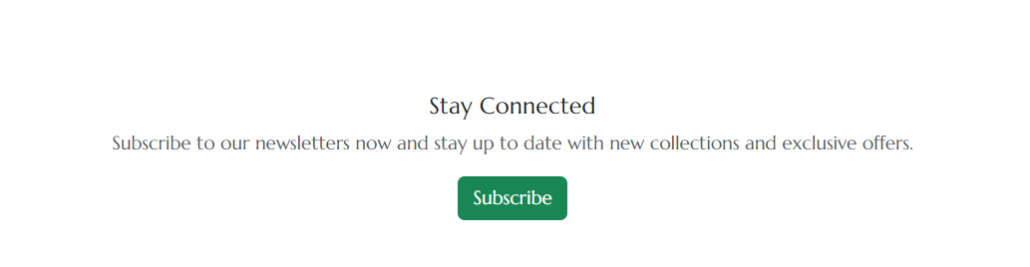

Таблица реализованных дополнительных компонентов

Карточки | 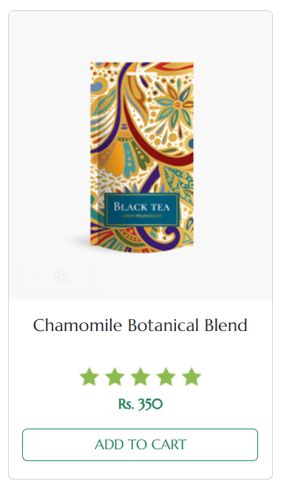
Уведомления (toast) | 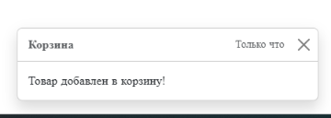
Код
<!DOCTYPE html>
<html lang="en">
<head>
<meta charset="UTF-8">
<meta name="viewport" content="width=device-width, initial-scale=1.0">
<link href="https://cdn.jsdelivr.net/npm/bootstrap@5.3.0/dist/css/bootstrap.min.css" rel="stylesheet">
<link href="styles/main.css" rel="stylesheet">
<title>teapoz</title>
</head>
<body>
<!-- Header -->
<header class="bg-white">
<div class="bg-light py-2">
<div class="container">
<div class="d-flex justify-content-between align-items-center">
<div class="d-flex align-items-center">
<p class="mb-0 me-3 fs-sm-1 fs-md-2 fs-lg-3">Free shopping on orders of Rs.500 or more!</p>
<a href="#" class="text-decoration-none">See Details ></a>
</div>
<div>
<a href="#" class="text-decoration-none me-2">ENG</a>
<a href="#" class="text-decoration-none">IND</a>
</div>
</div>
</div>
</div>

<nav class="navbar navbar-expand-lg navbar-light bg-white py-3">
<div class="container">
<a class="navbar-brand" href="#">
<img src="images/Logo.png" alt="logo" height="40">
</a>

<!-- Бургер -->
<button class="navbar-toggler" type="button" data-bs-toggle="collapse" data-bs-target="#navbarNav">
<span class="navbar-toggler-icon"></span>
</button>

<!-- Ссылки -->
<div class="collapse navbar-collapse" id="navbarNav">
<ul class="navbar-nav mx-auto">
<li class="nav-item"><a class="nav-link" href="#">Home</a></li>
<li class="nav-item"><a class="nav-link" href="#">Shop</a></li>
<li class="nav-item"><a class="nav-link" href="#">Sale</a></li>
<li class="nav-item"><a class="nav-link" href="#">About</a></li>
<li class="nav-item"><a class="nav-link" href="#">Blog</a></li>
<li class="nav-item"><a class="nav-link" href="#">Contacts</a></li>
</ul>

<!-- Иконки -->
<div class="d-flex align-items-center">
<img src="images/user_icon.png" alt="user" class="mx-2" style="height: 20px;">
<img src="images/search_icon.png" alt="search" class="mx-2" style="height: 20px;">
<img src="images/cart_icon.png" alt="cart" class="mx-2" style="height: 20px;">
</div>
</div>
</div>
</nav>
</header>

<!-- Hero Section -->
<div class="container hero-section">
<div class="row justify-content-md-center align-items-center">
<div class="col-12 col-md-6 order-2 order-md-1">
<img src="images/Main_image.png" alt="Main_image" class="img-fluid rounded mx-auto d-block mobile-img-size ">
</div>

<div class="col-12 col-md-6 order-1 order-md-2 text-center text-md-start">
<h1 class="display-4 fw-bold">New Jasmine Green Tea</h1>
<p class="lead">Introducing a more premium and bold tea using only the finest ingredients.</p>
<button class="btn btn-success btn-lg">SHOP NOW</button>
</div>
</div>
</div>

<!-- Featured Products -->
<section class="container my-5">
<div class="text-center mb-5">
<p class="text-muted">SHOP OUR TEA</p>
<h2 class="fw-bold">Featured Products</h2>
</div>

<ul class="nav nav-tabs justify-content-center mb-4" id="productsTab" role="tablist">
<li class="nav-item" role="presentation">
<button class="nav-link active" id="best-seller-tab" data-bs-toggle="tab" data-bs-target="#best-seller" type="button">Best Seller</button>
</li>
<li class="nav-item" role="presentation">
<button class="nav-link" id="new-arrivals-tab" data-bs-toggle="tab" data-bs-target="#new-arrivals" type="button">New Arrivals</button>
</li>
<li class="nav-item" role="presentation">
<button class="nav-link" id="sales-offers-tab" data-bs-toggle="tab" data-bs-target="#sales-offers" type="button">Sales & Offers</button>
</li>
</ul>

<div class="tab-content" id="productsTabContent">
<div class="tab-pane fade show active" id="best-seller" role="tabpanel">
<div class="row g-4">
<div class="col-md-6 col-lg-3">
<div class="card h-100">
<img src="images/product_image_large_1.png" class="card-img-top" alt="Chamomile Tea">
<div class="card-body text-center">
<h5 class="card-title h-25 d-inline-block">Chamomile Botanical Blend</h5>
<img src="images/product_stars.png" alt="rating" class="my-2">
<p class="card-text text-success fw-bold">Rs. 350</p>
<button class="btn btn-outline-success w-100" onclick="showCartToast()">ADD TO CART</button>
</div>
</div>
</div>
<div class="col-md-6 col-lg-3">
<div class="card h-100">
<img src="images/product_image_large_2.png" class="card-img-top" alt="Chamomile Tea">
<div class="card-body text-center">
<h5 class="card-title h-25 d-inline-block">White Blend Organic Tea</h5>
<img src="images/product_stars.png" alt="rating" class="my-2">
<p class="card-text text-success fw-bold">Rs. 499</p>
<button class="btn btn-outline-success w-100" onclick="showCartToast()">ADD TO CART</button>
</div>
</div>
</div>
<div class="col-md-6 col-lg-3">
<div class="card h-100">
<img src="images/product_image_large_3.png" class="card-img-top" alt="Chamomile Tea">
<div class="card-body text-center">
<h5 class="card-title h-25 d-inline-block">Red Rooibos Organic, Fair Trade</h5>
<img src="images/product_stars.png" alt="rating" class="my-2">
<p class="card-text text-success fw-bold">Rs. 599</p>
<button class="btn btn-outline-success w-100" onclick="showCartToast()">ADD TO CART</button>
</div>
</div>
</div>
<div class="col-md-6 col-lg-3">
<div class="card h-100">
<img src="images/product_image_large_4.png" class="card-img-top" alt="Chamomile Tea">
<div class="card-body text-center">
<h5 class="card-title h-25 d-inline-block">Red Raspberry Organic White Tea</h5>
<img src="images/product_stars.png" alt="rating" class="my-2">
<p class="card-text text-success fw-bold">Rs. 625</p>
<button class="btn btn-outline-success w-100" onclick="showCartToast()">ADD TO CART</button>
</div>
</div>
</div>
</div>
</div>

<!-- New Arrivals Tab -->
<div class="tab-pane fade" id="new-arrivals" role="tabpanel">
<div class="row g-4">
<div class="col-md-6 col-lg-3">
<div class="card h-100">
<img src="images/product_image_large_5.png" class="card-img-top" alt="Chamomile Tea">
<div class="card-body text-center">
<h5 class="card-title h-25 d-inline-block">Lemon Ginger Herbal Tea</h5>
<img src="images/product_stars.png" alt="rating" class="my-2">
<p class="card-text text-success fw-bold">Rs. 350</p>
<button class="btn btn-outline-success w-100" onclick="showCartToast()">ADD TO CART</button>
</div>
</div>
</div>
<div class="col-md-6 col-lg-3">
<div class="card h-100">
<img src="images/product_image_large_6.png" class="card-img-top" alt="Chamomile Tea">
<div class="card-body text-center">
<h5 class="card-title h-25 d-inline-block">Organic Dandelion & Peach Naturally</h5>
<img src="images/product_stars.png" alt="rating" class="my-2">
<p class="card-text text-success fw-bold">Rs. 350</p>
<button class="btn btn-outline-success w-100" onclick="showCartToast()">ADD TO CART</button>
</div>
</div>
</div>
<div class="col-md-6 col-lg-3">
<div class="card h-100">
<img src="images/product_image_large_7.png" class="card-img-top" alt="Chamomile Tea">
<div class="card-body text-center">
<h5 class="card-title h-25 d-inline-block">Plum Berry Organic Tea</h5>
<img src="images/product_stars.png" alt="rating" class="my-2">
<p class="card-text text-success fw-bold">Rs. 350</p>
<button class="btn btn-outline-success w-100" onclick="showCartToast()">ADD TO CART</button>
</div>
</div>
</div>
</div>
</div>

<!-- Sales & Offers Tab -->
<div class="tab-pane fade" id="sales-offers" role="tabpanel">
<div class="row g-4">
<div class="col-md-6 col-lg-3">
<div class="card h-100">
<img src="images/product_image_large_8.png" class="card-img-top" alt="Chamomile Tea">
<div class="card-body text-center">
<h5 class="card-title h-25 d-inline-block">Lemon & Mint Organic Tea</h5>
<img src="images/product_stars.png" alt="rating" class="my-2">
<p class="card-text text-success fw-bold">Rs. 350</p>
<button class="btn btn-outline-success w-100" onclick="showCartToast()">ADD TO CART</button>
</div>
</div>
</div>
</div>
</div>
</div>
</section>

<section class="container my-5">
<h2 class="text-center mb-4 fw-bold">teapoz has the finest quality speciality teas, herbs, spices and flowers from around the world.</h2>

<div class="accordion" id="teapozAccordion">
<!-- Первый элемент аккордеона -->
<div class="accordion-item border-0">
<h2 class="accordion-header" id="headingOne">
<button class="accordion-button collapsed bg-white text-dark py-4"
type="button"
data-bs-toggle="collapse"
data-bs-target="#collapseOne"
aria-expanded="false"
aria-controls="collapseOne">
<div class="d-flex align-items-center w-100">
<img src="images/handmade.jpg"
class="rounded-circle me-4"
style="width: 60px; height: 60px; object-fit: cover;"
alt="Handmade">
<h5 class="card-title mb-0">Handmade</h5>
</div>
</button>
</h2>
<div id="collapseOne"
class="accordion-collapse collapse"
aria-labelledby="headingOne"
data-bs-parent="#teapozAccordion">
<div class="accordion-body text-center py-4">
<p class="card-text mb-0">We carefully handcraft exquisite teas, herbal blends, spices, and floral from every corner of the globe.</p>
</div>
</div>
</div>

<!-- Второй элемент аккордеона -->
<div class="accordion-item border-0">
<h2 class="accordion-header" id="headingTwo">
<button class="accordion-button collapsed bg-white text-dark py-4"
type="button"
data-bs-toggle="collapse"
data-bs-target="#collapseTwo"
aria-expanded="false"
aria-controls="collapseTwo">
<div class="d-flex align-items-center w-100">
<img src="images/freshness.jpg"
class="rounded-circle me-4"
style="width: 60px; height: 60px; object-fit: cover;"
alt="Freshness">
<h5 class="card-title mb-0">Freshness</h5>
</div>
</button>
</h2>
<div id="collapseTwo"
class="accordion-collapse collapse"
aria-labelledby="headingTwo"
data-bs-parent="#teapozAccordion">
<div class="accordion-body text-center py-4">
<p class="card-text mb-0">We are dedicated to crafting fresh teas that embody the essence of their natural ingredients.</p>
</div>
</div>
</div>

<!-- Третий элемент аккордеона -->
<div class="accordion-item border-0">
<h2 class="accordion-header" id="headingThree">
<button class="accordion-button collapsed bg-white text-dark py-4"
type="button"
data-bs-toggle="collapse"
data-bs-target="#collapseThree"
aria-expanded="false"
aria-controls="collapseThree">
<div class="d-flex align-items-center w-100">
<img src="images/sustainability.jpg"
class="rounded-circle me-4"
style="width: 60px; height: 60px; object-fit: cover;"
alt="Sustainability">
<h5 class="card-title mb-0">Sustainability</h5>
</div>
</button>
</h2>
<div id="collapseThree"
class="accordion-collapse collapse"
aria-labelledby="headingThree"
data-bs-parent="#teapozAccordion">
<div class="accordion-body text-center py-4">
<p class="card-text mb-0">We source our ingredients from sustainable gardens, ensuring every cup of tea is eco-friendly.</p>
</div>
</div>
</div>
</div>
</section>

<div id="carouselExampleCaptions" class="carousel slide container">
<div class="carousel-inner">
<div class="carousel-item active">
<div class="d-flex flex-column align-items-center justify-content-center text-center py-5">
<img src="images/people_photo.jpg" class="img-fluid w-20 w-md-50 w-lg-25 mb-3" alt="...">
<div class="col-md-8 col-lg-6">
<h5 class="fs-2 fs-md-3 fs-lg-2">Отзыв 1</h5>
<p class="fs-6 fs-md-5 fs-lg-6">Текст очень положительного отзыва</p>
</div>
</div>
</div>
<div class="carousel-item">
<div class="d-flex flex-column align-items-center justify-content-center text-center py-5">
<img src="images/people_photo.jpg" class="img-fluid w-20 w-md-50 w-lg-25 mb-3" alt="...">
<div class="col-md-8 col-lg-6">
<h5 class="fs-2 fs-md-3 fs-lg-2">Отзыв 2</h5>
<p class="fs-6 fs-md-5 fs-lg-6">Текст очень положительного отзыва</p>
</div>
</div>
</div>
<div class="carousel-item">
<div class="d-flex flex-column align-items-center justify-content-center text-center py-5">
<img src="images/people_photo.jpg" class="img-fluid w-20 w-md-50 w-lg-25 mb-3" alt="...">
<div class="col-md-8 col-lg-6">
<h5 class="fs-2 fs-md-3 fs-lg-2">Отзыв 3</h5>
<p class="fs-6 fs-md-5 fs-lg-6">Текст очень положительного отзыва</p>
</div>
</div>
</div>
</div>
<button class="carousel-control-prev" type="button" data-bs-target="#carouselExampleCaptions" data-bs-slide="prev">
<span class="carousel-control-prev-icon" aria-hidden="true"></span>
<span class="visually-hidden">Предыдущий</span>
</button>
<button class="carousel-control-next" type="button" data-bs-target="#carouselExampleCaptions" data-bs-slide="next">
<span class="carousel-control-next-icon" aria-hidden="true"></span>
<span class="visually-hidden">Следующий</span>
</button>
</div>

<section class="container my-5 text-center">
<h5>Stay Connected</h5>
<p class="text-muted">Subscribe to our newsletters now and stay up to date with new collections and exclusive offers.</p>
<button class="btn btn-success" data-bs-toggle="modal" data-bs-target="#newsletterModal">Subscribe</button>
</section>

<!-- Newsletter Modal -->
<div class="modal fade" id="newsletterModal" tabindex="-1">
<div class="modal-dialog">
<div class="modal-content">
<div class="modal-header">
<h5 class="modal-title">Stay Connected</h5>
<button type="button" class="btn-close" data-bs-dismiss="modal"></button>
</div>
<div class="modal-body">
<p>Subscribe to our newsletters now and stay up to date with new collections and exclusive offers.</p>
<form>
<div class="mb-3">
<label for="email" class="form-label">Your email address</label>
<input type="email" class="form-control" id="email" placeholder="Your email address" required>
</div>
<button type="submit" class="btn btn-success w-100">Subscribe</button>
</form>
</div>
</div>
</div>
</div>

<!-- Footer -->
<footer class="bg-dark text-white py-5">
<div class="container-md">
<div class="row">
<!-- Column 1 -->
<div class="col-md-3 mb-4">
<img src="images/logo2.png" alt="logo" class="mb-3">
<div class="d-flex">
<img src="images/facebook.png" alt="facebook" class="me-2" style="height: 30px;">
<img src="images/instagram.png" alt="instagram" class="me-2" style="height: 30px;">
<img src="images/twitter.png" alt="twitter" style="height: 30px;">
</div>
</div>
<!-- Column 2 -->
<div class="col-md-2 mb-4">
<h6>About</h6>
<p class="mb-1">Company</p>
<p class="mb-1">FAQs</p>
<p class="mb-1">Quality</p>
<p class="mb-1">Giftings</p>
<p class="mb-0">Contacts</p>
</div>
<!-- Column 3 -->
<div class="col-md-2 mb-4">
<h6>Shop</h6>
<p class="mb-1">Loose Leaf Tea</p>
<p class="mb-1">Green Tea</p>
<p class="mb-1">Packaged Tea</p>
<p class="mb-1">Teaware</p>
<p class="mb-0">Fruit Tea</p>
</div>
<!-- Column 4 -->
<div class="col-md-2 mb-4">
<h6>Help Center</h6>
<p class="mb-1">Delivery Information</p>
<p class="mb-1">Terms & Conditions</p>
<p class="mb-1">Returns & Refunds</p>
<p class="mb-1">Privacy Notice</p>
<p class="mb-0">Shopping</p>
</div>
<!-- Column 5 -->
<div class="col-md-3 mb-4">
<h6>Get in Touch</h6>
<p class="mb-1">2972 Westheimer</p>
<p class="mb-1">Rd. Sanra Ana,</p>
<p class="mb-1">Illinois 85486</p>
<p class="mb-1">support@example.com</p>
<p class="mb-0">+91 7038308976</p>
</div>
</div>
</div>
</footer>

<!-- Toast контейнер -->
<div class="toast-container position-fixed bottom-0 end-0 p-3">
<div id="cartToast" class="toast" role="alert" aria-live="assertive" aria-atomic="true">
<div class="toast-header">
<strong class="me-auto">Корзина</strong>
<small>Только что</small>
<button type="button" class="btn-close" data-bs-dismiss="toast" aria-label="Close"></button>
</div>
<div class="toast-body">
Товар добавлен в корзину!
</div>
</div>
</div>

<script src="https://cdn.jsdelivr.net/npm/bootstrap@5.3.0/dist/js/bootstrap.bundle.min.js"></script>
<script>
function showCartToast() {
const cartToast = new bootstrap.Toast(document.getElementById('cartToast'));
cartToast.show();
}
</script>

<script src="https://cdn.jsdelivr.net/npm/bootstrap@5.3.0/dist/js/bootstrap.bundle.min.js"></script>

<script>
function showToast() {
const toast = new bootstrap.Toast(document.getElementById('liveToast'));
toast.show();
}
</script>

<!-- Bootstrap JS -->
<script src="https://cdn.jsdelivr.net/npm/bootstrap@5.3.0/dist/js/bootstrap.bundle.min.js"></script>
<script src="JS/script.js"></script>
<script src="bootstrap.bundle.min.js"></script>
</body>
</html>

style.scss

@charset "UTF-8";
@font-face {
font-family: "Marcellus";
src: url("/fonts/Marcellus-Regular.woff2") format("woff2");
font-weight: 400;
}
:root {
--bs-body-font-family: "Marcellus";
--color1: #AFD726;
--color2: #425400;
}

.hero-section {
background: var(--color1);
background: linear-gradient(to right, #425400, #AFD726);
}

.carousel-control-prev,
.carousel-control-next {
width: 50px;
height: 50px;
background-color: #425400;
border-radius: 50%;
top: 50%;
transform: translateY(-50%);
opacity: 0.8;
}

.carousel-control-prev:hover,
.carousel-control-next:hover {
background-color: #AFD726;
opacity: 1;
}

.carousel-control-prev-icon,
.carousel-control-next-icon {
filter: invert(1); /* Делает белую стрелку черной */
width: 25px;
height: 25px;
}

.mobile-img-size {
width: 250px;
}

@media (max-width: 575.98px) {
.mobile-img-size {
width: 200px;
}
}
/* Точно на 375px */
@media (max-width: 375px) {
.mobile-img-size {
width: 150px;
}
}/*# sourceMappingURL=main.css.map */

