  Software Detailed Design  Project IV | Abstract  DocNest is a secure client–server document storage system that allows authenticated users to upload, download, list, and delete documents stored on a centralized server. The system consists of a JavaFX client application and a console-based Java server communicating through TCP sockets using a custom binary packet protocol. The server manages user authentication, file storage within per-user vault directories, metadata management using JSON files, and event logging. The client provides a graphical interface for interacting with stored files and issuing commands to the server. The design follows an object-oriented architecture and implements a state-driven protocol to ensure reliable communication and secure operation.  Team Members  Moutushi Sarkar

Table of Contents
System Level Design 3
Description 3
System Architecture Description 3
System Architecture Diagram 3
Data Packet Structure 3
Packet Layout Diagram 3
Command Protocol 3
Server Lifecycle State Machine 3
Server Lifecycle Diagram 3
Session Protocol State Machine 3
Allowed Commands per State 3
Session Protocol State Machine Diagram 3
Communication Flow 3
Client Design 3
Description 3
Client Software Architecture Description 3
Client Architecture Diagram 3
Client Data Flow 3
Graphical User Interface Design Description 3
GUI Wireframes 3
ClientSessionManager - Moutushi Sarkar 3
Description 3
ClientSessionManager manages the network connection between the client and the server. 3
Functional Design 3
PacketBuilder - Moutushi Sarkar 3
Server Design 3
Description 3
Server Software Architecture Description 3
User Interface Design Description 3
Example Server Console Output 3
Server Modules 3
ServerMain – Moutushi Sarkar 3
ClientSession – Moutushi Sarkar 3
PacketRouter - Moutushi Sarkar 3
MetadataStore - Moutushi Sarkar 3
FileStorageManager - Moutushi Sarkar 3
Logger - Moutushi Sarkar 3
Data Structures 3
FileRecord 3
UserRecord 3
DataPacket Class 3
Core Algorithms 3
Authentication Process 3
File Upload Process 3
File Download Process 3
File Deletion Process 3
Error Handling 3
Error Packet Format 3
Error Categories 3
Error Logging 3
Security Design 3
Credential Storage 3
Vault Isolation 3
Session Enforcement 3
Traceability to Requirements 3

System Level Design

Description
DocNest is a distributed client–server system designed to securely store and manage user documents over a network. The system allows authenticated users to upload, download, list, and delete files that are stored on a central server.
The system consists of two main applications:
- JavaFX Client Application
- Java Console Server Application
The client provides a graphical interface through which users authenticate and interact with stored files. The server manages file storage, metadata management, authentication, and command execution.
Communication between the client and server occurs using TCP sockets and a custom binary packet protocol. All commands and responses are transmitted using structured packets containing a command identifier and payload.
The design satisfies the following major system requirements:
- SR-1: Two-application architecture (client + server)
- SR-3: Custom packet communication protocol
- SR-4: Server state machine enforcing protocol validity
- SR-5: Large data transfer using chunked file transmission
Functional requirements implemented include authentication (FR-1–FR-3), file listing (FR-4–FR-5), upload (FR-6–FR-10), download (FR-11–FR-14), deletion (FR-15–FR-17), and logging (FR-18–FR-19).

System Architecture Description
DocNest uses a layered client-server architecture. The client application is responsible for user interaction and constructing requests.
The server handles authentication, storage, and command processing. All communication occurs using TCP connections between a client session and the server.
Core Architectural Components
Component | Description
Client UI Screens | JavaFX interface for login, file listing, upload, download, delete
Client Packet Builder | Serializes commands into packets
Client Session Manager | Manages connection and state
ServerMain | Accepts incoming TCP connections
ClientSession | Manages per-client session state
Packet Router | Routes packets to appropriate handlers
Command Handlers | Login, upload, download, delete
MetadataStore | Loads/saves metadata.json
FileStorageManager | Reads/writes file chunks
Logger | Writes timestamped logs

System Architecture Diagram
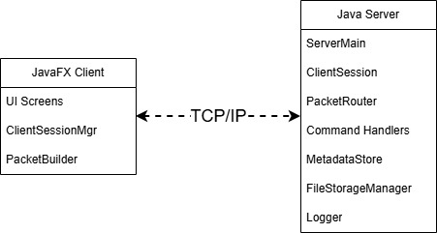
Figure 1: System Architecture Diagram

Data Packet Structure
All client-server communication uses a custom binary packet format. This packet structure implements SR-3 (Data Packet requirement).
Field | Type | Description
commandId | int | Identifies command type
payloadSize | int | Payload length
payload | byte[] | JSON or binary data
The payload format varies depending on whether the packet carries a control command or file transfer data. Payload types include:
- JSON payloads for control commands such as LOGIN or LIST_FILE
- Binary chunks for file transfer chunks
File transfers use a fixed chunk size of 4096 bytes to allow efficient streaming of large files. This protocol supports all major functional operations including login, file listing, upload, download, deletion, and logout.

Packet Layout Diagram
The diagram below shows the structure of the custom binary packet that we will use for this software. The payload size will be variable depending on if it is used for control command, response, or actual file/resource transfer.
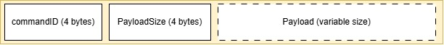
Figure 2: Packet Layout Diagram

Command Protocol
The following commands are supported by the DocNest protocol.
Command List
Command ID | Name | Direction | Payload
1 | LOGIN | Client → Server | JSON
2 | LOGIN_RESPONSE | Server → Client | JSON
3 | LIST_FILES | Client → Server | JSON
4 | LIST_FILES_RESPONSE | Server → Client | JSON
5 | UPLOAD_INIT | Client → Server | JSON
6 | UPLOAD_READY | Server → Client | JSON
7 | UPLOAD_CHUNK | Client → Server | Binary
8 | UPLOAD_COMPLETE | Client → Server | JSON
9 | UPLOAD_RESULT | Server → Client | JSON
10 | DOWNLOAD_INIT | Client → Server | JSON
11 | DOWNLOAD_READY | Server → Client | JSON
12 | DOWNLOAD_CHUNK | Server → Client | Binary
13 | DOWNLOAD_COMPLETE | Server → Client | JSON
14 | DELETE_FILE | Client → Server | JSON
15 | DELETE_RESPONSE | Server → Client | JSON
16 | LOGOUT | Client → Server | JSON
17 | ERROR | Server → Client | JSON

Server Lifecycle State Machine
DocNest distinguishes between two different types of system states:
- Server lifecycle states
- Session protocol states
The server lifecycle state machine describes the global operational state of the server process.
States include:
- STARTING
- LISTENING
- ACCEPTING
- HANDLING_SESSION
- CLOSING

Server Lifecycle Diagram
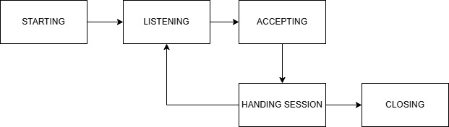
The lifecycle states of the server and the state machine operate independently of that of the sessions it spins up to deal with authenticated clients. The lifecycle states of the individual session are governed by a separate protocol.

Session Protocol State Machine
The session protocol state machine governs the state of a single client connection.
States include:
- CONNECTED
- AUTHENTICATING
- READY
- TRANSFERRING
- CLOSING
These states enforce the communication protocol and prevent invalid command execution.

Allowed Commands per State
State | Allowed Commands
CONNECTED | LOGIN
READY | LIST_FILES, UPLOAD_INIT, DOWNLOAD_INIT, DELETE_FILE, LOGOUT
TRANSFERRING | UPLOAD_CHUNK, DOWNLOAD_CHUNK
CLOSING | none

Session Protocol State Machine Diagram
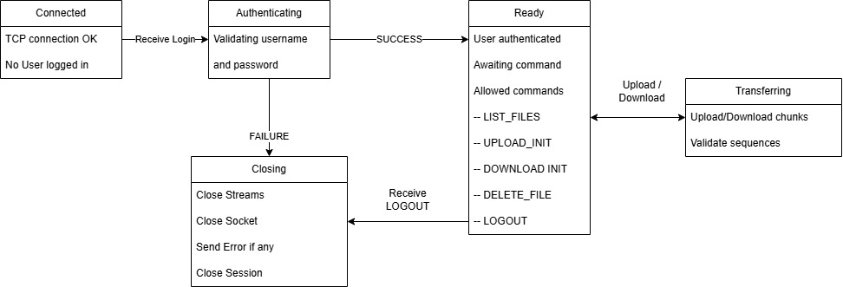
Figure 3: Session Protocol Lifecycle State Machine

Communication Flow
Typical client-server interaction sequence (for LogIn usecase):
- Client connects to server
- Client sends LOGIN request
- Server authenticates credentials
- Client requests file list
- Client performs upload, download, or deletion
- Client logs out and connection closes
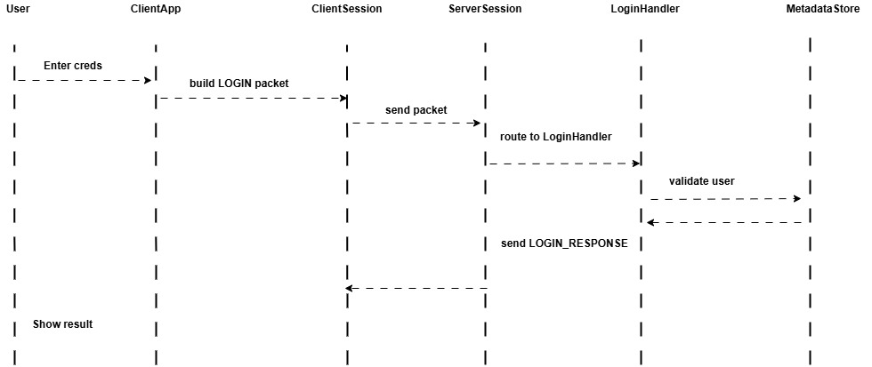
Figure 4: Sequence Diagram for LogIn
Sequence of operation for the download file chunk use-case:
- The User initiates a download request through the Client Application UI.
- The ClientApp constructs a DOWNLOAD_INIT request and delegates packet creation to the ClientSession.
- The ClientSession sends the DOWNLOAD_INIT packet to the ServerSession over the established communication channel.
- The ServerSession identifies the request type and forwards it to the DownloadHandler for processing.
- The DownloadHandler queries the FileStorageManager to locate the requested file and retrieve associated metadata.
- The FileStorageManager returns the lookup result (file existence, size, metadata).
- The DownloadHandler generates a DOWNLOAD_READY response and sends it back to the ServerSession.
- The ServerSession forwards the DOWNLOAD_READY response to the ClientSession.
- The ClientSession delivers the file metadata to the ClientApp for initialization of the download process.
- The ClientApp issues a chunk request to the ClientSession.
- The ClientSession forwards the chunk request to the ServerSession.
- The ServerSession invokes the DownloadHandler to read the next file chunk.
- The DownloadHandler requests the chunk data from the FileStorageManager.
- The FileStorageManager returns the requested chunk.
- The DownloadHandler packages the chunk into a DOWNLOAD_CHUNK response and sends it to the ServerSession.
- The ServerSession forwards the chunk to the ClientSession.
- The ClientSession delivers the chunk to the ClientApp.
- Steps 10–17 repeat until all chunks have been transferred.
- Upon receiving the final chunk, the ClientApp assembles and saves the file locally and signals completion to the User.
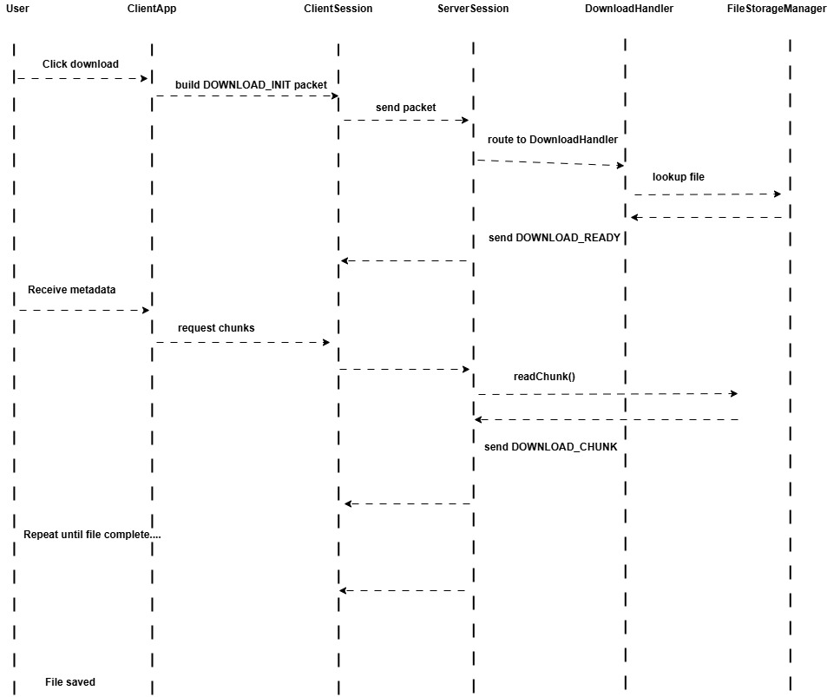
Figure 5: Sequence Diagram for Download File

Client Design

Description
The DocNest client application provides a graphical interface that allows users to interact with documents stored on the server.
The client performs the following functions:
- Authenticate users
- Display stored files
- Upload new files
- Download existing files
- Delete files
- Display metadata
The client application is implemented using JavaFX and communicates with the server using TCP sockets.
The client architecture separates user interface components from networking logic to maintain modular design and satisfy maintainability requirements.

Client Software Architecture Description
The client architecture consists of three primary components:
- User Interface
- ClientSessionManager
- PacketBuilder
User interactions within the graphical interface generate requests that are transmitted to the server through the session manager.

Client Architecture Diagram
Figure 6: Client Architecture Diagram
The client architecture is composed of the JavaFX user interface, the ClientSessionManager responsible for maintaining the server connection, and the PacketBuilder which constructs protocol-compliant packets that are transmitted through the TCP socket.

Client Class Diagram
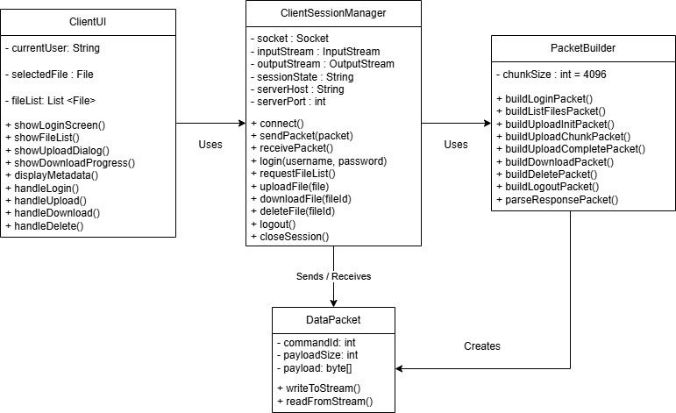
Figure 7: Client Class Diagram
The client class diagram illustrates the relationships between the primary classes used in the client application. The ClientUI handles user interaction, while the ClientSessionManager manages the network session and communicates with the server. The PacketBuilder class constructs the DataPacket objects that are transmitted over the TCP connection.

ClientSessionManager – Moutushi Sarkar

Description
The ClientSessionManager class is responsible for managing the network communication between the client application and the server. It maintains the active TCP connection, manages the client session state, and handles the sending and receiving of packets according to the DocNest communication protocol.
This class acts as the primary interface between the user interface layer and the network layer. All client requests generated by the graphical interface are routed through the ClientSessionManager before being transmitted to the server.

Functional Design
The ClientSessionManager performs several key responsibilities within the client application.
These responsibilities include:
- Establishing and maintaining the TCP connection with the server
- Managing the lifecycle of the client session
- Sending request packets to the server
- Receiving and interpreting response packets from the server
- Handling connection termination and cleanup procedures
The class ensures that all communication follows the protocol defined by the system packet structure and session state machine.

Key Methods
The primary methods implemented within this class include:
- connect() establishes a TCP connection to the server.
- sendPacket() transmits a DataPacket object to the server.
- receivePacket() listens for and processes responses from the server.
- closeSession() safely terminates the network connection and releases resources.

PacketBuilder – Moutushi Sarkar

Description
The PacketBuilder class is responsible for constructing the packets used for communication between the client and server. It encapsulates the logic required to assemble protocol-compliant DataPacket objects from application-level commands and data.
By isolating packet construction within a dedicated class, the design ensures that communication formatting remains consistent throughout the application and simplifies maintenance of the network protocol.

Functional Design
The PacketBuilder handles the transformation of client requests into properly structured packet objects.
Its responsibilities include:
- Serializing command data into JSON format for control messages
- Packaging binary data when transmitting file chunks
- Constructing DataPacket objects according to the protocol specification
- Ensuring packet fields such as command identifiers and payload sizes are correctly formatted
This separation of concerns allows the ClientSessionManager to focus solely on network transmission while delegating packet construction to the PacketBuilder.

Key Methods
The PacketBuilder provides several methods used to construct packets for the various system operations:
- buildLoginPacket()
- buildUploadPacket()
- buildDownloadPacket()
- buildDeletePacket()
Each method constructs a packet corresponding to a specific command defined in the system protocol.

Client Data Flow
This section describes the interaction between the main client components during typical file operations. The client application follows a layered interaction model where the user interface initiates requests that are processed through the network management components before being transmitted to the server.

Upload Operation Flow
The following sequence illustrates the typical process for uploading a file from the client to the server:
- The user selects a file to upload through the graphical user interface.
- The user interface sends an upload request to the ClientSessionManager.
- The PacketBuilder constructs an UPLOAD_INIT packet containing file metadata.
- The ClientSessionManager transmits the packet to the server through the TCP connection.
- The server responds with an UPLOAD_READY message indicating that it is prepared to receive file data.
- The client begins transmitting the file as a sequence of fixed-size data chunks until the entire file has been transferred.
This process allows large files to be transferred reliably using the chunked data transfer mechanism defined by the communication protocol.

Sequence Diagram Description
The accompanying sequence diagram illustrates the interaction between the major client components during a file upload operation.
The user initiates the upload request through the JavaFX user interface, which delegates the request to the ClientSessionManager. The session manager then utilizes the PacketBuilder to construct the appropriate protocol packet and sends the request to the server. Server responses are received through the session manager and forwarded back to the user interface for display and progress updates.
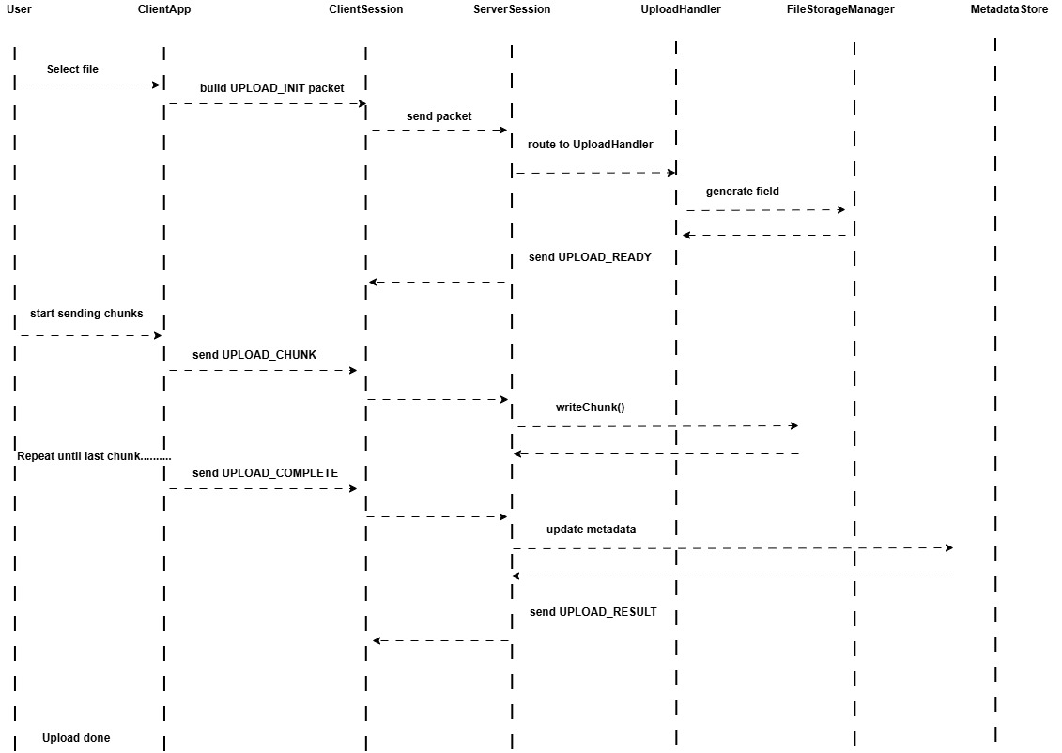
Figure 8: Sequence diagram for Upload Use case

Graphical User Interface Design Description
The client interface is designed to be intuitive and user-friendly, satisfying the usability requirements defined in the Software Requirements Specification. The graphical interface provides a streamlined environment for interacting with the document storage system and supports all core user operations including authentication and file management.
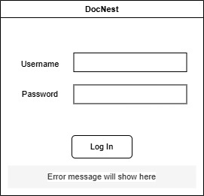
Figure 9: Login Screen Wireframe
- Login Screen – Allows users to authenticate using their credentials.
- File List Screen – Displays the list of files stored in the user’s vault.
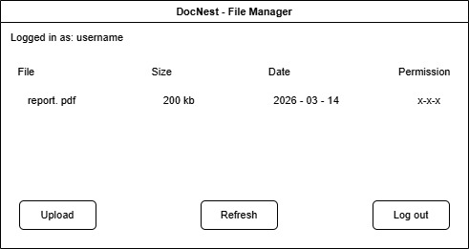
Figure 10: File List Screen WireFrame
- Upload Dialog – Enables users to select and upload files to the server.
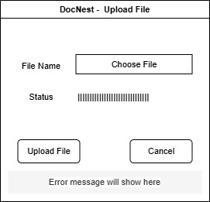
Figure 11: Upload File Wireframe
- Download Progress Dialog – Displays the progress of ongoing download operations.
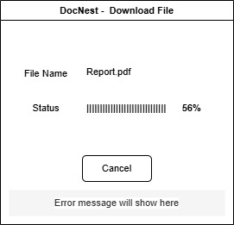
Figure 12: Download File Wireframe
- Metadata View – Displays detailed information about selected files.
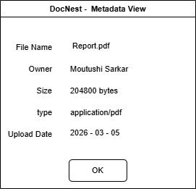
Figure 13: Metadata view wireframe
These interface components provide clear feedback to the user and allow file operations to be performed in a simple and efficient manner.

Server Design

Description
The DocNest server manages authentication, file storage, metadata management, and logging. It accepts TCP connections from clients and processes commands using the defined packet protocol.
The server enforces authentication before allowing any file operations and manages file storage within isolated user vault directories.
Major server responsibilities include:
- Authenticating users
- Managing metadata storage
- Handling file uploads and downloads
- Processing client commands
- Logging system activity

Server Software Architecture Description
The DocNest server is designed using a modular architecture in which each component is responsible for a specific aspect of server functionality. This modular structure improves maintainability, simplifies debugging, and ensures that the responsibilities of connection management, command processing, file storage, and logging remain clearly separated.
The primary server components include:
- ServerMain
- ClientSession
- PacketRouter
- Command Handlers
- MetadataStore
- FileStorageManager
- Logger
The ServerMain component acts as the entry point for the server application. It initializes the server environment, loads configuration data such as user credentials and metadata, and opens the server socket to listen for incoming client connections.
When a client connects, the server creates a ClientSession instance to manage the communication with that specific client. Each ClientSession maintains the session state, reads incoming packets from the network, and sends responses back to the client.
Incoming packets received by the ClientSession are forwarded to the PacketRouter, which determines the type of command contained in the packet. The PacketRouter then delegates processing to the appropriate command handler, such as login, upload, download, or delete operations.
These command handlers interact with other server components to complete their tasks. The MetadataStore manages the metadata associated with stored files, including loading and updating the metadata.json file. The FileStorageManager handles the physical storage of file data, including writing uploaded file chunks, retrieving files for download, and deleting files from the vault directory.
Throughout the execution of server operations, the Logger component records system events, errors, and operational messages to a persistent log file. This logging functionality supports debugging, monitoring, and system maintenance.
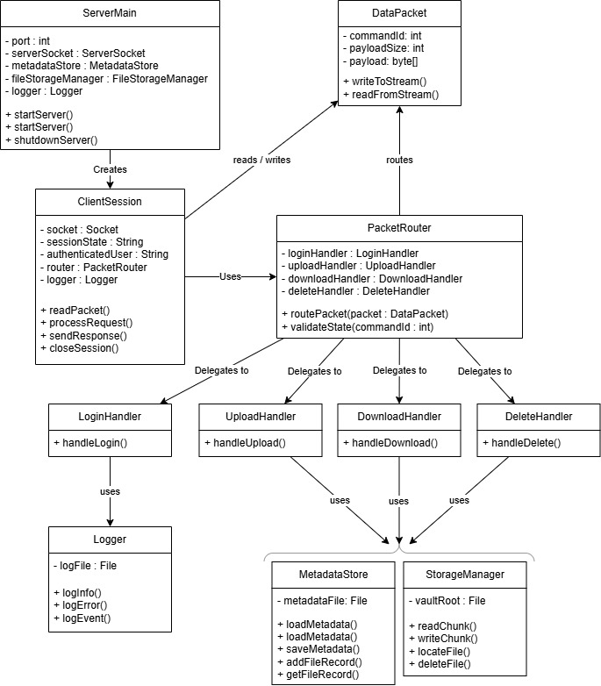
Figure 14: Server Class Diagram
The server class diagram above illustrates the relationships between the primary server components and how they collaborate to process client requests.

User Interface Design Description
The server uses a console-based interface that provides system status and logging output.
The console displays events such as:
- server startup
- client connections
- authentication events
- file operations
- system errors

Example Server Console Output
[INFO] DocNest Server Starting...
[INFO] Listening on port 5000
[INFO] Client connected: 192.168.1.10
[INFO] User authenticated: moutushi
[INFO] Upload started: report.pdf
[INFO] Upload completed: report.pdf
[INFO] Download request: notes.txt
[INFO] File deleted: draft.docx
[INFO] Client disconnected

Server Modules

ServerMain – Moutushi Sarkar

Description
ServerMain initializes the server environment and listens for incoming client connections.

Functional Design
Responsibilities include:
- Loading metadata
- Loading user credentials
- Initializing vault directories
- Starting ServerSocket
- Accepting incoming connections

ClientSession – Moutushi Sarkar

Description
ClientSession represents a single client connection and maintains the session state for that client.

Functional Design
Responsibilities include:
- Maintaining session protocol state
- Reading incoming packets
- Forwarding packets to PacketRouter
- Closing connections when necessary

PacketRouter - Moutushi Sarkar

Description
PacketRouter routes incoming packets to the appropriate command handler.

Functional Design
Processing flow:
receive packet
extract commandId
switch(commandId)
call appropriate handler
return response

MetadataStore - Moutushi Sarkar

Description
MetadataStore manages the metadata.json file that tracks information about stored files.

Functional Design
Responsibilities include:
- Loading metadata during server startup
- Updating metadata after uploads
- Removing entries after deletions

FileStorageManager - Moutushi Sarkar

Description
FileStorageManager handles the reading and writing of file data to disk.

Functional Design
Responsibilities include:
- Writing uploaded file chunks
- Reading files for download
- Deleting stored files

File storage structure:
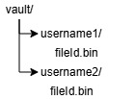

Logger - Moutushi Sarkar

Description
The Logger component records system events to a persistent log file.

Functional Design
Responsibilities include:
- Recording timestamps
- Logging authentication events
- Logging file operations
- Logging system errors
Log file location:
logs/server.log

Data Structures
The following JSON structures would be implemented for the server to capture the necessary data and keep track of the resources and communications with the client.

FileRecord
This is the metadata associated with each file. This will be stored as JSON (as opposed to some database structure for simplicity)
json
{
"id": "uuid",
"owner": "username",
"name": "resume.pdf",
"size": 204800,
"mime": "application/pdf",
"uploadedAt": "2026-03-05T22:04:00"
}

UserRecord
This will also be stored in a separate JSON file. This information will be used to validate authentication. For the demonstration purposes, we will hardcode registered users.
json
{
"username": "moutushi",
"password": "1234"
}

DataPacket Class
This would be the class that will be structuring the data being transferred.
Fields:
- int commandId
- int payloadSize
- byte[] payload
Methods:
- writeToStream()
- readFromStream()

Core Algorithms
This section describes the operational flow of the main file management and authentication processes supported by the DocNest system. The descriptions below illustrate the logical sequence of actions performed by the server when handling client requests. These descriptions are not intended to represent strict pseudocode; rather, they provide a conceptual overview of how the system processes each type of operation during a client session.

Authentication Process
The authentication process is responsible for validating user credentials before any file operations can occur. When a client first connects to the server, the session enters the CONNECTED state. The client must successfully authenticate before the session transitions to the READY state where file operations are permitted.
Authentication proceeds as follows:
- The server receives a LOGIN packet from the client containing the username and password encoded as a JSON payload.
- The server parses the JSON payload to extract the submitted credentials.
- The credentials are validated against the stored user records in the users.json file.
- If the credentials are valid, the server updates the session state to READY and sends a LOGIN_RESPONSE packet confirming successful authentication.
- If authentication fails, the server returns an ERROR packet indicating authentication failure and terminates the session.
This process ensures that only authenticated users are permitted to interact with the file storage system.

File Upload Process
The file upload process enables a client to transfer a file to the server in a controlled and reliable manner. Because files may be large, they are transmitted in fixed-size chunks rather than as a single payload.
The upload process operates as follows:
- The client sends an UPLOAD_INIT packet containing file metadata such as filename and size.
- Upon receiving the request, the server generates a unique fileId (typically a UUID) that will be used to identify the stored file.
- The server responds with an UPLOAD_READY packet indicating that it is prepared to receive file data.
- The client begins transmitting the file as a sequence of UPLOAD_CHUNK packets, each containing a fixed-size block of binary data (typically 4096 bytes).
- As each chunk is received, the server writes the data sequentially to a file in the user’s vault directory.
- When all chunks have been transmitted, the client sends an UPLOAD_COMPLETE packet indicating that the transfer has finished.
- The server finalizes the file storage process and updates the metadata.json file to include the new file record.
This chunked transfer mechanism ensures reliable handling of large files while maintaining protocol consistency.

File Download Process
The file download process allows a client to retrieve a stored file from the server. Similar to uploads, file transfers occur in chunks to support efficient streaming and avoid large memory usage.
The download sequence proceeds as follows:
- The client sends a DOWNLOAD_INIT request specifying the fileId of the file to retrieve.
- The server verifies that the file exists and that the requesting user has permission to access it.
- If the file is valid, the server sends a DOWNLOAD_READY response containing metadata such as file size and type.
- The server reads the stored file and transmits it to the client in a sequence of DOWNLOAD_CHUNK packets, each containing a block of binary data.
- After all file data has been transmitted, the server sends a DOWNLOAD_COMPLETE packet indicating the end of the transfer.
The client reconstructs the file locally by assembling the received chunks in sequence.

File Deletion Process
The deletion process allows a user to permanently remove a stored file from the server.
The deletion sequence occurs as follows:
- The client sends a DELETE_FILE request specifying the fileId of the file to remove.
- The server verifies that the file exists and that the requesting user is authorized to delete it.
- If the file is valid, the server deletes the corresponding file from the user’s vault directory.
- The server updates the metadata.json file to remove the file’s metadata entry.
- A DELETE_RESPONSE packet is sent to the client confirming successful deletion.
This process ensures that both the physical file and its associated metadata are removed from the system.

Error Handling
The DocNest system implements a structured error handling mechanism to ensure robust communication between the client and server. When an error occurs during command processing, the server responds with a standardized ERROR packet containing a JSON payload that describes the issue.

Error Packet Format
This structured format allows the client application to interpret the error and provide appropriate feedback to the user.
Example Error Packet Format
{
"code": "INVALID_STATE",
"message": "Command not allowed in current session state.",
"details": null
}
The code field identifies the specific error condition, while the message field provides a human-readable description of the problem. The optional details field may contain additional diagnostic information when applicable.

Error Categories
The server defines several error categories to handle different types of protocol violations and runtime failures. Some errors require the session to be terminated to maintain protocol integrity, while others allow the session to continue.
Error Code | Description | Close Session
AUTH_FAILED | Authentication failed due to invalid credentials | Yes
INVALID_STATE | Command issued in an invalid session state | Yes
INVALID_COMMAND | Unrecognized command identifier | Yes
FILE_NOT_FOUND | Requested file does not exist | No
CHUNK_OUT_OF_ORDER | File transfer chunks received in an incorrect sequence | Yes
BAD_REQUEST | Malformed packet or invalid request format | Yes
INTERNAL_ERROR | Unexpected server-side failure | Yes

Error Logging
All errors generated by the server are recorded in the system log. Each log entry includes a timestamp, the error code, and relevant contextual information. Logging errors ensures that system failures can be diagnosed and supports troubleshooting during development and maintenance.

Security Design
The DocNest system incorporates several security mechanisms to ensure that user data is protected and that only authorized operations are permitted during a client session. These mechanisms focus on credential management, file isolation, and session enforcement.

Credential Storage
User credentials are maintained in a server-side configuration file named users.json. This file stores the usernames and associated passwords required for authentication. For the purposes of this course project, storing passwords in plain text is acceptable; however, the design allows for the optional use of SHA-256 hashing to improve security. If hashing is enabled, passwords are stored as hashed values rather than readable text, reducing the risk of credential exposure.

Vault Isolation
To ensure that users cannot access each other’s files, the server organizes stored documents using a vault directory structure. Each authenticated user has a dedicated folder where their uploaded files are stored.
Example storage structure:
vault/<username>/<fileId>.bin
This design ensures that files are logically separated by user and helps enforce access control when processing file requests.

Session Enforcement
All file operations require a successfully authenticated session. The server enforces this rule using the session state machine defined in the communication protocol. Commands such as file listing, upload, download, or deletion are only permitted after the client has completed the LOGIN operation.
The session state machine prevents invalid command transitions and ensures that unauthorized operations cannot occur before authentication is complete.

Traceability to Requirements
Design Component | Related FRs | Related NFRs
Packet Protocol | FR-1–FR-17 | NFR-1, NFR-2, NFR-3
State Machines | FR-1–FR-17 | NFR-3, NFR-7
MetadataStore | FR-4, FR-10, FR-17 | NFR-4, NFR-9
FileStorageManager | FR-6–FR-14 | NFR-1, NFR-2
Logger | FR-18–FR-19 | NFR-3, NFR-9
Client UI | FR-1–FR-17 | NFR-5, NFR-6
Authentication | FR-1–FR-3 | NFR-7, NFR-8

