  Software Detailed Design  Project IV | Abstract  DocNest is a secure client–server document storage system designed to support reliable file upload, download, listing, and deletion over a custom TCP-based protocol.  Team Members  Moutushi Sarkar

Table of Contents
1. Introduction - DocNest 3
1.1 Purpose 3
1.2 Scope 3
1.3 Intended Audience 3
1.4 References 3
2. System Architecture 3
2.1 High-Level Architecture Overview 3
2.2 Architectural Components 5
3. Detailed Design 6
3.1 Packet Protocol Design 6
3.2 State Machine Design 8
3.3 Server Design 11
3.4 Client Design 14
3.5 Data Structures 17
4. Algorithms 18
4.1 Authentication Algorithm 18
4.2 Upload Algorithm 18
4.3 Download Algorithm 18
4.4 Delete Algorithm 18
5. Error Handling 20
5.1 Error Categories 20
5.2 Logging Errors 20
6. Security Design 20
6.1 Credential Storage 20
6.2 Vault Isolation 20
6.3 Session Enforcement 20
7. Design Constraints 20
8. Traceability Matrix (Design → Requirements) 21

1. Introduction - DocNest

1.1 Purpose
This Software Design Document (SDD) describes the internal design of DocNest, a secure client–server document storage system. It explains how the system will be built, including architecture, components, data structures, algorithms, packet protocol, and state machines.

1.2 Scope
This document covers the design of:
- JavaFX client application
- Console-based Java server
- Custom packet protocol
- Metadata storage subsystem
- Vault file storage
- Logging subsystem

1.3 Intended Audience
- Instructor and evaluators
- Developers
- Testers
- Anyone reviewing system design

1.4 References
- Software Requirements Specification (SRS)
- Project Proposal (Group 14)
- Project Management Plan
- COMP72070 Proposal Requirements Guide

2. System Architecture

2.1 High-Level Architecture Overview
DocNest follows a client-server architecture using TCP sockets and a custom binary packet protocol.
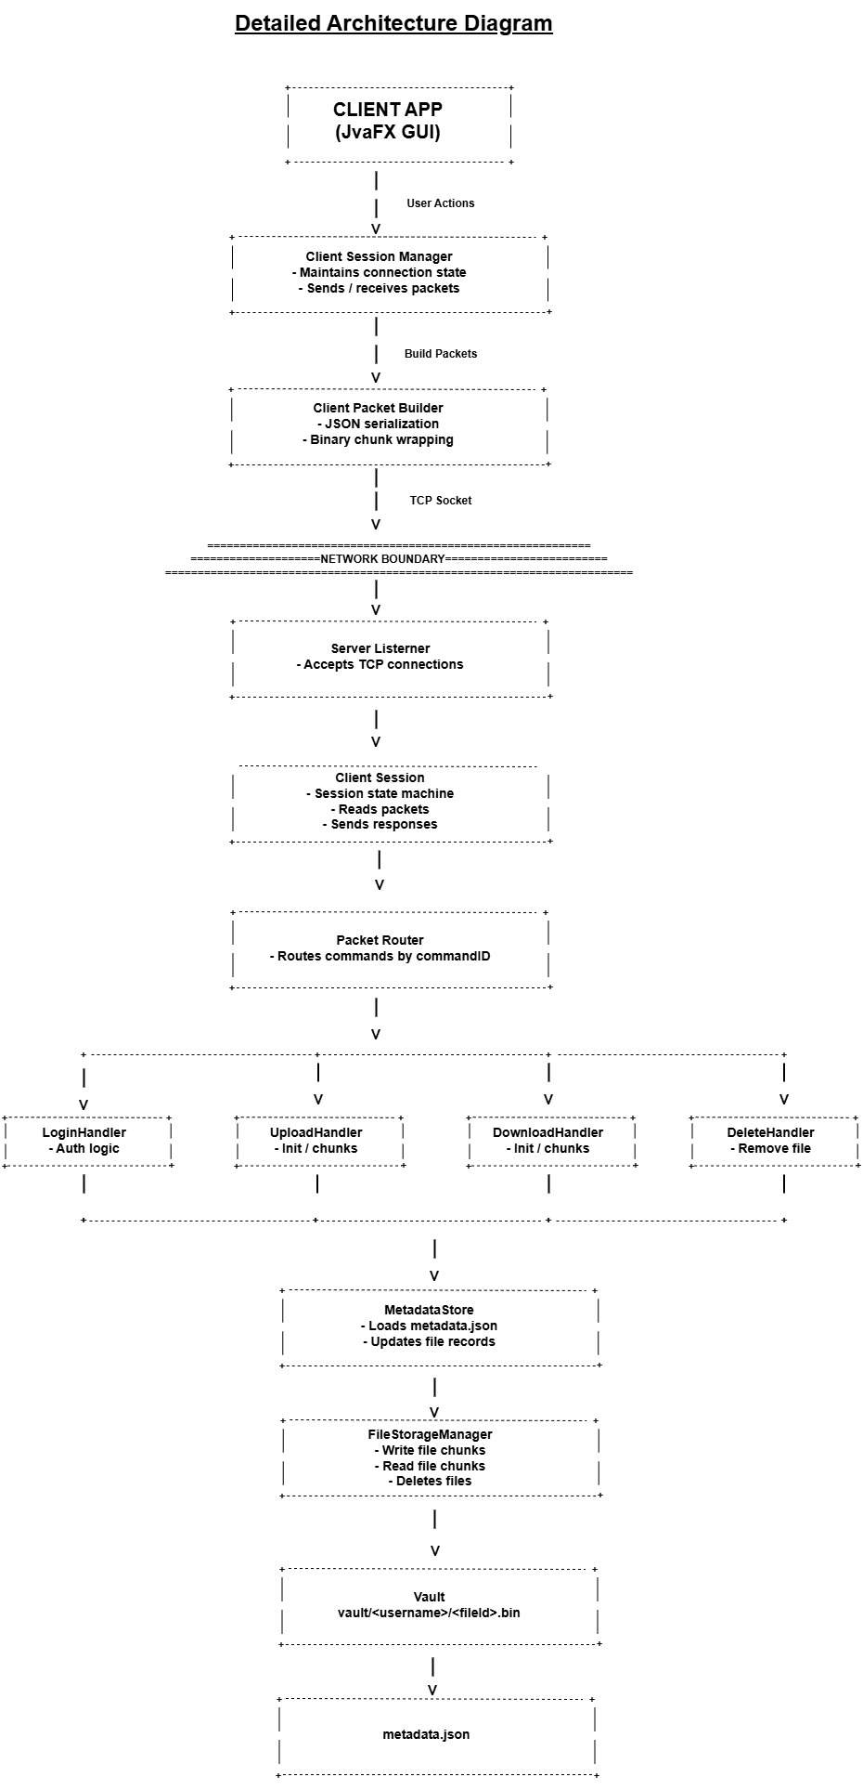

2.2 Architectural Components
Component | Description
Client UI | JavaFX interface for login, file listing, upload, download, delete
Client Packet Builder | Serializes commands into packets
Client Session Manager | Manages connection and state
Server Listener | Accepts incoming TCP connections
Session Handler | Manages per-client session state
Packet Router | Routes packets to appropriate handlers
Command Handlers | Login, upload, download, delete
MetadataStore | Loads/saves metadata.json
FileStorageManager | Reads/writes file chunks
Logger | Writes timestamped logs

3. Detailed Design

3.1 Packet Protocol Design
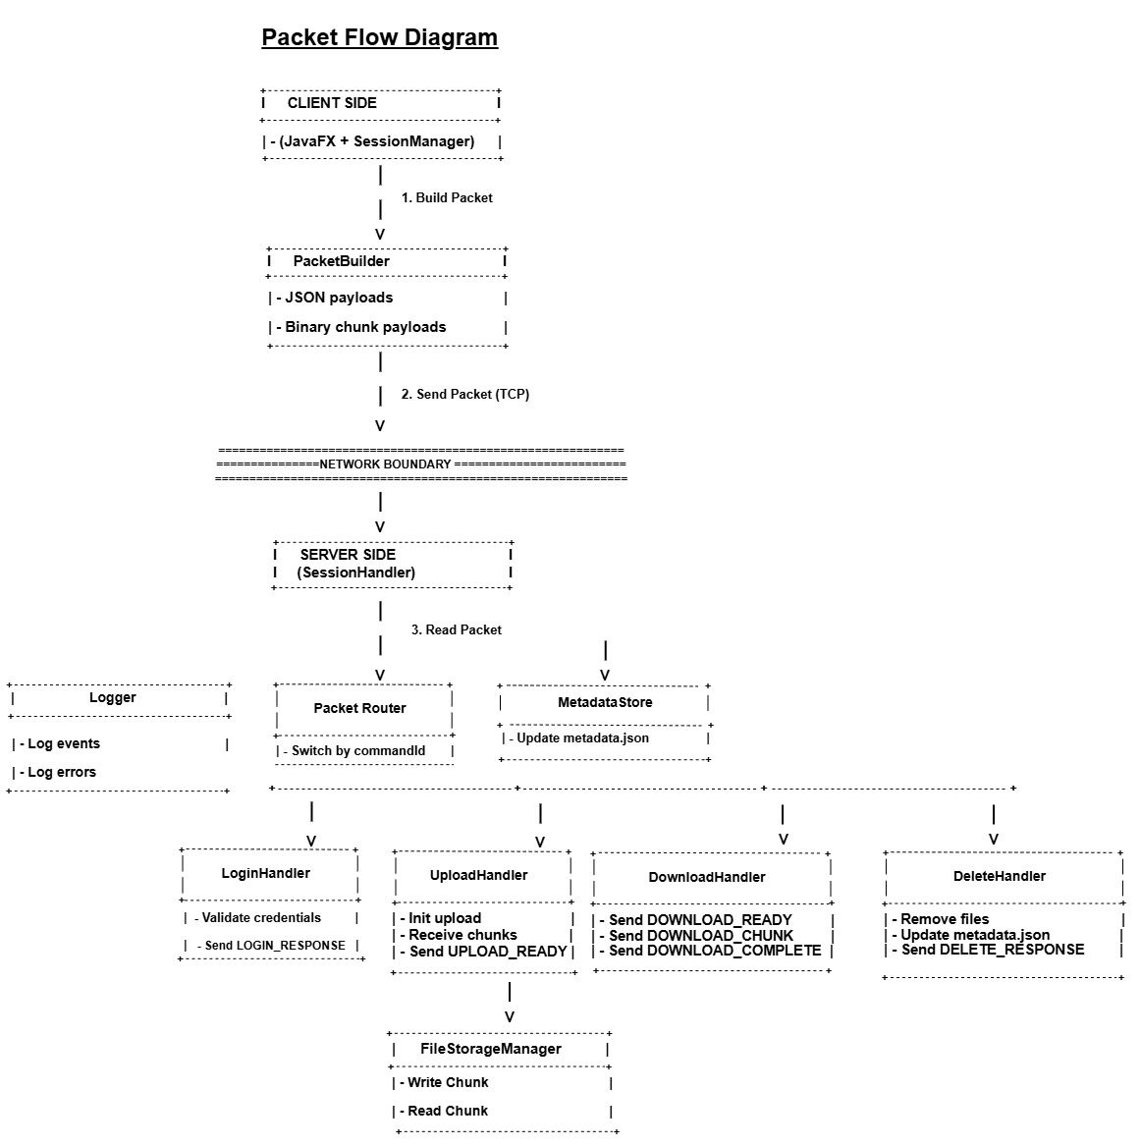

3.1.1 Packet Structure
Each packet consists of:
Field | Type | Description
commandId | int | Identifies command
payloadSize | int | Size of payload in bytes
payload | byte[] | JSON or binary data

3.1.2 Payload Types
- JSON for control commands
- Binary for file chunks
- Fixed chunk size: 4096 bytes

3.1.3 Command List
Command ID | Name | Direction | Payload
1 | LOGIN | C → S | JSON
2 | LOGIN_RESPONSE | S → C | JSON
3 | LIST_FILES | C → S | JSON
4 | LIST_FILES_RESPONSE | S → C | JSON
5 | UPLOAD_INIT | C → S | JSON
6 | UPLOAD_READY | S → C | JSON
7 | UPLOAD_CHUNK | C → S | binary
8 | UPLOAD_COMPLETE | C → S | JSON
9 | UPLOAD_RESULT | S → C | JSON
10 | DOWNLOAD_INIT | C → S | JSON
11 | DOWNLOAD_READY | S → C | JSON
12 | DOWNLOAD_CHUNK | S → C | binary
13 | DOWNLOAD_COMPLETE | S → C | JSON
14 | DELETE_FILE | C → S | JSON
15 | DELETE_RESPONSE | S → C | JSON
16 | LOGOUT | C → S | JSON
17 | ERROR | S → C | JSON

3.1.4 Error Packet Format
json
{
"code": "INVALID_STATE",
"message": "Command not allowed in current session state.",
"details": null
}

3.2 State Machine Design

3.2.1 Server Lifecycle State Machine
States:
- STARTING
- LISTENING
- ACCEPTING
- HANDLING_SESSION
- CLOSING
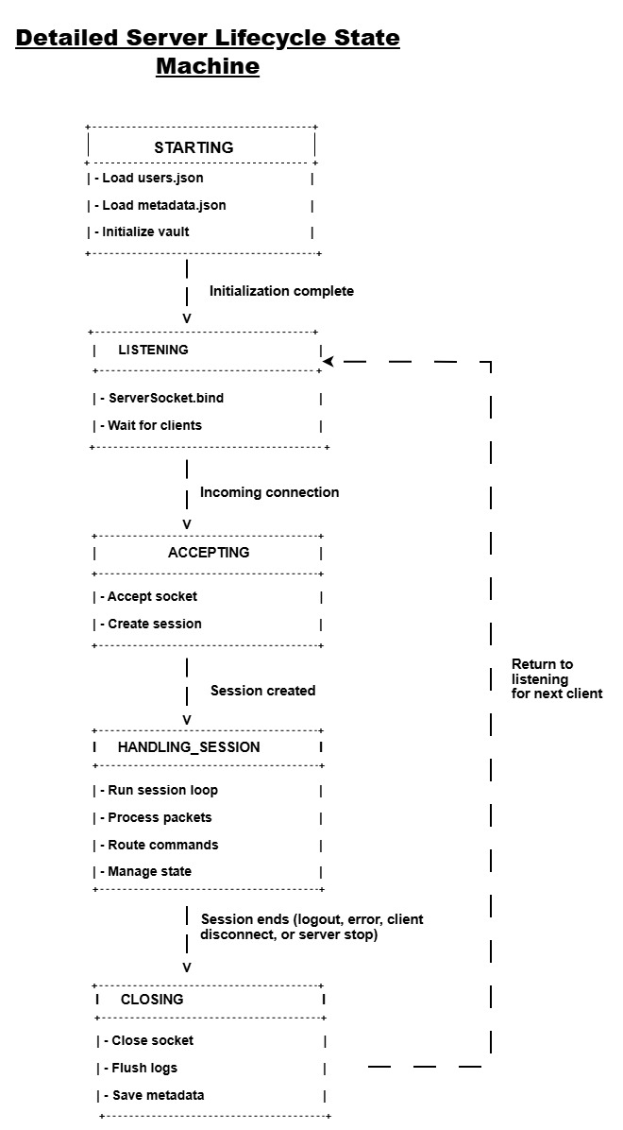

3.2.2 Session Protocol State Machine
States:
- CONNECTED
- AUTHENTICATING
- READY
- TRANSFERRING
- CLOSING
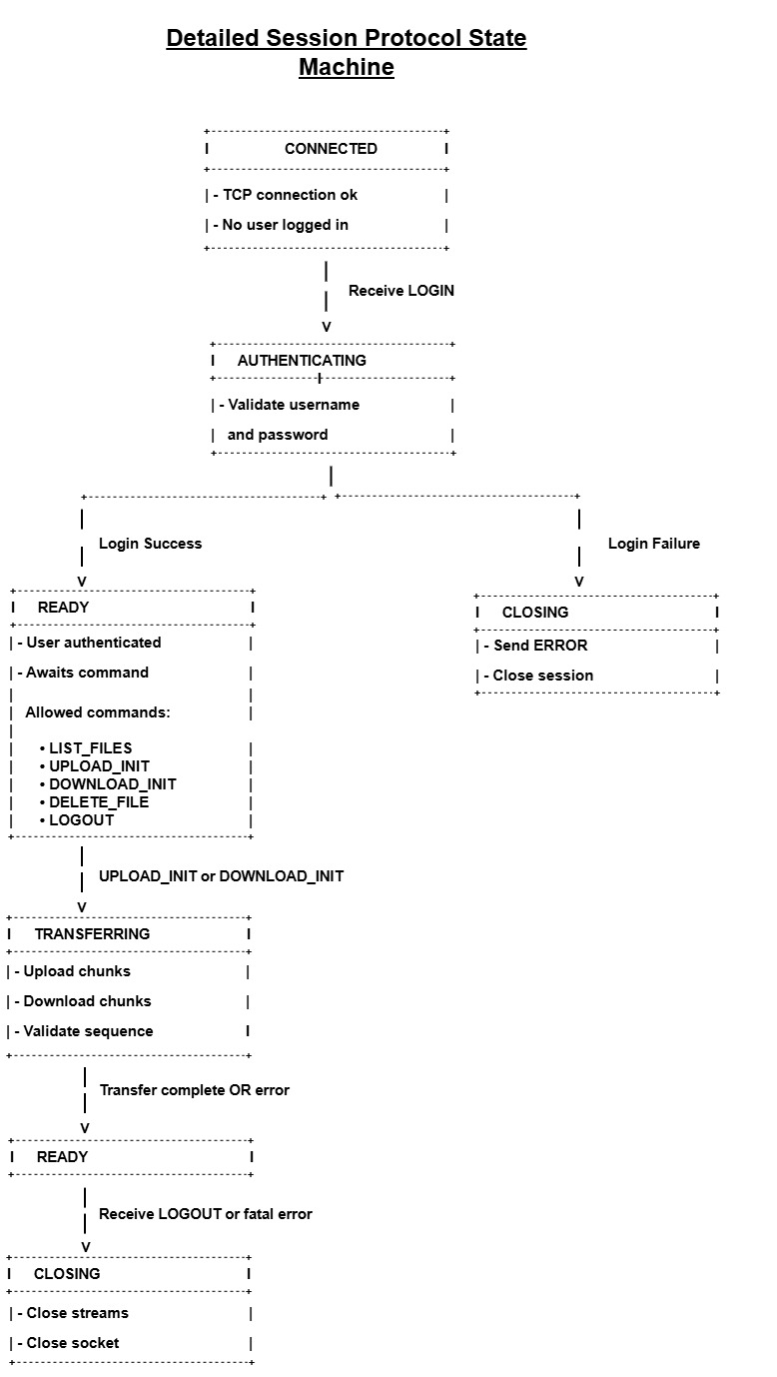

3.2.3 Allowed Commands per State
State | Allowed Commands
CONNECTED | LOGIN
AUTHENTICATING | (none)
READY | LIST_FILES, UPLOAD_INIT, DOWNLOAD_INIT, DELETE_FILE, LOGOUT
TRANSFERRING | UPLOAD_CHUNK, DOWNLOAD_CHUNK, UPLOAD_COMPLETE
CLOSING | (none)

3.3 Server Design

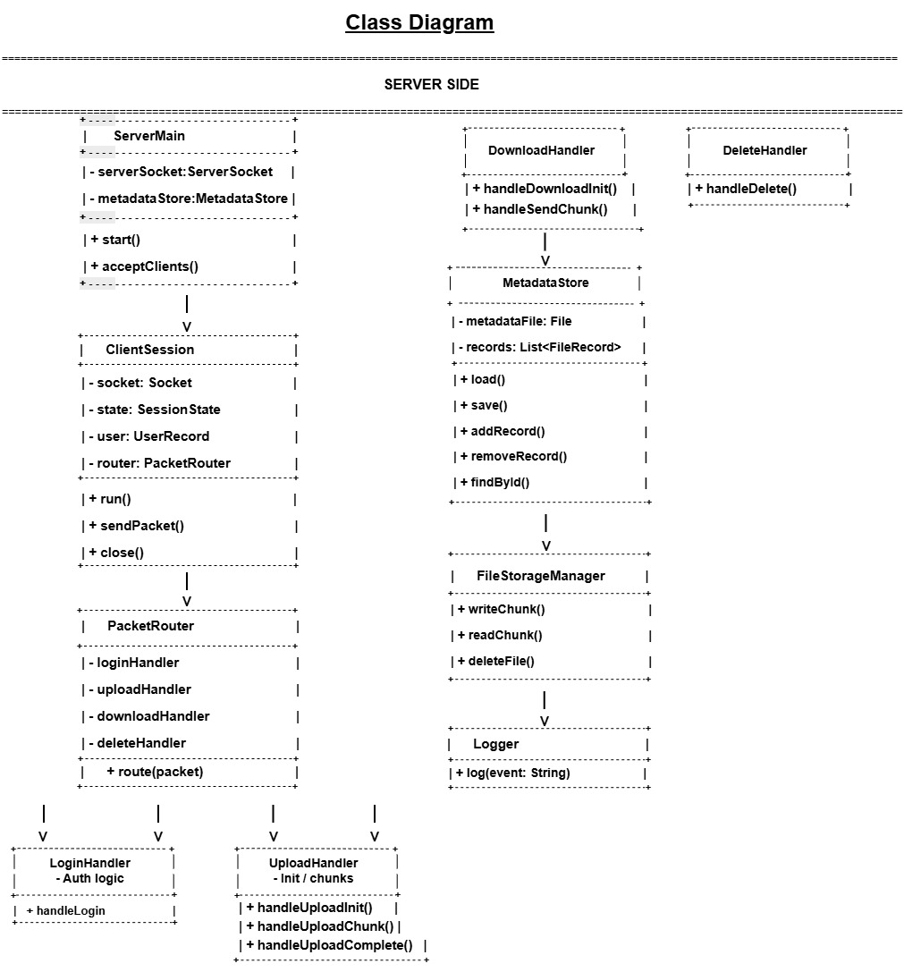

3.3.1 ServerMain
Responsibilities:
- Load metadata
- Load users.json
- Initialize vault directories
- Start ServerSocket
- Accept connections

3.3.2 ClientSession
Responsibilities:
- Maintain session state
- Store authenticated username
- Read packets
- Route commands
- Close session gracefully

3.3.3 PacketRouter
Routes packets to handlers based on commandId
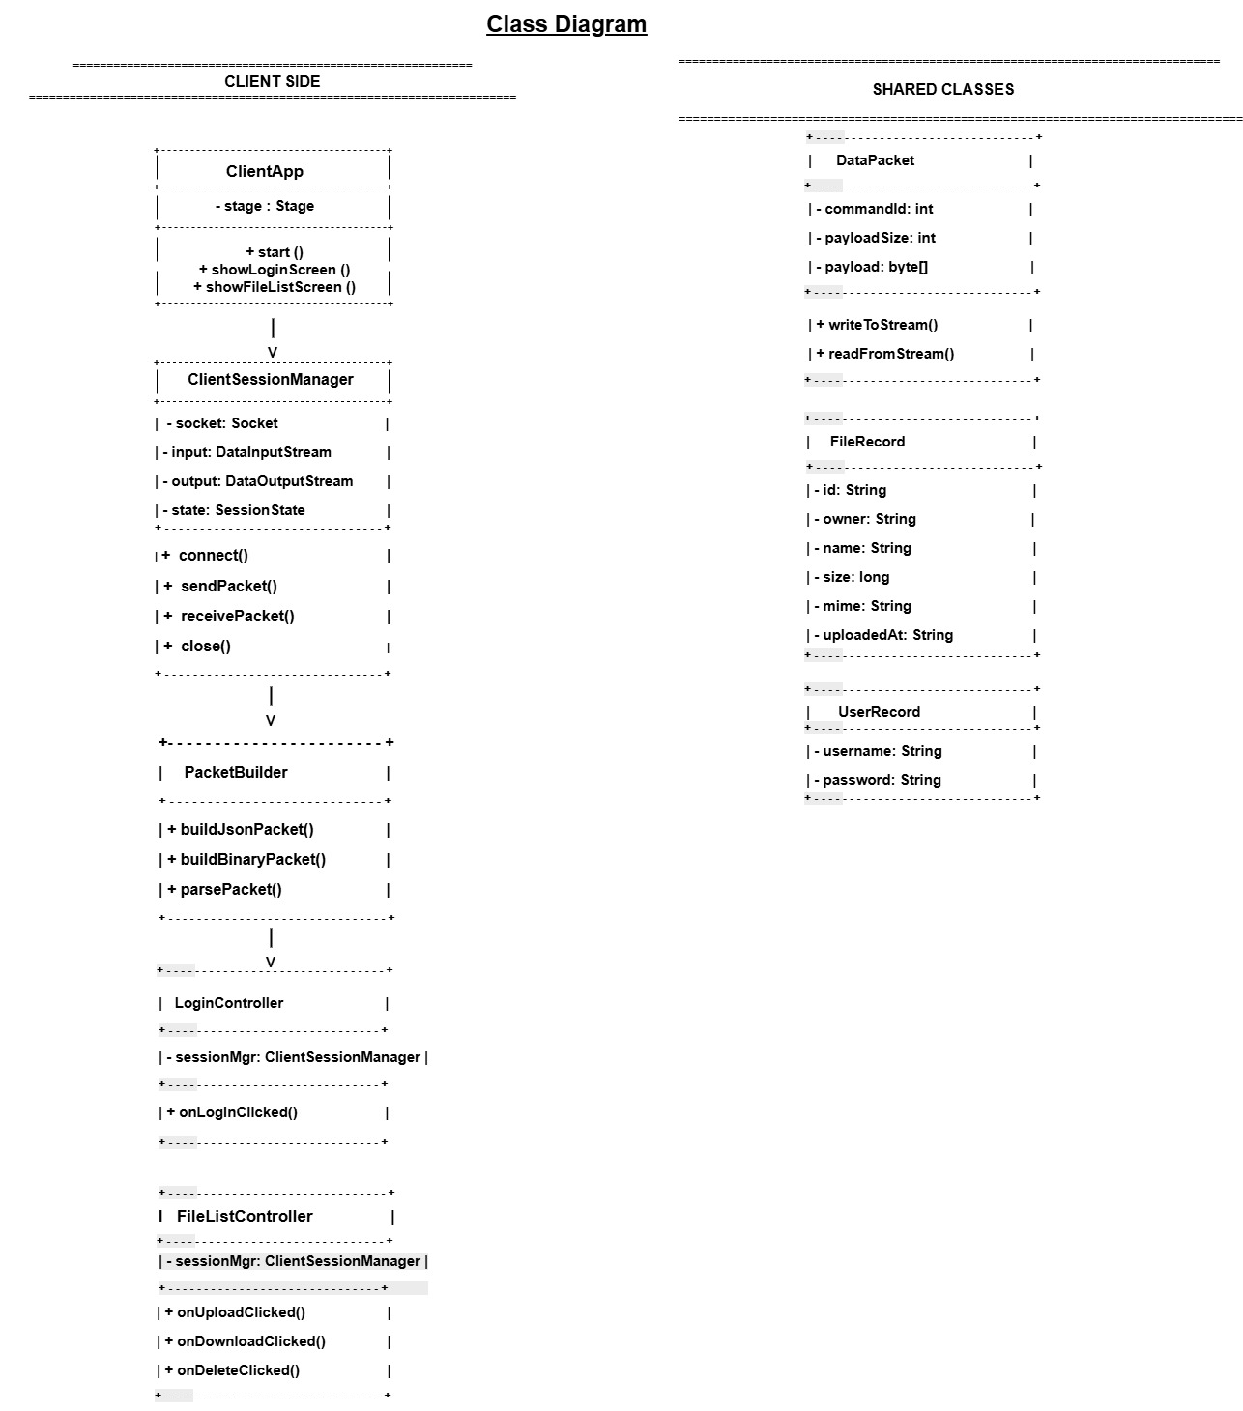

3.3.4 Command Handlers
Handler | Responsibilities
LoginHandler | Validate credentials, send LOGIN_RESPONSE
ListFilesHandler | Return metadata list
UploadHandler | Handle init, chunk, complete
DownloadHandler | Handle init, chunk sending
DeleteHandler | Remove file + metadata
LogoutHandler | End session

3.3.5 MetadataStore
- Loads metadata.json at startup
- Stores list of FileRecord objects
- Saves metadata.json after every change

3.3.6 FileStorageManager
- Writes file chunks to vault
- Reads file chunks for download
- Deletes files

3.3.7 Logger
- Writes timestamped entries to logs/server.log
- Append-only

3.4 Client Design

3.4.1 UI Screens
- Login screen
- File list screen
- Upload dialog
- Download progress popup
- Metadata display
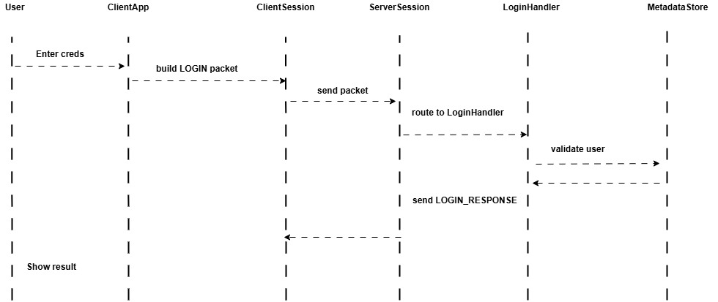
1 Sequence Diagram for LogIn

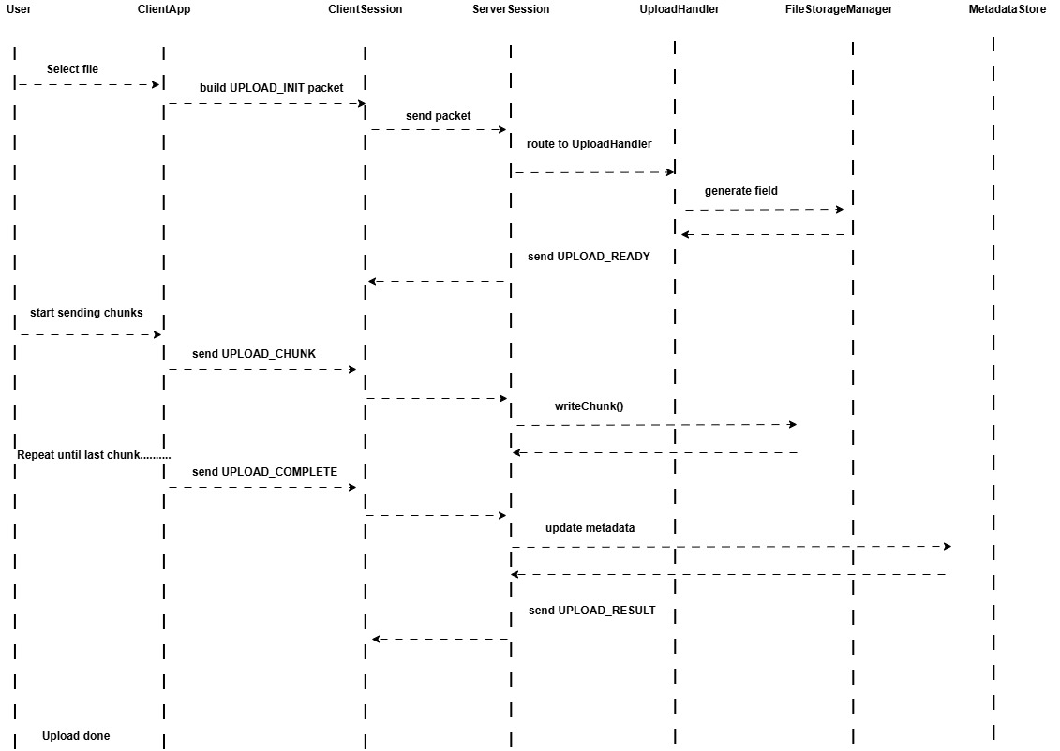
2 Sequence Diagram for Upload

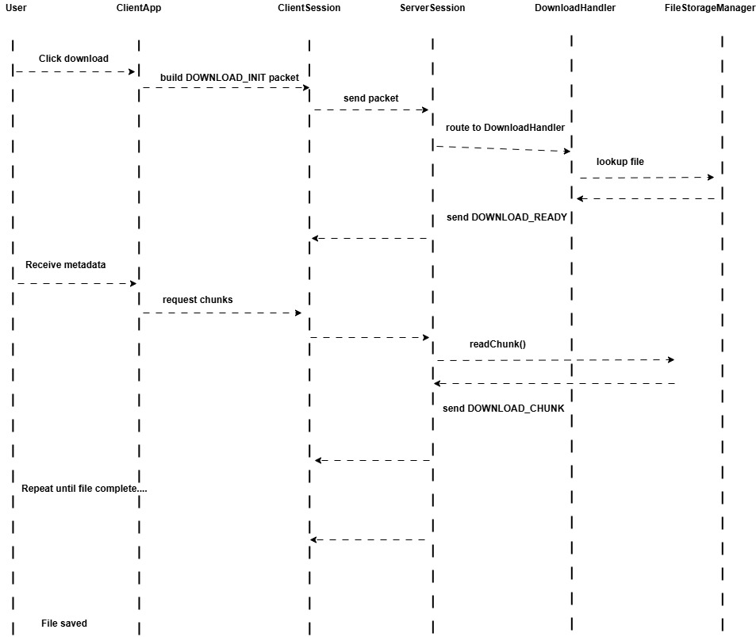
3 Sequence Diagram for Download

3.4.2 ClientSessionManager
- Connects to server
- Sends packets
- Receives packets
- Maintains client-side state

3.4.3 PacketBuilder
- Serializes JSON
- Wraps binary chunks
- Builds DataPacket objects

3.5 Data Structures

3.5.1 FileRecord
json
{
"id": "uuid",
"owner": "username",
"name": "resume.pdf",
"size": 204800,
"mime": "application/pdf",
"uploadedAt": "2026-03-05T22:04:00"
}

3.5.2 UserRecord
json
{
"username": "moutushi",
"password": "1234"
}

3.5.3 DataPacket Class
Fields:
- int commandId
- int payloadSize
- byte[] payload
Methods:
- writeToStream()
- readFromStream()

4. Algorithms

4.1 Authentication Algorithm
- Receive LOGIN packet
- Parse JSON
- Validate against users.json
- On success → READY
- On failure → send ERROR + close session

4.2 Upload Algorithm
- Receive UPLOAD_INIT
- Generate UUID fileId
- Send UPLOAD_READY
- Receive UPLOAD_CHUNK repeatedly
- Write chunks to file
- On UPLOAD_COMPLETE → update metadata

4.3 Download Algorithm
- Receive DOWNLOAD_INIT
- Look up file
- Send DOWNLOAD_READY
- Send file in 4096-byte chunks
- Send DOWNLOAD_COMPLETE

4.4 Delete Algorithm
- Receive DELETE_FILE
- Delete file from vault
- Remove metadata entry
- Send DELETE_RESPONSE

5. Error Handling

5.1 Error Categories
Error Code | Close Session?
AUTH_FAILED | Yes
INVALID_STATE | Yes
INVALID_COMMAND | Yes
FILE_NOT_FOUND | No
CHUNK_OUT_OF_ORDER | Yes
BAD_REQUEST | Yes
INTERNAL_ERROR | Yes

5.2 Logging Errors
All errors are logged with timestamp and details.

6. Security Design

6.1 Credential Storage
- Stored in users.json
- Plain text acceptable for course
- Optional: SHA-256 hashing

6.2 Vault Isolation
Files stored in:
Code
vault/<username>/<fileId>.bin

6.3 Session Enforcement
- No operations allowed before LOGIN
- Session state machine prevents invalid transitions

7. Design Constraints
- Java only
- TCP sockets
- No database
- Single-threaded server
- JSON metadata

8. Traceability Matrix (Design → Requirements)
Design Component | Related FRs | Related NFRs
Packet Protocol | FR-1–FR-17 | NFR-1, NFR-2, NFR-3
State Machines | FR-1–FR-17 | NFR-3, NFR-7
MetadataStore | FR-4, FR-10, FR-17 | NFR-4, NFR-9
FileStorageManager | FR-6–FR-14 | NFR-1, NFR-2
Logger | FR-18–FR-19 | NFR-3, NFR-9
Client UI | FR-1–FR-17 | NFR-5, NFR-6
Authentication | FR-1–FR-3 | NFR-7, NFR-8

