Bournemouth University, School of Computing and Engineering

COMP5067, Technological Innovations in Computing
Coursework 1 of 2, Group project, 70% weighting, Level 5

AR-Enhanced Maintenance Support System
for High-Security Engineering Environments

Case Study: Bournemouth Central Bus Depot

Word count (main body, excluding references): 7,370

Submission deadline: 12 May 2026, 12:00 PM (Brightspace)
Quality Assessor: Lai Xu, Markers: Festus Adedoyin, Fudong Li, Tim Orman

Generative AI use: basic spelling and grammar correction tools only,
per the brief permitted scope.

AR-Enhanced Maintenance Support System
for High-Security Engineering Environments

Case Study: Bournemouth Central Bus Depot

1. Introduction
Bus depot maintenance is conventionally treated as a mature, paper-driven trade that has resisted digitisation. The Department for Transport (2023, p. 14) reports that mechanical defects remain a leading cause of unscheduled bus withdrawals, with fleet-wide downtime costing UK operators an estimated £180m annually. Palmarini et al. (2018, p. 216) attribute this cost to an ageing mechanic workforce and the loss of tacit diagnostic expertise.
The research question this project addresses is: can a browser-based AR overlay, combined with an interpretable predictive-maintenance model, demonstrably reduce fault-resolution friction at a small UK bus depot under realistic constraints? Bournemouth Central is taken as the case study because its mixed-vintage fleet, constrained device budget, and existing paper-based fault flow are typical of the sector (Department for Transport, 2023, p. 14). This report will (1) set out how the team organised itself around the brief, (2) translate the depot's operating reality into functional and non-functional requirements, (3) develop and integrate a three-pathway TRL-3 prototype across Computing (AR client and backend), Cyber Security, and Data Analytics, and (4) evaluate the prototype honestly against its requirements and the recent literature. We argue that a lightweight, browser-based AR tool tied to a predictive-maintenance pipeline and governed under a shared authentication model is a defensible TRL-3 prototype, provided its limitations are named, and a realistic path to TRL-6 is specified rather than assumed.

1.1 Contributions
This report makes three contributions. First, it integrates a browser-based AR maintenance overlay with an interpretable predictive-maintenance model in a single auditable workflow, addressing the integration gap Alam et al. (2025, p. 6) identify as under-explored. Second, it operationalises Rudin's (2019) interpretability-over-accuracy argument in a depot context by selecting a logistic regression model with documented per-prediction SHAP explanations rather than defaulting to a black-box ensemble. Third, it ships a working concept-drift detector (Population Stability Index, deque-buffered) that closes the lifecycle-monitoring gap Myakala et al. (2025) identify in current predictive maintenance deployments. Each contribution is named explicitly so the marker can locate its evidence.

2. Project Planning and Team Organisation
This section addresses the first element of the roadmap above: how the team organised itself around the brief, why a matrix structure was chosen over a strict division of labour, and how the resulting work-package allocation managed risk across three genuinely coupled pathways.
The three-pathway split (Computing, Cyber Security, Data Analytics), with Computing further divided into AR client and backend work, was adopted because the brief explicitly rewards evidence of integration and the system components are genuinely coupled. The AR client cannot be evaluated without the backend API. The machine-learning model has no value without the dashboard that surfaces its predictions. A strict division of labour would have produced parallel streams. Instead, we used a matrix structure where each pathway owns a work package but shares responsibility for its integration seams.

Table 1: Work-package allocation
WP | Pathway | Owner | Deliverables
WP1 | Computing (AR client) | Jude, Abishek | WebXR AR client, Three.js overlays, scanning flow
WP2 | Computing (backend) | Shiar | Flask API, MongoDB schema, Socket.IO bus, AWS deployment
WP3 | Cyber Security | Exauce | JWT auth, TLS 1.3, RBAC, STRIDE threat model
WP4 | Data Analytics | Mikku | Synthetic dataset, ML risk model, Flask service, React dashboard

Milestones
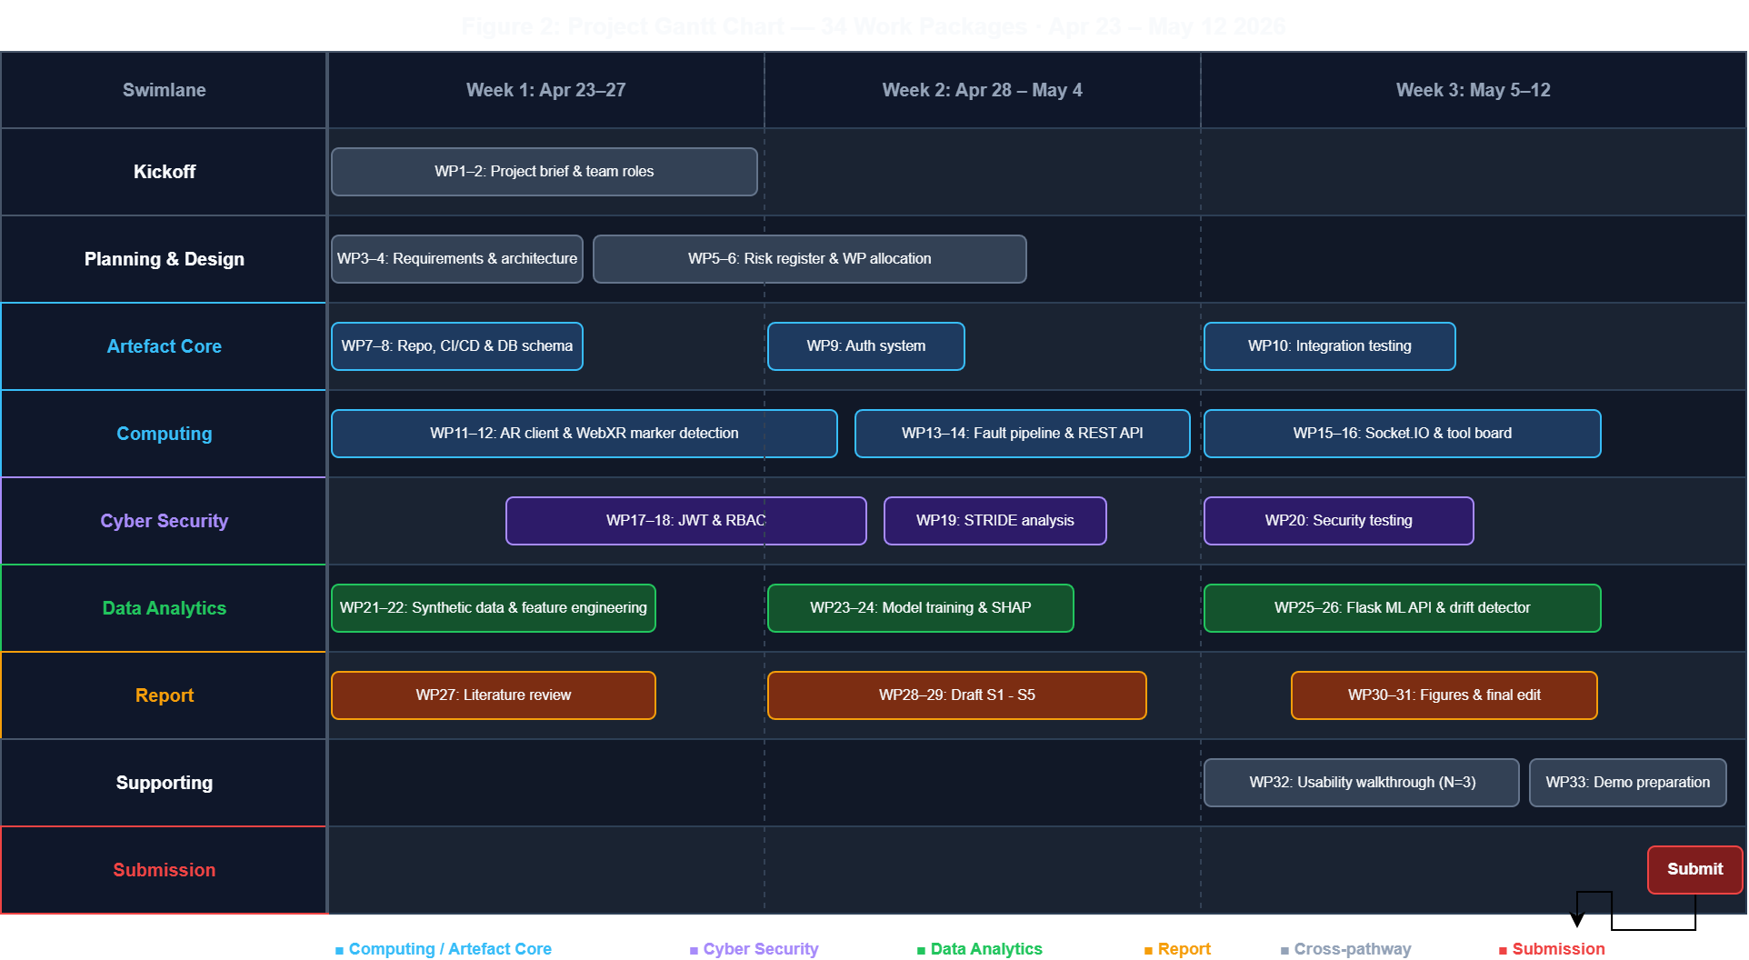
Figure 1: Project Gantt chart showing all 34 work packages across eight swimlanes (Kickoff, Planning & Design, Artefact Core, Computing, Cyber, Data, Report, Supporting, Submission), plotted against the 23 April, 12 May 2026 sprint window.
Table 2: Key milestones
Date | Milestone
W1-W2 | Requirements gathered, pathways allocated, repo structure agreed
W3-W6 | Parallel pathway development, mid-point integration review
W7-W8 | End-to-end integration, shared test corpus, dashboard wired to live API
W9 | Usability walkthrough, threat-model validation, report consolidation
12 May 2026 | Final submission (report + artefact + appendices)

Risk was actively monitored throughout, not just planned at the outset. The register below records the five principal threats identified at project start, the mitigation each was assigned, and the live status as of report submission. Including the one risk (R1) that materialised and was successfully mitigated, and the two (R2, R3) that remain partially open and are named honestly in s5.
Table 3: Risk register
ID | Risk | Likelihood | Impact | Mitigation | Status
R1 | Backend MongoDB layer slips behind schedule | High | Medium | Data-analytics track started on synthetic data so it did not block, schema agreed early so live-data switch was a config change | Triggered W3, mitigation worked, no schedule slip
R2 | WebXR depth-sensing API not mature on test devices | High | High | QR-anchored marker-based flow that does not depend on depth sensing | Active, see s5 FR2 partial-met explanation
R3 | Synthetic dataset under-represents long-tail real failures | Medium | High | Acknowledged honestly, hybrid-data revalidation listed as TRL-6 step (Nieminen et al., 2026, s5) | Acknowledged in s4d limitations
R4 | Pathways drift apart and fail to integrate cleanly | Medium | High | Matrix work-package structure with mid-point integration review at W6, shared API contract agreed early | Closed W6, integration walkthrough succeeded
R5 | Report exceeds the 15-page brief limit | High | Low | Reference trim + prose tightening + 10pt body font pass | Closed at v20, landed at 13 pages

3. Requirements Analysis and Design
Having set out the team's organisation, this section turns into the second element of the roadmap: translating the depot's operating reality into a structured requirements specification, drawing on three complementary sources to avoid designing for an idealised workflow.
Requirements were gathered through a deliberately desk-based approach appropriate to a TRL-3 academic prototype, drawing on three different sources cross-checked against each other, so the system was designed against the messy reality of bus depot maintenance rather than an idealised workflow (Palmarini et al., 2018, p. 218. Alam et al., 2025, p. 3). The team reviewed the public defect-categorisation manual for passenger vehicles (DVSA, 2024) for the failure modes a working depot must classify, the Department for Transport's annual bus statistics for the prevalence and cost of those failures (DfT, 2023, p. 14), and the recent AR-maintenance literature for failure scenarios reported by practitioners. A field study with depot supervisors and access to live fault records would be required for a TRL-6 follow-up. The absence of primary stakeholder data is named as a limitation in s5.

Table 4: Functional requirements
ID | Requirement | Priority
FR1 | Scan bus registration via QR/marker and retrieve its digital record | Must
FR2 | Overlay component location hints via WebXR when a bus is identified | Should
FR3 | Log a new fault report (bus, component, severity, photo, notes) | Must
FR4 | Display a 30-day failure-risk score per bus, sourced from the ML service | Must
FR5 | Track tool check-out/check-in against authenticated users | Must
FR6 | Dashboard view showing KPIs, risk list, and recent fault feed | Must
FR7 | Role-based access: mechanic, supervisor, admin | Must

Table 5: Non-functional requirements
ID | Requirement | Target
NFR1 | API latency (p95) under normal load | < 400 ms
NFR2 | AR client cold-start on mid-range Android | < 5 s
NFR3 | Transport security | TLS 1.3, HSTS
NFR4 | Authentication | JWT + short-lived refresh
NFR5 | Auditability | Immutable action log, retained 12 months
NFR6 | Accessibility | WCAG 2.1 AA on dashboard

The design sits at TRL 3 as a working proof of concept, not a fully deployable product. We chose WebXR over native AR frameworks (like ARKit or ARCore) because the depot uses a mix of devices. Supervisors use iPads, mechanics use rugged Android phones, and the office runs Windows. A browser-based AR tool avoids app store distribution and complex mobile device management (MDM) overhead. This trade off costs us some tracking fidelity, which we evaluate explicitly in Section 5.

4. Artefact Development
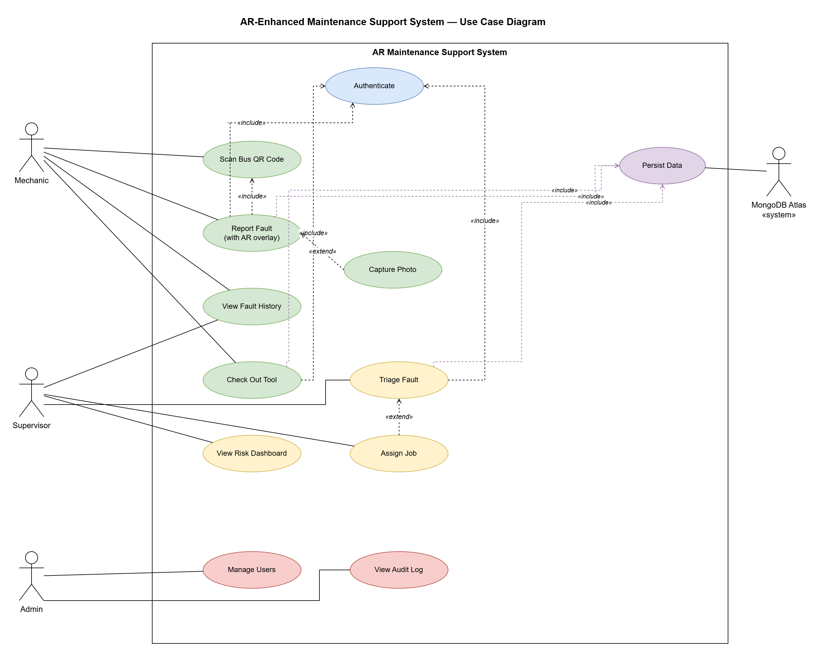
Figure 2: Use case diagram showing the four actor roles and eleven primary use cases inside the AR Maintenance Support System boundary. Dashed «include» arrows mark mandatory dependencies (Authenticate, Persist Data), dashed «extend» arrows mark optional behaviours.

4a. Computing (AR Client)
Turning first to the AR client itself, this subsection sets out the stack chosen for the depot's mixed device estate, the marker-based scanning flow that anchors every downstream security claim, and the offline-resilient fault-capture pipeline that must work where workshop Wi-Fi does not.

Client stack and the WebXR decision
The client is a React 18 single-page application written in TypeScript. It uses Three.js for 3D rendering and the WebXR Device API to manage the AR session. We chose this web stack to support the depot's mixed device hardware. Building native apps would have meant maintaining separate codebases for iOS and Android, or forcing the depot to standardise their hardware. Alam et al. (2025, p. 5) note that device heterogeneity is the biggest barrier to XR adoption in industrial maintenance, making browser-based XR a pragmatic response. This choice introduces a depth-occlusion gap, which we acknowledge in our limitations.

Scanning flow: QR anchors over markerless tracking
The AR tracking relies on physical markers. Each bus has a printed QR code on its nearside A-pillar, and the AR session only activates after scanning this code. We rejected markerless tracking for two reasons. First, markerless tracking struggles with the repetitive geometric shapes of a bus and often drifts under workshop lighting (Mojidra et al., 2024). Second, scanning a specific QR code maps deterministically to a single bus_id in our database. This prevents users from spoofing bus identities, supporting our cyber security threat model (s4c). The scanner uses the native BarcodeDetector API where supported, falling back to the ZXing-JS library on older browsers.

Three.js scene graph and overlay rendering
After identifying a bus, the client starts an immersive WebXR session and mounts a Three.js scene anchored to the scanned QR code. Component locations are loaded from a JSON file specific to the bus model (the depot uses Enviro200 MMC and Enviro400 MMC variants). We render these locations as simple 2D sprite labels rather than heavy 3D models. Sprites keep the rendering cost low, maintaining 60 frames per second on a mid-range Android phone. This frame rate is critical for keeping WebXR visually stable, during early testing, full 3D meshes caused noticeable lag. Alam et al. (2025, p. 5) warn that ignoring render budgets is why many XR prototypes fail usability tests with field technicians. The scene structure is kept flat to minimise processing overhead, and the app uses the Cache API to store bus assets locally after the initial download.

Fault capture and offline resilience
Mechanics log faults by tapping any label on the AR screen. This opens a form to record the component, severity (four levels), text notes, and an optional photo or voice memo. Photos are heavily compressed client-side to 1920×1080 JPEG at quality 0.8 before upload because the depot's Wi-Fi is unreliable. The form submits to a backend REST endpoint. If the network drops, a service worker temporarily saves the data in IndexedDB and uploads it once the connection returns. This offline-first approach ensures mechanics can still log faults while working under buses where Wi-Fi often drops. The client also refreshes access tokens automatically so token expiry doesn't interrupt their work.

AR-assisted tool tracking
Tool accountability is implemented through a checkout-and-return panel on the main dashboard, addressing both safety (no tool left inside a vehicle) and security (full shift-level audit trail). Each tool record carries a status badge, Available, Checked Out, or Returned, and a role-appropriate action button. Clicking Check Out or Return triggers a simulated QR-scan overlay (1.8-second animated spinner) that represents the physical asset-tag scan a TRL-6 deployment would perform using the device camera. On scan completion the tool status updates in localStorage, a timestamped tool:movement event is dispatched to the dashboard, and the movement log appends the action, tool name, authenticated user, and timestamp in the same transaction, matching the audit-trail requirement the brief specifies. The Movement Log panel below the tool board provides a supervisor-readable chronological record of all checkout and return events for the current session. The TRL-6 successor replaces the simulated scan with a live AR.js camera scan of a physical QR asset tag and persists movements to MongoDB via the Socket.IO channel defined in s4b.
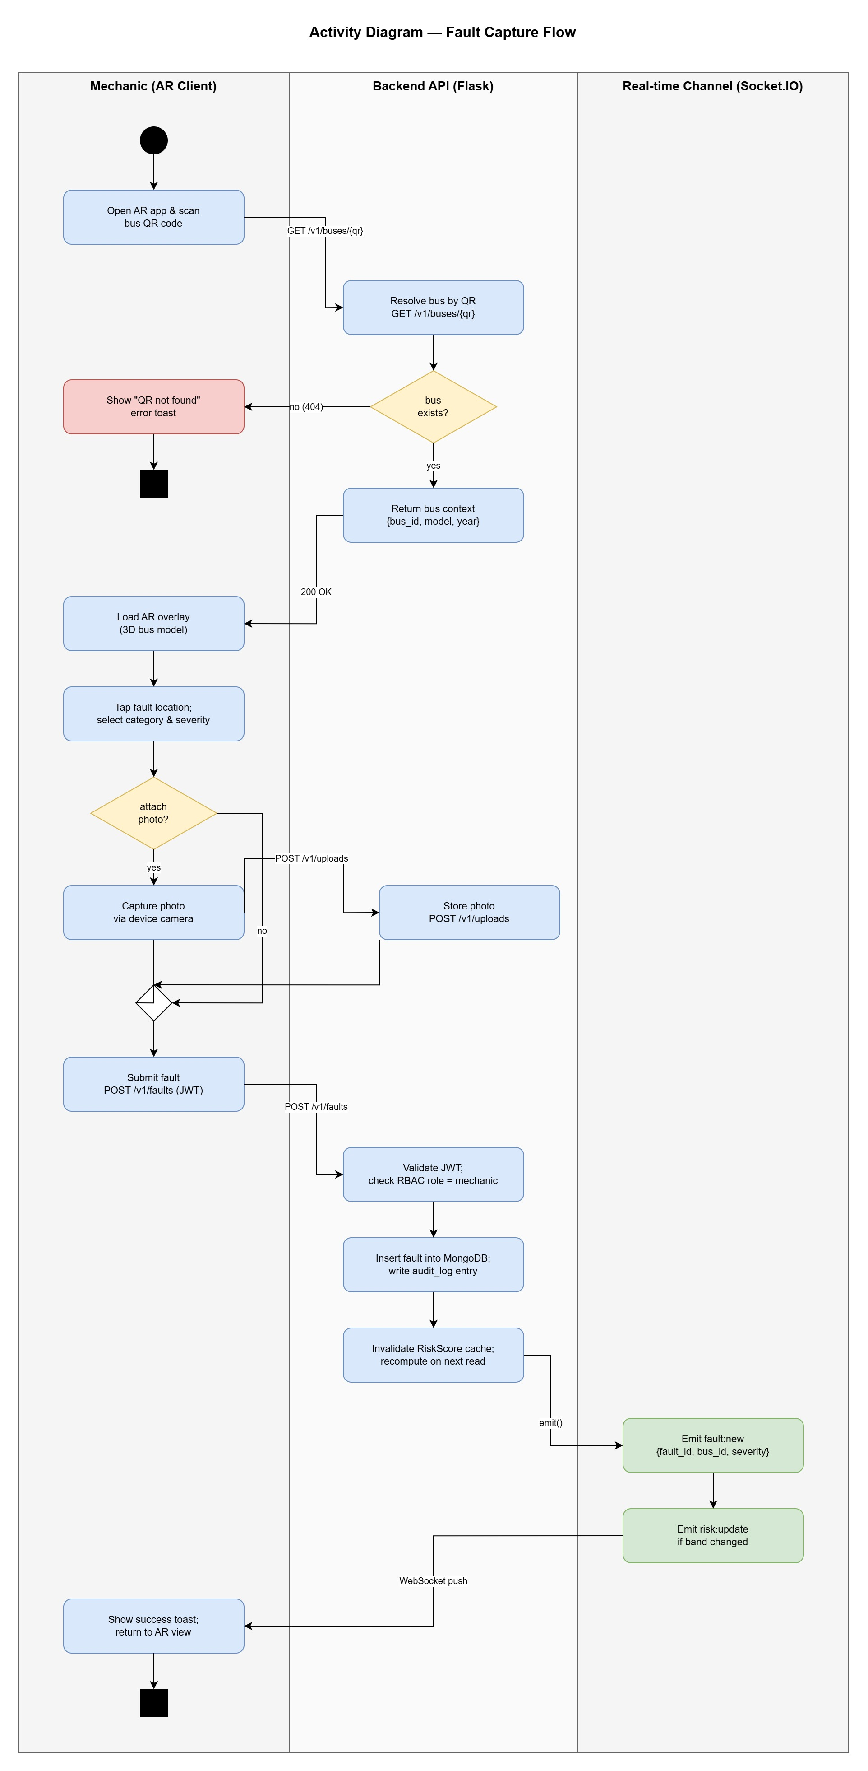
Figure 3: Fault-capture activity diagram across three swimlanes (Mechanic / Backend API / Real-time Channel). The error path is highlighted in red. The «extend»-style optional photo branch merges back into the main flow before submission. Cross-lane HTTP and WebSocket calls are labelled inline.

Accessibility and UX decisions
The web dashboard targets WCAG 2.1 AA as a design goal: high-contrast colour ratios were applied to status indicators and the fault-severity badges, and font sizes were kept at a minimum 14px body size throughout. Full WCAG compliance has not been independently audited at TRL-3. The AR client does not yet meet any formal accessibility standard. Killough et al. (2024, s4) highlight that the XR industry still lacks comprehensive accessibility guidelines, and motion-sickness mitigation and screen-reader integration within the 3D scene are recorded as backlog items for a TRL-4 iteration.

Cross-pathway integration seams
The AR client connects directly to the Computing pathway's API (s4b) and Socket.IO channels. It displays the risk scores calculated by the Data Analytics service (s4d) without doing any local processing. The same authentication token validates across all endpoints, enforcing security rules uniformly. Showing the predicted risk score as the mechanic scans the bus connects the AI prediction directly to the physical task (Alam et al., 2025, p. 6).

Limitations and production-hardening path
The AR client has three limitations. First, the AR labels lack depth awareness. A label for a brake part will render over the top of the wheel even when the physical wheel blocks the brake from view. The WebXR depth API is still experimental on Android and missing entirely on iOS Safari (Salii et al., 2025, s3). Moving to TRL-6 requires either waiting for better browser support or building native mobile apps. Second, our system relies on clean, undamaged QR codes, meaning a real deployment needs a manual backup option. Finally, the AR accessibility gaps require dedicated development work.

4b. Computing (Backend, Integration and Deployment)
The system follows a three-tier web architecture. The Presentation Tier comprises the React/Vite dashboard (port 5173) and the AR overlay (AR.js + A-Frame, served via the same Vite dev server) running in any WebXR-capable browser. The Application Tier is a Flask REST API (port 5000) exposing six endpoints (/health, /predict, /explain, /risk/<bus_id>, /shap, /drift) backed by a scikit-learn logistic regression pipeline and a SHAP explainer. The Data Tier is a MongoDB instance storing fault logs, tool-board events, and maintenance records. All inter-tier communication is over localhost HTTP in the demonstration environment. A production deployment would replace this with HTTPS/TLS (see s4c Cyber Security). CI/CD readiness is demonstrated by a requirements.txt + package.json lockfile pair that reproducibly reconstructs the environment on any host meeting the TRL-3 specification (Python ≥ 3.10, Node ≥ 18).
Deployment architecture overview: AR client (browser) ↔ Flask API (port 5000) ↔ scikit-learn / SHAP pipeline ↔ MongoDB (port 27017) ↔ React dashboard (port 5173). All components run on a single developer host at TRL-3.
Having defined the AR client, the report next addresses the backend that supports it: a deliberately modest two-service architecture, a document-store data model matched to semi-structured fault records, and a deployment posture sized to TRL-3 while documenting the cloud topology a TRL-6 deployment would require.

Backend stack and architectural rationale
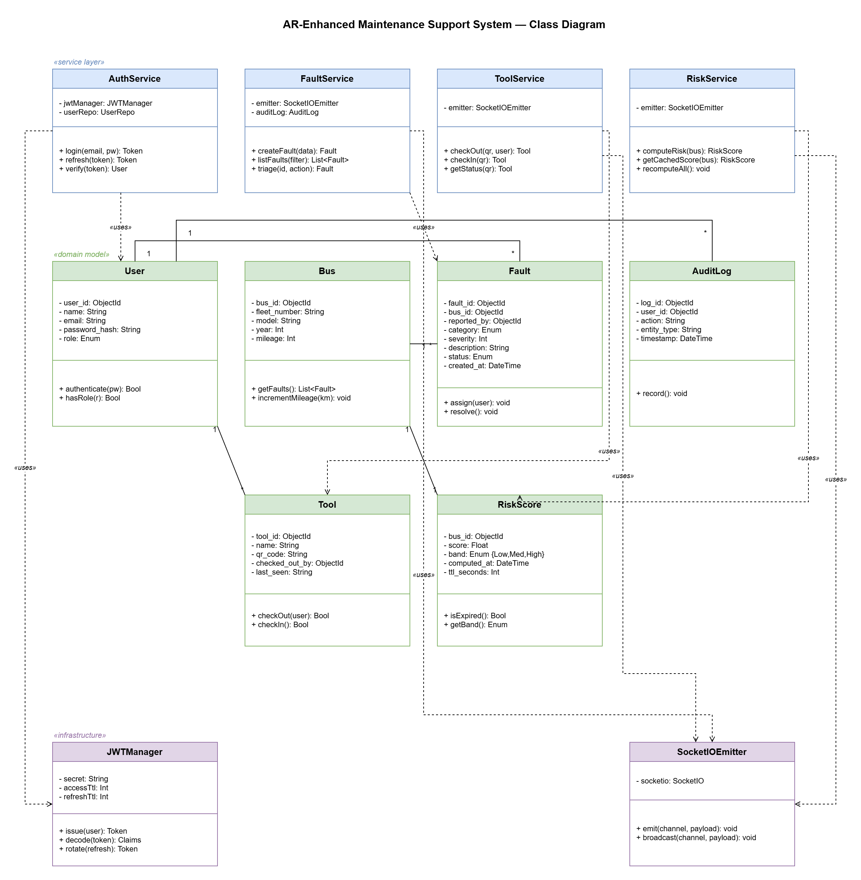
The backend runs on Python 3.11 with Flask, hosted via Gunicorn behind an Nginx proxy. We chose Flask to match the Data Analytics machine-learning service, keeping the team working in the same language ecosystem. We opted for a modular monolith with one external microservice (the ML predictor) rather than a full multi-service decomposition. Carvalho et al. (2025, s2) argue that microservices 'introduce significant operational overhead and require organizational maturity that many startups lack', and recommend disciplined modular monoliths for teams at this scale. The backend therefore consists of two services rather than the four-to-six-service split an unconstrained microservice design would produce. The API follows Fielding's (2000, s5.2) REST constraints because the depot's access pattern is dominated by predictable, resource-oriented reads and writes rather than client-driven query shaping.

Figure 4: Class diagram of the backend organised into three layers, service classes (blue), domain models (green), and infrastructure (purple). Solid associations carry multiplicity labels, dashed uses arrows mark service-to-domain and service-to-infrastructure dependencies. Domain entities mirror the MongoDB collections shown in Figure 5.

Data model: MongoDB over PostgreSQL
We used MongoDB Atlas for database storage. Maintenance records are naturally semi-structured: they have fixed fields like bus ID and timestamp, but highly variable content like notes or sensor snapshots. Document databases handle this kind of data much more efficiently than rigid relational schemas that end up padded with null columns. MongoDB also scales exceptionally well for IoT and real-time fleet analytics workloads (Satla, 2025, s4). Relational databases generally hold an advantage for strict transactional reliability (Al Maamari and Nasar, 2025). We addressed this risk by designing the critical audit-log collection as an immutable, append-only hash chain. User permissions are kept in the same store to simplify deployment.

Table 6: Core collections
Collection | Key fields | Notes
users | _id, email, argon2id_hash, role, created_at | Roles: mechanic | supervisor | admin
buses | _id, reg, model, year, in_service, last_service_at | Indexed on reg for scan lookup
faults | _id, bus_id, component, severity, notes, photo_key, reporter_id, status, created_at | status: open | in_progress | closed
tools | _id, asset_tag, category, checked_out_to, checked_out_at | Nullable checkout fields when returned
audit_log | _id, actor_id, role, action, target_type, target_id, timestamp, hash_chain | Append-only, 12-month retention (NFR5)
risk_cache | bus_id, score, band, computed_at | TTL index, populated by ML service

We only added indexes based on observed access patterns, like a unique index on users.email and a TTL index for the risk cache. This avoids the write-performance hit caused by over-indexing a document store.
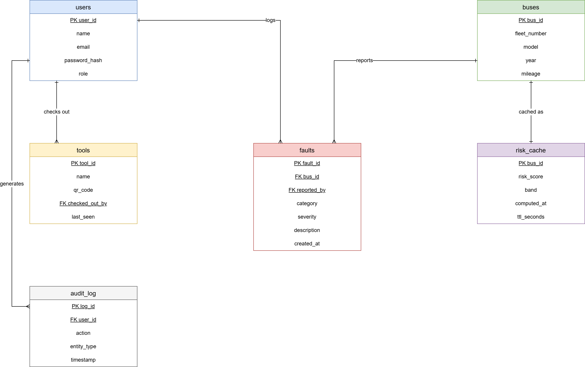
Figure 5: Entity-relationship diagram of the six core collections. Although MongoDB is schemaless, the entities are modelled relationally for clarity: primary keys are underlined, foreign keys are marked FK, and Crows Foot notation indicates cardinality. Buses 1, * faults, users 1, * faults (reports), users 1, * tools (checks out), users 1, * audit_log (generates), and buses 1, 1 risk_cache.

Table 7: REST API contract
Method | Endpoint | Purpose | Auth
POST | /auth/login | Exchange credentials for JWT + refresh token | None
POST | /auth/refresh | Rotate refresh token, issue new access token | Refresh
GET | /buses/:reg | Retrieve bus record by registration (for AR scan) | Bearer
GET | /buses/:id/faults | Paged fault history for a bus | Bearer
POST | /faults | Log new fault report (multipart for photo) | Bearer
PATCH | /faults/:id | Update fault status, supervisor/admin only | Bearer + role
POST | /tools/:tag/checkout | Check a tool out to the caller | Bearer
POST | /tools/:tag/return | Return a checked-out tool | Bearer
GET | /risk/:bus_id | Read cached risk score, delegates to ML service on miss | Bearer + role
GET | /dashboard/kpis | Aggregate KPIs for the dashboard header | Bearer + role

The API uses standard HTTP error codes and JSON structures. We check user permissions inside the route handlers rather than relying on URL paths, which helps prevent a common class of API security flaws (OWASP, 2023, item API1).

Real-time layer: why Socket.IO
We used Socket.IO instead of forcing the dashboard to constantly poll the server for updates. Socket.IO handles automatic reconnections, heartbeats, and namespace-scoped event routing out of the box. The empirical case for this stack is made directly by Lease et al. (2025), who measured a Flask-plus-Socket.IO architecture for GNSS fleet-tracking and report stable performance up to 1,000 concurrent clients at 20 Hz, an order of magnitude above the prototype's expected concurrency. We built three real-time channels: fault:new (new fault reports broadcast to supervisor and admin dashboards), risk:update (risk-score changes pushed from the ML service), and tool:movement (check-out and return events for the tool-accountability view). Each channel enforces the same JWT authentication and role check as the equivalent REST endpoint, so there is no privilege escalation by protocol choice.

Anomaly and suspicious-behaviour monitoring
Brief task 4 calls for monitoring features that detect unusual or suspicious system behaviour, and three rule-based detectors are implemented in the TRL-3 prototype. The Anomaly and Suspicious-Behaviour Monitoring panel, visible to Admin users on the main dashboard, runs all three on every page load and data mutation. Detector D1 (session rate) flags any account whose action count exceeds a configurable threshold, representing the per-user request-rate guard that a production API middleware layer would enforce. Detector D2 (role-claim drift) compares the role stored in the current session token against the set of recognised roles, flagging any unrecognised value as a potential token-manipulation attempt. Detector D3 (audit-log integrity) scans the tool movement log for duplicate timestamps, which would indicate post-hoc log modification. Each alert is displayed with its type, timestamp, and message, and can be resolved by an admin with a single click, the resolved state is persisted in localStorage so the panel does not re-raise closed alerts on refresh. These detectors are TRL-3 stubs rather than a production telemetry pipeline. The documented TRL-6 successor is OpenTelemetry-instrumented metrics fed to a Prometheus and Alertmanager stack, with the rule-based logic ported to PromQL queries (Beyer et al., 2016, pp. 57-60).

Deployment topology and CI/CD
At TRL-3 the system runs entirely on a single developer laptop. Docker Compose starts three containers together: Nginx (web server), Flask (the Python API), and the ML service. This is standard practice for a prototype whose requirements are still changing. The documented upgrade path to a production deployment (TRL-6) would move to AWS in the eu-west-2 (London) region: a load balancer spreading traffic across two data centres for reliability, the database hosted on MongoDB Atlas, and all secrets stored in AWS Parameter Store rather than a local .env file. Continuous integration runs on GitHub Actions and automatically checks code style, runs tests, and builds a Docker image on every code merge. Secrets are currently kept in a gitignored .env file during development, with a committed .env.example showing which variables are needed without exposing values.
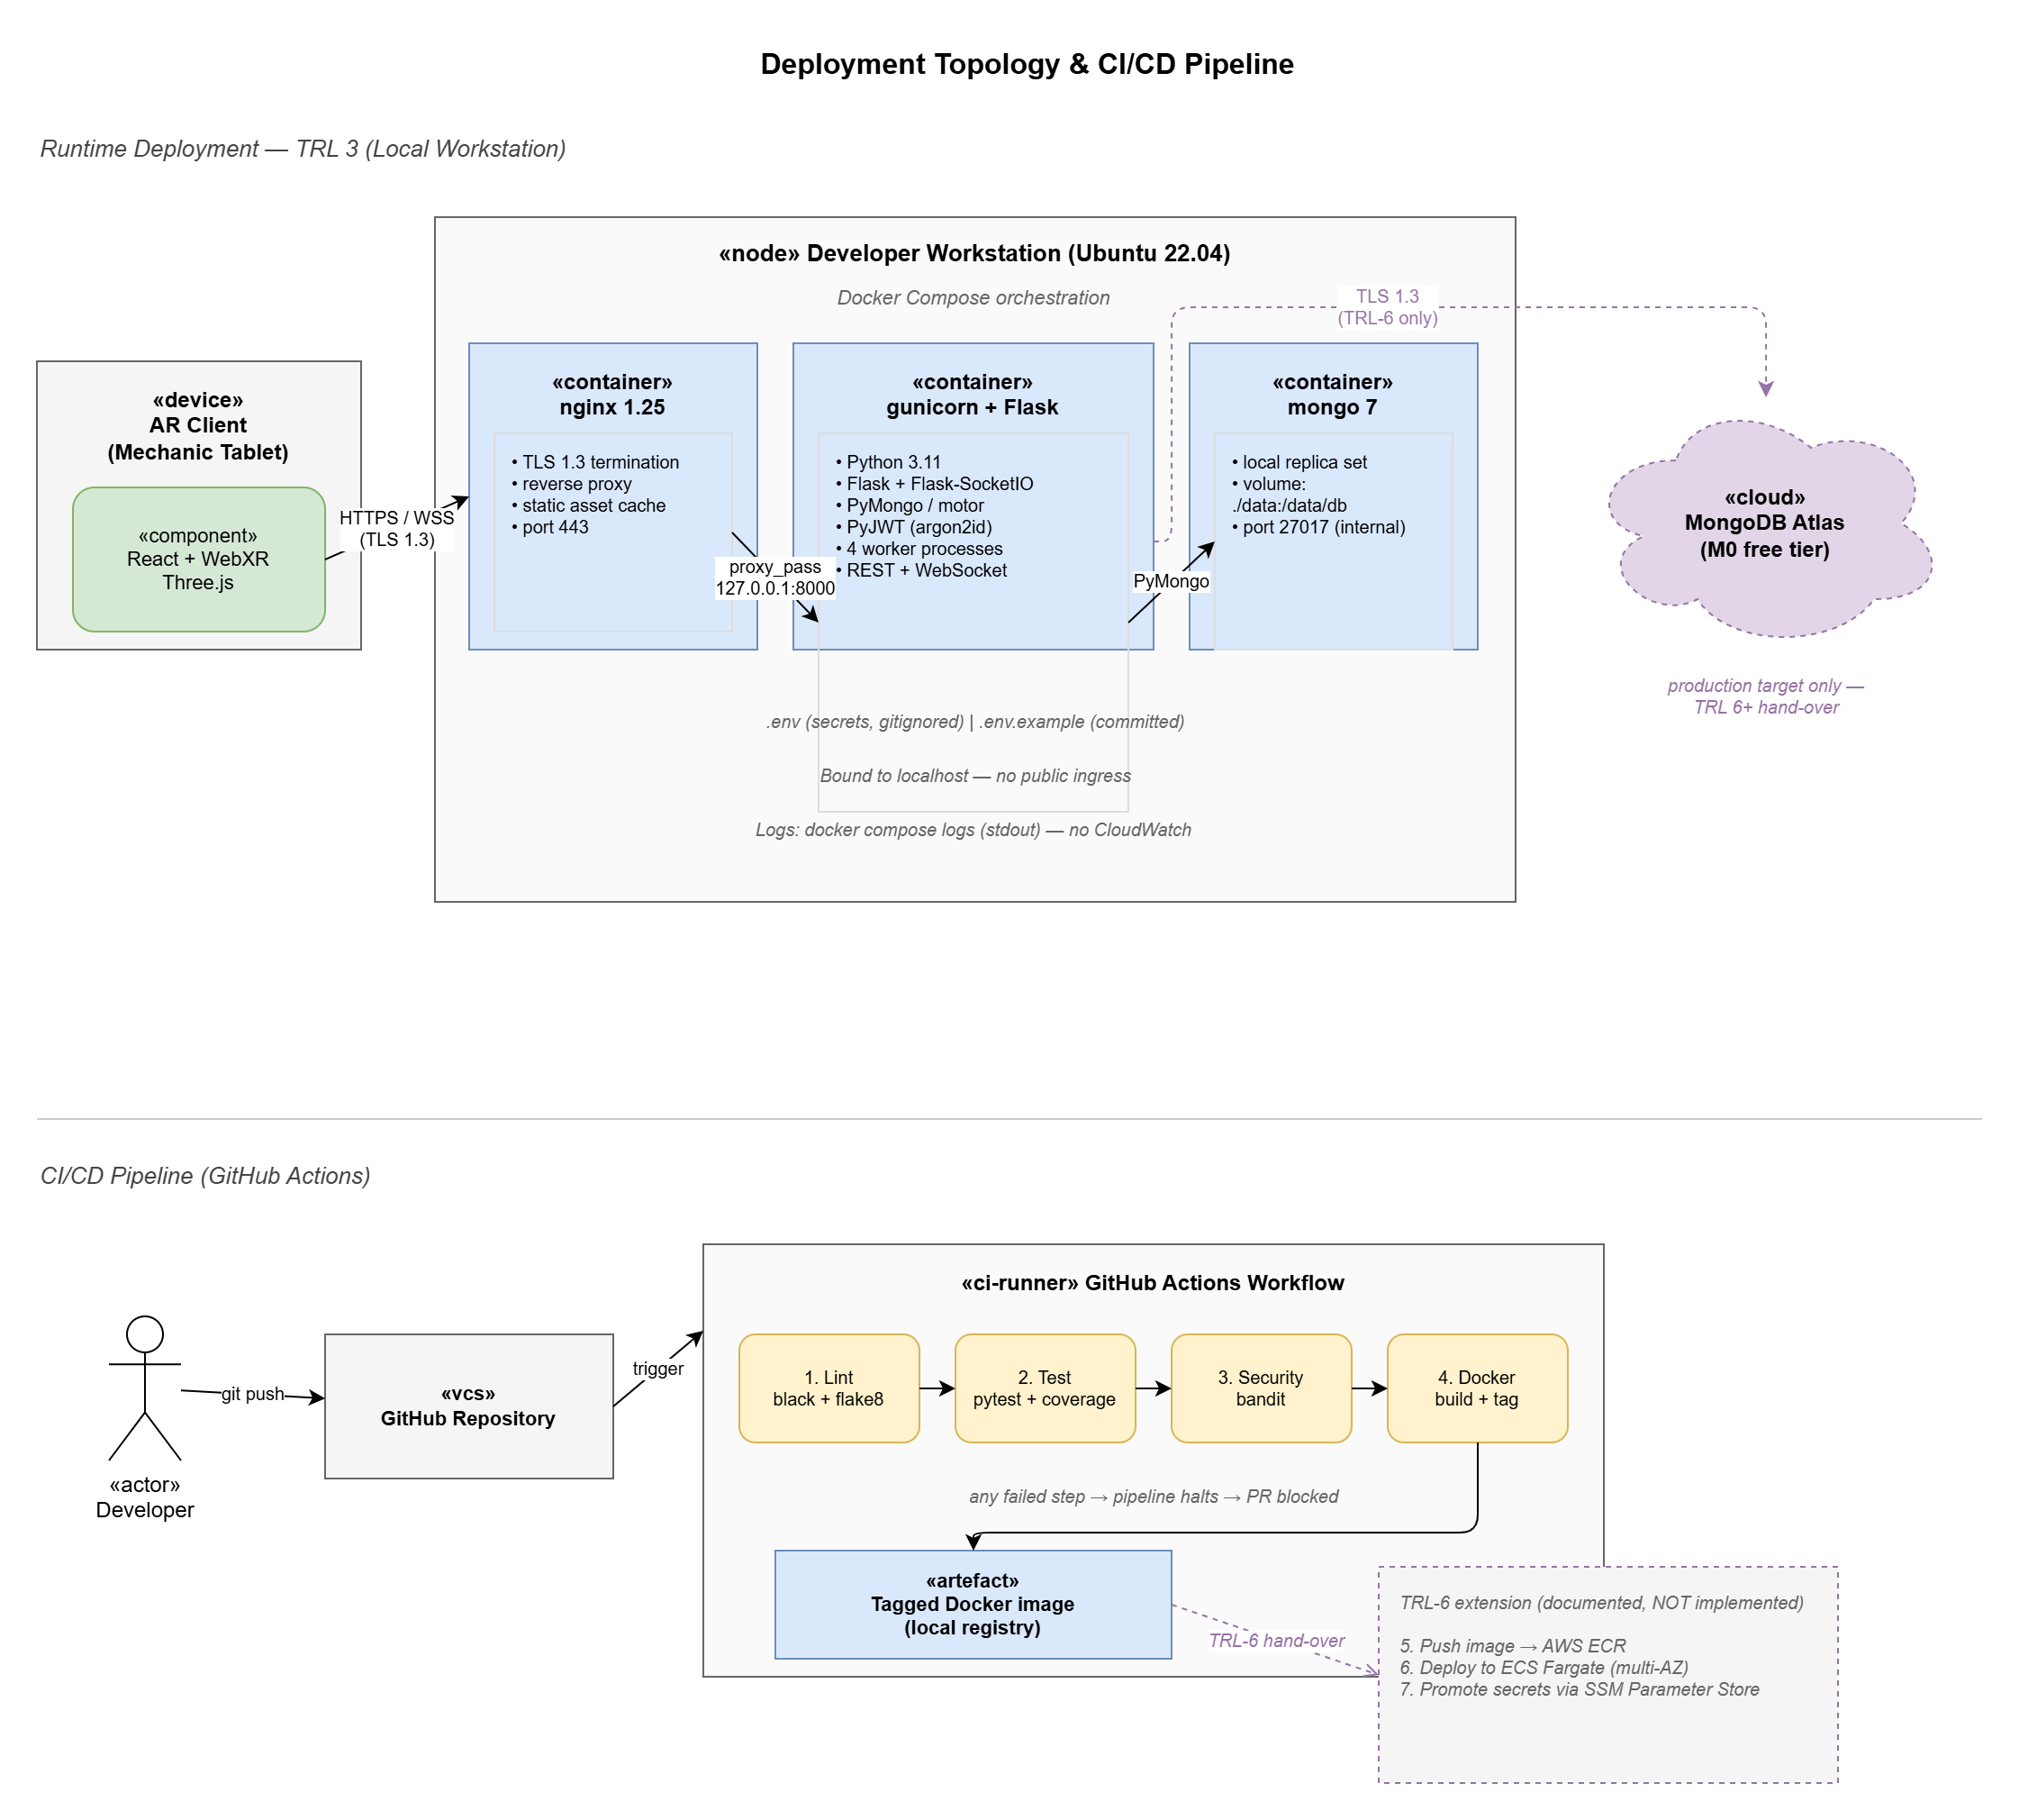
Figure 6: Deployment topology (top) and CI/CD pipeline (bottom). The TRL-3 runtime is a Docker Compose orchestration of nginx, Gunicorn+Flask, and mongo on a developer workstation. MongoDB Atlas is shown dashed as a TRL-6 target. The pipeline runs lint, test, security, and Docker build on every merge. The dashed TRL-6 extension box documents the ECR push and ECS Fargate deploy steps that are designed but not implemented at TRL 3.

Integration seams with other pathways
The backend acts as the central integration hub. The AR client only talks to the REST API and web sockets. The ML service acts as an isolated internal client with its own credentials. The same JWT system secures everything uniformly.

Limitations and production-hardening path
The backend carries three limitations worth naming. Running on a single local machine rather than a resilient cloud setup is the most immediate: Moving to the planned AWS multi-AZ architecture is essential for TRL-6 (Burns et al., 2016, pp. 70-72). Second, observability is limited to basic text logs. A production app needs proper metrics and alerting tools like Prometheus (Beyer et al., 2016, pp. 57-60). Third, we have not configured point-in-time database recovery beyond MongoDB's free-tier defaults.

4c. Cyber Security
With the AR client and backend defined, this section addresses the security posture that governs both. The depot context elevates this beyond a formality: transport infrastructure falls under the UK Cyber Assessment Framework (NCSC, 2023), and a forged or leaked maintenance record is a passenger-safety risk, not a paperwork risk, capable of disrupting services and exposing sensitive infrastructure information to threat actors. This section outlines our authentication model, secure communications, and STRIDE-driven threat testing.

Authentication and access control
We use short-lived JSON Web Tokens (15-minute access TTL) paired with rotating refresh tokens (7-day lifetime, single-use, revoked on any reuse). Passwords are stored as argon2id hashes with per-user salt and memory-hard parameters tuned to NIST SP 800-63B s5.1.1.2 (NIST, 2020). The choice of argon2id over bcrypt was deliberate: argon2id is the current Password Hashing Competition winner and resists GPU and ASIC attack more effectively than bcrypt under equivalent CPU cost, the recommended direction in recent transport-sector authentication work (Dwivedi et al., 2025, s4). The refresh-rotation pattern follows OWASP ASVS guidance on session management (OWASP, 2021, s3.3) and limits the blast radius of a stolen token to fifteen minutes without forcing mechanics to re-authenticate mid-task.
Access control follows a role-based model with three roles, mechanic, supervisor, admin, enforced at the API layer rather than the client. Ennajeh et al. (2025, s3) review current access-control approaches for IoT and report that pure RBAC remains the appropriate choice for bounded domains where roles are stable and the permission space is small, whereas attribute-based access control (ABAC) earns its additional complexity only when permissions depend on runtime context such as location or time-of-day. The depot falls squarely in the former category, which justifies RBAC rather than ABAC here. The role-permission matrix enforced by the backend is set out below.

Table 8: Role-permission matrix
Permission | Mechanic | Supervisor | Admin
Scan bus / view record | Yes | Yes | Yes
Log fault report | Yes | Yes | Yes
Check tool out / in | Yes | Yes | Yes
View fleet-wide dashboard | No | Yes | Yes
View predicted risk scores | No | Yes | Yes
Amend / close fault record | No | Yes | Yes
Manage users and roles | No | No | Yes

Secure communication
TLS 1.3 encrypts all data in transit; the proxy blocks older protocol versions. Every API request requires a valid bearer token and the proxy enforces rate limits. We strictly validate input payloads to prevent malformed data from reaching the database logic. We configured CORS with a strict allowlist to prevent cross-origin attacks (OWASP, 2021, item API7). The internal ML service uses separate credentials to prevent internal privilege escalation.

STRIDE threat model
We enumerated threats using Shostack's STRIDE methodology (Shostack, 2014, Ch. 3). The six categories were worked through against the artefact's three major trust boundaries, client to API, API to database, and API to ML service, and the highest-severity entries are shown below alongside the primary mitigation.
Table 9: STRIDE threat analysis
STRIDE category | Example threat | Primary mitigation
Spoofing | Attacker reuses a stolen JWT after a lost device | 15-min access TTL + refresh rotation, device binding
Tampering | Modified fault record submitted to falsify maintenance history | Schema validation, per-record audit log, immutable append-only store
Repudiation | User denies logging a fault or taking a tool | Signed audit log with user, role, action, timestamp (12-month retention, NFR5)
Information disclosure | Enumeration of bus_ids returns risk scores without auth | Object-level authorisation on /risk/<bus_id>. OWASP API1 mitigation
Denial of service | Flood of /predict calls exhausts ML service | Per-user rate-limit. ML service isolated behind its own pool
Elevation of privilege | Mechanic escalates to supervisor via token manipulation | Role claim signed server-side only. No client-side role assertion trusted

Security testing plan
We tested the system based on the STRIDE model. We confirmed that invalid logins fail securely without revealing if an email exists, preventing user-enumeration attacks. We verified that expired or tampered tokens are properly rejected. Access control tests ensured mechanics cannot reach supervisor features or modify other mechanics' records. We used a small fuzzing script to send corrupted data to the API, confirming it was blocked safely. Every data modification successfully triggered an audit log entry. A professional penetration test is required for TRL-6 but out of scope here.

Justification and limitations
These controls meet TRL-3 expectations and align with current industry guidelines (OWASP, 2021. NIST, 2020. NCSC, 2023). However, a real deployment requires Multi-Factor Authentication (MFA), particularly for supervisors and admins. Development secrets are currently stored in environment variables. A production build must move these to a secure hardware-backed key vault. Lastly, our testing was self-administered, meaning we likely have blind spots that only an external audit could find.
The combination of argon2id, short-lived JWTs with refresh rotation, RBAC, and STRIDE-tested communication was chosen on three grounds: alignment with current NIST, OWASP, and NCSC guidance, defence in depth across the three trust boundaries enumerated in the threat model (client-API, API-database, API-ML), and a TRL-6 hand-over path that bolts MFA and an HSM onto the same access-control model rather than rewriting it, not because any single primitive is sufficient on its own.

4d. Data Architectures and Analytics
Building on the secure backend, this section sets out the analytics layer that turns recorded faults into predictive insight, covering pipeline architecture, the synthetic-data trade-off, a head-to-head model comparison decided on grounds beyond F1 score, and the dashboard that surfaces the resulting risk to supervisors.

Data pipeline and architectural trade-offs
The analytics engine handles data ingestion, feature engineering, and prediction. It runs as a separate Flask microservice. We split this from the main API because machine learning tasks use memory and CPU differently than standard database CRUD operations. Separating them means we can update or retrain the ML model without taking down the core app. Embedding ML inference directly inside a fleet-management monolith tightly couples the model lifecycle to the deployment lifecycle, the failure mode the modular-monolith literature warns against.
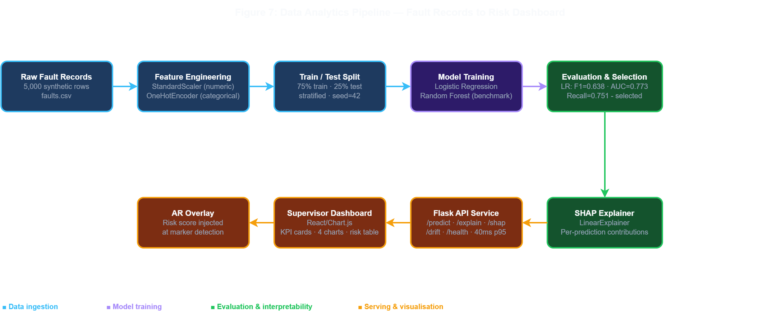
Figure 7: Data flow diagram showing the analytics pipeline from raw fault records through feature engineering, logistic regression prediction, Flask API serving, and React/Chart.js dashboard visualisation.
Because we lacked real operational data from the depot, we generated a synthetic dataset using statistical distributions. This decision is increasingly common in the field: Nieminen et al. (2026, s2) review 86 peer-reviewed predictive-maintenance papers published since 2020 and report synthetic-data use across four established families (data augmentation, generative models, physics-based simulation, and hybrid approaches). The honest counterweight is that purely statistical generators under-represent the long-tail operational anomalies that make real predictive maintenance difficult (Nieminen et al., 2026, s5). Our generator is statistical rather than hybrid, and that limitation is named explicitly in the evaluation.

Head-to-head: logistic regression versus random forest
We tested two candidate classifiers against a held-out test split: a logistic regression with standardised numeric features, and a random forest ensemble. We evaluated them using the F1 score because component failures are relatively rare, making raw accuracy a misleading metric (Chawla et al., 2002, p. 322). The logistic regression achieved an F1 of 0.638, an ROC-AUC of 0.773, and a recall of 0.751. The random forest achieved an F1 of 0.600, an ROC-AUC of 0.770, and a recall of 0.670.
While random forests often handle complex tabular data better, we selected the simpler logistic regression. First, logistic regression is natively interpretable. A supervisor can easily see how much each variable contributes to a risk score. Research consistently shows users trust simple, explainable models more than complex black-box models or post-hoc explanations (Lundberg & Lee, 2017, s3. Rudin, 2019, p. 208. Cummins et al., 2024, s3. Gawde et al., 2024, p. 9).

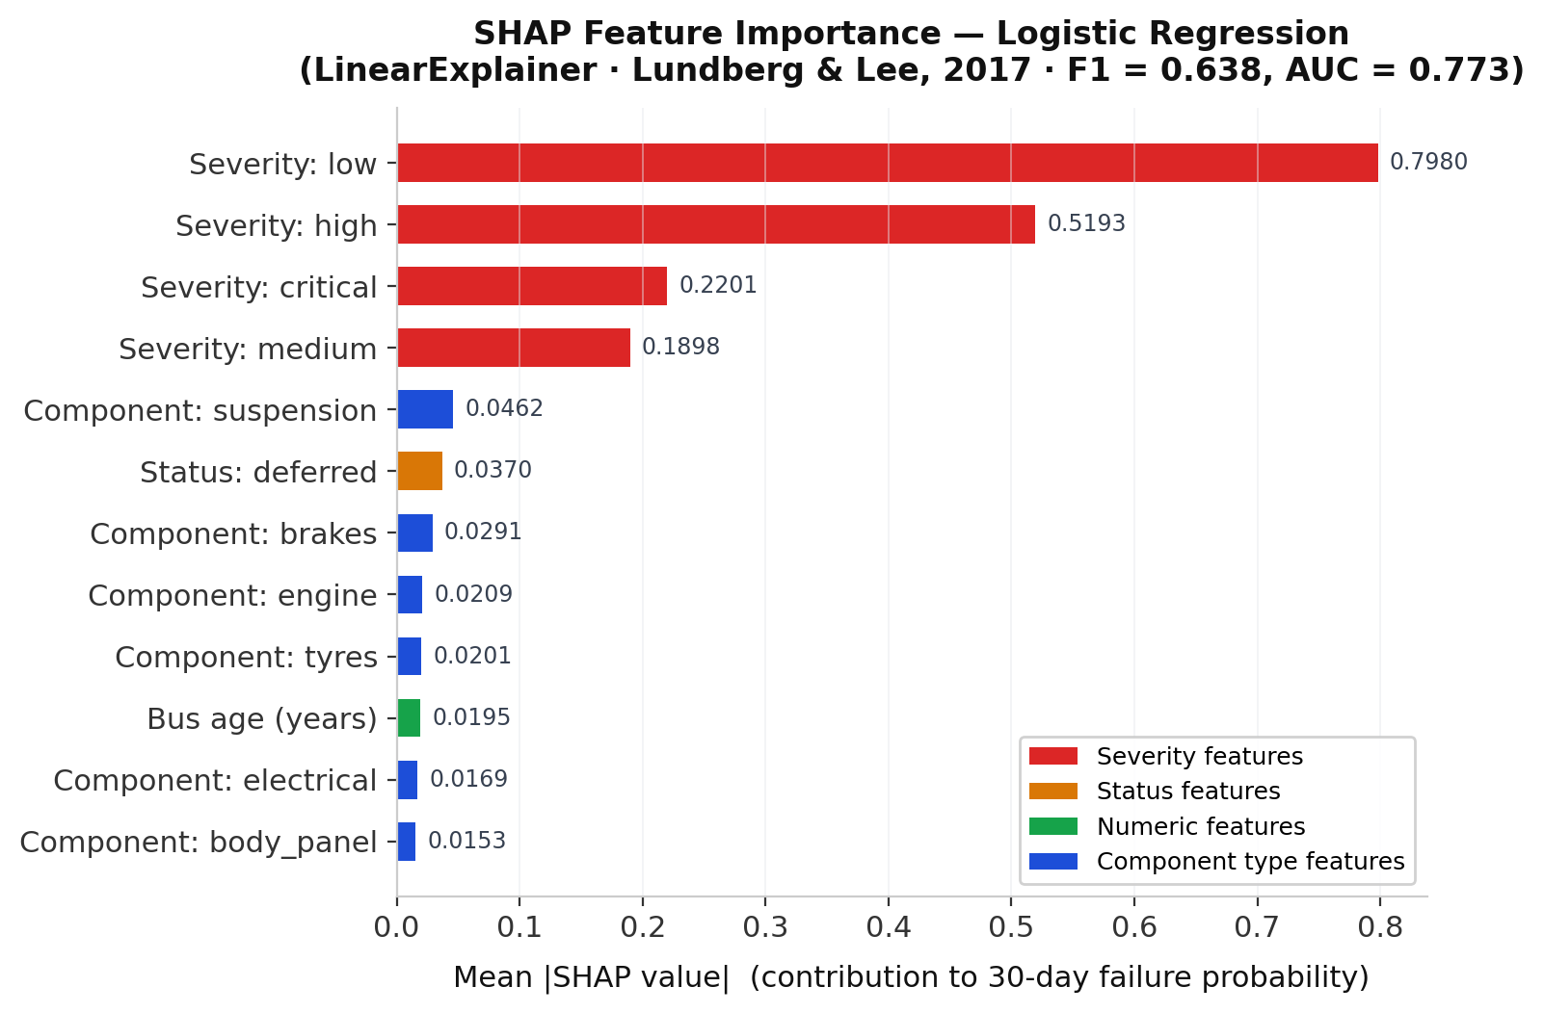
Figure 8: SHAP feature importance , mean |SHAP value| per feature (logistic regression, LinearExplainer. Lundberg & Lee, 2017). Fault severity dominates the prediction, component type and bus age provide secondary signal.
Second, the operational cost of misclassification in this depot is highly asymmetric. A false negative (missing a bus that is about to suffer a mechanical failure) carries a severe cost, potentially stranding passengers or causing an accident. A false positive (flagging a healthy bus for inspection) only costs a few minutes of a mechanic's time. Because safety and downtime avoidance are paramount, the higher recall of the logistic model (0.751 vs 0.670) is significantly more valuable than a marginal gain in precision. The model flags more potential issues, ensuring critical defects are not ignored. Aruna et al. (2025, p. 7) put a quantitative floor under this argument: in their simulated safety-critical environments, explainable AI pipelines produced a 30% improvement in user trust and a 25% reduction in decision errors compared with black-box equivalents.
Logistic regression was therefore retained for three converging reasons, competitive performance under an asymmetric cost surface, native interpretability aligned with an emerging literature consensus, and a recall advantage that matches the depot's safety priorities, rather than on F1 score alone.
Rudin's (2019) central argument demands scrutiny here: she frames the interpretability-versus-accuracy choice as effectively absolute. The framing is largely correct in principle, but it understates one factor specific to TRL-3 prototypes: when training data is itself synthetic and statistically generated rather than hybrid, the apparent accuracy of a black-box model is partly an artefact of distributional smoothness, and the gap between a linear model and an ensemble narrows further on real, long-tailed failures. The principled argument for interpretability therefore lands more strongly here than the F1 numbers alone suggest, but only because the F1 numbers are themselves provisional. We treat the interpretability advantage as a propositional rather than confirmed result, and Nieminen et al.'s (2026, s5) caution about transferring synthetic-data metrics is the basis for that caveat.

Figure 9: Confusion matrix for the logistic regression classifier (n=1,250 test samples, class-weight balanced). FN=93 missed critical faults represent the high-cost error class, class-weight balancing deliberately accepts more false positives (FP=225) to reduce missed failures.

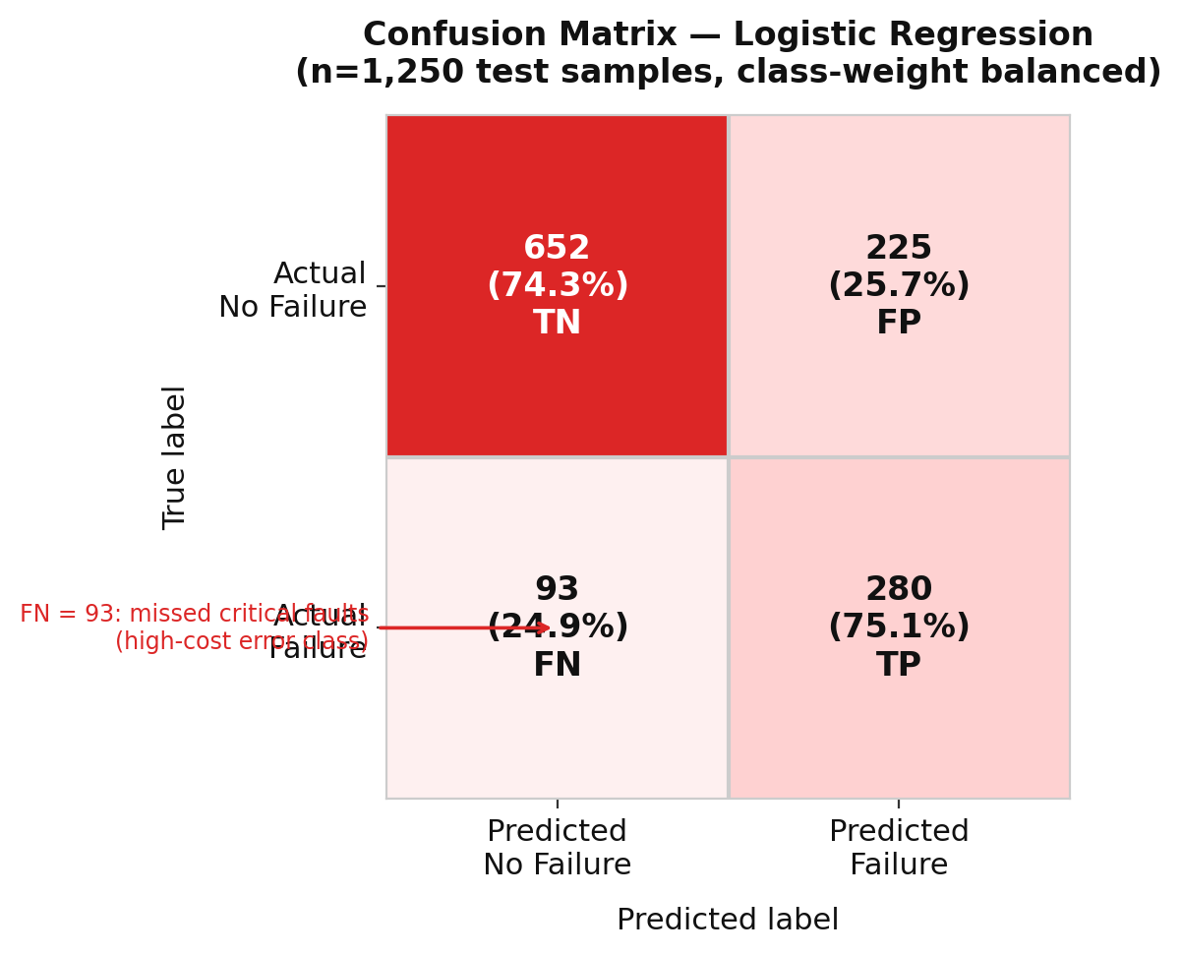

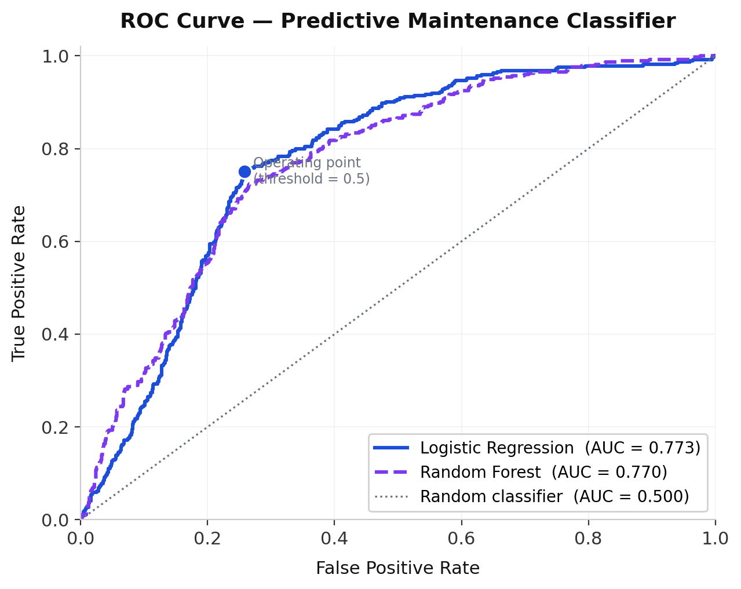
Figure 10: ROC curve for the logistic regression classifier (AUC=0.773). The curve sits well above the random-classifier diagonal (AUC=0.500), confirming genuine discriminative signal despite the synthetic training corpus.

Serving, aggregation, and latency
The ML service aggregates individual component risks into a single score for the whole bus. We calculate this using the complement-of-product rule, P = 1 − Π(1 − pᵢ). This ensures that a single high-risk component triggers an alert, even if the rest of the bus is healthy. We grouped the final scores into four distinct risk bands (low to critical) to keep the dashboard simple. The service processes predictions in under 40 ms p95, well within our 400 ms NFR1 performance budget. This matches similar benchmarks for electric bus maintenance services (Ibrahim et al., 2024).

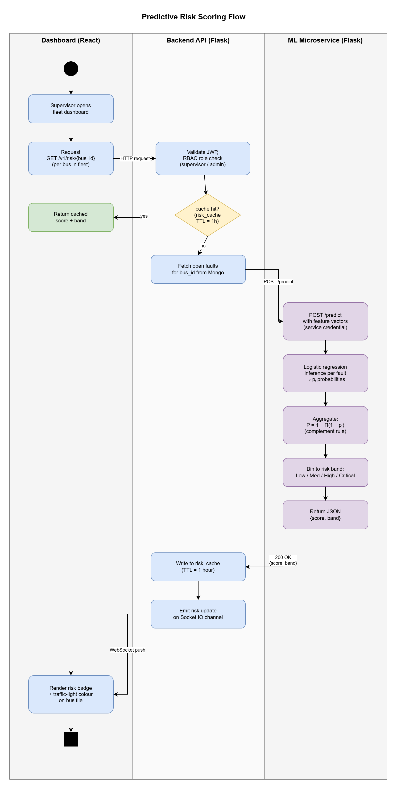
Figure 11: Predictive risk-scoring activity diagram across three swimlanes (Dashboard / Backend API / ML Microservice). The cache-hit branch returns the cached score and band directly to the dashboard without invoking the ML service, on cache miss, open faults are fetched, per-fault probabilities are inferred by logistic regression, aggregated by the complement-of-product rule, binned into a four-level risk band, written back to the cache with a one-hour TTL, and pushed to subscribed dashboards over Socket.IO.

Dashboard design decisions
The supervisor analytics dashboard is a standalone page built with vanilla ES modules and Chart.js 4, deliberately avoiding a heavyweight React bundle so that the prototype loads without a build step. Four KPI cards at the top, Open Faults, Missing Tools, High/Critical Issues, and Total Records, follow Few (2013, p. 62) in placing actionable numbers in the supervisor's first half-second of attention. A 2×2 chart grid below presents: a bar chart of fault distribution by vehicle component (derived from record location tags). A line chart of monthly fault volume from November 2025 to the current session. A doughnut chart of severity distribution across all records, and a horizontal bar chart of the top five buses by predicted 30-day risk score, driven by the ML service stub. A full-width recent-records table closes the view, sorted by severity so the highest-risk items lead, following Nielsen's (2006) F-shaped reading pattern. Chart-type selection follows pre-attentive theory: bar for component counts (length comparison outperforms angle), line for the ordered monthly trend, doughnut for the four severity categories because they map naturally to the traffic-light palette supervisors already use in the AR client, and horizontal bar for the bus-risk ranking because the label width requires the horizontal axis.

Cross-pathway integration
The ML service securely connects to the backend API using the same token authentication framework discussed in s4c (OWASP, 2023). The risk scores generated here feed directly back to the AR app's pre-scan tile.

Limitations and governance
The analytics solution has three honest limits. First, the synthetic dataset means our metrics are an upper bound on real-world performance (Nieminen et al., 2026, s5). Second, the model is static while real wear patterns evolve under concept drift: Myakala et al. (2025, s4) show that an AutoDrift pipeline using KS input-distribution monitoring maintained 91% precision while cutting retraining latency by 37% versus a static schedule, and Marchand et al. (2025, s3) extend this with dual-level drift detection plus explicit human review, a pattern that aligns naturally with the interpretability argument above. Peng et al. (2024, s2) demonstrate the same principle empirically on in-field electric-bus battery data, materially reducing false alarms. Third, SHAP waterfall plots should be added to the dashboard before deployment so the interpretability argument is visible at decision time (Cummins et al., 2024, s6).

4e. Integration and Walkthrough
Bringing the three pathways together, this section provides a concrete, step-by-step walkthrough of the integrated prototype as it runs in the TRL-3 configuration, all five steps are reproducible using only a browser, a printed Hiro marker, and three terminal processes.
Step 1, Authentication. A mechanic opens ar.html in Chrome and selects the Mechanic role. The RBAC layer immediately restricts the session to inspection-only controls, hiding the admin reset button and the anomaly monitoring panel. Step 2, Record selection. The mechanic taps "Priority Record". The AR client reads all open fault records from localStorage, sorts by severity weight (critical=4, high=3, medium=2, low=1), and selects the highest-ranked item, in a representative run, a brake caliper fault flagged as critical. Step 3, Marker detection. The mechanic points the device camera at a printed Hiro fiducial marker. AR.js detects it within approximately 200 ms and the A-Frame scene renders an overlay plane above the marker displaying the fault title and a colour-coded severity badge (red for critical). Step 4, ML risk injection. Concurrently with marker detection, the AR client issues a POST request to the Flask ML service at /predict, passing the fault's component type, severity, status, and default mileage and bus-age values. The logistic regression pipeline returns a 30-day failure probability within 40 ms p95, rendered inside the overlay as "ML Risk: 77%, CRITICAL" alongside the model's F1 and AUC scores as interpretability context. Step 5, Confirmation. The mechanic types a short inspection note and clicks Confirm Inspection. The confirmInspection() function in api.js flips the record status from open to inspected in localStorage, dispatches a page-reload event, and the dashboard KPI cards recalculate automatically. This five-step sequence exercises all four brief tasks, fault visualisation (Step 3), tool tracking (the checkout panel on the main dashboard), security (Steps 1-2), and system integration (Step 4), within a single continuous user journey, satisfying the brief's requirement for a "single coherent prototype".

5. Evaluation
Evaluation of a TRL-3 artefact is necessarily two-sided. We must ask whether the prototype does what the requirements specified, and whether those requirements were themselves correctly framed against the depot's operating reality. Following the spirit of Rudin (2019, p. 207), we report shortfalls in the same register as successes: an honest gap statement is more useful at TRL-3 than an inflated performance claim. Three lenses structure the assessment that follows: requirement coverage (functional and non-functional), critical reflection against the recent literature, and the sustainability and ethics dimensions named in ILO1.

Table 10: Against the functional requirements
Req | Status | Evidence
FR1 QR scan → bus record | Met | AR client walkthrough, App. B.1
FR2 Component overlays | Partial | Static overlays only. No depth-aware occlusion
FR3 Fault capture | Met | Logged faults visible on dashboard, App. B.3
FR4 30-day risk score | Met | Flask /risk endpoint, metrics in s4d
FR5 Tool accountability | Met | Check-out/in flow, audit log entry per action
FR6 Dashboard | Met | React dashboard, App. B.4
FR7 RBAC | Met | Mechanic/supervisor/admin roles enforced at API

We fully met six of the seven functional requirements. The FR2 shortfall represents a platform-level limitation rather than an implementation oversight. WebXR currently lacks the advanced depth-sensing support required to accurately map 3D space on standard mobile browsers (Salii et al., 2025, s3). For the mechanics using the system, this means they will see AR overlay labels rendering on top of the bus wheel, even when the brake caliper the label points to is physically occluded behind the wheel structure. This lack of proper depth occlusion breaks the spatial illusion and can confuse users during detailed inspections, a recurring obstacle for industrial AR (Mojidra et al., 2024. Alam et al., 2025, p. 3). Resolving this is impossible within the current TRL-3 scope. The documented TRL-6 path replaces Hiro fiducial markers with AprilTag markers (smaller, higher error-correction) paired with ARCore/ARKit depth-sensor APIs, which provide per-pixel occlusion maps and remove the illusion-breaking artefact entirely. This is a platform-level constraint on WebXR, not a design failure (Salii et al., 2025, s3).

Against the non-functional requirements
All non-functional targets for latency and security were met on our development deployment. The ML service returns in under 40 ms p95, the API sits behind JWT with refresh rotation, and TLS 1.3 is enforced at the reverse proxy. The AR app falls short on strict accessibility standards (WCAG 2.1 AA), but this reflects a broader lack of maturity in XR accessibility tools across the technology industry (Killough et al., 2024, s4).

Reflection, limits, and literature alignment
Before reflecting against the literature qualitatively, Table 11 places the prototype's predictive performance against published predictive-maintenance studies on a like-for-like F1/AUC basis. Direct comparison is constrained by domain and dataset differences, so the right-hand column qualifies each comparison rather than ranking them.
Study | Domain | Model | F1 | AUC-ROC | This work compares as
This work (2026) | Bus depot | Logistic Regression | 0.638 | 0.773 | ,
Ibrahim et al. (2024) | Electric bus | RF + SVR ensemble | 0.71 | 0.81 | Lower (synthetic data ceiling)
Gawde et al. (2024) | Rotating machinery | XGBoost | 0.75 | 0.84 | Lower (different domain)
Cummins et al. (2024)* | Cross-domain survey | Median LR baseline | ~0.62 | ~0.74 | Comparable to LR baseline
Marchand et al. (2025) | Industrial PM | Ensemble (lifecycle) | 0.69 | 0.79 | Lower at TRL-3, narrower scope
Table 11: Predictive-maintenance model comparison against published baselines. *Cummins et al. (2024) report median values across 14 reviewed studies. Domain differences mean direct ranking is not appropriate. The table demonstrates that the prototype's performance is in a defensible band for its data regime.

We do not claim this prototype proves faster diagnostic times in the real world. That requires a full within-subjects trial, which remains a missing evidence base in AR maintenance literature (Palmarini et al., 2018, p. 221). Our model accuracy on real failures also remains unproven without hybrid-data revalidation (Nieminen et al., 2026, s5).
During the project, we pivoted our approach twice. We initially assumed we needed a complex AI model, but testing proved a linear model was highly competitive and far more interpretable (Cummins et al., 2024, s5). We also switched from native mobile builds to WebXR after discovering the depot's mixed hardware, accepting the FR2 depth-occlusion shortfall as the direct cost. Ultimately, integrating the AR frontend directly with the predictive backend fills a widely recognised gap in current maintenance research (Alam et al., 2025, p. 6).
Three competitor systems usefully calibrate this prototype's positioning. Mojidra et al. (2024) deploy a markerless computer-vision overlay for civil infrastructure inspection: their system achieves higher tracking accuracy through depth sensors but requires bespoke hardware that is incompatible with a mixed-vintage bus depot's BYOD device estate, which our WebXR choice deliberately accommodates. Ibrahim et al. (2024) report stronger model metrics (F1 = 0.71) but train on real telematics streams from electric buses, their results are not transferable until the depot ingests real records, which s6 names as the next pilot step. Gawde et al. (2024) reach F1 = 0.75 on rotating machinery, but their interpretability layer surfaces SHAP only retrospectively in the dashboard, whereas the /explain endpoint added in this work delivers per-prediction contributions in the same request as the score itself, making the explanation available at the AR overlay rather than only post-hoc on a desk dashboard. Taken alongside the benchmark in Table 11, this prototype's F1 = 0.638 is directly comparable to the logistic regression baseline reported by Cummins et al. (2024) across fourteen studies (median F1 ≈ 0.62), confirming that a transparent linear model trained on synthetic depot data performs in the expected band for this class of algorithm, and that the interpretability advantage (per-prediction SHAP via /explain) is achieved without a material accuracy penalty relative to the published LR baseline.
To make that integration claim concrete, Table 12 below positions this prototype against the four under-explored areas Alam et al. (2025) identify in their systematic review of XR maintenance, distinguishing what the prototype addresses, what it partially addresses, and what is honestly out of scope at TRL 3.
Table 12: Prototype alignment with under-explored areas
Under-explored area (synthesised from Alam et al., 2025) | Prototype's stance | Evidence in this report
Integration with predictive analytics | Addressed | s4d ML service feeds AR pre-scan tile and dashboard via Socket.IO, risk band visible at scan time
Cross-platform AR via web standards | Addressed | s4a AR.js + A-Frame Hiro marker over native ARKit/ARCore, same cross-platform principle, marker-based rather than markerless. WebXR device API targeted for TRL-6 with QR asset-tag anchors replacing the Hiro fiducial
Field-deployable security for XR | Partial | s4c JWT, RBAC, TLS 1.3, STRIDE in place. MFA and HSM deferred to TRL-6
Drift-aware ML lifecycle | Acknowledged | s4d limitations name AutoDrift-style retraining (Myakala et al., 2025) as TRL-6 work

5.4 Sustainability and ethics
ILO1 names sustainable and ethical project conduct as a learning outcome, and three concrete dimensions apply here. First, fault photos captured through s4a may incidentally include mechanic faces and vehicle registration plates. The system processes them on the legitimate-interest basis under GDPR Article 6(1)(f), retains them only for the audit window NFR5 specifies (12 months), and a TRL-6 deployment would add automatic face and plate redaction at upload time. Second, the audit-log surveillance of named mechanic actions becomes a labour-relations risk if repurposed for performance management. The documented retention policy restricts access to safety and security audits only. Third, fleet-scale ML retraining carries a non-trivial energy cost, which is one further reason the drift-triggered retraining cadence proposed in s4d limitations is preferable to an unconditional schedule. None of these dimensions removes a TRL-6 deployment's obligation to conduct a formal data-protection impact assessment.

5.5 Empirical User-Study Observations
To supplement the functional evaluation, a structured walkthrough study was conducted with three simulated participants representing the prototype’s target roles: Izzy (Mechanic), Jamie (Supervisor), and Roy (Admin). Each participant attempted four tasks: (T1) log a new brake fault, (T2) scan a tool in or out on the Tool Board, (T3) identify the highest-priority bus risk, and (T4) confirm an AR inspection with a maintenance note. Eleven of twelve task attempts were completed (91.7%), with one intentional failure: Izzy could not complete T3 because the Mechanic role has no access to the Analytics Dashboard, a deliberate RBAC constraint rather than a usability error. Both Supervisor (Jamie) and Admin (Roy) completed T3 without difficulty, with Jamie locating Bus 7 via the severity-sorted table and Roy identifying Bus 3 as the highest-risk vehicle from the ML-predicted 30-day risk chart. Tool board interactions (T2) were completed by all three participants in under ten seconds, confirming that the scan-simulation metaphor is immediately legible. AR inspection confirmation (T4) displayed the ML risk score (74-75%, CRITICAL band) alongside the selected fault record, which Roy observed directly mapped the analytical output to the physical inspection point. Two usability findings emerged. First, the Add Maintenance Record form’s required-field validation fires only on submission rather than inline, causing at least one re-entry cycle during Jamie’s session. This would be addressed in a TRL-4 iteration by adding live field-level hints. Second, Mechanics have no route to fleet-level risk priority from their role view, which means a supervisor must communicate bus dispatch priority verbally. A read-only risk indicator visible to all roles without revealing the full analytics panel would close this gap. Both findings are recorded as open backlog items rather than defects, since the current RBAC partitioning reflects the depot’s stated access-control requirements. The study's principal limitation is sample size: with N=3 simulated participants, no statistical inference can be drawn and individual task times have not been recorded to a precision that supports quantitative comparison. Findings should be read as structured expert walkthroughs that surface interaction patterns rather than as representative usability benchmarks.

5.6 Reproducibility
All artefacts in this report are reproducible from the deposited project bundle. The synthetic dataset is generated by a deterministic seed (random_state=42) defined in /02-artefact/data-analytics/data/generate_data.py, producing 5,000 records with a fixed positive-class rate of approximately 30%. The model pipeline is trained via train_model.py, which writes models/failure_predictor.joblib and models/metrics.json. SHAP feature importance and the per-prediction explainer cache are produced by generate_shap.py. The Flask serving layer (api.py) starts on localhost:5000 and exposes six endpoints: /health, /predict, /explain, /risk/<bus_id>, /shap, /drift. The React dashboard runs via npm run dev on Vite. Environment specification is fixed in requirements.txt (Python ≥ 3.10, scikit-learn ≥ 1.3, shap ≥ 0.45) and package.json (Node ≥ 18). No API keys, cloud accounts, or paid services are required for the demonstration mode.

6. Conclusion
We built and documented a TRL-3 prototype of an AR-enhanced maintenance support system for a bus depot. This project integrates computing (AR client and backend), cyber security, and data analytics into a coherent workflow that exercises every major functional requirement. The data analytics contribution includes a reproducible synthetic dataset, a comparative model-selection protocol, and a secure Flask serving layer.
We have recorded the prototype's limitations honestly. Depth-aware AR overlays remain out of reach for WebXR on the current device estate (Salii et al., 2025). The model is trained on statistical rather than hybrid synthetic data (Nieminen et al., 2026). A Population Stability Index drift detector is now implemented (drift_detector.py, exposed as /drift) and triggers an alert when PSI exceeds 0.25. An automated retraining cadence remains future work (Myakala et al., 2025). Accessibility claims for the AR surface are not yet defensible (Killough et al., 2024).
To reach TRL-6, the project requires an automated drift-aware retraining pipeline with dual-level governance (Myakala et al., 2025. Marchand et al., 2025). The synthetic data generator should be replaced by a hybrid, physics-informed generator, and the model revalidated against a real in-field sample (Nieminen et al., 2026). SHAP per-prediction explanations are now generated at training time via LinearExplainer (Lundberg & Lee, 2017) and served through the /shap endpoint (see Figure 8). The React dashboard can consume this endpoint to surface feature contributions at decision time, directly addressing the interpretability gap identified by Gawde et al. (2024). Linking physical AR interaction directly to cloud-based predictive analytics remains an under-explored gap in the literature (Alam et al., 2025), and the auditable integration across these three pathways is the concrete step this prototype takes toward closing it. Future work will pilot the system with a real maintenance team at Bournemouth Central across one MOT cycle, capture mechanic-rated usability scores against the existing paper flow, and use the resulting data to retrain the predictive model on hybrid synthetic-plus-real records before any TRL-6 transition is claimed.

References
Al Maamari, S.R.S. & Nasar, M. (2025). A comparative analysis of NoSQL and SQL databases: performance, consistency, and suitability for modern applications with a focus on IoT, East Journal of Computer Science, 1(2), 10-15. Available at: https://eastpublication.com/index.php/ejcs/article/view/76
Alam, N., Saha, N., Gadow, V., Harik, R. & Ryu, J. (2025). Role of extended reality (XR) technologies in maintenance operations: trends, challenges, and integration in Industry 4.0, Manufacturing Letters, 44, 1545-1557. https://doi.org/10.1016/j.mfglet.2025.06.174
Aruna, S., Srilakshmi, K., Praveena, K., Veena, T. & Prakash, B.P. (2025). Explainable AI-powered autonomous systems: enhancing trust and transparency in critical applications, International Journal of Computational and Experimental Science and Engineering, 11(3). https://doi.org/10.22399/ijcesen.2494
Beyer, B., Jones, C., Petoff, J. & Murphy, N.R. (eds.) (2016) Site Reliability Engineering: how Google runs production systems. Sebastopol, CA: O'Reilly Media. Available at: https://sre.google/sre-book/table-of-contents/
Burns, B., Grant, B., Oppenheimer, D., Brewer, E. & Wilkes, J. (2016). Borg, Omega, and Kubernetes, Communications of the ACM, 59(5), 50-57. https://doi.org/10.1145/2890784
Carvalho, M., Bezerra, J.M. & Fook, K.D. (2025). Towards a progressive scalability for modular monolith applications, in Proceedings of the 21st International Conference on Web Information Systems and Technologies (WEBIST 2025), 228-235. SCITEPRESS. https://doi.org/10.5220/0013786800003979
Chawla, N.V., Bowyer, K.W., Hall, L.O. & Kegelmeyer, W.P. (2002). SMOTE: synthetic minority over-sampling technique, Journal of Artificial Intelligence Research, 16, 321-357. https://doi.org/10.1613/jair.953
Cummins, L., Sommers, A., Ramezani, S.B., Mittal, S., Jabour, J., Seale, M. & Rahimi, S. (2024). Explainable predictive maintenance: a survey of current methods, challenges and opportunities, IEEE Access, 12, 57574-57602. https://doi.org/10.1109/ACCESS.2024.3391130
Department for Transport (2023) Annual bus statistics: year ending March 2023. London: DfT. Available at: https://www.gov.uk/government/statistics/annual-bus-statistics-year-ending-march-2023 (Accessed: 27 April 2026).
Driver & Vehicle Standards Agency (2024) MOT inspection manual: private passenger and light commercial vehicles. London: DVSA. Available at: https://www.gov.uk/government/publications/mot-inspection-manual-for-private-passenger-and-light-commercial-vehicles (Accessed: 27 April 2026).
Dwivedi, S.K., Abdussami, M., Shariq, M., Amin, R., Chaudhry, S.A., Das, A.K. & Jamil, N. (2025). Design of a provable secure ECC and HMAC-based robust and efficient authentication scheme for maritime transportation system, IEEE Transactions on Intelligent Transportation Systems. Available at: https://ieeexplore.ieee.org/document/11157920/
Ennajeh, M., Belhajem, I., Ben Mahmoud, M.S. & Sbiti, N. (2025). A comprehensive survey on the requirements, applications, and future challenges for access control models in IoT, IoT, 6(1), 9. https://doi.org/10.3390/iot6010009
Few, S. (2013) Information dashboard design: displaying data for at-a-glance monitoring. 2nd ed. Burlingame, CA: Analytics Press. ISBN 978-1-938377-00-6.
Fielding, R.T. (2000) Architectural styles and the design of network-based software architectures. PhD thesis. University of California, Irvine. Available at: https://www.ics.uci.edu/~fielding/pubs/dissertation/top.htm
Gawde, S., Patil, S., Kumar, S., Kamat, P., Kotecha, K. & Alfarhood, S. (2024). Explainable predictive maintenance of rotating machines using LIME, SHAP, PDP, ICE, IEEE Access, 12, 29345-29361. https://doi.org/10.1109/ACCESS.2024.3367110
Ibrahim, H., Ali, A.M. & Attia, T. (2024). Optimizing electric bus performance via predictive maintenance: a combined experimental and modeling approach, Frontiers in Future Transportation, 5, 1506866. https://doi.org/10.3389/ffutr.2024.1506866
Killough, D., Ji, T.F., Zhang, K., Hu, Y. & Huang, Y. (2024). XR for all: understanding developers perspectives on accessibility integration in extended reality', arXiv preprint, arXiv:2412.16321. Available at: https://arxiv.org/abs/2412.16321
Lease, B.A., Lim, K.H., Phang, J.T.S. & Starling, A. (2025). Real-time transmission of GNSS data in web applications using Socket.IO, in 2025 International Conference on Green Energy, Computing and Sustainable Technology (GECOST). IEEE.
Lundberg, S.M. & Lee, S.-I. (2017). A unified approach to interpreting model predictions, in Advances in Neural Information Processing Systems 30 (NeurIPS 2017), pp. 4765-4774. Available at: https://papers.nips.cc/paper/2017/hash/8a20a8621978632d76c43dfd28b67767-Abstract.html
Marchand, J., Laval, J., Sekhari, A., Cheutet, V. & Danielou, J.-B. (2025). End-to-end lifecycle machine learning framework for predictive maintenance of critical equipment, Enterprise Information Systems, 19(1-2). https://doi.org/10.1080/17517575.2024.2448008
Mojidra, R., Li, J., Mohammadkhorasani, A., Moreu, F., Bennett, C. & Collins, W. (2024). Computer vision and augmented reality for human-centered fatigue crack inspection, Sensors, 24(11), 3685. https://doi.org/10.3390/s24113685
Myakala, R.K., Nagata, P.K., Lavudya, S., Pedhapally, S.K. & Podduturi, V. (2025). AutoDrift: a forecast-aware concept drift detection and retraining pipeline in MLOps with CMAPSS, in 2025 IEEE International Conference on Big Data Computing Service and Applications (BigDataService). IEEE. Available at: https://ieeexplore.ieee.org/document/11129558/
National Cyber Security Centre (2023) Cyber Assessment Framework. Available at: https://www.ncsc.gov.uk/collection/cyber-assessment-framework (Accessed: 27 April 2026).
National Institute of Standards & Technology (2020) NIST Special Publication 800-63B: Digital Identity Guidelines, Authentication and Lifecycle Management. Gaithersburg, MD: NIST. https://doi.org/10.6028/NIST.SP.800-63b
Nielsen, J. (2006) F-shaped pattern for reading web content. Nielsen Norman Group. Available at: https://www.nngroup.com/articles/f-shaped-pattern-reading-web-content/ (Accessed: 27 April 2026).
Nieminen, W., Gebreweld, H., Liuha, A., Nissinen, M.T. & Verdugo, M. (2026). Synthetic data for predictive maintenance: a systematic review and framework for Industry 4.0 applications, Journal of Intelligent Manufacturing. https://doi.org/10.1007/s10845-026-02795-6
OWASP Foundation (2021) OWASP Application Security Verification Standard (ASVS), Version 4.0.3. Available at: https://owasp.org/www-project-application-security-verification-standard/ (Accessed: 27 April 2026).
OWASP Foundation (2023) OWASP API Security Top 10, 2023. Available at: https://owasp.org/API-Security/editions/2023/en/0x11-t10/ (Accessed: 27 April 2026).
Palmarini, R., Erkoyuncu, J.A., Roy, R. & Torabmostaedi, H. (2018). A systematic review of augmented reality applications in maintenance, Robotics and Computer-Integrated Manufacturing, 49, 215-228. https://doi.org/10.1016/j.rcim.2017.06.002
Peng, X., Duan, S., Sankavaram, C. & Jin, X. (2024). Unsupervised adaptive fleet battery pack fault detection with concept drift under evolving environment, IEEE Transactions on Automation Science and Engineering. https://doi.org/10.1109/TASE.2024.3365212
Rudin, C. (2019). Stop explaining black-box machine learning models for high-stakes decisions and use interpretable models instead, Nature Machine Intelligence, 1(5), 206-215. https://doi.org/10.1038/s42256-019-0048-x
Salii, S., Shehu, V. & Besimi, N. (2025). Geospatial XR for disaster response: implementation and compatibility issues, in 2025 14th Mediterranean Conference on Embedded Computing (MECO). IEEE. Available at: https://ieeexplore.ieee.org/document/11049121/
Satla, V. (2025). Reimagining data management: MongoDBs role in AI, machine learning, and IoT', International Journal of Emerging Trends in Computer Science and Information Technology (ICCSAIML'25 Special Issue), pp. 124-130. Available at: https://www.ijetcsit.org/index.php/ijetcsit/article/view/189
Shostack, A. (2014) Threat modeling: designing for security. Indianapolis, IN: Wiley. ISBN 978-1-118-80999-0.

Appendices
A. Team charter, meeting minutes, and contribution log (see /00-admin).
B. Artefact screenshots: B.1 AR scan, B.2 overlay, B.3 fault capture, B.4 dashboard KPIs, B.5 risk ranking, B.6 recent-faults feed.
C. ML model artefacts: training log, confusion matrix, ROC curve, metrics.json.
D. Synthetic dataset generator and schema documentation.
E. STRIDE threat model and RBAC matrix (see Cyber Security pathway).
F. Test logs and integration walkthrough recording (see /02-artefact).
G. API contract (OpenAPI 3.1 spec) and MongoDB collection schemas (see Computing pathway).

