Intelligent Systems Autumn School 2025
Course List

Course title: | Industrial Smart Solutions
Provider(s): | Mohamed El Habib Abaakil - P’ (www.pprime.net)
Duration and date(s): | Tuesday 09 Dec. (AM keynote + PM co-creation workshop)
Location: | Salle de conférences + Salle Polyvalente
Photo ; | TBC
Course abstract: | This course explores integrated smart-system design for industries and cities. Drawing on PPRIME’s expertise in digital engineering and systems integration, it introduces how IoT, cloud platforms, and data analytics enable smarter operations across water, energy, transformation and mobility networks. The afternoon lab guides participants through designing smart solutions and creating a simple decision-support dashboard based on real-world use cases.
Prerequisites/knowledge: | Basic understanding of sensors or data flows  Basics of programming
Needed software :
Needed hardware :
Needed downloads :
Readings :

Course title: | Building Information Modeling (BIM) & Virtual Reality
Provider(s): | Ismail Khoubbaz — BIM-R (www.bim-r.com)
Duration and date(s): | Wednesday 10 Dec. (AM Keynote + PM Hands-on VR session)
Location: | Salle de conférences + Salle Polyvalente
Photo ; | TBC
Course abstract: | A practical journey into BIM, VR, and digital twins for the built environment. Participants learn how BIM supports collaboration, sustainability, and asset management, and experience immersive project visualization. The workshop walks students through model creation and VR exploration using open-source tools or Autodesk Revit.
Prerequisites/knowledge: | Basic CAD skills (Revit, AutoCAD or SketchUp)
Needed software : | Autodesk Revit / Blender  Unity or Twinmotion
Needed hardware : | Laptop with GPU  VR headset
Needed downloads : | Sample BIM models

Course title: | Building a modern open-source data pipeline
Provider(s): | Nabil Ayoub — AgriData
Duration and date(s): | Thursday 11 Dec. – (PM - Workshop session)
Location: | Salle Polyvalente
Photo: | 
Course abstract: | Building a modern open-source data pipeline: API Extraction with Airtable, Python Processing & Metabase Dashboards
Prerequisites/knowledge: | TBC
Needed software : | TBC
Needed hardware : | TBC
Needed downloads : | TBC

Course title: | Data-Driven Agriculture, real use cases!
Provider(s): | Anas Bennis – ENA Meknès
Duration and date(s): | December 12th (AM - Keynote)
Location: | Salle de conférences
Photo: | 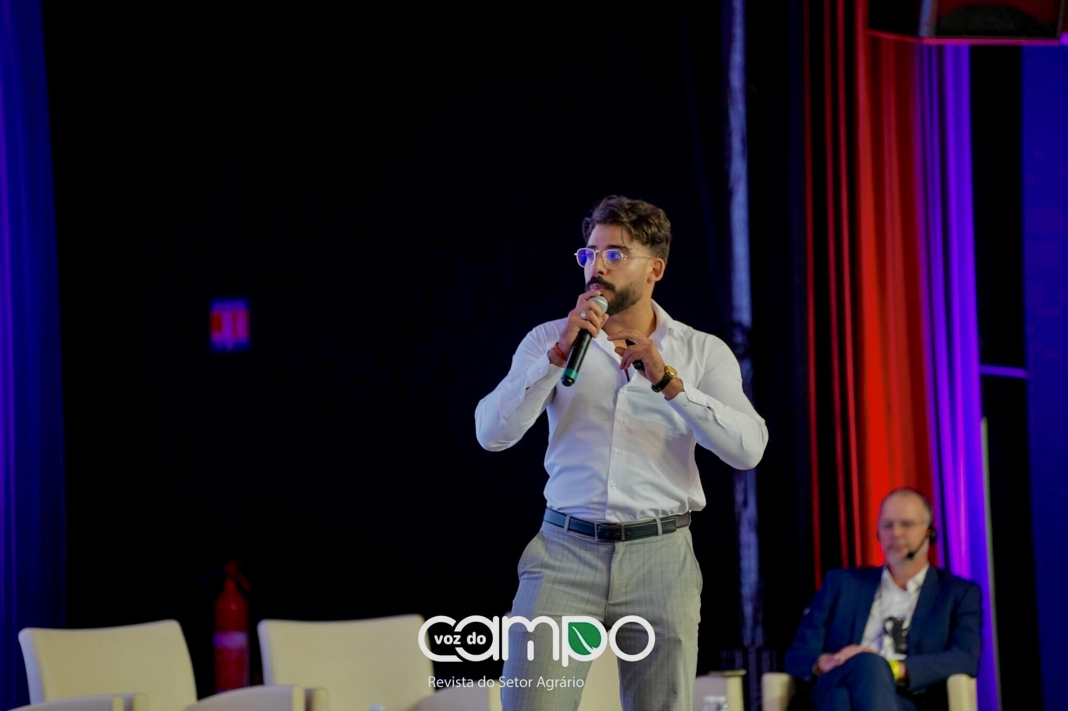  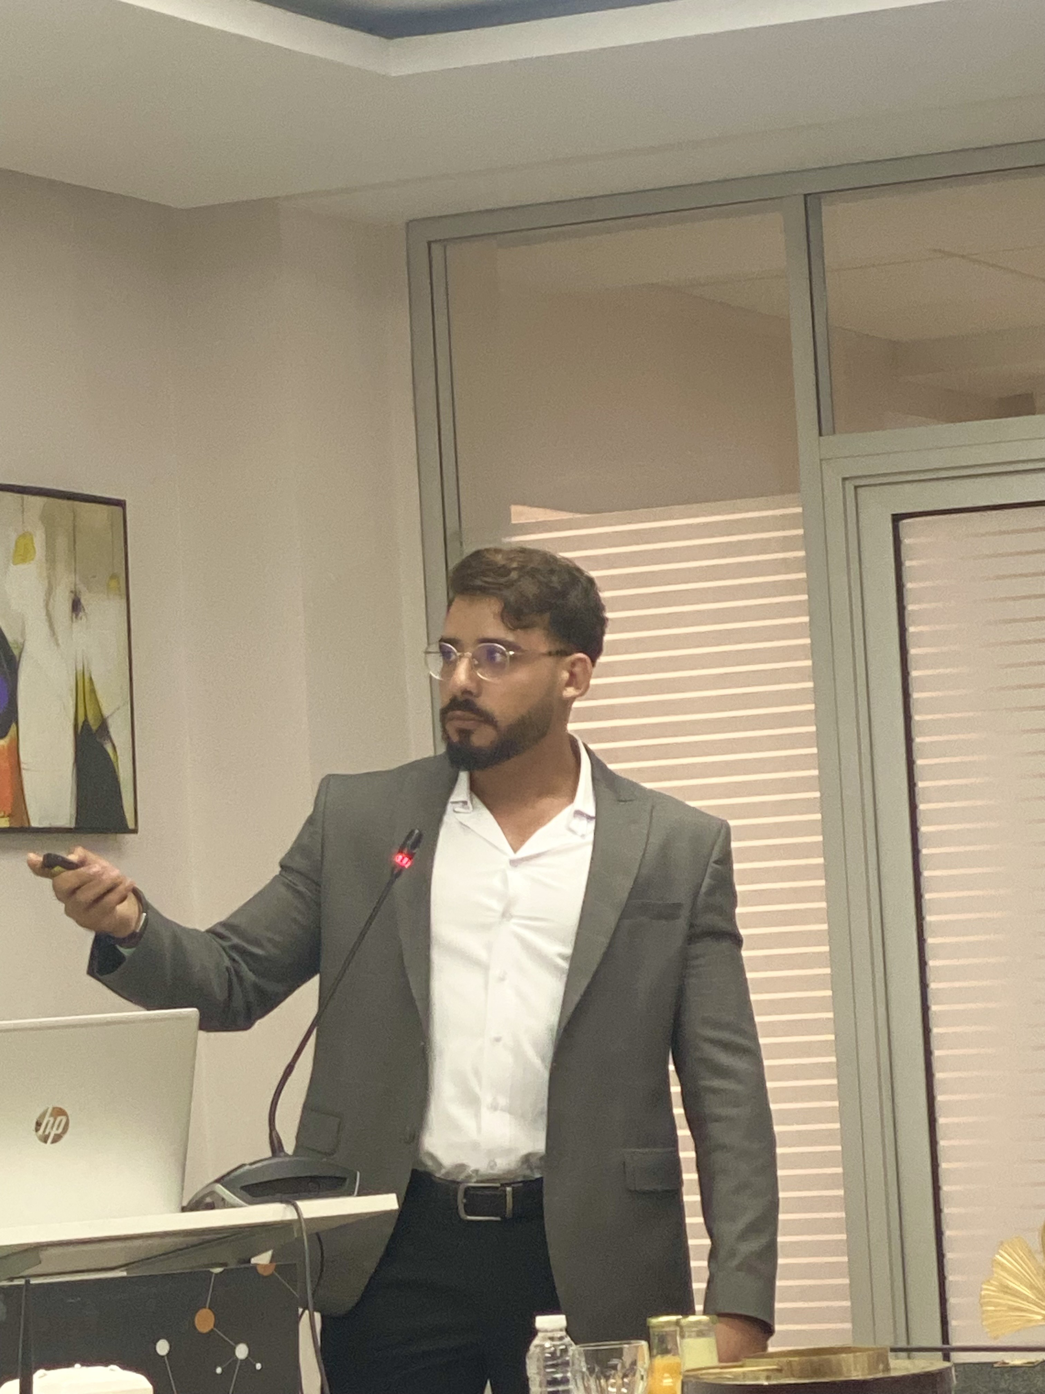
Course abstract:
Prerequisites/knowledge:
Needed software :
Needed hardware :
Needed downloads :

Course title: | Systems Integration Hackathon: From Sensor to Dashboard
Provider(s): | Zakaria OULAD – MOZA Partners
Duration and date(s): | Friday 12 Dec.- (AM & PM)
Location: | Salle de conférences + Salle Polyvalente
Photo: | 
Course abstract: | A capstone hackathon where interdisciplinary teams design a mini-prototype combining IoT sensors, data visualization, and BIM or VR elements into an integrated smart system (e.g., monitoring energy or irrigation efficiency). Teams pitch their solutions to a jury of experts.
Prerequisites/knowledge: | Previous courses of the ISAS program
Needed software : | Google Workspace, MS Office or similar (other needs depend on project types)
Needed hardware : | Laptop (other needs depend on project types)
Needed downloads : | Depend on project types

Course title: | Building a project from scratch
Provider(s): | Ismail Saddik
Duration and date(s): | Monday 08 Dec. - (AM - Keynote)
Location: | Salle de conférences
Photo: | 
Course abstract:
Prerequisites/knowledge:
Needed software :
Needed hardware :
Needed downloads :

Course title: | Robotic Precision Agriculture: Sensors, Drones, and Innovations
Provider(s): | Amine Saddik
Duration and date(s): | Thursday 11 Dec. - AM keynote
Location: | Salle de conférences
Photo: | 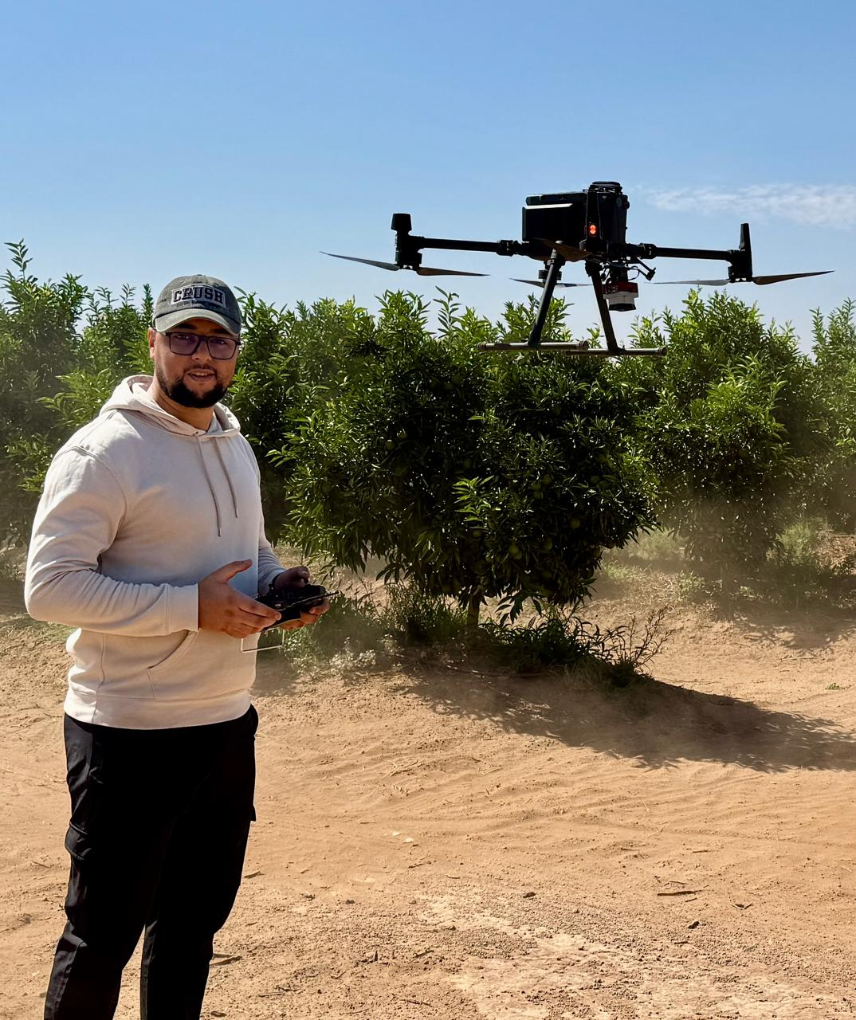  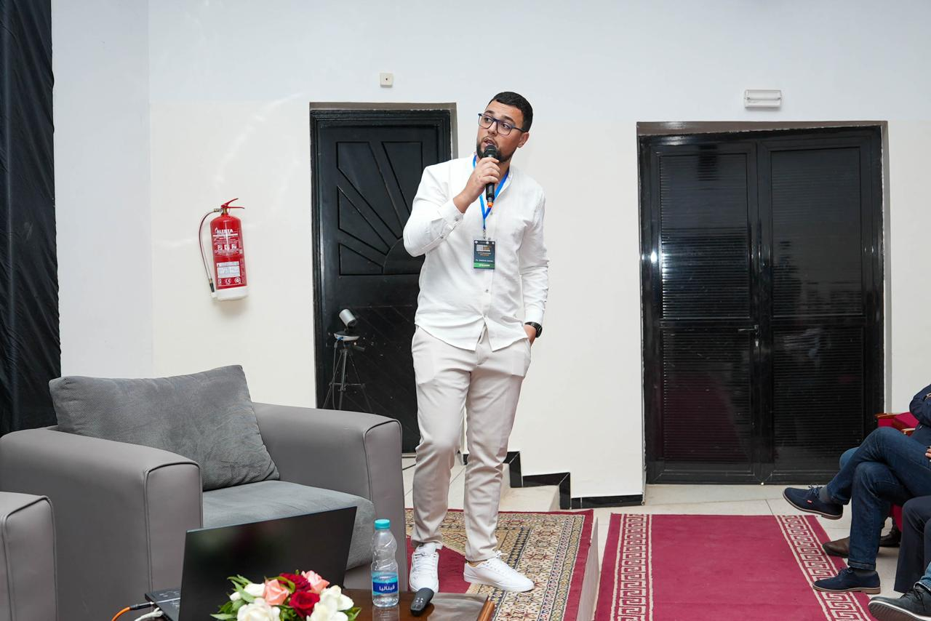
Course abstract:
Prerequisites/knowledge:
Needed software :
Needed hardware :
Needed downloads :

Course title: | Engineering ADAS: A Gateway to Vehicle Autonomy
Provider(s): | Zakaria El Khadiri
Duration and date(s): | Wednesday 10 Dec. - AM keynote
Location: | Salle de conférences
Photo:
Course abstract:
Prerequisites/knowledge:
Needed software :
Needed hardware :
Needed downloads :

